**1. High level description:**

**1.1. Technologies Used:**

Development language: Qt (Development of application)

Platform: Mobile – Android and iOS

Mathematical Modelling: Matlab

Qt will be used to program the application. It is the prime choice because it is a hybrid platform, which allow it develop the application once and deploy to both Android and iOS devices. The Matlab program will be used to construct the mathematical models.

**1.2. Deployment diagram:**

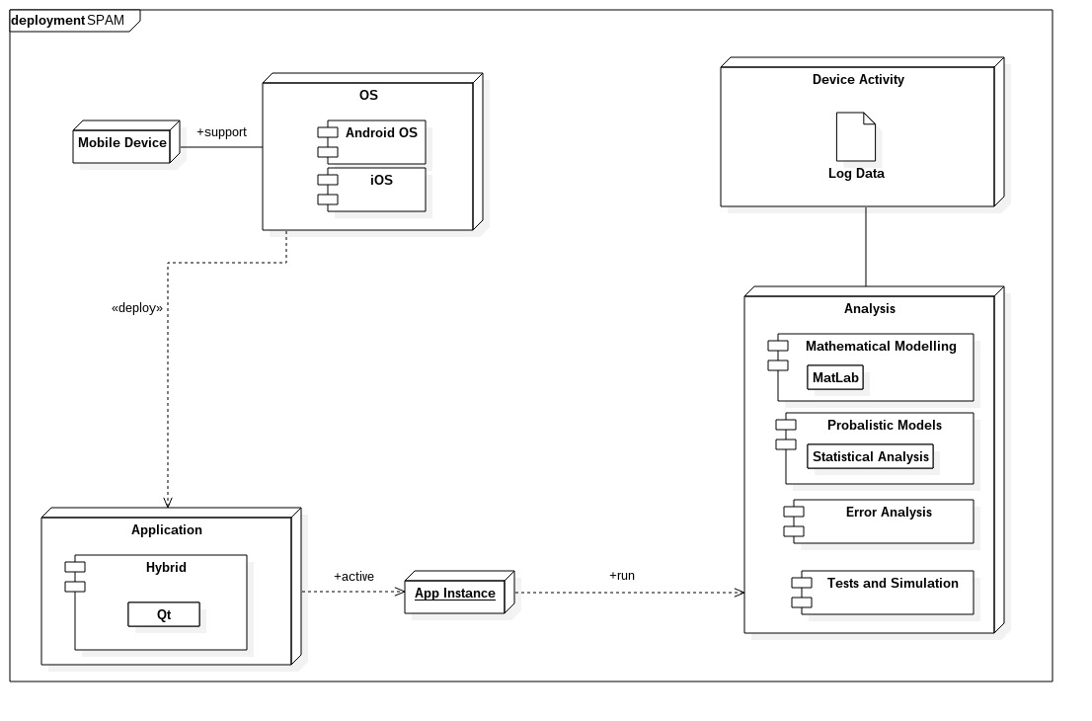  
Figure 1: SPAM deployment diagram

# **2. Deployment methodology:**

After each demonstration the team will have to meet up with the clients. When the demonstration dates are too far apart then a bi-monthly meeting will have to take place with the client. This will give the client an opportunity to share any feedback concerning the project. If the client has any changes that need to be made, he/she will have to make them during said meetings. AGILE principles will be used throughout the software life cycle development process. This will help in developing innovative ideas and increase in efficiency of the implementation stage.

# **3. Team details:**

### **Melvin Zitha:**

* Programming languages: C++, Java, JavaScript
* Web design
* Concurrent programming
* Quality Control Analysis
* Mathematical Analysis
* Good at solving problems
* MongoDb, Neo4j

I'm knowledgeable in Android application development, which is needed because the project must be designed for android, my knowledge of Java will also assist as the system will be built using java.

**Nathan Ngobale:**

* Programming languages: C++, Java, Javascript, PHP, Python
* Concurrent programming
* Net centric Computer Systems
* Computer Organisation and Architecture
* Data structures and algorithms
* SQL Database
* Good at mathematical based code

I am good when working with coordinates and direction, and other forms of coding that require a mathematical background.

### **Nkosinathi Mothoa:**

* Database Design and Implementation
* Concurrent Programming
* OO Programming
* Software Design Patterns
* Data Structures and Algorithms knowledge
* Programming Languages – C++/C, Java (FX, Swing, Android Development)

[missing description]

#### **Nkosenhle Ncube:**

* C and C++ programming
* Java programming
* Assembly programming
* Web Design
* Database design (in SQL and MongoDB)
* Critical thinking
* Time management
* Constructing suitable algorithms for various problems

The knowledge in Java and C will be most helpful with regard to the implementation phase of the application. Assembly knowledge will help when communication with the device’s hardware is needed to log the processor’s data. Critical thinking will be needed when it comes to the capturing and assessing the log data and seeing how to use the information when needed.

##### **Kamogelo Tsipa:**

* Programming - C/C++, Java, Javascript, PHP
* Web Design
* Data structures
* Mathematical modelling
* Reading Comprehension
* Complex Problem Solving
* Active Listening
* Judgment and Decision Making
* Critical Thinking

I will apply my problem solving skills and mathematical abilities to develop models which will be used by the app to test the phones performance and also my ability to develop mobile applications for a wide range of platforms to implement and develop a light weight application needed to test for malware.