**1. High Level Description:**

**1.1. Technologies used:**

Development language: Java

Database: MongoDB

Platform: Mobile - Android

Data processing: Apache Spark

MongoDB will be used as a database which will house the master product list as a key value pair. Apache spark will be used to process the data from the master product list in order to return the same product from the suppliers / wholesalers database. The database will run on cloud based servers. MongoDB conncector for Apache Spark will be used in order to access Apache Spark functionalities. This will maximize performance across the distributed data sets.

**1.2. Deployment diagram:**

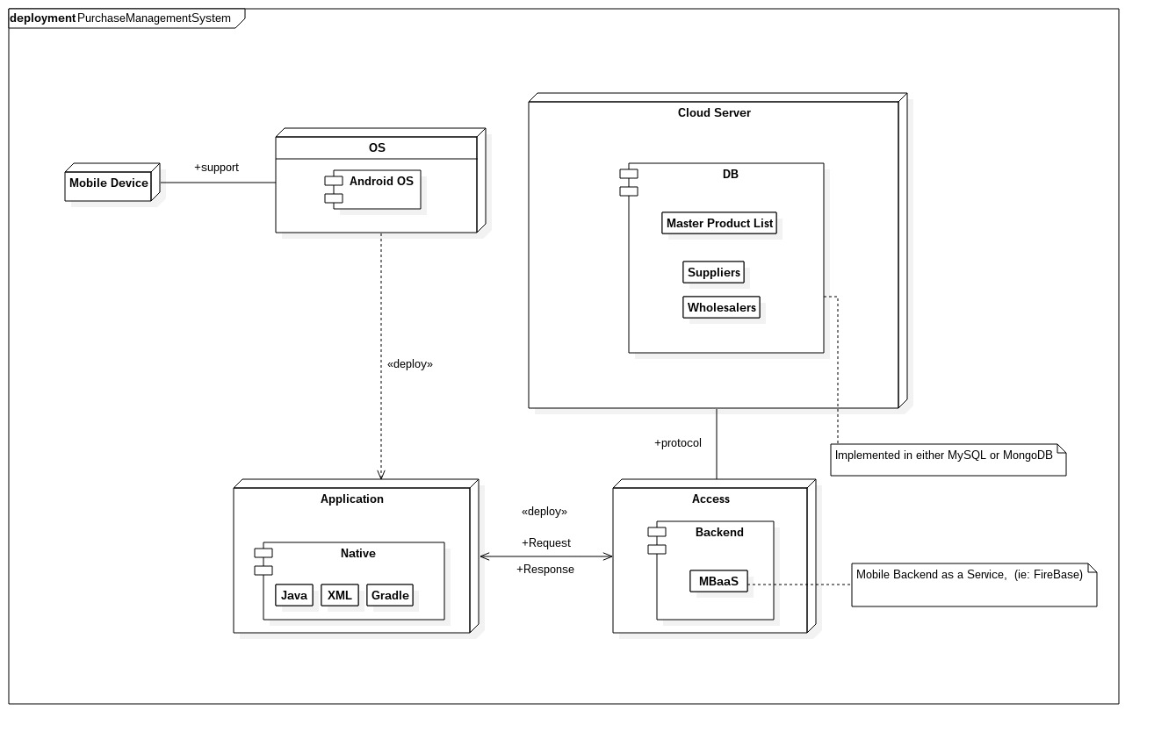

# **2. Deployment methodology:**

Our team will use the Agile Unified Process (AUP) to carry out the activities involved in implementing the Purchase Management Systems project. During the planning phase, the team will meet with the client to identify the requirements and derive the use cases from the requirements. we will have two team meetings per week and communicate with the client on a weekly basis in order to accommodate changes to the requirements, during the requirements analysis and design phases and all other phases of the project, if they are any.

# **3. Team details:**

###### **Melvin Zitha:**

* Programming languages: C++, Java, JavaScript
* Web design
* Concurrent programming
* Quality Control Analysis
* Mathematical Analysis
* Good at solving problems
* MongoDb, Neo4j

I'm skilled in database design and this project will need alot of database knowledge, I've studied and have knowledge on string matching algorithms which are needed in order to build a system that will find multiple results on different databases

**Nathan Ngobale:**

* Programming languages: C++, Java, Javascript, PHP, Python
* Concurrent programming
* Net centric Computer Systems
* Computer Organisation and Architecture
* Data structures and algorithms
* SQL Database
* Good at mathematical based code

SQL database manipulation will be useful when evaluating the prices of the stock of items vercies the price a person will be paying, efficient algorithms will be needed in order to produce fast responses from the system, also utilizing concurrent systems so the server can satisfy multiple connections and requests at the same time.

**Nkosinathi Mothoa:**

* Database Design and Implementation
* Concurrent Programming
* OO Programming
* Software Design Patterns
* Data Structures and Algorithms knowledge
* Programming Languages – C++/C, Java (FX, Swing, Android Development)

Use of skills: Apply Android Dev knowledge in the building and deploy of the mobile application.

**Nkosenhle Ncube:**

* C and C++ programming
* Java programming
* Assembly programming
* Web Design
* Database design (in SQL and MongoDB)
* Critical thinking
* Time management
* Constructing suitable algorithms for various problems

When constructing the application, the Java programming, algorithm construction and critical thinking skills will be most beneficial. They will be needed because the task will be delegated to every member, in order for the project to be implemented on time and correctly.

**Kamogelo Tsipa:**

* Programming - C/C++, Java, Javascript, Python
* Web Design
* Mathematical modelling
* Reading Comprehension
* Complex Problem Solving
* Active Listening
* Judgment and Decision Making
* Critical Thinking

Database skills are needed in order to complete this project successfully. My ability to write algoritms will prove valuable as a fast and effective algorithm is needed for searching the databases and returning the list of prices to the user.