Sailing Orders Manual
April 2022

1 Software requirements 1
2 Structure of the R project 3
3 Creation of the Sailing Orders for a survey 4
4 Details 6
4.1 Catch sampling workflow 6
4.2 Image size 6
4.3 Page orientation 6
4.4 Examples 6

Software requirements
You will need to ensure that the right software is installed on your machine for the compilation of the Sailing Orders. When it comes to R and R-Studio, ensure that you have the latest versions of packages and R before inquiries to personnel of the “Sustainable Development” research group. Also, make sure of the following:
- Ensure that all software installations are carried out with administrative rights. The code should also be executed after having started R-Studio as administrator. To do that right click on the R-Studio icon, select “Run as administrator” and provide any admin password, if required by your IT-section.
- The easiest way to update R if it is already installed on your machine is described here:
https://www.r-statistics.com/2015/06/a-step-by-step-screenshots-tutorial-for-upgrading-r-on-windows/. To carry out the update, Start R as administrator on your machine (assuming you have already installed any version of R) and follow the instructions (easy way is to follow the instructions in the “A GUI interface to updating R on Windows”. Select ‘Yes’ in step 9 and ‘NO’ in steps 10 and 12. ‘Yes’ to step 13. Wait until the process is finished.
- If it is the first time you are installing R on your machine, use the latest R version from CRAN. At the time of writing R-4.1.2-win.exe can be found in the folder of software delivered to the cruise leader. Install it as administrator.
- IF NOT INSTALLED already in your system, Install Rtools as administrator (for R versions >4 use rtools40-x86_64.exe). It can be found in the folder of software delivered to the cruise leader. Install it as administrator. If it is already installed it will show up under C:\rtools40. If it exists you do not need to do anything.
- Install the latest version of R-Studio as an administrator, using RStudio-2021.09.1-372.exe (at the time of writing this).
- Start R-Studio as administrator.
- Go to FileàOpen project and browse to the path where you have the SailingOrdersDFN.Rproj (it is in the folder SailingOrdersDFN which you can download from the channel of your survey under the DFN surveys Team. From the Files tab (bottom right panel) locate the SailingOrdersDFN.Rmd and select it. Once it opens in the top left panel you might get warnings for missing packages like the one below
- 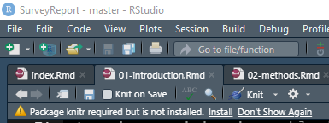
- Select install if you do.
- If you get errors indicating there are missing packages:
  - Select with your mouse the lines between “# Packages loading” and “# End of Packages loading” and click control+Enter on your keyboard.
  - Select Yes on the following window and let it install and compile what is needed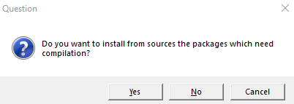
  - If you get errors about packages install them manually by going to the bottom right panel, selecting the Packages tab and clicking install. There type in the name(s) of missing packages and repeat steps 10a and 10b.
  - If during package installations you are asked the following
“Enter one or more numbers, or an empty line to skip updates:” use the number corresponding to ‘All’.
  - If you get warning messages that a package had non-zero exit status, try to install it manually using step 10c.
  - In case you get this screen
- 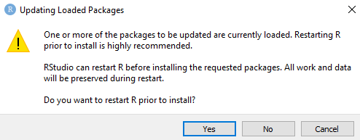
- Select No
  - In case you get an error saying:
- Warning in file.copy(lp, dirname(pkgdir), recursive = TRUE, copy.date = TRUE) :
- problem copying C:\Program Files\R\R-4.1.1\library\00LOCK-glue\glue\libs\x64\glue.dll to
- C:\Program Files\R\R-4.1.1\library\glue\libs\x64\glue.dll: Permission denied
- go to the bottom right panel, locate under the packages tab the problematic package and click on the X mark that is in the circle at the far right of the row. Select to uninstall the package and then re-install it using step 10c but this time select Yes to restarting R
- Close and restart R-Studio as admin
If you keep experiencing packages problems contact Piera Carpi, Nikos Nikolioudakis or Erik Olsen for assistance.

Structure of the R project

The folder contains the following
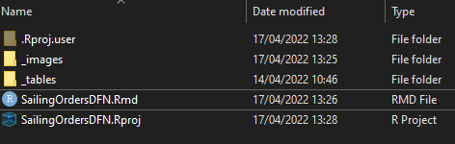

The user is required to open the SailingOrdersDFN.Rmd file in administrator mode in R-Studio. Renaming of the file name is not allowed. Once opened, the user should click on the icon looking like an “A” (Switch to visual markdown editor).
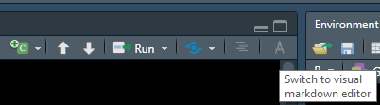

All text edits can be done now in a MS-Word-like environment, through the new toolbar.

In the _images folder, the user can include all images that are expected to be rendered in the output document. Renaming of the folder name is not allowed. Change of file names of images is permitted (but see further down for instructions).
In the _tables folder, the user is to open the excel file before rendering the SailingOrders document and included the info required in each sheet. Renaming of the file name or the sheets is not allowed, but additional sheets can be added (ut see further down for instructions).

Creation of the Sailing Orders for a survey
Draft version:
For pre-survey meetings to be held a draft version of the Sailing Orders is required as a basis for the discussions. It is advisable that a draft Sailing Orders document is compiled and circulated to meeting participants before the meeting. To be able to compile a draft version of the Sailing Orders the following steps need to be ensured in the following order:
- The “SO_input_dataframes.xlsx” is filled in as completely as possible.
- The images in the _images folder are the correct ones.
- The text part in the “SailingOrdersDFN.Rmd” file is updated to the extent possible.
Note: The provided “SailingOrdersDFN.proj” contains all the necessary elements to compile a final version of Sailing Orders for a survey. However, the information rendered applies only to that specific survey.
For step (A), open the excel file in MS Excel and ensure that the correct information is provided in each sheet.
For each of the non-captions suffix sheets, a caption for the tables is required to be included in the “SO.tab.captions” sheet.
If specific formatting is required for elements of the various tables the user can do it either in the Excel file using specific rules or do it manually every time that the output document will be compiled.
- Inclusion of text with specific font face should be done in the input_text according to the following:
  - For text to appear in italics surround the word with single asterisks, e.g. *italics* will be in the output italics
  - For text to appear in bold surround the word with double asterisks, e.g. **bold** will be in the output bold
  - To combine the above use ***bold italics*** to get bold italics
  - To superscript surround the character with caret, e.g., x^2^ to give x²
  - To subscript surround the character with tilde, e.g., x ~2~ to give x₂

The user should avoid merging cells in the “SO_input_dataframes.xlsx” sheets. The tidier and plainer a table is, the rendering will be the intended one. If complicated table structures are required and inevitable, contact Piera Carpi or Nikos Nikolioudakis.
For step (B), under the _images folder, the user can include all images that are expected to be rendered in the output document. Renaming of the folder name is not allowed. Change of file names of images is permitted (but see further down for instructions). Preferential image format is .png or .jpeg. The code might need to be adjusted accordingly if .jpeg images are included. Once the user has placed the images in the folder, correspondence must be ensured between the file names of the images and what is listed listed in the “SO.fig.captions” sheet of the “SO_input_dataframes.xlsx”. Otherwise, the image captions will not be rendered and cross-referencing in the output document will not work as intended.

For step (C), the text editing the user is required to open the “SailingOrdersDFN.Rmd” file in administrator mode in R-Studio. Renaming of the file name is not allowed. Once opened, the user should click on the icon looking like an “A” (Switch to visual markdown editor).


All text edits can be done now in a MS-Word-like environment, through the new toolbar.
Compilation of the draft Sailing Orders
If steps A, B and C have been carried out correctly, the user needs to expand the “Knit” menu and select the Knit to rodxc_document option. The document will compile and open in MS Word once rendering is completed. The location of the “SailingOrdersDFN.docx” is in the .Rproj directory.
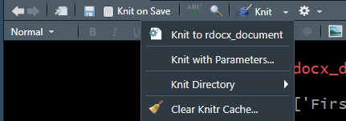

At this point, the draft Sailing Orders can be shared with the pre-survey meeting participants or any other person involved, as a .docx.

Final version:
Text edits on the draft SailingOrdersDFN.docx, comments, track changes etc. need to be resolved and accepted/rejected. Then, the final, updated text needs to be included in the “SailingOrdersDFN.Rmd” file and recompiled.
This will produce the final Sailing Orders document that should not be altered during the survey.

Details

Catch sampling workflow
Under the _images folder, there is the “catchsamplingworkflow.pptx”. This .pptx is to be modified accordingly during the pre-survey meeting and once finalized it should be saved in the _images folder as .png with the name “catchsamplingworkflow”.

Image size
The output image size is controlled from within the code chunks, through the arguments fig.width and fig.height. The user should modify the images accordingly to achieve the expected output. Note: Image sizes for images that are standard for each survey should not be tampered with, as the set values provide an acceptable output.

Page orientation
If the user needs to change the orientation of a section this is achievable by using the following red highlighted notation before (the start part) and after (the stop part) the desired section (e.g. a wide table).
<!---BLOCK_LANDSCAPE_START--->
Section to have landscape
<!---BLOCK_LANDSCAPE_STOP--->

Examples

How to include a new table in the Sailing Orders
- Add a new sheet in the “SO_input_dataframes.xlsx”. Name it using a similar pattern to the existing tables, e.g. “SO_taxonomytab”. The “SO” prefix is to indicate that the table belongs to the Sailing Orders and the “tab” part, that it is a table to be included.
- In the “SO_tab_captions” sheet, add under the tab.name column the name of the sheet you created in step 1 and provide a caption under the caption column.
- Open the “SailingOrdersDFN.Rmd” file with the process described in Step C above.
- Let’s assume that you want to include the new table that you created in step 1 under “ANNEX V. Survey-specific additional sampling” location. Find any other table code chunk, e.g. the table “SO_equipmenttab” of ANNEX VI.
- Copy the table code chunk by selecting it and copying it with Ctrl+C . The code chunk is looking like this:
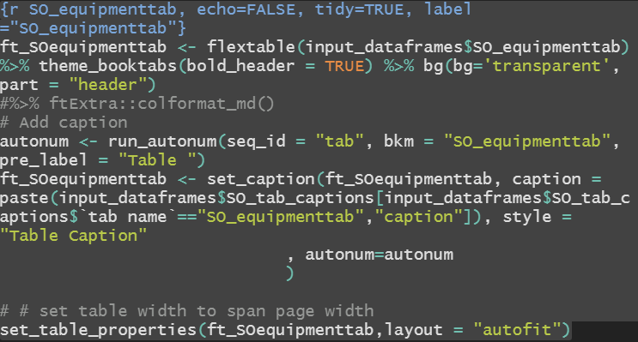
- Once copied, place your cursor before the “\newpage” and paste (Ctrl+V). The copied code chunk will be placed there.
- Now you need to modify the code chunk accordingly. To do this, replace the “SO_equipmenttab” with “SO_taxonomytab” in all instances of the code chunk.
- If a cross-reference to the table is needed somewhere in the text this can be done be adding the notation: Table @ref(tab:SO_taxonomytab). If the table is placed in an Annex, then the notation is slightly modified to: Table @ref(tab:SO_taxonomytab) (ANNEX V)

How to include a new image in the Sailing Orders
- Add a new image in the _images folder of the project. Name it using a similar pattern to the existing images, e.g. “new_imageSOfig”. Preferably, it should be a .png image format. The “SO” prefix is to indicate that the table belongs to the Sailing Orders and the “fig” part, that it is an image to be included.
- In the “SO_fig_captions” sheet of the “SO_input_dataframes.xlsx”, add under the fig.name column the name of the image you added in step 1 and provide a caption under the caption column.
- Open the “SailingOrdersDFN.Rmd” file with the process described in Step C above.
- Let’s assume that you want to include the new image that you created in step 1 under “ANNEX V. Survey-specific additional sampling” location. Find any other image code chunk, e.g. the image “surveyareamapSOfig”.
- Copy the table code chunk by selecting it and copying it with Ctrl+C . The code chunk is looking like this:
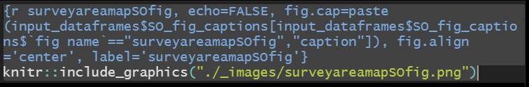
- Once copied, place your cursor before the “\newpage” and paste (Ctrl+V). The copied code chunk will be placed there.
- Now you need to modify the code chunk accordingly. To do this, replace the “surveyareamapSOfig” with “new_imageSOfig” in all instances of the code chunk.
- If a cross-reference to the table is needed somewhere in the text this can be done be adding the notation: Figure @ref(fig:surveyareamapSOfig). If the image is placed in an Annex, then the notation is slightly modified to: Figure @ref(fig:surveyareamapSOfig) (ANNEX V)

