CompTIA A+ 220-1200 Series Complete Study Guide
Copyright © 2026 Niko Williams. All rights reserved.
No part of this publication may be reproduced, distributed, or transmitted in any form or by any means, including photocopying, recording, or other electronic or mechanical methods, without the prior written permission of the publisher, except in the case of brief quotations embodied in critical reviews and certain other non-commercial uses permitted by copyright law.
Original Illustrations and Diagrams
All original illustrations, diagrams, charts, infographics, and visual study aids contained in this publication are the exclusive intellectual property of the author and are protected under United States and international copyright law. No illustration or diagram may be reproduced, copied, distributed, displayed, modified, or used in any derivative work without the express written permission of the copyright holder. Unauthorized use, including but not limited to screen captures for redistribution, tracing, recreating, or uploading to any platform, is strictly prohibited and subject to legal action.
Trademark Notices
CompTIA A+ is a registered trademark of CompTIA, Inc. This guide is an independent study resource and is not affiliated with, endorsed by, or sponsored by CompTIA. The CompTIA A+ certification program and all related exam content are the sole property of CompTIA, Inc.
Microsoft, Windows, Windows 10, Windows 11, BitLocker, Hyper-V, and Active Directory are registered trademarks of Microsoft Corporation. Apple, macOS, iOS, iPadOS, iCloud, and Time Machine are registered trademarks of Apple Inc. Android, Google, Gmail, and Google Drive are registered trademarks of Google LLC. Linux is a registered trademark of Linus Torvalds.
All other product names, trademarks, and registered trademarks mentioned in this guide are the property of their respective owners and are used solely for identification and educational purposes. Their use does not imply any affiliation with or endorsement by the respective trademark holders.
Image and Illustration Notice
Product images, photographs, and diagrams depicting third-party hardware are used for illustrative and educational purposes only. All manufacturer names, trademarks, logos, and product images remain the property of their respective owners. Specifically:
- ASUS, TUF Gaming, and the ASUS TUF Gaming Z590-PLUS WIFI product image are trademarks and property of ASUSTeK Computer Inc. Used for educational illustration only.
- No affiliation with, sponsorship by, or endorsement from any hardware or software manufacturer depicted in this guide is claimed or implied.
- The use of these images does not constitute a commercial relationship with any manufacturer referenced herein.
Disclaimer of Warranties
While every effort has been made to ensure the accuracy and completeness of the information presented in this guide, the author and publisher make no warranty, express or implied, with respect to the material contained herein. Exam objectives, formats, and passing scores are subject to change by CompTIA at any time. Readers are advised to verify current exam objectives at comptia.org before sitting for any examination.
This guide is intended as a supplementary study resource only and does not guarantee examination success. Results will vary based on individual preparation, experience, and other factors.

CompTIA A+
220-1200 Series

Complete Study Guide

Examination Coverage
Core 1 - 220-1201 — Mobile Devices · Networking · Hardware · Virtualization & Cloud · Hardware & Network Troubleshooting
Core 2 - 220-1202 — Operating Systems · Security · Software Troubleshooting · Operational Procedures
Passing Scores — Core 1: 675/900 Core 2: 700/900
Exam Time — 90 minutes per exam · Up to 90 questions each
Testing Vendor — Pearson VUE (in-person or online proctored)
Certification Validity — 3 years - renew via Continuing Education (CE) credits

How to Use This Guide
Study modules in order. Pay attention to Module Objectives as they map directly to exam domains.
Review ⚠️Exam Traps, ℹ️Exam Tips, ✔Pro Tips, diagrams, and Troubleshooting Mnemonics before your exam to memorize key processes.
Access Your FREE Online Study Portal. Scan the QR code for instant access.
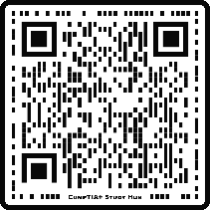
The free portal includes:
- Interactive PBQs — Practice exam-style performance-based questions.
- Printable Reference Sheets — Downloadable study aids for quick review.
- Arcade & Puzzle Games — Reinforce knowledge with Port Blaster, Maze Runner, Jeopardy, and more.
Want the full experience? Use the access code on the last page of this book to unlock the Members-Only Portal – with 500+ flash cards, a searchable glossary, bonus games, and exclusive study tools.

Important Information First

What is The CompTIA A+ Certification?
The CompTIA A+ certification validates foundational IT support and troubleshooting skills required for entry-level technical roles.
Unlike some certifications that only focus on one brand (like Apple or Microsoft), the A+ is “vendor neutral.” This means it covers all sorts of technology from different companies and operating systems, including Windows, Apple (macOS, iOS), Linux, Android, and Chrome OS. CompTIA, a global non-profit, manages the program and helps the IT industry grow.
To get your A+ certification, you need to pass two separate tests: Core 1 (220-1201) and Core 2 (220-1202).

Core 1 (220-1201) and Core 2 (220-1202) Overview
Core 1 is all about physical stuff and how computers talk to each other. This test dives into mobile devices, networking, hardware components (motherboard, CPU, RAM, hard drives), basic cloud computing, and hardware/network troubleshooting.
Core 2 switches to the software, operating systems, and how IT teams actually work. This exam checks your knowledge of different operating systems, security, software troubleshooting, and important business procedures.

Exam Format and Scoring
Time limit — 90 minutes each
Max questions — 90 questions each
Passing score (Core 1) — 675 out of 900
Passing score (Core 2) — 700 out of 900
Question types — Multiple-choice, Multiple-response, Fill-in-the-blank, Drag-and-drop, Performance-Based Questions (PBQs)

Exam Domain Weights

Core 1 (220-1201) Domain
Mobile Devices — 13%
Networking — 23%
Hardware — 25%
Virtualization and Cloud Computing — 11%
Hardware and Network Troubleshooting — 28%

Core 2 (220-1202) Domain
Operating Systems — 28%
Security — 28%
Software Troubleshooting — 23%
Operational Procedures — 21%

EXAM TIPS
A super important tip for these exams is to answer every single question. You don’t lose points for wrong answers, so it’s always better to guess than to leave it blank. You can also “flag” tough questions and come back to them later if you have time.

Logistics and Registration
- Testing Options: You can go to a certified Pearson VUE testing center in person or take them online from home with someone watching you through a webcam.
- Prerequisites: You don’t need any special qualifications to sign up, but CompTIA suggests you have at least 9-12 months of hands-on experience.
- Registration: Register through the Pearson VUE website. It’s a good idea to register for one exam at a time.
- Cost Savings: The exams can be expensive, so look for discount codes or vouchers online. Students with an active .edu email address often get big discounts!
- Certification Validity: Once you pass both exams, your A+ certification is good for three years, and then you need to do some continuing education to keep it active.

Great Ways to Study
- Use Different Study Materials: Don’t just rely on one book or website. Mix it up! Watch video courses (like on Pluralsight or Udemy), read official CompTIA study guides, and do practice exams.
- Get Hands-on Experience: The A+ is all about doing things. Try to get an inexpensive used laptop, desktop, or smartphone to take apart, put back together, and try to fix it.
- Check the Official Exam Objectives: CompTIA has free, detailed lists of everything that will be covered on Core 1 and Core 2 on their website.

CORE 1 - EXAM 220-1201
Hardware, Networking, Mobile Devices, Virtualization & Cloud
This section corresponds to the CORE 1 EXAM OBJECTIVES (220-1201) and emphasizes the physical side of computing, including hardware components, mobile technologies, connectivity standards, networking fundamentals, virtualization, and hardware-level troubleshooting.

Module: Understanding Mobile Devices

Module Objectives
Mobile devices come in a wide range of forms - smartphones, tablets, wearables, and specialized tools like AR/VR headsets - all designed to provide powerful computing capabilities in compact, portable designs.
By the end of this module, learners will be able to:
- Identify different types of mobile devices, including smartphones, tablets, wearables, and AR/VR headsets.
- Describe key characteristics and features of each device type (form factor, connectivity, operating systems, and hardware components).
- Understand basic repair and maintenance considerations, including field-serviceability and warranty implications.
- Recognize connectivity options such as Wi-Fi, Bluetooth, NFC, and cellular networking.

Wearable Technology
Wearable technology refers to compact, body-worn computing devices designed for personal use, fitness tracking, communication, and immersive experiences.
Smartwatches — Run specialized OS (e.g., watchOS, Wear OS). Support notifications, calls, texts. Features include heart rate monitoring, LTE, and NFC.
Fitness Trackers — Focused on biometric monitoring (heart rate via PPG, blood oxygen, step count). Typically, waterproof with Organic LED displays.
AR/VR Headsets — Virtual Reality (VR): Fully immersive, computer-generated environments. Augmented Reality (AR): Real-world view with digital overlays. Mixed Reality (MR): Interactive blend of real and digital content.

Smartphones
Smartphones are the most rapidly evolving and widely adopted mobile devices. They serve as compact, multifunctional tools for communication, productivity, entertainment, and more.
- Form Factor: Unitary construction (no integrated keyboard). Typically, not field-serviceable.
- Ports: The modern standard is a single multi-use USB-C port. The Lightning port is now largely obsolete for new Apple devices.
- Operating Systems: Apple iOS (closed ecosystem) and Android AOSP (open-source, used by multiple manufacturers).

Tablets
Tablets are mid-sized mobile devices that operate primarily via touchscreen input. They are larger than smartphones but smaller than laptops.
Mobile OS — Apple iOS and Google Android dominate the mobile market.
Full OS — Windows tablets run Windows 10/11 and are common in corporate environments.
Custom OS — Amazon Fire tablets run Fire OS, a modified version of Android.

E-Readers
E-readers are tablet variations designed specifically for reading digital books. They feature non-glare high-resolution displays (~300 PPI), extremely low-power consumption, and some models support cellular in addition to Wi-Fi.

Laptops & Two-in-One Devices
Laptops are mobile computers with integrated keyboards and the ability to run full desktop operating systems. Two-in-one devices bridge the gap between tablets and laptops.
Detachable — Physical keyboard can be removed (e.g., Microsoft Surface Pro)
Convertible — Keyboard folds behind screen via a 360° hinge

Connectivity Options Overview
Mobile devices rely on a variety of wireless technologies to communicate, transfer data, and connect to networks. The information below summarizes the most common connectivity options found across mobile device types.
Wi-Fi
Range: Medium (~100–300 ft indoors)
Primary Use: Internet access, local network connectivity
Common Devices: Smartphones, tablets, laptops, e-readers
Bluetooth
Range: Short (~30 ft typical)
Primary Use: Pairing peripherals (headsets, keyboards, speakers), file transfer
Common Devices: Smartphones, wearables, tablets, laptops
NFC (Near Field Communication)
Range: Very short (~1–2 inches)
Primary Use: Contactless payments, quick device pairing
Common Devices: Smartphones, smartwatches
Cellular (4G LTE / 5G)
Range: Long (miles, tower-dependent)
Primary Use: Mobile internet, voice calls, SMS
Common Devices: Smartphones, some tablets, some laptops, cellular-enabled wearables
ℹ️ Exam Tip: Most smartphones support all four technologies. Tablets and laptops commonly include Wi-Fi and Bluetooth, with cellular as an optional upgrade. Wearables typically support Bluetooth and may include Wi-Fi, NFC, or LTE depending on the model.

Warranty and Repair Considerations
Always verify the device's warranty status before attempting any repair. Not all mobile devices are designed to be repaired by the end user or a technician. Understanding field-serviceability helps IT professionals determine whether to repair, replace, or escalate a device issue. Unauthorized disassembly can void warranties, and many manufacturers now use tamper-evident seals or serialized components to detect unauthorized work.
- Smartphones are generally not field-serviceable — they use sealed unitary construction with glued components. Opening the device typically voids the manufacturer's warranty.
- Tablets vary by manufacturer. Some allow battery or screen replacement, but most consumer tablets share the sealed design of smartphones.
- Wearables (smartwatches, fitness trackers) are almost never user-serviceable due to their compact size and waterproof seals. Repairs are handled exclusively by the manufacturer.
- Laptops are the most field-serviceable mobile devices, with many models offering access to RAM, storage, batteries, and Wi-Fi cards as Field-Replaceable Units (FRUs).
- AR/VR Headsets are typically manufacturer-serviced only, with limited user-replaceable parts (such as face cushions or straps).

Module: Working on Laptops

Module Objectives
By the end of this module, learners will be able to:
- Identify key laptop hardware components.
- Differentiate between laptop power states.
- Understand best practices for disassembly and repair.
- Select and use appropriate tools for laptop maintenance.
- Recognize safety precautions and warranty considerations.

Key Laptop Hardware Components
Display Assembly — Screen (LCD or OLED), Webcam, Microphone, Wi-Fi/Bluetooth antennas.
Base Assembly — Motherboard, CPU, RAM (SO-DIMM), Storage Drive (SSD or HDD), Battery, Cooling System, Input Devices.
Ports & Connectivity — USB-A, USB-C, Thunderbolt, HDMI, Ethernet (RJ-45), SD card reader, I/O Board.

Laptop Power Management States
Sleep/Standby
Low-power state.
- CPU is off, but RAM remains powered to hold the current session.
- Recovery Time: Fastest (instant)
- Data Storage / Safety: RAM (Vulnerable to power loss)

Hibernate
The system writes the current state of RAM to the hard drive (a hibernation file) and then powers off completely.
- Recovery Time: Slow (must read data from disk)
- Data Storage / Safety: HDD/SSD (Safe from power loss)

Hybrid Sleep
Combines Sleep and Hibernate: RAM stays powered, but data is also saved to the hard drive.
- Recovery Time: Fast (if power is stable)
- Data Storage / Safety: RAM & HDD/SSD

Essential Tools for Laptop Repair
- Specialized Toolkit: Includes plastic spudgers, tweezers, screwdrivers with interchangeable bits, magnifying glass.
- Screwdriver Bits: Most commonly used: Phillips. Less common: Slotted, Torx, Pentalobe, and Robertson.
- Compressed Air: Removes dust that can cause overheating.
- Contact Cleaner: Improves connection reliability when reattaching connectors.

Safety & ESD Precautions
- Antistatic Wrist Strap: Worn on the non-dominant wrist. Clip attached to a grounded metal surface. Prevents electrostatic discharge (ESD) damage.
- Antistatic Mat: Provides a grounded surface for working on sensitive components.
- Power Off & Battery Removal: Always disconnect power before working on internal components. Hold the power button for a few seconds to dissipate residual charge.

Maintenance & Repair Considerations
- I/O Board: A small, separate circuit board that controls ports (USB, audio). A common FRU - often replaced instead of the entire motherboard.
- CPU/Heatsink Replacement: Always clean off the old thermal paste completely from both the CPU and heatsink, and apply a small, fresh amount before reattaching.
- Storage Migration: In-Place Clone is the fastest method. Backup and Restore is the safest method.
- FRUs (Field-Replaceable Units): Examples include RAM, hard drives, batteries, and Wi-Fi cards.

Quick Checklist Before You Begin
- Verify warranty status.
- Power off and remove battery.
- Ground yourself with an antistatic strap.
- Gather proper tools.
- Assess the risk vs. benefit of the repair.

Module: Mobile Input Devices

Module Objectives
By the end of this module, learners will be able to:
- Identify common laptop input devices and their functions.
- Demonstrate safe removal of a laptop keyboard.
- Recognize best practices for handling input device components.

Common Mobile Input Devices
Integrated Keyboard — Standardized within product lines. Typically easier to remove than other major components. Individual key caps can often be replaced.
Virtual Keyboard — A software-based keyboard displayed on touchscreens. Supports predictive text and various layouts.
Trackpad — May include physical click mechanisms or rely on tap gestures. Sensitivity issues can often be adjusted via system settings.
Touch Bar (Apple-specific) — A dynamic OLED strip that replaced function keys on some older MacBook models.
Stylus (Pen/Pencil) — Used with touchscreen devices. Features may include pressure and tilt sensitivity. Compatibility is device-specific.
Docking Station — Allows a laptop to easily connect to multiple external peripherals (monitors, external keyboards, etc.).

Removing a Laptop Keyboard: Step-by-Step
Preparation:
- Power off the laptop and remove the battery.
- Download the service manual for your specific model.
- Use plastic tools (spudgers) to avoid damaging fragile plastic parts.
Procedure:
- Releasing the Keyboard: Identify snap-fit tabs or screws (often near the F-keys). Use a plastic spudger to gently release the clips.
- Lifting and Flipping: Carefully lift the keyboard from the top edge and tilt it upward.
- Handling Ribbon Cables: Be cautious of the delicate ribbon cables underneath.
- Disconnecting Cables: Identify the backlight power cable (small, orange) and the keystroke signal cable (larger, blue). Use a spudger to lift the plastic clamps. Slide the cables out gently.
- Reassembly: Replace the keyboard with a new FRU. Reconnect cables and clamps. Snap or screw the keyboard back into place.
Ribbon cable connectors are delicate and not designed for frequent use. Handle with care.
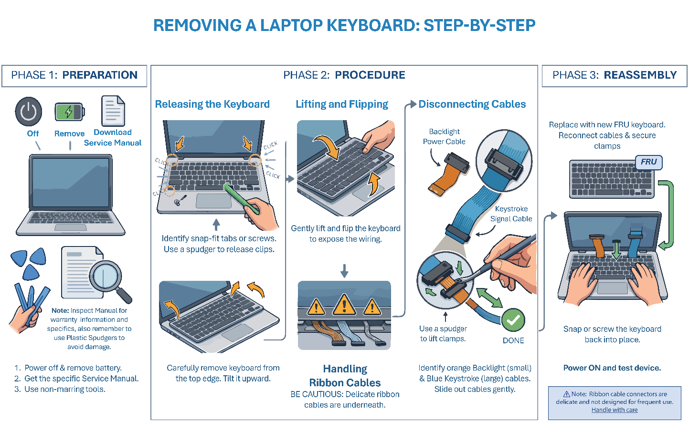

Module: Laptop System Board

Module Objectives
By the end of this module, learners will be able to:
- Identify the main components of a laptop system board.
- Understand the layout and function of the CPU, fan, and I/O board.
- Safely disassemble a laptop to access the system board.
- Recognize best practices for replacing system board components.

System Board Design Trends
Slimmer Profiles — Modern laptops feature ultra-thin designs with low-profile connectors and densely packed components.
Flat Ribbon Cables — Frequently used for internal connections; they are delicate and prone to damage during handling.
Limited Airflow — Compact layouts restrict ventilation, requiring fans to run more often.
Improved Efficiency — Leads to lower energy consumption, longer battery life, and enhanced performance.

Accessing the System Board
- Initial Disassembly: The typical sequence involves removing the battery, lower access panel, and keyboard, followed by unscrewing the top and bottom case screws.
- Key Components to Identify: Memory Modules, Coin Cell Battery (powers the system clock), Antenna Wires, Display Connector Assembly, and the Ribbon Cable to the I/O Board.

CPU and Cooling System
- CPU Location: Located underneath the heat sink. Replacement is only possible if the CPU is not soldered to the motherboard.
- Cooling System: A copper thermal conductor transfers heat from the CPU to the fan, which expels the heat. Fan failure can quickly lead to an overheating CPU.
- Thermal Paste: Clean off the old thermal paste completely from CPU and the heat sink, and apply a small, fresh amount before reassembly.
- Verification: After reassembly, run a hardware monitoring app (e.g., CPUID) to verify the CPU temperature is correct.

I/O Board
The I/O Board is often a small, separate circuit board that controls external ports like USB and audio jacks. It is typically linked to the main motherboard via a delicate ribbon cable and is a common FRU in laptops.

Module: Mobile Expansion Cards and Radios

Module Objectives
By the end of this module, learners will be able to:
- Identify common types of expansion cards for laptops.
- Explain the purpose and use of wireless radios (Wi-Fi, Bluetooth, NFC).
- Understand legacy and modern expansion interfaces.

External Expansion Cards
Modern Trend: Expansion slots are largely obsolete due to USB and Thunderbolt versatility. Legacy devices that may still appear on the A+ exam:
- ExpressCard: Replaced older PCMCIA/CardBus standards. Added ports (USB, Ethernet), media readers, etc.
- eSATA: External storage interface (faster than USB 2.0). Mostly replaced by USB/Thunderbolt.

Internal Expansion Cards
- Memory (RAM) Modules: Form factor: SO-DIMM. Types: DDR2, DDR3, DDR4, DDR5.
- M.2 Cards: Modern replacement for mSATA. Used for SSDs and wireless cards. Supports PCIe and NVMe interfaces.
- Cellular Modem Cards: Provide LTE/5G connectivity in business laptops.

Modern Wireless and Networking Standards
Bluetooth
Speed: Short-range
Definition / Feature: Short-range radio standard for pairing devices like keyboards, mice, headsets.

Wi-Fi 5 — 802.11ac
Speed: Up to 3.5 Gbps
Definition / Feature: Designed to work in the 5 GHz band with legacy 2.4 GHz support.

Wi-Fi 6 — IEEE 802.11ax
Speed: Up to 9.6 Gbps
Definition / Feature: Uses OFDMA for better efficiency in crowded environments.

Wi-Fi 7 — IEEE 802.11be
Speed: Up to 46 Gbps
Definition / Feature: Uses MLO (Multi-Link Operation) to use multiple bands simultaneously.

NFC — Near Field Communication
Speed: Short-range (inches)
Definition / Feature: Used for tap-to-pay and file transfer.

Thunderbolt 5
Speed: Up to 80 Gbps
Definition / Feature: Supports 240W charging and dual 8K monitors.
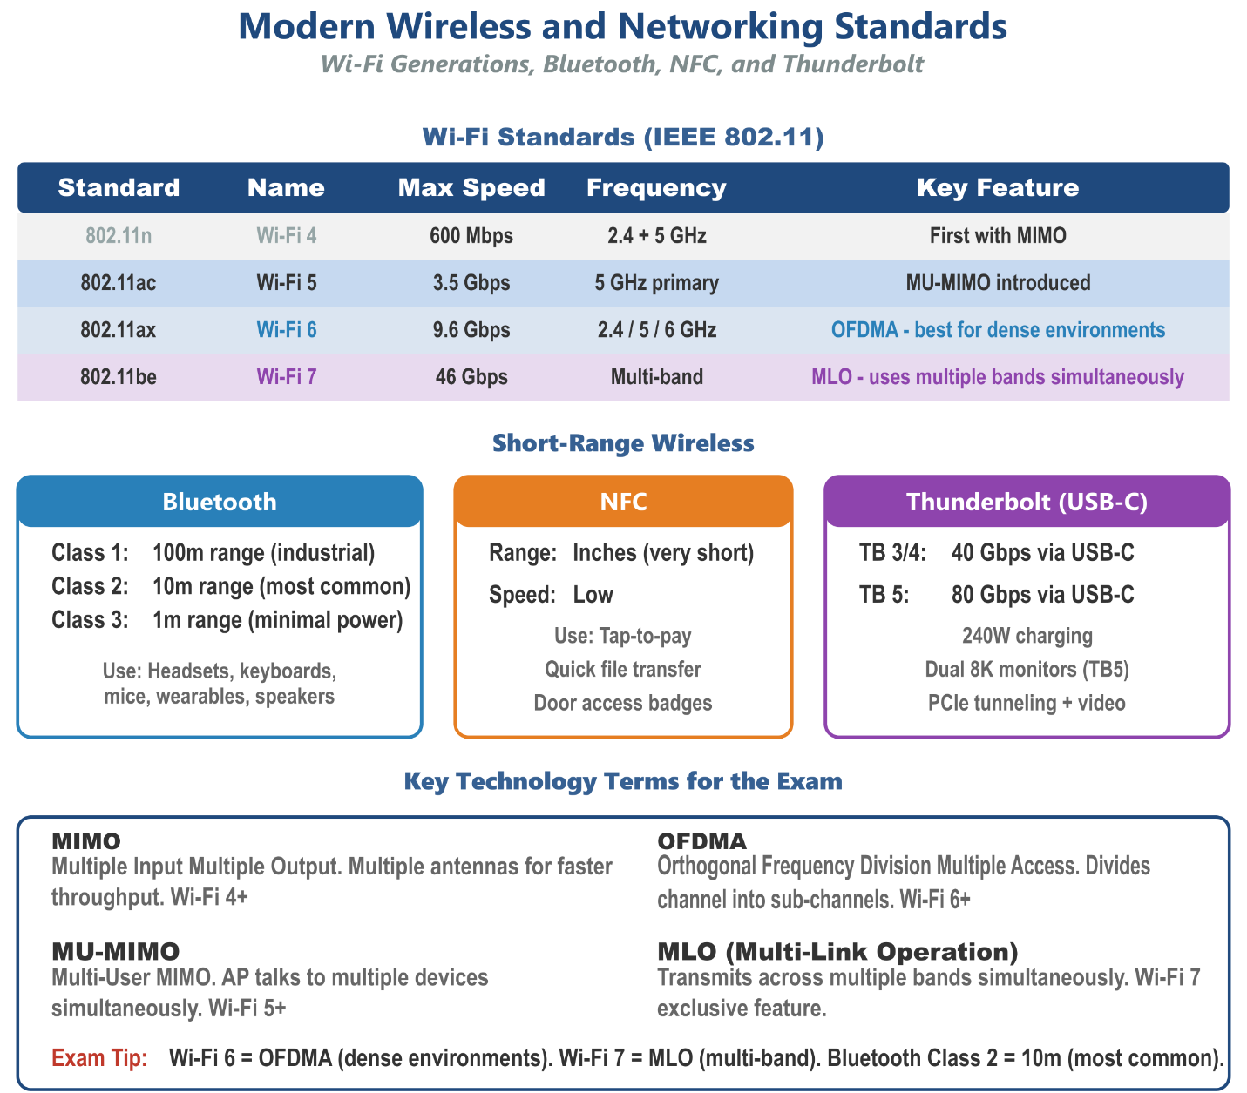

Module: Wireless and Cellular Connectivity

Module Objectives
By the end of this module, learners will be able to:
- Configure and enable both cellular and Wi-Fi connectivity on mobile devices.
- Define and identify cellular network terminology (IMEI, ICCID, IMSI, PRL).
- Explain and configure short-range wireless connectivity (Bluetooth).
- Understand the function, configuration, and security settings of Location Services.
- Explain tethering (mobile hotspot) and VPN setup on mobile operating systems.

Long-Distance Connectivity: Cellular (WWAN)
Cellular service provides long-distance networking for smartphones and mobile broadband-enabled laptops (WWAN - Wireless Wide Area Network).

Cellular Identification Terminology
IMEI Full Name: International Mobile Equipment Identity Definition and Purpose: A 15-to-17-digit identifier for the cell phone hardware itself. Allows a provider to blacklist a stolen phone.
ICCID Full Name: Integrated Circuit Card Identifier Definition and Purpose: A 19-to-20-digit number unique to the SIM card (or eSIM).
IMSI Full Name: International Mobile Subscriber Identity Definition and Purpose: A 15-digit or fewer ID for the user/subscriber. Identifies the user on all cellular networks for roaming charges.
PRL (Preferred Roaming List) Definition and Purpose: A list of radio frequencies and tower settings installed on the device to determine which cell system to use when roaming.

Medium-Distance Connectivity: Wi-Fi
- Modern Standards: Modern devices support Wi-Fi 6 (802.11ax, up to 9.6 Gbps) and, some support Wi-Fi 7 (802.11be, up to 46 Gbps).
- SSID Details: Connection details often reveal the protocol (e.g., 802.11ax), security type (e.g., WPA2-Personal), and the frequency band (2.4 GHz, 5 GHz, or 6 GHz).
- Driver Management (Windows): The Device Manager allows viewing and managing Wi-Fi adapter configuration options and drivers.

Tethering (Mobile Hotspot)
Tethering allows a smartphone to use its cellular connection to create a mobile hotspot that other devices (like a Wi-Fi-only laptop) can use to access the Internet. The hotspot can share the connection over Wi-Fi or Bluetooth.

VPN Configuration on Mobile Devices
A VPN (Virtual Private Network) encrypts mobile traffic and routes it through a corporate or private server, which is essential for protecting data on public Wi-Fi and accessing internal company resources remotely.
iOS – VPN Setup: Settings → General → VPN & Device Management → VPN → Add VPN Configuration → select type (IKEv2, IPSec, or L2TP) → enter server address, account credentials, and shared secret if required.
Android - VPN Setup: Settings → Network & Internet → VPN → + (Add) → select type (IKEv2/IPSec, L2TP/IPSec, PPTP) → enter server, username, and password.

VPN Protocol
IKEv2/IPSec — Most secure and stable. Preferred for corporate deployments. Handles network switching well (Wi-Fi to cellular).
L2TP/IPSec — Common and widely supported. Slightly older but still in use.
PPTP — Legacy. Weak encryption - avoid.
⚠️ Exam Trap: VPN configuration on mobile devices is typically pushed automatically via MDM configuration profiles in corporate environments. Manual setup is used for personal or BYOD devices only.

Short-Range Connectivity: Bluetooth
Bluetooth facilitates short-range wireless connectivity over very short distances, creating Personal Area Networks (PANs).
Class 3 — Up to 1 meter (3.3 feet); minimal power devices.
Class 2 — Up to 10 meters (33 feet); most common for consumer devices.
Class 1 — Up to 100 meters (330 feet); industrial use, higher power.

Location Services (GPS and Alternatives)
Location Services allow mobile devices to determine their geographical position. While GPS is most well known (using four or more satellites, accurate to within 5 meters), other methods exist:
- Wi-Fi Positioning System: Uses data from Wi-Fi hotspots, including signal intensity, to estimate position.
- Cellular Triangulation/Trilateration: Uses signals from multiple cell towers to approximate location.
- Bluetooth (iBeacons): Can leverage localized transmission points often used for advertising.
- IP Address: Provides a rudimentary, less-precise location based on the ISP’s location.

Configuring Location Services
- iOS: Settings → Privacy & Security → Location Services. Toggle globally on/off, or set per-app permissions (Never, Ask Next Time, While Using, Always).
- Android: Settings → Location. Toggle on/off. Under App Permissions, set per-app access levels (Allow all the time, Allow only while using, Ask every time, Deny).
✔ Pro Tip: - Be Aware of security considerations. Location data is sensitive. Best practices include granting location access only to apps that require it, using "While Using" instead of "Always" when possible, and disabling Location Services entirely when not needed to reduce tracking risk and conserve battery

Module: Mobile Device Synchronization

Module Objectives
Mobile device synchronization ensures that data (email, contacts, calendars, photos, files) stays consistent and up-to-date across multiple devices and platforms. This is a Core 1 objective covering configuration of synchronization on both iOS and Android.
By the end of this module, learners will be able to:
- Configure email, contacts, and calendar synchronization on iOS and Android.
- Understand cloud synchronization services for both platforms.
- Explain synchronization data types and their purposes.
- Troubleshoot common synchronization problems.

Cloud Synchronization Platforms
iCloud (Apple) — Apple ecosystem. Syncs: photos, contacts, calendars, notes, reminders, Safari bookmarks, passwords (iCloud Keychain), documents (iCloud Drive), app data, health data, device backups. Configured in Settings > [Your Name] > iCloud.
Google Account / Google One — Android and cross-platform. Syncs: Gmail, Google Contacts, Google Calendar, Google Drive files, Chrome bookmarks, Google Photos, Play Store app data. Configured in Settings > Accounts > Google.
Microsoft 365 / Exchange — Corporate and cross-platform. Syncs: Outlook email, Exchange contacts, Exchange calendar, OneDrive files. The standard for business email configuration on both iOS and Android.
OneDrive — Microsoft’s cloud storage. Cross-platform file sync. Integrated deeply into Windows and available as an app on iOS/Android.
Samsung Cloud — Samsung-specific. Syncs Samsung device backups, Gallery photos, contacts, calendar, and Samsung-specific app data.

Configuring Email on Mobile Devices
Email configuration is one of the most common tasks for IT support. The key information needed to set up any email account is:
- Email address and password.
- Incoming mail server address and port (IMAP or POP3).
- Outgoing mail server address and port (SMTP).
- Whether SSL/TLS is required (it should always be used).
- Authentication method (username/password, OAuth, certificate).
IMAP (Recommended) — Keeps email on the server. Syncs across all devices. Port 143 (plain) or 993 (SSL/TLS). Best for users accessing email from multiple devices.
POP3 (Legacy) — Downloads email to the device and typically removes it from the server. Port 110 (plain) or 995 (SSL/TLS). Not recommended for multi-device users.
Exchange ActiveSync (EAS) — Microsoft protocol for syncing Exchange/Microsoft 365 email, contacts, AND calendar in a single connection. The preferred method for corporate environments.
SMTP (Outgoing) — Used for sending email. Port 25 (server-to-server), 587 (submission with STARTTLS), or 465 (implicit SSL). Always use 587 or 465 for client configuration.

Contacts & Calendar Synchronization
CardDAV — Protocol for synchronizing contacts with a server. Used by iCloud, Google Contacts, and many corporate systems. Allows contacts to sync across devices from a central server.
CalDAV — Protocol for synchronizing calendars with a server. Used by iCloud Calendar, Google Calendar, and corporate calendar systems. Allows calendar events to sync across devices.
Exchange ActiveSync — Syncs contacts and calendar (in addition to email) from Microsoft Exchange or Microsoft 365. Single-protocol solution for all three data types - preferred in corporate environments.

iOS Synchronization Configuration
- iCloud Sync: Settings > [Your Name] > iCloud - toggle each type on/off individually.
- Add Corporate Email: Settings > Mail > Accounts > Add Account > Microsoft Exchange (for corporate) or select provider for personal.
- Manual CardDAV/CalDAV: Settings > Mail > Accounts > Add Account > Other > Add CardDAV/CalDAV account.
- iTunes/Finder Backup: Connect iPhone to Mac/PC for local backup — alternative to iCloud backup.

Android Synchronization Configuration
- Google Account Sync: Settings > Accounts > Google - toggle each service on/off.
- Add Corporate Email: Settings > Accounts > Add Account > Exchange (for corporate email, contacts, calendar).
- Sync Frequency: Settings > Accounts > [account] - set sync frequency or enable automatic push.
- Background Data: Some apps require background data access for continuous sync. Settings > Data Usage > [app] > Allow Background Data.

Common Sync Troubleshooting
Email not receiving / syncing — Check internet connection. Verify server settings (incoming/outgoing). Confirm password hasn’t changed. Check account storage quota.
Contacts / Calendar not syncing — Check sync is enabled for that account. Ensure the account is set as the default for contacts/calendar. Remove and re-add the account.
iCloud sync stuck — Check iCloud storage isn’t full. Sign out of iCloud and sign back in. Check Apple System Status page for service outages.
Duplicate contacts — Multiple accounts (Google, Exchange, iCloud) all syncing contacts to the same app. Merge duplicates in the contacts app or choose one sync source.
Battery drain from sync — Too-frequent sync schedule. Change from push to fetch (every 15/30 min) or manual for non-critical accounts.

Sync Direction
Not all sync relationships work the same way. Understanding sync direction matters when troubleshooting why changes made on one device aren’t showing up somewhere else.
Two-way (mutual) sync means changes flow in both directions. If you edit a contact on your phone, that change pushes to the server and then down to every other synced device. This is the default behavior for most personal accounts - Google, iCloud, and Microsoft 365 all use mutual sync for contacts, calendars, and email.
One-way sync means data flows in a single direction only. A read-only shared calendar is a common example - events pushed from the source show up on your device but changes you make locally don’t push back. Corporate environments also use one-way sync intentionally, such as pushing a standard contacts list to employee devices without allowing edits from those devices.
The practical takeaway for troubleshooting: if a user reports that changes on their phone aren’t showing up on their computer (or vice versa), confirm whether the account is configured for mutual sync or whether one-way sync is expected behavior for that account type.
ℹ️ Exam Tip: The CompTIA A+ exam expects you to know that Exchange ActiveSync handles email, contacts, AND calendar in a single configuration - making it the preferred corporate solution. Also know that IMAP keeps mail on the server (multi-device friendly) while POP3 downloads and removes it.

Quick Review — Mobile Devices

Questions
- What is the difference between Virtual Reality (VR), Augmented Reality (AR), and Mixed Reality (MR)?
- What are the three laptop power management states, and which one is safest from data loss during a power failure?
- What type of tools should a technician use when removing a laptop keyboard, and why?
- After replacing a CPU and heatsink, what step should a technician take to verify the repair was successful?
- What is the maximum theoretical speed of Wi-Fi 7 (802.11be), and what key technology does it use to achieve this?
- What single Microsoft protocol syncs email, contacts, AND calendar in one connection, and why is it preferred in corporate environments?
- What does IMEI stand for, and what is its primary purpose in cellular networking?

Answer Key
- VR creates a fully immersive, computer-generated environment. AR overlays digital content onto the user's real-world view. MR is an interactive blend where virtual objects interact with the physical environment.
- Sleep/Standby (RAM powered, fastest recovery), Hibernate (state saved to disk), and Hybrid Sleep (RAM + disk). Hibernate is safest because data is written to the HDD/SSD and is not lost if power fails.
- Plastic tools (spudgers) — to avoid damaging fragile plastic parts and delicate components during removal.
- Run a hardware monitoring application (e.g., CPUID) to verify that CPU temperatures are within normal operating range.
- Up to 46 Gbps, using MLO (Multi-Link Operation) to utilize multiple bands simultaneously.
- Exchange ActiveSync (EAS) — it handles all three data types (email, contacts, calendar) in a single configuration, simplifying corporate device setup and management.
- International Mobile Equipment Identity — a 15-to-17-digit identifier for the cell phone hardware itself that allows a provider to blacklist a stolen phone.

Module: Networking Fundamentals

Module Objectives
Networking is 23% of the Core 1 exam - one of the largest domains. This module builds the foundational knowledge every A+ technician needs to understand how data moves across networks, how devices are addressed, and how common protocols work.
By the end of this module, learners will be able to:
- Explain common network types (LAN, WAN, PAN, MAN, WLAN) and their use cases.
- Understand the TCP/IP model and the role of each layer.
- Identify IP addressing concepts including IPv4, IPv6, subnetting, and CIDR notation.
- Describe the function of key network protocols (DNS, DHCP, HTTP/S, FTP, SMTP, etc.).
- Identify common network hardware: routers, switches, access points, and firewalls.
- Understand common ports and their associated protocols.
- Describe network topologies and explain the difference between client-server and peer-to-peer networks.
- Identify the 7 layers of the OSI model and map them to the TCP/IP model.

Network Types
PAN (Personal Area Network) — Very short range, typically within a few meters. Examples: Bluetooth headset, smartwatch. Technology: Bluetooth, NFC.
LAN (Local Area Network) — Covers a single building or campus. Examples: home network, office network. Technology: Ethernet, Wi-Fi.
WLAN (Wireless LAN) — A LAN using wireless (Wi-Fi) technology instead of cables. Most home/office wireless networks are WLANs.
MAN (Metropolitan Area Network) — Covers a city or large campus. Often managed by ISPs or municipalities.
WAN (Wide Area Network) — Covers large geographic distances (cities, countries, the internet). Example: connecting branch offices across the country.
WWAN (Wireless WAN) — Wide-area wireless networking uses cellular towers. Used by smartphones and mobile broadband cards.

Network Topologies
A network topology describes how devices are physically or logically arranged and connected.
Star — All devices connect to a central hub or switch. Most common in modern LANs. If the central device fails, the whole network goes down. Easy to troubleshoot.
Bus — All devices share a single communication line (the “bus”). If the bus fails, the entire network fails. Obsolete in modern networks.
Ring — Devices are connected in a closed loop. Data travels in one direction. Rarely used today except in some fiber-optic (FDDI) configurations.
Mesh — Every device connects to every other device. Highly redundant and fault-tolerant. Used in enterprise WANs and some wireless mesh networks.
Hybrid — A combination of two or more topologies. Most real-world enterprise networks are hybrid (commonly star-bus).
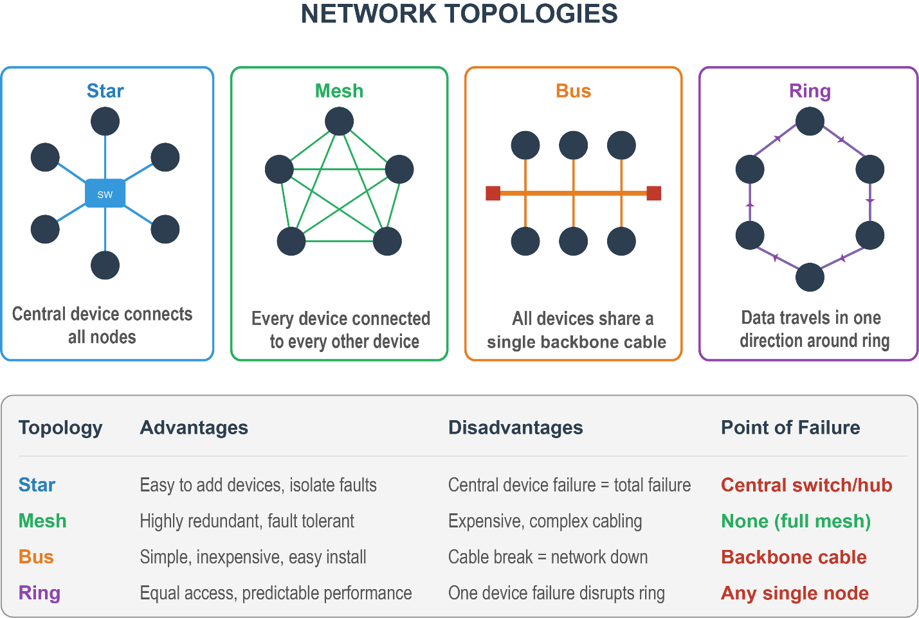

Network Architectures
Client-Server: A dedicated server provides resources (files, authentication, email) to client devices. Centrally managed. Scales well. Examples: Corporate Active Directory domain, web servers, email servers.
Peer-to-Peer (P2P): Devices connect directly and share resources with each other - no dedicated server. Each device acts as both client and server. Examples: Home workgroup, small office file sharing, BitTorrent.
ℹ️ Exam Tip: The exam tests this in scenario form. If the question mentions a dedicated server, domain, or Active Directory - that’s client-server. If it mentions a small office with no server where users share files directly - that’s peer-to-peer.

TCP/IP Model
The TCP/IP model is the foundational framework that defines how data is transmitted over a network. It has four layers:
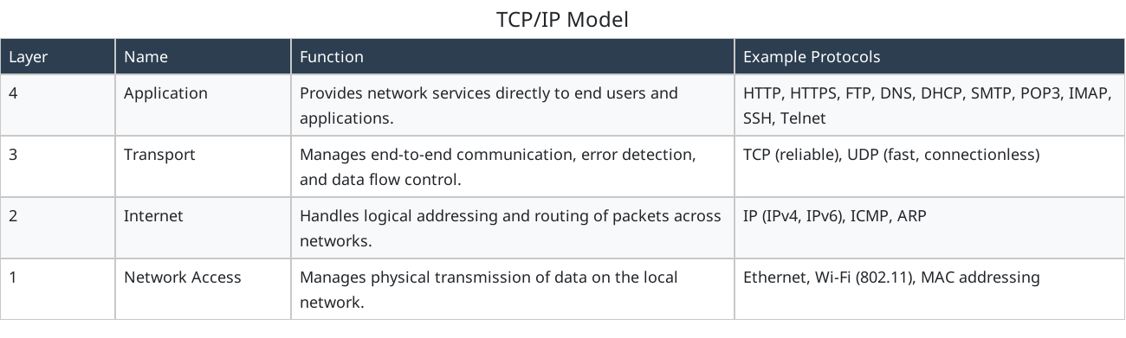
4 — Application: Provides network services directly to end users and applications. Example Protocols: HTTP, HTTPS, FTP, DNS, DHCP, SMTP, POP3, IMAP, SSH, Telnet
3 — Transport: Manages end-to-end communication, error detection, and data flow control. Example Protocols: TCP (reliable), UDP (fast, connectionless)
2 — Internet: Handles logical addressing and routing of packets across networks. Example Protocols: IP (IPv4, IPv6), ICMP, ARP
1 — Network Access: Manages physical transmission of data on the local network. Example Protocols: Ethernet, Wi-Fi (802.11), MAC addressing

TCP vs. UDP
Connection-oriented: establishes a connection before sending data. — Connectionless: sends data without establishing a connection first.
Reliable: guarantees delivery, order, and error checking. — Unreliable: no guarantee of delivery or order.
Slower due to acknowledgment overhead. — Faster - ideal for real-time applications.
Used for: web browsing (HTTP/S), email, file transfers. — Used for: video streaming, VoIP, gaming, DNS queries.
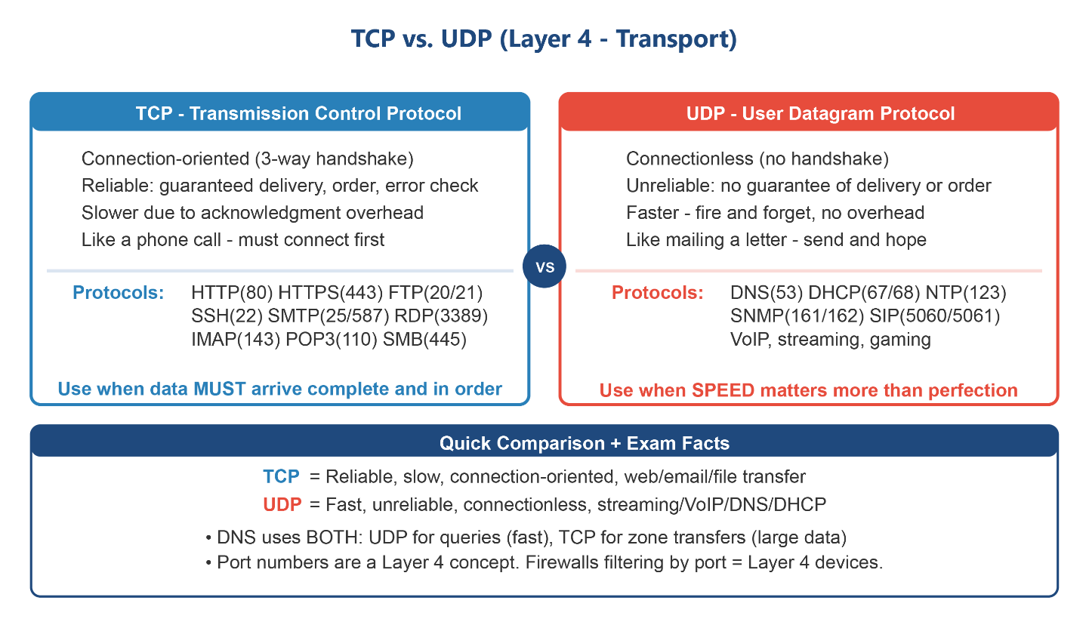

The OSI Model
The OSI (Open Systems Interconnection) model is a 7-layer conceptual framework that describes how data travels from one device to another across a network. While TCP/IP is the model that actually runs the internet, the OSI model is the standard reference used in networking education and troubleshooting - and the A+ exam tests it directly.
Think of the OSI model as a checklist. When something breaks, technicians work layer by layer - from Physical (is the cable plugged in?) up to Application (is the software configured correctly?) to isolate the fault.

The 7 Layers of the OSI Model
7 — Application Function: Provides network services directly to user-facing applications. Layer users interact with. Key Protocols & Devices: HTTP, HTTPS, FTP, DNS, DHCP, SMTP, POP3, IMAP, SSH, Telnet
6 — Presentation Function: Translate data between the application and the network. Handles encryption, compression, and formatting. Key Protocols & Devices: TLS/SSL encryption, JPEG, ASCII, Unicode
5 — Session Function: Establishes, manages, and terminates sessions (conversations) between applications. Key Protocols & Devices: NetBIOS, RPC, SMB session setup
4 — Transport Function: Segments data for transmission. Manages end-to-end delivery, port numbers, error checking, and flow control. Key Protocols & Devices: TCP (reliable), UDP (fast/connectionless)
3 — Network Function: Handles logical (IP) addressing and routing packets between different networks. Key Protocols & Devices: IP (IPv4, IPv6), ICMP, ARP - Device: Router
2 — Data Link Function: Manages physical (MAC) addressing, frame creation, and error detection on the local network. Key Protocols & Devices: Ethernet, Wi-Fi (802.11) Device: Switch
1 — Physical Function: Transmits raw bits over the physical medium (cable, fiber, radio waves). Defines connectors, voltages, and timing. Key Protocols & Devices: Ethernet cable, fiber optic, hubs, repeaters
ℹ️ Exam Tip: ARP operates at the boundary of Layer 2 and Layer 3. It resolves Layer 3 addresses (IP) to Layer 2 addresses (MAC). CompTIA typically associates ARP with Layer 2, but it’s most accurately described as a Layer 2/3 bridge protocol.

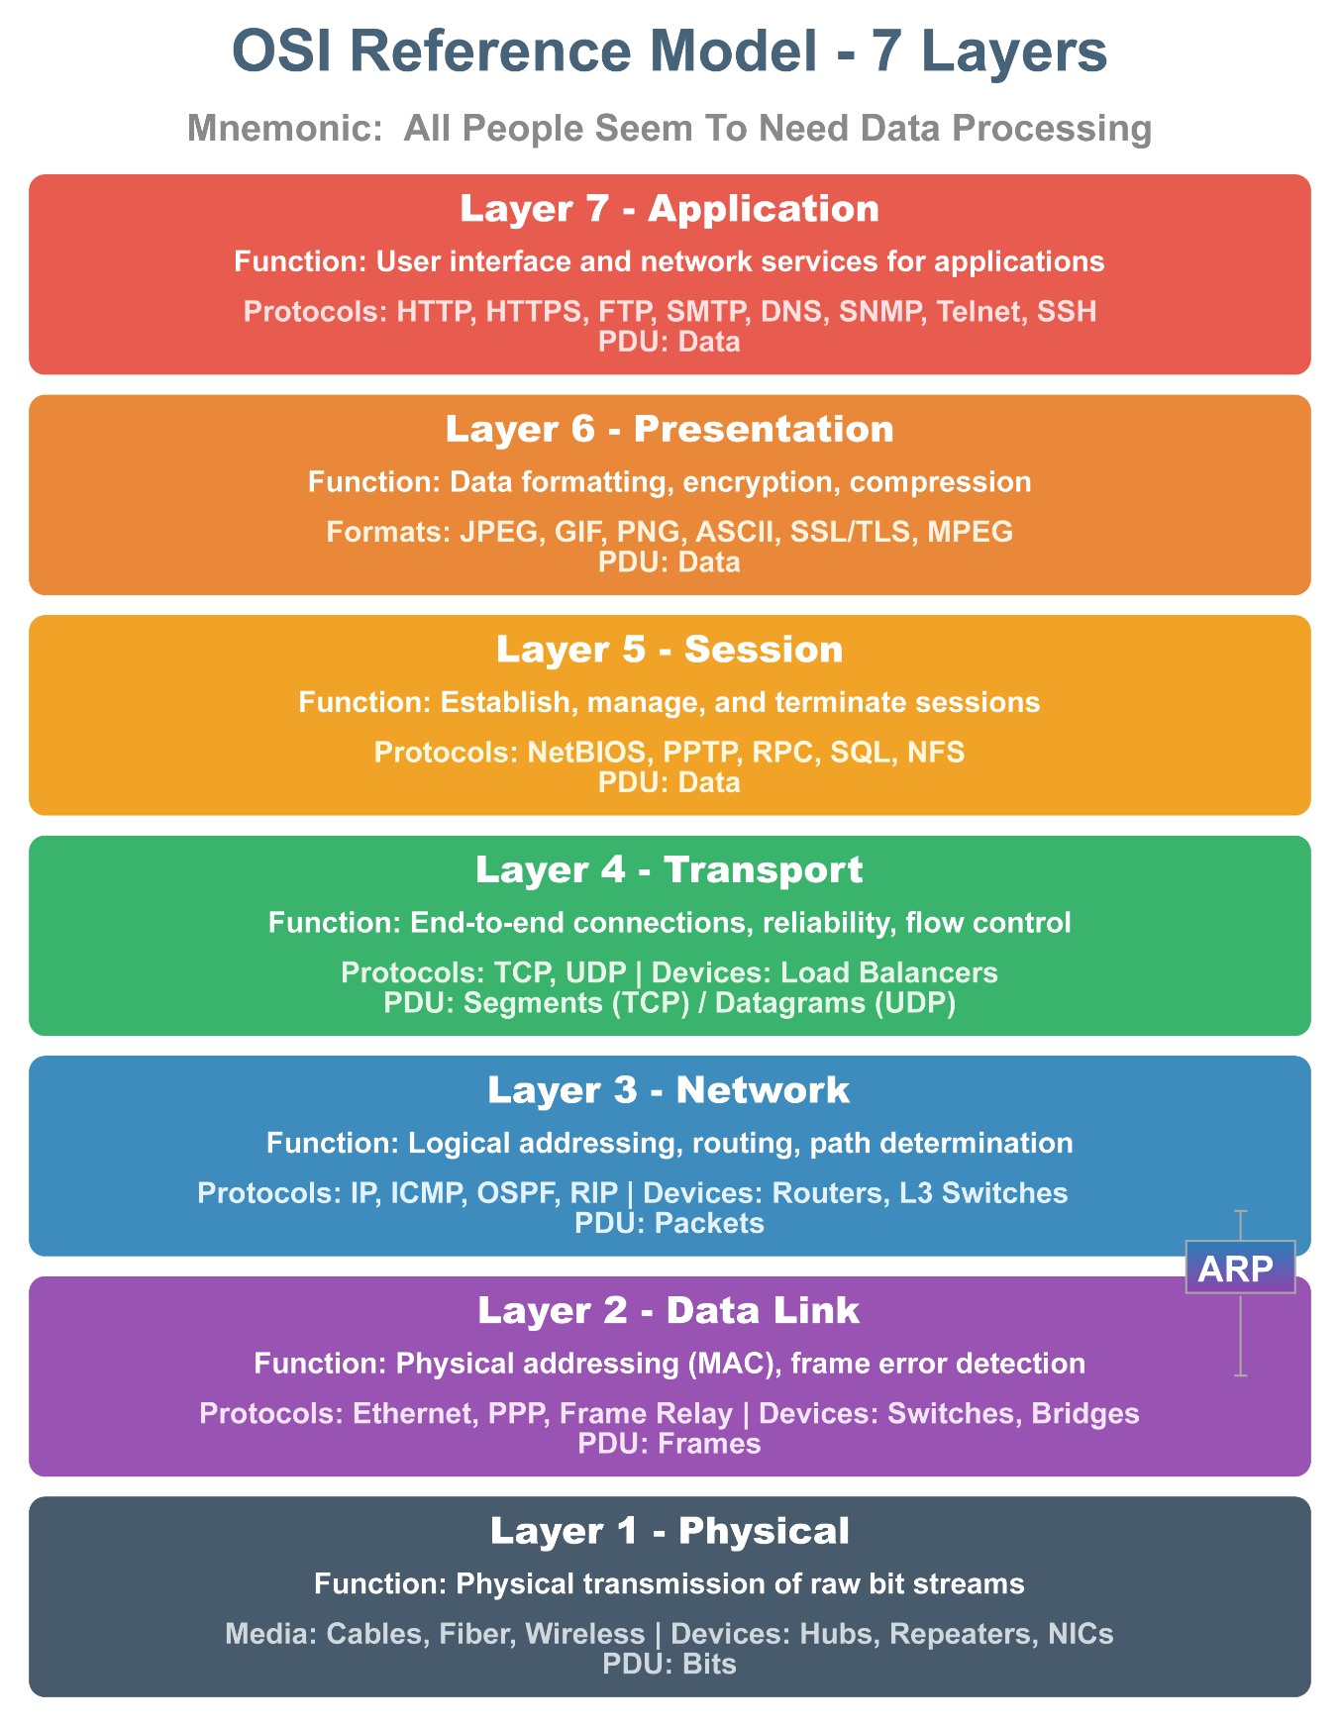

OSI vs. TCP/IP: Side-by-Side
The TCP/IP model collapses the 7 OSI layers into 4. Understanding this mapping is frequently tested - especially questions that ask which layer a protocol or device belongs to.
7 (Application) — TCP/IP Layer: Application
6 (Presentation) — TCP/IP Layer: Application
5 (Session) — TCP/IP Layer: Application
4 (Transport) — TCP/IP Layer: Transport
3 (Network) — TCP/IP Layer: Internet
2 (Data Link) — TCP/IP Layer: Network Access
1 (Physical) — TCP/IP Layer: Network Access
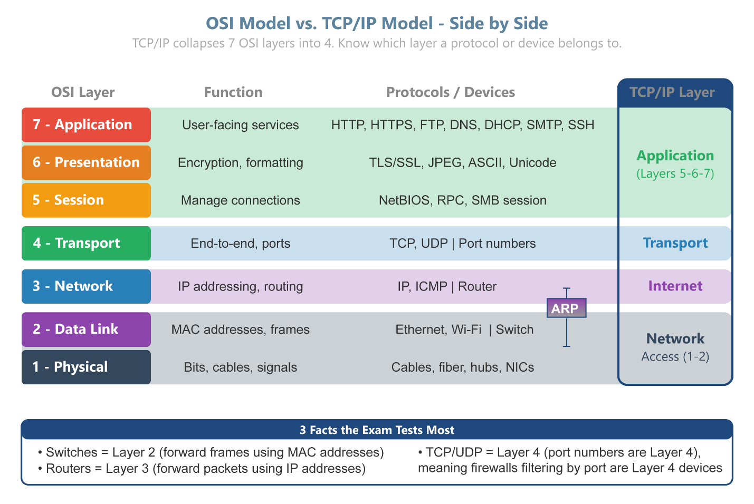

The 3 OSI Facts the Exam Tests Most
Switches operate at Layer 2 (Data Link) — Switches forward frames using MAC addresses. If a question mentions a MAC address table, think Layer 2.
Routers operate at Layer 3 (Network) — Routers forward packets using IP addresses. If a question involves routing or IP addressing, think Layer 3.
TCP and UDP live at Layer 4 (Transport) — Port numbers are a Layer 4 concept. Firewalls that filter by port number are considered Layer 4 devices.
✔ Pro Tip: - The mnemonic “All People Seem To Need Data Processing” maps layers 7 down to 1 (Application → Physical). See the Mnemonics section in the Exam Preparation section for the full breakdown
⚠️ Exam Trap: While ARP resolves Layer 3 IP addresses to Layer 2 MAC addresses, CompTIA and Cisco traditionally classify ARP as a Layer 2 (Data Link) protocol

Network IP Addressing
IPv4 addresses are 32-bit numbers written in dotted decimal notation (e.g., 192.168.1.100). Every device on a network needs a unique IP address to communicate.

IPv4 Addressing and Private Ranges
Class A — 1.0.0.0 – 126.255.255.255. Large networks. First octet = network, last three = host.
Class B — 128.0.0.0 – 191.255.255.255. Medium networks. First two octets = network.
Class C — 192.0.0.0 – 223.255.255.255. Small networks. First three octets = network.
Private IP ranges (not routable on internet) — 10.0.0.0/8, 172.16.0.0/12, 192.168.0.0/16. Used inside homes and offices.
APIPA (169.254.x.x) — Automatically assigned when a device cannot reach a DHCP server. Indicates a DHCP problem.
Loopback (127.0.0.1) — Always refers to “this device.” Used for testing the local network stack.
(Note: Class A/B/C ranges are legacy and not tested directly — focus on private ranges, APIPA, and loopback.)

Subnet Masks and CIDR Notation
A subnet mask identifies which portion of an IP address is the network ID and which is the host ID. CIDR notation expresses this as a prefix length (e.g., /24).
255.255.255.0 (/24) Hosts per Subnet: 254 hosts
255.255.0.0 (/16) Hosts per Subnet: 65,534 hosts
255.0.0.0 (/8) Hosts per Subnet: 16,777,214 hosts
255.255.255.128 (/25) Hosts per Subnet: 126 hosts
255.255.255.192 (/26) Hosts per Subnet: 62 hosts
Default Gateway: The IP address of the router on the local network. Devices send traffic to the default gateway when the destination is outside the local network.

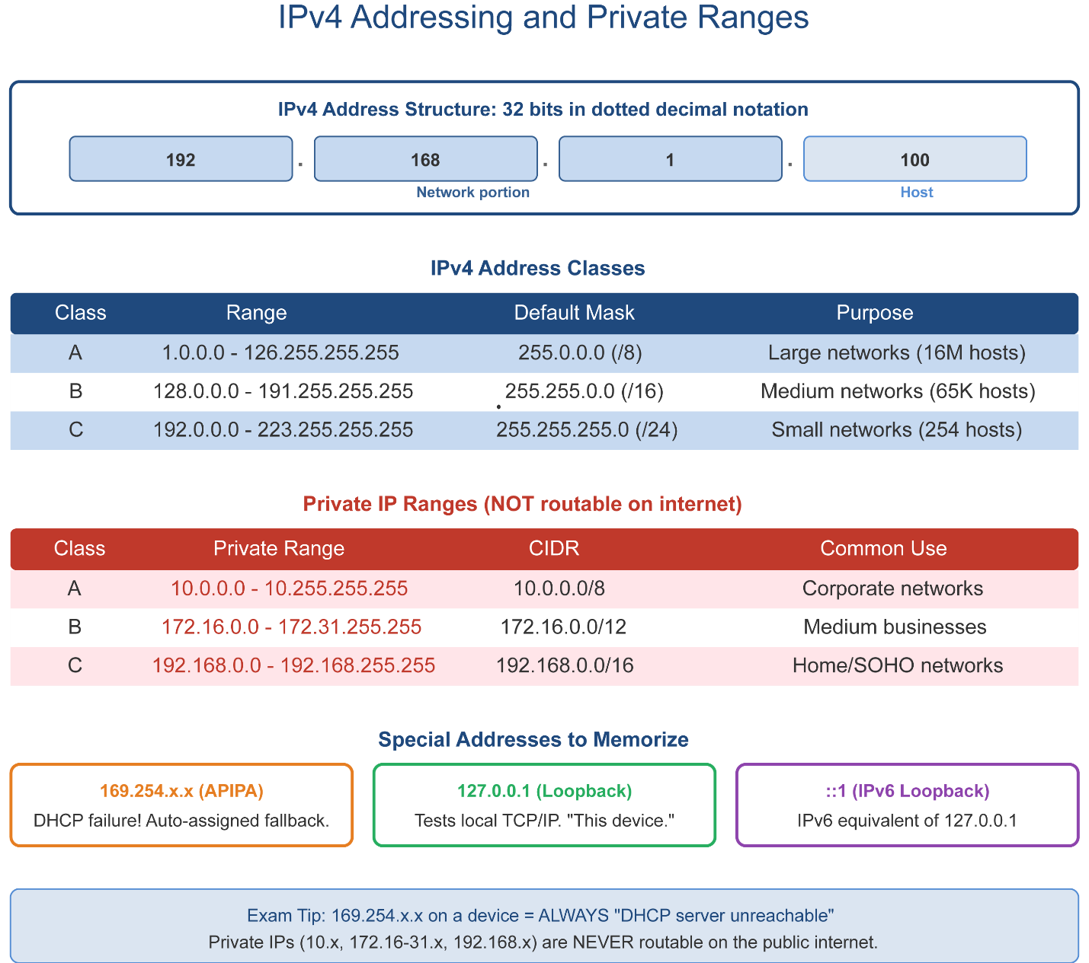

IPv6 Addressing
IPv6 addresses are 128-bit numbers written in hexadecimal notation, separated by colons (e.g., 2001:0db8:85a3::8a2e:0370:7334). IPv6 was developed to solve the IPv4 address exhaustion problem.
Address format — 128-bit hexadecimal, 8 groups of 4 hex digits separated by colons.
Loopback — ::1 (equivalent to 127.0.0.1 in IPv4).
Link-local — fe80::/10 - auto-configured addresses for local network communication only.
No broadcast — IPv6 uses multicast and anycast instead of broadcast.
Auto-configuration — Devices can self-assign global IPv6 addresses using SLAAC (Stateless Address Autoconfiguration).
IPv6 uses prefix length instead of subnet masks. Standard LAN prefix: /64 (network portion = 64 bits, host portion = 64 bits).
Example:
- Address: 2001:db8:abcd:0012::/64
- Network ID: 2001:db8:abcd:0012::
- Host range: practically unlimited (2^64).
Key Point: Focus on recognizing /64 and the concept of prefix delegation (e.g., /48, /56, `/64). You do not need to calculate host counts.
⚠️ Exam Trap: A+ won’t ask you to calculate subnetting, but it will test whether you can spot when a wrong mask breaks communication. Look for clues like: “Two PCs are on the same switch but can’t ping each other.” → Check subnet masks first. Remember: IPv6 doesn’t use broadcast, so mask errors show up differently.

Troubleshooting Subnet Masks
A subnet mask defines which devices are considered “local.” If the mask is wrong, devices may think they’re on different networks even when they’re not — and communication fails.

Common Exam-Relevant Scenarios
Wrong mask prevents communication
Example if PC1 is 192.168.1.10/24 but sees network as 192.168.1.0 and if PC2 is 192.168.1.20/16 but sees network as 192.168.0.0 then the result is they believe they’re on different subnets, so traffic must go through a router. If no router is configured, they can’t talk.
Overlapping subnets
Two DHCP scopes overlap (e.g., one set to /24, another /25). Devices may get conflicting IPs, leading to routing errors.
Default gateway unreachable
If the mask is too restrictive, the gateway may appear “outside” the subnet, so devices can’t reach it.

Common Network Protocols and Ports
The A+ exam expects you to know these protocol names, their function, and their default port numbers. TCP/UDP indicates which transport protocol they use.
HTTP — 80
TCP/UDP: TCP
Function: Hypertext Transfer Protocol — unencrypted web browsing.
HTTPS — 443
TCP/UDP: TCP
Function: HTTP Secure - encrypted web browsing using TLS/SSL.
FTP — 20/21
TCP/UDP: TCP
Function: File Transfer Protocol - transferring files between systems. Port 21 = control, Port 20 = data.
SFTP — 22
TCP/UDP: TCP
Function: SSH File Transfer Protocol - encrypted file transfer.
SSH — 22
TCP/UDP: TCP
Function: Secure Shell - encrypted remote command-line access.
Telnet — 23
TCP/UDP: TCP
Function: Unencrypted remote access. Largely replaced by SSH.
SMTP — 25 / 587
TCP/UDP: TCP
Function: Simple Mail Transfer Protocol - sends email.
POP3 — 110
TCP/UDP: TCP
Function: Post Office Protocol v3 - receives email (downloads and removes from server).
IMAP — 143
TCP/UDP: TCP
Function: Internet Message Access Protocol — receives email (stays on server, syncs across devices).
DNS — 53 TCP/UDP: TCP/UDP
Function: Domain Name System - translates domain names to IP addresses.
DHCP — 67/68 TCP/UDP: UDP
Function: Dynamic Host Configuration Protocol — automatically assigns IP addresses. Server=67, Client=68.
LDAP — 389 TCP/UDP: TCP/UDP
Function: Lightweight Directory Access Protocol — accesses directory services (e.g., Active Directory).
LDAPS — 636
TCP/UDP: TCP
Function: LDAP over SSL - encrypted directory access.
SMB — 445
TCP/UDP: TCP
Function: Server Message Block - Windows file sharing protocol.
RDP — 3389
TCP/UDP: TCP
Function: Remote Desktop Protocol - graphical remote access to Windows systems.
SNMP — 161/162 TCP/UDP: UDP
Function: Simple Network Management Protocol — monitors and manages network devices.
NTP — 123 TCP/UDP: UDP
Function: Network Time Protocol - synchronizes clocks across devices.
SIP — 5060/5061 TCP/UDP: TCP/UDP
Function: Session Initiation Protocol - sets up VoIP calls. 5061 is encrypted.

Network Hardware
Hub — Legacy device that broadcasts all incoming data to every connected port. Creates collisions. Replaced by switches.
Switch — Forwards frames only to the correct destination port using MAC address tables. Most common LAN device. Operates at Layer 2 (Data Link).
Router — Connects different networks together and routes packets between them using IP addresses. Operates at Layer 3 (Network).
Wireless Access Point (WAP) — Connects wireless devices to a wired network. Does NOT route - just bridges wireless and wired segments.
Modem — Converts the ISP’s signal (cable, DSL, fiber) into a format usable by the local network.
Firewall — Monitors and controls incoming/outgoing network traffic based on security rules. Can be hardware or software.
Proxy Server — Acts as an intermediary between clients and the internet. Can filter content, cache web pages, and improve security.
IDS/IPS — Intrusion Detection System monitors traffic for threats. Intrusion Prevention System also blocks detected threats.
PoE Switch / Injector — Power over Ethernet - supplies electrical power to devices (IP cameras, WAPs, IP phones) through network cables.

DNS Deep Dive
DNS (Domain Name System) is the “phone book” of the internet - it translates human-readable domain names (like www.comptia.org) into IP addresses that computers use.
A Record — Maps a hostname to an IPv4 address. Example: comptia.org → 104.21.x.x
AAAA Record — Maps a hostname to an IPv6 address.
CNAME Record — Creates an alias (canonical name) that points to another hostname.
MX Record — Mail Exchanger - specifies which server handles email for a domain.
PTR Record — Reverse DNS lookup - maps an IP address back to a hostname.
NS Record — Name Server - identifies which DNS servers are authoritative for a domain.
TXT Record — Stores text information for various purposes (e.g., SPF email validation, domain verification).

DHCP Process (DORA)
DHCP automatically assigns IP addresses to devices. The process uses four steps, remembered by the acronym DORA:
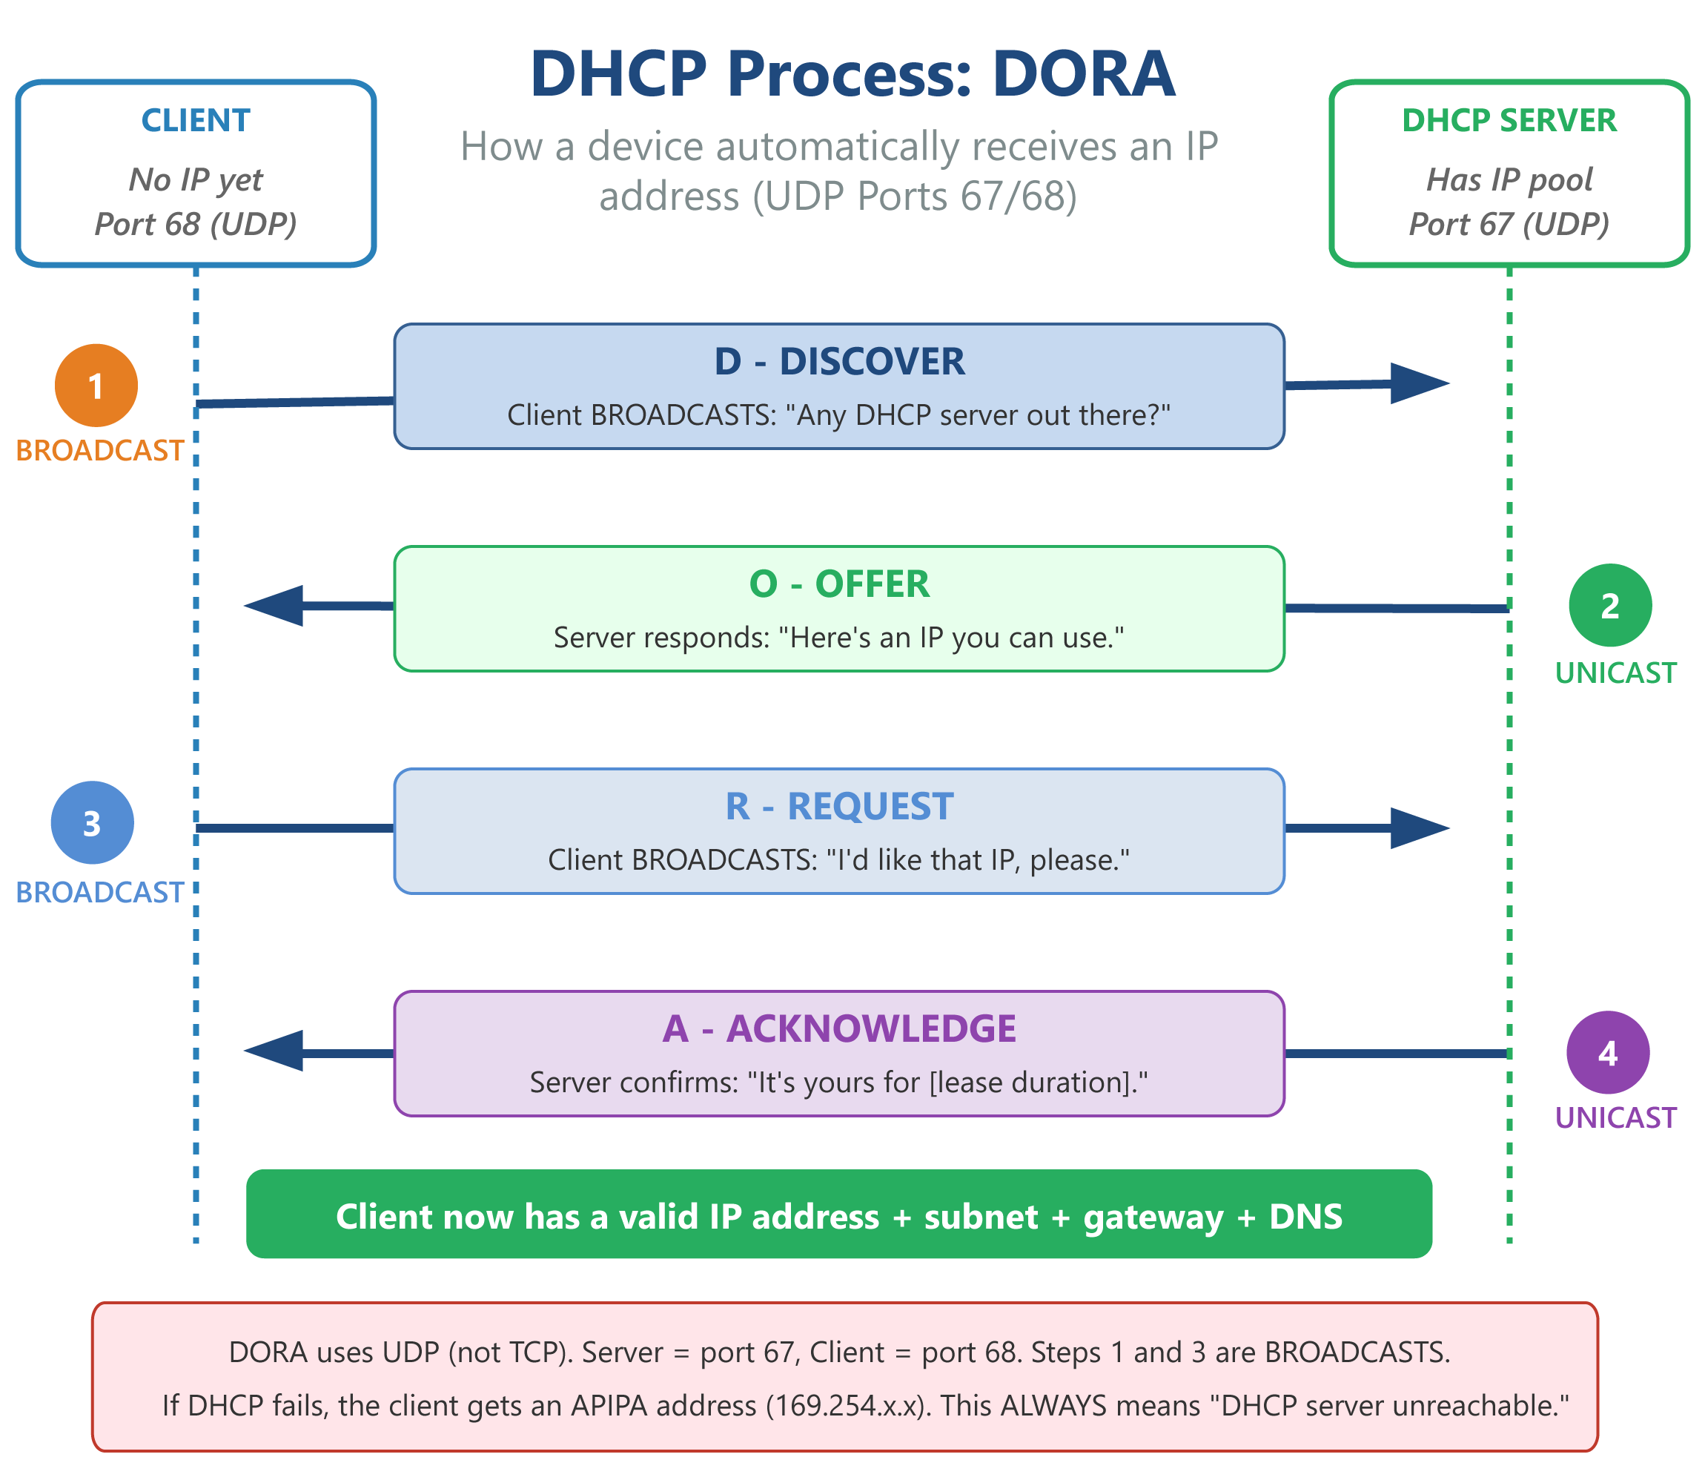
D - Discover — The client broadcasts a DHCPDISCOVER message looking for a DHCP server.
O - Offer — The DHCP server responds with a DHCPOFFER, proposing an available IP address.
R - Request — The client broadcasts a DHCPREQUEST to accept the offered IP address.
A - Acknowledge — The DHCP server sends a DHCPACK confirming the IP assignment with lease duration.

NAT and Private Addressing
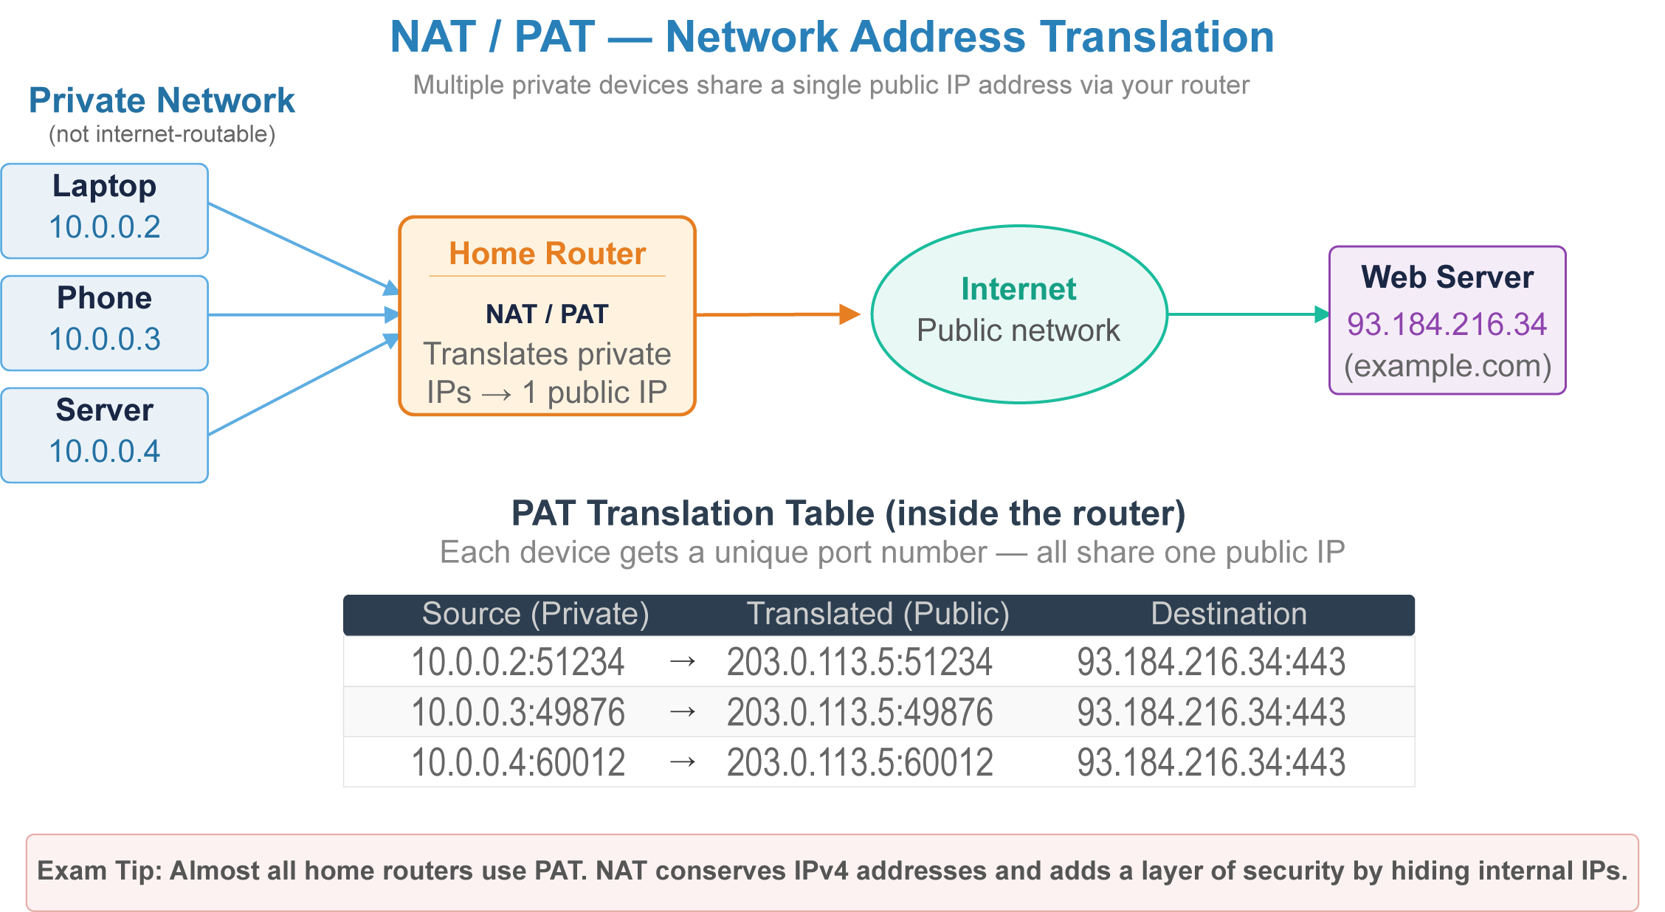

NAT
(Network Address Translation) allows multiple devices on a private network to share a single public IP address. Your home router performs NAT - all your devices share one public IP when accessing the internet.
PAT (Port Address Translation) — A form of NAT that uses unique port numbers to map multiple private IPs to one public IP. Most home routers use PAT.
Private IP ranges — 10.0.0.0/8, 172.16.0.0/12, 192.168.0.0/16 — not routable on the internet. Used inside networks.
Public IP — A globally unique, internet-routable IP address assigned by your ISP.

VLANs (Virtual Local Area Networks)
A VLAN logically segments a physical network into separate broadcast domains, even if the devices share the same physical switches. This improves security, performance, and manageability.
- Example: A company might use VLAN 10 for HR, VLAN 20 for Engineering, and VLAN 30 for Guest Wi-Fi - all running on the same physical switch infrastructure.
- Inter-VLAN routing requires a Layer 3 switch or router.
- Trunk ports carry traffic for multiple VLANs between switches.

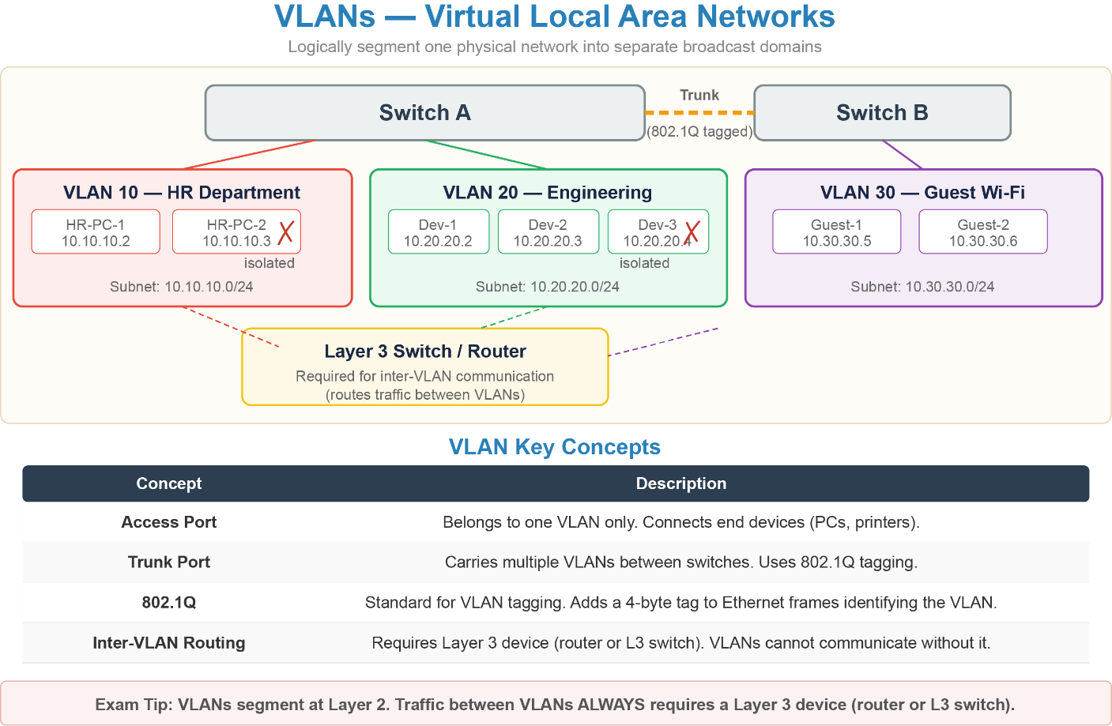
✔ Pro Tip: - Know the difference between a hub (broadcasts to all) and a switch (sends to correct port only). - Memorize the most common ports - especially 80, 443, 22, 25, 53, 67/68, 3389, 110, 143, 445. - An APIPA address (169.254.x.x) always means a DHCP problem. - Default gateway = the local router IP. DNS = translates names to IPs. DHCP = assigns IPs automatically. - IPv6 loopback is ::1 - IPv4 loopback is 127.0.0.1 - TCP is reliable and connection-oriented. UDP is fast but does not guarantee delivery.

Quick Review — Networking

Questions
- What does an APIPA address (169.254.x.x) indicate when it appears on a device?
- Name the four steps of the DHCP process (DORA) and what happens at each step.
- A switch operates at which OSI layer, and what type of address does it use to forward traffic?
- What is the difference between NAT and PAT?
- What is the key difference between TCP and UDP, and give one use case for each?

Answer Key
- An APIPA address indicates that the device cannot reach a DHCP server and has self-assigned a link-local address. It signals a DHCP problem — the device will not have internet connectivity.
- Discover — Client broadcasts looking for a DHCP server. Offer — Server responds with an available IP address. Request — Client broadcasts acceptance of the offered IP. Acknowledge — Server confirms the assignment with a lease duration.
- A switch operates at Layer 2 (Data Link) and uses MAC addresses to forward frames to the correct port.
- NAT (Network Address Translation) maps private IPs to a public IP for internet access. PAT (Port Address Translation) is a form of NAT that uses unique port numbers to allow multiple private IPs to share a single public IP simultaneously. Most home routers use PAT.
- TCP is connection-oriented and guarantees delivery, order, and error checking — used for web browsing (HTTP/S), email, and file transfers. UDP is connectionless and does not guarantee delivery — used for video streaming, VoIP, gaming, and DNS queries.

Module: Virtualization & Cloud Computing

Module Objectives
Virtualization and cloud computing are major topics on the CompTIA A+ Core 1 exam (11% of exam weight). They enable modern computing environments, from virtual machines used in training labs to enterprise cloud services used by IT teams daily.
By the end of this module, learners will be able to:
- Explain the purpose of virtualization and the difference between Type 1 and Type 2 hypervisors.
- Configure local client-side virtual machines.
- Understand resource allocation concepts (CPU, RAM, storage, networking).
- Use snapshots, cloning, and virtual networking.
- Identify cloud service models (IaaS, PaaS, SaaS).
- Describe common cloud concepts (elasticity, high availability, shared responsibility).

Hypervisor Types
Runs directly on hardware without a host OS. — Runs on top of a host OS (Windows, macOS, Linux).
Most efficient - enterprise/server environments. — Easier to install - ideal for students and labs.
Examples: VMware ESXi, Microsoft Hyper-V Server, Xen, KVM. — Examples: VMware Workstation, VirtualBox, Parallels Desktop.

Configuring a Local Virtual Machine
Setting up a VM involves more than installing the hypervisor. Each VM requires its own allocation of host resources - and those allocations directly affect both the VM’s performance and the stability of the host system.

VM Resource Allocation
CPU (vCPU)
What to Configure: Number of virtual CPU cores assigned to the VM.
Key Considerations: Never allocate more vCPUs than the host has physical cores. Over-allocating causes host slowdowns. Most lab VMs run fine with 1–2 vCPUs.
RAM
What to Configure: Amount of host RAM dedicated to the VM.
Key Considerations: The VM’s RAM is reserved from the host while the VM is running. A host with 16 GB RAM running a VM with 8 GB leaves 8 GB for the host OS.
Storage
What to Configure: Size and type of the virtual disk file.
Key Considerations: Two options: Dynamically allocated (disk file grows as data is added — saves space) or Fixed size (full size reserved immediately - better performance).
Network Adapter
What to Configure: Networking mode assigned to the VM.
Key Considerations: Choose NAT, Bridged, Host-only, or Internal (see Virtual Networking table above). Can be changed after creation.
Display / Video Memory
What to Configure: Amount of VRAM assigned for the VM’s display.
Key Considerations: Increase if the VM will run a GUI-heavy OS. Minimal for server/CLI-only VMs.

VM Setup Best Practices
- Install Guest Additions (VirtualBox) or VMware Tools after OS installation. These drivers improve display resolution, clipboard sharing, and drag-and-drop between host and guest.
- Keep VM disk files on an SSD when possible - spinning disk VMs run noticeably slower.
- Set RAM conservatively. A VM that uses 75% of host RAM will cause the host OS to page to disk, slowing everything down.
- Always name VMs descriptively (e.g., Win11-Lab, Ubuntu-Server-Test)
  - generic names like VM1 create confusion in multi-VM environments.

Snapshots and Cloning
Snapshots and clones are two critical VM management tools that every A+ technician should understand - and the exam distinguishes clearly between them.
Snapshot: Captures the exact state of the VM (disk, RAM, settings) at a point in time.
Use case: Before making changes - allows you to instantly revert if something breaks.
Speed: Very fast to create.
Dependency: The VM depends on the snapshot chain. Too many snapshots degrade performance.
Storage: Small - only records what changed.
Clone: Creates a complete independent copy of the entire VM.
Use case: Deploying multiple identical VMs from a well-known-good baseline.
Speed: Slower - copies the entire disk file.
Dependency: The clone is fully independent - deleting the original has no effect on the clone.
Storage: Large - full copy of the VM disk.
⚠️ Exam Trap: Snapshots are not backups. A snapshot lives on the same physical disk as the VM. If the disk fails, both the VM and all its snapshots are lost. Use a proper backup solution for VMs you cannot afford to lose. Too many accumulated snapshots causes significant performance degradation.

Virtual Networking in VMs
NAT: VM shares host’s IP via translation. Use Case: Safest, easiest setup.
Bridged: VM receives its own IP from the network. Use Case: Needed for servers or lab networks.
Host-only: VM communicates ONLY with the host. Use Case: Secure, isolated labs.
Internal network: VMs communicate only with each other. Use Case: Multi-VM simulations.

Cloud Service Models
SaaS (Software as a Service): Software is delivered fully online. Examples: Microsoft 365, Gmail, Salesforce.
PaaS (Platform as a Service): Platform for building applications. Examples: Azure App Service, Google App Engine.
IaaS (Infrastructure as a Service): Virtual machines & storage. Examples: AWS EC2, Azure VMs.

Cloud Deployment Models
Public Cloud — Shared infrastructure managed by providers (AWS, Azure, GCP).
Private Cloud — Organization-owned cloud infrastructure.
Hybrid Cloud — Mix of public + private cloud.
Community Cloud — Shared by similar organizations (e.g., government agencies).

Core Cloud Concepts

Elasticity
Elasticity is the ability of a cloud environment to automatically scale resources up or down in response to demand - without manual intervention. This is one of the defining characteristics of cloud computing and a direct advantage over on-premises infrastructure.
- A web server hosting a retail site can automatically spin up 20 additional VM instances during a holiday sale and scale back down to 2 instances when traffic drops - paying only for what was used.
- On-premises hardware cannot do this. You buy for peak capacity, and those resources sit idle the rest of the time.
Elasticity vs. Scalability: These terms appear together on the exam. Scalability is the ability to grow capacity - it can be manual. Elasticity specifically means automatic, on-demand scaling. All elastic systems are scalable; not all scalable systems are elastic.

High Availability (HA)
High Availability refers to a system or service designed to remain operational with minimal downtime, even when individual components fail. It is measured as a percentage of uptime over a given period.
99% (~87.6 hours) Common Name: Two nines
99.9% (~8.76 hours) Common Name: Three nines
99.99% (~52.6 minutes) Common Name: Four nines
99.999% (~5.26 minutes) Common Name: Five nines
Cloud providers achieve high availability through redundancy - duplicate systems, data centers, and network paths so that no single failure brings the service down. When a VM host fails in a properly configured cloud environment, workloads automatically migrate to a healthy host.

Shared Responsibility Model
The shared responsibility model defines who is responsible for securing what in a cloud environment. The exact boundary shifts depending on the service model - and the exam tests this directly.
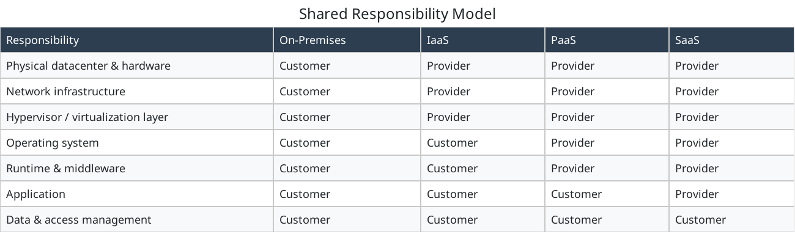
Physical datacenter & hardware
- On‑Premises: Customer
- IaaS: Provider
- PaaS: Provider
- SaaS: Provider
Network infrastructure
- On‑Premises: Customer
- IaaS: Provider
- PaaS: Provider
- SaaS: Provider
Hypervisor / virtualization layer
- On‑Premises: Customer
- IaaS: Provider
- PaaS: Provider
- SaaS: Provider
Operating system
- On‑Premises: Customer
- IaaS: Customer
- PaaS: Provider
- SaaS: Provider
Runtime & middleware
- On‑Premises: Customer
- IaaS: Customer
- PaaS: Provider
- SaaS: Provider
Application
- On‑Premises: Customer
- IaaS: Customer
- PaaS: Customer
- SaaS: Provider
Data & access management
- On‑Premises: Customer
- IaaS: Customer
- PaaS: Customer
- SaaS: Customer
The key insight: the customer always owns their data and is always responsible for identity and access management, regardless of the service model. The provider takes on progressively more responsibility as you move from IaaS → PaaS → SaaS, but they never take ownership of the customer’s data.
✔ Pro Tip: - Know the difference between Type 1 vs Type 2 hypervisors. - Understand SaaS vs PaaS vs IaaS. - Be able to identify NAT, bridged, and host-only networking. - Remember: snapshots are NOT backups. - Elasticity = automatic scaling. High availability = minimal downtime through redundancy. Shared responsibility = customer always owns their data, even in SaaS.
⚠️ Exam Trap: “The cloud provider is responsible for everything” is never correct. Even in a SaaS model, the customer owns their data, controls who has access to it, and is responsible for compliance with regulations like HIPAA and GDPR as they apply to that data.

Module: Desktop PC Hardware

Module Objectives
Desktop hardware is 25% of Core 1 - the largest single domain. While laptops get most hands-on attention, the exam tests desktop components, form factors, power supply specs, and cooling in depth.
By the end of this module, learners will be able to:
- Identify and describe the major components inside a desktop PC.
- Differentiate between motherboard form factors (ATX, microATX, mini-ITX).
- Select the correct power supply wattage and connector types for a system.
- Understand CPU socket types, cooling solutions, and thermal management.
- Identify RAM types, slots, and installation rules (dual-channel).
- Recognize PCIe slot versions and their use cases.
- Understand case/chassis types and their trade-offs.

Motherboard Form Factors
The form factor determines the motherboard’s physical size, screw hole positions, and how it fits into a case. Choosing compatible components requires matching form factors.
ATX — 305 × 244 mm PCIe Slots: 7 expansion slots Best Use Case: Full desktop towers — maximum expandability for workstations and gaming rigs.
Micro-ATX (mATX) — 244 × 244 mm PCIe Slots: 4 expansion slots Best Use Case: Mid-size builds balancing size and expansion. Most common in pre-built systems.
Mini-ITX — 170 × 170 mm PCIe Slots: 1 expansion slot Best Use Case: Compact/small form factor (SFF) builds. Limited cooling and expansion.
Extended ATX (E-ATX) — 305 × 330 mm PCIe Slots: 8+ expansion slots Best Use Case: High-end workstations and servers needing maximum PCIe lanes.
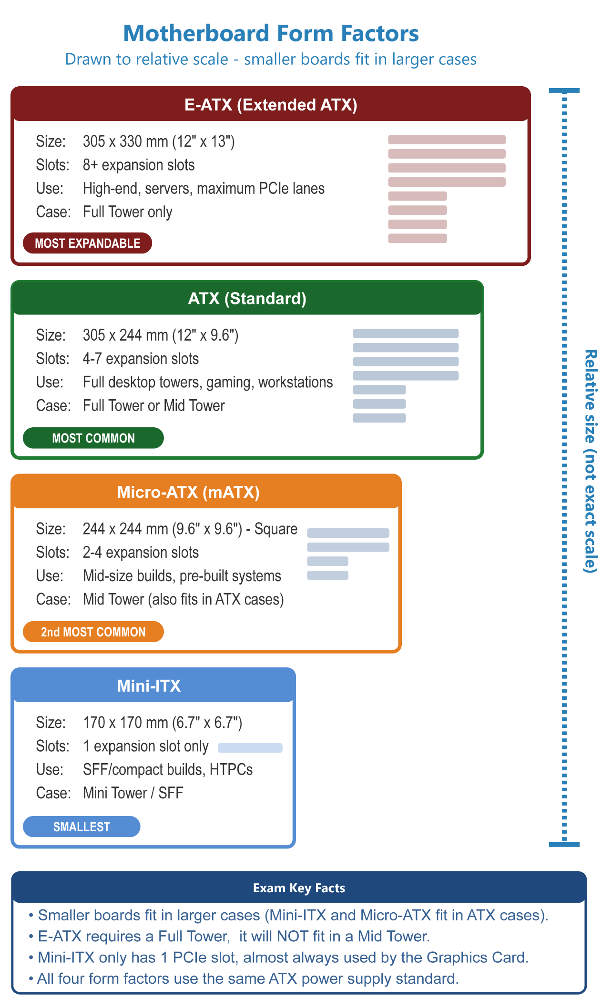

Motherboard Form Factors Comparison
Figure: ATX motherboard (ASUS TUF Gaming Z590-PLUS WIFI). Numbers 1–22 identify board components; letters A–K identify rear panel connectors. See accompanying table for full descriptions and exam notes.
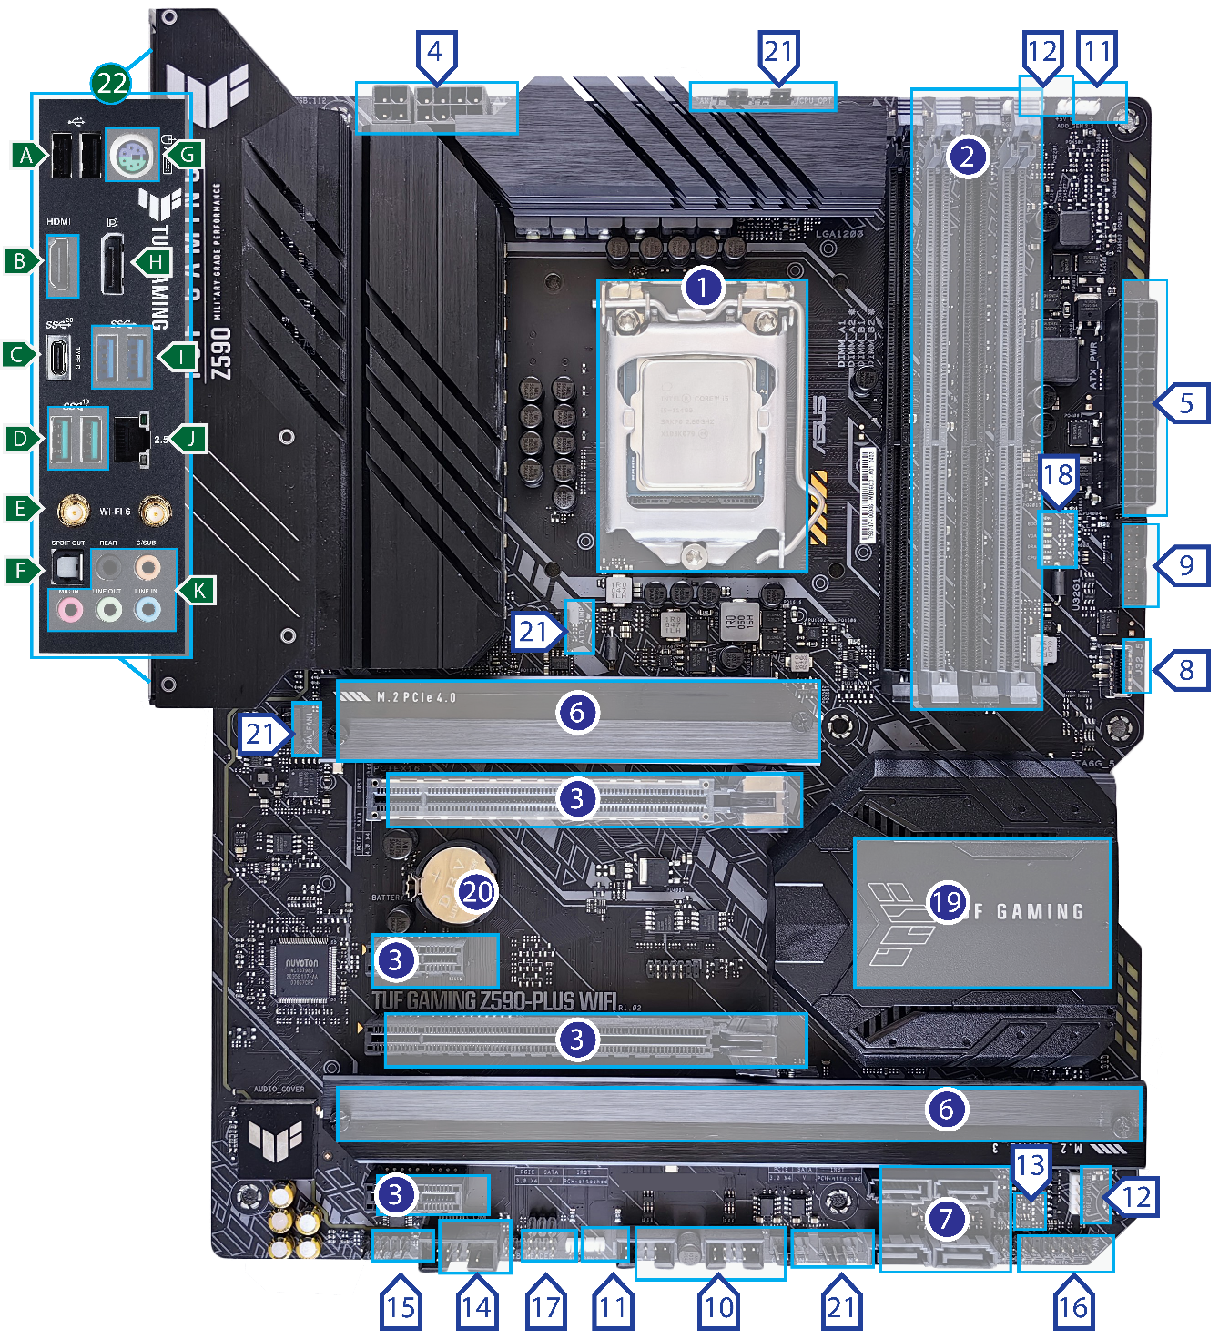

Motherboard Components
— Board Components (1–22) —
1 — CPU Socket LGA 1200
Exam Notes: Intel 10th/11th gen. LGA = pins on motherboard, not CPU. Must match CPU socket type exactly. Incompatible with LGA 1700 (12th gen+). Priority: High
2 — DIMM Slots DDR4
4 slots. Dual-channel requires matched pairs in correct slots (A1+B1 or A2+B2). DDR4 and DDR5 are NOT interchangeable - different notch positions. Priority: High
3 — Expansion Slots (PCIe)
Top long slot = PCIe x16 for GPU. Shorter slots = PCIe x1/x4. PCIe versions (3.0/4.0/5.0) are backward compatible but run at slower speed. Priority: High
4 — Power Connector 8+4 pin EPS
Dedicated 12V CPU power. 8-pin required; +4 pin optional for overclocking. Separate from the 24-pin main board power. Priority: High
5 — Power Connector 24-pin ATX
Main motherboard power. Provides 3.3V, 5V, and 12V rails. System will not POST without this connected. PSU symptom: random shutdowns, burning smell. Priority: High
6 — M.2 Slots (Socket 3)
Supports PCIe NVMe and SATA SSDs. Top slot = PCIe 4.0 (fastest). NVMe speeds up to 7,000 MB/s vs SATA III at 600 MB/s. Priority: High
7 — SATA 6Gb/s Ports
For HDDs, SSDs, and optical drives. Max 6 Gb/s (SATA III). Clicking sounds = HDD head crash. ‘Boot device not found’ = check SATA + power cables. Priority: High
8 — USB 3.2 Gen 1 Front Panel Connector
Internal header connecting front panel USB ports on the case. 19-pin connector. Gen 1 = 5 Gbps. Priority: Medium
9 — USB 3.2 Gen 1 Header
Additional internal USB 3.x header. Blue-colored connectors indicate USB 3.x. Used for case front panel or add-in cards. Priority: Medium
10 — USB 2.0 Headers
9-pin internal headers for case front panel USB 2.0 ports. Max 480 Mbps. Still common for connecting peripherals via internal headers. Priority: Medium
11 — AURA Addressable Gen2 Headers
ARGB header for addressable RGB lighting strips and fans. Each LED is individually controllable. Not exam tested. Priority: Low
12 — AURA RGB Headers
Standard RGB header (4-pin). All LEDs are the same color. Distinct from ARGB. Not exam tested. Priority: Low
13 — Clear CMOS Header
Resets BIOS settings to factory defaults. Used when system won’t POST after bad BIOS settings. Alternative: remove CMOS battery for 10-15 seconds. Priority: Medium
14 — COM Port Header
Legacy serial port header. Used in industrial/POS systems. Managed by Super I/O chip. Rarely tested on modern A+ exam. Priority: Low
15 — Front Panel Audio Header
Connects case front-panel headphone/mic jacks to motherboard. HD Audio standard. If front audio doesn’t work, check this header first. Priority: Medium
16 — System Panel Header
Connects power button, reset button, HDD LED, and power LED from the case. Incorrect wiring = system won’t power on. Check polarity for LEDs. Priority: High
17 — Thunderbolt Header
Internal header for add-in Thunderbolt card. TB5 = up to 80 Gbps, 240W charging, dual 8K monitors. Uses USB-C connector. Priority: Low
18 — Q-LEDs
Diagnostic LEDs that light up during POST failure. Indicate which component is failing: CPU / DRAM / VGA / BOOT. Critical for no-POST troubleshooting. Priority: Medium
19 — PCH Heatsink
Covers the Platform Controller Hub - modern replacement for North/South Bridge. Handles SATA, USB, audio, and PCIe lanes from chipset. Priority: Medium
20 — CMOS Battery
CR2032 coin cell. Powers BIOS clock and settings when PC is off. Dead battery = clock resets every boot, BIOS settings lost. Replace every 3-5 years. Priority: High
21 — Fan & Pump Headers
CPU_FAN = required (system won’t boot without fan detected). AIO_PUMP = liquid cooler pump. CHA_FAN 1/2/3 = optional case fans. 4-pin = PWM speed control. Priority: High
22 — Rear Panel I/O
All external ports are on the back of the board. Includes USB, video, audio, network, and PS/2. See rear panel section below. Priority: Medium

— Rear Panel Connectors (A–K) —
A — USB 2.0 Type-A
480 Mbps. Usually black colored. Still used for keyboards, mice, and low-speed peripherals. Backward compatible with USB 1.1. Priority: High
B — HDMI Port
Carries video and audio over single cable. 19-pin. Only available when using CPU with integrated graphics (no discrete GPU required). Priority: High
C — USB 3.2 Gen 2x2 Type-C
Fastest USB on this board - 20 Gbps. USB-C connector. Gen 2x2 = two 10 Gbps channels bonded. not Thunderbolt. Priority: Medium
D — USB 3.2 Gen 2 Type-A
10 Gbps. Usually red on ASUS boards to distinguish from Gen 1 (blue). Type-A = standard rectangular USB connector. Priority: Medium
E — Wi-Fi Module (Wi-Fi 6)
802.11ax - up to 9.6 Gbps. Built-in Bluetooth. Antennas connect here. Uses M.2 E-key slot internally. Managed via Device Manager in Windows. Priority: High
F — Optical S/PDIF OUT
Digital audio output using fiber optic cable. Immune to electrical interference. Used for home theater receivers. Legacy but may appear on exam. Priority: Low
G — PS/2 Combo Port
Legacy keyboard/mouse port. NOT hot-swappable - must plug in before boot. Purple = keyboard, green = mouse (older individual ports). Priority: Medium
H — DisplayPort
20-pin latching connector. Replacement for VGA/DVI. Supports higher refresh rates than HDMI. Can transmit via USB-C alt mode. Priority: High
I — USB 3.2 Gen 1 Type-A
5 Gbps. Blue colored. Most common USB 3.x ports. SuperSpeed USB. Backward compatible with USB 2.0 devices at slower speed. Priority: High
J — Ethernet RJ-45 (2.5G)
2.5 Gbps wired network. RJ-45 connector. APIPA address (169.254.x.x) = DHCP failure, not a physical port issue. Priority: High
K — Audio Jacks (3.5mm)
Color coded: green = line out/speakers, pink = mic in, blue = line in. Rear outputs for surround sound. Managed by onboard audio codec. Priority: Medium
⚠️ Exam Trap: CompTIA Core 1 loves to test you on identifying these physical components. Pay close attention to the difference between the main 24-pin power (#5) and the 8-pin CPU power (#4), as well as identifying PCIe slots vs. RAM slots!

RAM (Random Access Memory)

RAM Types
DDR4 — 2133–3200+ MHz Voltage: 1.2V Key Notes: Current mainstream standard. Most desktops and laptops shipping 2016–2023.
DDR5 — 4800–7200+ MHz Voltage: 1.1V Key Notes: Current high-performance standard. Required for Intel 12th gen+ and AMD Ryzen 7000+. Higher bandwidth and capacity.
DDR3 — 1066–1866 MHz Voltage: 1.35–1.5V Key Notes: Legacy. Found in older systems. NOT compatible with DDR4/DDR5 slots.
ECC RAM — Varies Voltage: Varies Key Notes: Error-Correcting Code RAM. Detects and corrects single-bit memory errors. Used in servers and workstations.

RAM Installation Rules
- Dual-Channel: Installing matched pairs of RAM in the correct slots (usually slots 1&3 or 2&4 - check motherboard manual) doubles memory bandwidth. Color-coded slots on most boards.
- Capacity: Install RAM in matched pairs (e.g., 2×8GB, 2×16GB) for dual-channel operation. Mismatched sizes default to single-channel.
- Compatibility: DDR4 and DDR5 slots are physically different and not interchangeable. DDR5 DIMMs have a different notch position.
- Max Capacity: Determined by the motherboard chipset and CPU, not just the number of slots.

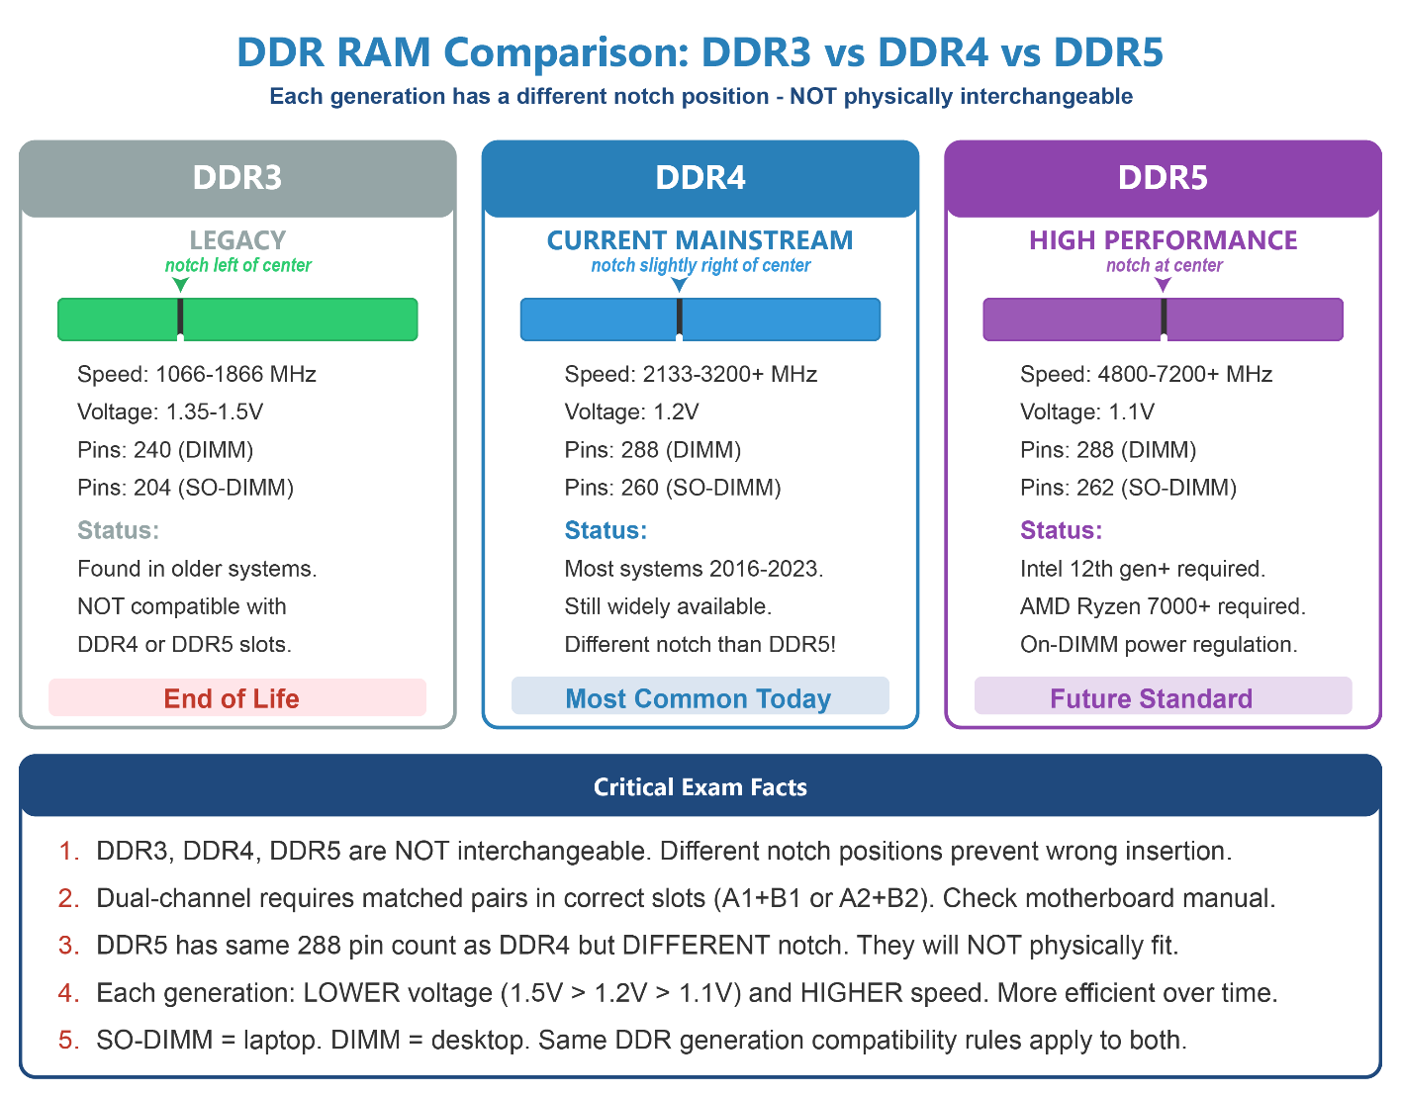

Power Supply Unit (PSU)

PSU Form Factors & Ratings
ATX PSU — Standard desktop PSU. Uses a 24-pin ATX connector to the motherboard and an 8-pin (or 4+4 pin) EPS connector for the CPU.
SFX PSU — Small Form Factor PSU. Used in compact cases. Physically smaller than ATX but uses the same connectors.
Wattage — Must be sufficient for all components. Rule of thumb: Add up TDP of CPU + GPU + storage + fans, then add 20-30% headroom.
80 PLUS Rating — The 80 PLUS program certifies PSUs at 20%, 50%, and 100% load (Titanium also adds 10%). Efficiency means how much wall power is converted into usable DC power for components. 50% Load Is Peak Efficiency
Modular vs. Non-Modular — Modular PSUs allow unused cables to be removed, improving airflow and cable management. Semi-modular keeps essential cables attached.
✔ Pro Tip: - Why 80 Plus Matters
Higher ratings = less wasted energy as heat, quieter cooling, and lower electricity draw. Savings are modest (about $5–8/year between Bronze and Gold for a typical gaming PC), but higher rated PSUs often use better components and last longer. Gold is the sweet spot for most builds — balancing cost, efficiency, and reliability.

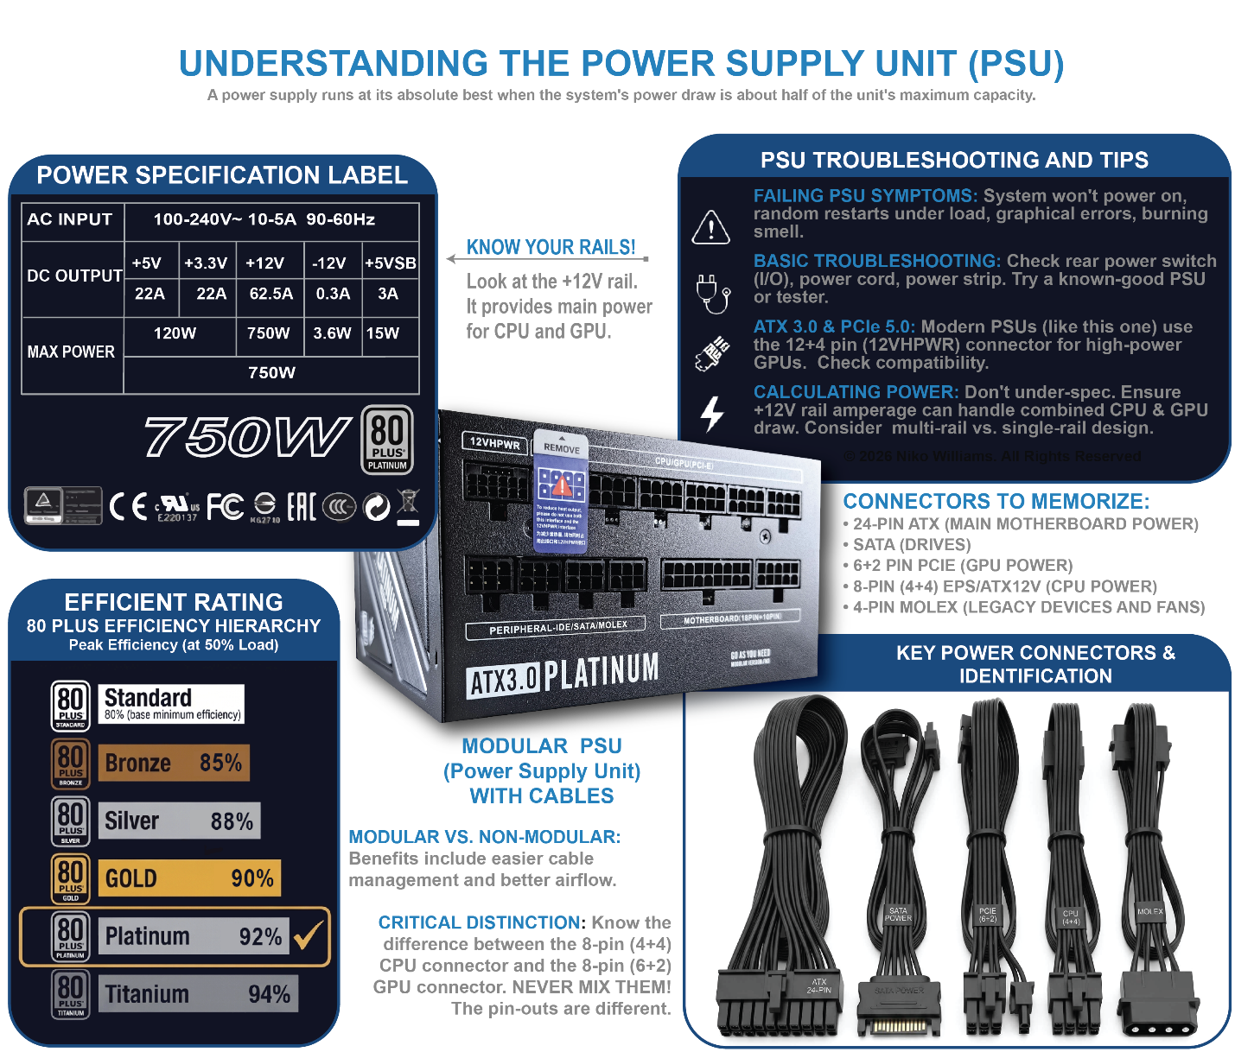
⚠️ Exam Trap: A PSU with insufficient wattage causes random shutdowns and instability - symptoms that look like software or RAM errors. Always check PSU wattage when troubleshooting unexplained crashes.

PSU Connector Types
8-pin EPS (4+4 pin) — CPU power. Provides dedicated 12V power to the processor VRM. Some high-end boards use dual 8-pin.
24-pin ATX — Main motherboard power connector. Provides 3.3V, 5V, and 12V rails to the board.
6+2 pin PCIe — Dedicated GPU power. Mid-range GPUs use one connector; high-end GPUs may require two or three.
SATA Power — 15-pin connector for SATA HDDs, SSDs, and optical drives.
Molex (4-pin) — Legacy connector for older HDDs, fans, and case lighting. Mostly obsolete but may appear on older systems.
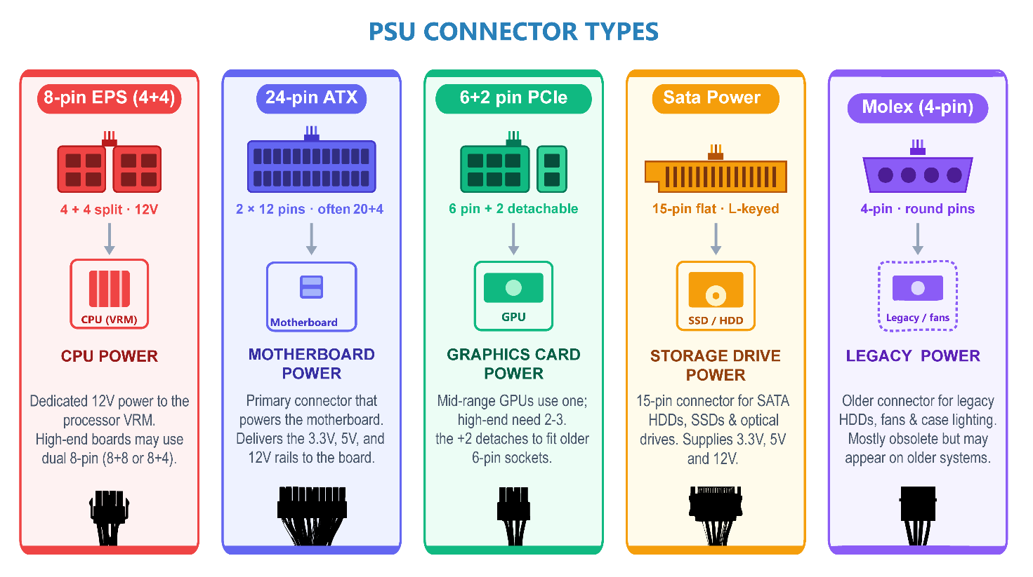

Expansion Cards & PCIe

PCIe Slot Versions & Speeds
PCIe 3.0 — ~1 GB/s Speed at x16: ~16 GB/s Common Use: GPUs, NVMe SSDs (still common in many systems).
PCIe 4.0 — ~2 GB/s Speed at x16: ~32 GB/s Common Use: High-performance NVMe SSDs, modern GPUs.
PCIe 5.0 — ~4 GB/s Speed at x16: ~64 GB/s Common Use: Cutting-edge NVMe SSDs, next-gen GPUs.
PCIe 6.0 — ~8 GB/s Speed at x16: ~128 GB/s Common Use: Emerging standard — data center and future consumer use.

Common Expansion Card Types
GPU (Video Card) — Handles display output and graphics rendering. Connects to PCIe x16 slot. Requires separate PCIe power from PSU.
Sound Card — Dedicated audio processing. Used when onboard audio is insufficient for professional audio work.
NIC (Network Card) — Adds wired or wireless networking. Used when onboard NIC is insufficient or fails.
RAID Controller — Manages RAID arrays in hardware, and offloading processing from the CPU.
Capture Card — Records or streams video input from external sources (cameras, gaming consoles).
USB Expansion Card — Adds additional USB ports (especially USB 3.x or USB4) when onboard ports are insufficient.
Thunderbolt Add-In Card — Adds Thunderbolt connectivity to systems without native support.

System Cooling & Airflow
Proper airflow is critical for system stability. Poor cooling leads to thermal throttling, random shutdowns, and reduced component lifespan.
Positive vs. Negative Pressure — Positive pressure: more intake than exhaust fans - keeps dust out. Negative pressure: more exhaust than intake - better airflow but draws in unfiltered air.
Front-to-Back Airflow — Standard airflow pattern: cool air enters from front/bottom, hot air exits from rear/top. Components should be oriented to match this flow.
Case Fans — Typically 120mm or 140mm. More fans = better cooling but more noise. Fan headers on motherboard: CPU_FAN (required), SYS_FAN (optional).
CPU TDP (Thermal Design Power) — Maximum heat output in watts the cooling system must handle. A 65W TDP CPU needs a cooler rated at least 65W.
Dust Filters — Prevent dust accumulation on components. Clean every 3–6 months using compressed air.

Case / Chassis Form Factors
Full Tower — Supports E-ATX, ATX, mATX, Mini-ITX. Maximum space for components, cooling, and cable management.
Mid Tower — Supports ATX, mATX, Mini-ITX. Most common case type. Good balance of size and expandability.
Mini Tower / SFF — Supports mATX or Mini-ITX. Compact footprint. Limited cooling and expansion options.
Rack Mount (1U/2U/4U) — Used in server environments. Measured in rack units (U). Slides into standard 19-inch server racks.
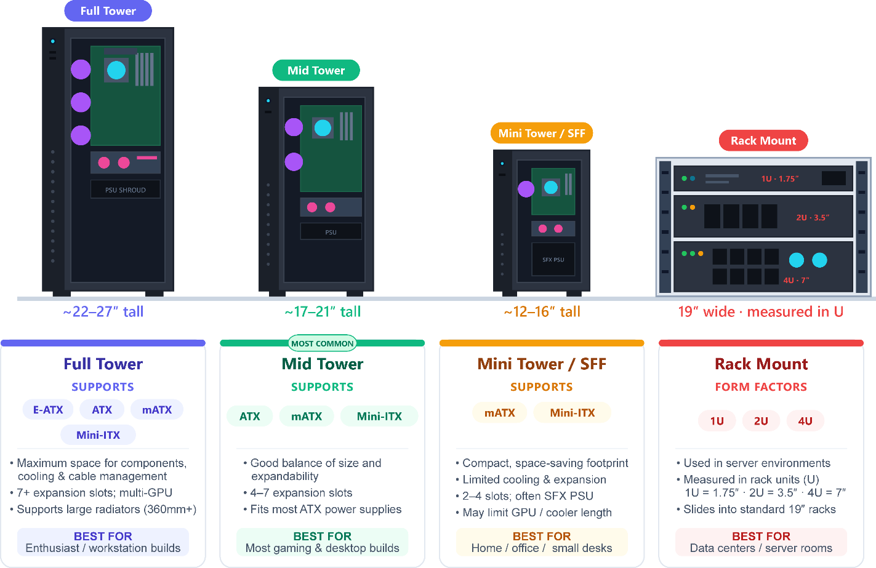
ℹ️ Exam Tip: - Memorize PCIe slot sizes: x1 (short), x4 (medium), x8 (medium), x16 (long). GPUs always use x16 slots. - ATX power connector is 24-pin to motherboard + 8-pin to CPU - know both connectors. - DDR4 and DDR5 are NOT interchangeable - different notch positions prevent accidental insertion. - Dual-channel requires matched DIMMs in the correct slot pair - check the motherboard manual. - A dead CMOS battery = system clock resets on every boot and BIOS settings are lost. - PSU failure symptoms: random shutdowns, won’t power on, burning smell - always replace, never repair

CPU (Central Processing Unit)

CPU Socket Types
The CPU socket on the motherboard must match the CPU’s socket type. Sockets are generation-specific - always verify compatibility before purchasing.
LGA 1700 (Intel): Used by Intel 12th, 13th, and 14th gen Core processors. LGA (Land Grid Array) - pins on motherboard.
LGA 1851 (Intel): Emerging: expected for Intel 15th gen (Arrow Lake) and possibly 16th gen. Next-generation standard in LGA design
AM4 (AMD): Used by AMD Ryzen 1000-5000 series. One of the longest-lasting sockets in history using PGA (Pin Grid Array) – pins on CPU.
AM5 (AMD): Used by AMD Ryzen 7000 series and newer. LGA-style (AMD moved pins to motherboard). AM5 is expected to support multiple future Ryzen generations
SP3 / SP5 (AMD Server): SP3 is used for EPYC Naples/Rome/Milan and SP5 is used for EPYC Genoa/Bergamo (Zen 4 server). Distinct sockets for different EPYC generations, not interchangeable..
LGA 4677 (Intel Server): Used in Intel Xeon Scalable server processors.

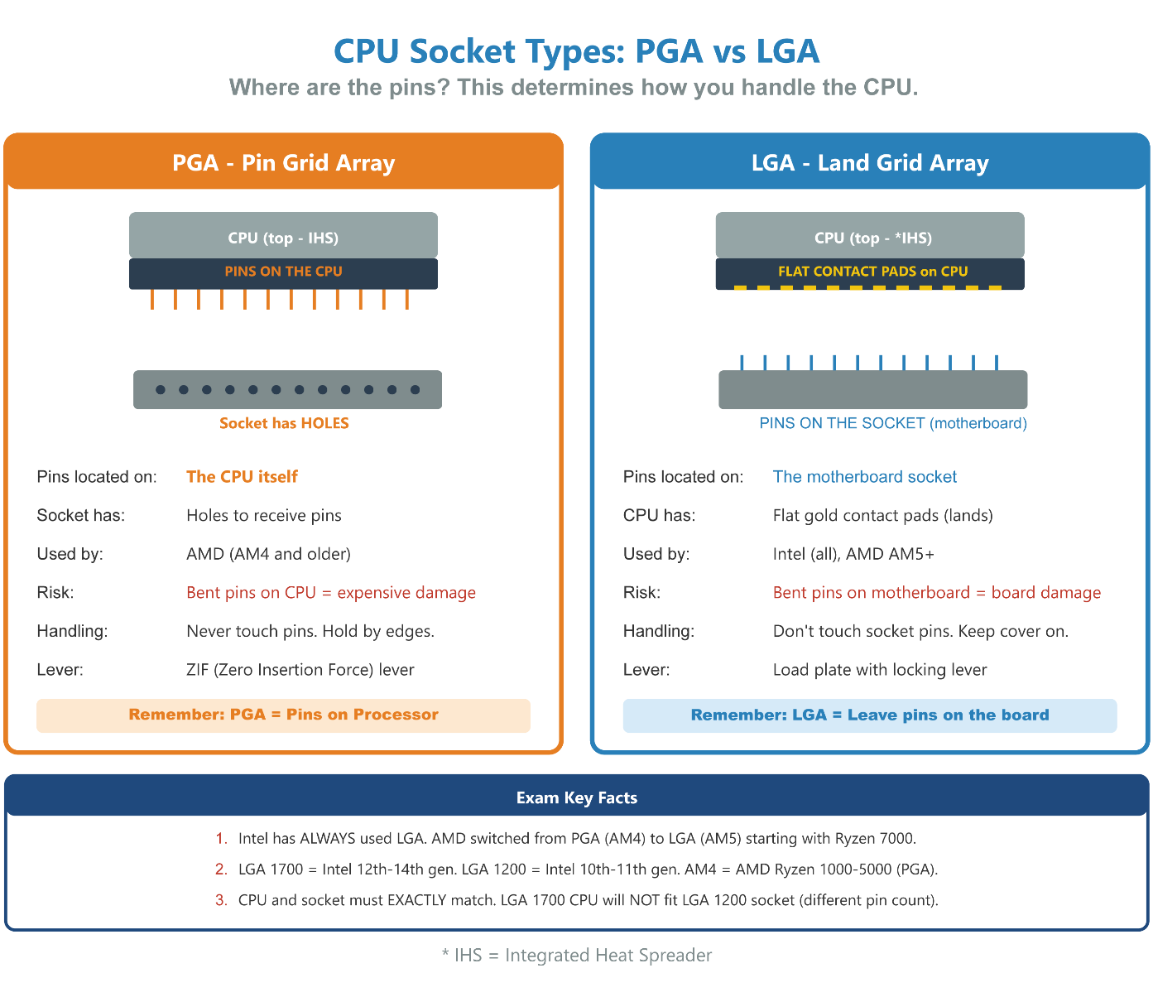
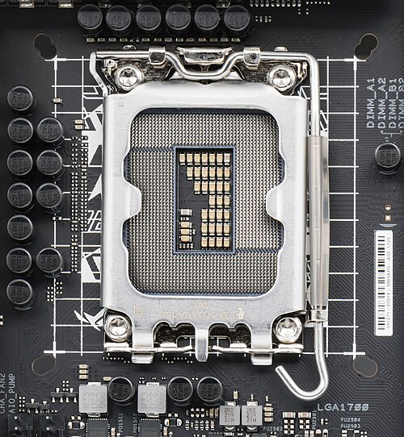
Intel LGA 1700 Socket - Land Grid Array architecture where pins are on the motherboard. (Photo by Jacek Halicki, used under CC BY-SA 4.0).
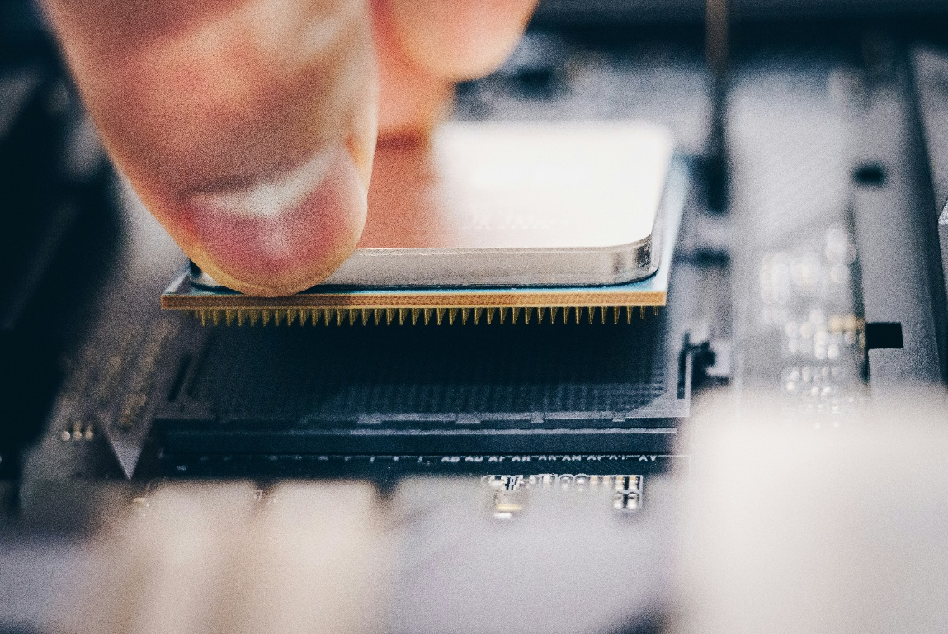
AMD Ryzen Processor – Pin Grid Array architecture where pins are located on the processor (PGA). (Photo by Fidel Fernando on Unsplash).

CPU Cooling Solutions
Stock / Boxed Cooler — Included with most non-K Intel and AMD CPUs. Adequate for stock speeds. Not recommended for overclocking. Intel “K” series and high-end AMD often ship without a cooler — worth noting explicitly.
Aftermarket Air Cooler — Third-party heatsink + fan. Better thermal performance than stock. Varies widely in size and TDP rating. Large tower coolers may require case clearance checks.
All-in-One (AIO) Liquid Cooler — Closed-loop liquid cooling with a pump, radiator, and fans. Excellent performance. Requires radiator mounting space in case. Lifespan limited by pump reliability (typically 5–7 years).
Custom Water-Cooling Loop — Fully custom liquid cooling. Maximum performance. Complex installation. Used in enthusiast/overclocking builds.
Passive Cooling — No fans - relies on heatsink mass and airflow. Used in low-power/silent systems. Not suitable for high-TDP CPUs.

Module: Computer Displays

Module Objectives
By the end of this module, learners will be able to:
- Differentiate between major display panel technologies: LCD, LED, OLED, and their variants.
- Identify the function of an inverter and a digitizer and their role in display assembly.
- Explain key display attributes such as resolution, refresh rate, and pixel density.

Display Technologies
LCD (Liquid Crystal Display) Description: Uses liquid crystals between polarized glass panes. Requires backlighting. Variants / Features: TN: Fastest, cheapest, worst color. IPS: Best color, widest viewing angle. VA: Best contrast ratio.
LED Description: Technically an LCD that uses LEDs for backlighting instead of older fluorescent lamps (CCFL). Variants / Features: More power efficient. LEDs are DC devices, requiring driver circuits for stable operation.
OLED (Organic LED) Description: Uses organic compounds that emit their own light. Self-emissive pixels. Variants / Features: No backlighting needed. Truly black colors. Common in smartphones and foldables.
QLED (Quantum Dot LED) Description: LCD display that uses a quantum-dot enhanced LED backlight. Variants / Features: Higher brightness, vibrant and more saturated colors. It’s still LCD — not self-emissive like OLED
Mini-LED Description: Advanced LED backlight technology using thousands of tiny LEDs. Variants / Features: Precise local dimming zones. Higher contrast than traditional LED.
CCFL (Cold Cathode Fluorescent Lamp) Description: Older backlight technology used before LED. Variants / Features: Requires inverter to convert DC to AC. Bulkier and hotter. Obsolete in modern systems.
✔ Pro Tip: LCD itself is the umbrella term — TN/IPS/VA are panel types. OLED is susceptibility to burn-in with static images. Mini-LED is often marketed as ‘near-OLED’ contrast, but still LCD-based.

Inverter and Digitizer
- Inverter: A circuit board that converts Direct Current (DC) from the laptop to Alternating Current (AC). If an LCD display goes dark but an external monitor works, the inverter may be faulty. LED-backlit and OLED displays do NOT require inverters, only CCFL‑backlit LCDs.
- Digitizer: The component that registers touches and touch gestures (swiping, pinching) on a touchscreen. Works by monitoring the capacitance of a conductive layer. If integrated, you must often replace the entire panel.

Display Attributes
Resolution Definition: Number of pixels horizontally × vertically (e.g., 1920×1080). Key Detail: Native Resolution is the one at which the display looks its best.
Pixel Density Definition: Number of pixels per linear unit (e.g., per inch). Key Detail: Higher density = greater perceived detail.
Refresh Rate Definition: How many times the display redraws per second, measured in Hertz (Hz). Key Detail: Faster refresh rates (120 Hz+) provide a more fluid experience.
Color Depth Definition: Number of bits per pixel for color information. Key Detail: 8-bit color gives approximately 17 million possible colors.
Color Gamut Definition: Range of visible colors a monitor can display. Key Detail: Often expressed as a percentage of sRGB or Adobe RGB.

Multiple Display Setup
Internal Display Only — Uses only the laptop screen.
Duplicate / Clone — The external display shows the same content as the internal one (useful for presentations).
Extend — The external display expands the virtual desktop across both monitors.
External Only — Disables the laptop screen and uses only the external monitor.

Module: Hard Drives & Storage Technologies

Module Objectives
By the end of this module, learners will be able to:
- Identify and differentiate between primary storage device types, including HDDs, SSDs, and hybrid technologies.
- Understand common storage interfaces and connections, including SATA, NVMe, and PCIe.
- Differentiate between MBR (Master Boot Record) and GPT (GUID Partition Table) partition formats.
- Describe RAID concepts, including striping, mirroring, and parity.

Storage Drive Comparison
Type: HDD (Hard Disk Drive):
Mechanical (spinning platters, moving read/write heads).
Cost: More affordable per GB.
Performance: Slower read/write speeds, higher latency.
Durability: Lower durability; susceptible to physical shock.
Power/Heat: Consumes more power and generates more heat.
Type: SSD (SATA):
Electronic (NAND flash memory chips).
Cost: More expensive per GB.
Performance: Much faster, very low latency.
Durability: Higher durability; no moving parts.
Power/Heat: Consumes less power and generates less heat.
Type: SSHD (Solid State Hybrid Drive):
Combines a traditional spinning HDD with a small amount of NAND flash cache.
Cost: Mid-range - more than HDD, less than SSD.
Performance: Faster than HDD for frequently accessed data (cached on flash); slower than SSD overall.
Durability: Same as HDD - still has moving parts susceptible to physical shock.
Power/Heat: Similar to HDD - spinning platters still consume power and generate heat.
Type: M.2 NVMe SSD:
Electronic (NAND flash memory chips) connected directly via PCIe bus and bypasses the SATA bottleneck.
Cost: Most expensive per GB of consumer drives.
Performance: Fastest consumer storage, 3,500-7,000+ MB/s read/write (vs. 600 MB/s max for SATA SSD).
Durability: High durability; no moving parts. Compact M.2 form factor (no cables needed).
Power/Heat: Low power consumption but can run hotter than SATA SSDs under sustained load. Many motherboards include M.2 heatsinks.

Storage Interfaces & Form Factors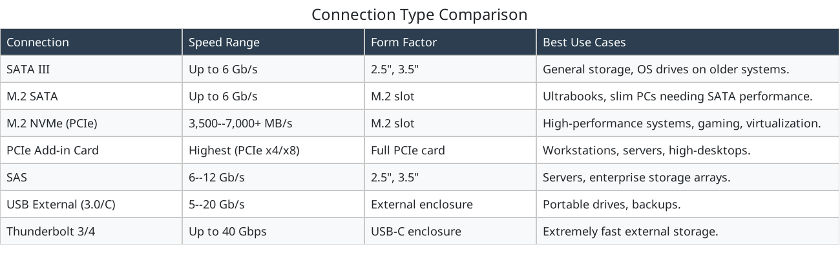
SATA III — Up to 6 Gb/s Form Factor: 2.5”, 3.5” Best Use Cases: General storage, OS drives on older systems.
M.2 SATA — Up to 6 Gb/s Form Factor: M.2 slot Best Use Cases: Ultrabooks, slim PCs needing SATA performance.
M.2 NVMe (PCIe) — 3,500-7,000+ MB/s Form Factor: M.2 slot Best Use Cases: High-performance systems, gaming, virtualization.
PCIe Add-in Card — Highest (PCIe x4/x8) Form Factor: Full PCIe card Best Use Cases: Workstations, servers, high-desktops.
SAS — 6–12 Gb/s Form Factor: 2.5”, 3.5” Best Use Cases: Servers, enterprise storage arrays.
USB External (3.0/C) — 5–20 Gb/s Form Factor: External enclosure Best Use Cases: Portable drives, backups.
Thunderbolt 3/4 — Up to 40 Gbps Form Factor: USB-C enclosure Best Use Cases: Extremely fast external storage.
✔ Pro Tip: - SATA III = 6 Gb/s theoretical, ~600 MB/s practical throughput. NVMe speeds vary by PCIe generation (Gen 3 ≈ 3,500 MB/s, Gen 4 ≈ 7,000 MB/s, Gen 5 ≈ 12,000 MB/s emerging).
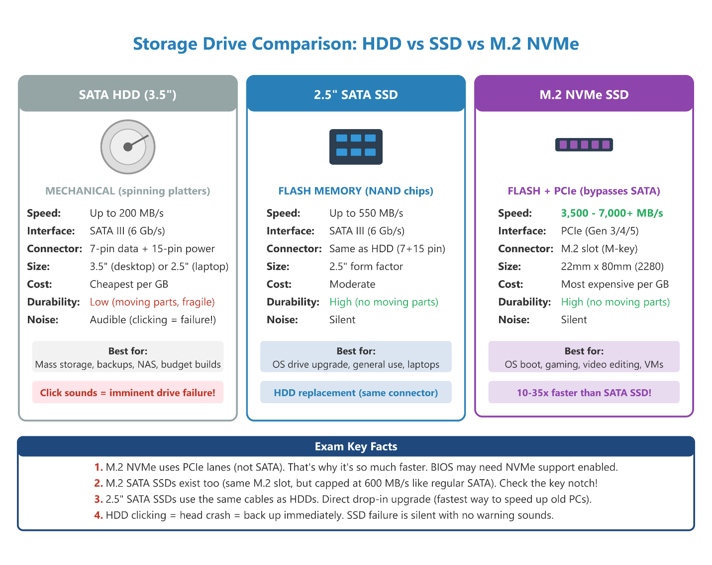

Partition Table Formats: MBR vs. GPT
Before an operating system can use a storage drive, the drive must be partitioned - divided into logical sections the OS can read, write, and boot from. The partition table is a data structure written at the very beginning of the drive that describes how those sections are organized. There are two standards the A+ exam tests: the legacy MBR and the modern GPT.

MBR vs. GPT Comparison

MBR (Master Boot Record)
Full Name: Master Boot Record
Age / Origin: Legacy system introduced with IBM PC DOS in 1983
Max Drive Size: Limited to 2 TB; drives larger than this cannot be fully utilized
Max Partitions: Supports 4 primary partitions, or 3 primary plus 1 extended partition with logical drives
Boot Firmware: Requires BIOS (Legacy Boot)
Redundancy: Stores only a single partition table; corruption makes the drive unreadable
OS Support: Compatible with Windows XP and earlier, Linux, and older macOS versions
Drive ID Method: Partitions are identified by their physical location on the disk

GPT (GUID Partition Table)
Full Name: GUID Partition Table
Age / Origin: Modern system, part of the UEFI standard introduced in the 2000s
Max Drive Size: Up to 9.4 ZB (zettabytes), effectively unlimited for current hardware
Max Partitions: Allows up to 128 primary partitions, with no extended/logical distinction
Boot Firmware: Requires UEFI; cannot boot on BIOS-only systems
Redundancy: Stores a backup copy of the partition table at the end of the drive
OS Support: Supported by Windows 8/10/11 (64-bit), modern Linux distributions, and macOS (Intel and Apple Silicon)
Drive ID Method: Each partition is assigned a globally unique identifier (GUID)

The Key Details
MBR’s 4-partition limit was worked around for decades using extended partitions - a container partition holding multiple logical drives. This is legacy knowledge but still appears on the exam.
GPT’s 128-partition limit is functionally unlimited for real-world use. Windows only displays 128, but the spec allows more.
UEFI vs. BIOS is the deciding factor when choosing a partition style. A modern Windows 11 install requires UEFI + GPT. If you see a scenario where Windows 11 won’t install, check whether the drive is MBR and whether Secure Boot / UEFI is enabled in the firmware.
A drive formatted as MBR cannot boot Windows in UEFI mode, and a drive formatted as GPT cannot boot in Legacy BIOS mode. If a system boots to a “bootmgr is missing” or “No bootable device” error after a drive swap, the first thing to check is whether the partition style matches the firmware mode set in BIOS/UEFI.
✔ Pro Tip: - In Windows, you can check a drive’s partition style at any time: Disk Management → right-click the disk number (not the volume) → Properties → Volumes tab → Partition style shows MBR or GPT. Alternatively, diskpart → list disk - a disk with an asterisk (*) in the GPT column is GPT-formatted.
⚠️ Exam Trap: MBR’s 2 TB limit is absolute - a 4 TB drive with an MBR partition table will only show ~2 TB of usable space. The remaining capacity is inaccessible without converting to GPT.

Converting Between MBR and GPT
During Windows installation — Windows Setup → “Drive Options (Advanced)” → Delete all partitions → select drive → Convert appears automatically. Conversion option only appears if UEFI mode is enabled in firmware.
From Windows (non-destructive, Windows 10 1703+) — mbr2gpt /convert command - converts without data loss if prerequisites are met
From command line (destructive) — diskpart → clean → convert gpt - erases all data
From macOS — Disk Utility → Erase → select GUID Partition Map as the scheme

RAID Configurations
RAID 0 — Striping only Fault Tolerance: None — one drive failure loses all data. Best Use Cases: Video editing, scratch disks, temporary workloads.
RAID 1 — Mirroring Fault Tolerance: Survives one drive failure. Best Use Cases: Small servers, OS volumes needing high reliability.
RAID 5 — Striping + single parity Fault Tolerance: Survives one drive failure (min 3 drives). Best Use Cases: General NAS, balanced performance & redundancy.
RAID 6 — Striping + double parity Fault Tolerance: Survives two drive failures (min 4 drives). Best Use Cases: Large arrays prioritizing reliability.
RAID 10 — Mirroring + striping Fault Tolerance: Excellent (Survives one failure per mirrored pair). Best Use Cases: Databases, virtualization hosts.
JBOD — JBOD (Just a Bunch of Disks/Drives) is a storage architecture that treats each disk as an independent unit rather than a redundant array. When configured to function as a single logical drive, it uses spanning: data is written sequentially to one drive until it reaches capacity, then seamlessly flows to the next drive. Unlike RAID, data is not striped, mirrored, or parity-protected. Good for non-critical data, simple capacity expansion.
⚠️ Exam Trap: RAID is not a backup. A RAID array protects against drive failure but not against accidental deletion, ransomware, file corruption, or theft - all of which affect every drive in the array simultaneously. Always maintain a separate backup strategy alongside RAID.
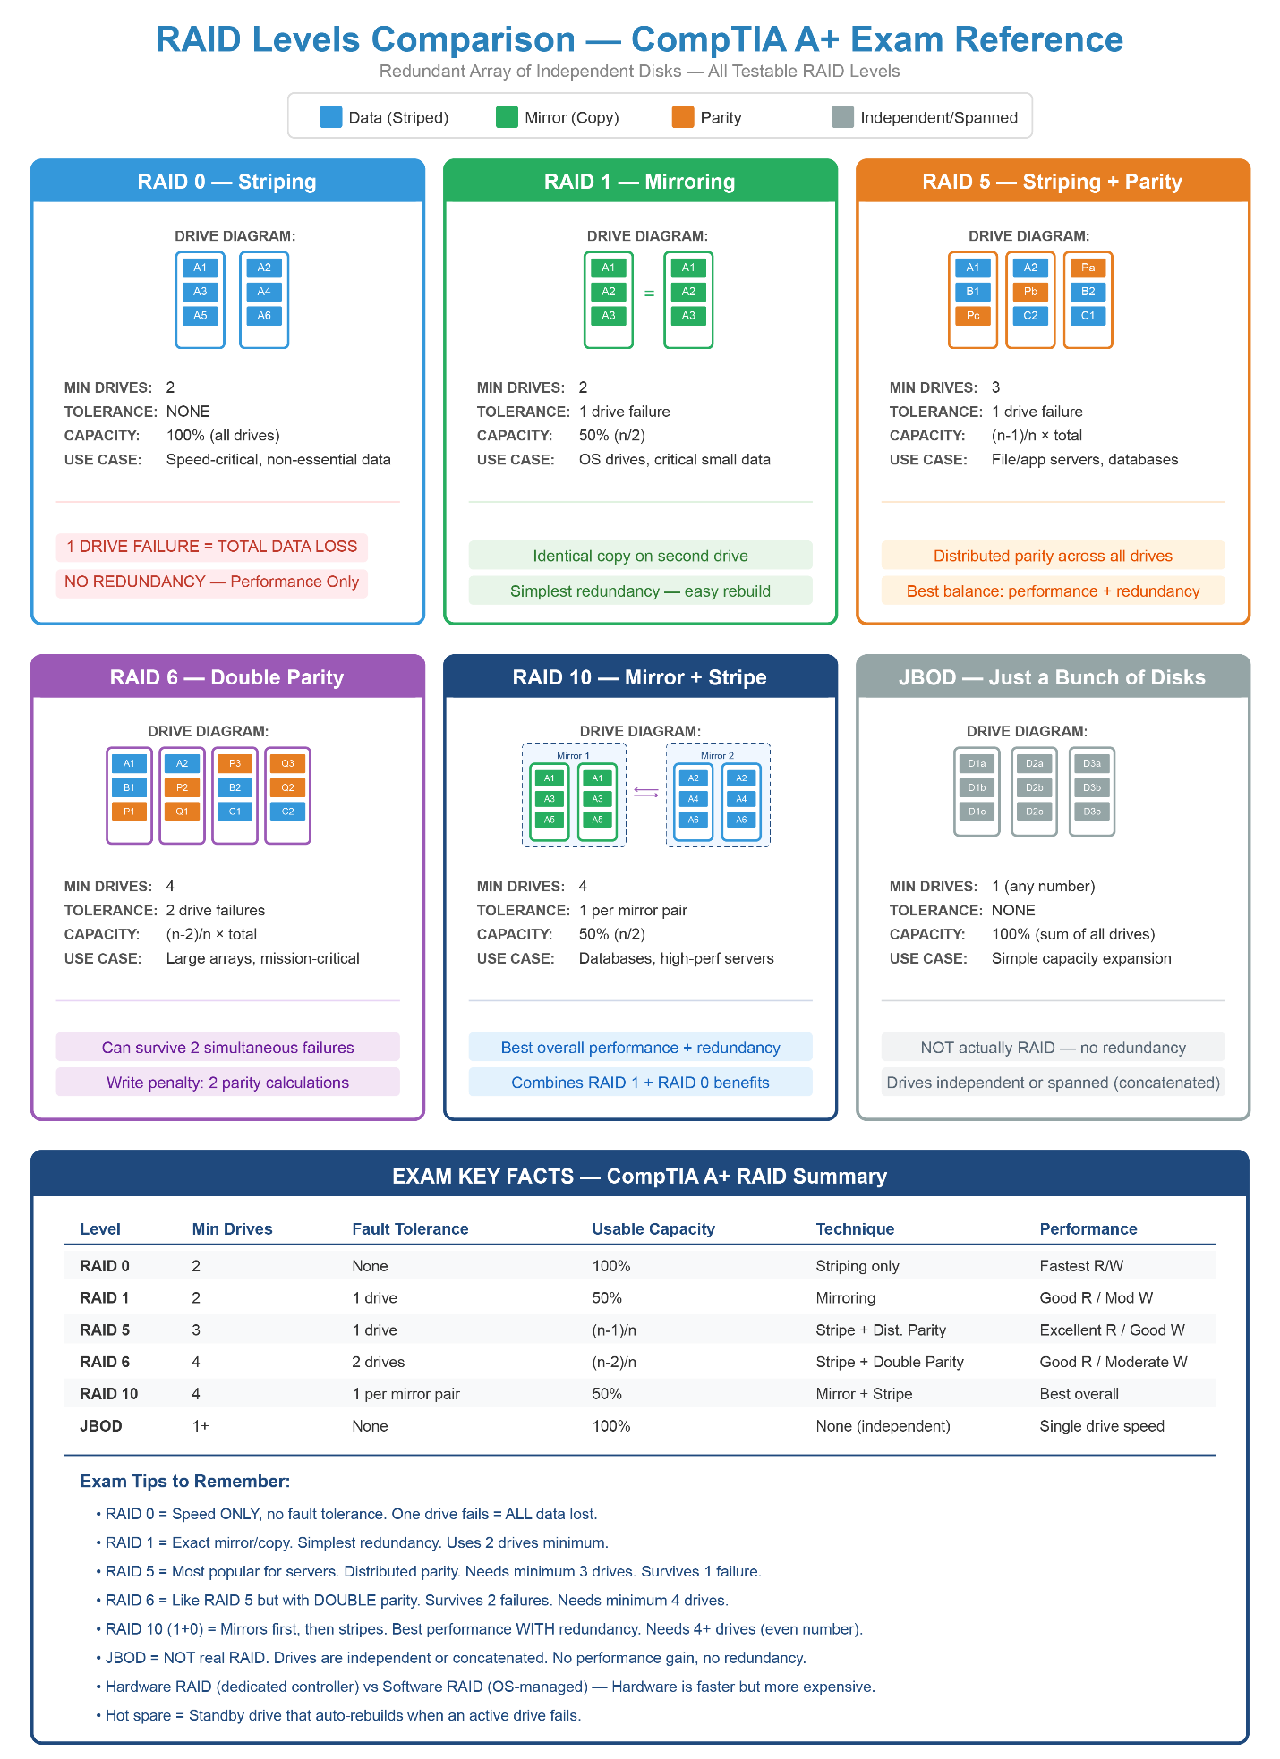

Module: Windows File Systems (NTFS, FAT32, exFAT)

Module Objectives
By the end of this module, learners will be able to:
- Identify and compare the three primary Windows file systems: NTFS, FAT32, and exFAT.
- Explain the capabilities and limitations of each file system.
- Convert drives between file systems using appropriate tools.

File System Comparison
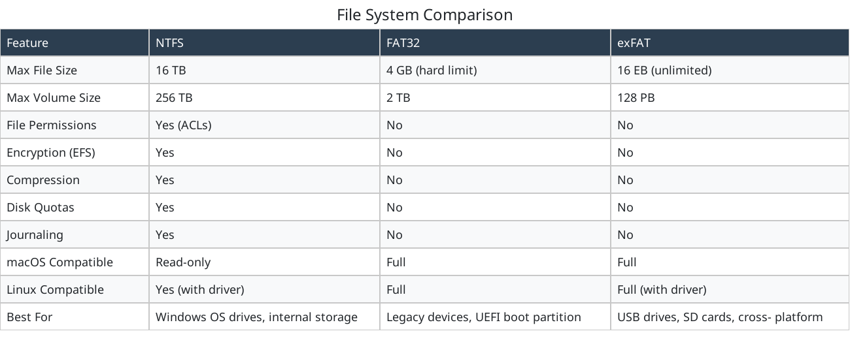
✔ Pro Tip: NTFS theoretical max file size is 16 EB, but Windows implementations cap it lower (~16 TB practical). FAT32 max volume size is technically 16 TB, but Windows limits formatting to 2 TB. exFAT is designed for removable storage, not OS drives.

Key File System Facts
NTFS is the required file system for Windows operating system drives. It is the only file system that supports Windows security features:
- File and folder permissions (ACLs) for granular access control
- Encrypting File System (EFS) for file-level encryption
- Disk quotas limiting per-user storage consumption
- Journaling for crash recovery (logs changes before committing)
- Volume Shadow Copy Service (VSS) for restore points and “Previous Versions”
- Support for files larger than 4 GB
FAT32 is a legacy file system with a hard 4 GB maximum file size limit. It has no security features (no permissions, no encryption, no journaling). Its key advantage is universal compatibility across all operating systems and devices. The UEFI System Partition (ESP) is always FAT32.
exFAT is the modern replacement for FAT32 on removable media. It removes the 4 GB file limit while maintaining cross-platform compatibility (Windows, macOS, Linux). Like FAT32, it has no permissions or journaling.

File System Troubleshooting
“File is too large for the destination file system” → Likely Cause: Drive is FAT32; file exceeds 4 GB → Fix: Reformat drive to exFAT or NTFS
Cannot set file permissions on external drive → Likely Cause: Drive is FAT32 or exFAT → Fix: Reformat to NTFS if permissions needed
Drive shows as RAW in Disk Management → Likely Cause: File system corrupted → Fix: Run chkdsk /f or reformat
“Access Denied” on drive moved from another PC → Likely Cause: NTFS permissions tied to old user SID → Fix: Take ownership (Properties, Security, Advanced, Change Owner)

Converting Between File Systems
FAT32 to NTFS
convert X: /fs:ntfs (command line) X=Drive Letter
Data Loss?: No (non- destructive)
NTFS to FAT32
(Must reformat the drive)
Data Loss?: Yes (all data erased)
Any to exFAT
(Must reformat the drive)
Data Loss?: Yes (all data erased)
ℹ️ Exam Tip:
- “File too large” error on a USB drive with free space = FAT32’s 4 GB limit.
- NTFS is the ONLY file system supporting Windows file permissions. If a question mentions security, ACLs, or EFS, the answer is NTFS.
- The UEFI System Partition (ESP) is always FAT32, even on GPT drives.
- The convert command is one-way: FAT32 to NTFS works non-destructively. NTFS to FAT32 requires reformatting.
- exFAT is the correct answer when cross-platform AND large files are needed on removable media.

Module: Cables, Connectors, & Adapters

Module Objectives
By the end of this module, learners will be able to:
- Identify and distinguish between copper and fiber-optic network cables and their associated connectors.
- Compare and contrast the different USB and Thunderbolt standards and types.
- Recognize legacy and modern video interfaces, including HDMI, DisplayPort, DVI, and VGA.
- Differentiate between hard drive cabling standards: SATA, SAS, and IDE.

Ethernet Cable Categories
Cat 5e
Speed and Distance: Supports 1 Gbps up to 100 m.
Shielding & Jacket Types: UTP (Unshielded Twisted Pair): No protection from interference.
Cat 6
Speed and Distance: Supports 5 Gbps up to 100 m or 10 Gbps up to 55 m.
Shielding & Jacket Types: STP (Shielded Twisted Pair): Protective shield against EMI and RFI.

Cat 6a
Speed and Distance: Handles 10 Gbps at the full 100 m length.
Shielding & Jacket Types: CMR (Riser): Fire-resistant jacket for running cables between floors.

Cat 8 / 8.1 / 8.2
Speed and Distance: Supports 25 to 40 Gbps over ~30 m.
Shielding & Jacket Types: *CMP (Plenum): Jacket that produces less smoke in a fire, suited for HVAC ducts.

Note:CMP is a jacket fire-rating applicable to any cable category (Cat5e, Cat6, etc.). CMP information is not likely to be on exam but is good to know for real‑world installers.

Fiber Optic Cables
Single-mode: A single ray of light travels down the core tube. Connectors: More expensive transceivers; used for longer distances.
Multimode: Multiple light beams travel down a larger core tube. Connectors: Less expensive transceivers; often used for shorter distances.
Common connectors: ST (Straight Tip), LC (Lucent Connector), and SC (Subscriber/Square Connector).

USB & Thunderbolt Standards
USB 2.0 — 480 Mbps (2001)
Connector Type: Type A, B, Mini, Micro
Key Feature / Notes: Cables max out at 5 m.

USB 3.x — SuperSpeed (5/10 Gbps)
Connector Type: Type A, B, Micro, Type C
Key Feature / Notes: 3.x connectors are usually blue.

USB 4.0 — Up to 40 Gbps
Connector Type: Type C only
Key Feature / Notes: Supports alt mode (tunneling DisplayPort, HDMI, PCIe).

Thunderbolt 1/2 — Up to 20 Gbps
Connector Type: Mini DisplayPort
Key Feature / Notes: Compatible with DisplayPort.

Thunderbolt 3/4 — Up to 40 Gbps
Connector Type: USB Type C
Key Feature / Notes: Thunderbolt 4 supports two 4K displays; Thunderbolt 3 supports one.

Thunderbolt 5 — Up to 80 Gbps
Connector Type: USB Type C
Key Feature / Notes: Supports 240W charging and dual 8K monitors.

Video Cables & Adapters
HDMI (Most common digital port.) Notes: Manages both video and audio over a 19-pin connector. Comes in Standard, Mini, and Micro sizes.
DisplayPort (DP) (Replacement for VGA/DVI.) Notes: Uses a 20-pin latching connector. Can transmit over USB-C via alt mode.
DVI (Older digital video port.) Notes: DVI-I carries both digital and analog; DVI-D is digital only.
VGA Standard: Obsolete analog-only standard. Notes: Uses a 15-pin D-type connector. Does not support audio.

Hard Drive Cabling Standards
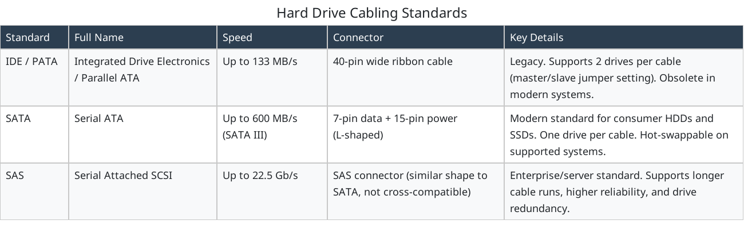
IDE / PATA — Integrated Drive Electronics / Parallel ATA Speed: Up to 133 MB/s Connector: 40-pin wide ribbon cable Key Details: Legacy. Supports 2 drives per cable (master/slave jumper setting). Obsolete in modern systems.
SATA — Serial ATA Speed: Up to 600 MB/s (SATA III) Connector: 7-pin data + 15-pin power (L-shaped) Key Details: Modern standard for consumer HDDs and SSDs. One drive per cable. Hot-swappable on supported systems.
SAS — Serial Attached SCSI Speed: Up to 22.5 Gb/s Connector: SAS connector (similar shape to SATA, not cross-compatible) Key Details: Enterprise/server standard. Supports longer cable runs, higher reliability, and drive redundancy.
⚠️ Exam Trap: SAS controllers can accept SATA drives, but SATA controllers cannot accept SAS drives. The compatibility is one-directional.

Module: Printers & Multifunction Devices

Module Objectives
By the end of this module, learners will be able to:
- Understand how laser printing works (charging, exposing, developing, transferring, fusing).
- Compare laser, inkjet, thermal, impact, and 3D printing technologies.
- Configure printers on wired, wireless, and cloud networks.
- Troubleshoot common printer failures and error symptoms.

Laser Printers
Laser printers use an electro-photographic (EP) process to produce high-quality text and graphics. They are common in business environments due to speed and low cost per page.

Laser Printer Components
Imaging Drum — Holds the electrostatic image
Primary Corona / Charging Roller — Charges the drum
Laser Assembly — Writes the image
Developer Unit — Applies toner to the drum
Transfer Roller/Belt — Moves toner to paper
Fuser Assembly — Melts toner into paper
Pickup Rollers — Pull paper from tray
Toner Cartridge — Supplies toner + sometimes drum

Laser Printing Process Steps
- Processing: The printer receives and rasterizes the page into a bitmap that the engine can print.
- Charging: A primary corona or charging roller applies a uniform negative charge to the drum.
- Exposing: A laser beam writes the image onto the drum by neutralizing selected areas.
- Developing: Negatively charged toner is attracted to neutral areas on the drum.
- Transferring: A transfer roller applies a positive charge to pull toner from the drum onto the paper.
- Fusing: The toner is melted and pressed into the paper using heat and pressure rollers.
- Cleaning: A cleaning blade removes any excess toner left on the drum after the transfer, and an erase lamp neutralizes any remaining electrical charge on drum.
⚠️ Exam Trap: CompTIA heavily tests the exact chronological order of the laser printing cycle. The exam will occasionally include Cleaning as the final step after Fusing, where the photosensitive drum is scraped clean of residual toner before the cycle restarts!
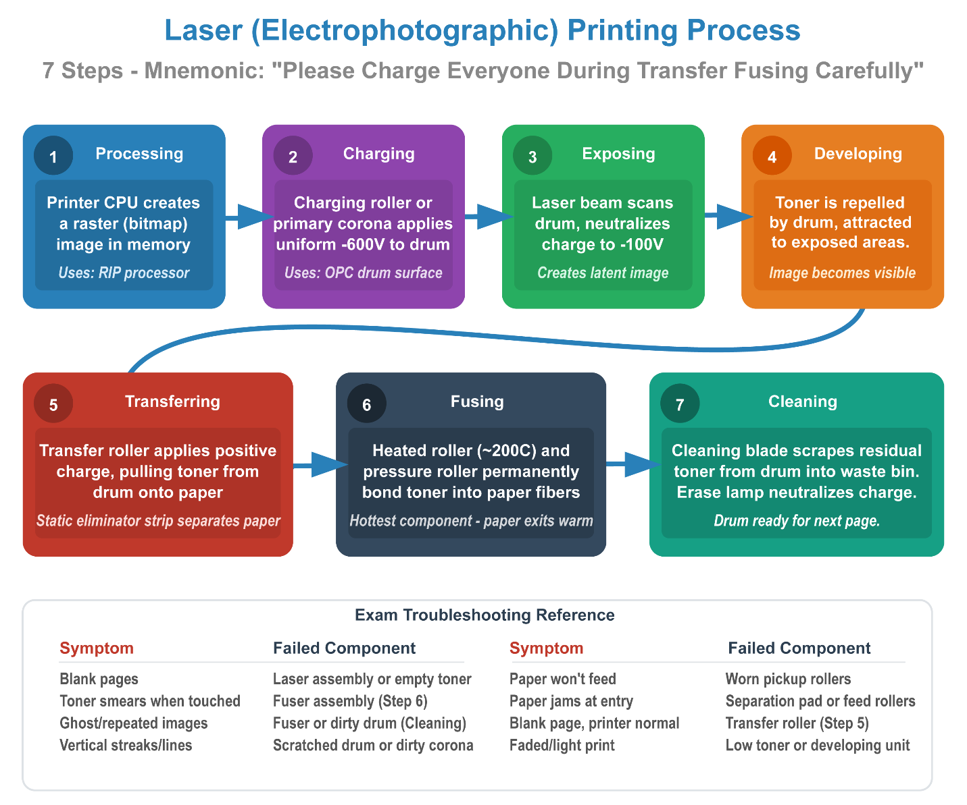

Laser Printer Troubleshooting
Streaks / vertical lines (Dirty corona, scratched drum) Fix: Replace toner/drum
Ghosted images (Bad fuser) Fix: Replace fuser assembly
Toner not binding (Fuser failure) Fix: Replace fuser
Paper jams (Worn rollers) Fix: Replace rollers / separation pad
Blank pages (Failed laser unit) Fix: Replace laser assembly

Inkjet Printers
Inkjet printers spray microscopic droplets of ink onto paper using Thermal bubble technology (HP, Canon) or Piezoelectric technology (Epson).

Inkjet Troubleshooting
Streaks / missing colors (Clogged nozzles) Fix: Run print head cleaning
Faded print (Low ink) Fix: Replace cartridges
Paper not feeding (Dirty/worn rollers) Fix: Clean or replace rollers
Colors incorrect (Misalignment) Fix: Run alignment utility
Smearing (Wet ink, humidity) Fix: Adjust paper type setting

Thermal Printers
Used in cash registers, shipping centers, and kiosks. No ink or toner — uses heat-sensitive paper. Extremely low maintenance.

Thermal Troubleshooting
Faded or blank prints (Dirty heating element) Fix: Clean the heating element with isopropyl alcohol.
Blank prints (Paper inserted upside down) Fix: Ensure the paper is inserted correctly (heat-sensitive side facing the element).

Impact Printers (Dot-Matrix)
Still used where multi-part (carbon copy) forms are required. Pins strike ink ribbon. Very loud but durable and long-lasting.

Impact Troubleshooting
Light/faded text (Worn ink ribbon) Fix: Replace the faded ink ribbon.
Missing lines/gaps (Stuck or broken pins) Fix: Clean or replace the printhead.
Paper jams (Misaligned paper feed) Fix: Adjust the tractor feed mechanism.

3D Printers
Uses additive manufacturing to build objects layer-by-layer. Common technologies: FDM (Filament Deposition Modeling), SLA (Stereolithography), SLS (Selective Laser Sintering).

3D Printer Troubleshooting
Clogged nozzle (Filament buildup/blockage) Fix: Clean or replace the extruder tip.
Poor bed adhesion Cause: Unlevel bed or lack of adhesion Fix: Re-level the print bed or apply an adhesive.
Filament snapping Cause: Moisture-ruined filament or incorrect temperature settings Fix: Check filament storage and adjust heat settings.

Virtual Printers
Virtual printers do not output physical paper. Instead, they act like standard printers but send the final output to a digital file. This is highly tested on the A+ exam as a method for preserving documents or sharing them across platforms.
Print to PDF: Converts the document into a Portable Document Format (.pdf). This is the industry standard for sharing documents that look identical on any operating system.
Print to XPS: Microsoft’s native alternative to PDF. Creates an XML Paper Specification (.xps) file. While less common today, it is still tested on the exam.
Print to Image: Renders the document as an image file (e.g., .jpg, .png, .tiff). Useful for graphic design workflows or when inserting a document into a presentation.
Print to Image: Renders the document as an image file (e.g., TIFF) rather than text-based output.

Virtual Printer Troubleshooting
Symptom: "Print to PDF" produces a blank or corrupted file. Likely Cause: Driver conflict or insufficient disk space for temp file. Fix: Update/reinstall virtual printer driver; check free space.
Symptom: Print to File job won't replay on real printer. Likely Cause: Wrong printer driver used when generating the file. Fix: Re-capture using the driver that matches the destination printer.
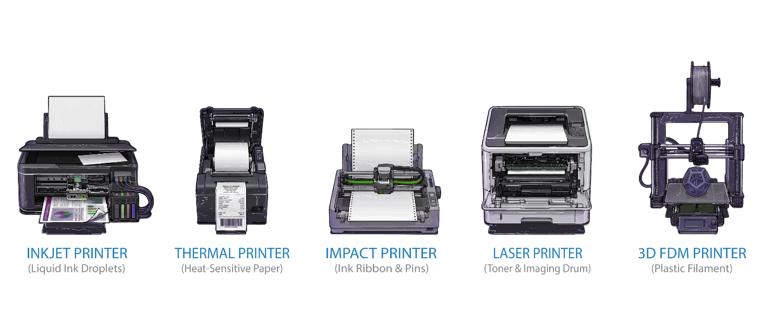

Printer Networking & Management Tools
Bridging the gap between physical hardware and network infrastructure, this table maps out the critical connectivity protocols and OS management tools necessary to solve cross-domain printing issues on both A+ exams.

Printer Networking & Configuration
Connections: USB, Ethernet, Wi-Fi / Wi-Fi Direct, Bluetooth.
Protocols: AirPrint (Apple), Cloud Printing, SMB, IPP, LPR.
Common Troubleshooting:
- Device not found (AirPrint/Wi-Fi)—Ensure the device and the printer are on the exact same subnet/VLAN.
- Constantly dropping offline—Assign a static IP address or DHCP reservation to the printer.

Print Management Tools
Windows: Print Management Console.
macOS: System Settings → Printers & Scanners.
Network: Embedded Web Server (EWS).
Common Troubleshooting:
- Stuck print queue—Stop the local Print Spooler service, clear the spool folder, and restart the service.
- Cannot access EWS—Verify the printer’s IP address on the physical control panel and ensure HTTP/HTTPS is enabled.
⚠️ Exam Trap: "Print spooler" questions are very common. If print jobs disappear from the queue but nothing prints, or the queue won't clear, the fix is almost always: stop the Print Spooler service, delete the contents of the spool folder, restart the service.

Module: Embedded Systems and IoT

Module Objectives
By the end of this module, learners will be able to:
- Define embedded systems and explain how they differ from general-purpose computers.
- Identify common IoT device categories in home, office, and industrial environments.
- Understand connectivity protocols used by IoT devices (Zigbee, Z-Wave, Matter, Thread).
- Recognize security risks unique to IoT and apply best practices for securing them.
- Troubleshoot common IoT connectivity issues.

What is an Embedded System?
An embedded system is a purpose-built computer designed for a specific, dedicated function within a larger device. Unlike a general-purpose PC, you cannot install arbitrary software on it.
Purpose (Single dedicated function) General-Purpose PC: Any user-installed software
OS Embedded System: Specialized / RTOS / embedded Linux General-Purpose PC: Windows, macOS, full Linux
User Interface (Minimal or none) General-Purpose PC: Full GUI
Hardware Upgrades (Not possible) General-Purpose PC: RAM, storage, GPU upgradeable
Software Install (Firmware updates only) General-Purpose PC: Users install/remove freely
Examples Embedded System: Smart thermostat, printer controller, car ECU General-Purpose PC: Desktop, laptop, tablet

IoT Device Categories
Smart Home / Consumer: Smart speakers (Echo, Nest), thermostats, smart lighting (Philips Hue), smart locks, cameras/doorbells (Ring), smart appliances, robot vacuums.
Office / Enterprise: Network printers, IP cameras (PoE), VoIP phones, badge/access control systems, environmental sensors, digital signage, conference room systems.
Industrial (IIoT): SCADA systems (critical infrastructure), PLCs (factory automation), medical devices (patient monitors), POS systems (payment terminals), building automation (HVAC).

IoT Connectivity Protocols
Wi-Fi — Medium (~50m) Speed: High (Mbps) Power: High Use Cases: Cameras, printers, anything needing bandwidth
Bluetooth/BLE — Short (10-100m) Speed: Low-Med Power: Very Low Use Cases: Wearables, sensors, locks, beacons
Zigbee — Short-Med (10-100m) Speed: Low (250 Kbps) Power: Very Low Use Cases: Smart lighting, home automation; mesh; needs hub
Z-Wave — Short-Med (30-100m) Speed: Low (100 Kbps) Power: Very Low Use Cases: Smart locks, thermostats; mesh; proprietary
NFC — Very Short (inches) Speed: Low Power: Minimal Use Cases: Tap-to-pay, door access badges
Cellular 4G/5G — Long (miles) Speed: High Power: High Use Cases: Fleet tracking, remote sensors
LoRaWAN — Very Long (miles) Speed: Very Low Power: Very Low Use Cases: Agriculture, city sensors, utility meters
Thread — Short-Med Speed: Low Power: Very Low Use Cases: Smart home (Matter standard); IPv6 mesh
Matter — Varies Speed: Varies Power: Varies Use Cases: Universal smart home standard (Apple, Google, Amazon)

IoT Security Risks and Best Practices
Why IoT devices are vulnerable:
- Default credentials shipped unchanged (the #1 IoT security risk)
- Infrequent or no firmware updates from manufacturers
- Cannot install antivirus or endpoint protection
- Always-on, always-connected (persistent attack surface)
- Weak or no encryption on some devices
- Difficult to monitor with traditional tools
Best Practices:
- Change all default credentials immediately during setup
- Isolate IoT on a separate network (guest VLAN or dedicated IoT network)
- Keep firmware updated; enable automatic updates where available
- Disable unused features (UPnP, remote access, cloud features)
- Use WPA3 or WPA2-AES; never use open networks for IoT
- Replace end-of-life devices that no longer receive security patches
- SCADA and industrial systems must be air-gapped from the internet

IoT Troubleshooting
IoT device won’t connect to Wi-Fi → Likely Cause: Wrong password, 5 GHz incompatibility (many IoT devices only support 2.4 GHz) → Fix: Verify password; check if device only supports 2.4 GHz; check MAC filtering
Device connected but unresponsive in app → Likely Cause: Cloud service outage, hub/bridge offline → Fix: Check manufacturer status page; restart hub; power-cycle device
Smart home devices slow → Likely Cause: Wi-Fi congestion, too many devices → Fix: Add dedicated IoT AP; change channel
Device disappears periodically → Likely Cause: DHCP lease expiring, weak signal → Fix: Assign DHCP reservation; improve signal strength
Multiple devices stopped at same time → Likely Cause: Router/hub failure, ISP outage → Fix: Check router; verify internet; power-cycle hub

Exam Tips
- IoT devices should ALWAYS be on a separate network segment (guest or IoT VLAN).
- Default credentials are the #1 IoT risk. If a compromised IoT device is mentioned, “change default password” is likely correct.
- Many IoT devices only support 2.4 GHz Wi-Fi. If a device won’t connect after router upgrade, check frequency band.
- SCADA and Industrial Control Systems should be air-gapped (never connected to internet).
- PoE is commonly used for IP cameras and VoIP phones (data + power on one cable).
- Cannot install antivirus on IoT. Network-level protections (firewalls, IDS/IPS, VLANs) are primary controls.

Quick Review — Hardware

Questions
- What is the difference between the 24-pin ATX connector and the 8-pin EPS connector on a motherboard?
- A technician installs a 4 TB hard drive but only 2 TB of space is accessible. What is the most likely cause, and how is it fixed?
- A user receives a "File is too large for the destination file system" error when copying a 6 GB video file to a USB drive that has 32 GB of free space. What is the problem and what are two possible solutions?
- What is the key difference between single-mode and multimode fiber optic cables?
- List the seven steps of the laser printing process in correct order.
- Why should IoT devices be placed on a separate network segment, and what is the #1 security risk associated with IoT devices?
- A desktop PC's system clock resets every time the computer is powered off. What component has failed, and what is the replacement?
- What is the key difference between a Type 1 and a Type 2 hypervisor, and why are snapshots not considered backups?

Answer Key
- The 24-pin ATX connector provides main power to the motherboard (3.3V, 5V, and 12V rails) — the system will not POST without it. The 8-pin EPS connector provides dedicated 12V power specifically to the CPU. Both must be connected for the system to function.
- The drive is using an MBR partition table, which has a maximum addressable size of 2 TB. The fix is to convert the drive to GPT (which supports drives up to 9.4 ZB).
- The USB drive is formatted with FAT32, which has a maximum file size limit of 4 GB. Solutions: reformat the drive to exFAT (best for cross-platform removable media with large files) or NTFS (if Windows-only use is acceptable).
- Single-mode fiber uses a single ray of light through a smaller core and is used for longer distances (but requires more expensive transceivers). Multimode fiber uses multiple light beams through a larger core and is used for shorter distances with less expensive transceivers.
- Processing → Charging → Exposing → Developing → Transferring → Fusing → Cleaning.
- IoT devices should be isolated because they cannot run antivirus or endpoint protection, receive infrequent updates, and are always connected — making them persistent attack surfaces. If compromised, isolation prevents lateral movement to critical systems. The #1 security risk is unchanged default credentials.
- The CMOS battery (CR2032 coin cell) has failed. It powers the BIOS clock and settings when the PC is off. Replace with a new CR2032 battery.
- A Type 1 hypervisor runs directly on hardware without a host OS (most efficient, enterprise use — e.g., VMware ESXi). A Type 2 hypervisor runs on top of a host OS (easier to install, ideal for labs — e.g., VirtualBox). Snapshots are not backups because they live on the same physical disk as the VM — if the disk fails, both the VM and all snapshots are lost.

CORE 2 - EXAM 220-1202
Operating Systems, Security, Troubleshooting & Operational Procedures
This section corresponds to the CORE 2 EXAM OBJECTIVES (220-1202) and expands beyond hardware topics to address software functionality, operating systems, security practices, and system-level troubleshooting.

Module: Windows Editions & Features

Module Objectives
The CompTIA A+ exam tests knowledge of the differences between Windows editions - particularly which features are available in Home vs. Pro vs. Enterprise. IT technicians must match the right edition to business requirements.
By the end of this module, learners will be able to:
- Compare Windows 10/11 editions (Home, Pro, Pro for Workstations, Enterprise).
- Identify which features require Windows Pro or Enterprise.
- Understand upgrade paths between editions.

Windows 10/11 Edition Comparison
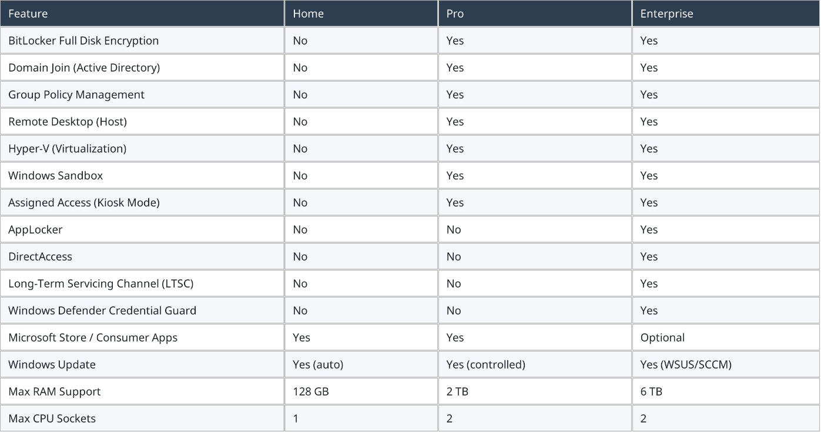

Key Edition Decision Rules
- If a question mentions “joining a corporate domain” or “Active Directory” → requires Windows Pro or Enterprise (NOT Home).
- If a question mentions “BitLocker” → requires Windows Pro or Enterprise (NOT Home).
- If a question mentions “Group Policy” → requires Windows Pro or Enterprise (NOT Home).
- If a question mentions “Remote Desktop Host” (being connected TO, not connecting from) → requires Pro or Enterprise.
- If a question mentions “Hyper-V” → requires Pro or Enterprise with hardware virtualization enabled.
✔ Pro Tip: - Home edition = consumer. Pro = business. Enterprise = large organizations with Volume Licensing. - BitLocker, Domain Join, Group Policy, Hyper-V, Remote Desktop Host = Pro/Enterprise ONLY. This comes up constantly. - Remote Desktop CLIENT (connecting to another machine) works on Home. Remote Desktop HOST (being connected to) requires Pro+.

Windows Upgrade Paths
Home → Pro — Can be done directly within Windows: Settings > System > About > Change product key. Enter a Pro license key. No reinstall needed.
Pro → Enterprise — Requires a Volume License or Microsoft 365 E3/E5 subscription. Managed through Microsoft’s Volume Licensing Service Center
Any → Clean Install — Wipe and reinstall with the target edition’s media. Loses all installed applications and settings.
In-Place Upgrade (older Windows → Win 10/11) — Run the Windows 10/11 installer while the old OS is running. Preserves files and most settings. Upgrades the edition to match the new OS’s equivalent tier.

Module: Operating Systems (Windows, macOS, Linux)

Module Objectives
By the end of this module, learners will be able to:
- Identify major desktop and mobile operating systems and their key characteristics.
- Install, configure, and update operating systems.
- Use essential system utilities (GUI + command-line) for troubleshooting.
- Manage users, permissions, and security settings.

Understanding Operating Systems
Windows 10/11 — Most used in business; supports Group Policy, domain join, extensive troubleshooting tools.
macOS — Apple desktop OS with tight hardware-software integration.
Linux (Ubuntu, Mint, Kali) — Open-source OS; strong command-line tools; widely used in security and servers.
ChromeOS — Cloud-centric OS used in education and lightweight deployments.

Installing and Upgrading Operating Systems
Clean Installation Description: Installs a fresh OS on a formatted drive. When to Use: Replacing a corrupted OS, deploying a new computer, repurposing a device.
Upgrade Installation Description: Moves to a newer OS version while keeping files and applications. When to Use: Example: Windows 10 → Windows 11.
Repair / In-Place Upgrade Description: Reinstalls the OS over itself to fix damaged system files while retaining user data. When to Use: System files are corrupted, but user data must remain intact.
Image Deployment Description: Installs a preconfigured, organization-approved OS image across multiple systems. When to Use: Windows Deployment Services (WDS), Microsoft Intune / Autopilot.

Windows System Tools
Task Manager Purpose: View CPU/RAM usage, stop unresponsive apps, manage startup. Common Uses: Slow performance, malware-like behavior.
Event Viewer Purpose: Displays system logs to diagnose issues. Common Uses: Boot issues, application crashes, driver errors.
Device Manager Purpose: Manages hardware and device drivers. Common Uses: Enable/disable devices, roll back or update drivers.
Disk Management Purpose: Tool for managing storage devices and partitions. Common Uses: Creating partitions, formatting disks, assigning drive letters.

Command-Line Tools
ipconfig — Shows IP configuration; use /release + /renew for network issues.
ping — Tests network connectivity.
sfc /scannow — Repairs Windows system files.
chkdsk — Checks disk integrity and fixes file system issues.
bootrec — Repairs bootloader problems (MBR/BCD).
gpupdate /force — Forces Group Policy to reapply immediately.
gpresult /r — Shows applied Group Policies on the PC.
tasklist — Lists running processes and their Process ID (PID).
taskkill /PID <PID> — Terminates processes. Must include PID Code
diskpart — Advanced partition manager for disks and volumes.
format — Formats a drive with a file system such as NTFS or FAT32.
robocopy — Copy tool supporting resume, multi-threading, and backup modes.
netstat — Shows active network connections.
net use — Maps or disconnects network drives and shared folders.
shutdown — Shuts down or restarts the system (/s shutdown, /r restart, /t time).

Users, Groups, and Permissions
Windows uses groups to simplify management. Instead of assigning permissions to each user one by one, technicians assign rights to the group.
Administrators — Members have full control over the system.
Users (Standard Users) — Members have limited permissions and cannot make system-wide changes.
Guests — Highly restricted access, typically disabled for security.
Remote Desktop Users — Allowed to sign in via Remote Desktop.
Backup Operators — Can backup and restore files regardless of permissions.
NTFS Permissions: Determine which users or groups can read, modify, delete, or execute files and folders on an NTFS-formatted drive. Supports inheritance - permissions flow from parent folders to subfolders.
Sharing Permissions: Control how users access a folder over the network via SMB. When NTFS + Share permissions conflict → the most restrictive wins.

Essential Linux Commands
ls — List files in a directory.
pwd — Show current directory.
cd — Change directories.
sudo — Run a command with administrative privileges.
chmod — Change file/folder permissions.
chown — Change file/folder ownership.
ps / top — View running processes.
ifconfig / ip — View or configure network settings.
apt-get / dpkg — Package management for Debian/Ubuntu-based systems.
yum / dnf — Package management for Red Hat/Fedora-based systems.

macOS Essentials
Finder — The macOS file manager used to navigate files, manage storage, and organize applications.
System Settings — Central location for configuring network, users, displays, and privacy settings.
Terminal — Command-line interface for advanced tasks.
Disk Utility — Used for formatting drives, partitioning, and running First Aid to repair file system issues.
Activity Monitor — Shows CPU, memory, energy, disk, and network usage (macOS version of Task Manager).
Time Machine — Built-in backup solution that creates continuous versioned snapshots for easy system restore.

Quick Review — Operating Systems & Software

Questions
- A Windows 10 Home user needs to join their company's Active Directory domain. What is the minimum edition upgrade required?
- A technician runs sfc /scannow but it reports it cannot fix corrupted files. What command should be run first before retrying sfc?
- What PowerShell execution policy allows local scripts to run but requires downloaded scripts to be digitally signed?

Answer Key
- Windows 10 Pro — Domain join, BitLocker, Group Policy, and Hyper-V all require Pro minimum.
- DISM /Online /Cleanup-Image /RestoreHealth — DISM repairs the Windows component store that sfc relies on. Always run DISM before retrying sfc.
- RemoteSigned — Local scripts run freely; downloaded scripts must be digitally signed by a trusted publisher.

Module: Scripting Overview

Module Objectives
Scripting automates repetitive or complex tasks. Unlike compiled programs, scripts are interpreted line-by-line, making them lightweight, flexible, and ideal for system administration.
By the end of this module, learners will be able to:
- Identify and describe common scripting languages used in IT environments.
- Understand essential scripting concepts including variables, loops, conditionals, and functions.
- Troubleshoot common scripting errors including syntax issues, permissions, and missing modules.

Common Scripting Languages
PowerShell Purpose: Windows automation and administrative tasks. File Type: .ps1
Bash Purpose: Linux/macOS system and file operations. File Type: .sh
Python Purpose: Cross-platform automation, parsing, and tooling. File Type: .py
JavaScript Purpose: Browser automation and UI manipulation. File Type: .js
Visual Basic Script (Legacy Windows automation.) File Type: .vbs

Core Scripting Concepts
Variables — Store data for use in scripts.
Conditionals — Allow scripts to perform different actions depending on the situation.
Loops — Repeat tasks automatically, ideal for system scans or file operations.
Functions — Reusable code blocks.
Arguments — Parameters for flexible input.
Comments — For documentation - exclude line from code (# // <# #>).
Shebang — Defines the interpreter at the top of a script (e.g., #!/bin/bash).

Security Considerations
Key principles when working with scripts:
- PowerShell Execution Policies: Restricted (no scripts run), RemoteSigned (local scripts run; downloaded must be signed), Unrestricted (not recommended).
- Linux/macOS Permissions: Scripts must be made executable: chmod +x script.sh
- Only run scripts from trusted sources. Avoid executing scripts delivered via email or chat.
- Follow Least Privilege: Run scripts with minimum necessary rights. Only elevate when required.
- Avoid Destructive Commands: Be cautious with rm -rf / (Linux) or del /s /q C: (Windows).

Common Scripting Errors
Syntax Error Symptom: Script fails immediately with a parsing or unexpected token error. Fix: Review the flagged line. Check for missing quotes, brackets, or incorrect operators. Run python -m py_compile script.py or pwsh -Command “Get-Command” to validate.
Permission Error Symptom: “Access denied,” “permission denied,” or script won’t execute at all. Fix: Windows: Run PowerShell as administrator. Check execution policy: run Get-ExecutionPolicy. Set with Set-ExecutionPolicy RemoteSigned. Linux/macOS: Run chmod +x script.sh to make the file executable. Use sudo if elevated rights are needed.
Missing Module / Not Found Symptom: “Module not found,” “cannot find module,” or “command not recognized.” Fix: Python: Install the missing module with pip install <module-name>. PowerShell: Install with Install-Module <module-name>. Bash: Install missing tools via apt-get install or yum install.
Wrong Interpreter Symptom: Script runs but produces unexpected output or fails with an unrecognized command error. Fix: Verify the shebang line (#!/bin/bash, #!/usr/bin/env python3). Confirm the correct interpreter is installed and in the system PATH.
Path Error Symptom: “File not found” even though the file exists. Fix: Use absolute paths instead of relative paths. Verify the working directory with pwd (Linux) or cd (Windows). Check for typos in the path.
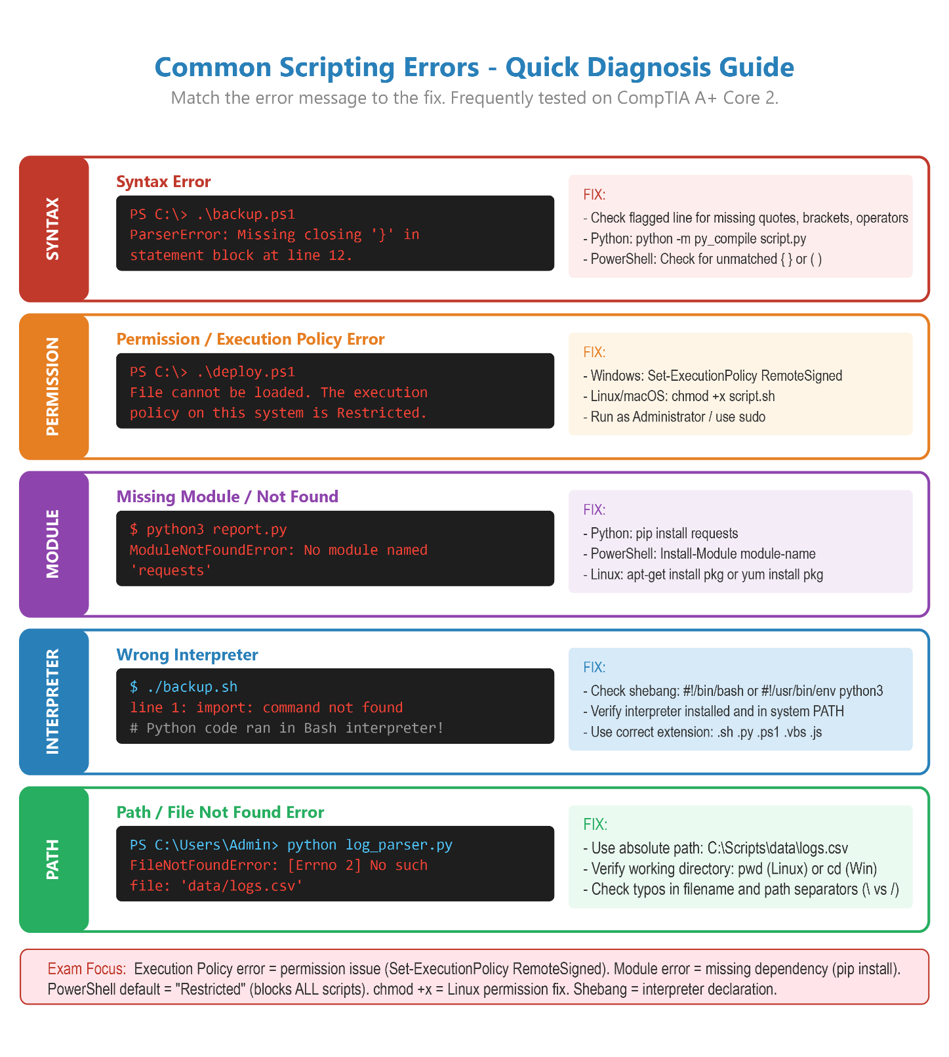

Module: Security

Module Objectives
By the end of this module, learners will be able to:
- Identify and mitigate common security threats (malware, unsafe networks, unauthorized access).
- Understand workstation, mobile, and network security best practices.
- Apply authentication, permission, and encryption controls.
- Remove malware using CompTIA’s recommended process.
- Recognize and prevent social engineering attacks.
- Configure wireless security and physical device protection.

Common Types of Malware
Virus — Attaches to legitimate files and spreads when executed.
Worm — Self-replicates across networks without user action.
Trojan — Appears legitimate but contains harmful code.
Spyware — Steals sensitive information such as passwords or browsing data.
Ransomware — Encrypts user data and demands payment for decryption.
Rootkit — Hides deep within the OS to conceal attackers or malware.
Adware — Displays unwanted ads, sometimes malicious.
Fileless Malware — Resides in memory using legitimate system tools instead of files.
Keyloggers — Covertly records user keystrokes to steal data.

The 7-Step Malware Removal Procedure
Memorizing the exact chronological order of this process is non-negotiable for the Core 2 exam. If a system is compromised, you must execute these steps sequentially to prevent the spread of the infection and ensure total remediation.
1 — Identify and research malware symptoms.
Exam Focus & Critical Details: Do not assume; verify. Ask the user what they were doing when the issue started. Look for redirected browsers, fake antivirus alerts, or unusually high CPU/network usage.
2 — Quarantine the infected system.
Exam Focus & Critical Details: Disconnect the network cable and disable Wi-Fi immediately! Your primary goal is to prevent the malware from spreading across the corporate network. Do not power off the machine, as you may lose valuable volatile memory (RAM) data.
3 — Disable System Restore (Windows).
Exam Focus & Critical Details: Malware often hides copies of itself inside Windows System Restore points. If you do not disable this feature, the malware will simply reinstall itself the next time the system reboots.
4 — Remediate the infected system.
Exam Focus & Critical Details: This is a two-part phase: 1. Update: Manually update your anti-malware signatures. 2. Scan: Boot the computer into Safe Mode or a pre-installation environment (WinPE) and run the removal tool.
5 — Schedule updates and additional scans.
Exam Focus & Critical Details: Once the immediate threat is removed, automate your defenses. Configure the anti-malware software to pull daily signature updates and run full system scans automatically.
6 — Enable System Restore and create a restore point.
Exam Focus & Critical Details: Now that the system is 100% clean, turn System Restore back on. Manually create a brand-new, malware-free restore point so the user has a safe fallback state.
7 — Educate the user.
Exam Focus & Critical Details: The final step is always training. Teach the user how to identify phishing emails, avoid suspicious downloads, and recognize social engineering tactics to prevent a repeat incident.
⚠️ Exam Trap: The “Skip a Step” Scenario - CompTIA frequently uses multiple-choice questions designed to trick you into performing actions out of order.

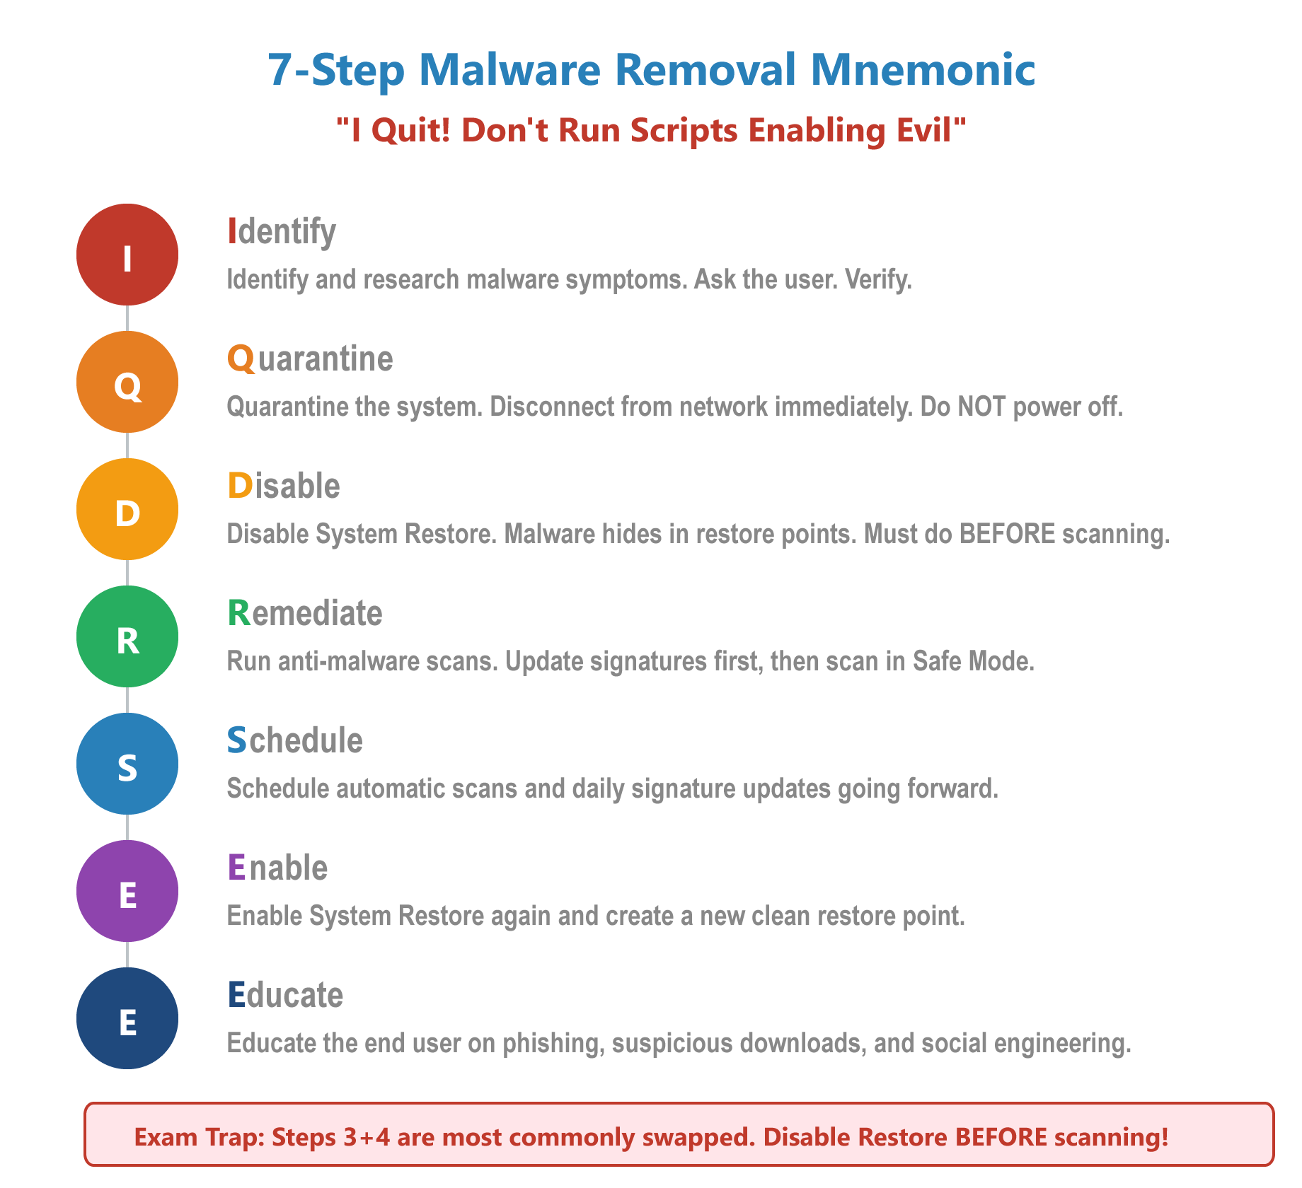

Wi-Fi Security Protocols
WEP Description: Very old; easily cracked; should never be used. Security Level: Very Weak
WPA Description: Early improvement over WEP, but outdated. Security Level: Weak
WPA2 Description: Modern baseline standard; commonly used. Security Level: Strong
WPA3 Description: Latest and most secure standard. Security Level: Very Strong

Social Engineering Attack Types
Phishing / Spear-Phishing / Whaling / Quishing — Fraudulent messages designed to trick users into revealing sensitive data. Spear-phishing targets specific individuals; whaling targets executives; quishing uses QR codes.
Vishing — Voice-based phishing using phone calls to extract information.
Smishing — SMS/text-based phishing attempts.
Impersonation — Attacker pretends to be someone trusted (IT staff, coworker, vendor).
Tailgating / Piggybacking — Gaining physical access by following someone into a secured area.
Pretexting — Attackers create a fabricated scenario to obtain information or access.

Encryption & Data Protection
- Full-Disk Encryption: BitLocker (Windows) and FileVault (macOS) encrypt entire drives to protect data if a device is lost or stolen.
- VPN for public Wi-Fi: Creates a secure, encrypted tunnel for data in transit.
- HTTPS / TLS: Ensures encrypted web browsing.

Physical Security Controls

Deterrent Controls
Security Signage — Warns unauthorized users to stay out.
Visible Cameras — Reduces attempted theft or intrusion.
Exterior Lighting — Removes hiding spots and improves visibility.

Preventive Controls
Badge / Keycard Access — Restricts entry to authorized employees.
Biometric Locks — Fingerprint or facial authentication.
Mantraps — Two-door system preventing tailgating.
Cable Locks — Secure laptops, desktops, and projectors.

Detective Controls
CCTV Monitoring — Records activity for investigation.
Motion Sensors — Detects unauthorized movement.
Door Access Logs — Tracks who entered and when.

Quick Review — Security

Questions
- What is the correct order of the first four steps in the CompTIA 7-step malware removal process?
- A user's browser shows "Your connection is not private" on every HTTPS website. What should the technician check first?
- What is WPS, and why should it always be disabled on a SOHO router?
- What is the difference between a full wipe and a selective wipe in MDM, and when would each be used?
- Why should RDP (port 3389) never be exposed directly to the internet, and what should protect it?

Answer Key
- Identify symptoms → Quarantine the system → Disable System Restore → Remediate (update signatures and scan). Steps 1–4 in exact order.
- Check the system date and time. SSL/TLS certificates rely on time validation — an incorrect clock causes every certificate to appear invalid.
- Wi-Fi Protected Setup — it uses an 8-digit PIN that can be brute-forced in hours. It should always be disabled regardless of which security protocol (WPA2/WPA3) is in use.
- Full wipe erases ALL data on a lost/stolen corporate device. Selective wipe removes only corporate data/apps while leaving personal data intact — used for BYOD devices when an employee leaves the company.
- Exposed RDP is one of the most common ransomware entry points. Attackers scan for open port 3389 and brute-force credentials. Always protect RDP behind a VPN or SSH tunnel.

Module: Browser Security & Settings

Module Objectives
Web browsers are the primary interface through which users access cloud applications, email, and the internet - making them a major attack surface. Technicians must know how to configure browser security settings and recognize browser-based threats.
By the end of this module, learners will be able to:
- Configure essential browser security settings.
- Understand how SSL/TLS certificates protect web traffic.
- Identify and remediate browser-based security issues.
- Recognize browser-based attack vectors.

SSL/TLS Certificates & HTTPS
When you visit a site with HTTPS, the browser verifies the site’s SSL/TLS certificate before establishing an encrypted connection. Understanding certificate errors is essential for both security and helpdesk support.
SSL/TLS Certificate — A digital certificate issued by a Certificate Authority (CA) that verifies a website’s identity and enables encrypted HTTPS communication.
Certificate Authority (CA) — A trusted organization that issues and validates SSL/TLS certificates. Examples: DigiCert, Let’s Encrypt, Comodo. Browsers have a built-in list of trusted CAs.
Certificate Error: Expired — The certificate’s validity period has passed. The site may be legitimate but the cert needs renewal. Warn the user - do not dismiss this error on sites handling sensitive data.
Certificate Error: Untrusted CA — Issued by a CA not trusted by the browser. Could indicate a self-signed certificate (common on internal corporate tools) or a malicious site.
Certificate Error: Name Mismatch — The domain name on the certificate doesn’t match the site being visited. Could indicate DNS hijacking or a misconfigured server.
Certificate Error: Wrong System Clock — If the device’s date/time is incorrect, all certificates appear invalid. Always check system time first when troubleshooting SSL errors.

Key Browser Security Settings
Pop-up Blocker — Prevents unsolicited pop-up windows - a common vector for adware and scam sites. Enable by default; whitelist trusted sites that require pop-ups.
Private / Incognito Mode — Does NOT save browsing history, cookies, or form data to the local device. Does NOT make you anonymous - ISP and employer can still see traffic. Useful for shared computers.
Clear Browsing Data — Removes cached files, cookies, and history. Fixes many browser performance and display issues. Useful first troubleshooting step for browser problems.
Browser Extensions — Add-ons extending browser functionality. Security risk: malicious extensions can steal data, inject ads, or redirect searches. Audit extensions regularly - remove unused ones.
Password Manager — Built-in (or third-party) tool for storing and auto-filling passwords. Encourages use of unique, complex passwords per site. Far more secure than reusing passwords.
Secure DNS — Routes DNS queries over HTTPS (DoH) or TLS (DoT) to prevent ISP snooping and DNS hijacking. Available in Chrome, Firefox, Edge.
Site Permissions — Controls per-site access to camera, microphone, location, and notifications. Review and revoke permissions for sites that no longer need them.
SmartScreen / Safe Browsing — Browser-level phishing and malware protection. Microsoft SmartScreen (Edge/IE) and Google Safe Browsing (Chrome) warn users before visiting known malicious sites.

Browser-Based Attack Vectors
Browser Hijacking — Malware changes the browser’s homepage, default search engine, or new tab page without consent. Fix: Remove malicious extensions, run malware scan, reset browser settings.
Drive-By Download — Malware automatically downloads when a user visits a compromised or malicious website - no clicking required. Defense: Keep browser and plugins updated, enable SmartScreen/Safe Browsing.
Malicious Extensions — Fake or compromised browser add-ons that steal credentials, inject ads, or redirect traffic. Defense: Only install extensions from official stores, review permissions before installing.
Cross-Site Scripting (XSS) — Attacker injects malicious scripts into a trusted website that then execute in the victim’s browser. Defense: Keep browser updated; browser-level XSS filters provide some protection.
Clickjacking — A transparent malicious layer is placed over a legitimate page, tricking users into clicking hidden elements. Defense: Browser X-Frame-Options headers prevent most clickjacking.
Fake Certificate Warnings — Scammers display fake browser security alerts (not real browser warnings) to trick users into calling a phone number or downloading software. Defense: Real browser warnings come from the browser itself - not pop-up windows.

Module: SOHO Network Security

Module Objectives
Small Office/Home Office (SOHO) networks are among the most common environments A+ technicians support. Securing these networks requires configuring routers, access points, and connected devices correctly - many of which ship with dangerously insecure default settings.
By the end of this module, learners will be able to:
- Identify and remediate common SOHO network security vulnerabilities.
- Configure router and wireless security settings correctly.
- Set up guest network isolation.
- Understand firewall configuration basics for SOHO environments.

Common SOHO Security Mistakes
Using default admin credentials — CRITICAL. Default passwords (admin/admin, admin/password) are published online. Anyone on the network can access the router admin interface. Fix: Change admin username and password immediately on setup.
Using default SSID — The default SSID (e.g., “NETGEAR-5G” or “Linksys”) reveals the router model, helping attackers target known vulnerabilities. Fix: Change to a non-identifying SSID.
Using WEP or WPA (old security) — WEP can be cracked in minutes. WPA (original) has known vulnerabilities. Fix: Use WPA2-AES or WPA3 exclusively.
WPS enabled — Wi-Fi Protected Setup has a known PIN brute-force vulnerability. The 8-digit PIN can be cracked in hours. Fix: Disable WPS entirely.
Remote management enabled — Allows access to the router admin interface from the internet - a direct attack vector. Fix: Disable remote management unless specifically needed.
Outdated router firmware — Unpatched firmware contains known exploits. Fix: Enable automatic firmware updates or check monthly for updates.
No guest network — Visitors and IoT devices on the main network can potentially access shared resources. Fix: Create a separate guest VLAN/network for visitors and untrusted devices.

SOHO Router Security Checklist
- Change the default admin username and password to something strong and unique.
- Update router firmware to the latest version. Enable auto-updates if available.
- Set wireless security to WPA3 or WPA2-AES. Disable WEP, WPA (TKIP), and WPS.
- Change the default SSID to something that does not identify the router brand or household.
- Create a separate guest network for visitors and IoT devices with network isolation enabled.
- Disable remote management (WAN access to router admin panel).
- Disable UPnP (Universal Plug and Play) - it can be exploited to open ports automatically.
- Enable the built-in firewall (SPI firewall) if not already active.
- Review port forwarding rules - remove any that are no longer needed.
- Change the default LAN IP range if possible (e.g., from 192.168.1.x to 10.0.x.x) to reduce automated attack scripts.

Guest Network Configuration
A properly configured guest network is one of the most important security measures for SOHO environments. It isolates visitors and untrusted devices (smart TVs, IoT gadgets, personal phones) from the main network where sensitive data and shared resources live.
Network Isolation (Client Isolation) — Prevents devices on the guest network from communicating with each other or with devices on the main network. Guests can only reach the internet.
Separate SSID & Password — Guest network has its own name and password. Main network credentials are never shared with guests.
Bandwidth Limiting — Optionally limits how much bandwidth guest devices can consume, preventing a guest from saturating the connection.
IoT Device Segmentation — Smart home devices (cameras, speakers, thermostats) should be on the guest/IoT network - not the main network with computers and phones containing sensitive data.

SOHO Firewall Configuration
SPI (Stateful Packet Inspection) Firewall — Built into most consumer routers. Tracks the state of active connections and blocks unsolicited inbound traffic. Should always be enabled.
Port Forwarding — Opens specific ports to allow inbound connections to a specific internal device (e.g., game server, NAS). Only open ports that are actively needed — close them when done.
DMZ (Demilitarized Zone) — Places a single device completely outside the firewall, exposing all ports to the internet. Very risky - use only for devices that genuinely need it and accept the security implications.
Inbound vs. Outbound Rules — Most SOHO firewalls only filter inbound traffic by default. Consider adding outbound filtering to block known malicious domains and restrict which applications can reach the internet.
✔ Pro Tip: - WPS is always a vulnerability - disable it regardless of the security protocol in use. - Default credentials = instant compromise. Always change them first. - Guest network + client isolation = visitors and IoT devices can’t reach your main computers. - UPnP is convenient but dangerous - disable it in security-conscious environments. - DMZ exposes a device to the entire internet with no firewall protection - use with extreme caution.

Module: Mobile Device Management (MDM)

Module Objectives
By the end of this module, learners will be able to:
- Explain the purpose and role of MDM in a corporate environment.
- Differentiate between Corporate and BYOD device ownership models.
- Identify common MDM features such as remote wipe, app control, and geofencing.
- Recognize how MDM integrates with security, networking, and operational procedures.

What is MDM?
Mobile Device Management is a centralized system used by organizations to manage smartphones, tablets, laptops, and BYOD/Corporate-owned devices. It allows IT administrators to push updates, enforce security policies, and monitor device status.

Device Ownership Models
Corporate-Owned Devices → Definition: Devices purchased and supplied by the company for employee use. → MDM Control Level: Full Control. MDM can enforce strict policies, install/remove apps, and fully wipe the device.
Bring Your Own Device (BYOD) → Definition: Employees use their personal mobile devices to access corporate resources. → MDM Control Level: Limited Control. MDM uses MAM, focusing only on securing corporate data within a container on the device.

Key MDM Features
Remote Wipe — Erases all data on a lost or stolen device (Full Wipe) or only corporate data (Selective Wipe for BYOD).
Remote Lock — Locks device to prevent unauthorized access of a misplaced or stolen device.
App Whitelisting — Only approved apps can run on the device.
App Blacklisting — Blocks specific apps (e.g., Dropbox, risky social apps).
Geofencing — Creates virtual boundaries that trigger security actions based on the device’s physical location.
VPN Enforcement — Forces encrypted tunnels for corporate apps and data.
Certificate Deployment — Uses device certificates for secure authentication to Wi-Fi, VPN, and internal resources.
Configuration Profiles — Enforce Wi-Fi settings, VPN, email setup, password policies, and feature restrictions.

Privacy Management

(What MDM Can vs. Cannot See on BYOD)
Can See:
- Device model & serial number
- OS version & security patch level
- Whether the device is encrypted
- Installed work apps
- Compliance status & jailbreak/root status
Can Not See:
- Personal photos
- Personal text messages or phone call logs
- Personal email accounts
- Browser history
- Personal app data or location history
⚠️ Exam Trap: Full vs Selective Wipe → Full = all data erased (lost/stolen corporate device). Selective = only corporate data removed (BYOD). BYOD Privacy → MDM cannot see personal content; only corporate container. Geofencing → Location‑based enforcement is a common exam scenario.

Module: Remote Access Technologies

Module Objectives
Remote access technologies allow technicians, administrators, and end users to connect to systems from a different physical location. This is a standalone Core 2 objective covering a range of tools from basic desktop sharing to enterprise remote management platforms.
By the end of this module, learners will be able to:
- Identify and differentiate between common remote access methods.
- Understand when to use each tool based on the scenario.
- Recognize security best practices for remote access.
- Explain the difference between user-initiated remote access and IT-managed remote monitoring.

Remote Desktop Technologies
RDP (Remote Desktop Protocol) — Microsoft’s built-in protocol for graphical remote access to Windows systems. Port 3389. Provides full desktop experience. Should always be protected behind a VPN - never expose RDP directly to the internet.
VNC (Virtual Network Computing) — Cross-platform screen-sharing protocol. Shares the actual display (rather than creating a new session like RDP). Common tools: TightVNC, RealVNC, TigerVNC. Port 5900.
SPICE (Simple Protocol for Independent Computing Environments) — High-performance remote display protocol used primarily in virtual machine environments (e.g., Red Hat Virtualization, KVM VMs). Supports audio, video, and USB redirection.
Apple Remote Desktop — macOS-specific remote management tool. Allows screen sharing, file transfer, and remote command execution on Mac systems.

Secure Remote Access Methods
VPN (Virtual Private Network) — Creates an encrypted tunnel between a remote device and the corporate network. Allows access to internal resources as if physically on-site.
SSH (Secure Shell) — Encrypted command-line remote access. Port 22. Primary tool for remote administration of Linux/Unix servers and network devices. Replaces insecure Telnet (port 23).
SFTP (SSH File Transfer Protocol) — Secure file transfer over an SSH connection. Port 22. Used to securely upload/download files on remote servers. Replaces insecure FTP.
Zero Trust Network Access (ZTNA) — Modern replacement for VPN that grants access to specific applications (not the whole network) based on identity and device compliance, regardless of location.

IT Remote Management Tools
RMM (Remote Monitoring and Management) — Enterprise platforms allowing MSPs and IT teams to monitor, manage, patch, and troubleshoot endpoints remotely without user interaction.
WinRM (Windows Remote Management) — Microsoft’s command-line remote management service based on WS-Management protocol. Enables PowerShell remoting and remote script execution on Windows systems.
IPMI (Intelligent Platform Management Interface) — Out-of-band management interface built into server motherboards. Allows remote power control, console access, and hardware monitoring even when the OS is offline.
iDRAC / iLO / IMM — Vendor-specific out-of-band management: Dell iDRAC, HP iLO, IBM IMM. Allow remote server management independent of the OS.
⚠️ Exam Trap: RDP Port 3389, never exposed directly; always behind VPN. RDP creates new session; VNC shares existing display. Out-of-band management → IPMI/iDRAC/iLO/IMM work even if OS is offline. SSH encrypted, Telnet insecure. SFTP secure, FTP insecure.

Screen Sharing & Collaboration Tools
TeamViewer — Popular cross-platform remote support and screen-sharing tool. Does not require VPN — connects through TeamViewer’s cloud relay. Widely used for remote helpdesk support.
AnyDesk — Remote desktop tool similar to TeamViewer. Known for low-latency performance. Used for both IT support and remote work.
Microsoft Quick Assist — Built into Windows 10/11. Allows screen sharing and remote control for IT support sessions. Requires both parties to be signed into Microsoft accounts.
Chrome Remote Desktop — Free Google tool allowing remote access through a Chrome browser. Cross-platform. Good for basic remote support.
Videoconferencing (Zoom, Teams, Meet) — While not traditional remote access tools, screen sharing via videoconferencing is frequently used in helpdesk scenarios for guided troubleshooting.

Remote Access Security Best Practices
- Never expose RDP (port 3389) or VNC (port 5900) directly to the internet - always use a VPN or SSH tunnel.
- Use multi-factor authentication (MFA) for all remote access solutions.
- Implement principle of least privilege - remote users should only access what they need.
- Use jump servers (bastion hosts) as a single controlled entry point for remote access to internal networks.
- Monitor and log all remote access sessions for security auditing.
- Disable remote access services when not in use to reduce attack surface.
- Keep remote access software updated - vulnerable RDP/VNC instances are a common ransomware entry point.
✔ Pro Tip: - VNC = cross-platform screen sharing, port 5900. - RMM = IT management platform for monitoring and managing many endpoints remotely. - WinRM enables PowerShell remoting on Windows systems. - SPICE is used for virtual machine remote display, not general desktop access.

Module: Windows Recovery Environment (WinRE)

Module Objectives
By the end of this module, learners will be able to:
- Access the Windows Recovery Environment using multiple methods.
- Identify and use each recovery tool available within WinRE.
- Differentiate between Startup Repair, System Restore, System Image Recovery, and Reset This PC.
- Understand Safe Mode options and when to use each variant.
- Apply the correct recovery method based on the failure scenario.

What is WinRE?
WinRE (Windows Recovery Environment) is a minimal operating environment built into Windows 10/11 that provides diagnostic and repair tools when the main OS cannot start normally. It runs from a hidden recovery partition.

How to Access WinRE
From within Windows — Settings, System, Recovery, Advanced Startup, Restart Now
Shift + Restart — Hold Shift while clicking Restart (Start Menu or Lock Screen)
Command Line — shutdown /r /o /t 0
Automatic Trigger — Windows enters WinRE after two consecutive failed boot attempts
From Installation Media — Boot from USB/DVD, select language, click “Repair your computer”

WinRE Recovery Tools
Startup Repair Purpose: Automatically fixes common boot problems (missing boot files, BCD corruption) Data Loss?: No
Startup Settings Purpose: Access Safe Mode, boot logging, disable driver signature enforcement Data Loss?: No
System Restore Purpose: Returns system files/registry to a previous point in time Data Loss?: No (personal files safe; apps after point removed)
System Image Recovery Purpose: Restores entire system from previously created image backup Data Loss?: Overwrites current drive
Command Prompt Purpose: Manual repair commands (bootrec, sfc, DISM, chkdsk, diskpart) Data Loss?: Depends on commands used
Uninstall Updates Purpose: Removes most recent quality or feature update Data Loss?: No
UEFI Firmware Settings Purpose: Reboots directly into UEFI/BIOS setup Data Loss?: No

Safe Mode Options
Safe Mode — Essential drivers only. No networking. Diagnose driver/software conflicts.
Safe Mode with Networking — Includes network drivers and internet. Download fixes or run cloud AV scans.
Safe Mode with Command Prompt — Command prompt only (no desktop GUI). Advanced repair when desktop won’t load.
Enable Boot Logging — Creates ntbtlog.txt listing every driver loaded. Identify which driver causes failure.
How to reach Safe Mode: WinRE, Troubleshoot, Advanced Options, Startup Settings, Restart, then press 4 (F4) for Safe Mode, 5 (F5) for Safe Mode with Networking, or 6 (F6) for Command Prompt.
Important: F8 does NOT reliably work in Windows 10/11. WinRE is the official path.
Safe Mode diagnostic logic: If the problem disappears in Safe Mode, the cause is a third-party driver, service, or startup program. If the problem persists in Safe Mode, the issue is in Windows core files or hardware.

Reset This PC
Option: Keep my files
What it Does: Reinstalls Windows, removes all apps, keeps personal files
Option: Remove everything
What it Does: Wipes drive and reinstalls Windows from scratch
Reinstallation Source Options:
- Cloud Download: Downloads fresh image from Microsoft (~4 GB). Use when local image may be corrupted.
- Local Reinstall: Uses recovery image on device. Faster, works offline.
“Clean the drive” option: When choosing “Remove everything,” enables basic data overwrite. Use when giving away or reassigning device. Not a substitute for proper data destruction on regulated data.

WinRE Command Prompt Reference
bootrec /fixmbr — Writes new Master Boot Record
bootrec /fixboot — Writes new boot sector
bootrec /rebuildbcd — Rebuilds Boot Configuration Data store
sfc /scannow /offbootdir=C:\ /offwindir=C:\Windows — Repairs corrupted Windows system files (offline mode)
DISM /Image:C:\Windows /Cleanup-Image /RestoreHealth — Repairs Windows image from WinRE (offline mode)
chkdsk C: /f /r /x — Checks and repairs disk errors and bad sectors
bcdedit — Views or modifies boot configuration

Recovery Method Decision Matrix
Won’t boot after Windows Update → First Try: Startup Repair, then Uninstall Updates → If That Fails: System Restore
Won’t boot after driver install → First Try: Safe Mode, roll back driver → If That Fails: System Restore
Corrupted system files → First Try: sfc /scannow, then DISM → If That Fails: System Restore
“bootmgr is missing” or BCD error → First Try: Startup Repair → If That Fails: bootrec commands from Command Prompt
Malware preventing normal operation → First Try: Safe Mode, malware scan → If That Fails: Reset (Remove everything)
Complete drive failure (new drive) → First Try: System Image Recovery → If That Fails: Clean install from media
Preparing PC for new user → First Try: Reset (Remove everything + Clean the drive) → If That Fails: N/A
ℹ️ Exam Tip:
- Startup Repair is always the FIRST tool to try when Windows won’t boot.
- Safe Mode isolates problems. Problem gone = third-party cause. Problem persists = core OS or hardware.
- System Restore does NOT affect personal files. Applications installed after the restore point WILL be removed.
- F8 does NOT work in Windows 10/11 for Safe Mode. Use Shift+Restart or WinRE automatic trigger.
- System Image Recovery requires a pre-existing image. If none exists, this option is unavailable.
- The WinRE Command Prompt runs with SYSTEM privileges (no admin elevation needed).
- “bootmgr is missing” = use bootrec commands. BSOD after update = Uninstall Updates.

Module: Workstation Backup & Recovery

Module Objectives
Data loss from hardware failure, ransomware, accidental deletion, or disasters is a constant risk. A+ technicians must understand backup strategies, types, schedules, and recovery procedures to protect organizational data.
By the end of this module, learners will be able to:
- Identify and explain backup types: full, incremental, and differential.
- Design appropriate backup schedules for given scenarios.
- Understand on-site, off-site, and cloud backup strategies.
- Use Windows and macOS built-in backup tools.
- Execute basic recovery procedures.

Backup Types
Full Backup — Everything - all selected files and folders regardless of whether they’ve changed. Speed: Slowest to create Recovery Complexity: Simplest - restore from the single full backup.
Incremental Backup — Only files changed since the LAST backup (full OR incremental). Speed: Fastest to create Recovery Complexity: Most complex — need the last full + every incremental since.
Differential Backup — All files changed since the last FULL backup (regardless of differentials). Speed: Medium Recovery Complexity: Simpler than incremental - need last full + latest differential only.
Synthetic Full — Combines a previous full + all incrementals into a new full backup without running a new full backup against the source. Speed: Fast (server-side) Recovery Complexity: Same as full — single restore point.

Backup Schedules
Full Weekly + Daily Incrementals — Full backup every weekend; incremental backups each weekday. Balances backup speed with recovery complexity. Most common enterprise strategy.
Full Weekly + Daily Differentials — Full backup every weekend; differential backups each weekday. Slower backup than incremental strategy but faster and simpler recovery.
Continuous / Real-Time Backup — Changes are backed up as they happen. Used for critical systems where minimal data loss is acceptable. Examples: database transaction logs, VSS shadow copies.
GFS (Grandfather-Father-Son) — A rotation scheme keeping daily (son), weekly (father), and monthly (grandfather) backups. Provides multiple recovery points at different time scales.

Backup Storage Locations
On-Site (Local) — Fast backup and recovery. No internet dependency. Risk: destroyed in the same disaster (fire, flood) as the primary data.
Off-Site (Physical) — Protected from on-site disasters. Tapes/drives physically transported to a secure location. Slow recovery if media must be shipped.
Cloud Backup — Protected from local disasters. Accessible from anywhere. Scalable. Cons: dependent on internet speed for backup and recovery; ongoing cost.
3-2-1 Rule (Best Practice) — 3 copies of data, on 2 different media types, with 1 copy off-site. Gold standard backup strategy.

Windows Backup Tools
File History — Automatically backs up personal files (Documents, Pictures, Desktop, etc.) to an external drive or network location at regular intervals. Not a full system backup.
Windows Backup (System Image) — Creates a complete image of the entire drive including OS, applications, and data. Can restore the full system to a previous state. Available in Control Panel > Backup and Restore.
System Restore — Creates restore points of Windows system files and registry. Does NOT back up personal files. Used to undo problematic driver installations or system changes.
OneDrive Sync — Syncs designated folders to Microsoft’s cloud. Provides cloud backup for files in synced folders. Not a full backup solution but protects against local file loss.
Reset This PC — Reinstalls Windows from a recovery image. Option to keep or remove personal files. Does not restore applications. Last resort for severe OS issues.
WBAdmin (Command Line) — Windows Server Backup command-line tool. Can create full system backups and bare-metal recovery images from the command prompt.

macOS Backup Tools
Time Machine — Apple’s built-in backup solution. Backs up to an external drive or network location hourly (keeping 24 hours), daily (keeping a month), and weekly (keeping all previous months). Supports file-level and full system restore.
iCloud Drive — Syncs Desktop and Documents folders to iCloud. Protects against local hardware failure but not a complete backup.
Migration Assistant — Transfers data, applications, and settings from an old Mac to a new one via Time Machine backup, direct connection, or network.
✔ Pro Tip: - Incremental = backs up changes since last ANY backup. Faster to back up, slower to restore. - Differential = backs up changes since last FULL backup. Slower to back up, faster to restore. - 3-2-1 rule: 3 copies, 2 different media types, 1 off-site. Memorize this. - System Restore does NOT protect personal files - only system files and registry. - File History protects personal files - NOT the OS or applications. - A system image is the only tool that lets you restore an entire Windows installation.

Quick Review — Recovery & Backup

Questions
- A Windows system won't boot after a driver installation. Using WinRE, what is the first recovery approach?
- What is the difference between an incremental backup and a differential backup in terms of what each backs up and restore complexity?

Answer Key
- Boot into Safe Mode and roll back the driver via Device Manager. If that fails, use System Restore to return to a point before the driver was installed.
- Incremental backs up files changed since the LAST backup (full or incremental) — fastest to create but slowest to restore (need last full + every incremental). Differential backs up all files changed since the last FULL backup — slower to create but simpler to restore (need last full + latest differential only).

Module: Operational Procedures & Troubleshooting

Module Objectives
By the end of this module, learners will be able to:
- List and apply the six steps of the systematic troubleshooting methodology.
- Explain the importance of documentation in the troubleshooting process.
- Recognize the procedural requirement to back up data before implementing any solution.

The Official CompTIA 6-Step Troubleshooting Methodology
Memorizing this exact sequence is mandatory. CompTIA will routinely present a scenario where a technician has just completed one of these actions and will ask you, “What should the technician do next?”
Step 1: Identify the Problem
Question the user to find out what recent changes were made. Check event logs and system alerts. Crucial: Always perform a full system and data backup before you make any changes to the system!
Step 2: Establish a Theory of Probable Cause
Start by questioning the obvious (e.g., “Is the device actually plugged in?”). Use the OSI model (top-to-bottom or bottom-to-top) to systematically narrow down the issue. If necessary, conduct internal/external research (knowledge bases, manufacturer websites).
Step 3: Test the Theory to Determine Cause
Try a quick, non-destructive test to see if your theory is correct.
- If confirmed: Move to Step 4.
- If incorrect: Go back to Step 2 and establish a new theory.
- If out of your depth: Escalate the ticket to a higher-level technician.
Step 4: Establish a Plan of Action & Implement
Write out the steps needed to fix the issue. Consider potential negative impacts or corporate downtime (e.g., “Will restarting this switch disconnect the entire floor?”). Once the plan is safe, execute the repair.
Step 5: Verify Functionality & Implement Preventive Measures
Do not just assume the fix worked. Have the user independently confirm that their workflow is restored. Once verified, implement preventative measures (e.g., installing a surge protector, updating policies) so the issue doesn’t happen again.
Step 6: Document Findings, Actions, and Outcomes
The job is not done until the paperwork is finished. Update the helpdesk ticketing system with a clear record of the initial symptoms, the root cause, and the exact steps taken to resolve it. This builds the corporate knowledge base for future technicians.
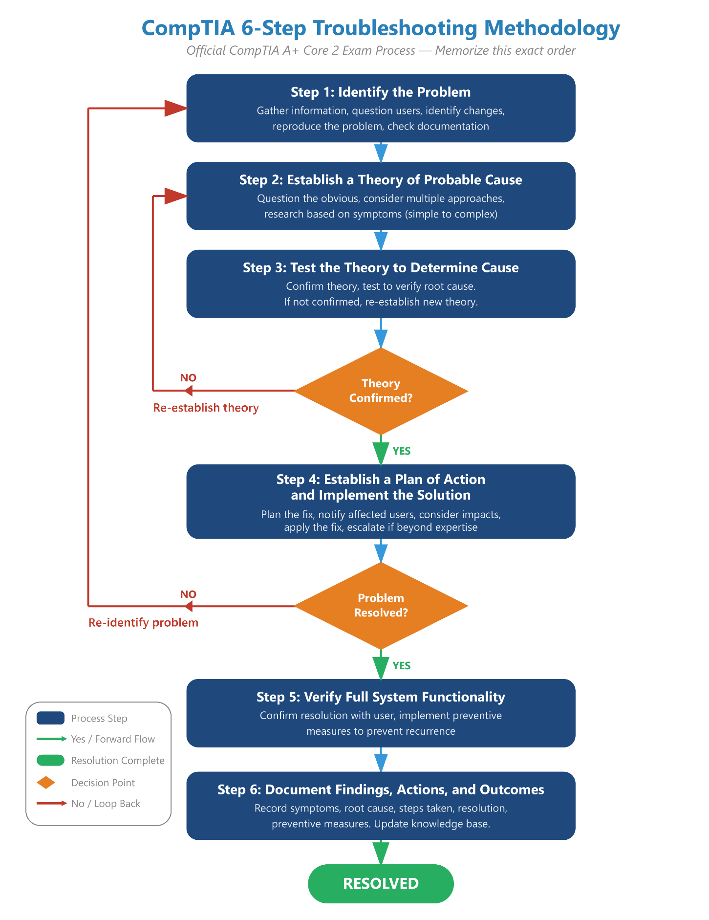

Data Backups Procedural Requirement
Before a technician ever opens a computer case, changes a registry key, or runs a malware removal tool, they must secure the user’s data. CompTIA enforces this as a strict procedural requirement in Step 1: Identify the Problem.
Why is this non-negotiable?
- Mitigating Catastrophic Loss: Troubleshooting is inherently risky. A simple fix (like rebuilding a boot partition or running a system restore) can unexpectedly corrupt a drive. If the data is backed up, a broken OS is just a minor inconvenience. If it isn’t backed up, it is a catastrophic business failure.
- Liability and Accountability: In corporate environments, user data often contains critical financial records, legal documents, or proprietary assets. Backing up data protects the IT department from liability if the hardware fails during the repair process.

Step 6 Deep Dive: The Importance of Documentation
The phrase to memorize for the A+ exam is: “The job is not done until the paperwork is finished.” Documentation is the final, essential step of the troubleshooting methodology.
Why Documentation is Critical:
- Building the Corporate Knowledge Base (KB): When you document a complex fix, you ensure the next technician who faces the same issue doesn’t have to start from scratch. This drastically reduces future ticket resolution times.
- Identifying Recurring Problems: Helpdesk software tracks documented tickets. If ten users report a broken printer connection in one week, proper documentation allows IT management to identify a systemic network issue rather than treating it as ten isolated incidents.
- SLA and CYA: Documentation provides a legal and procedural paper trail. It proves you met your Service Level Agreement (SLA) response times and protects you (Cover Your Assets) if a user claims a repair wasn’t completed properly.
1. The Initial Symptoms — Exactly what the user reported (e.g., “Monitor flashing blue when opening CAD software”).
2. The Root Cause — What actually caused the issue (e.g., “Outdated NVIDIA display drivers”).
3. The Exact Steps Taken — A clear record of the exact steps taken to resolve it (e.g., “Uninstalled v1.2, installed v1.5 from manufacturer website, rebooted”).
4. The Preventative Measures — How you ensured it won’t happen again (e.g., “Enabled automatic driver updates in Group Policy”).
✔ Pro Tip: - Memorize the 6 steps of the troubleshooting methodology - these apply to software and hardware. - Know the difference between Task Manager and Resource Monitor. - Compatibility mode is the first thing to try for legacy application issues. - BSOD error codes are in Event Viewer → Windows Logs → System. - On mobile devices: soft reset → settings reset → factory reset is the correct escalation path.

Module: Safety, Environmental & Facility Controls
Technicians must understand proper safety procedures, environmental requirements, and facility controls to protect both equipment and personnel.

Module Objectives
By the end of this module, learners will be able to:
- Identify fire extinguisher classes and when to use each type in an IT environment.
- Apply the PASS method for operating a fire extinguisher.
- Understand environmental requirements (temperature, humidity, airflow) for IT facilities.
- Recognize ESD hazards and proper prevention techniques.
- Follow safe handling procedures for toner, batteries, and other IT-specific materials.

Environmental Standards for IT Facilities
Temperature — 18–27°C (64–80°F) for server rooms.
Humidity — 40–60%. Lower humidity increases ESD risk; higher humidity increases condensation risk.
Airflow & Filtration — Use HVAC redundancy (N+1 or higher). Maintain cold aisle / hot aisle alignment.

Fire Safety Essentials
Class A (Wood, paper, cloth) Notes: Common combustibles.
Class B (Flammable liquids) Notes: Grease, gasoline, solvents.
Class C (Electrical fires) Notes: Most important for IT environments.
Class D (Combustible metals) Notes: Industrial settings.
Class K (Cooking oils & fats) Notes: Commercial kitchens.

PASS Method
When operating a fire extinguisher, remember: P - Pull the pin. A - Aim at the base of the fire. S - Squeeze the handle. S - Sweep side-to-side.
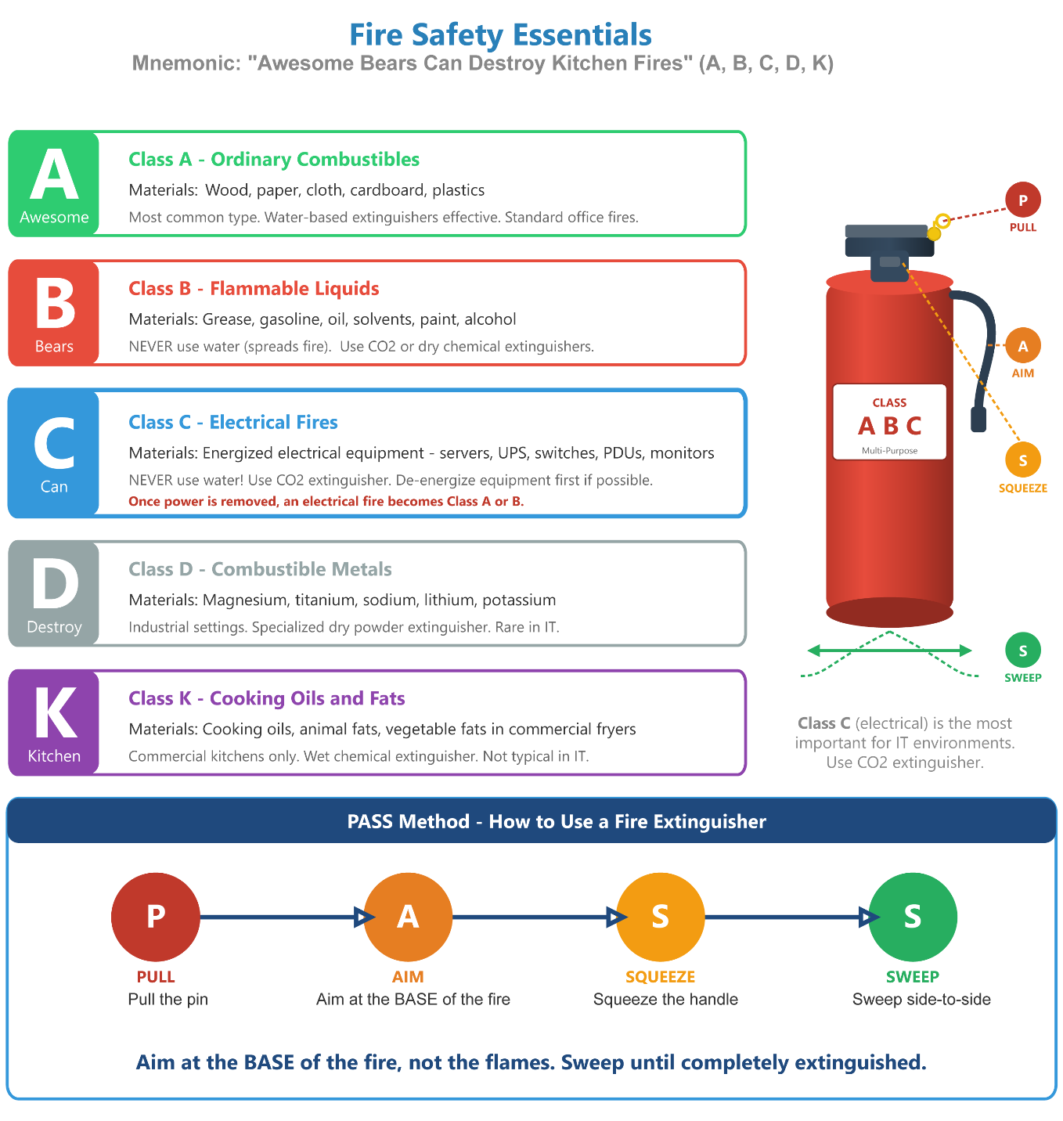

Additional IT-Specific Safety Guidelines
- Toner Safety: Use cold water for toner spills on skin - hot water melts and embeds toner.
- Battery Disposal: Batteries (especially Li-ion / Li-poly) must be recycled, not trashed.
- ESD Safety: Avoid household vacuum cleaners - they generate static. Use ESD-safe vacuums. Wear ESD wrist straps and use ESD mats when handling components.

Module: Customer Service & Ticket Lifecycle

Module Objectives
By the end of this module, learners will be able to:
- Demonstrate effective and professional communication skills with end users.
- Follow the complete help desk ticket lifecycle from intake to resolution.
- Identify prioritization methods (severity, impact, urgency).

Communication Essentials
Technical brilliance won’t save a ticket if you can’t communicate effectively with a frustrated user. This section breaks down the essential soft skills - from active listening to managing expectations - required to navigate high-stress helpdesk scenarios. CompTIA heavily tests these concepts on the Core 2 (220-1202) exam, making your IT “bedside manner” just as critical to passing as your hardware knowledge!

Tone and Word Choice
Words dictate the trajectory of a customer interaction. Effective word choice builds cooperation, de-escalates conflict, and ultimately saves valuable troubleshooting time. Whether communicating verbally or via a helpdesk ticketing system, a technician must always use language that is confident, professional, and positive.
⚠️ Exam Trap: You are highly likely to encounter a PBQ that simulates a live chat window with a very angry user. You will be given a drop-down menu of potential responses. Always choose the option that acknowledges the user’s frustration, avoids blaming them, and immediately offers a collaborative solution - just like the right-hand column of the table above!

Professional Translation Matrix
Avoid Saying Defensive or Negative Statements but instead convert to saying Collaborative and positive statements.
Instead of: “You did it wrong.” Say: “Let’s walk through the steps together.”
Instead of: “That’s not my department.” Say: I’ll connect you with the right resource and follow up.”
Instead of: “Calm down.” Say: “I understand this is frustrating. I’m here to help.”
Instead of: “I don’t know.” Say: “Let me find out for you.”
Instead of: “You have to…” Say: “To fix this, here is what I will need from you…”
Instead of: “Who is this?” Say: “May I ask who is calling?”

Verbal vs. Written Communication Standards
CompTIA expects technicians to adapt their communication style based on the medium they are using. You must master the specific rules for both verbal and written support:
- Verbal Communication (Phone/In-Person): You must control your pace, inflection, tone, and volume. Speaking too quickly can overwhelm a user, while a flat, monotone inflection can make you sound dismissive or bored.
- Written Literacy (Email/Live Chat): Without the benefit of vocal tone, written text can easily be misinterpreted. You must utilize proper grammar, spelling, sentence structure, and vocabulary. Never use text-message shorthand (e.g., “BRB,” “U R”), and strictly avoid drowning the user in highly technical jargon or “acronym soup.”

Ticket Lifecycle
Every support interaction in a help desk environment follows a structured path from the moment a user reports a problem to the moment the ticket is officially closed. Understanding this lifecycle ensures consistent, professional service and complete documentation - both critical for CompTIA A+ exam scenarios and real-world IT work.
1. Ticket Creation (Intake) — Username, contact info, device/asset ID, problem description, date/time, affected system.
2. Categorization & Prioritization — P1 Critical (Outage), P2 High (Major function impaired), P3 Medium (Non-critical), P4 Low (Minor inconvenience).
3. Troubleshooting & Documentation — User Q&A, testing, logs, system tools. Document steps taken, tools used, error messages, findings.
4. Escalation (If Needed) — When issue exceeds permissions, specialized knowledge required, or SLA time is at risk.
5. Resolution & Implementation — Apply fix, install updates, restore service, complete configuration change.
6. Verification of Functionality — Confirm issue fully resolved. User confirmation required.
7. User Education (If Applicable) — Explain how to avoid future issues. Provide documentation.
8. Ticket Closure — Closed only after user confirms solution and all documentation is entered.
✔ Exam Tip: The A+ exam frequently presents ticket lifecycle questions as ordering tasks - drag-and-drop or sequencing scenarios where you must arrange steps in the correct order. The two most commonly misplaced steps are User Education (step 7 - after resolution, not before) and Ticket Closure (step 8 - always last, always requires user confirmation first). Memorize the 8-step sequence cold.
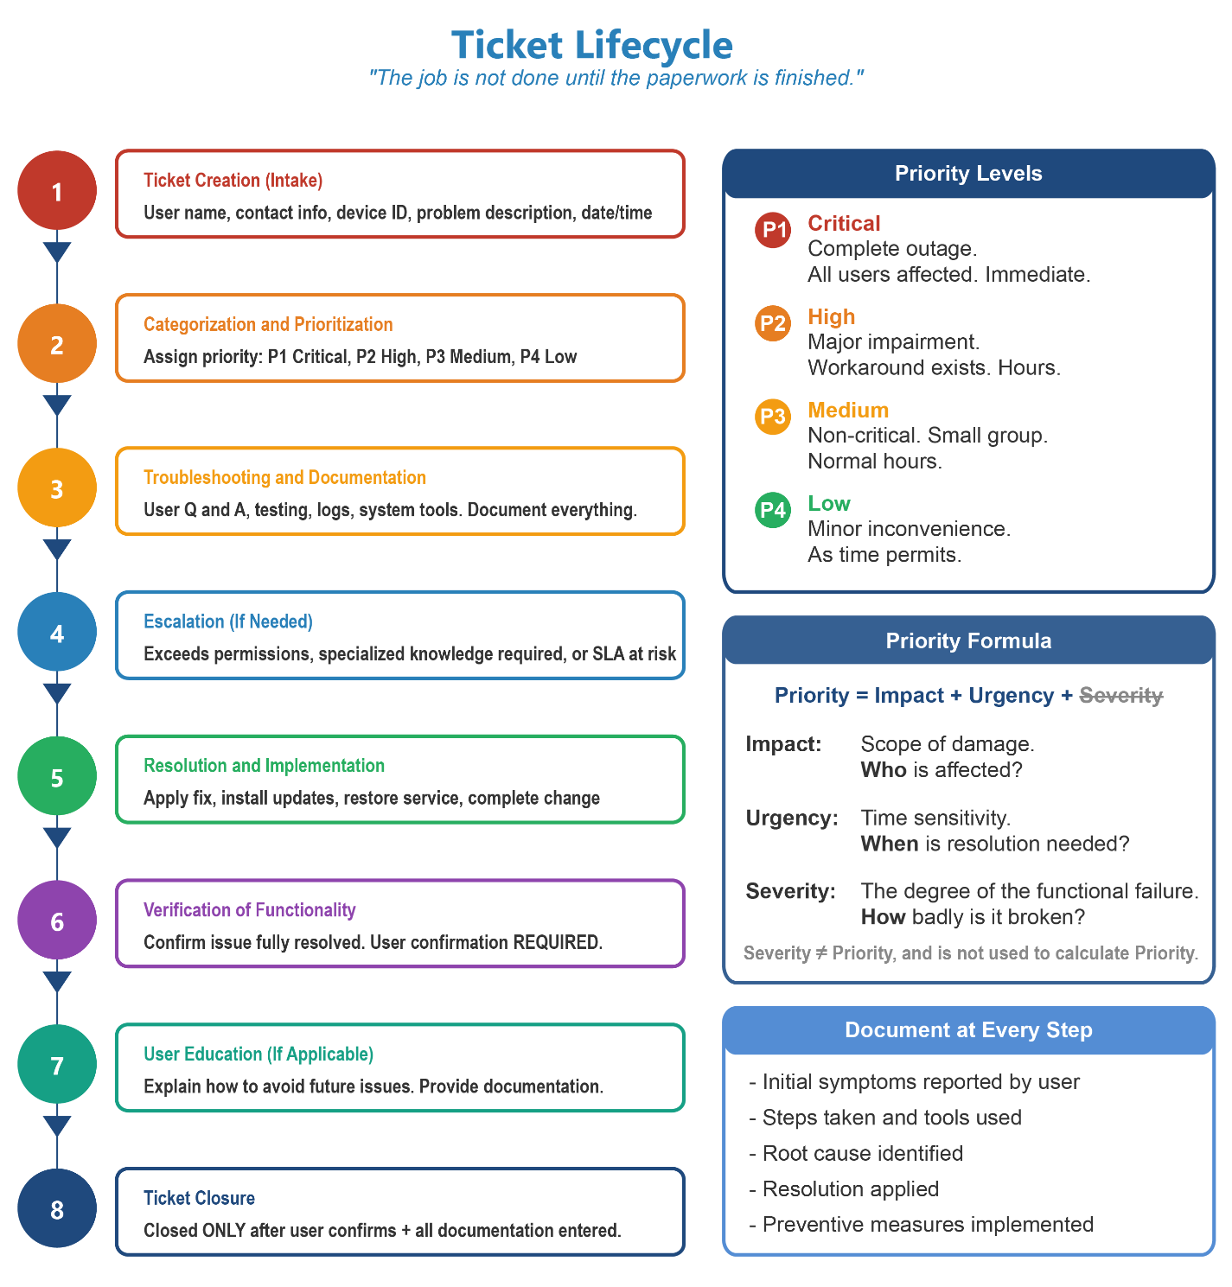

Prioritization Methods
Technicians use a structured prioritization matrix to objectively calculate a ticket’s priority.
Severity
The Definition : The Technical Degree of Failure. How badly is the specific hardware or software broken, regardless of its business use?
Real-World Example: A totally fried motherboard is a High Severity hardware failure. However, if that motherboard is in a spare laptop in the storage closet, the overall ticket priority remains low.
Impact
The Definition : The Scope of the Damage. A How much of the business is affected? Does this halt one user, an entire department, or the whole company’s revenue stream?
Real-World Example: single broken printer in a cubicle has Low Impact. The main switch failing in the server room has High Impact.
Urgency
The Definition : The Time Sensitivity. How quickly will the business feel the pain, and is there a viable workaround available?
Real-World Example: A payroll server failing on a Sunday has Low Urgency (nobody needs it until Friday). A payroll server failing on Friday morning has High Urgency.
✔ Exam Tip: The "SIU" Formula To remember how ticket Priority works, think SIU (like the university): Severity = How badly is the system broken? (technical damage) Impact = Who and how many are affected? Urgency = When does the business need this resolved?

The Priority Calculation
Helpdesk software automatically calculates the final Ticket Priority (P1 through P4) by combining Impact and Urgency.
- High Impact + High Urgency = P1 (Critical Outage): The main database is down, it is the middle of the workday, and the company is actively losing money. All available IT staff must drop what they are doing to resolve it.
- Low Impact + High Urgency = P2 or P3 (High/Medium): The CEO’s laptop will not connect to Wi-Fi, and they have a major presentation in 10 minutes.
- Low Impact + Low Urgency = P4 (Low):A user wants a dual-monitor setup installed at their desk by next week.
⚠️ Exam Trap: Do not confuse severity with priority. Severity describes the technical damage, but it does NOT directly calculate priority. Remember: I+U=P (Impact + Urgency = Priority). Priority = Impact + Urgency only. Severity is the distractor.
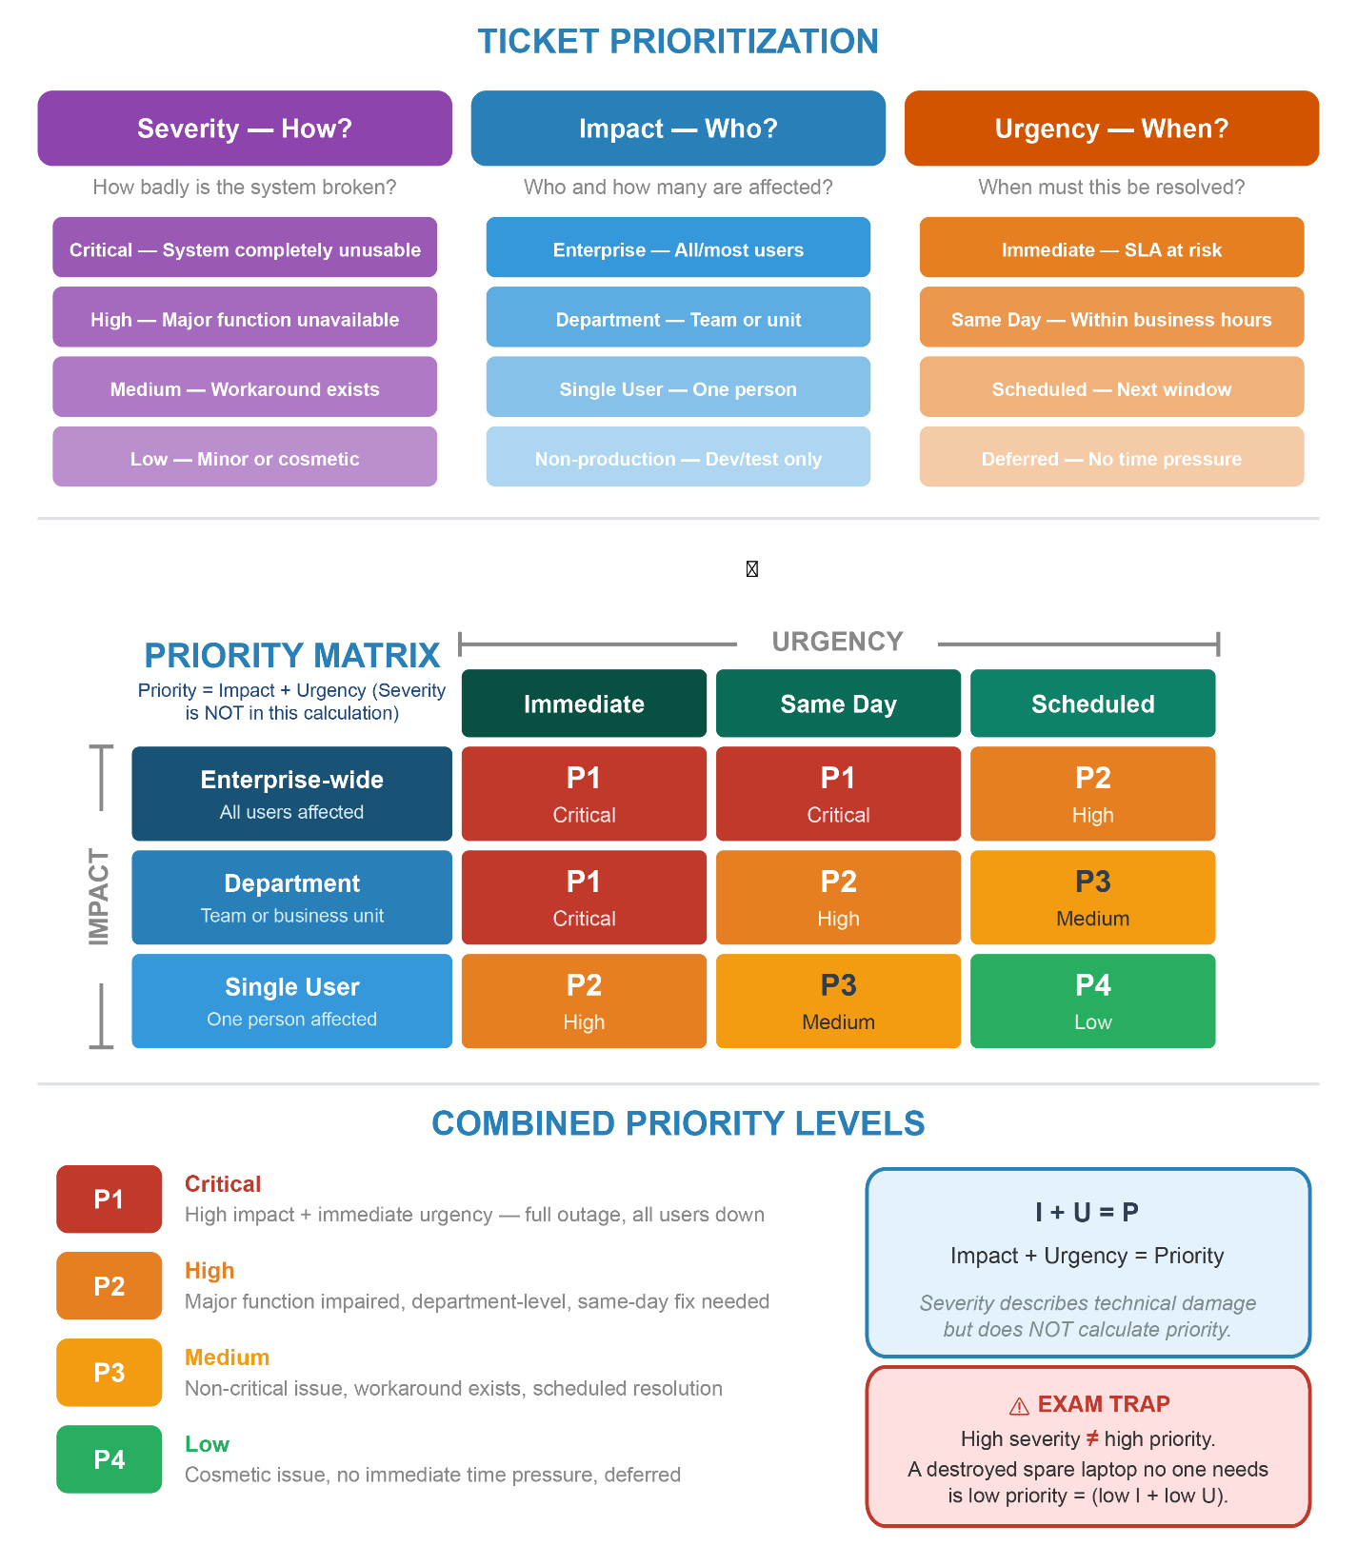

Quick Review — Procedures & Customer Service

Questions
- In the CompTIA 6-step troubleshooting methodology, what must a technician do BEFORE making any changes to a system?
- Which fire extinguisher class is most important for IT environments, and what does it cover?
- A technician receives two tickets simultaneously: the CEO's laptop won't connect to Wi-Fi before a presentation in 10 minutes, and a warehouse employee wants a second monitor by next week. Using the Impact + Urgency = Priority formula, what priority level would each receive?

Answer Key
- Back up the user's data. This is a mandatory procedural requirement in Step 1 (Identify the Problem) before any changes are made to the system.
- Class C — electrical fires. Most important for IT environments because data centers and server rooms contain energized equipment. Use CO2 or dry chemical extinguishers, never water.
- CEO ticket: Low Impact (one user) + High Urgency (time-sensitive) = P2/P3 (High/Medium). Warehouse ticket: Low Impact (one user) + Low Urgency (no time pressure) = P4 (Low).

Module: Software Troubleshooting

Module Objectives
Software troubleshooting is 23% of the Core 2 exam - one of the largest domains. Technicians must diagnose and resolve issues across operating systems, applications, browsers, and mobile platforms.
By the end of this module, learners will be able to:
- Diagnose and resolve common Windows OS errors and performance issues.
- Troubleshoot application installation, update, and compatibility problems.
- Identify and resolve browser and internet application issues.
- Troubleshoot common mobile OS problems on iOS and Android.
- Address security-related software symptoms (malware, unauthorized access).
- Use appropriate tools to diagnose software-level failures.

Windows OS Troubleshooting

Common Windows Error Screens & Startup Problems
Blue Screen of Death (BSOD) → Likely Cause: Driver failure, RAM error, corrupted system files, hardware fault. → Recommended Fix: Note the error code. Run memory diagnostic. Check Event Viewer for details. Roll back recent drivers.
“No Boot Device Found” / “No Operating System” → Likely Cause: Corrupted bootloader, missing boot partition, failed drive. → Recommended Fix: Boot to Safe Mode. Run sfc /scannow. Check Windows Update history. Repair or roll back update.
System stuck at login screen / spinning circle → Likely Cause: Corrupted Windows Update, profile corruption. → Recommended Fix: Boot to Safe Mode. Run sfc /scannow. Check Windows Update history. Repair or roll back update.
Slow startup → Likely Cause: Too many startup programs, fragmented HDD, low RAM. → Recommended Fix: Task Manager → Startup tab. Run Disk Cleanup. Upgrade to SSD. Check for malware.
System randomly reboots / shuts down → Likely Cause: Overheating, failing RAM, power supply issue. → Recommended Fix: Check CPU temps. Run Windows Memory Diagnostic. Inspect PSU and fans.
Black screen after login → Likely Cause: Corrupted display driver, Remote Desktop conflict, explorer.exe crash. → Recommended Fix: Use Ctrl+Alt+Del. Open Task Manager. Run new task: explorer.exe. Update/roll back display driver.

Windows Performance Issues
High CPU usage — Open Task Manager → Processes tab. Identify the process consuming CPU. Check for malware (high svchost.exe usage is a common malware sign). Disable unnecessary startup programs.
High RAM usage — Task Manager → Performance tab. Identify memory-hungry processes. Consider adding RAM. Check for memory leaks in applications.
High Disk usage (100%) — Common with HDDs and can cause severe slowdowns. Disable Superfetch/SysMain in Services. Check for malware. Consider replacing HDD with SSD.
App not responding (frozen) — Task Manager → right-click → End Task. If recurring, update or reinstall the application. Check Event Viewer for crash logs.

Application Troubleshooting

Installation & Update Problems
Application fails to install → Likely Cause: Insufficient disk space, missing dependencies, corrupt installer, permission issues. → Fix: Free disk space. Run installer as administrator. Download fresh installer. Check Windows Event Log.
Application won’t update → Likely Cause: Corrupted update cache, network issue, insufficient permissions. → Fix: Clear application cache/temp files. Re-run update as admin. Uninstall and reinstall.
Application won’t start / immediately crashes → Likely Cause: Corrupt app files, missing Visual C++ or .NET runtime, incompatible OS version. → Fix: Reinstall the application. Install required runtimes. Check compatibility settings (right-click → Properties → Compatibility).
Error: “DLL not found” / “Missing file” → Likely Cause: Missing or corrupted dependency files. → Fix: Reinstall the application. Run sfc /scannow. Reinstall Visual C++ Redistributable or .NET Framework.
“Access Denied” during installation → Likely Cause: UAC restrictions, insufficient permissions. → Fix: Right-click installer → “Run as administrator.” Verify user account has admin rights.

Application Compatibility
When an application was designed for an older version of Windows and fails to run correctly:
- Right-click the application → Properties → Compatibility tab.
- Enable “Run this program in compatibility mode for:” and select the appropriate OS version.
- Enable “Run this program as an administrator” if needed.

Browser & Internet Application Troubleshooting
When a user submits a ticket regarding browser issues, a technician must quickly distinguish between a simple misconfiguration, a local privacy misunderstanding, and an active attack. The table below maps common symptoms to their root cause concepts and the correct fix.
Browser won't load pages (internet works) → Root Cause & Concept : Cache/Cookie Corruption or Proxy Misconfiguration. The browser has stale or corrupted local data, or traffic is being routed through a broken proxy. → Technician's Fix: Clear cache and cookies. Check proxy settings. Flush DNS (ipconfig /flushdns). Test in a different browser to isolate the issue.
Specific sites won't load → Root Cause & Concept : DNS Resolution Failure or Hosts File Tampering. Malware commonly modifies the hosts file to redirect or block specific domains. Browser extensions can also interfere. → Technician's Fix: Check the hosts file (%SystemRoot%\System32\drivers\etc\hosts) for unauthorized entries. Try incognito mode. Disable extensions. Verify DNS settings.
Slow browser performance → Root Cause & Concept : Extension Bloat, Excessive Tabs, or Malware. Too many active extensions consume memory; malware may run background processes through the browser. → Technician's Fix: Disable unnecessary extensions. Update the browser. Run a malware scan.
"Your connection is not private" on every HTTPS site → Root Cause & Concept : Incorrect System Clock. SSL/TLS certificates rely on strict time validation. A clock set years in the past causes every modern certificate to appear mathematically invalid. → Technician's Fix: Verify and sync the OS date and time settings with an NTP server. This resolves the majority of widespread certificate errors immediately.
Certificate name mismatch warning → Root Cause & Concept : DNS Hijacking or On-Path Attack. The browser requested bank.com but the certificate returned identifies a different server — a serious red flag. → Technician's Fix: Do not bypass this warning. Flush the local DNS cache (ipconfig /flushdns). Check the router for unauthorized DNS server entries.
SSL/TLS certificate error — expired or untrusted CA → Root Cause & Concept : Expired Certificate or Self-Signed Certificate. The site's certificate has lapsed, or it was issued by a CA not trusted by the browser (common on internal corporate tools). → Technician's Fix: Warn the user — do not dismiss on sensitive sites. For internal tools, the IT team may need to install the organization's root CA certificate.
Browser homepage or search engine changed → Root Cause & Concept : Browser Hijacker. Malicious code has injected itself into the browser's core configuration. → Technician's Fix: Run a full anti-malware scan. Perform a complete browser reset via browser settings to wipe all malicious modifications. Remove suspicious extensions.
Pop-up ads and redirects → Root Cause & Concept : Adware or Browser Hijacker Infection. Same root cause as homepage change — often installed as a bundle with freeware. → Technician's Fix: Remove suspicious extensions. Run an anti-malware scan. Reset browser settings to default.
Extension requesting unrelated permissions (e.g., a flashlight app asking for "access to all website data") → Root Cause & Concept : Over-Privileged Extension. Malicious developers use simple utility tools as Trojan horses to harvest user data across every site visited. → Technician's Fix: Enforce the principle of least privilege. Remove any extension requesting permissions unrelated to its stated function. Only install extensions from official stores.
✔ Pro Tip: - Wrong system clock = every SSL certificate appears invalid. Always check date/time first before diving deeper into certificate errors. - Private/Incognito mode only prevents local history from being saved - it does not hide traffic from ISPs, employers, or network monitoring tools. - Homepage change + redirects + pop-up ads = browser hijacker. The fix is always: malware scan + browser reset. - A certificate name mismatch is not a routine error - it can indicate DNS hijacking. Treat it seriously, especially on financial or authentication sites. - Hosts file tampering is a classic malware technique for blocking security sites or redirecting banking domains.

Mobile OS Troubleshooting (iOS & Android)

Common Mobile Software Issues
App crashes immediately → Likely Cause: Corrupt app data, incompatible OS version, insufficient storage. → Fix: Clear app cache (Android: Settings → Apps → Storage). Update or reinstall app. Free storage space.
Device running slowly / freezing → Likely Cause: Too many background apps, low storage, outdated OS. → Fix: Close background apps. Restart device. Free storage (delete unused apps/photos). Update OS.
Wi-Fi connects but no internet → Likely Cause: IP conflict, DNS issue, router-side problem. → Fix: Forget the network and reconnect. Toggle Airplane Mode. Check if other devices can connect.
Mobile data not working → Likely Cause: APN settings incorrect, SIM card issue, data limit reached. → Fix: Check APN settings (carrier-specific). Reinsert SIM. Check data plan usage.
Device won’t charge → Likely Cause: Dirty/damaged charging port, faulty cable/adapter, battery issue. → Fix: Try different cable/adapter. Clean port with compressed air. Restart device.
Location services inaccurate → Likely Cause: GPS off, poor signal, app permissions. → Fix: Enable High Accuracy mode. Ensure app has location permission. Toggle GPS off/on.
Touch screen unresponsive → Likely Cause: Screen protector interference, software glitch, digitizer failure. → Fix: Restart device. Remove screen protector. Test with different input. May require hardware repair.
Cannot receive calls or texts → Likely Cause: Airplane mode enabled, SIM issue, carrier outage. → Fix: Disable Airplane Mode. Reinsert SIM. Check carrier network status.

Mobile OS Reset Options
When software issues cannot be resolved through normal troubleshooting, a reset may be required:
Soft Reset — Restarting or rebooting the device. Resolves minor glitches, freezes, and performance issues. No data loss.
Network Settings Reset — Resets all Wi-Fi, Bluetooth, cellular, and VPN settings to defaults. Use when network connectivity cannot be restored by normal means.
Factory Reset / Hard Reset — Erases all data and returns the device to factory settings. Use as a last resort for unfixable software issues or before selling/reassigning a device. ALWAYS back up data first.

Security-Related Software Symptoms
Some software issues are symptoms of a security compromise rather than a hardware or software defect. Technicians must recognize these patterns:
Antivirus suddenly disabled or uninstalled — Malware often disables AV to prevent detection. Boot from external media or Safe Mode to run AV scan.
New, unexpected user accounts appear — Possible backdoor or unauthorized account creation. Review accounts in Control Panel / Settings. Remove unknown accounts.
System files missing or altered — Malware, rootkit, or ransomware. Run sfc /scannow. Use anti-rootkit tools. Consider OS reinstall.
Pop-up warning saying “Your PC is infected – call this number” — Tech support scam (scareware). Do NOT call the number. Close browser via Task Manager if needed. Run legitimate AV scan.
Files encrypted with ransom message — Ransomware infection. Do NOT pay ransom. Disconnect from network immediately. Restore from backup. Report to management.
Slow performance with high disk/network activity (no user action) — Possible malware, cryptomining, or botnet activity. Check Task Manager and netstat. Run AV/malware scan.

Software Troubleshooting Tools Reference
Task Manager — Monitor CPU/RAM/Disk/Network usage. Kill unresponsive processes. Manage startup programs.
Event Viewer — View application, system, and security logs for error codes and crash details.
Device Manager — Check for driver errors (yellow exclamation marks). Roll back or update drivers.
Reliability Monitor — Windows tool (in Control Panel) showing a visual timeline of system stability and recent failures.
Resource Monitor — Detailed view of CPU, memory, disk, and network usage per process.
sfc /scannow — Scans and repairs corrupted Windows system files.
DISM /Online /Cleanup-Image /RestoreHealth — Repairs the Windows image used by sfc. Run before sfc if system image is corrupted.
System Restore — Returns system settings to a previous restore point without affecting personal files.
msconfig (System Configuration) — Manage startup programs and services. Enable Selective or Diagnostic Startup to isolate issues.
Safe Mode — Boots Windows with only essential drivers. Used to diagnose whether the issue is caused by drivers or startup programs.

Module: Hardware Troubleshooting

Module Objectives
By the end of this module, learners will be able to:
- Recognize common hardware failure symptoms.
- Diagnose and troubleshoot issues with desktops, laptops, components, and peripherals.
- Understand POST codes, BIOS/UEFI indicators, and error messages.
- Apply the CompTIA troubleshooting model systematically.

Common Hardware Symptoms
No Power / System Won’t Turn On Symptoms & Likely Causes: No fans, no lights, no display, no beeps. Causes: Failed PSU, bad power cable, motherboard short. Fix: Test with known-good PSU. Reseat power connectors (ATX 24-pin, CPU 8-pin). Check surge protector or outlet.
POST Errors & Beep Codes Symptoms & Likely Causes: Causes: Bad RAM, missing CPU fan, no GPU detected, motherboard fault. Fix: Reseat/replace RAM modules. Ensure CPU fan is connected. Install/reseat GPU. Consult motherboard manual for beep patterns.
No Display / Black Screen Symptoms & Likely Causes: Fans spin, lights on, no video output. Causes: Loose cable, GPU failure, RAM not seated, BIOS corruption. Fix: Test with known-good monitor & cable. Reseat GPU and RAM. Clear CMOS (remove coin-cell battery 10-15 seconds).
Overheating Symptoms & Likely Causes: Sudden shutdowns, high fan speeds, thermal throttling. Causes: Dust buildup, failed fan, dried thermal paste. Fix: Remove dust with compressed air. Replace thermal paste (clean old paste first). Improve airflow.
RAM Failures Symptoms & Likely Causes: Random reboots, blue screens, application crashes, failure to POST. Fix: Test sticks individually. Run Windows Memory Diagnostic. Clean RAM contacts. Replace failing module.
Storage Failures Symptoms & Likely Causes: Slow performance, clicking sounds (HDD), boot device not found, file corruption. Fix: Back up immediately. Replace failing drive. Check SSD firmware. Verify SATA/power cables.
PSU Failures Symptoms & Likely Causes: Burning smell, intermittent shutdowns, random reboots, PSU fan not spinning. Fix: Replace PSU (no internal repair). Ensure wattage is sufficient for CPU/GPU.

Warning Signs of Imminent Hardware Failure
Burning smell — PSU or motherboard failure.
Clicking sounds — HDD head crash.
Bulging capacitors — Motherboard or PSU issue.
Frequent BSODs — RAM or storage failure.
Artifacting on screen — GPU overheating/failure.
System clock resets — Dead CMOS battery.

Module: Networking Troubleshooting

Module Objectives
By the end of this module, learners will be able to:
- Diagnose wired, wireless, and internet connectivity issues.
- Recognize symptoms such as APIPA addresses, DNS failures, slow speeds, and IP conflicts.
- Use network diagnostic tools (software + hardware).
- Support SOHO (Small Office/Home Office) networking environments.

Common Network Symptoms
No Connectivity → Likely Causes: “No Internet” message, Red X on network icon, cannot ping gateway. Causes: Unplugged cable, disabled adapter, bad port, router offline. → Fix: Check cable connection. Reset router. Enable adapter in OS. Test another port.
Limited or Intermittent Connectivity → Likely Causes: Frequent disconnects, slow loading, Wi-Fi icon flickers. Causes: Weak signal, interference, congested channel, DHCP lease expiring. → Fix: Move closer to AP. Change Wi-Fi channel. Restart router. Renew IP address.
APIPA Address (169.254.x.x) → Likely Causes: Device did not receive DHCP IP - OS assigns a fallback self-assigned address. Causes: DHCP server offline, DHCP scope full, bad cable. → Fix: Restart DHCP server/router. Run ipconfig /release + ipconfig /renew. Reconnect to Wi-Fi with correct password.
DNS Issues (Can’t Resolve Names) → Likely Causes: Can ping IP but not hostname. “DNS server not found.” Causes: DNS server down, incorrect settings, malware modifying DNS. → Fix: Flush DNS (ipconfig /flushdns). Set DNS to automatic or use public DNS (8.8.8.8). Check hosts file. Run malware scan.
Slow Performance on Network → Likely Causes: Long loading, video buffering, high ping. Causes: Bandwidth saturation, Wi-Fi interference, faulty cables, ISP congestion. → Fix: Check for heavy downloads. Replace cable (Cat6 preferred). Move device/AP. Reset modem.
IP Address Conflicts → Likely Causes: “IP address already in use,” random disconnects. Causes: Static IP duplicates DHCP address. → Fix: Change static IP. Use DHCP. Reserve IPs correctly in DHCP scope.

Diagnostic and Troubleshooting Tools

Windows Command-Line Tools
ipconfig — Shows IP info; renew DHCP leases.
ping — Tests connectivity to a host.
tracert — Traces route to destination.
netstat — Shows active network connections.
nslookup — Tests DNS name resolution.
ipconfig /flushdns — Clears the local DNS cache.

Essential Hardware Troubleshooting Tools
Multimeter — Test voltage, continuity, power rails.
Power Supply Tester — Quickly checks PSU health.
POST Card — Diagnoses motherboard POST errors.
Loopback Plug — Tests NIC transmit/receive functions.
Compressed Air — Removes dust blocking cooling systems.
Anti-static Wrist Strap & Mat — Prevents ESD damage.
Cable Tester — Checks continuity & wiring issues.
Tone Generator & Probe — Identifies cable runs in walls.
Crimper — Installs RJ-45 ends on UTP cables.
Punch-down Tool — Terminates cables on patch panels.
Precision Screwdriver Set — Provides access to micro screws to use on modern PC components and cases.

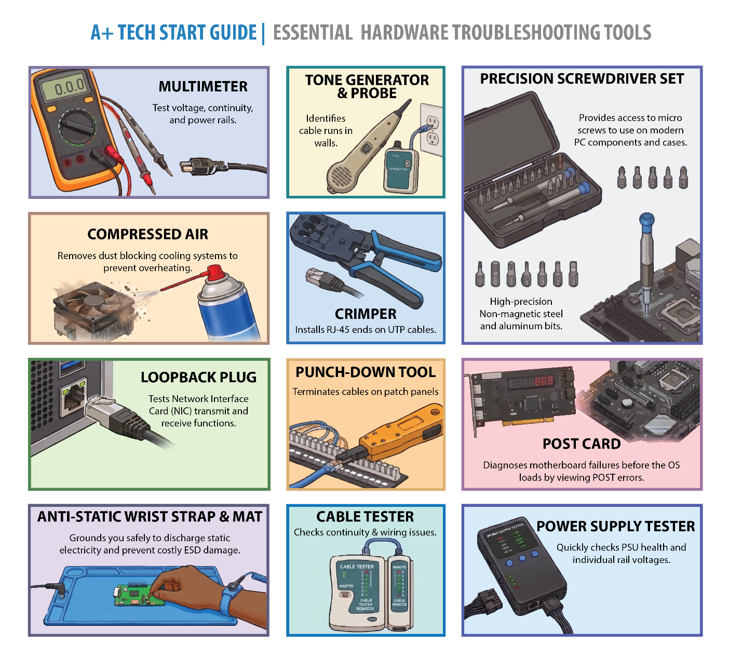

Quick Review — Troubleshooting

Questions
- A legacy application won't run on Windows 11. What is the first thing a technician should try?
- A desktop PC makes no sound but the fans spin and lights turn on after pressing the power button. What are the most likely causes?
- A device receives a 169.254.x.x IP address. What does this indicate, and what command should the technician run to attempt resolution?

Answer Key
- Right-click the application → Properties → Compatibility tab → enable "Run this program in compatibility mode" and select the appropriate older Windows version.
- Most likely causes: loose/failed GPU, unseated RAM, or BIOS corruption. Fix: test with known-good monitor and cable, reseat GPU and RAM, clear CMOS.
- It indicates the device cannot reach a DHCP server (APIPA fallback address). Run ipconfig /release followed by ipconfig /renew to force a new DHCP request.

Module: Data Destruction & Disposal

Module Objectives
Before disposing of, reselling, or repurposing any device, IT technicians must ensure that sensitive data is completely and unrecoverably destroyed. Improper disposal is one of the most common sources of data breaches.
By the end of this module, learners will be able to:
- Identify the correct data destruction method for different media types.
- Differentiate between physical and software-based destruction methods.
- Understand regulatory and compliance requirements for data disposal.
- Explain what a Certificate of Destruction is and when it is required.

Why Data Destruction Matters
Simply deleting files or even formatting a drive does NOT permanently erase data. Standard deletion removes only the file pointer - the actual data remains on the storage medium and can be recovered with forensic tools. Proper destruction ensures data cannot be recovered by any means.

Certificate of Destruction
A Certificate of Destruction (CoD) is a formal document provided by a certified destruction vendor confirming that specified media was destroyed in compliance with relevant regulations. It includes:
- Description and serial numbers of the destroyed media.
- Date and method of destruction.
- Name and signature of the certified destruction provider.
- Chain of custody documentation.
Organizations required by regulations (HIPAA, GDPR, PCI-DSS, SOX) to protect sensitive data must retain Certificates of Destruction as evidence of compliance.

Physical Destruction Methods
Physical destruction is the most thorough and irreversible method. Used when the device will not be reused.
Shredding — Industrial shredders physically destroy hard drives, SSDs, optical discs, and documents into tiny pieces. The gold standard for complete destruction. Often used with a Certificate of Destruction.
Drilling / Punching — Drilling holes through a hard drive platter or SSD destroys the storage media. Quick and effective for individual drives. Pieces may still be recoverable with advanced forensics.
Degaussing — Exposes magnetic storage (HDDs, magnetic tape) to a powerful magnetic field that scrambles all data. Effective for HDDs and tape but has NO effect on SSDs, flash memory, or optical discs (they have no magnetic media).
Incineration — Complete burning of media in a controlled furnace. Used for highly sensitive government/military data. Requires certified destruction facility.
Pulverizing — Crushing media into fine dust using industrial equipment. Similar to shredding - used for high-security environments.
⚠️ Exam Trap: Degaussing only works on magnetic media (HDDs, magnetic tape). It has absolutely NO effect on SSDs, USB drives, optical discs, or any flash-based storage.

Software-Based Destruction Methods
Software methods overwrite data on the drive, making it unrecoverable without physically destroying the media. Used when the device will be reused, donated, or resold.
Zero Fill (Single-Pass Overwrite) — Overwrites every bit on the drive with zeros. Fast and effective for modern drives. Recommended by NIST SP 800-88 for most situations.
Multi-Pass Overwrite (DoD 5220.22-M) — Overwrites data multiple times (3 or 7 passes) with different patterns. Once considered the gold standard but modern research shows single-pass is equally effective on current drives.
Secure Erase (ATA) — A built-in firmware command available on most modern SSDs and HDDs that resets all storage cells to factory state. Fast and highly effective - recommended for SSDs over multi-pass overwrite.
Cryptographic Erasure (Crypto Shredding) — Encrypts all data on the drive with a strong key, then destroys the key. The data is still present but permanently unreadable without the key. Very fast and effective.
Factory Reset — Restores a device to factory settings. For mobile devices with hardware encryption enabled, this effectively destroys the encryption key, rendering data unrecoverable. For non-encrypted devices, data may be partially recoverable.
⚠️ Exam Trap: Multi-pass overwrite (DoD method) is largely ineffective on SSDs due to wear-leveling - the drive’s firmware may skip sectors. Use Secure Erase or cryptographic erasure for SSDs instead.
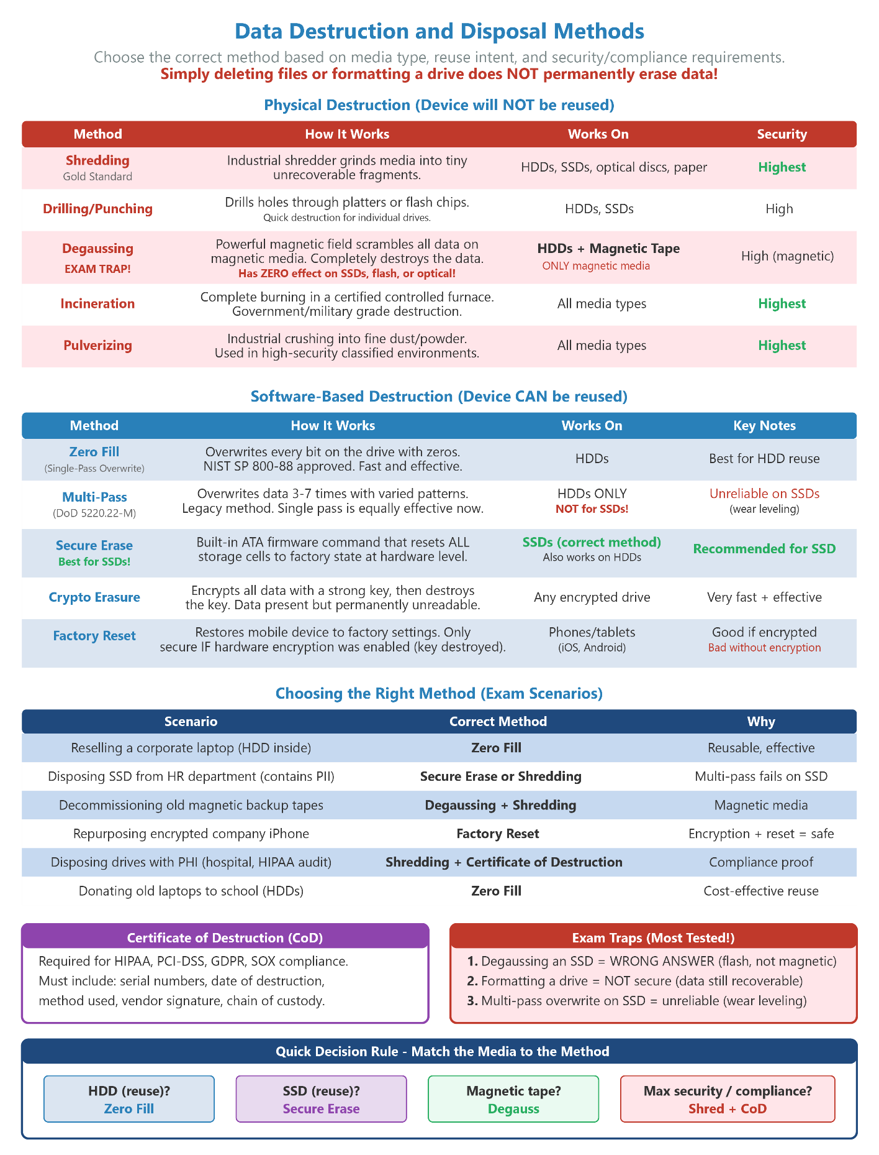

Choosing the Right Method
Reselling a corporate laptop with an HDD → Recommended Method: Multi-pass overwrite or Zero Fill → Why: Drive will be reused — physical destruction not needed. Overwrite renders data unrecoverable.
Disposing of an old SSD from an HR workstation → Recommended Method: Secure Erase or physical shredding → Why: Multi-pass overwrite is unreliable on SSDs. Secure Erase or destruction is preferred.
Decommissioning a server with magnetic tape backups → Recommended Method: Degaussing + shredding → Why: Degaussing destroys tape data; shredding provides physical assurance.
Repurposing a company phone (encrypted) → Recommended Method: Factory reset → Why: Hardware encryption + factory reset destroys the key, making data unrecoverable.
Disposing of drives containing classified information → Recommended Method: Physical shredding + Certificate of Destruction → Why: Highest security requirement - physical destruction with documented chain of custody.
Retiring dozens of old laptops for charity donation → Recommended Method: Zero fill overwrite → Why: Cost-effective, allows reuse, meets standard compliance requirements.
✔ Pro Tip: - Degaussing = magnetic destruction ONLY. For SSDs use Secure Erase or physical destruction. Certificate of Destruction is required when regulations (HIPAA, PCI-DSS, GDPR) mandate proof of disposal. Crypto shredding = encrypt everything, then destroy the key. Deleting files + emptying the recycle bin does NOT destroy data.

Module: Licensing & Regulated Data

Module Objectives
IT technicians regularly deal with software licensing compliance and must understand the types of data their organization handles and the regulations that govern it. Mishandling either can expose the organization to significant legal and financial risk.
By the end of this module, learners will be able to:
- Identify and describe common software license types.
- Explain the consequences of non-compliance with licensing terms.
- Define PII, PHI, PCI, and other regulated data categories.
- Describe basic requirements under GDPR, HIPAA, and PCI-DSS.
- Understand the IT technician’s role in data protection compliance.

Software Licensing Types
OEM (Original Equipment Manufacturer) — Software licensed to a specific piece of hardware. Cannot be transferred to a different device. Typically pre-installed by the manufacturer. Example: Windows that comes with a new PC.
Retail / Full Packaged Product — Purchased by a consumer and can be transferred to a new device (by uninstalling from the old one). More flexible than OEM. Example: Purchasing a boxed copy of software.
Volume License — A single license agreement covering multiple installations across an organization. Managed through a central portal. Cost-effective for businesses. Example: Microsoft Volume Licensing, Microsoft 365 Business.
Subscription — Recurring payment (monthly/annual) for ongoing access to software. Stops working when the subscription lapses. Includes automatic updates. Examples: Microsoft 365, Adobe Creative Cloud.
Open Source — Source code is publicly available. Use, modification, and distribution are governed by specific open-source licenses (GPL, MIT, Apache). Free but comes with obligations (e.g., GPL requires sharing modifications).
Freeware — Free to use but source code is not provided and modification/redistribution is restricted. Different from open source. Example: most free utility tools.
Shareware — Try-before-you-buy model. Functional version distributed freely for a trial period; full features require purchase.
End-User License Agreement (EULA) — The legal contract between the software vendor and the user defining how the software may be used. Must be accepted during installation. IT must ensure compliance.
⚠️ Exam Trap: OEM licenses are tied to the hardware - you cannot move them to a different machine. Retail licenses can be transferred. Volume licenses belong to the organization, not individual users.

Regulated Data Categories
Certain types of data are subject to legal regulations that impose specific requirements for how they must be stored, accessed, transmitted, and disposed of. IT technicians must recognize these categories.
PII (Personally Identifiable Information) — Any data that can identify a specific individual: name, address, SSN, email, phone, date of birth, IP address, biometric data. Protected under multiple regulations including GDPR and many US state laws.
PHI (Protected Health Information) — Any health information that can identify a patient: diagnoses, treatment records, insurance information, test results. Regulated under HIPAA in the United States.
PCI DSS Data — Payment card data: cardholder names, card numbers, CVVs, expiration dates. Regulated under the Payment Card Industry Data Security Standard (PCI-DSS).
Intellectual Property (IP) — Proprietary business information: trade secrets, source code, product designs, business strategies. Protected under copyright, patent, and trade secret law.
FERPA Data — Student education records. Protected under the Family Educational Rights and Privacy Act in the United States. Applies to schools receiving federal funding.
Corporate Confidential — Internal business data not legally regulated but protected by employment contracts and NDA agreements: financial projections, acquisition plans, HR data.

Key Regulations IT Technicians Should Know
GDPR (General Data Protection Regulation) — EU regulation governing PII of EU residents. Requires: explicit consent for data collection, right to erasure (“right to be forgotten”), data breach notification within 72 hours, data minimization. Applies to any organization serving EU residents regardless of location.
HIPAA (Health Insurance Portability and Accountability Act) — US law protecting PHI. Requires: access controls limiting PHI to those who need it, audit logs of all PHI access, encryption of PHI in transit and at rest, secure disposal of PHI media, Business Associate Agreements with vendors.
PCI-DSS (Payment Card Industry Data Security Standard) — Standard for organizations handling payment cards. Requires: encrypted transmission of cardholder data, restricted access to card data, regular security testing, not storing CVV codes after authorization.
SOX (Sarbanes-Oxley Act) — US law for public companies requiring accurate financial reporting and IT controls around financial data systems. IT must maintain audit trails and access controls for financial systems.

The IT Technician’s Role in Compliance
- Implement access controls ensuring only authorized personnel can access regulated data.
- Ensure devices handling regulated data use full-disk encryption.
- Follow proper data disposal procedures (see Data Destruction module) for media containing regulated data.
- Never share, copy, or access regulated data beyond what is needed for the job (principle of least privilege).
- Report suspected data breaches immediately - most regulations have strict breach notification deadlines.
- Ensure software licenses are current and compliant - unlicensed software creates legal liability.

Consequences of Non-Compliance
Software vendor audits result in forced license purchases and fines. Legal action and financial penalties. Loss of access (subscription termination). Organizational reputation damage. Personal liability for IT staff who knowingly allow unlicensed software.
✔ Pro Tip: - OEM = tied to hardware. Retail = transferable. Volume = organization-owned. Subscription = recurring payment. - PII = any data identifying a person. PHI = health data. PCI = payment card data. - GDPR = EU data protection. HIPAA = US health data. PCI-DSS = payment cards. - A technician who improperly disposes of media containing PHI could expose their employer to HIPAA fines.

Module: Asset Management & Documentation

Module Objectives
Asset management and documentation are core operational responsibilities for IT professionals. Proper documentation reduces troubleshooting time, ensures compliance, and maintains organizational knowledge when staff changes occur.
By the end of this module, learners will be able to:
- Explain the purpose and components of an IT asset management system.
- Identify and describe common types of IT documentation.
- Understand the importance of change management documentation.
- Create and maintain basic network and system documentation.

Asset Management
IT asset management (ITAM) tracks hardware and software assets throughout their entire lifecycle - from procurement and deployment through maintenance and final disposal.
Asset Tag / Barcode — A physical label (barcode or QR code) applied to equipment for inventory tracking. Tied to a database record containing the device’s full details.
Asset Inventory Database — Central repository recording all hardware and software assets. Includes: make/model, serial number, purchase date, warranty, assigned user, location, and current status.
Procurement Records — Documentation of when and how assets were purchased, including vendor invoices, purchase orders, and licensing agreements.
Warranty & Support Records — Tracks warranty expiration dates, support contract terms, and vendor contact information for each asset.
Disposal Records — Documents how decommissioned assets were handled - sold, donated, recycled, or destroyed. Includes Certificates of Destruction where required.
Software Licensing — Tracks software licenses (number of seats, license type, renewal dates) to ensure compliance and avoid over/under-licensing.

IT Documentation Types
Network Diagram — Visual map of the network infrastructure showing devices (routers, switches, servers, APs), their connections, IP addresses, and VLANs. Essential for troubleshooting and planning.
Network Topology Map — Shows the physical and logical layout of the network. Logical topology shows data flow; physical topology shows actual cable and device placement.
Standard Operating Procedure (SOP) — Step-by-step instructions for routine IT tasks (e.g., onboarding a new user, deploying a workstation, responding to a security incident). Ensures consistency regardless of who performs the task.
Knowledge Base Article — A searchable document describing how to resolve a specific issue, configure a system, or understand a technology. Built from resolved tickets and technician experience.
Runbook / Playbook — Detailed procedures for specific operational or incident response scenarios. Similar to SOPs but often more granular and scenario-specific.
Change Log — A record of all changes made to systems, configurations, or infrastructure. Includes what changed, when, by whom, why, and the approval reference.
Incident Report — Documents a security incident or major outage from detection through resolution. Includes timeline, impact, root cause, and corrective actions taken.
Acceptable Use Policy (AUP) — Policy document defining what employees are and are not allowed to do with company IT resources.
Disaster Recovery Plan (DRP) — Documented procedures for restoring IT systems and operations following a catastrophic event (fire, flood, ransomware attack, etc.).
Business Continuity Plan (BCP) — Broader than a DRP - covers how the entire business continues operating during and after a disruption, not just IT systems.

Change Management
Change management is the formal process for requesting, evaluating, approving, implementing, and documenting changes to IT systems. It prevents unplanned outages caused by untested changes.
1. Change Request (RFC) — A formal Request for Change is submitted describing what change is needed, why, and the expected impact.
2. Impact Assessment — The change is evaluated for potential risks, dependencies, and business impact. A rollback plan is defined.
3. Change Advisory Board (CAB) — A group of stakeholders reviews and approves or rejects the change request.
4. Scheduling — The change is scheduled during an appropriate maintenance window to minimize disruption.
5. Implementation — The change is implemented exactly as planned, with the rollback plan ready if problems occur.
6. Testing & Verification — The change is verified to work as expected and no unintended side effects occurred.
7. Documentation & Closure — The change log is updated. If issues arose, a post-implementation review is conducted.
✔ Pro Tip: - Network diagrams and documentation save enormous time during troubleshooting - especially in complex environments. - Change management prevents “it worked fine before” problems - always document changes. - Knowledge base articles are built from closed help desk tickets - good ticket documentation builds the KB. - Asset tags connect physical hardware to the inventory database - serial number + asset tag = full device history.

Module: Artificial Intelligence (AI) Basics

Module Objectives
Artificial Intelligence is a new addition to the CompTIA A+ V15 exam objectives. IT technicians are expected to understand basic AI concepts, how AI tools integrate into business workflows, the limitations of AI, and the security and ethical considerations that come with AI use in the workplace.
By the end of this module, learners will be able to:
- Define key AI concepts including machine learning, generative AI, and large language models.
- Differentiate between public AI models and private/organizational AI models.
- Identify appropriate and inappropriate use cases for AI tools in an IT environment.
- Recognize the limitations of AI including bias, hallucinations, and accuracy concerns.
- Understand basic AI security and privacy considerations.

Key AI Concepts
Artificial Intelligence (AI) — The simulation of human intelligence in machines - enabling systems to perform tasks that typically require human thinking (learning, reasoning, problem-solving).
Machine Learning (ML) — A subset of AI where systems learn from data to improve performance without being explicitly programmed. The more data, the better the model learns.
Generative AI — AI that creates new content (text, images, code, audio) based on patterns learned from training data. Examples: ChatGPT, GitHub Copilot, DALL-E.
Large Language Model (LLM) — A type of generative AI trained on massive text datasets to understand and generate human-like text. Powers most modern AI chatbots and assistants.
Natural Language Processing (NLP) — AI ability to understand, interpret, and generate human language. Enables voice assistants, chatbots, and automated translation.
Neural Network — A computing system loosely inspired by the human brain. Layers of interconnected nodes process data to recognize patterns and make decisions.
Training Data — The dataset used to teach an AI model. The quality and diversity of training data directly affects model accuracy and bias.

Public vs. Private AI Models
A critical distinction for IT professionals is understanding the difference between publicly accessible AI tools and private organizational AI deployments - particularly from a data security perspective.
Accessible to anyone via the internet (e.g., ChatGPT, Claude, Gemini). — Deployed internally by an organization, not accessible outside the company.
Data entered may be used to train future models. — Data stays within the organization’s controlled environment.
Lower cost - often free or subscription-based. — Higher cost - requires infrastructure and maintenance.
Risk: Employees may accidentally share confidential data. — Designed to protect sensitive business and customer data.
Examples: ChatGPT (OpenAI), Copilot (Microsoft), Gemini (Google). — Examples: Azure OpenAI Service (private deployment), on-premises LLMs.
⚠️ Exam Trap: Entering sensitive company data, customer PII, or trade secrets into a public AI tool is a security violation. Organizations must have clear AI use policies that employees follow.

Appropriate Use Cases for AI in IT
- Drafting documentation, knowledge base articles, and SOPs.
- Summarizing long technical documents or logs.
- Writing and reviewing code or scripts (with human review).
- Generating test cases and troubleshooting checklists.
- Answering general technical questions and providing guidance.
- Automating repetitive tasks like ticket categorization and report generation.

Inappropriate / Risky Use Cases
- Entering customer PII, passwords, or financial data into a public AI tool.
- Using AI-generated code in production without thorough human review.
- Relying on AI for compliance decisions without expert verification.
- Sharing internal network diagrams, system configurations, or security policies.
- Using AI output as a final answer for medical, legal, or safety-critical decisions.

AI Limitations Technicians Must Understand
Hallucinations — AI confidently generates information that is factually incorrect or completely fabricated. Always verify AI output, especially for technical facts, port numbers, or procedures.
Training Data Cutoff — AI models are trained on data up to a certain date and have no knowledge of events or products released after that point.
Bias — AI can reflect biases present in its training data - leading to unfair, inaccurate, or skewed outputs, especially in areas involving people or demographics.
Context Limitations — AI models can only process a limited amount of text at once (context window). Very long documents may be summarized inaccurately if they exceed this limit.
No Real-World Verification — AI cannot independently verify claims against live systems, databases, or the internet (unless given tools to do so).
Privacy Risk — Data entered into public AI tools may be retained and used for training. Sensitive data should never be entered into public AI systems.

AI Security Considerations
- Prompt Injection: Attackers craft malicious inputs designed to override an AI’s instructions and make it behave unexpectedly. A significant security concern for AI-integrated applications.
- Data Leakage: Public AI tools may expose confidential data shared in prompts. Use private/organizational AI deployments for sensitive workflows.
- Model Poisoning: In ML pipelines, attackers can corrupt training data to cause a model to make incorrect decisions. A concern for organizations training their own models.
- Deepfakes: AI-generated realistic fake audio/video of real people. Used in social engineering attacks (e.g., fake CEO video call requesting a wire transfer).

Organizational AI Policies
IT technicians must understand and enforce their organization’s AI acceptable use policy. Key elements typically include:
- Which AI tools are approved for use (whitelist of approved platforms).
- What types of data may and may not be entered into AI systems.
- Requirements for human review of AI-generated content before use.
- Reporting procedures for AI-related security incidents.
- Copyright and intellectual property considerations for AI-generated work.
✔ Pro Tip: - Know the difference between public AI (internet-accessible, data privacy risk) and private AI (organizational control, data stays internal). - Hallucination = AI confidently making things up. Always verify AI output. - AI cannot replace human judgment for compliance, legal, medical, or safety decisions. - Entering sensitive data into a public AI tool = potential security incident. Know your org’s AI use policy.

Quick Review — Compliance & IT Responsibilities

Questions
- A technician needs to securely erase an SSD containing sensitive employee data. The drive will be reused. Why is multi-pass overwrite NOT appropriate, and what method should be used instead?
- What is the difference between an OEM license and a Retail license in terms of transferability?
- What is the purpose of a Change Advisory Board (CAB) in the change management process?
- An employee enters customer credit card numbers into a public AI chatbot for analysis. What is the primary security and compliance concern?

Answer Key
- Multi-pass overwrite is unreliable on SSDs because wear-leveling causes the firmware to skip sectors, leaving data intact. Use the Secure Erase (ATA firmware command) instead, which resets all storage cells at the firmware level.
- OEM licenses are tied to the original hardware and cannot be transferred to a different machine. Retail licenses can be transferred to a new device by uninstalling from the old one.
- The CAB is a group of stakeholders that reviews, evaluates risk, and approves or rejects change requests before implementation. It prevents untested changes from causing unplanned outages.
- Data entered into public AI tools may be retained and used for model training, violating PCI-DSS requirements that prohibit sharing cardholder data with unauthorized third parties. This constitutes a potential data breach and compliance violation.

EXAM PREPARATION & STUDY TOOLS
This section brings together everything you need for final exam preparation: mnemonics for every domain, exam traps, quick reference cards and diagrams, a practice test covering all modules, a 8-week study plan, and 500 term Glossary.

Mnemonics and Reference Cards

Email Protocols
“Send It, Pop It, Map It” - SMTP sends out, POP3 pops down to one device, IMAP maps across all devices
25 / 587 — SMTP
TCP/UDP: TCP Description: Sends outbound email. Port 25 = server-to-server. Port 587 = client submission with STARTTLS. Always use 587 for client config.
110 / 995 — POP3 / POP3S
TCP/UDP: TCP Description: Downloads email to one device and removes from server. Port 110 = plain. Port 995 = encrypted (SSL/TLS). Not recommended for multi-device users.
143 / 993 — IMAP / IMAPS
TCP/UDP: TCP Description: Keeps email on server and syncs across all devices. Port 143 = plain. Port 993 = encrypted (SSL/TLS). Recommended for modern use.
Quirky Notes:
- “Send More Tasty Pizza” (SMTP = Sends outbound)
- POP3 is like popping a balloon - it’s one and done (downloads to one device and destroys the server copy).
- IMAP is like a map on your phone - no matter where you travel or what device you look at, the view stays completely synchronized.

The Official CompTIA 6-Step Troubleshooting Process (I-E-T-E-V-D)
I — Identify the Problem: Gather information, question the user, identify recent changes, and check documentation.
E — Establish a Theory of Probable Cause: Question the obvious, consider multiple approaches, and research based on the symptoms.
T — Test the Theory: Confirm your theory and verify the root cause. (If the theory is incorrect, loop back and re-establish a new one).
E — Establish a Plan of Action: Plan the fix, notify affected users, consider impacts, and implement the solution.
V — Verify Full System Functionality: Confirm the resolution works and implement preventive measures to stop the issue from recurring.
D — Document Findings: Record the symptoms, root cause, steps taken, resolution, and preventive measures for the knowledge base.

Mnemonic Memory Hooks
Professional Focus
- "I Expect To Execute Very Decisively"
- "Investigate Every Technical Error Very Deliberately"
Easy to Recall
- "I Eat Tacos Every Valentine's Day"
- "Impatient Elephants Trample Every Village Daily"
Quirky & Memorable
- "Iguanas Enjoy Teasing Earthworms Very Deliberately"
- "I Enjoy Taming Energetic Velociraptors Diligently"
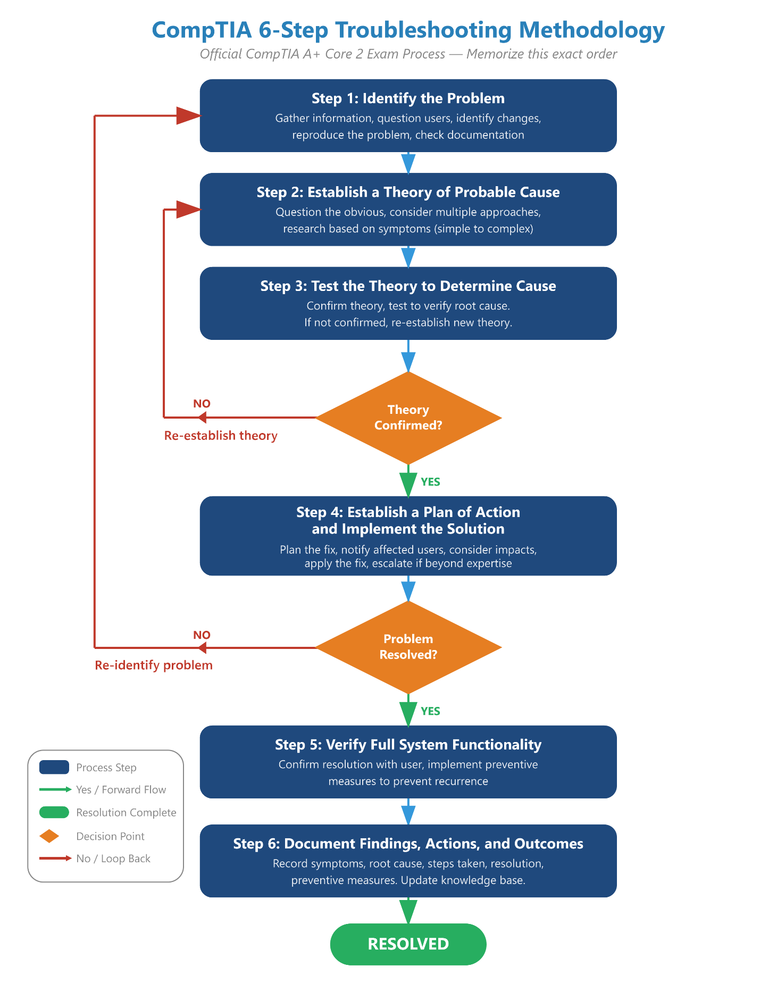

Web Browsing
“80 is plain, 443 is protected” - just two numbers, no phrase needed
80 — HTTP
TCP/UDP: TCP Description: Hypertext Transfer Protocol. Unencrypted web browsing. Never use for sensitive data - traffic can be intercepted.
443 — HTTPS
TCP/UDP: TCP Description: HTTP Secure. Encrypted web browsing using TLS/SSL. Lock icon in browser. Standard for all modern websites.
Quirky Notes:
- 80 mph in a plain sedan vs. 443 layers of armor on a Secured bank vault.
  - Alternatively: Imagine an 80-year-old grandmother shouting her password out loud on the street (HTTP - Unencrypted), versus a secret agent with 443 gadgets locking down a briefcase (HTTPS - Secure).

Wi-Fi Standards Quick Reference
802.11a — Wi-Fi 1 Max Speed: 54 Mbps Key Feature: 5 GHz only. Legacy.
802.11b — Wi-Fi 2 Max Speed: 11 Mbps Key Feature: 2.4 GHz. Legacy.
802.11g — Wi-Fi 3 Max Speed: 54 Mbps Key Feature: 2.4 GHz. Legacy.
802.11n — Wi-Fi 4 Max Speed: 600 Mbps Key Feature: 2.4 & 5 GHz. MIMO introduced.
802.11ac — Wi-Fi 5 Max Speed: 3.5 Gbps Key Feature: 5 GHz primary. MU-MIMO.
802.11ax — Wi-Fi 6/6E Max Speed: 9.6 Gbps Key Feature: 2.4/5/6 GHz. OFDMA. Best for dense environments.
802.11be — Wi-Fi 7 Max Speed: 46 Gbps Key Feature: Multi-Link Operation (MLO). Latest standard.
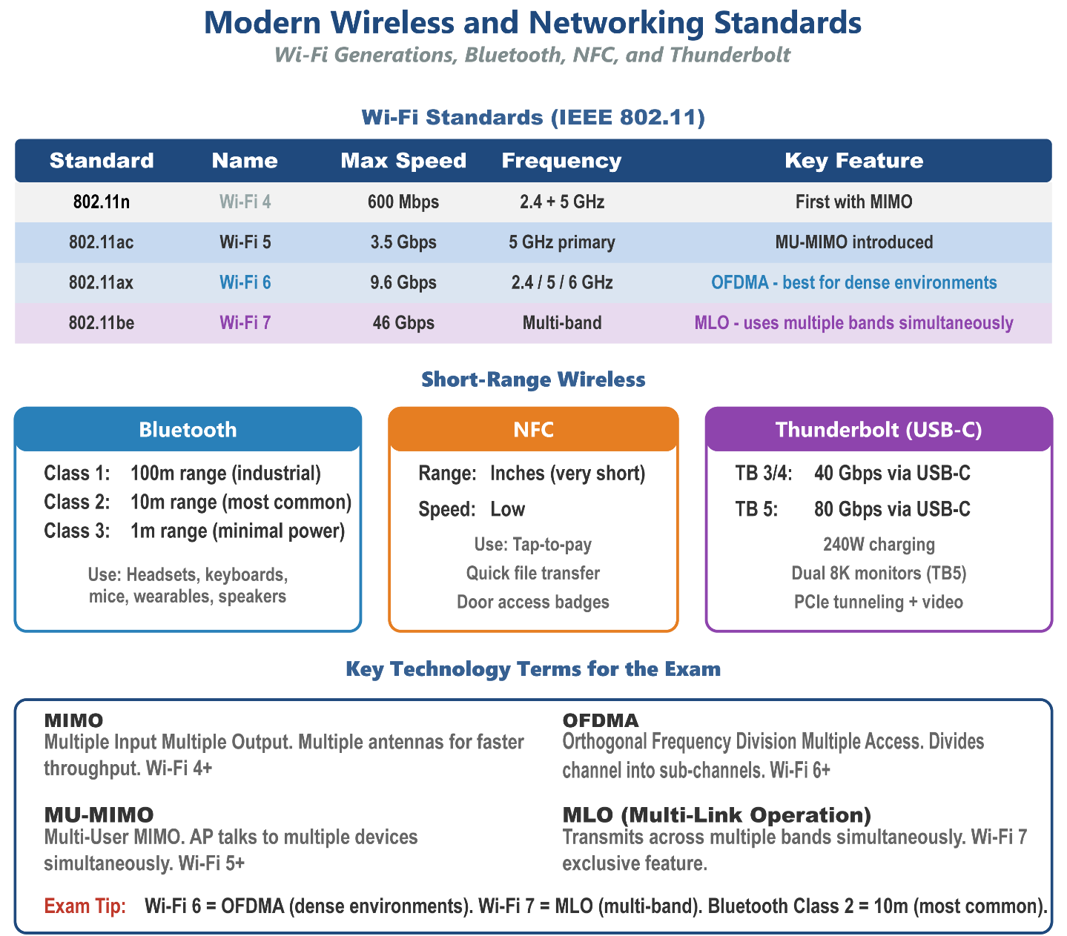

IP Addresses Quick Reference
169.254.x.x (APIPA) What it Means on the Exam: The device cannot reach the DHCP server.
127.0.0.1 (IPv4 Loopback) What it Means on the Exam: Used to ping the local network card to test if TCP/IP is working.
::1 (IPv6 Loopback) What it Means on the Exam: The IPv6 equivalent of 127.0.0.1.
10.x.x.x (Class A Private) What it Means on the Exam: A non-routable private IP (used heavily in corporate networks).
192.168.x.x (Class C Private) What it Means on the Exam: A non-routable private IP (used heavily in home/SOHO networks).
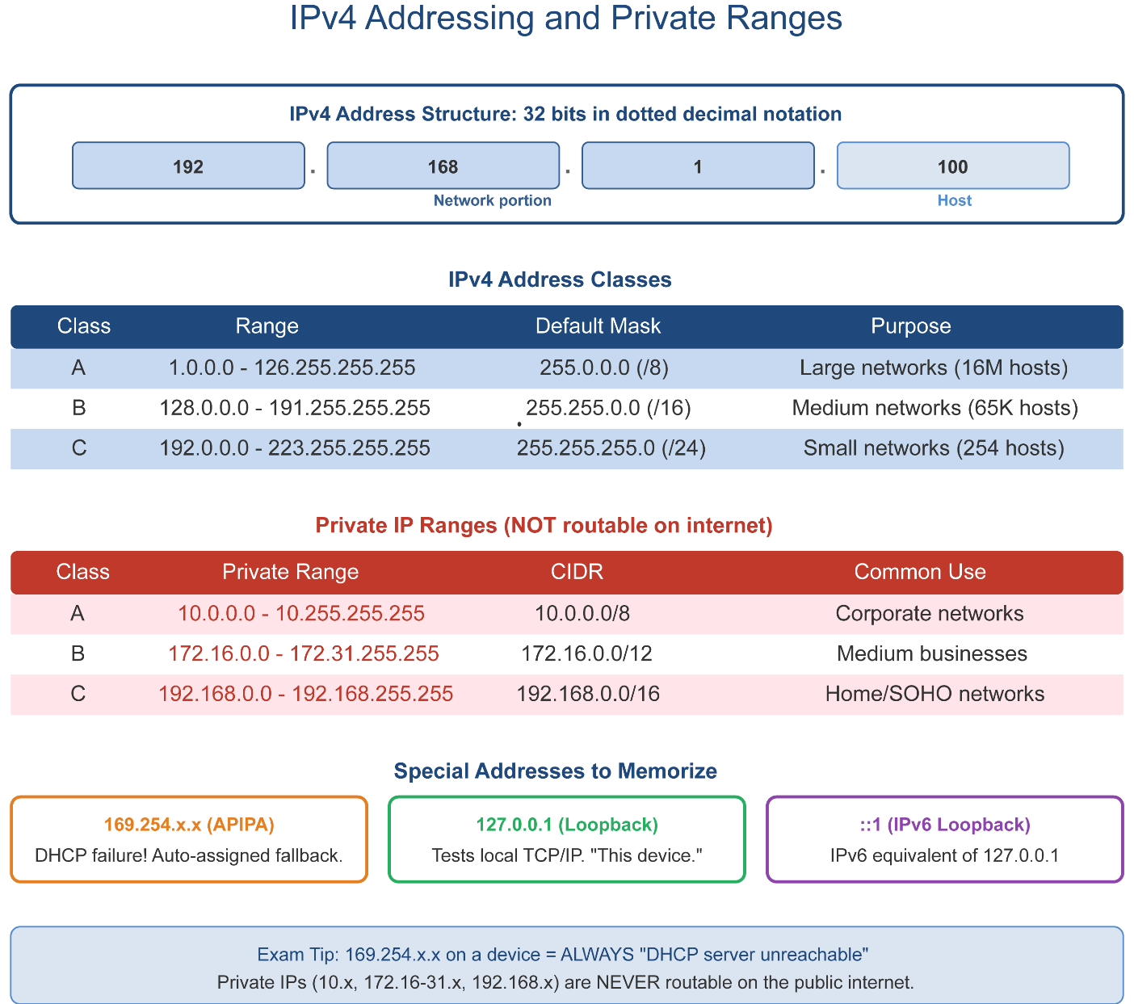

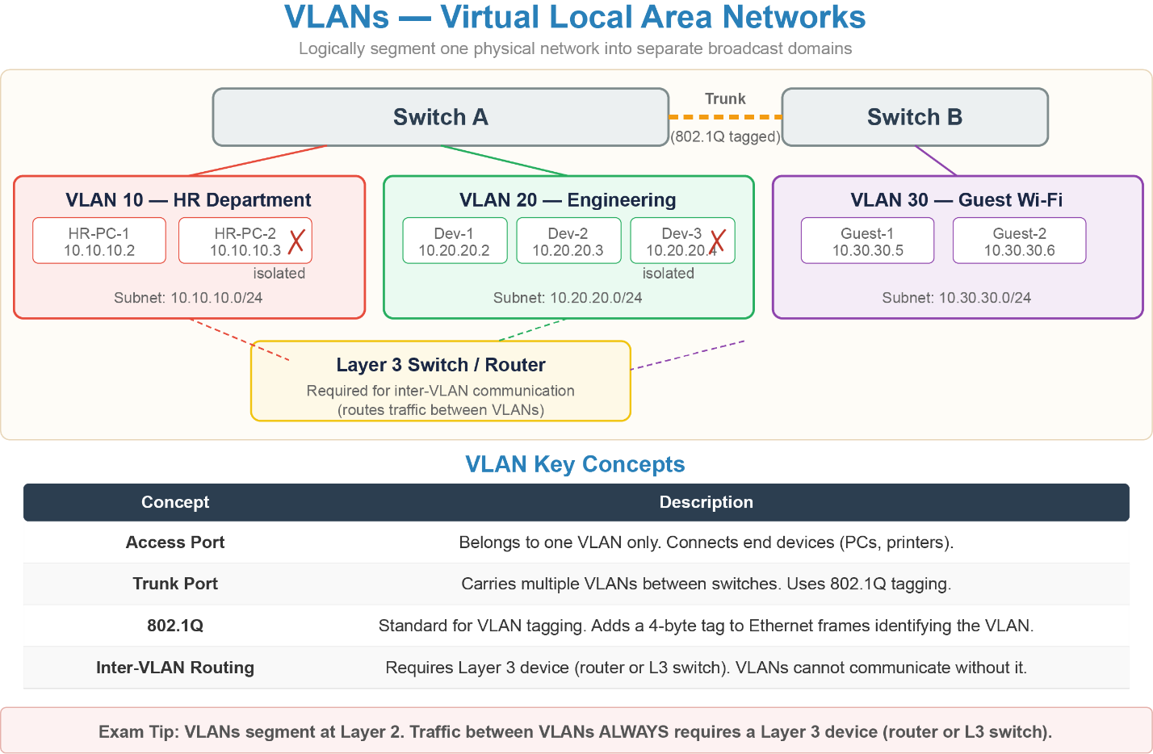

Security Protocols Quick Reference
WEP — Broken - cracks in minutes. Never use.
WPA (TKIP) — Weak - has known vulnerabilities. Do not use.
WPA2 (AES/CCMP) — Current baseline standard. Use if WPA3 unavailable.
WPA3 (SAE) — Latest standard. Strongest protection. Use when possible.
SSL — Deprecated. Replaced by TLS. Do not use.
TLS 1.2 / 1.3 — Current standard for encrypting data in transit. TLS 1.3 is preferred.
BitLocker — Windows full-disk encryption. Requires TPM. Pro/Enterprise only.
FileVault — macOS full-disk encryption. Built into all macOS versions.

Malware Mnemonic
“Very Wild Tigers Sneak Rapidly Around Forests, Keeping trouble.”
Each word maps to a malware type:
- Very → Virus
- Wild → Worm
- Tigers → Trojan
- Sneak → Spyware
- Rapidly → Ransomware
- Around → Adware
- Forests → Fileless Malware
- Keeping → Keylogger
- Trouble → Rootkit

Social Engineering Mnemonic
“People Very Smart Will Quickly Identify Tricky Pretexts.”
Each word maps to an attack type:
- People → Phishing (general fraudulent messages)
- Very → Vishing (voice-based phishing)
- Smart → Smishing (SMS/text phishing)
- Will → Whaling (executives targeted)
- Quickly → Quishing (QR code phishing)
- Identify → Impersonation (pretending to be trusted staff/vendor)
- Tricky → Tailgating/Piggybacking (physical access by following)
- Pretexts → Pretexting (fabricated scenario to gain info)

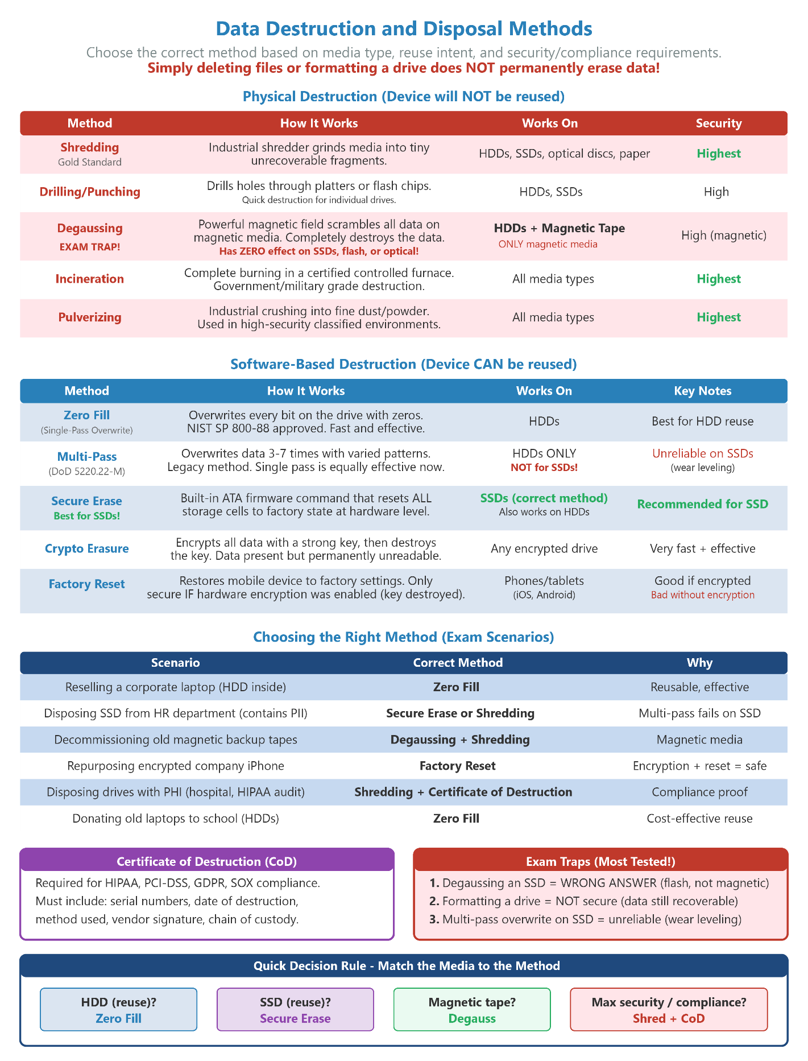

File Transfer
“21 to connect, 20 to send” - control channel first, then data. SFTP rides SSH so it uses port 22.
20 / 21 — FTP
TCP/UDP: TCP Description: File Transfer Protocol. Port 21 = control channel (commands). Port 20 = data channel (file transfer). Unencrypted — avoid on public networks.
22 — SFTP
TCP/UDP: TCP Description: SSH File Transfer Protocol. Secure file transfer over SSH tunnel. Replaces FTP. Same port as SSH.
Quirky Notes:
- 21 keys to open the Control tower, 20 trucks to move the actual Data.
- Since SFTP relies completely on SSH, it steals SSH’s seat and rides shotgun on Port 22.

Secure Access
“22 is always secure, 23 is never secure” - one number apart, opposite security
22 — SSH
TCP/UDP: TCP Description: Secure Shell. Encrypted command-line remote access to Linux/Unix servers and network devices. Replaces Telnet.
23 — Telnet
TCP/UDP: TCP Description: Unencrypted remote access. Completely obsolete - passwords sent in plain text. Never use on production systems.
Quirky Notes:
- Port 22 SSH is a Super Secure Haven.
- Port 23 is a Tel-net (Tell-it-to-the-internet) with zero safety nets. One number apart, completely opposite worlds.

Network Services
“53 names things, 67/68 assigns addresses, 123 keeps time”
53 — DNS TCP/UDP: TCP/UDP Description: Domain Name System. Translates domain names (comptia.org) to IP addresses. UDP for queries, TCP for zone transfers.
67 / 68 — DHCP TCP/UDP: UDP Description: Dynamic Host Configuration Protocol. Port 67 = server. Port 68 = client. Automatically assigns IP addresses. APIPA (169.254.x.x) = DHCP failure.
123 — NTP TCP/UDP: UDP Description: Network Time Protocol. Synchronizes system clocks across devices. Wrong clock = all SSL certificates appear invalid.
161 / 162 — SNMP TCP/UDP: UDP Description: Simple Network Management Protocol. Port 161 = queries to devices. Port 162 = trap alerts from devices. Used for network monitoring.
5060 / 5061 — SIP TCP/UDP: TCP/UDP Description: Session Initiation Protocol. Sets up and manages VoIP calls. Port 5060 = plain. Port 5061 = encrypted TLS version.
Quirky Notes:
- Port 53 DNS: A 53 year old Digital Name Spellbook (translates names to numbers).
- 67/68 DHCP: Think of an old-school diner where the (67) server dishes to hungry clients.
- 123: Tick-tock-tick-tock (1-2-3, clock time!).
- Port 161/162 SNMP: The Spy Network Management Protocol. Agent 161 asks the questions, Agent 162 sets the trap.
- 5060/5061: Sets Inbound Phones on your network lines.

Network Types Mnemonic
“Please Let Wireless Make Wide Waves.”
Each word maps to a network type:
- Please → PAN (Personal Area Network) — Bluetooth headset, smartwatch.
- Let → LAN (Local Area Network) — Home/office wired network.
- Wireless → WLAN (Wireless LAN) — Wi-Fi version of LAN.
- Make → MAN (Metropolitan Area Network) — City-wide, ISP-managed.
- Wide → WAN (Wide Area Network) — Large geographic distances, the internet.
- Waves → WWAN (Wireless WAN) — Cellular towers, mobile broadband.

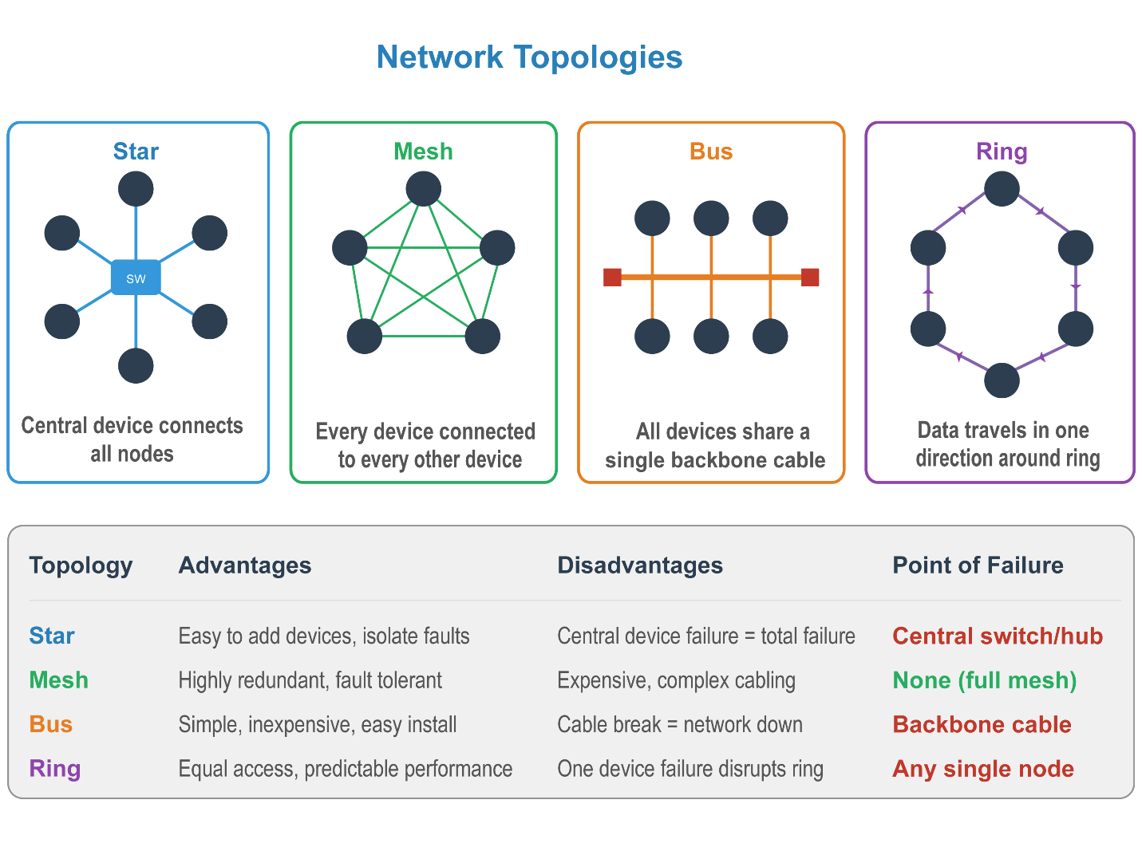
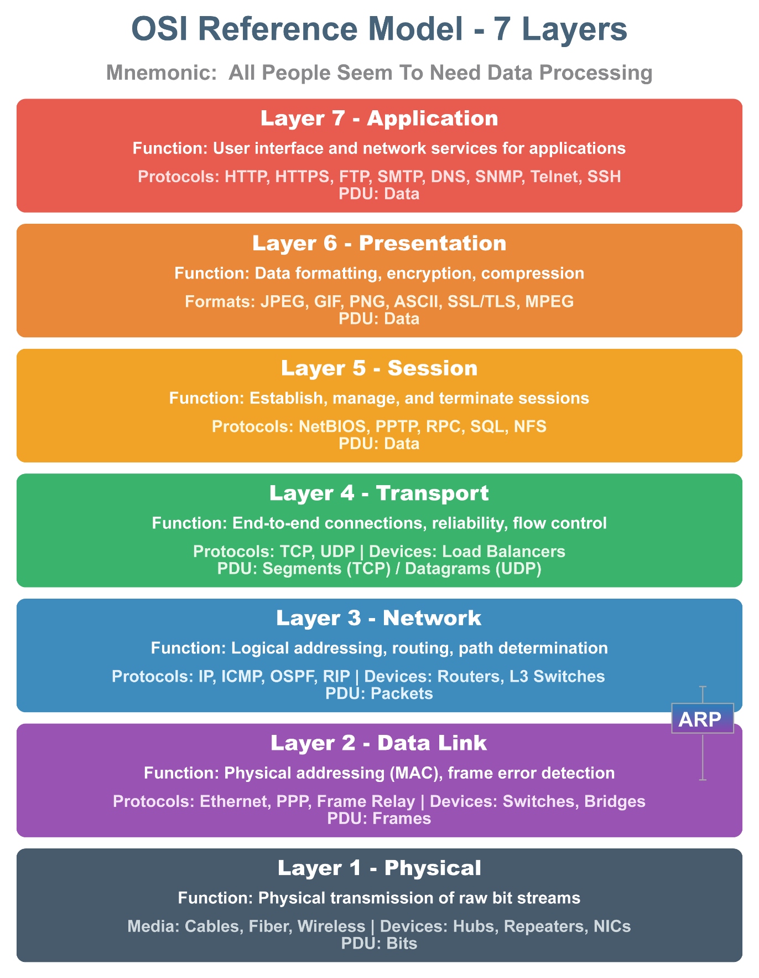
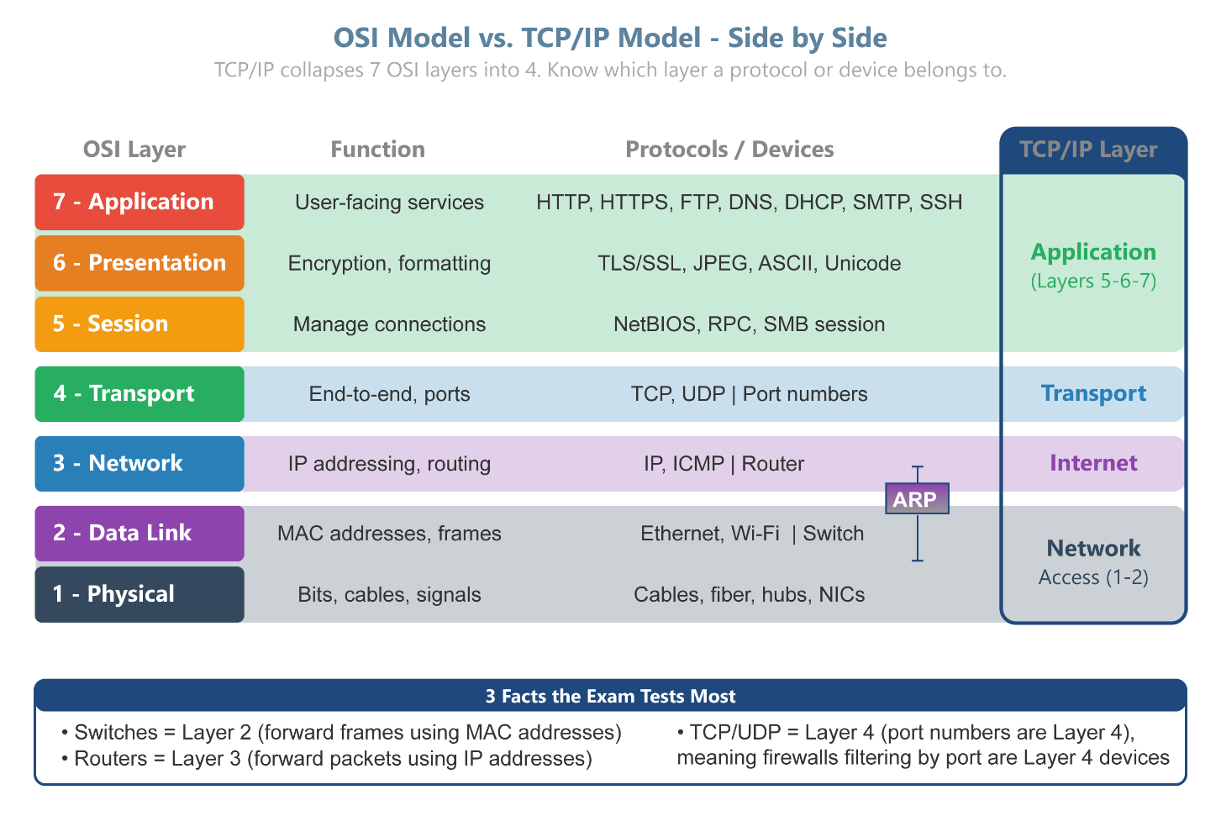
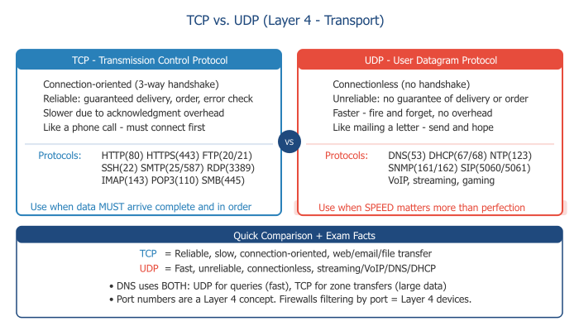

Remote Access
“3389 = Windows Remote Desktop, 5900 = cross-platform VNC” - always protect both behind a VPN
3389 — RDP
TCP/UDP: TCP Description: Remote Desktop Protocol. Windows graphical remote desktop. Full desktop experience. NEVER expose directly to internet - always use VPN.
5900 — VNC
TCP/UDP: TCP Description: Virtual Network Computing. Cross-platform screen sharing. Tools: TightVNC, RealVNC. Always protect behind VPN or SSH tunnel.
Quirky Notes:
- 3389: Three-three-eight-nine, Remote Desktop on the line!
- Port 5900 (VNC): Very Nosey Colleagues have 59 ways to spy on your 00 (eyeballs/screen)

Directory & File Sharing
“389 looks up people (Active Directory), 445 shares files (Windows), 636 does 389 securely”
389 — LDAP
TCP/UDP: TCP/UDP Description: Lightweight Directory Access Protocol. Queries Active Directory for user accounts and group memberships. Unencrypted.
636 — LDAPS
TCP/UDP: TCP Description: LDAP over SSL. Encrypted version of LDAP. Use instead of port 389 wherever possible.
445 — SMB
TCP/UDP: TCP Description: Server Message Block. Windows file and printer sharing. Common ransomware attack vector - keep patched and firewalled.
Quirky Notes:
- 389: “Three-eight-nine, Active Directory is on the line!”
- 636: “Six-three-six, secures the directory mix!”
- 445: “Four-four-five, Windows file shares come alive!”

Number Patterns to Memorize
Always 22 — SSH and SFTP - if it’s secure remote access or secure file transfer, it’s port 22
Sequential pairs — 20/21 = FTP (control/data) 67/68 = DHCP (server/client)
Plain → encrypted — 110 → 995 (POP3) 143 → 993 (IMAP) 389 → 636 (LDAP) 80 → 443 (HTTP) 5060 → 5061 (SIP)
Four digits — 3389 = RDP 5060/5061 = SIP 5900 = VNC - the only four-digit ports you need
UDP only — 67/68 DHCP 123 NTP 161/162 SNMP - fast, fire-and-forget services use UDP

Cloud Service Models
SaaS — Software as a Service — “You use it — they run it." Like a Coffee Shop - you just show up and drink. Examples: Gmail, Microsoft 365, Salesforce.
PaaS — Platform as a Service — "You build on it — they manage the platform." Like a Pottery class - they give you the wheel, you make the pot. Examples: Azure App Service, Google App Engine
IaaS — Infrastructure as a Service — “You control the VMs — they own the hardware." Like IKEA — you get the parts, you build it yourself. Examples: AWS EC2, Azure VMs.

Printers
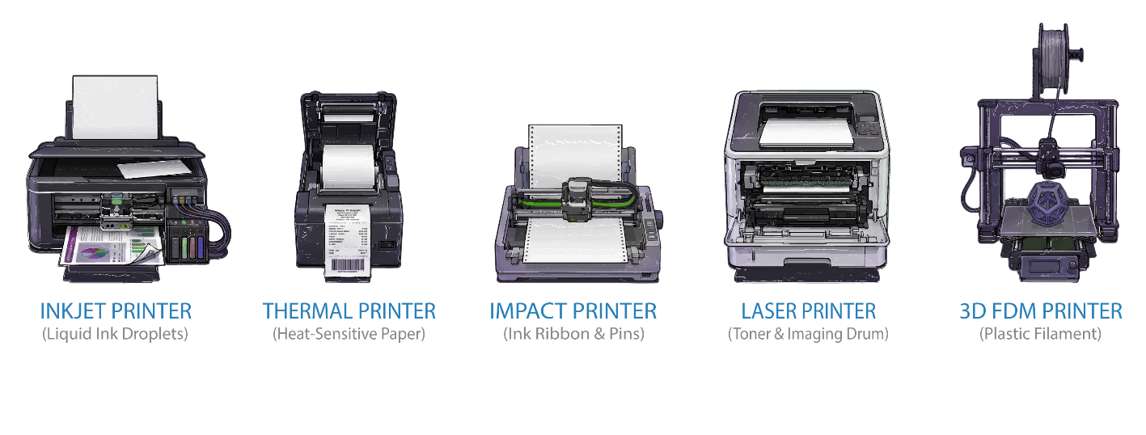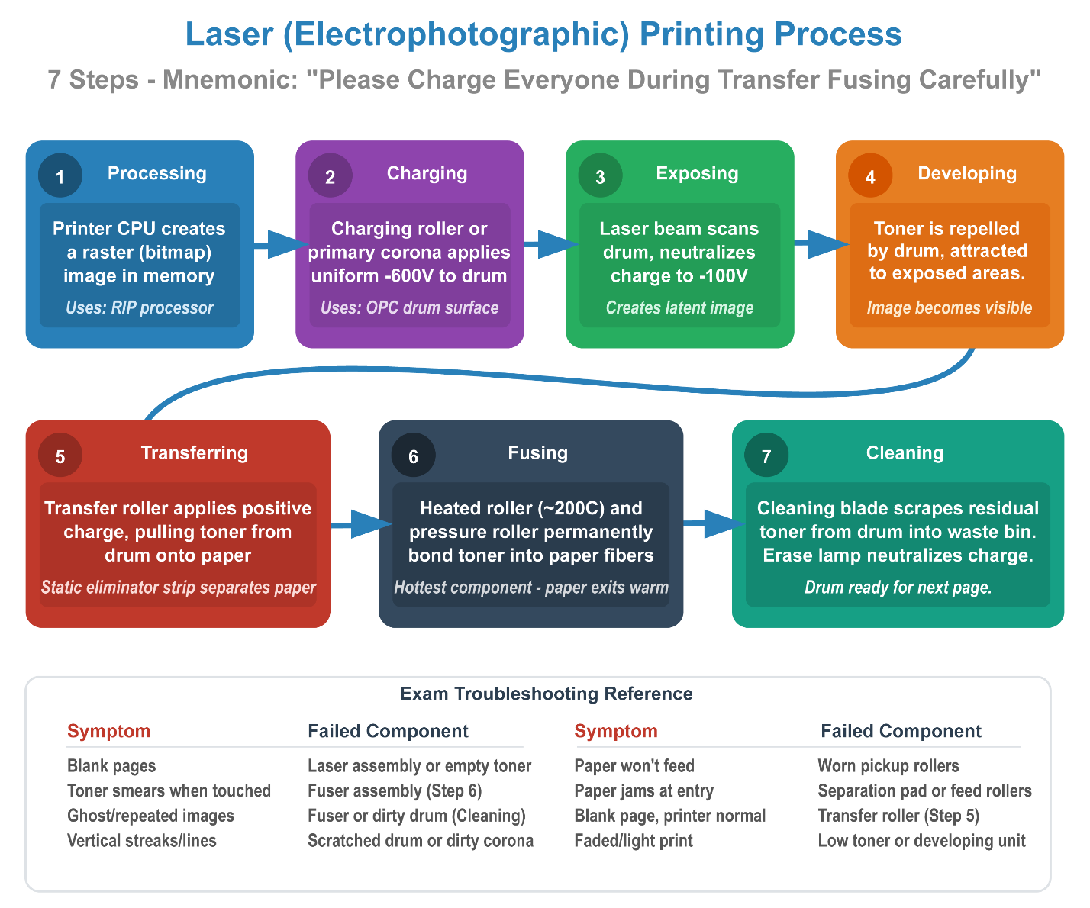

Procedures
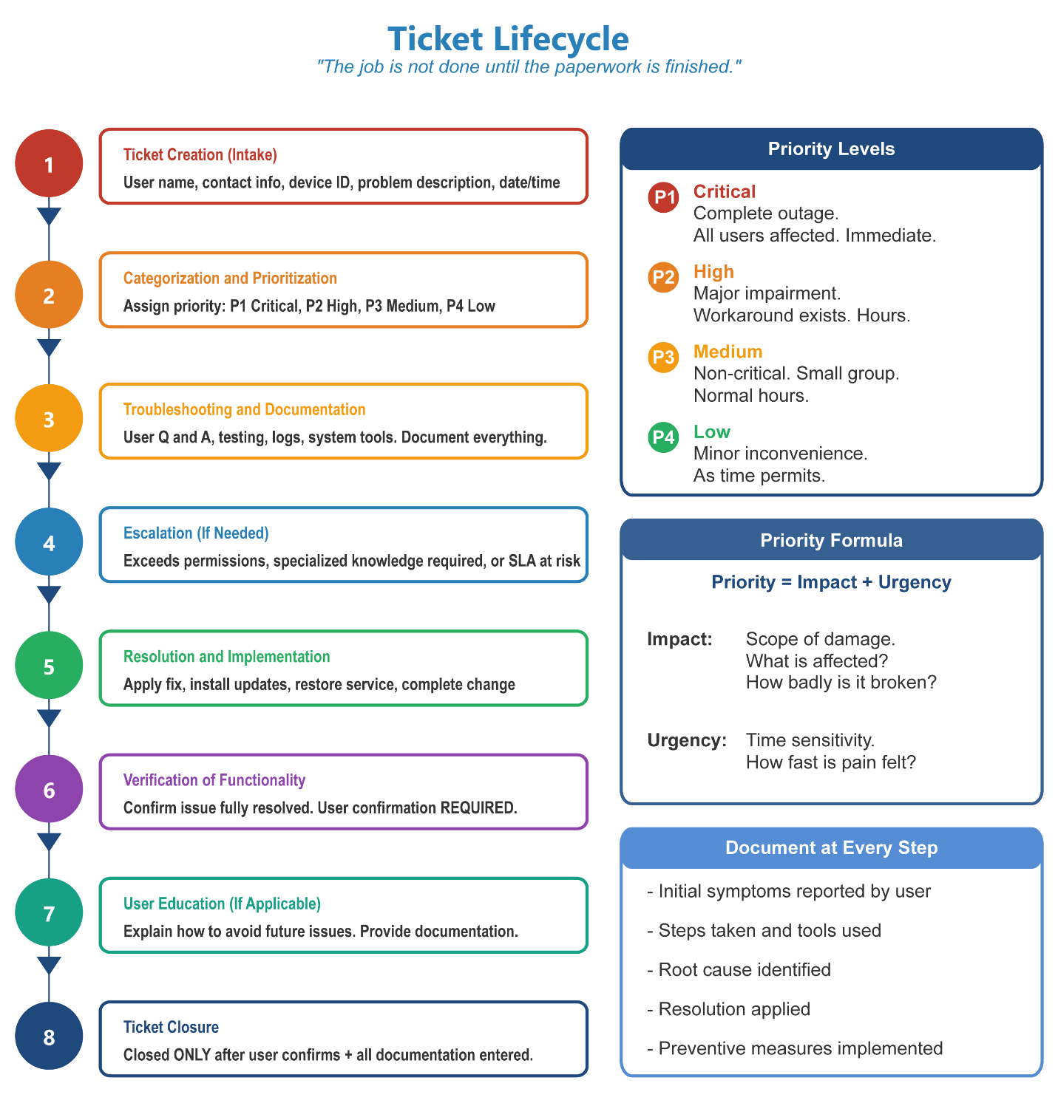
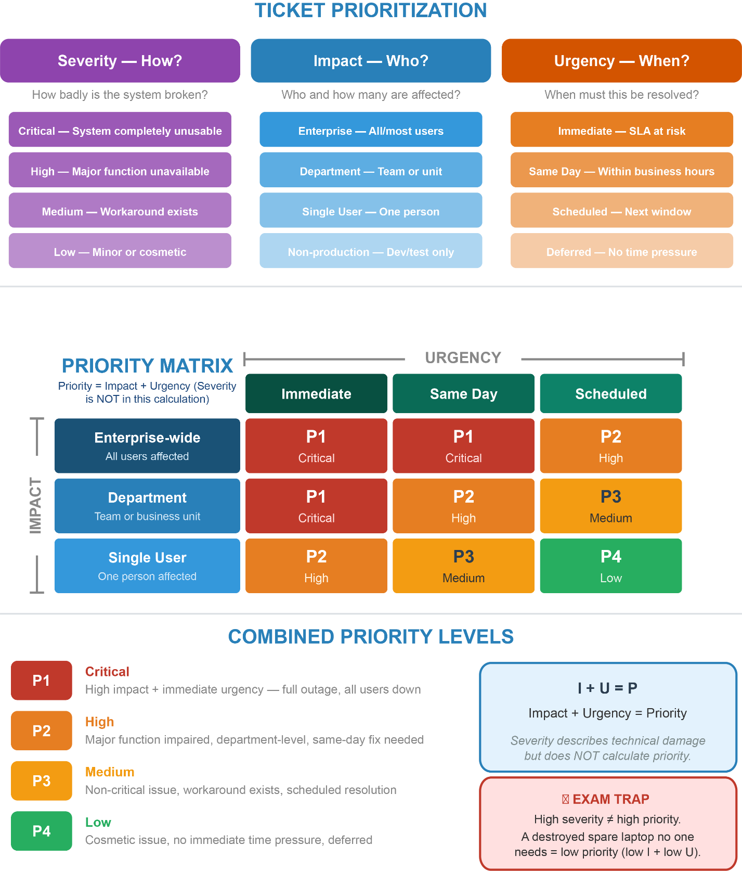

Must-Know Port Numbers
20/21 — FTP
Transport: TCP
File Transfer Protocol - 21 control, 20 data
22 — SSH / SFTP
Transport: TCP
Secure Shell - encrypted command line
23 — Telnet
Transport: TCP
Unencrypted remote access - obsolete
25 — SMTP
Transport: TCP
Send mail outbound
53 — DNS
Transport: TCP/UDP
Domain Name System - name to IP
67/68 — DHCP
Transport: UDP
IP address assignment - server/client
80 — HTTP
Transport: TCP
Web browsing - unencrypted
110 — POP3
Transport: TCP
Download email to one device
143 — IMAP
Transport: TCP
Sync email across devices
389 — LDAP
Transport: TCP/UDP
Active Directory queries
443 — HTTPS
Transport: TCP
Secure web browsing
445 — SMB
Transport: TCP
Windows file sharing
636 — LDAPS
Transport: TCP
Encrypted LDAP
993 — IMAPS
Transport: TCP
Encrypted IMAP
995 — POP3S
Transport: TCP
Encrypted POP3
3389 — RDP
Transport: TCP
Remote Desktop Protocol

Cable Categories & Speeds Quick Reference
Cat 5e — 1 Gbps Max Distance: 100 meters Notes: Minimum requirement for Gigabit networks.
Cat 6 — 10 Gbps Max Distance: 55 meters Notes: Drops to 1 Gbps at full 100m distance and 10 Gbps at up to 55m
Cat 6a — 10 Gbps Max Distance: 100 meters Notes: “a” stands for augmented. Handles full distance.
Cat 8 — 40 Gbps Max Distance: 30 meters Notes: Used primarily in data centers for short server runs.

USB & Thunderbolt Speeds Quick Reference
USB 2.0 (480 Mbps) Connector Types: Type-A, Type-B, Mini, Micro
USB 3.2 Gen 1 (USB 3.0) (5 Gbps) Connector Types: Type-A, Type-B, Type-C
USB 3.2 Gen 2 (USB 3.1) (10 Gbps) Connector Types: Type-A, Type-C
USB 4 (40 Gbps) Connector Types: Type-C only
Thunderbolt 3 / 4 (40 Gbps) Connector Types: Type-C only

Command-Line Rosetta Stone (Windows vs. Linux/macOS)

Commands that are similar.
View IP Address (ipconfig)
What It’s Used For: Displays the system’s IP address and network configuration.
Linux / macOS Equivalent: ifconfig or ip a
Trace Network Route (tracert)
What It’s Used For: Shows the path packets take across the network to a destination.
Linux / macOS Equivalent: traceroute
Test Connectivity (ping)
What It’s Used For: Sends ICMP echo requests to verify network connectivity.
Linux / macOS Equivalent: ping
View Running Processes (tasklist)
What It’s Used For: Lists all active processes on the system.
Linux / macOS Equivalent: ps or top
Kill a Process (taskkill)
What It’s Used For: Terminates a running process.
Linux / macOS Equivalent: kill
Elevate Permissions (Run as Administrator)
What It’s Used For: Executes commands with elevated privileges.
Linux / macOS Equivalent: sudo

Essential Windows Run Commands Quick Reference
Launch these tools directly from the Run dialog (Win + R) or Command Prompt
compmgmt.msc (Computer Management)
What It’s Used For: The master console. Accesses Event Viewer, Task Scheduler, and local users/groups all in one place.
devmgmt.msc (Device Manager)
What It’s Used For: Used to update, roll back, or disable hardware drivers. Look here for the dreaded “yellow exclamation mark.”
diskmgmt.msc (Disk Management)
What It’s Used For: Used to initialize new hard drives, format partitions, and assign drive letters.
services.msc (Services)
What It’s Used For: Used to start, stop, or restart background Windows services (like the Print Spooler).
mstsc (Remote Desktop Connection)
What It’s Used For: Think “Microsoft Terminal Services Client.” Opens the RDP window to connect to another PC.
msinfo32 (System Information)
What It’s Used For: Displays a massive, read-only list of hardware resources, components, and software environments.
dxdiag (DirectX Diagnostic Tool)
What It’s Used For: Used to test and verify audio and video hardware functionality.
regedit (Registry Editor)
What It’s Used For: The central database for Windows settings.
⚠️ Exam Trap: Never edit the registry without backing it up first!

Essential Linux Commands Quick Reference
ls (List files)
What It’s Used For: View directory contents. Equivalent to dir in Windows.
pwd (Print working directory)
What It’s Used For: Shows current directory path.
cd (Change directory)
What It’s Used For: Navigate between folders.
sudo (Superuser do)
What It’s Used For: Run commands with elevated privileges. Equivalent to “Run as Administrator.”
chmod (Change mode)
What It’s Used For: Modify file/folder permissions.
chown (Change ownership)
What It’s Used For: Assign ownership of files/folders.
ps / top (Process status)
What It’s Used For: View running processes. Equivalent to tasklist.
kill (Kill process)
What It’s Used For: Terminate a process. Equivalent to taskkill.
ifconfig / ip a (Network config)
What It’s Used For: View IP address and network settings. Equivalent to ipconfig.
traceroute (Trace route)
What It’s Used For: Diagnose network path issues. Equivalent to tracert.
apt-get / yum / dnf (Package managers)
What It’s Used For: Install/remove software packages. Equivalent to Windows Installer.

Essential macOS Commands & Tools Quick Reference
Finder (File manager)
What It’s Used For: Navigation and storage management.
System Settings
What It’s Used For: Configure network, users, displays, privacy.
Terminal (CLI)
What It’s Used For: Run advanced command-line tasks.
diskutil (Disk Utility CLI)
What It’s Used For: Partition/format drives.
open (Launch apps/files)
What It’s Used For: Open applications or files from Terminal.
Activity Monitor
What It’s Used For: Monitor CPU, memory, disk, and network usage.
Time Machine
What It’s Used For: Built-in backup with snapshots.

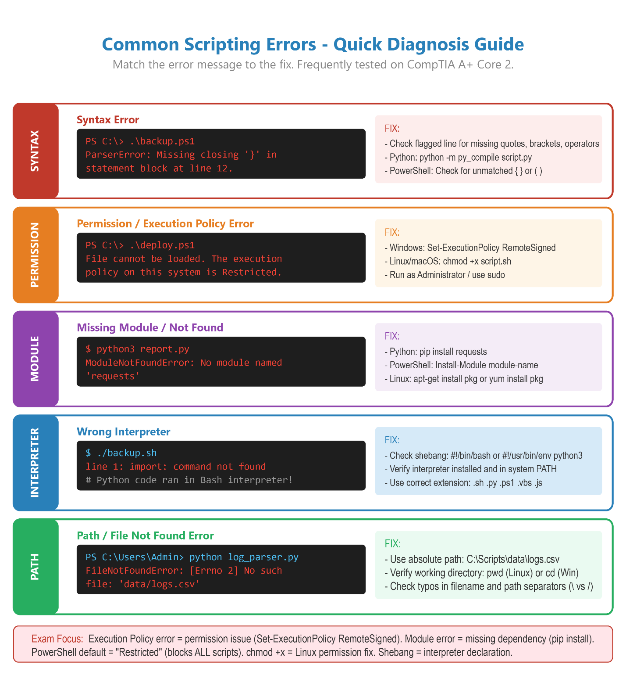

Backup Types: “Full Incremental Differential”
- “Full = Everything. Slowest to create, fastest to restore.”
- “Incremental = Changes since LAST backup. Fastest to create, slowest to restore (need all incrementals).”
- “Differential = Changes since LAST FULL. Medium both ways. Need last full + latest diff only.”

Hardware
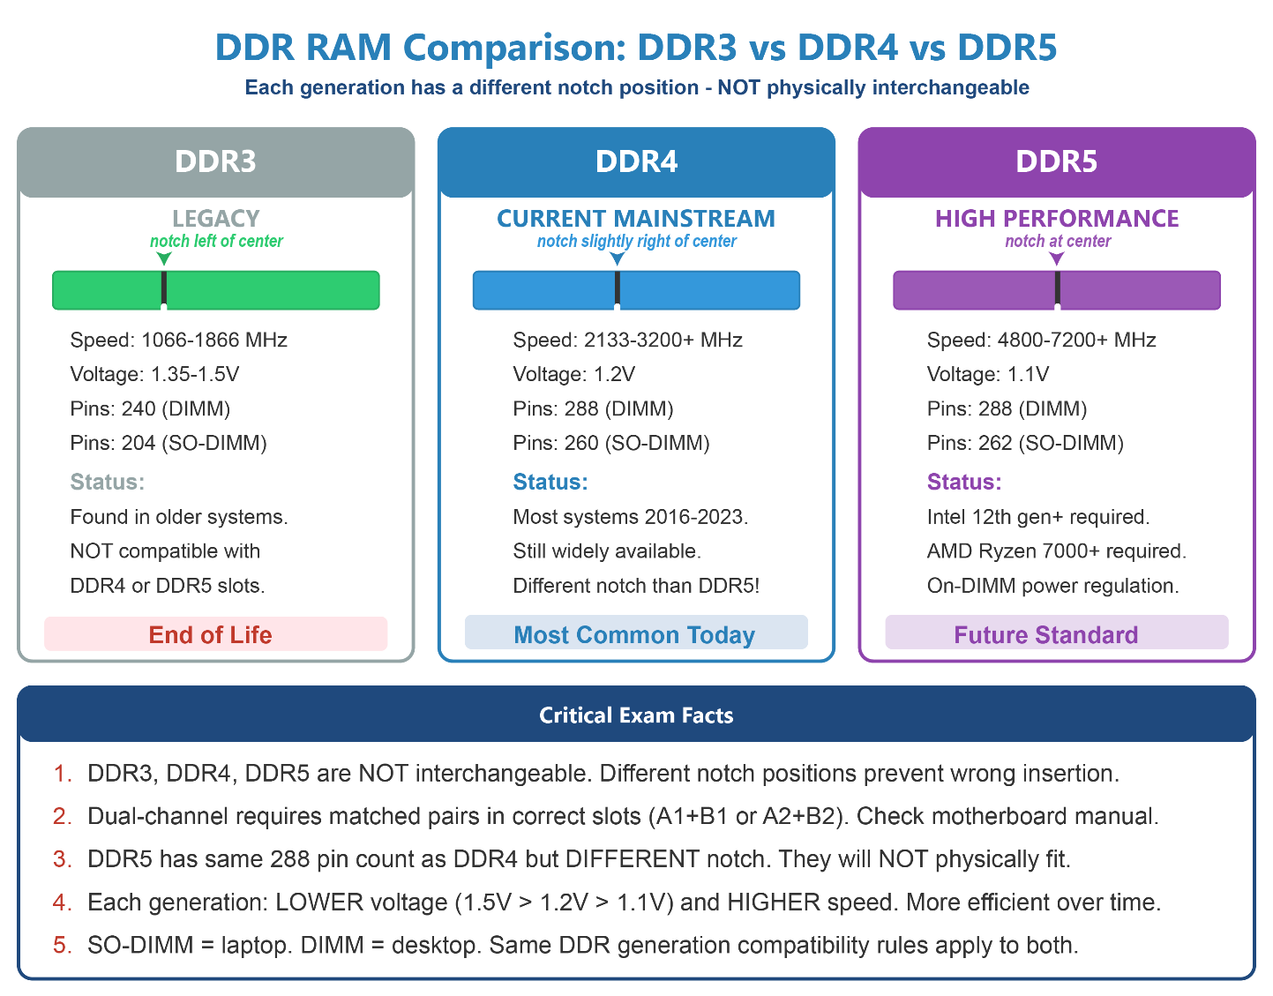
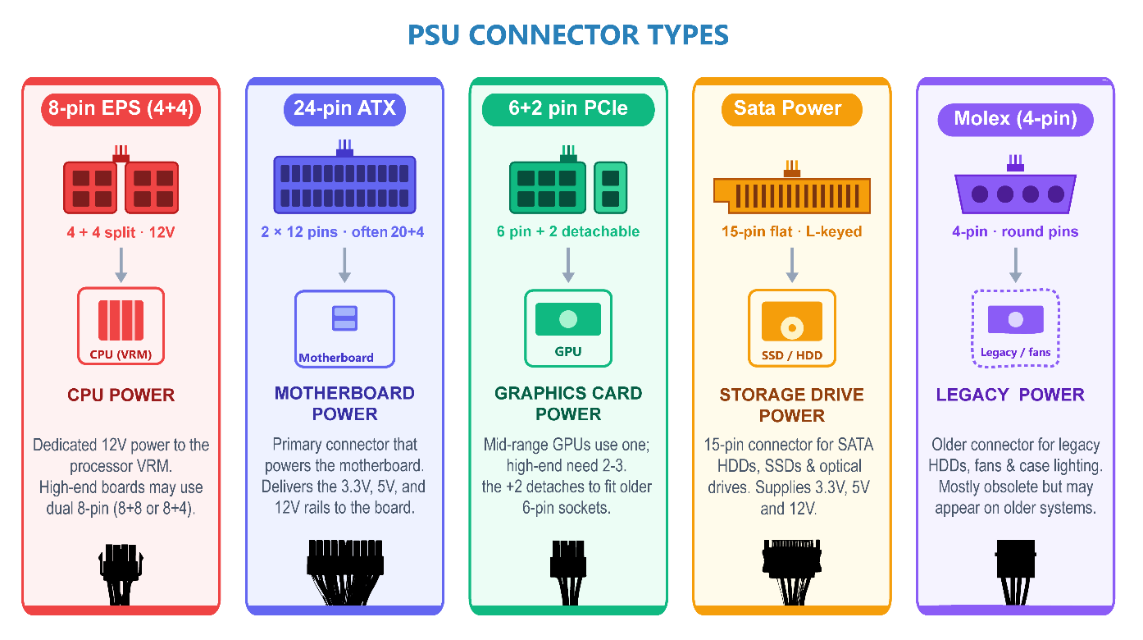
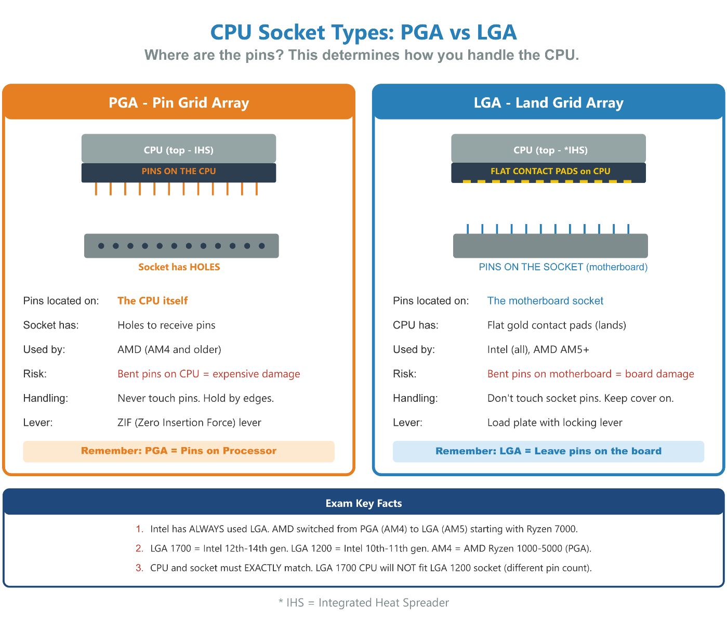
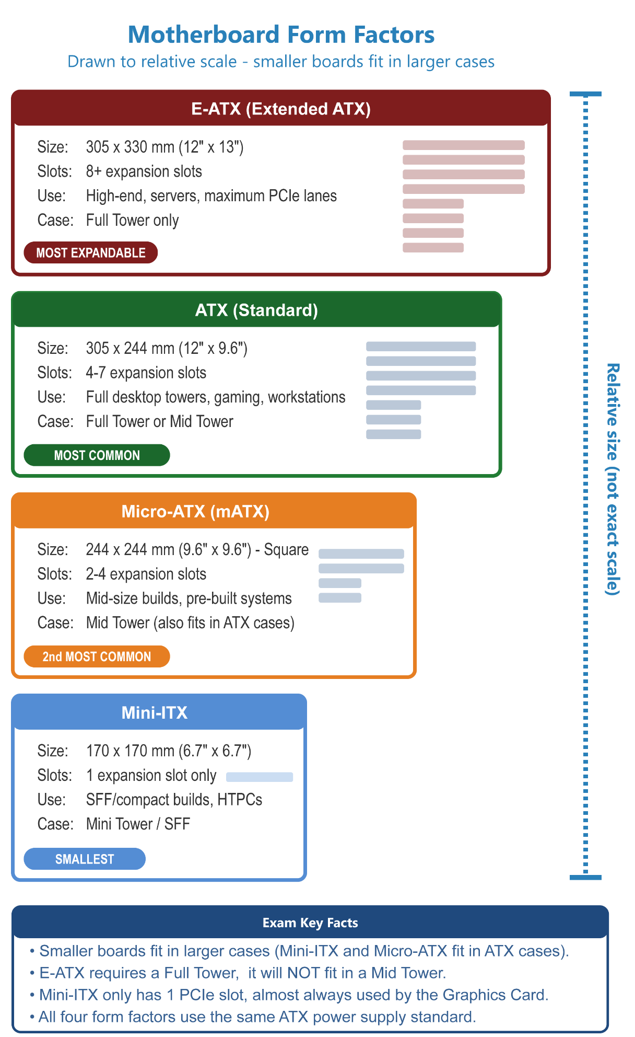
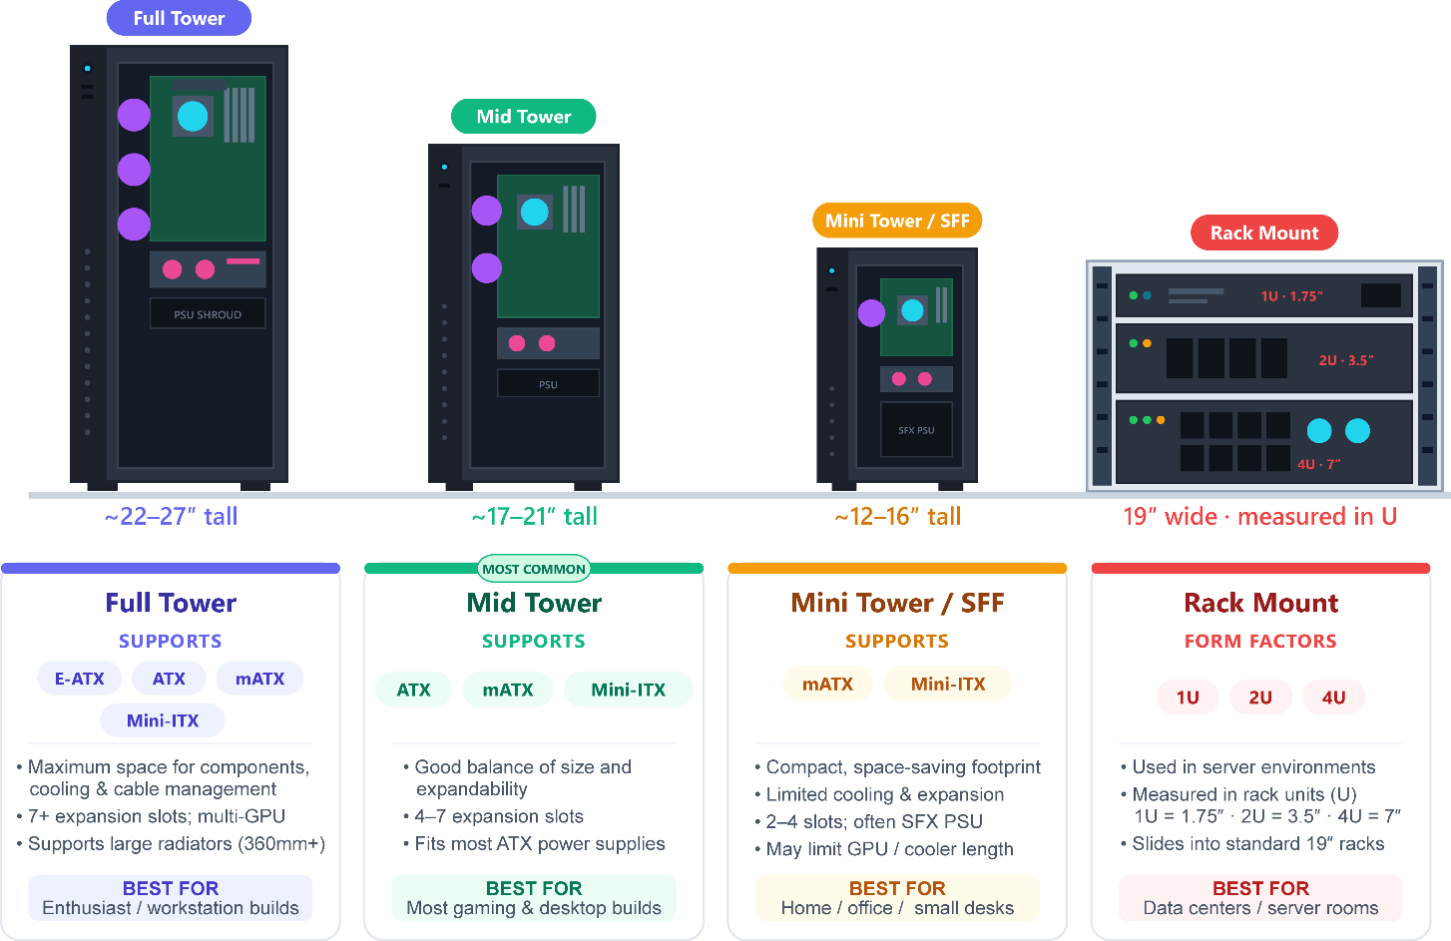
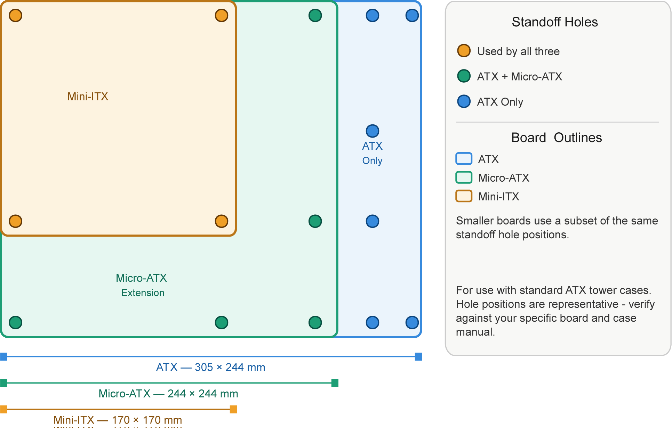
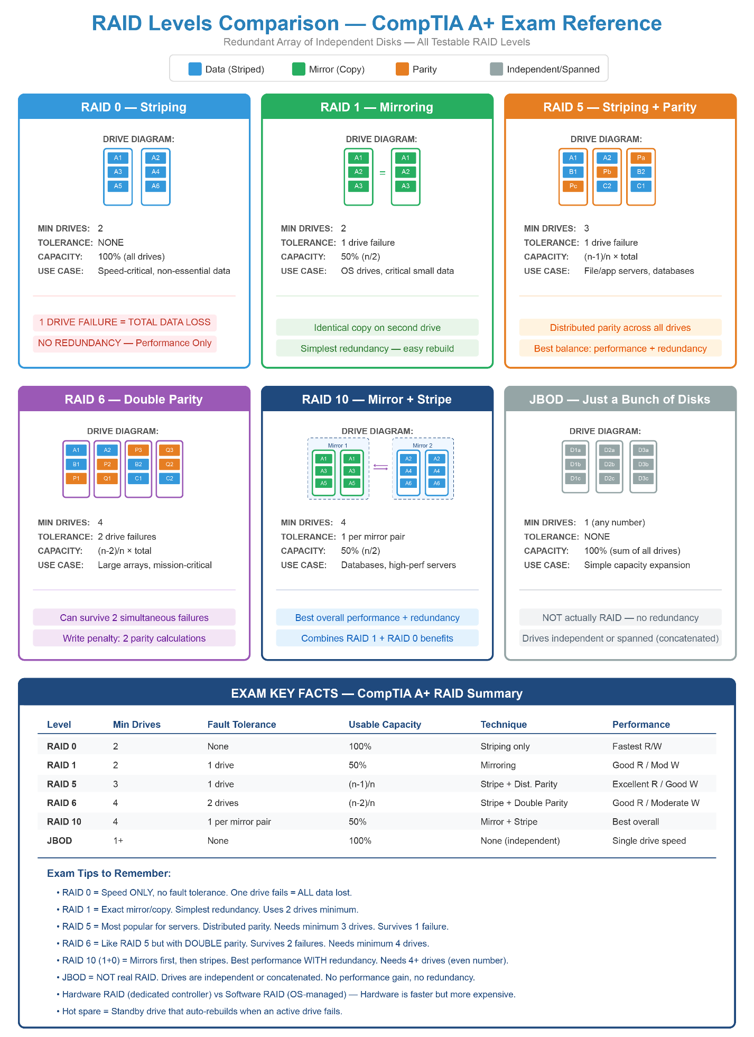

Safety
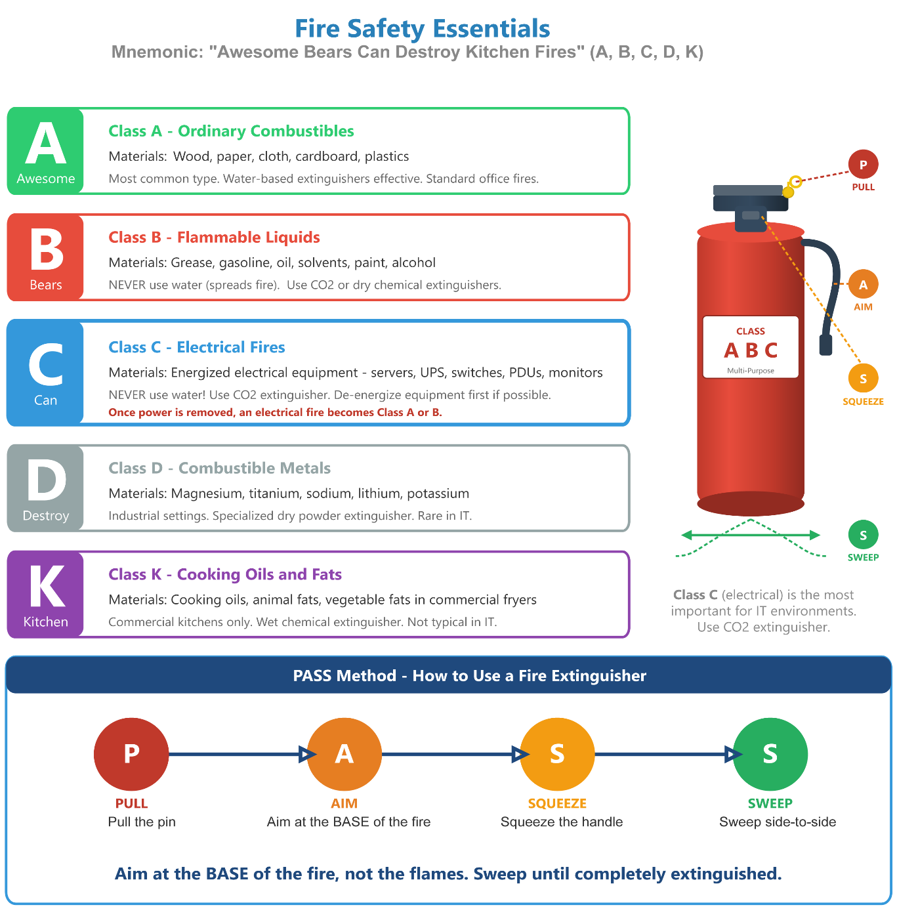

Exam Traps & Common Wrong Answers
These are the most common trick questions and misconceptions on the A+ exam. Review these carefully before test day.

Hardware Traps
Degaussing an SSD to erase data — WRONG - degaussing only works on magnetic media. SSDs use flash memory. Use Secure Erase or physical destruction for SSDs.
Formatting a drive before disposal makes data unrecoverable — WRONG - format only removes the file system metadata. Data can be recovered. Use proper data wiping or physical destruction.
DDR4 RAM works in a DDR5 slot — WRONG - DDR4 and DDR5 have different notch positions. They are physically incompatible.
Dual-channel requires any two sticks in any two slots — WRONG - DIMMs must be matched pairs in the CORRECT slot pair (e.g., slots 1+3 or 2+4). Check the motherboard manual.
Replacing a laptop CPU requires removing the motherboard first — Only true if the CPU is NOT soldered. Modern laptops often have soldered CPUs that cannot be replaced at all.

Networking Traps
IMEI is used for roaming charges — WRONG - IMSI identifies the subscriber for billing/roaming. IMEI identifies the hardware device.
An APIPA address means the network is working — WRONG - APIPA (169.254.x.x) means the device FAILED to get a DHCP address. It’s a fallback, not a success.
Fiber optic cables are affected by EMI — WRONG - fiber uses light, not electrical signals. It is immune to electromagnetic interference. That’s one of its key advantages.
A switch broadcasts to all ports like a hub — WRONG - a switch sends frames only to the correct destination port using MAC address tables. A HUB broadcasts to all ports.
DNS assigns IP addresses automatically — WRONG - DHCP assigns IP addresses. DNS translates domain names to IP addresses.

OS & Security Traps
Remote Desktop works the same on Windows Home and Pro — WRONG - Windows Home can be a Remote Desktop CLIENT (connect to others) but cannot be a HOST (be connected to). Pro/Enterprise required to host.
BitLocker is available on Windows Home — WRONG - BitLocker requires Windows Pro, Pro for Workstations, or Enterprise. Windows Home does not include BitLocker.
Deleting files and emptying the Recycle Bin permanently removes data — WRONG - it only removes the file pointer. Data remains until overwritten. Use proper wiping tools for secure deletion.
Private/Incognito mode makes browsing anonymous — WRONG - it only prevents LOCAL history, cookies, and cache from being saved. ISPs, employers, and websites can still see all traffic.
Antivirus software alone is sufficient security — WRONG - defense in depth requires multiple layers: AV + firewall + patch management + user education + MFA + encryption.

Mobile & Cloud Traps
Remote Wipe should be used first when a phone is missing — WRONG - use Remote LOCK first. Remote Wipe permanently erases everything. Lock first; wipe only if confirmed stolen.
PRL updates must be done manually by the user — WRONG - PRL updates are pushed automatically via OTA (Over-The-Air) updates from the carrier.
SaaS means the customer manages the underlying infrastructure — WRONG - with SaaS, the provider manages everything including the application, platform, and infrastructure. The customer just uses it.
Public AI tools are safe for entering customer data — WRONG - data entered into public AI tools may be used for training and is not guaranteed to be private. Never enter PII or sensitive data.

8-Week Study Plan
This plan assumes approximately 1-2 hours of study per day. Adjust based on your existing experience level.
Week 1 - Core 1 Hardware Foundations — Desktop PC Hardware · Working on Laptops · Laptop System Board · Mobile Input Devices · Mobile Expansion Cards. Goal: Understand all physical components and how they connect.
Week 2 - Core 1 Connectivity & Displays — Mobile Devices · Wireless & Cellular Connectivity · Computer Displays · Cables, Connectors & Adapters. Goal: Know every connector type, wireless standard, and display technology.
Week 3 - Core 1 Storage, Networking & Printing — Hard Drives & Storage · Networking Fundamentals · Printers & Multifunction Devices. Goal: Master TCP/IP, IP addressing, ports, RAID, and the laser printing process.
Week 4 - Core 1 Virtualization + Core 1 Review — Virtualization & Cloud Computing · Review all Core 1 modules · Take a Core 1 practice test. Goal: Identify weak areas before the exam.
Week 5 - Core 2 Operating Systems & Scripting — Windows Editions & Features · Operating Systems · Scripting Overview. Goal: Know all Windows tools, command-line utilities, and Linux/macOS basics.
Week 6 - Core 2 Security & MDM — Security · Browser Security · SOHO Network Security · Mobile Device Management. Goal: Master malware removal steps, Wi-Fi protocols, physical security, and MDM features.
Week 7 - Core 2 Troubleshooting & Procedures — Software Troubleshooting · Hardware Troubleshooting · Networking Troubleshooting · Operational Procedures · Customer Service. Goal: Know all troubleshooting tools and the 6-step methodology cold.
Week 8 - New AI Topics + Final Review — Basics · Data Destruction · Remote Access · Asset Management · Licensing & Regulated Data · Mobile Sync · Workstation Backup. Review Glossary, Mnemonics, and Quick Reference Cards. Take full practice tests for Core 1 AND Core 2.

Practice Test
This practice test covers all modules from both Core 1 and Core 2. Try to answer each question before looking at the answers. Time yourself - aim to answer each question in under 60 seconds.

Part 1: Hardware (Core 1)
Q1. A technician is replacing RAM in a desktop. The motherboard has 4 DIMM slots labeled A1, A2, B1, B2. To enable dual-channel mode, which slots should be populated first?
A) A1 and A2
B) A1 and B1
C) A2 and B2
D) Any two adjacent slots
Q2. Which connector provides the main power from the PSU to a modern desktop motherboard?
A) 8-pin EPS
B) 4-pin Molex
C) 24-pin ATX
D) 6+2 pin PCIe
Q3. A technician replaces an aging HDD with an NVMe SSD. After installation, the system does not detect the new drive. What is the MOST likely cause?
A) The SATA cable is disconnected
B) The BIOS/UEFI needs to be updated to support NVMe
C) The NVMe drive is defective
D) NVMe drives require a PCIe power cable
Q4. Which RAID level requires a minimum of 4 drives and can survive two simultaneous drive failures?
A) RAID 0
B) RAID 5
C) RAID 6
D) RAID 10
Q5. A laser printer is producing pages where toner smears when touched. Which component is MOST likely failing?
A) Imaging drum
B) Charging roller
C) Fuser assembly
D) Transfer belt
Q6. A user reports their laptop screen is very dim, but connecting an external monitor shows a clear image. What component is MOST likely faulty?
A) GPU
B) Digitizer
C) Inverter
D) LVDS cable
Q7. Degaussing is an effective data destruction method for which of the following?
A) SSD
B) USB flash drive
C) Magnetic tape
D) Optical disc (DVD)
Q8. A laptop connects to Wi-Fi but receives a 169.254.x.x IP address. What does this indicate?
A) The laptop is connected to a 5 GHz network
B) DHCP server is unreachable
C) The DNS server is down
D) WPA3 authentication failed

Part 2: Operating Systems & Software (Core 2)
Q9. A Windows 10 Home user needs to join the corporate Active Directory domain. What is the MINIMUM upgrade required?
A) Windows 10 Pro
B) Windows 10 Enterprise
C) Windows 10 Pro for Workstations
D) No upgrade needed - Home supports domain join
Q10. A technician runs sfc /scannow but it reports it cannot fix corrupted files. What command should be run FIRST before trying sfc again?
A) chkdsk /f
B) DISM /Online /Cleanup-Image /RestoreHealth
C) bootrec /fixmbr
D) gpupdate /force
Q11. Which Windows tool provides a visual timeline of system stability, showing application crashes and failed updates over time?
A) Event Viewer
B) Task Manager
C) Reliability Monitor
D) Resource Monitor
Q12. A user’s browser homepage has changed and web searches redirect to an unknown site. What is the MOST likely cause?
A) DNS server failure
B) Browser hijacker infection
C) Corrupt browser installation
D) ISP throttling
Q13. Which backup type backs up only files changed since the last FULL backup, making it faster to restore than incremental backups?
A) Full backup
B) Incremental backup
C) Differential backup
D) Synthetic full backup
Q14. An employee is leaving the company and their laptop needs to be repurposed. The laptop contains sensitive HR data on an SSD. Which is the MOST appropriate data destruction method?
A) Quick format the drive
B) Delete all files and empty the Recycle Bin
C) Degauss the SSD
D) Use the SSD's Secure Erase feature

Part 3: Security (Core 2)
Q15. A user receives an email appearing to be from the company CEO asking them to wire $50,000 immediately and keep it confidential. What type of attack is this?
A) Spear-phishing
B) Whaling
C) Vishing
D) Smishing
Q16. Which Wi-Fi security protocol uses SAE (Simultaneous Authentication of Equals) for stronger password protection?
A) WEP
B) WPA
C) WPA2
D) WPA3
Q17. During the CompTIA 7-step malware removal process, what must be done BEFORE running anti-malware scans?
A) Update Windows
B) Educate the user
C) Disable System Restore
D) Enable the firewall
Q18. An IT technician is disposing of old workstations from the hospital’s HR department. The drives contain both PHI and employee PII. What document should be obtained from the destruction vendor?
A) Bill of lading
B) Non-disclosure agreement
C) Certificate of Destruction
D) Chain of custody log
Q19. A company wants to ensure that if a corporate laptop is lost, the data cannot be accessed by unauthorized parties. Which feature should be enabled?
A) WPA3
B) BitLocker
C) Windows Defender
D) NTFS permissions
Q20. An employee enters sensitive customer credit card data into a public AI chatbot to analyze spending patterns. What is the PRIMARY security concern?
A) The AI may give incorrect analysis
B) The data may be retained and used for AI training, violating PCI-DSS
C) The AI tool is not approved software
D) The AI output cannot be audited

Part 4: Networking & Remote Access (Core 1 & 2)
Q21. A technician uses SSH to remotely administer a Linux server. Which port must be open on the server’s firewall?
A) 23
B) 22
C) 3389
D) 443
Q22. Which remote access technology allows an IT administrator to manage a server’s hardware (power on/off, view console) even when the operating system is not running?
A) RDP
B) VNC
C) IPMI / iDRAC
D) TeamViewer
Q23. A technician needs to configure a SOHO router for maximum wireless security. WPS is currently enabled. What should be done?
A) Change WPS PIN to a stronger value
B) Enable WPS only on the 5 GHz band
C) Disable WPS entirely
D) WPS is required for WPA3 - leave it enabled
Q24. Which email protocol should be recommended for a user who accesses email from both a desktop and a mobile phone?
A) POP3 - downloads to each device
B) SMTP - best for multi-device access
C) IMAP - keeps mail on server, syncs across devices
D) MAPI - most compatible protocol

Part 5: Additional Practice Questions (Additional Practice Questions)
Q25. A user reports their desktop computer is making a loud, rhythmic clicking noise, and the operating system is running extremely slowly. What should the technician do FIRST?
A) Run the chkdsk command to repair bad sectors
B) Back up the user's data immediately
C) Replace the power supply unit (PSU)
D) Defragment the hard drive
Q26. An organization wants to move its email and document collaboration to the cloud. They want the cloud provider to manage the servers, the software updates, and the security. Which cloud model does this represent?
A) IaaS (Infrastructure as a Service)
B) PaaS (Platform as a Service)
C) SaaS (Software as a Service)
D) DaaS (Desktop as a Service)
Q27. A laser printer is outputting pages with repeated, faint images of previously printed text. According to the CompTIA troubleshooting guide, what is the MOST likely cause?
A) Depleted toner cartridge
B) Failing fuser assembly
C) Dirty primary corona wire
D) Paper jam in the pickup rollers
Q28. Which command-line tool is used to force a Windows computer to request a new IP address from the DHCP server?
A) ipconfig /flushdns
B) ipconfig /release followed by ipconfig /renew
C) netstat -a
D) ping -t
Q29. An attacker follows an authorized employee through a secure door into a server room without swiping a badge. Which physical security control would have BEST prevented this attack?
A) Security cameras
B) Biometric fingerprint locks
C) A mantrap
D) Cable locks
Q30. A technician needs to run a network cable through the drop ceiling of an office building where the HVAC system circulates breathable air. What type of cable MUST be used to comply with safety codes?
A) Cat 5e UTP
B) Fiber optic
C) PVC-jacketed cable
D) Plenum-rated cable
Q31. A smartphone’s battery is visibly bulging, causing the screen to lift away from the chassis. What is the safest immediate action for the technician to take?
A) Squeeze the screen firmly back into place
B) Put the phone in a freezer to reduce the swelling
C) Power off the device and isolate it in a fire-safe container
D) Connect it to a charger to drain the battery's swelling
Q32. A technician is setting up a virtual machine (VM) that needs its own IP address from the physical office router’s DHCP server, allowing it to act like a standard physical PC on the network. Which virtual network mode should be used?
A) NAT
B) Host-only
C) Bridged
D) Internal
Q33. A user calls the help desk in a panic because a full-screen message says the FBI has locked their computer and demands a $500 fine paid in cryptocurrency to unlock it. What type of malware is this?
A) Ransomware
B) Spyware
C) Rootkit
D) Trojan
Q34. A technician has just applied a registry fix to resolve a user’s crashing application. The application now opens successfully. According to the CompTIA 6-step troubleshooting methodology, what should the technician do NEXT?
A) Document the findings, actions, and outcomes
B) Establish a plan of action
C) Verify full system functionality and implement preventive measures
D) Close the help desk ticket

Answer Key
Q1. B or C
Dual-channel requires matched DIMMs installed across both channels — one in Channel A and one in Channel B (e.g., A1+B1 or A2+B2). Installing both in the same channel (A1+A2) gives only single-channel bandwidth.
Q2. C
24-pin ATX - The 24-pin ATX connector is the main motherboard power connector. The 8-pin EPS powers the CPU separately.
Q3. B
BIOS/UEFI needs updating - Older BIOS versions may not include NVMe support drivers. Update BIOS first. NVMe drives do not use SATA cables or PCIe power connectors.
Q4. C
RAID 6 - Double parity, minimum 4 drives, survives two simultaneous failures. RAID 10 also uses 4 drives but can only survive failures in different mirror pairs.
Q5. C
Fuser assembly - The fuser melts toner into paper using heat and pressure. If it fails, toner doesn’t bond and smears easily.
Q6. C
Inverter - The inverter converts DC to AC for the CCFL backlight. If the external monitor works, the GPU is fine. A failed inverter dims or kills the internal display only.
Q7. C
Magnetic tape - Degaussing only works on magnetic media. SSDs, USB drives, and optical discs are unaffected.
Q8. B
DHCP server is unreachable - APIPA (169.254.x.x) is automatically assigned when no DHCP server responds. The Wi-Fi connection may be active but DHCP failed.
Q9. A
Windows 10 Pro - Domain join requires Pro or Enterprise. Home cannot join an AD domain.
Q10. B
DISM /Online /Cleanup-Image /RestoreHealth - DISM repairs the Windows component store that sfc relies on. Always run DISM before retrying sfc.
Q11. C
Reliability Monitor - Shows app crashes and failed updates on a timeline. Event Viewer is more detailed but not visual. Task Manager shows current processes.
Q12. B
Browser hijacker - This is a classic browser hijacker symptom. Fix: malware removal + browser settings reset.
Q13. C
Differential backup - Only needs the last full + the latest differential. Incremental requires the last full + every incremental in sequence.
Q14. D
Secure Erase - Multi-pass overwrite is unreliable on SSDs (wear-leveling). Secure Erase uses the drive’s firmware to reset all cells. Degaussing has no effect on SSDs.
Q15. B
Whaling - Whaling specifically targets executives (like a CEO requesting action). Spear-phishing targets specific individuals generally; whaling targets senior leadership specifically.
Q16. D
WPA3 - WPA3 uses Simultaneous Authentication of Equals (SAE) to replace WPA2’s PSK, providing stronger protection against offline dictionary attacks.
Q17. C
Disable System Restore - Step 3 of the 7-step process. System Restore must be disabled first so malware cannot hide in restore points and reinfect after removal.
Q18. C
Certificate of Destruction - Required for regulated data (PHI, PII) to prove compliance with HIPAA and other regulations.
Q19. B
BitLocker - Full-disk encryption renders data unreadable without the recovery key, even if the drive is removed and read in another machine.
Q20. B
Data retained, violates PCI-DSS - PCI-DSS prohibits sharing cardholder data with unauthorized third parties. Public AI tools are not approved processors of payment card data.
Q21. B
22 - SSH uses port 22. Telnet (23) is unencrypted. RDP is 3389. HTTPS is 443.
Q22. C
IPMI / iDRAC - Out-of-band management tools allow hardware-level server access regardless of OS state. RDP/VNC/TeamViewer require a running OS.
Q23. C
Disable WPS entirely - WPS has an exploitable 8-digit PIN vulnerability and should always be disabled regardless of which Wi-Fi security protocol is in use.
Q24. C
IMAP - IMAP keeps email on the server and syncs across all devices. POP3 downloads to one device and removes from server.
Q25. B
Back up the data immediately. A rhythmic clicking sound indicates an imminent physical hard drive (HDD) failure (head crash). Data recovery takes priority over diagnostics.
Q26. C
SaaS (Software as a Service) The provider manages everything, and the user simply consumes the application (like Microsoft 365 or Gmail).
Q27. B
Failing fuser assembly. Ghosted images are typically caused by a failing fuser or a bad cleaning blade on the imaging drum.
Q28. B
ipconfig /release followed by ipconfig /renew. This drops the current IP and forces the DORA process to request a new one.
Q29. C
A mantrap. A mantrap uses two interlocking doors to ensure only one authorized person can enter a secure area at a time, specifically preventing tailgating.
Q30. D
Plenum-rated cable. Plenum cables have a special fire-retardant jacket that produces less toxic smoke when burned, making them legally required for HVAC air spaces.
Q31. C
Power off and isolate. A bulging Li-ion battery is a severe fire hazard. Never squeeze, puncture, or charge a swollen battery.
Q32. C
Bridged. Bridged networking connects the VM directly to the physical network, allowing it to request its own IP address from the local DHCP server.
Q33. A
Ransomware. Malware that locks the system or encrypts files and demands payment is ransomware.
Q34. C
Verify full system functionality. Step 6 of the troubleshooting process is to verify the fix works and check that no other systems were broken in the process, followed by documenting the findings.

Skills Test - Performance-Based Scenarios
These scenarios simulate the Performance-Based Questions (PBQs) found on the CompTIA A+ exam. PBQs require you to apply knowledge to realistic situations - not just recall facts. Each scenario describes a real-world task. Read carefully, complete the task, then check the Answer Key at the end.
Format: Step-ordering, fill-in, configuration, matching, and decision-making
Exam Weight: PBQs = 3-5 questions on the actual exam; they count the same as multiple-choice
Coverage: 10 scenarios covering both Core 1 and Core 2 domains
Strategy: On the real exam, flag PBQs and return to them after finishing multiple-choice questions

Scenario 1: Malware Incident Response
Domain: Core 2 - Security
SITUATION:
A user calls the help desk. Their desktop is showing pop-up warnings claiming the FBI has locked their computer and demanding a $500 cryptocurrency payment to unlock it. The machine is connected to the corporate LAN. You have confirmed it is malware.
YOUR TASK: The steps below are out of order. Write the correct sequence number (1-7) next to each step.
- Educate the user on how to avoid similar infections in the future.
- Run your anti-malware scanning and removal tools.
- Re-enable System Restore and create a new clean restore point.
- Identify and research the malware symptoms.
- Disable System Restore on Windows to prevent the malware from sheltering in restore points.
- Schedule additional follow-up scans and apply any outstanding updates.
- Quarantine the infected system - disconnect it from the corporate LAN immediately.
Scenario 1 ANSWER KEY:
A: 7461352
- Identify and research the malware symptoms.
- Quarantine the infected system (disconnect from the LAN immediately).
- Disable System Restore on Windows.
- Run anti-malware scanning and removal tools.
- Schedule additional follow-up scans and apply updates.
- Re-enable System Restore and create a new clean restore point.
- Educate the user.
⚠️ Exam Trap: Steps 3 and 4 are the most commonly swapped - you MUST disable System Restore BEFORE scanning, or the malware can hide in restore points and reinfect after removal.

Scenario 2: SOHO Router Security Audit
Domain: Core 2 - Network Security
SITUATION:
You are setting up a new wireless router for a small dental office. The router is brand new, straight out of the box. The office handles patient records (PHI) on workstations connected to this network. Your job is to secure it before going live.
YOUR TASK: Review each current setting below. For each one, decide whether to CHANGE, DISABLE, or LEAVE AS-IS, and explain your reasoning.
- Admin Username — Current value: admin
- Admin Password — Current value: password
- Default SSID — Current value: NETGEAR-5G-23A1
- Wireless Security — Current value: WPA2-TKIP
- WPS (Wi-Fi Protected Setup) — Current value: Enabled
- Remote Management (WAN access) — Current value: Enabled
- Guest Network — Current value: Disabled
- Firmware Version — Current value: 1.0.0 (latest is 3.2.1)
- UPnP (Universal Plug and Play) — Current value: Enabled
- SPI Firewall — Current value: Enabled
Scenario 2 ANSWER KEY:
- Admin Username → CHANGE. Default ‘admin’ is publicly known. Create a unique admin username.
- Admin Password → CHANGE. ‘password’ is the first thing an attacker tries.
- Default SSID → CHANGE. ‘NETGEAR-5G-23A1’ reveals the router brand — attackers target known vulnerabilities.
- Wireless Security → CHANGE. WPA2-TKIP is outdated. Switch to WPA2-AES or WPA3.
- WPS → DISABLE. WPS has a known 8-digit PIN brute-force vulnerability. Always disable.
- Remote Management → DISABLE. WAN access to the admin panel is a direct attack vector.
- Guest Network → CHANGE (Enable). IoT devices and visitors must be isolated from patient record workstations.
- Firmware → CHANGE (Update). Unpatched firmware contains known exploits. Update to 3.2.1 immediately.
- UPnP → DISABLE. UPnP can be exploited to automatically open ports. Disable in security-conscious environments.
- SPI Firewall → LEAVE AS-IS. Already enabled — stateful packet inspection should always be on.

Scenario 3: Network Connectivity Troubleshooting
Domain: Core 1 - Networking
SITUATION:
A user calls saying they have “no internet.” They are on a Windows 11 workstation connected via Ethernet. Other users on the same floor are working fine. You remote into the machine. You open Command Prompt and type ipconfig — the result shows: IP Address: 169.254.12.55 / Subnet Mask: 255.255.0.0 / Default Gateway: (blank)
YOUR TASK: Answer each diagnostic question in sequence. Select the correct action and explain the reasoning.
- Q1: What does the 169.254.x.x address immediately tell you?
    - The DNS server is down
    - The DHCP server did not respond — this is an APIPA address
    - The user has a static IP that conflicts with another device
    - The network adapter is disabled
- Q2: What is your next command to attempt resolving this?
    - ping 8.8.8.8
    - tracert google.com
    - ipconfig /release followed by ipconfig /renew
    - netstat -a
- Q3: After running the command, the IP is still 169.254.x.x. What do you check next?
    - Replace the Ethernet cable immediately
    - Verify the DHCP server/router is online and check if the Ethernet cable is fully seated
    - Reinstall Windows network drivers
    - Call the ISP
- Q4: You swap the cable and run ipconfig /renew again. The user now gets 192.168.10.45. What should you verify before closing the ticket?
    - Check that the user can ping the default gateway AND open a website
    - Simply confirm the IP changed — that is sufficient
    - Run sfc /scannow to check for system file corruption
    - Reboot the router
Scenario 3 ANSWER KEY:
Q1 → B.
APIPA (169.254.x.x) = the device broadcast for a DHCP server and got no response. This is not a DNS or static IP issue.
Q2 → C.
ipconfig /release drops the current lease; ipconfig /renew forces a new DHCP request (DORA process).
Q3 → B.
If renewing failed, the DHCP server may be unreachable OR the physical connection is the problem. Check both — a bad cable means the DORA discover never reaches the router.
Q4 → A.
Verify full functionality: the user should be able to ping the gateway (local connectivity) AND load a website (DNS + internet working). Never close a ticket on an IP change alone.

Scenario 4: RAM Upgrade & Dual-Channel Configuration
Domain: Core 1 - Hardware
SITUATION:
You are upgrading a desktop workstation. The motherboard has 4 DIMM slots labeled A1, A2, B1, B2. The manual states: “For dual-channel operation, install matched DIMMs in slots A1+B1 (Channel 1) or A2+B2 (Channel 2). For 4-DIMM dual-channel, populate all four slots with matched pairs.” Currently installed: one 8GB DDR5 stick in slot A1.
YOUR TASK: For each upgrade scenario below, specify which slots to populate and whether dual-channel will be active.
- Add one more 8GB DDR5 stick (same model) — Slots? Dual-channel?
- Add two more 8GB DDR5 sticks (same model) — Slots? Dual-channel?
- Replace all RAM: install 4× 16GB DDR5 — Slots? Dual-channel?
- Add one 16GB DDR5 stick (different model/speed) — Slots? Dual-channel?
- Add one 8GB DDR4 stick (different generation) — Slots? Dual-channel?
Scenario 4 ANSWER KEY:
- Add one 8GB DDR5 (same model) → Populate A1 + B1. YES, dual-channel active. Matched pair in the correct channel pair.
- Add two more 8GB DDR5 (same model) → Populate A1 + A2 + B1 + B2. YES, dual-channel active. Four matched sticks across both channels.
- Replace with 4× 16GB DDR5 → Populate A1 + A2 + B1 + B2. YES, dual-channel active. Matched quad-channel set.
- Add 16GB DDR5 (different model) → If installed, runs in single-channel only — mismatched size prevents dual-channel. NOT recommended.
- Add 8GB DDR4 → CANNOT DO THIS. DDR4 and DDR5 have different notch positions and are physically incompatible. Will not fit in a DDR5 slot.
⚠️ Exam Trap: Dual-channel requires matched DIMMs in the CORRECT slot pair — A1+B1 or A2+B2. Putting two sticks in A1+A2 (same channel) gives you single-channel only.

Scenario 5: Mobile Email Account Configuration
Domain: Core 1 - Mobile Sync
SITUATION:
You are configuring email on an employee’s new iPhone. They need access to both their personal Gmail (IMAP) and the company’s Microsoft Exchange server. They access email from their phone, laptop, and desktop — all devices must stay synchronized.
YOUR TASK: Complete the configuration for each account with the correct protocol, port numbers, and encryption setting.
- Protocol to use — Gmail? Exchange?
- Incoming port (encrypted) — Gmail? Exchange?
- Outgoing port (client submission) — Gmail? Exchange?
- Encryption required? — Gmail? Exchange?
- Syncs contacts & calendar too? — Gmail? Exchange?
- Best for multi-device access? — Gmail? Exchange?
Scenario 5 ANSWER KEY:
- Protocol → Gmail: IMAP Exchange: Exchange ActiveSync (EAS)
- Incoming port (encrypted) → Gmail: 993 (IMAPS) Exchange: EAS uses HTTPS (port 443) — no separate incoming port
- Outgoing port → Gmail: 587 (SMTP with STARTTLS) or 465 (implicit SSL) Exchange: Handled by EAS — same single connection
- Encryption → Both: YES — always use SSL/TLS. Never configure email without encryption.
- Syncs contacts & calendar → Gmail (IMAP): Email only (need separate CardDAV/CalDAV for contacts/calendar) Exchange EAS: YES — email + contacts + calendar in one connection.
- Best for multi-device → Both: YES for email. Exchange EAS is the clear winner for corporate because one connection syncs everything.
⚠️ Exam Trap: EAS (Exchange ActiveSync) is the corporate standard because it handles email + contacts + calendar over a single protocol. IMAP alone only handles email.

Scenario 6: Data Destruction Method Selection
Domain: Core 2 - Data Disposal
SITUATION:
Your company is decommissioning a variety of devices. Compliance requires proper data destruction before disposal. Some devices will be reused; others will not. Match each device and situation to the single BEST destruction method.
YOUR TASK: For each scenario, write the most appropriate method. Choose from: Secure Erase, Zero Fill, Multi-Pass Overwrite (DoD), Degaussing, Physical Shredding, Cryptographic Erasure, Factory Reset.
- A 5-year-old HDD from an accounting workstation. The drive will be donated to a school after wiping.
- An SSD from the HR director’s laptop. Contains employee PII. The laptop is being repurposed internally.
- A box of 50 old magnetic backup tapes from the server room. They will not be reused.
- A corporate iPhone that was issued to an employee (hardware encryption enabled). Being reassigned to a new hire.
- A SATA SSD from a healthcare workstation containing PHI. Being disposed of permanently. Compliance audit required.
- A USB flash drive found in the lost and found. Unknown contents, will not be reused.
- An NVMe SSD from a workstation that will be repurposed for another department.
Scenario 6 ANSWER KEY:
- HDD for donation → Zero Fill (Single-Pass Overwrite). Drive is reused — physical destruction not needed. Meets NIST SP 800-88 standard.
- SSD from HR laptop (repurposed) → Secure Erase (ATA firmware command). Multi-pass overwrite is unreliable on SSDs due to wear-leveling. Secure Erase resets all cells.
- Magnetic backup tapes (disposed) → Degaussing + Shredding. Degaussing destroys the magnetic data; shredding provides physical assurance. degaussing alone is acceptable but physical destruction adds security.
- iPhone with hardware encryption (reassigned) → Factory Reset. Hardware encryption + factory reset destroys the encryption key, rendering data unrecoverable. Fast and effective.
- SSD from healthcare workstation (PHI, compliance audit) → Physical Shredding + Certificate of Destruction. PHI requires documented proof of disposal for HIPAA compliance. Shredding is the most thorough method.
- Unknown USB flash drive (disposed) → Physical Shredding. Unknown contents, not reused — shredding is fastest and most thorough.
- NVMe SSD (repurposed) → Secure Erase. Same reasoning as #2 — Secure Erase is the correct method for any flash-based storage being reused.
⚠️ Exam Trap: Never use Multi-Pass Overwrite (DoD) on SSDs — wear-leveling means the firmware may skip sectors. Always use Secure Erase for SSDs.

Scenario 7: Virtual Machine Network Mode Configuration
Domain: Core 1 - Virtualization
SITUATION:
You are a lab instructor setting up virtual machines for a security training course. Different VMs need different levels of network access based on their purpose. You are using VMware Workstation (Type 2 hypervisor) on a Windows 11 host.
YOUR TASK: For each VM purpose below, select the correct network mode. Choose from: NAT, Bridged, Host-Only, Internal Network.
- A student needs to practice web browsing and downloading security tools from the internet. The VM should share the host’s internet but not be directly visible on the network.
- A simulated web server VM must get its own IP address from the office DHCP server and be accessible to other real computers on the network.
- A malware analysis sandbox. The VM must have ZERO access to the internet or the host machine — completely isolated.
- Two Kali Linux VMs need to attack and defend each other in a simulated penetration test. They should only communicate with each other, not the host or internet.
- A monitoring VM needs to communicate with the host machine for log collection but must not touch the external network.
Scenario 7 ANSWER KEY:
- Internet access, shares host IP → NAT. VM uses host’s IP via translation. Safest default for internet-connected student VMs.
- Own IP, visible on real network → Bridged. VM gets its own IP from the physical network’s DHCP server, fully visible to other devices.
- Malware sandbox — completely isolated → Internal Network. VMs communicate only with each other. No host access, no internet. Most secure isolation.
- Two VMs attack/defend each other only → Internal Network. Same reasoning — VMs communicate only with each other, not the host or internet.
- VM to host only, no internet → Host-Only. VM communicates only with the host machine. External network and internet are blocked.
⚠️ Exam Trap: NAT = internet access, shared IP. Bridged = own IP, on the real network. Host-Only = host only. Internal = VMs only. Remember this hierarchy.

Scenario 8: Windows Edition Requirements
Domain: Core 2 - Operating Systems
SITUATION:
You work IT support for a mid-size company. The purchasing manager asks for help ordering the correct Windows edition for five different employee types. Choosing the wrong edition will mean features don’t work — or they overspend.
YOUR TASK: For each employee requirement, specify the MINIMUM Windows edition needed (Home, Pro, or Enterprise) and identify the key feature driving that choice.
- A receptionist who only needs email, web browsing, and Microsoft 365. No IT management needed. Budget is a priority.
- A developer who needs to run Linux virtual machines locally using Hyper-V. Must also join the corporate Active Directory domain.
- A C-suite executive whose laptop must encrypt the entire drive with BitLocker in case it is lost or stolen.
- A large hospital network that needs to centrally manage 2,000 PCs using Group Policy, deploy apps silently via SCCM, and use DirectAccess for VPN-less remote connectivity.
- A warehouse employee who uses only one application on a kiosk-style machine (Assigned Access / kiosk mode). The machine must never show the desktop.
Scenario 8 ANSWER KEY:
- Receptionist → HOME. Basic consumer features only. No domain join, no BitLocker, no Group Policy needed. Most cost-effective choice.
- Developer (Hyper-V + AD domain) → PRO. Both Hyper-V and Active Directory domain join require Windows Pro minimum.
- Executive (BitLocker) → PRO. BitLocker full-disk encryption requires Windows Pro, Pro for Workstations, or Enterprise — NOT Home.
- Hospital (SCCM + DirectAccess + Group Policy, 2000 PCs) → ENTERPRISE. DirectAccess and volume management at scale (SCCM/WSUS) are Enterprise features. Also requires volume licensing.
- Kiosk (Assigned Access) → PRO. Assigned Access (kiosk mode) to lock a machine to a single app requires Windows Pro or Enterprise.
⚠️ Exam Trap: BitLocker + Domain Join + Group Policy + Hyper-V + Remote Desktop Host + Assigned Access = Pro minimum. DirectAccess + AppLocker + LTSC = Enterprise only.

Scenario 9: Backup Strategy Design
Domain: Core 2 - Backup & Recovery
SITUATION:
You are the IT administrator for a 30-person accounting firm. The firm generates critical financial records Monday through Friday. A ransomware attack last year destroyed a week of work. Management has mandated a formal backup strategy that: (a) meets the 3-2-1 rule, (b) allows restoring any single day’s work within 2 hours, and (c) minimizes daily backup time.
YOUR TASK: Complete the backup schedule and answer the follow-up questions.
- Sunday night — Backup type? Storage location? Retention period?
- Monday–Friday nights — Backup type? Storage location? Retention period?
- End of month — Backup type? Storage location? Retention period?
Follow-up Questions:
- What specific backup type meets the 3-2-1 rule? Explain the 3 elements.
- To restore Wednesday’s work, which backups do you need?
- Why is incremental chosen over differential for daily backups in this scenario?
- If the office burns down, how is the data protected?
Scenario 9 ANSWER KEY — Backup Schedule:
- Sunday night → FULL backup External NAS + offsite cloud Keep 4 weekly fulls (1 month)
- Monday–Friday nights → INCREMENTAL backups Local external drive Keep 7 days of incrementals
- End of month → FULL backup Offsite cloud only Keep 12 monthly fulls (1 year)
Follow-up Answers:
- 3-2-1 Rule → 3 copies of data: the live data, the local backup, and the cloud backup. On 2 different media types: external drive + cloud. With 1 copy off-site: cloud storage.
- Restore Wednesday → Need Sunday’s full backup + Monday incremental + Tuesday incremental + Wednesday incremental (4 total restore operations).
- Why incremental over differential → Incremental backups are faster to create daily (only changes since the LAST backup). This minimizes backup window during business hours. Differential would grow in size each day across the week.
- Office fire protection → The offsite cloud copy. This is why the 3-2-1 rule mandates 1 copy off-site — a local-only strategy fails completely in a disaster.

Scenario 10: Laser Printer Component Diagnosis
Domain: Core 1 - Printers
SITUATION:
You support a fleet of laser printers in a corporate office. Users have been calling in with various print quality issues. Each symptom points to a specific failed component in the laser printing process. Your job is to identify the correct component and recommend a fix.
YOUR TASK: For each symptom, identify the most likely failed component and the recommended fix. Use the laser printing process (Processing → Charging → Exposing → Developing → Transferring → Fusing → Cleaning) to guide your reasoning.
1. Pages come out blank — no text or image at all.
2. Toner smears and rubs off the page when touched.
3. A faint “ghost” of the previous page appears behind the current print.
4. Vertical black or white streaks run down every page.
5. The printer feeds paper but immediately jams at the entry point every time.
6. Print quality looks perfect but the machine won’t pull paper from the tray.
Scenario 10 ANSWER KEY:
- Blank pages → Failed laser assembly (or empty toner). The laser writes the image onto the drum — if it fails, no image forms. Also check toner level first (easy win).
- Toner smears when touched → Fuser assembly failure. The fuser’s heat/pressure rollers melt toner into the paper. If the fuser fails, toner sits loose on the surface and smears.
- Ghost image from previous page → Fuser failure (incomplete fusing) OR dirty/worn imaging drum. A residual charge on the drum attracts toner in the ghost pattern.
- Vertical streaks → Scratched/dirty imaging drum OR dirty primary corona/charging roller. A scratch on the drum creates a consistent line on every page.
- Paper jams immediately on entry → Worn or dirty separation pad or feed rollers. These components separate individual sheets — when worn, sheets either double-feed or jam.
- Won’t pull paper from tray → Worn or dirty pickup rollers. Pickup rollers grab paper from the tray. When worn smooth, they spin without gripping the paper.
⚠️ Exam Trap: Smearing = fuser. Ghost images = fuser or drum. Streaks = drum or corona. Paper feed problems = pickup rollers. Blank pages = laser assembly or toner.

Skills Test - Scoring Guide
Use the rubric below to assess your performance. Each scenario is worth 10 points for a total of 100 points.
Score Ranges:
- 90–100 — Exam Ready: You have strong conceptual + applied knowledge. Focus your final review on the Quick Reference Cards and port numbers.
- 75–89 — Almost There: Review the scenarios you missed. Re-read the relevant module and attempt those scenarios again without looking at the answers.
- 60–74 — Needs Reinforcement: Return to the core content modules for the scenarios you struggled with. Focus on the ‘Pro Tips’ and ‘Exam Traps’ sections.
- Below 60 — Back to Basics: Complete a full re-read of all modules before re-attempting the Skills Test. Consider adding hands-on lab practice.
Which Scenarios Map to Which Exam Domains:
- Scenario 1 — Malware Response → Core 2: Security (28%)
- Scenario 2 — SOHO Router Audit → Core 2: Security - Network Security
- Scenario 3 — Network Troubleshooting Flowchart → Core 1: Hardware & Network Troubleshooting (28%)
- Scenario 4 — RAM Installation Lab → Core 1: Hardware (25%)
- Scenario 5 — Email Configuration → Core 1: Mobile Devices / Core 2: Operational Procedures
- Scenario 6 — Data Destruction Matrix → Core 2: Operational Procedures (21%)
- Scenario 7 — VM Network Modes → Core 1: Virtualization & Cloud (11%)
- Scenario 8 — Windows Edition Requirements → Core 2: Operating Systems (28%)
- Scenario 9 — Backup Strategy Design → Core 2: Operational Procedures
- Scenario 10 — Laser Printer Diagnosis → Core 1: Hardware & Network Troubleshooting
Final PBQ Tips for Exam Day:
- Skip PBQs first — flag them and do all multiple-choice questions first to build confidence and bank time.
- Read every word of the scenario — the answer is almost always embedded in the details.
- Use the process of elimination — even on simulations, removing wrong options narrows your decision.
- If you cannot complete a PBQ fully, partial credit is awarded — enter your best attempt before time expires.
- There is no penalty for wrong answers — always submit something.

Final Words & Next Steps
You Are Ready! If you have made it through this guide, completed the practice tests, and practiced your troubleshooting steps, you have what it takes to pass the CompTIA A+ exams. The A+ is a marathon, not a sprint. It tests a massive ocean of information, but it is a shallow ocean. You do not need to be an engineer who can build a motherboard from scratch; you simply need to be a sharp, systematic problem solver who understands how the pieces fit together.

Your Pre-Exam Checklist:
- Schedule the Exam: Do not wait until you feel “100% perfectly ready” - that day never comes. Put a date on the calendar. A deadline forces you to focus.
- Review the Exam Objectives: Go to the official CompTIA website and download the Core 1 (220-1201) and Core 2 (220-1202) exam objectives. Read through the bullet points. If you can explain a bullet point out loud for 30 seconds, you know it.
- Memorize the “Cheat Sheet” Data: The night before your exam, review the mnemonics section in this book. Memorize your ports (Port 22, 53, 80, 443, 3389), your Wi-Fi speeds, and the 6-step troubleshooting process.
- Plan for PBQs: Expect the first 3 to 5 questions on your test to be Performance-Based Questions (drag-and-drop or simulation).
- ✔ Pro Tip: Skip them immediately. Flag them and do the multiple-choice questions first to build your confidence, then return to the PBQs at the end.
- Rest: Do not cram the morning of the test. A rested brain recalls information much faster than an exhausted one.
Ways to Save Money on Your CompTIA A+ Exam
Earning your certification is an investment in your IT career, but exam vouchers and study materials can add up quickly. Fortunately, there are several smart ways to reduce costs without compromising on quality training.
CompTIA Bundles
CompTIA frequently offers discounted bundles that include: Exam vouchers, Retake vouchers, Practice tests, CertMaster training tools.
These bundles are often cheaper than buying items separately and provide peace of mind if you need a second attempt.

2. Student Discounts
If you’re enrolled in a college, university, or technical school, check CompTIA’s academic purchasing options. Students can save 35–55% off retail prices by verifying their status through CompTIA’s academic verification program.

3. Employer Reimbursement
Many employers and unions offer: Tuition reimbursement, Professional development funding, Certification reimbursement programs.
If you work in customer service, technical support, or IT, ask your HR department whether certification assistance is available.

4. Workforce Development Programs
State unemployment offices, nonprofits, and workforce agencies often provide low-cost or fully funded IT training that includes CompTIA vouchers. These programs are ideal for: Career changers, Veterans, Unemployed workers, Individuals entering technology for the first time.

5. Watch for Promotions
CompTIA occasionally runs limited-time sales on: Exam vouchers, Study bundles, Training products.
✔ Pro Tip: - Combine a student discount with a bundle offer when possible. It can cut your total cost by more than half!

Final Advice
Do not rush to schedule your exam before you are ready. A failed exam costs more than taking extra time to study properly. Use practice exams, review weak areas, and schedule your test when you consistently score well on practice assessments.
Certification is an investment in yourself - and the skills you gain can open doors to help desk, technical support, networking, cybersecurity, and systems administration careers.
Welcome to IT
Earning your CompTIA A+ certification is more than just passing a test - it is the universal starting line for a career in Information Technology. Whether your goal is to become a Systems Administrator, a Cloud Engineer, or a Cybersecurity Analyst, the foundational knowledge you have built here will stay with you for the rest of your career.
Trust your preparation, read every question carefully, and systematically eliminate the wrong answers.

Good luck. You’ve got this!

CompTIA A+ 220-1200 Series: Glossary++

500 Essential Terms with Priority Ratings
Priority Key: ● HIGH ● MEDIUM ● LOW
● TCP — Connection-oriented transport protocol guaranteeing delivery, order, and error checking. Used for web, email, file transfers.
● UDP — Connectionless transport protocol with no delivery guarantee. Faster than TCP. Used for streaming, VoIP, gaming, DNS.
● DHCP — Automatically assigns IP addresses. UDP ports 67 (server) / 68 (client). Process: DORA (Discover, Offer, Request, Acknowledge).
● DNS — Translates domain names to IP addresses. Port 53 (TCP/UDP). Queries: A (IPv4), AAAA (IPv6), MX (mail), CNAME (alias).
● APIPA — Fallback IP (169.254.x.x) assigned when device cannot reach DHCP server. Always indicates DHCP failure.
● Default Gateway — IP address of the local router that devices send external traffic to. If misconfigured, LAN works but no internet access.
● NAT — Allows multiple private IPs to share one public IP. Performed by router.
● PAT — Form of NAT using unique port numbers to map multiple private IPs to one public IP.
● IPv4 — 32-bit addresses in dotted decimal (e.g., 192.168.1.100). ~4.3 billion addresses.
● IPv6 — 128-bit hexadecimal addresses (e.g., 2001:0db8::1). Solves IPv4 exhaustion.
● Subnet Mask — Defines network vs. host portion of an IP address. Common: 255.255.255.0 (/24) = 254 usable hosts per subnet.
● CIDR Notation — Prefix length expressing subnet mask (e.g., /24 = 255.255.255.0 = 254 hosts).
● VLAN — Logically segments a physical network into separate broadcast domains. Requires Layer 3 device for inter-VLAN routing.
● LAN — Network covering a single building or campus using Ethernet or Wi-Fi. Most common network type on CompTIA exams.
● WAN — Network spanning large geographic distances. Includes the internet, MPLS, leased lines. Connects multiple LANs.
● WLAN — A LAN using Wi-Fi (802.11) instead of cables. Managed by a wireless access point (WAP).
● PAN — Very short-range network (few meters) using Bluetooth or NFC.
● MAN — Network covering a city or large campus.
● WWAN — Wide-area wireless networking using cellular towers.
● Loopback (127.0.0.1) — Always refers to local device. Tests local TCP/IP stack without needing network. IPv6 equivalent: ::1.
● Private IP Ranges — Not routable on internet: 10.0.0.0/8, 172.16.0.0/12, 192.168.0.0/16. Require NAT for internet access.
● Link-Local IPv6 (fe80::/10) — Auto-configured IPv6 addresses valid only on local segment.
● SLAAC — IPv6 mechanism for devices to self-assign global addresses using router prefix.
● Star Topology — All devices connect to central switch. Most common. Central failure = full outage.
● Mesh Topology — Every device connects to every other. Highly redundant. Enterprise WANs.
● Bus Topology — All devices share single line. Obsolete. Single point of failure.
● Ring Topology — Devices in closed loop. Rarely used today.
● Client-Server — Dedicated server provides resources. Centrally managed. Scales well.
● Peer-to-Peer (P2P) — Devices share resources directly. No dedicated server.
● Trunk Port — Switch port carrying traffic for multiple VLANs between switches.
● OSI Model — 7-layer framework for network communication. Mnemonic: "All People Seem To Need Data Processing."
● Layer 7 - Application — Network services to end-user apps. HTTP, HTTPS, FTP, DNS, DHCP, SMTP, SSH.
● Layer 6 - Presentation — Data formatting, encryption, compression. TLS/SSL, JPEG, ASCII.
● Layer 5 - Session — Establishes, manages, terminates sessions. NetBIOS, RPC.
● Layer 4 - Transport — End-to-end communication using port numbers. TCP (reliable) and UDP (fast). Segmentation and flow control.
● Layer 3 - Network — IP addressing, routing packets. Device: Router. Protocols: IP, ICMP.
● Layer 2 - Data Link — MAC addresses, ARP, frame creation. Device: Switch. Protocols: Ethernet, Wi-Fi. Sublayers: LLC and MAC.
● Layer 1 - Physical — Raw bits over medium. Cables, fiber, radio signals. Devices: Hub, repeater, patch panel. Defines voltages/frequencies.
● MAC Address — Unique 48-bit hardware address for every NIC. Used for local delivery.
● Frame — Layer 2 data unit with source/destination MAC addresses.
● Packet — Layer 3 data unit with source/destination IP addresses.
● Segment — Layer 4 data unit with port numbers and sequence numbers.
● TCP/IP Model — 4-layer model (Application, Transport, Internet, Network Access). Runs the internet.
● ARP — Maps known IP address to MAC address on local network.
● ICMP — Diagnostic/error-reporting protocol. Underpins ping and tracert.
● HTTP — Port 80 (TCP). Unencrypted web browsing. Data visible in transit. Being replaced by HTTPS everywhere.
● HTTPS — Port 443 (TCP). Encrypted web browsing using TLS/SSL. Padlock icon in browser. Required for e-commerce and logins.
● FTP — Ports 20/21 (TCP). File transfer. 21=control, 20=data. Unencrypted credentials. Use SFTP or FTPS instead.
● SFTP — Port 22 (TCP). Encrypted file transfer over SSH tunnel. Preferred secure alternative to FTP. Single port simplifies firewall rules.
● SSH — Port 22 (TCP). Encrypted remote command-line access. Replaces Telnet. Used by Linux/Mac admins and SFTP.
● Telnet — Port 23 (TCP). Unencrypted remote access. Obsolete and insecure. Sends passwords in cleartext. Use SSH instead.
● SMTP — Port 25/587 (TCP). Sends outbound email. 587=client submission with STARTTLS (protocol command used to upgrade an insecure, plaintext connection to a secure, encrypted one using TLS (Transport Layer Security) or SSL).
● POP3 — Port 110/995 (TCP). Downloads email to one device, removes from server. 995=encrypted.
● IMAP — Port 143/993 (TCP). Keeps email on server, syncs across devices. 993=encrypted.
● DHCP — Ports 67/68 (UDP). IP assignment. Server=67, Client=68. DORA process: Discover, Offer, Request, Acknowledge.
● LDAP — Port 389 (TCP/UDP). Queries Active Directory.
● LDAPS — Port 636 (TCP). Encrypted LDAP over SSL/TLS. Secure directory queries for Active Directory.
● SMB — Port 445 (TCP). Windows file and printer sharing. Also used for mapped network drives. Block on firewall from WAN.
● RDP — Port 3389 (TCP). Windows remote desktop. Never expose directly to internet.
● SNMP — Ports 161/162 (UDP). Monitors network devices.
● NTP — Port 123 (UDP). Synchronizes clocks. Wrong clock = SSL errors.
● SIP — Ports 5060/5061 (TCP/UDP). VoIP call setup. 5061=encrypted.
● VNC — Port 5900 (TCP). Cross-platform screen sharing.
● Switch — Forwards frames to correct port using MAC tables. Layer 2. Most common LAN device.
● Router — Routes packets between networks using IP addresses. Layer 3. Connects LAN to WAN. Makes forwarding decisions.
● Hub — Legacy Layer 1. Broadcasts all data to every port. Creates collisions. Replaced by switches.
● WAP (Wireless Access Point) — Connects wireless clients to the wired network. Does not route traffic. Operates at Layer 2 like a switch.
● Modem — Converts ISP signal to usable format for local network.
● Firewall — Controls inbound/outbound traffic based on security rules. Can be hardware appliance or software. Blocks unauthorized access.
● PoE (Power over Ethernet) — Supplies power to devices (cameras, WAPs, phones) through network cables.
● Proxy Server — Intermediary filtering content, caching pages, improving security.
● IDS — Intrusion Detection System. Monitors traffic, alerts on threats.
● IPS — Intrusion Prevention System. Monitors AND blocks threats.
● Cable Tester — Checks Ethernet cable continuity and wiring order.
● Tone Generator & Probe — Identifies cable runs in walls without labels.
● Loopback Plug — Tests NIC transmit/receive by redirecting output to input.
● Crimper — Attaches RJ-45 connectors to network cables.
● Punch-Down Tool — Terminates wires into patch panels or keystone jacks.
● Wi-Fi 4 (802.11n) — Up to 600 Mbps. 2.4 GHz and 5 GHz. First with MIMO.
● Wi-Fi 5 (802.11ac) — Up to 3.5 Gbps. 5 GHz only. MU-MIMO. Wave 2 added multi-user downlink. Standard in most modern routers.
● Wi-Fi 6 (802.11ax) — Up to 9.6 Gbps. OFDMA for dense environments. 2.4/5/6 GHz. Better battery life for clients via Target Wake Time.
● Wi-Fi 7 (802.11be) — Up to 46 Gbps. MLO across multiple bands simultaneously.
● SSID — Broadcast name of a wireless network. Can be hidden but not encrypted.
● WEP — Original wireless security. Uses RC4 encryption. Cracked in minutes with freely available tools. Never use.
● WPA2 (AES/CCMP) — Current baseline wireless security using AES-128 encryption. Personal (PSK) or Enterprise (802.1X/RADIUS) modes.
● WPA3 (SAE) — Latest wireless security. Strongest. Uses Simultaneous Authentication of Equals.
● WPS — Wi-Fi Protected Setup. Known 8-digit PIN vulnerability. Always disable.
● OFDMA — Wi-Fi 6 tech dividing channels into sub-channels for simultaneous transmission.
● MU-MIMO — AP communicates with multiple devices simultaneously.
● Bluetooth Class 1 — Range 100m. Industrial use.
● Bluetooth Class 2 — Range 10m. Most common consumer devices.
● Bluetooth Class 3 — Range 1m. Minimal-power devices.
● NFC — Near Field Communication. Short-range (inches). Tap-to-pay, file transfer.
● IMEI — 15-17 digit hardware ID for cell phones. Used to blacklist stolen devices.
● IMSI — 15-digit subscriber ID. Used for billing/roaming. Identifies the USER.
● ICCID — 19-20 digit number unique to the SIM card or eSIM.
● PRL — Preferred Roaming List. Frequencies/tower settings for roaming. Updated OTA.
● Tethering / Hotspot — Sharing smartphone cellular connection with other devices.
● GPS — Uses 4+ satellites for positioning. Accurate within 5 meters.
● ATX — Standard motherboard (305x244mm). 7 expansion slots. Most common desktop form factor. Uses 24-pin + 8-pin EPS power.
● Micro-ATX — Mid-size board (244x244mm). 4 slots. Most common in pre-built PCs. Backward compatible with ATX cases.
● Mini-ITX — Compact board (170x170mm). 1 slot. Small form factor builds.
● LGA — Land Grid Array. CPU socket with pins on motherboard (not CPU). Used by Intel. Bent pin = motherboard damage.
● AM4 — AMD PGA socket for Ryzen 1000-5000 series. Pins on CPU. 1331 contacts.
● AM5 — AMD LGA socket for Ryzen 7000+ series. Pins on motherboard. DDR5 and PCIe 5.0 support.
● LGA 1700 — Intel socket for 12th-14th gen Core processors.
● DDR4 — RAM standard (2133-3200+ MHz, 1.2V). 288 pins. Mainstream 2016-2023. Not compatible with DDR5 slots.
● DDR5 — Current RAM (4800-7200+ MHz, 1.1V). 288 pins but different notch position. On-die ECC. Intel 12th gen+ and Ryzen 7000+.
● ECC RAM — Error-Correcting Code RAM. Detects/corrects single-bit errors. Servers only.
● Dual-Channel RAM — Matched pairs in correct color-coded slots (A1+B1 or A2+B2) doubles memory bandwidth. Check motherboard manual.
● SO-DIMM — Laptop/small-form-factor RAM. 260 pins (DDR4) vs desktop DIMM 288 pins. Not interchangeable with desktop RAM.
● 24-pin ATX — Main motherboard power connector providing 3.3V, 5V, and 12V rails. System won't POST without it connected.
● 8-pin EPS — Dedicated 12V CPU power connector near CPU socket. System won't boot if missing. Not same as PCIe 8-pin.
● 6+2-pin PCIe — Dedicated GPU power connector. 6-pin=75W, 8-pin=150W. GPU also draws 75W from PCIe slot.
● Molex — Legacy 4-pin connector for older HDDs and fans.
● 80 PLUS Rating — PSU efficiency: Bronze 82%, Silver 85%, Gold 87%, Platinum 92%.
● Modular PSU — Allows removing unused cables for better airflow.
● PCIe 3.0 — ~1 GB/s per lane. Common for GPUs and NVMe SSDs.
● PCIe 4.0 — ~2 GB/s per lane. High-performance NVMe and modern GPUs.
● PCIe 5.0 — ~4 GB/s per lane. Cutting-edge storage and next-gen GPUs.
● GPU — Graphics Processing Unit. PCIe x16 card for display output and rendering. Requires dedicated power connectors for gaming cards.
● TDP — Thermal Design Power. Max heat in watts the cooler must handle.
● Thermal Paste — Applied between CPU and heatsink for heat transfer. Clean and reapply when reseating.
● AIO Liquid Cooler — Closed-loop liquid cooling with pump, radiator, and fans.
● CMOS Battery — CR2032 coin cell powering BIOS clock/settings. Dead = clock resets every boot.
● POST — Power-On Self-Test. BIOS/UEFI checks CPU, RAM, hardware on boot. Failures = beep codes.
● BIOS — Legacy firmware initializing hardware on boot. Replaced by UEFI. 16-bit, limited to MBR and 2TB drives.
● UEFI — Modern firmware. Supports >2TB drives, GPT, Secure Boot, faster startup.
● TPM — Security chip storing encryption keys. Required by BitLocker and Windows 11.
● HDD — Mechanical storage. Spinning platters. Cheaper per GB. Slower. Clicking = failure.
● SSD — Flash memory storage. Much faster, more durable, lower power than HDDs.
● SATA III — Storage interface at 6 Gb/s (~550 MB/s real-world). Used for 2.5" and 3.5" drives. Same cable for HDD and SSD.
● M.2 NVMe — High-performance SSD connecting directly to motherboard. PCIe interface. 3,500-7,000+ MB/s. Key M slot.
● NVMe — Non-Volatile Memory Express protocol for flash over PCIe bus. Much lower latency than AHCI/SATA protocol.
● MBR — Legacy partition format. 2TB max. 4 partitions max. Requires BIOS boot.
● GPT — GUID Partition Table. Modern format supporting >2TB drives, up to 128 partitions. Requires UEFI boot. Has backup table.
● NTFS — Required for Windows. Supports permissions, encryption, compression, journaling, files >4GB.
● FAT32 — Legacy. 4GB max file size. No permissions. Universal compatibility. Used for UEFI ESP.
● exFAT — Designed for flash media (USB/SD). No 4GB file limit. Cross-platform compatible. No permissions or journaling.
● RAID 0 — Striping across drives. No fault tolerance. One failure loses ALL data. Fastest read/write but highest risk.
● RAID 1 — Mirroring. Identical copy on two drives. Survives one failure. Half usable capacity. Simplest redundancy.
● RAID 5 — Striping + parity. Min 3 drives. Survives one failure. Most popular NAS.
● RAID 6 — Double parity. Min 4 drives. Survives two failures.
● RAID 10 — Mirror + stripe (RAID 1+0). Min 4 drives. Best performance + redundancy. Survives one failure per mirror set.
● S.M.A.R.T. — Drive health monitoring. Predicts imminent failure.
● Secure Erase — SSD firmware command resetting all cells. Correct method for wiping SSDs.
● Degaussing — Magnetic field destroys data on HDDs/tape. NO effect on SSDs or flash.
● Cat 5e — 1 Gbps at 100m. Minimum cable category for Gigabit Ethernet. Enhanced version of Cat 5 with reduced crosstalk.
● Cat 6 — 10 Gbps at 55m or 1 Gbps at 100m. Thicker insulation and tighter twists than Cat 5e. Plastic spine separator.
● Cat 6a — 10 Gbps at full 100m distance. "a" = augmented. Thicker shielding eliminates alien crosstalk at longer runs.
● Cat 8 — 25-40 Gbps over ~30m. Data centers only.
● UTP — Unshielded Twisted Pair. Standard Ethernet cable.
● STP — Shielded Twisted Pair. Protection against EMI.
● Plenum (CMP) — Low-smoke fire-retardant cable jacket for air-handling (HVAC) spaces above drop ceilings. Required by building code.
● Riser (CMR) — Fire-resistant cable for running between floors.
● Single-Mode Fiber — One light ray, narrow core. Long-distance.
● Multimode Fiber — Multiple beams, wider core. Shorter distance.
● USB 2.0 — 480 Mbps (Hi-Speed). Connectors: Type-A, Type-B, Mini-B, Micro-B. Black-colored ports. Standard for keyboards and mice.
● USB 3.2 Gen 1 — 5 Gbps (SuperSpeed). Usually identified by blue connectors or SS logo. Backward compatible with USB 2.0 ports.
● USB 3.2 Gen 2 — 10 Gbps (SuperSpeed+). Type-A and Type-C connectors. Red or teal port color on some boards.
● USB 4.0 — 40 Gbps. Type-C only. Supports alt mode.
● Thunderbolt 3/4 — 40 Gbps via USB-C connector. Supports daisy-chaining, dual 4K displays, and PCIe tunneling. Lightning bolt icon.
● Thunderbolt 5 — 80 Gbps. 240W charging. Dual 8K monitors.
● HDMI — Most common digital audio/video connector. 19-pin. Supports 4K/8K, HDR, and ARC for audio return. No latch mechanism.
● DisplayPort — 20-pin digital video with locking latch. Supports daisy-chaining monitors. Alt mode delivers DisplayPort over USB-C.
● DVI — Older digital video. DVI-I=digital+analog. DVI-D=digital only.
● VGA — Obsolete 15-pin (DB-15) analog video connector. No audio. Blue-colored. Being phased out on modern hardware.
● LCD — Liquid crystals with backlight. TN=fastest, IPS=best color, VA=best contrast.
● OLED — Self-emissive pixels. True blacks. No backlight needed.
● Inverter — DC-to-AC for CCFL backlights. Dark screen + working external = likely inverter.
● Digitizer — Touchscreen component converting finger/stylus input to coordinates via capacitance changes. Ghost touches = failing digitizer.
● Laser Process — Six steps: Processing, Charging, Exposing, Developing, Transferring, Fusing.
● Fuser Assembly — Melts toner into paper using heat (up to 200C) and pressure. Failure = loose toner smearing off page. Let cool before servicing.
● Imaging Drum — Photosensitive cylinder holding electrostatic image. Scratches cause repeating vertical lines on prints. Light-sensitive.
● Transfer Roller — Positive charge pulls toner from drum onto paper.
● Charging Roller — Applies uniform negative charge to drum.
● Pickup Rollers — Rubber rollers pulling paper from tray into printer. Worn/glazed rollers = paper jams or no-feed. Clean with isopropyl.
● Thermal Printer — Heat-sensitive paper. No ink/toner. Receipts, shipping labels.
● Impact Printer — Pins strike ribbon. Multi-part carbon forms.
● 3D Printer (FDM) — Builds objects layer-by-layer with melted filament.
● AirPrint — Apple wireless printing. No drivers needed.
● Print Spooler — Windows service queuing print jobs. Restart via services.msc when stuck.
● IPP — Internet Printing Protocol. Port 631.
● Type 1 Hypervisor — Bare metal. Installs directly on hardware with no host OS. Most efficient. Examples: ESXi, Hyper-V Server, KVM.
● Type 2 Hypervisor — Hosted on top of existing OS. Easier to set up, less efficient. Examples: VirtualBox, VMware Workstation, Parallels.
● VM Snapshot — Point-in-time capture of VM state (RAM, disk, settings) for quick rollback. Not a long-term backup replacement.
● VM Clone — Exact independent copy of a VM. Full clone is standalone; linked clone shares base disk.
● NAT Mode — VM shares host IP address for outbound traffic. Safest default. VM invisible to LAN. Host acts as router.
● Bridged Mode — VM gets its own IP from physical network DHCP. Appears as separate device on LAN. Full network visibility.
● Host-Only Mode — VM communicates only with host machine. No internet access. Used for isolated testing environments.
● Internal Network — VMs talk only to each other. Most isolated.
● SaaS — Software as a Service. Provider manages everything. Microsoft 365, Gmail.
● PaaS — Platform as a Service. Provider manages infrastructure. Azure App Service.
● IaaS — Infrastructure as a Service. Customer manages VMs, OS, apps. Provider manages hardware/network. Most control. Examples: AWS EC2, Azure VMs.
● Public Cloud — Shared infrastructure (AWS, Azure, GCP).
● Private Cloud — Organization-owned, not shared externally.
● Hybrid Cloud — Combination of public and private cloud with data/apps shared between them. Common in enterprise.
● Community Cloud — Shared by similar organizations.
● Elasticity — Cloud ability to automatically scale resources up during demand spikes and down during lulls. Pay only for what you use. Key cloud advantage.
● High Availability — Minimal downtime design. 99.999% = ~5 min downtime/year.
● Shared Responsibility — Customer always owns data and access management regardless of cloud model.
● Smartphone — Compact device. USB-C. iOS or Android. Not field-serviceable.
● Tablet — Mid-sized touchscreen. Mobile OS, full OS, or custom OS.
● E-Reader — Tablet for digital books. ~300 PPI non-glare, low power.
● Smartwatch — Wrist device. watchOS/Wear OS. Notifications, heart rate, NFC.
● AR (Augmented Reality) — Digital information overlaid on real-world view through camera or glasses.
● VR (Virtual Reality) — Fully immersive computer-generated environment.
● eSIM — Embedded SIM. Programmable remotely by carrier. No physical card.
● iCloud — Apple cloud sync for photos, contacts, calendars, backups.
● Exchange ActiveSync — Microsoft protocol syncing email + contacts + calendar in one connection. Used by iOS and Android for corporate mail. Supports remote wipe.
● CardDAV — Protocol for contact synchronization with a server.
● CalDAV — Protocol for calendar synchronization with a server.
● Two-Way Sync — Changes flow both directions between devices and server.
● One-Way Sync — Data flows in single direction only. Source pushes to target but target changes do not sync back.
● BitLocker — Windows full-disk encryption (Pro/Enterprise). Requires TPM chip. Recovery key stored in AD or Microsoft account. Encrypts entire volume including OS.
● Group Policy — Centrally manages Windows settings across Active Directory domain via GPOs. Pro/Enterprise only. Applied at OU/domain level. gpupdate /force refreshes.
● Active Directory Domain Join — Connecting a Windows PC to corporate Active Directory domain for centralized management. Requires Pro/Enterprise. Home edition cannot join.
● Hyper-V — Windows built-in Type 1 hypervisor (Pro/Enterprise only). Runs VMs natively. Enable via Windows Features. Conflicts with VirtualBox/VMware.
● Remote Desktop Host — Being connected TO via RDP port 3389. Requires Pro/Enterprise edition to host. Home edition can connect TO others but cannot be connected to.
● Windows Sandbox — Disposable VM for testing suspicious files. Pro/Enterprise.
● Assigned Access — Kiosk mode locking user to single app. Pro/Enterprise.
● AppLocker — Application whitelisting. Enterprise only.
● Task Manager — Windows tool showing CPU/RAM/Disk/Network usage per process. Kill unresponsive apps. Manage startup programs. Ctrl+Shift+Esc to open directly.
● Event Viewer — Windows log viewer (eventvwr.msc). System/Application/Security logs. Filter by Error/Warning. Critical for diagnosing BSODs and service failures.
● Device Manager — Windows tool managing hardware drivers. Yellow triangle = driver problem. Right-click to update, roll back, or disable. devmgmt.msc to launch.
● Disk Management — Windows GUI tool (diskmgmt.msc) for creating/resizing partitions, formatting drives, assigning letters, and converting MBR/GPT.
● Reliability Monitor — Visual timeline of stability, crashes, failed updates.
● Resource Monitor — Detailed per-process CPU, memory, disk, network view.
● msconfig — System Configuration tool. Boot tab: Safe Mode options. Services tab: hide Microsoft services to isolate third-party conflicts. Diagnostic/Selective startup.
● services.msc — Windows Services console. Start/stop/restart background services. Set startup type: Automatic, Manual, Disabled. Fix stuck Print Spooler here.
● regedit — Registry Editor. Always back up before editing.
● Safe Mode — Windows boots with minimal drivers/services only. Isolates third-party driver/software conflicts. Access via msconfig Boot tab or WinRE.
● System Restore — Returns system files and registry to a previous restore point. Does NOT affect personal documents. Does remove recently installed programs/drivers.
● sfc /scannow — System File Checker. Scans all protected Windows files and replaces corrupted ones from cached copies. Run elevated CMD. If fails, run DISM first.
● DISM /RestoreHealth — Repairs Windows component store. Run before retrying failed sfc.
● bootrec — WinRE command repairing Windows boot. /fixmbr=rebuild MBR, /fixboot=write new boot sector, /rebuildbcd=rebuild Boot Configuration Data.
● ipconfig — Shows IP config. /release + /renew for DHCP refresh. /flushdns clears DNS cache. /all shows MAC address and DHCP server. First network troubleshooting command.
● chkdsk — Check Disk utility. /f=fixes file system errors. /r=locates bad sectors and recovers data. Requires reboot on system drive. Run elevated.
● gpupdate /force — Forces Group Policy to reapply immediately.
● diskpart — Advanced command-line disk/partition manager.
● netstat — Shows active connections, listening ports, routing tables.
● tracert — Traces path to destination showing each router hop.
● nslookup — Tests DNS resolution by querying DNS server directly.
● NTFS Permissions — File/folder access controls. When combined with Share permissions, most restrictive wins. Inherited from parent. Full Control, Modify, Read, Write.
● UAC — User Account Control. Prompts before system changes.
● BSOD — Blue Screen of Death. Critical kernel error halting Windows. Note stop code. Check Event Viewer for cause. Common: bad RAM, driver, or disk failure.
● sudo — "Superuser do." Temporarily elevates command to root privileges in Linux/macOS. Requires user password. Logged for audit trail.
● chmod — Linux command changing file permissions. chmod +x = make executable. chmod 755 = owner full, others read/execute. Numeric: read=4, write=2, execute=1.
● chown — Change file/directory ownership in Linux/macOS. Syntax: chown user:group filename.
● ls — List files in directory. Use -la for detailed listing with hidden files and permissions.
● pwd — Print Working Directory. Shows full path of current location in terminal.
● cd — Change directories. cd ~ goes home, cd .. goes up one level.
● apt-get / dpkg — Package management for Debian/Ubuntu Linux.
● yum / dnf — Package management for Red Hat/Fedora Linux.
● ps / top — View running processes. ps shows snapshot; top shows real-time updating list.
● ifconfig / ip — View/configure network settings (Linux).
● Time Machine — macOS automatic backup creating hourly/daily/weekly versioned snapshots to external drive. Browse and restore individual files from any point in time.
● Disk Utility — macOS tool for formatting, partitioning, First Aid.
● Activity Monitor — macOS equivalent of Task Manager. Shows CPU, memory, energy, disk, and network per process.
● FileVault — macOS full-disk encryption using XTS-AES-128. Enabled in System Preferences > Security. Recovery key required if password forgotten.
● Finder — macOS file manager.
● PowerShell (.ps1) — Windows automation and system administration scripting. Cmdlet-based (Verb-Noun). Run as admin for system changes. Extension .ps1.
● Bash (.sh) — Linux/macOS shell scripting for automation. Runs via terminal. Shebang (#!/bin/bash) required at top. chmod +x to make executable.
● Python (.py) — Cross-platform automation scripting. Readable syntax. Used for IT automation and data analysis.
● JavaScript (.js) — Browser and Node.js scripting. Used for web automation, UI interaction, and server-side tasks.
● Variables — Named containers storing data values for reuse in scripts. Syntax varies by language.
● Conditionals — Different actions based on conditions (if/else).
● Loops — Repeat tasks automatically. Types: for, while, do-while. Reduces repetitive code.
● Functions — Reusable named code blocks that accept parameters and return values. Reduces duplication.
● Shebang — Interpreter declaration at top of script (#!/bin/bash).
● Execution Policy — PowerShell script security levels. Restricted=no scripts. RemoteSigned=local OK, downloaded needs signature. Unrestricted=all run. Set via Set-ExecutionPolicy.
● Virus — Malicious code attaching to files, spreads when user runs infected file. Unlike worms, requires user action. Types: boot sector, macro, polymorphic.
● Worm — Self-replicating malware spreading across networks without user action. Unlike viruses, needs no host file. Consumes bandwidth. Example: WannaCry.
● Trojan — Malware disguised as legitimate software. Unlike viruses/worms, does not self-replicate. Users must be tricked into running it. Often creates backdoors.
● Ransomware — Encrypts victim's data and demands cryptocurrency payment for decryption key. Response: disconnect network, don't pay, restore from clean backup.
● Rootkit — Malware hiding deep in OS kernel or firmware. Extremely difficult to detect with standard antivirus. Often requires complete OS reinstall to remove.
● Spyware — Silently collects passwords and browsing data.
● Adware — Displays unwanted ads. Often bundled with free software. Can redirect browser searches and slow performance.
● Fileless Malware — Lives in memory using legitimate tools. No disk files.
● Keylogger — Records keystrokes to steal credentials.
● 7-Step Malware Removal — Identify, Quarantine, Disable Restore, Scan, Schedule, Enable Restore, Educate.
● Phishing — Fraudulent emails/messages impersonating trusted entities to trick users into revealing credentials or clicking malicious links. #1 attack vector.
● Spear-Phishing — Targeted phishing aimed at a specific individual using personal details to appear legitimate. Higher success rate.
● Whaling — Phishing targeting senior executives (CEO, CFO). Often involves wire transfer fraud or credential harvesting.
● Vishing — Voice-based phishing via phone calls. Caller pretends to be bank, IRS, or tech support.
● Smishing — SMS/text-based phishing. Malicious links sent via text message to steal credentials or install malware.
● Tailgating — Unauthorized person following an authorized person through a secured door without authenticating themselves.
● Pretexting — Fabricated scenario to obtain access/information.
● Social Engineering — Manipulating people into revealing confidential information or performing actions that compromise security.
● MFA — Multi-Factor Authentication. Combines two or more: something you know, have, are, or somewhere you are.
● Defense in Depth — Layered security with multiple independent controls.
● Least Privilege — Security principle: users/processes receive only minimum access required to perform their job function.
● Zero Trust — Nothing trusted. Every request verified regardless of location.
● VPN — Virtual Private Network. Creates encrypted tunnel between remote device and corporate network over the internet.
● Mantrap — Two-door entry system (now called Access Control Vestibule) preventing tailgating. Only one door opens at a time.
● Cable Lock — Physical cable securing laptops to fixture.
● SSL/TLS Certificate — Digital certificate verifying website identity and enabling HTTPS encryption. Expired cert = browser warning. Issued by CA.
● Certificate Authority — Trusted org issuing certificates (DigiCert, Let's Encrypt).
● Browser Hijacker — Malware that changes homepage, default search engine, or redirects URLs without user consent. Remove via browser reset.
● Drive-By Download — Malware auto-downloading from compromised site.
● Pop-up Blocker — Prevents unsolicited pop-ups. Enable by default.
● Private/Incognito — No local history/cookies saved after closing. Does NOT hide activity from ISP, employer, or network admin.
● Default Credentials — Factory-set admin/password on routers and IoT. #1 SOHO vulnerability. Always change immediately after setup.
● WPS Vulnerability — Wi-Fi Protected Setup 8-digit PIN is brute-forceable in hours. Always disable WPS in router settings.
● Remote Management — WAN access to router admin. Disable unless needed.
● UPnP — Auto-opens router ports. Exploitable by malware. Disable.
● Guest Network — Separate SSID with its own password isolating visitors/IoT devices from main network and shared resources.
● SPI Firewall — Stateful Packet Inspection. Blocks unsolicited inbound traffic.
● Port Forwarding — Opens specific ports to internal device.
● DMZ — Exposes device outside firewall. Very risky.
● RDP — Port 3389 (TCP). Windows remote desktop protocol. Never expose directly to internet without VPN. Pro/Enterprise to host.
● VNC — Port 5900. Cross-platform screen sharing. Needs VPN.
● SSH — Port 22 (TCP). Encrypted command-line remote access for Linux/Unix. Key-based auth more secure than passwords.
● IPMI / iDRAC / iLO — Out-of-band server management. Works even when OS is offline.
● RMM — Remote Monitoring & Management for enterprise endpoints.
● TeamViewer / AnyDesk — Cross-platform remote support via cloud relay.
● Quick Assist — Windows 10/11 built-in screen sharing.
● ZTNA — Zero Trust Network Access. App-specific access based on identity.
● Jump Server — Hardened gateway for controlled remote access.
● MDM — Centralized system managing mobile devices. Pushes policies and security.
● Remote Wipe — Erases all data on lost/stolen device remotely. Full wipe or Selective wipe (corporate data only for BYOD).
● Remote Lock — Immediately locks a lost/stolen device screen remotely. Always lock FIRST before deciding whether to wipe.
● BYOD — Bring Your Own Device. Personal devices for work. Limited MDM control.
● MAM — Mobile Application Management. Corporate apps only on personal devices.
● Geofencing — Virtual boundaries triggering actions when device crosses them.
● App Whitelisting — Only approved apps can run on managed devices.
● Configuration Profile — MDM-delivered file enforcing Wi-Fi, VPN, email policies.
● Degaussing — Powerful magnetic field permanently destroys data on HDDs and tape. Has NO effect on SSDs or flash storage.
● Secure Erase — SSD firmware-level command that resets all memory cells. The correct and complete method for sanitizing SSDs.
● Zero Fill — Overwrites all bits with zeros. NIST approved for HDDs.
● Cryptographic Erasure — Encrypts data then destroys key. Permanently unreadable.
● Physical Shredding — Industrial destruction of storage media into pieces. Gold standard for classified or highly sensitive data disposal.
● Certificate of Destruction — Formal documented proof of compliant media destruction. Required for regulatory compliance and audit trails.
● OEM License — Tied to original hardware. Cannot transfer to another machine. Cheapest license type.
● Volume License — Single agreement for multiple installations.
● Subscription License — Recurring payment. Stops when lapsed. (M365, Adobe)
● Open Source — Source code public. Governed by GPL, MIT, Apache.
● PII — Personally, Identifiable Information: name, SSN, email, phone, address. Breach requires notification under most laws.
● PHI — Protected Health Information governed by HIPAA. Includes medical records, insurance info, treatment history.
● PCI-DSS — Payment Card Industry Data Security Standard. 12 requirements for handling credit card data. Annual compliance audits.
● GDPR — EU regulation. Consent, right to erasure, 72-hour breach notification.
● HIPAA — US federal law protecting patient health information. Requires access controls, encryption, audit logs, and staff training.
● Full Backup — Copies everything. Slowest to create but fastest and simplest to restore. Clears archive bit on all files.
● Incremental — Only changes since LAST backup (any type). Fastest to create. Most complex restore: needs full + all incrementals.
● Differential — All changes since last FULL backup. Grows daily. Restore needs only full + latest differential.
● 3-2-1 Rule — Backup strategy: 3 total copies, 2 different media types, 1 stored off-site. Industry standard best practice.
● GFS — Grandfather-Father-Son rotation. Daily, weekly, monthly.
● System Image — Complete snapshot of entire drive (OS + apps + data).
● File History — Windows tool auto-backing up personal files.
● WinRE — Windows Recovery Environment accessed via boot menu or install media. Contains Startup Repair, Reset, Command Prompt tools.
● Startup Repair — Automated WinRE tool that fixes boot configuration problems. First step when Windows fails to start normally.
● Reset This PC — Reinstalls Windows keeping or removing personal files. "Keep files" preserves data; "Remove everything" for resale.
● 6-Step Troubleshooting — CompTIA method: Identify problem, Establish theory, Test theory, Establish plan, Verify function, Document findings.
● Change Management — Formal process ensuring all IT changes are requested, risk-assessed, approved, documented, and reviewed post-implementation.
● CAB — Change Advisory Board reviewing/approving changes.
● SLA — Service Level Agreement. Contract defining expected response times, uptime guarantees, and penalties for non-compliance.
● SOP — Standard Operating Procedure. Step-by-step instructions.
● Knowledge Base — Searchable docs describing how to resolve specific issues.
● Asset Tag — Physical barcode/QR label tied to inventory database.
● Ticket Escalation — Transferring a ticket to higher-tier support or management when issue exceeds current skill level or SLA threshold.
● P1 Critical — Complete outage affecting entire business. Requires immediate response and all-hands engagement until resolved.
● P2 High — Major impairment with workaround available. Affects large group but business can still function.
● P3 Medium — Non-critical issue affecting small group. Normal queue priority with standard SLA response.
● P4 Low — Minor inconvenience with no measurable productivity impact. Addressed as time permits.
● RTO / RPO — Recovery Time Objective = max acceptable downtime. Recovery Point Objective = max acceptable data loss (time between backups). Both defined in BCP/SLA.
● ESD — Electrostatic Discharge. As little as 100V can damage components (humans feel 3,000V). Always ground yourself first.
● Antistatic Wrist Strap — Prevents ESD damage. Worn on non-dominant wrist, alligator clip attached to unpainted metal chassis ground.
● Antistatic Mat — Grounded work surface dissipating static.
● Class A — Fire extinguisher for combustibles: wood, paper, cloth.
● Class B — For flammable liquids: grease, gasoline.
● Class C — Fire extinguisher for electrical fires. Most important for IT environments. Use CO2 or dry chemical, never water.
● PASS Method — Fire extinguisher technique: Pull pin, Aim at base of fire, Squeeze handle, Sweep side-to-side until extinguished.
● UPS — Uninterruptible Power Supply. Battery backup providing clean power during outages. Allows graceful server shutdown.
● Surge Protector — Protects from voltage spikes. No battery backup.
● Active Listening — Fully concentrating on user before responding.
● Ticket Lifecycle — Full process: Create, Categorize, Assign, Troubleshoot, Escalate if needed, Resolve, Verify with user, Close, and document.
● Impact — Measures scope of damage: how many users/systems affected. Combined with urgency to determine overall priority.
● Urgency — Measures time sensitivity: how quickly the business needs a resolution. Drives SLA response time requirements.
● Severity — How badly the hardware/software is broken.
● Documentation — Record symptoms, root cause, steps, preventive measures. Job not done until paperwork finished.
● Artificial Intelligence — Simulation of human intelligence in machines.
● Machine Learning — AI subset learning from data without explicit programming.
● Generative AI — AI that creates new content (text, images, code) from training patterns. Examples: ChatGPT, Copilot, DALL-E.
● LLM — Large Language Model. Trained on massive text. Powers chatbots.
● AI Hallucination — AI confidently generating factually incorrect or fabricated information. Always verify AI output with trusted sources.
● Training Data Cutoff — Fixed date beyond which an AI model has no knowledge. Answers about events after this date may be wrong.
● AI Bias — Skewed outputs from biased training data.
● Prompt Injection — Malicious inputs overriding AI instructions.
● Deepfake — AI-generated fake audio/video impersonating real people. Used for social engineering, fraud, and misinformation.
● Public AI Model — Shared AI services (ChatGPT, Gemini, Copilot). Never input PII, passwords, or proprietary company data.
● Private AI Model — Deployed internally. Data stays in organization.
● 802.1X — IEEE standard for port-based network access control. Authenticates devices before granting network access. Used with RADIUS in enterprise Wi-Fi.
● RADIUS — Remote Authentication Dial-In User Service. Centralized authentication for network access. Ports 1812/1813. Works with 802.1X.
● NAC (Network Access Control) — Enforces policies on devices connecting to a network. Checks device health before granting access. Blocks non-compliant devices.
● QoS (Quality of Service) — Prioritizes certain traffic types (voice, video) for consistent performance. Critical for VoIP.
● WPA2-Enterprise — Wi-Fi security using 802.1X/RADIUS authentication. Each user has unique credentials. Required for corporate environments.
● WPA2-Personal (PSK) — Wi-Fi security using a shared Pre-Shared Key (password). Suitable for home/small office. Not scalable for enterprise.
● Captive Portal — Web page displayed when first connecting to a network before granting internet access. Used in hotels, airports, guest networks.
● Split Tunnel VPN — Only corporate traffic goes through VPN tunnel. Personal internet routes directly. Reduces VPN bandwidth load.
● Full Tunnel VPN — ALL traffic routes through VPN tunnel. Maximum security. All traffic inspected by corporate firewall.
● DHCP Reservation — DHCP server always assigns the same IP to a specific device (by MAC address). Provides static IP consistency with DHCP management.
● DHCP Scope — Range of IP addresses a DHCP server distributes to clients. Example: 192.168.1.100-192.168.1.200.
● DHCP Lease — Time period a DHCP-assigned IP is valid. When expired, device must renew. Typical home lease: 24 hours.
● Port Forwarding — Router redirects incoming traffic on a specific port to a specific internal device. Used for servers, cameras, gaming.
● Wake-on-LAN (WoL) — Powers on a computer remotely by sending a "magic packet" over the network. Requires WoL enabled in BIOS and NIC.
● Latency — Time delay (milliseconds) for data to travel from source to destination. High latency = slow response. Measured with ping.
● Jitter — Variation in latency over time. Causes audio/video quality issues in VoIP and streaming. QoS helps mitigate.
● Bandwidth vs. Throughput — Bandwidth = maximum theoretical capacity. Throughput = actual speed achieved in practice (always less due to overhead).
● Zero-Day Vulnerability — Software vulnerability unknown to the vendor with no available patch. Attackers exploit before defense exists.
● Attack Surface — Total points where unauthorized access could occur (ports, services, accounts, physical access). Smaller = more secure.
● Honeypot — Decoy system appearing vulnerable to attract and trap attackers. Used to study methods and distract from real systems.
● Penetration Testing — Authorized simulated attacks to identify exploitable vulnerabilities. Different from vulnerability scanning (which only identifies, not exploits).
● Vulnerability Scan — Automated scan identifying known weaknesses (missing patches, misconfigurations, open ports). Does not exploit.
● Encryption at Rest — Data encrypted while stored on a drive. Examples: BitLocker, FileVault, EFS. Protects if physical drive is stolen.
● Encryption in Transit — Data encrypted during network transmission. Examples: HTTPS, VPN, SFTP. Protects from interception.
● Man-in-the-Middle (MitM) — Attacker secretly intercepts communication between two parties. VPNs and HTTPS with valid certificates prevent this.
● Brute Force Attack — Systematically tries every password combination until correct one found. Mitigated by lockout policies, long passwords, MFA.
● Dictionary Attack — Tries common words and known passwords from leaked databases. Faster than brute force. Mitigated by complex unique passwords.
● Credential Stuffing — Using stolen username/password pairs from one breach to attempt login on other services. Mitigated by unique passwords and MFA.
● Shoulder Surfing — Observing someone's screen or keyboard to steal credentials. Mitigated by privacy screens and awareness.
● Dumpster Diving — Searching trash for sensitive documents or discarded hardware containing data. Mitigated by shredding.
● Evil Twin Attack — Rogue Wi-Fi AP mimicking a legitimate network (same SSID). Users connect unknowingly. Mitigated by VPN on public Wi-Fi.
● Supply Chain Attack — Compromising a trusted vendor to distribute malware through legitimate update channels. Very difficult to detect.
● Insider Threat — Security risk from people within the organization who have authorized access but misuse it. Mitigated by least privilege and monitoring.
● DLP (Data Loss Prevention) — Tools detecting and preventing sensitive data from leaving the organization via email, USB, cloud, or printing.
● Indicators of Compromise (IoC) — Evidence a system has been breached: unusual traffic, unexpected processes, modified files, failed logins, new accounts.
● Chain of Custody — Documented record tracking who handled evidence, when, and why. Required for legal proceedings and compliance audits.
● Windows Sandbox — Lightweight disposable VM in Pro/Enterprise for safely testing suspicious files. Destroyed when closed.
● Fast Startup (Hybrid Boot) — Saves kernel session to disk during shutdown for faster boot. Can cause issues with dual-boot. Disable via Power Options.
● Secure Boot — UEFI feature only allowing OS signed with trusted certificates to boot. Prevents rootkits. Required by Windows 11.
● CSM (Compatibility Support Module) — UEFI backward compatibility with legacy BIOS boot. Must be disabled for Secure Boot and GPT booting.
● PXE Boot — Preboot Execution Environment. Boots a computer from a network server instead of local storage using DHCP for IP assignment and TFTP to download boot image. Used for OS deployment across multiple machines. Requires PXE-capable NIC enabled in BIOS/UEFI boot order.
● Boot Order — UEFI/BIOS setting determining which device boots first. Changed in firmware settings. Critical for booting from USB or network.
● BCD (Boot Configuration Data) — Database containing Windows boot entries. Corrupted BCD = "bootmgr is missing." Repaired with bootrec /rebuildbcd.
● Windows Memory Diagnostic — Built-in tool (mdsched.exe) testing RAM for errors. Requires reboot. Results in Event Viewer after next login.
● Task Scheduler — Automates script/program execution at specified times or events. Used for scheduled backups and maintenance.
● Performance Monitor (perfmon) — Advanced tool collecting detailed performance data over time using counters. More detailed than Task Manager.
● Credential Manager — Stores saved usernames/passwords for websites and networks. Useful for troubleshooting "access denied" errors.
● ext4 — Default Linux file system. Supports journaling, large files (16 TB). Linux equivalent of NTFS.
● APFS (Apple File System) — Apple's modern file system replacing HFS+. Optimized for SSD. Supports encryption, snapshots. Default on all modern Apple devices.
● Swap / Page File — Disk space used as virtual memory when RAM is full. Windows: pagefile.sys. Excessive swap = insufficient RAM.
● DaaS (Desktop as a Service) — Virtual desktops hosted in cloud, streamed to thin clients. Provider manages infrastructure. Examples: Amazon WorkSpaces, Azure Virtual Desktop.
● Serverless Computing — Cloud model where provider dynamically allocates resources per-request. No servers to manage. Developer only writes code.
● Multi-Tenant — Multiple customers share same physical infrastructure while data remains logically separated. Standard for public cloud.
● Thin Client — Lightweight computer with minimal processing that connects to a server for its desktop. Low cost, easy to manage, secure.
● Container — Lightweight portable package containing an application and dependencies. Shares host OS kernel. Faster than VMs. Example: Docker.
● Live Migration — Moving a running VM from one host to another with zero downtime. Used for maintenance. VMware: vMotion.
● Virtual Switch (vSwitch) — Software network switch inside a hypervisor connecting VMs to each other and physical network.
● Template (VM) — Pre-configured VM image for rapidly deploying new VMs. Faster than building each from scratch.
● Object Storage — Cloud storage managing data as objects (files + metadata) rather than hierarchies. Examples: AWS S3, Azure Blob.
● CDN (Content Delivery Network) — Geographically distributed servers caching content near end users. Reduces latency. Examples: Cloudflare, AWS CloudFront.
● Availability Zone — Physically separate data center within a cloud region. Deploying across multiple AZs provides fault tolerance.
● Auto-Scaling — Automatically increasing/decreasing running instances based on demand metrics. Implements cloud elasticity.
● Memory Leak — Software defect where an application gradually consumes more RAM without releasing it. Fix: restart app; update software.
● Clean Boot — Starting Windows with minimal drivers and startup programs via msconfig Selective Startup. More granular than Safe Mode.
● Baseline — Documented snapshot of normal system performance. Used as comparison when diagnosing future problems.
● Bottleneck — Single component limiting overall system performance. Identified using Task Manager, Resource Monitor, or Performance Monitor.
● Thermal Throttling — Automatic CPU/GPU speed reduction when max temperature reached. Causes performance loss. Fix: improve cooling, clean dust, reapply thermal paste.
● Driver Roll Back — Reverting device driver to previous version via Device Manager when new driver causes problems.
● Event ID — Unique number for each event type in Windows Event Viewer. Used to research specific errors. Example: ID 41 = unexpected restart.
● DISM — Deployment Image Servicing and Management. /RestoreHealth repairs component store sfc relies on. Run before retrying failed sfc.
● Windows Update Troubleshooter — Built-in automated diagnostic fixing common Windows Update problems. Settings, Troubleshoot, Other troubleshooters.
● Network Reset (Windows) — Removes and reinstalls all network adapters, resets networking to defaults. Last resort for persistent network issues.
● Incident Response Plan — Documented procedures for detecting, responding to, containing, and recovering from security incidents. Defines roles and escalation.
● Root Cause Analysis — Systematic process identifying the fundamental cause of a problem (not symptoms). Common method: "5 Whys."
● Scope Creep — Gradual expansion of project requirements beyond original agreement. In IT: a quick fix ticket evolving into full rebuild.
● Escalation Matrix — Chart defining who to contact as issues increase in severity or remain unresolved beyond SLA thresholds.
● Triage — Quickly assessing and prioritizing incoming tickets based on severity and impact. Determines order issues are addressed.
● Rollback Plan — Pre-defined procedure for reverting a system to previous state if a change causes problems. Required before implementation.
● Maintenance Window — Pre-scheduled time period for IT changes and reboots with minimal user impact. Defined in SLA.
● MTTR (Mean Time to Repair) — Average time to repair a failed system. Lower MTTR = better incident response. Key IT performance metric.
● MTBF (Mean Time Between Failures) — Average operating time between failures. Higher MTBF = more reliable. Used for hardware replacement planning.
● e-Waste — Discarded electronics requiring special disposal due to hazardous materials. Must be recycled through certified recyclers, not regular trash.
● MSDS/SDS (Safety Data Sheet) — Document describing hazards, handling, and disposal for chemical substances. Relevant for toner, cleaning chemicals, batteries.
● Separation of Duties — Security principle dividing critical tasks among multiple people so no single person has complete control.
● Journaling — File system feature logging changes before committing to disk. Prevents corruption after unexpected shutdowns. NTFS and ext4 use journaling.
● EFS (Encrypting File System) — Windows file-level encryption on NTFS. Tied to user's account. Different from BitLocker (whole volume). Pro/Enterprise only.
● Disk Quota — NTFS feature limiting per-user storage consumption on a shared volume. Prevents single user from filling shared drive.
● Volume Shadow Copy (VSS) — Windows service creating point-in-time snapshots. Powers System Restore and "Previous Versions" file recovery. NTFS only.
● Allocation Unit Size — Smallest disk space unit a file system can allocate. Larger clusters = better performance for large files but waste space for small files.
● ESP (EFI System Partition) — Small FAT32 partition (~100-500 MB) required on GPT drives for UEFI boot. Contains bootloader. Created during Windows install.
● Recovery Partition — Hidden partition containing WinRE tools and/or factory image. Used by Reset This PC. Should not be deleted.
● Storage Spaces — Windows feature pooling multiple drives into single logical pool with mirroring, parity, or simple options. Software RAID alternative.
● Trim (SSD) — Command informing SSD which blocks are no longer used so drive can erase proactively. Maintains write performance. Auto-enabled on modern Windows.
● Wear Leveling — SSD firmware distributing writes evenly across all cells to prevent premature failure. Extends SSD lifespan.
● Dynamic Disk — Windows disk configuration supporting spanning, striping, and mirroring across drives. Less common in consumer systems.
● Basic Disk — Default Windows disk type using standard MBR or GPT partition tables. Most common configuration.
● RTOS (Real-Time OS) — Specialized OS for embedded systems requiring guaranteed response times. Used in medical devices, industrial controllers, automotive.
● SoC (System on a Chip) — Single chip combining CPU, memory, GPU, and I/O. Common in smartphones and IoT devices. Examples: Apple M-series, Snapdragon.
● Firmware — Software stored in flash memory on embedded devices. Updated via firmware update, not traditional installation.
● OTA Update — Over-the-Air update. Firmware delivered wirelessly without physical access. Standard for smartphones and IoT.
● SCADA — Supervisory Control and Data Acquisition. Industrial systems for critical infrastructure. Must be air-gapped from internet.
● PLC — Programmable Logic Controller. Industrial computer controlling manufacturing automation. Must be on isolated networks.
● Air Gap — Physically isolating a system from all networks including internet. Strongest security. Used for SCADA, military, classified.
● Zigbee — Low-power mesh protocol (250 Kbps, 2.4 GHz) for smart lighting and home automation. Requires hub for IP integration.
● Z-Wave — Proprietary low-power mesh protocol for home automation. Sub-1 GHz frequencies. Range 30-100m per hop.
● Matter — Universal smart home standard by Apple, Google, Amazon, Samsung. Unifies IoT ecosystems for device interoperability.
● Thread — IPv6-based low-power mesh networking for IoT. Transport layer for Matter standard. Self-healing mesh.
● Edge Computing — Processing data locally on/near IoT device rather than sending to cloud. Reduces latency and bandwidth usage.
● CAN Bus — Controller Area Network. Communication protocol in vehicles allowing embedded controllers to communicate without central computer.

About Author
Niko Williams is a CompTIA A+ certified IT professional, entrepreneur, and technical writer with a singular mission: make complex technology accessible to everyone — and actually fun to learn.
Niko's journey into tech began in the late 1990s, an era when the internet was still finding its footing and Amazon was just a scrappy online bookstore. Since those early days of dial-up and CRT monitors, Niko has built a diverse career spanning IT support, hardware repair, web and graphic design, consulting, and technical documentation.
This study guide is the product of that decades-long journey. Frustrated by jargon-heavy resources that bury practical knowledge under layers of abstraction and boredom, Niko set out to create something different: a guide that cuts through the noise, focuses on what future technicians actually need to know, and delivers creative study materials that stick. As someone who has balanced entrepreneurship, client work, and professional development simultaneously, Niko understands the unique challenges of preparing for certifications while life refuses to slow down.
When not untangling technical concepts or tinkering with hardware, Niko is a self-described perpetual learner and proud geek. You'll find them exploring retro gaming classics, tending a garden, casting a fishing line, diving into a good book, experimenting with creative projects, keeping up with the latest innovations, and loudly complaining that since AI came along, they can't use their favorite symbol — the em dash (Alt+0151) — without everyone assuming a robot wrote it.
And on quieter days? Curled up with their partner and beloved pet family.
The tech world keeps evolving, and so does Niko. This guide is proof that the best way to learn something is to teach it. If even one section makes something finally click for you, then every late night spent writing it was worth it.

Now go pass that exam — and thank you for your support!

Bonus Gift for Readers
Unlock your Members-Only Portal with the access code below.
Inside you’ll find:
- Exclusive Glossary Access — Searchable, filterable by topic and priority
- Premium Study Resources — 500+ flash cards, interactive PBQs, downloadable aids
- Bonus Games Collection — Extra puzzles and arcade challenges beyond the free portal
Your access code:

Case Sensitive

