* Repository
  + A repository is basically a file in which all the work and the process of the work is going to be stored, the repository is the link between the file the user will be working on and the file on the internet

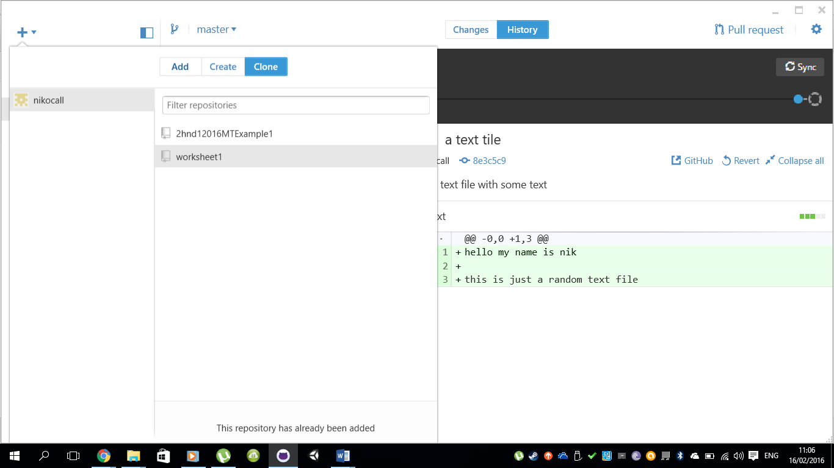

* Commit
  + The commit refers to the reference title of the changes the user has made on the file he/she is working on.

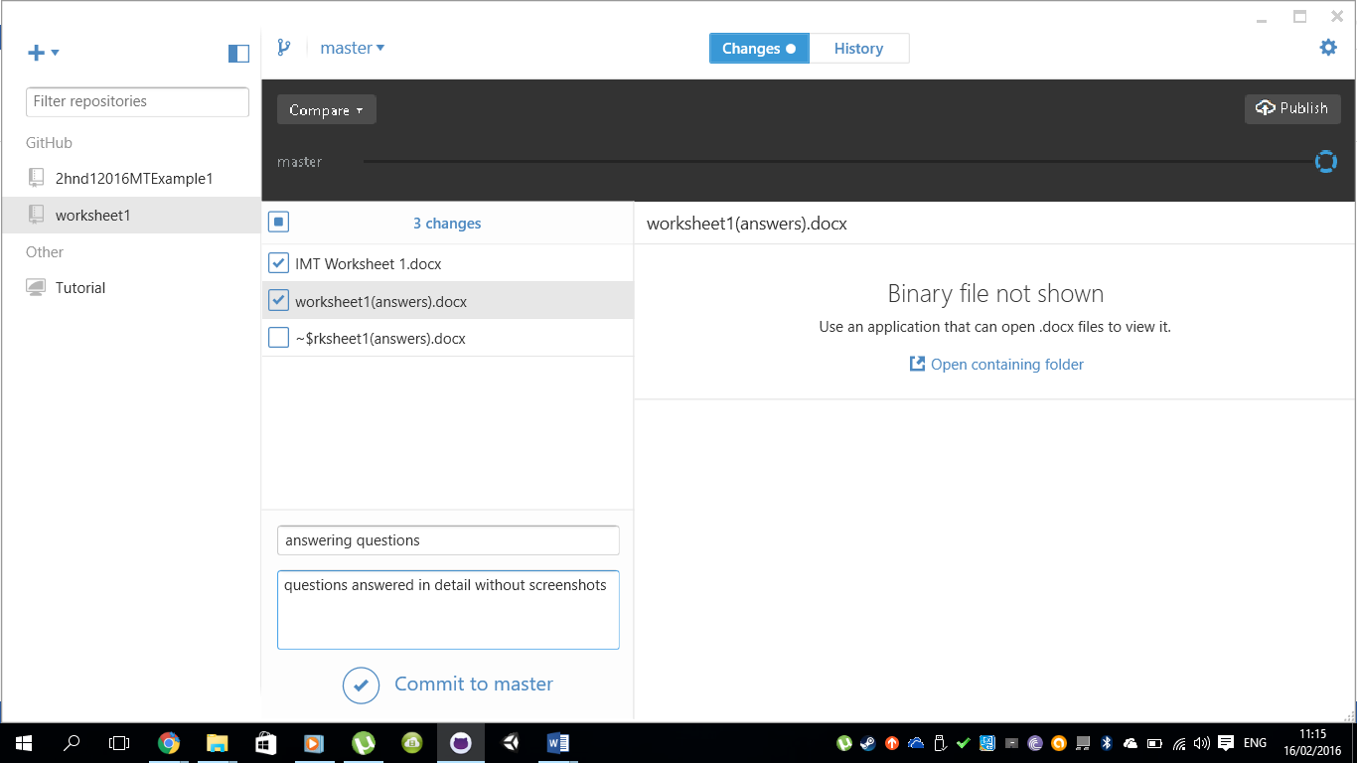

* Commit description
  + The commit description is basically a short description of what the user has changed/added to his/her works as an indication for not only his benefit but also to those who are working on the same file



* Github desktop
  + Github desktop is a seamless way to contribute to projects on GitHub. In other words it is the place where all the work in process is to be placed and shown to your coworkers to show them where you have arrived on your work and to show what changes you may have done with description of what the user has added.

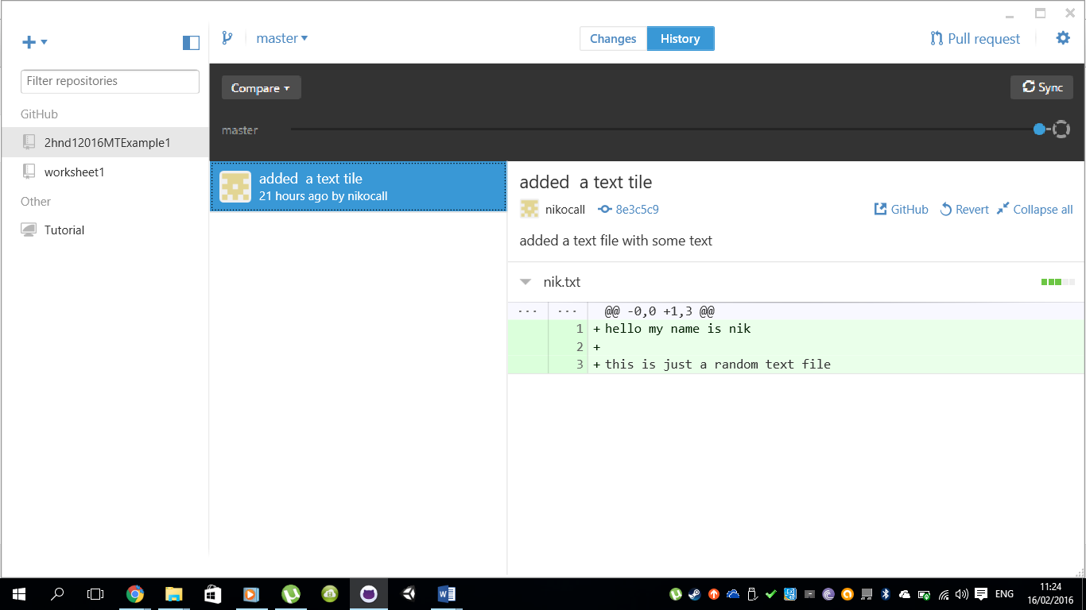

* Git Sync

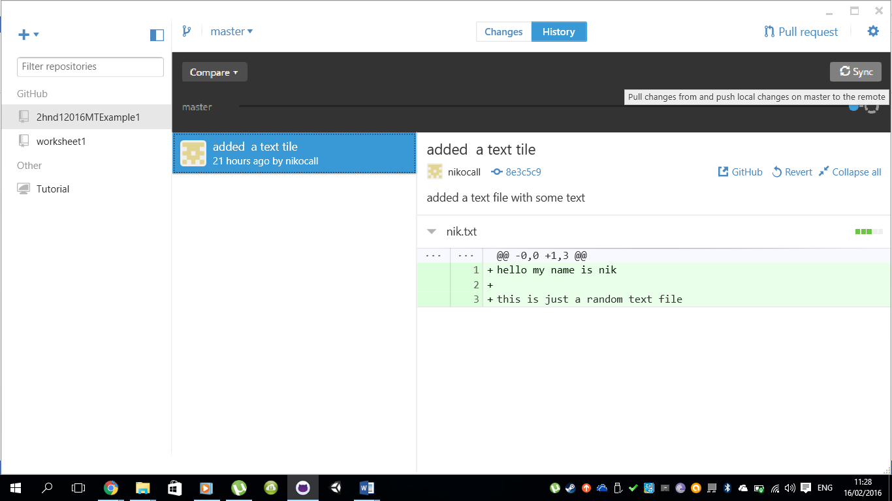

* What ‘download zip’ does.
  + The “download zip’ basically downloads all the files that have been uploaded by the user(the committed files)