Deterministic Layout Bias in a Ring-Oscillator PUF: A Pre-Silicon Study on the Open SKY130 Flow
Nikoloz Demetrashvili · Independent researcher · Georgia
Draft, 2026-07-23

Abstract
A ring-oscillator physical unclonable function (RO-PUF) turns manufacturing variation between nominally identical oscillators into a device secret. The physical implementation can add a deterministic frequency pattern of its own on top of that variation. I isolate this implementation contribution for layouts produced by the OpenLane/OpenROAD flow with the open SKY130 process design kit, by simulating routed netlists and extracted capacitances at the nominal device corner. No fabricated devices have been measured yet.
In an archived dual-arm build, the 16 automatically placed oscillators of Arm A spread 5.4% peak to peak in nominal post-layout simulation; an earlier automatically placed 32-oscillator layout spread 8.8%. The two layouts produced different frequency patterns, which fits placement and routing setting the bias run by run. Within this lumped-capacitance model the spread is almost entirely explained by the extracted ring capacitance the model puts back in as a load (Pearson r = -0.999 and -0.997), so the result worth keeping is the size of the spread and its physical cause, not the coefficient. The comparison arm, Arm B, uses one hardened oscillator macro sixteen times. A single extraction of that macro gives a 569.5 MHz reference for the shared internal layout, which removes internal-layout variation by construction but does not on its own prove a smaller total spread once the chips are made.
The contribution is a pre-fabrication diagnostic, traceable in the repository, that separates nominal layout bias from the variation a PUF is supposed to use. Whether the layout pattern repeats across dies, reduces uniqueness, or enables a practical prediction attack is left for the silicon phase, not claimed here.

1. Introduction
An RO-PUF compares the frequencies of nominally identical ring oscillators and converts comparisons into response bits [1]. Ideally the useful chip-to-chip differences come from manufacturing variation. In practice, placement and routing give instances different parasitic loads, which adds a deterministic component to the comparison.
A fixed layout pattern is not automatically a security failure. Random mismatch may be larger, comparisons may cancel shared structure, and response processing may absorb bias. But a layout component that repeats across chips could reduce uniqueness or make some comparisons predictable, and deciding between those outcomes takes measurements from multiple fabricated devices.
This paper reports the pre-silicon part of that investigation. The question is narrow: with transistor parameters held fixed, how much frequency variation does the physical implementation of one open-source RO-PUF design introduce? I contribute nominal post-layout results for two automatically placed oscillator arrays, a capacitance-based explanation for the observed spread, a matched-macro arm that gives every instance the same internal geometry, the scripts to run the same diagnostic before any fabrication, and the specific predictions I plan to test once chips come back.

2. Background and related work
Suh and Devadas introduced the widely used RO-PUF construction [1]. Maiti and Schaumont examined improved ring-oscillator PUF designs and compensation for systematic effects [2], and later FPGA studies mapped spatial variation and placement-dependent behaviour [3, 5]. Other work proposes statistical bias reduction, configurable structures, and placement-aware designs [5-8]. Katzenbeisser et al. evaluated several PUF constructions, including ring oscillators, across 96 ASICs [12].
The literature does not support a simple rule that any systematic structure makes an RO-PUF predictable. Wilde, Hiller, and Pehl found that adjacent-oscillator comparisons reduced exploitable spatial structure in their data, and that the estimated covariance was too small for their predictor to beat the relevant baseline [4]. That is important counterevidence: layout bias has to be judged together with the comparison scheme, the mismatch distribution, and the attacker model.
Open-source ASIC flows allow an experiment that closed flows make awkward: the designer can read the routed netlist and the parasitic extraction before fabrication instead of treating the implementation as opaque. OpenLane/OpenROAD [9] and the open SKY130 PDK [10] provide that setting, and a TinyTapeout RO-PUF project shows the circuit family works in the same ecosystem [11]. What I did not find is the measurement this paper makes: the nominal frequency component tied to instance-dependent routing in one automated ASIC layout, quantified from the flow’s own extraction.

3. Design under test
The candidate design, tt_um_nikodemetrashvili20_ro_puf, occupies a TinyTapeout 2x2 tile. It holds two 16-oscillator arms and a shared serial measurement core that enables one oscillator at a time and counts its edges over a fixed window.
Each oscillator is a 31-stage ring of SKY130 standard cells: an enable NAND, 30 inverters, and an isolating output buffer tapped near the middle of the chain. A nominal pre-layout SPICE control sits near 633 MHz. Arm A lets the flow place and route each oscillator with the surrounding logic. Arm B places 16 copies of one hardened oscillator macro on a regular grid. The logical circuit is identical in both arms; the physical implementation method is the experimental variable. Figure 1 summarizes the design.
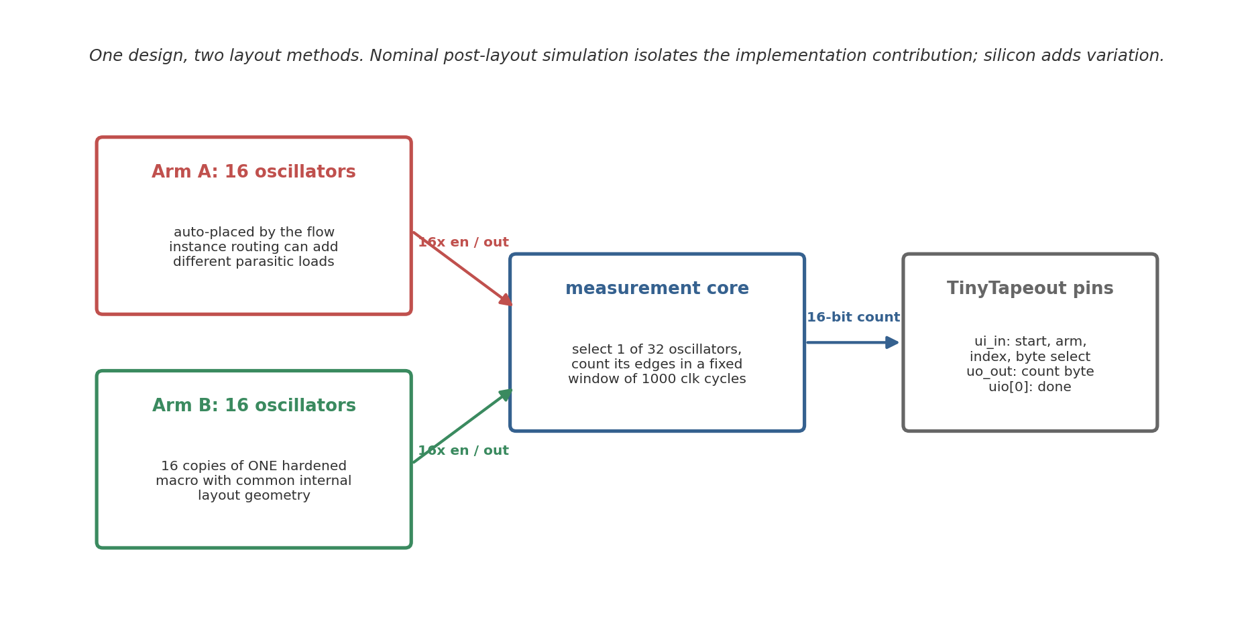
Figure 1. Block diagram of the two-arm design. Arm A lets the flow place and route each oscillator separately; Arm B repeats one hardened macro with a common internal layout.
Two caveats on the comparison itself. Arm B has a macro boundary and different top-level connectivity, so the arms are not perfect experimental twins. And the dual-arm physical results below come from an archived build of an earlier RTL revision; the current source adds synchronized controls, selector latching, and a stopped-counter stability handshake, and will go through a fresh flow run before the shuttle order (see SIGNOFF.md in the repository).

4. Method
The analysis starts from the routed gate-level netlist and the OpenROAD SPEF at the nominal corner. A generator identifies each oscillator, takes the total extracted capacitance from each ring net’s SPEF *D_NET record, and places it as a grounded lumped load. It emits two ngspice decks per automatically placed oscillator: a control deck without parasitics and a post-layout deck with them. Device models stay at the nominal corner, which isolates the layout contribution instead of simulating a population of fabricated parts.
Only one oscillator runs at a time in a real measurement, so coupling to inactive neighbours is treated as a fixed grounded load, and distributed wire resistance is omitted; a separate estimate put its stage-delay effect below 0.1% for these nets. Each oscillator starts disabled and is released by an enable pulse, which avoids a simulation artefact where an artificial initial condition excited an unintended ring mode. Frequency is measured over 20 periods after startup.
For the matched arm, the hardened macro is extracted and simulated once. The 16 instances share one internal GDS, so this single result serves as the internal-layout reference for all of them.
For each automatically placed array I report mean, standard deviation, range, peak-to-peak spread relative to the mean, and the Pearson correlation between frequency and extracted ring capacitance. Instances inside one routed design are not independent samples from a chip population, so these are descriptive statistics for that layout. The extracted capacitance is also the only spread-producing input to the model, so a strong frequency-capacitance correlation is expected almost by construction. The coefficient confirms the model behaves; the spread it produces, and the slope, are the physically interesting parts.

5. Automatically placed arrays

5.1 Earlier 32-oscillator layout
The earlier build placed all 32 oscillators automatically. In the no-parasitic control every deck produced the same nominal frequency, approximately 633.640 MHz, which checks the generator itself. With extracted capacitance the mean was 567.6 MHz with a standard deviation of 10.9 MHz. Frequencies ranged from about 539 to 589 MHz, a 50.2 MHz or 8.8% peak-to-peak spread.
Extracted ring capacitance ranged from 7.4 to 17.8 fF. Frequency and capacitance had Pearson r = -0.997 with a fitted slope of about -4.93 MHz/fF (Figure 2a). Correlations with placement coordinates were much weaker (|r| < 0.27; Figure 2b). For this layout the spread behaves like an instance-specific routing load, not a smooth die-wide gradient.
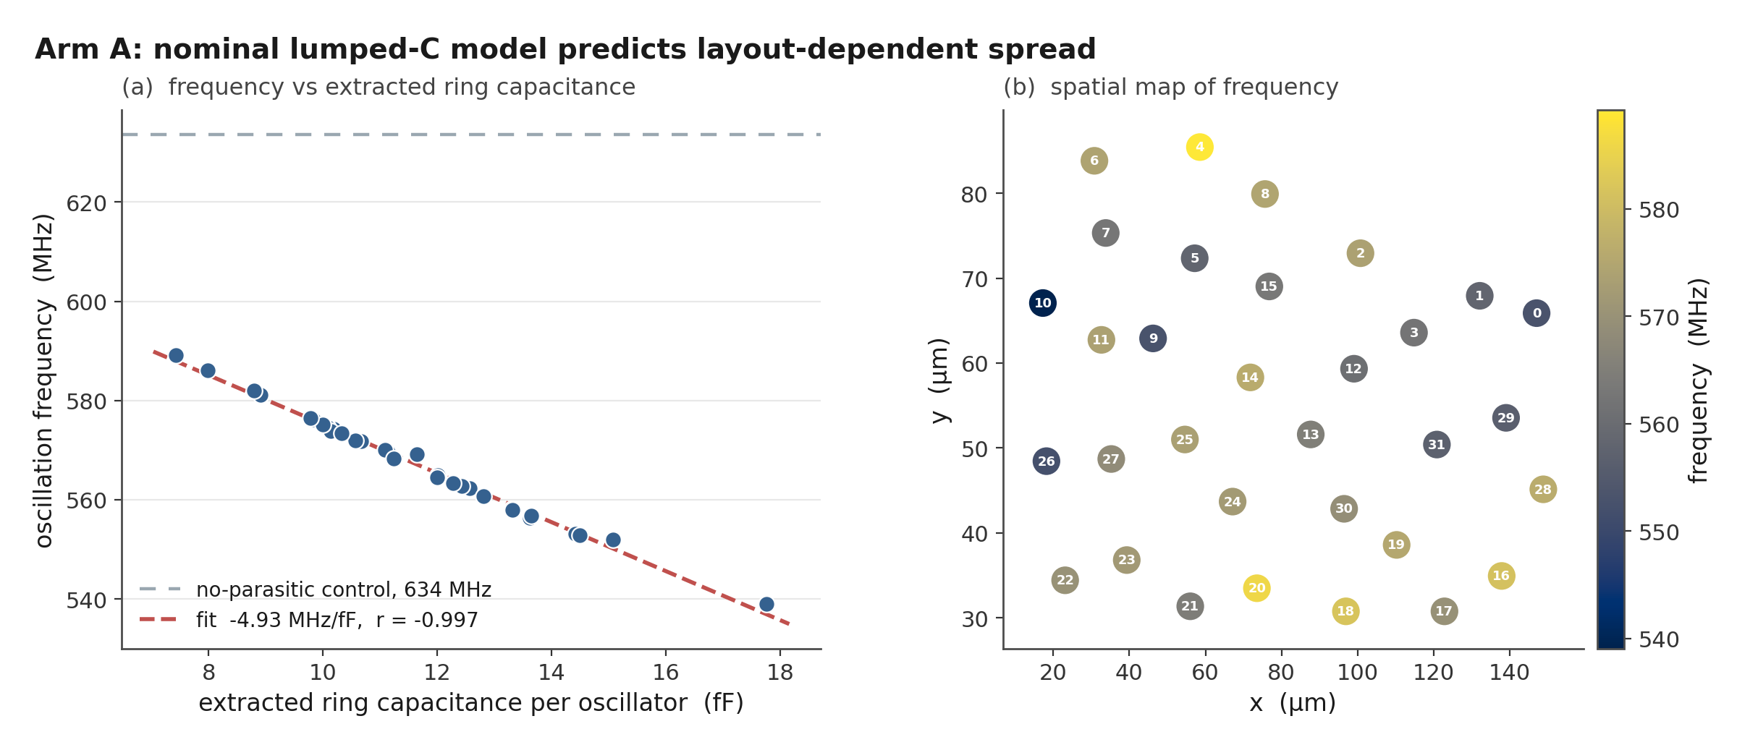
Figure 2. Nominal post-layout results for the earlier 32-oscillator layout: frequency versus extracted ring capacitance with the no-parasitic control, and a spatial frequency map.

5.2 Archived dual-arm Arm A
Arm A of the archived dual-arm layout contains 16 automatically placed oscillators. Their nominal post-layout frequencies have a mean of 551.7 MHz and a 29.7 MHz peak-to-peak range, 5.4% of the mean, with r = -0.999 against extracted ring capacitance (Figure 4).
The two builds do not share a frequency pattern or a spread. Two layouts are not a distribution, but a difference this large fits placement and routing setting the bias for each run. It also means a single layout cannot say what fraction of the response will be common across dies. Usefully, the earlier build’s capacitance fit predicts the archived Arm A mean within 0.10%, so the mechanism transfers between builds even though the pattern does not.

6. Matched-macro arm
The matched construction hardens one oscillator as a 60 x 40 micrometre macro. The macro layout passes the available DRC, LVS, antenna, and connectivity checks, and Arm B places 16 instances of it on a regular grid.
The extracted macro carries about 11.0 fF of total ring capacitance. One nominal post-layout simulation gives 569.5 MHz against a no-parasitic control of 633.15 MHz. The earlier Arm A capacitance fit predicts 570.2 MHz at that load, 0.12% away, a useful cross-check on the model. The macro result also lands within 0.35% of the earlier Arm A mean, so matching did not move the operating point.
Figures 3 and 4 draw Arm B as a single horizontal reference line at 569.5 MHz, because the sixteen instances share one internal layout and there is only one extracted simulation behind it. By construction the internal layout contributes zero spread; fabricated Arm B instances will still differ through device mismatch, top-level routing, supply, and temperature. So the honest pre-silicon claim is narrow. The matched arm removes the internal-layout term, and whether that gives a smaller total spread than Arm A is the measurement the chip exists to make, not something these simulations show.
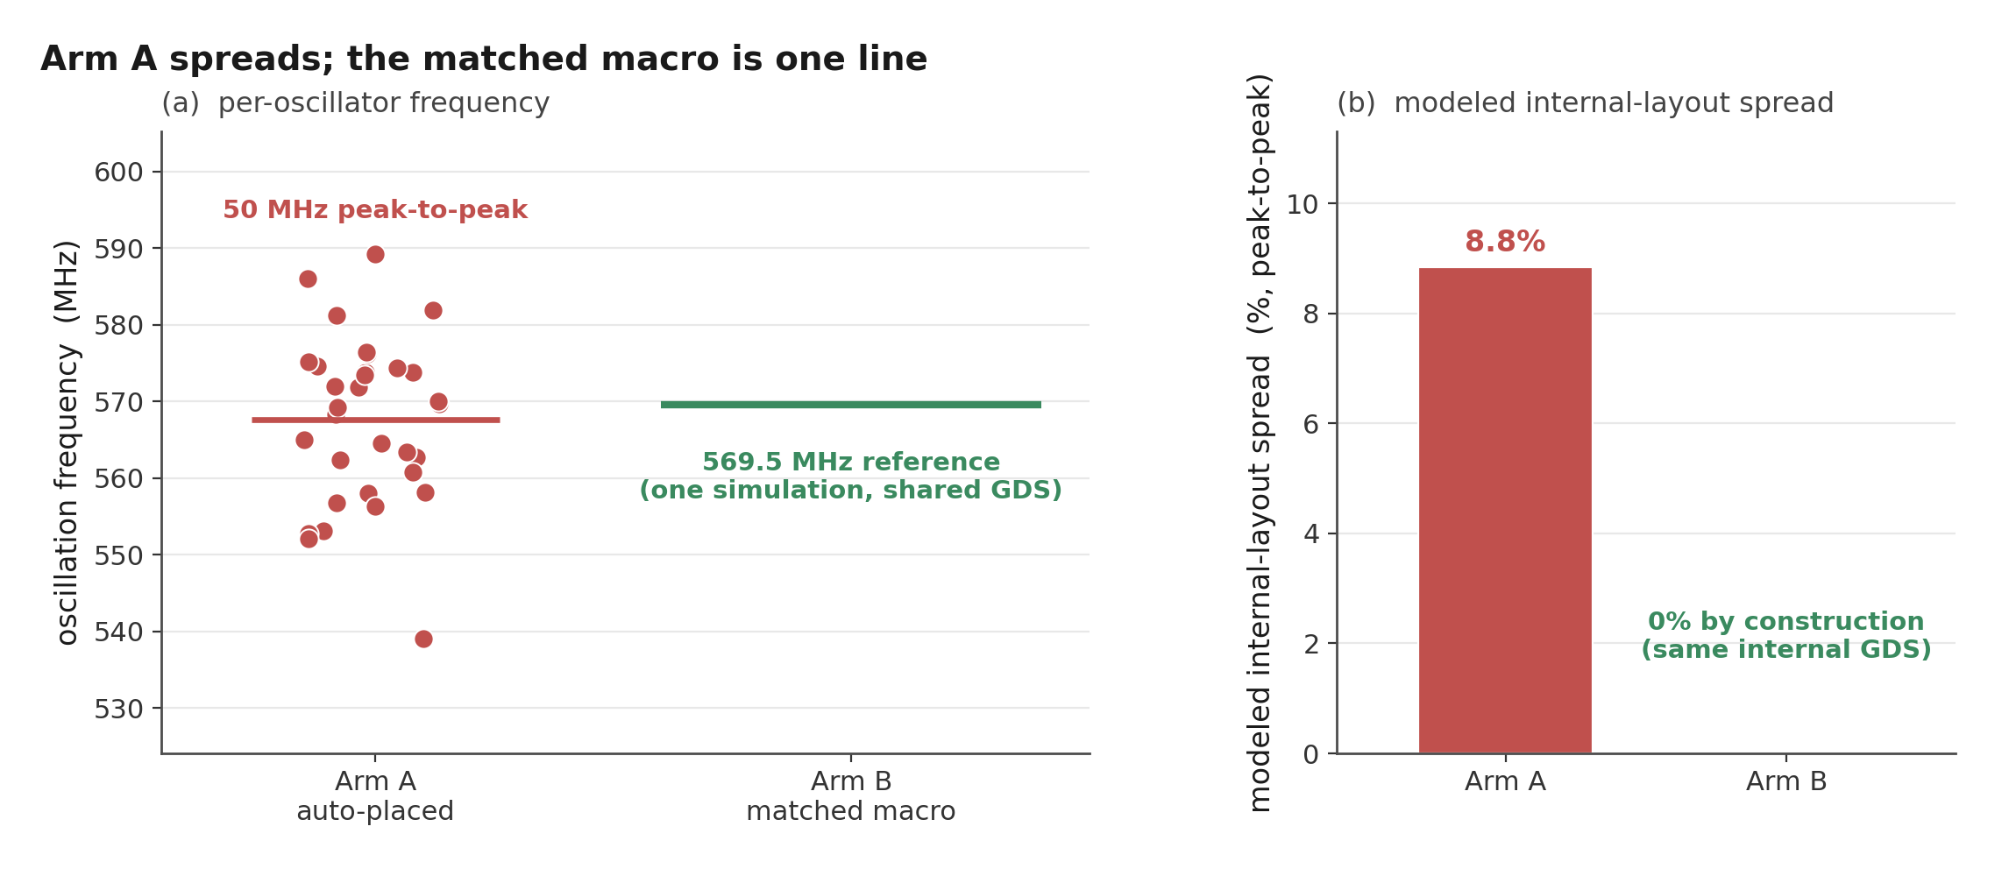
Figure 3. The earlier 32-oscillator array beside the matched-macro reference line at 569.5 MHz.
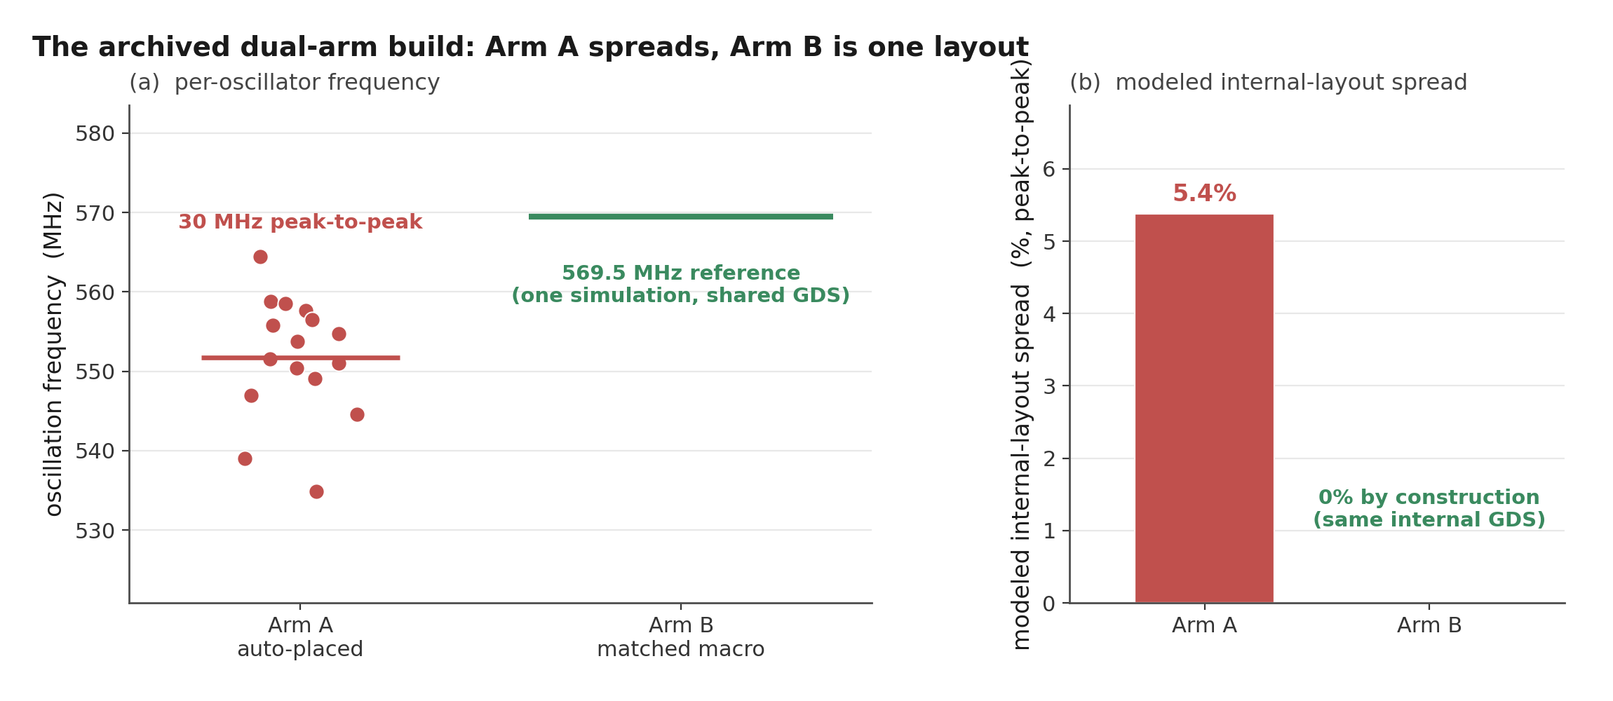
Figure 4. Arm A of the archived dual-arm build beside the same matched-macro reference line.

7. Security interpretation and planned silicon test

7.1 Parametric examples
The repository includes a simple virtual-population model in which each oscillator frequency is a shared layout term plus an independent mismatch term. Under one set of assumptions, 200 virtual chips and eight adjacent comparison bits gave 13.2% inter-chip Hamming distance for the automatically placed pattern and 49.9% for the matched pattern; a position-based predictor scored 91.2% and 49.2%. These numbers illustrate the proposed mechanism. They move substantially when the assumed mismatch scale, comparison pairs, or attacker information change, so I use them to motivate the silicon experiment rather than to quantify a real attack.

7.2 Mismatch scale estimate
A 40-run ngspice Monte Carlo exercise with the PDK’s global mismatch draw gave a frequency standard deviation of 0.345%. Dividing by sqrt(31) gives 0.062% as a first-order estimate of the per-ring contribution from 31 similar stages, with a sampling-only interval of roughly 0.051% to 0.080%. The scaling assumes equal, independent stage sensitivities, which the NAND stage in particular violates, and 40 global draws are not independent local mismatch. On this estimate the archived Arm A layout spread is roughly twenty times the mismatch scale by standard deviation. I treat that ratio as an argument that the layout term is large enough to be worth measuring, not as a measured entropy figure; silicon will measure the denominator directly.

7.3 What silicon has to show
The main question for silicon is whether Arm A retains more of its nominal layout pattern across dies than Arm B. Testing it needs multiple chip IDs, repeated measurements, matched voltage and temperature settings, and a fixed comparison rule; the firmware records chip and condition labels so groups stay separate. The planned metrics are repeatability within chip and condition, centered pattern correlation across chips under the same condition, inter-chip Hamming distance for a predeclared set of adjacent comparison pairs, and within-chip response changes across voltage and temperature. Results count only when the grouping and completeness requirements are met; a single chip or an incomplete oscillator vector does not support a population claim.

8. Limitations
This study is pre-silicon, and its model is deliberately simple. Nominal transistor models carry no random local mismatch. Lumped capacitance omits distributed RC and dynamic coupling; a distributed-RC extraction would test whether the frequency ordering and the spread survive a fuller electrical model, and running it on the fresh build is the obvious next check. Two layouts do not define a distribution over place-and-route seeds, floorplans, flows, or technologies, and instances within a layout are related observations, so instance-level confidence intervals would overstate the evidence. The Arm B reference is one simulation of one macro and cannot quantify fabricated Arm B variation. The 40-run global Monte Carlo cannot reproduce independent local device mismatch. Voltage, temperature, supply noise, ageing, package, and measurement-system effects are uncharacterized until chips exist, and uniqueness, reliability, min-entropy, and attack success all need a multi-chip data set with a stated threat model. The ripple counter is clocked by the oscillator itself, and its behaviour at the fastest corner is checked only in behavioural simulation; the standard-cell flop at the oscillator-to-counter boundary still needs extracted, across-corner timing before I trust the fast end of the range. None of this erases the observed nominal layout component; it bounds what can be concluded from it.

9. Conclusion
Two automatically placed SKY130 RO arrays show a nominal post-layout frequency pattern that tracks extracted ring capacitance closely: 5.4% peak to peak with r = -0.999 in the archived dual-arm Arm A, 8.8% with r = -0.997 in an earlier 32-oscillator build. A hardened macro provides a 569.5 MHz shared-internal-layout reference for Arm B. The supported conclusion is that the automated physical implementation introduced a sizeable deterministic component in these routed designs, and that the mechanism, capacitive routing load, transfers between builds while the pattern itself does not.
The stronger claims stay open on purpose. Whether the pattern survives fabrication, dominates mismatch, reduces uniqueness, or supports a real attack will be settled by measuring both arms of the fabricated chip under the measurement protocol in the firmware, after a fresh physical flow replaces the archived snapshot.

References
[1] G. E. Suh and S. Devadas, “Physical Unclonable Functions for Device Authentication and Secret Key Generation,” Proceedings of the 44th ACM/IEEE Design Automation Conference (DAC), pp. 9-14, 2007. https://doi.org/10.1145/1278480.1278484
[2] A. Maiti and P. Schaumont, “Improved Ring Oscillator PUF: An FPGA-Friendly Secure Primitive,” Journal of Cryptology, vol. 24, pp. 375-397, 2011. https://doi.org/10.1007/s00145-010-9088-4
[3] A. Maiti, J. Casarona, L. McHale, and P. Schaumont, “A Large Scale Characterization of RO-PUF,” IEEE International Symposium on Hardware-Oriented Security and Trust (HOST), pp. 66-71, 2010. https://schaumont.dyn.wpi.edu/schaum/pdf/papers/2010hostm.pdf
[4] F. Wilde, M. Hiller, and M. Pehl, “Statistic-Based Security Analysis of Ring Oscillator PUFs,” 2014 International Symposium on Integrated Circuits (ISIC), pp. 148-151, 2014. https://doi.org/10.1109/ISICIR.2014.7029528
[5] A. S. Chauhan, V. Sahula, and A. S. Mandal, “Novel Randomized Placement for FPGA Based Robust ROPUF with Improved Uniqueness,” Journal of Electronic Testing, vol. 35, no. 5, pp. 581-601, 2019. https://doi.org/10.1007/s10836-019-05829-5
[6] K. A. Asha, L. E. Hsu, A. Patyal, and H.-M. Chen, “Improving the Quality of FPGA RO-PUF by Principal Component Analysis (PCA),” ACM Journal on Emerging Technologies in Computing Systems, vol. 17, no. 3, article 34, 2021. https://doi.org/10.1145/3442444
[7] W.-C. Wang, Z. Li, J. Skudlarek, M. Larouche, M. Chen, and P. Gupta, “UNBIAS PUF: A Physical Implementation Bias Agnostic Strong PUF,” arXiv:1703.10725, 2017. https://arxiv.org/abs/1703.10725
[8] J. Miskelly, C. Gu, Q. Ma, Y. Cui, W. Liu, and M. O’Neill, “Modelling Attack Analysis of Configurable Ring Oscillator (CRO) PUF Designs,” 2018 IEEE 23rd International Conference on Digital Signal Processing (DSP), pp. 1-5, 2018. https://doi.org/10.1109/ICDSP.2018.8631638
[9] M. Shalan and T. Edwards, “Building OpenLANE: A 130nm OpenROAD-based Tapeout-Proven Flow,” 2020 IEEE/ACM International Conference on Computer Aided Design (ICCAD), article 110, pp. 1-6, 2020. https://doi.org/10.1145/3400302.3415735
[10] SkyWater Technology and Google, “SkyWater Open Source PDK (SKY130).” https://github.com/google/skywater-pdk
[11] litneet64, “RO-based Physically Unclonable Function in sky130 (TinyTapeout tt07).” https://github.com/litneet64/tt07-RO-based-PUF
[12] S. Katzenbeisser, U. Kocabas, V. Rozic, A.-R. Sadeghi, I. Verbauwhede, and C. Wachsmann, “PUFs: Myth, Fact or Busted? A Security Evaluation of Physically Unclonable Functions (PUFs) Cast in Silicon,” Cryptographic Hardware and Embedded Systems (CHES 2012), LNCS 7428, pp. 283-301, 2012. https://doi.org/10.1007/978-3-642-33027-8_17

