<https://www.aphasiasoftwarefinder.org>

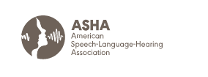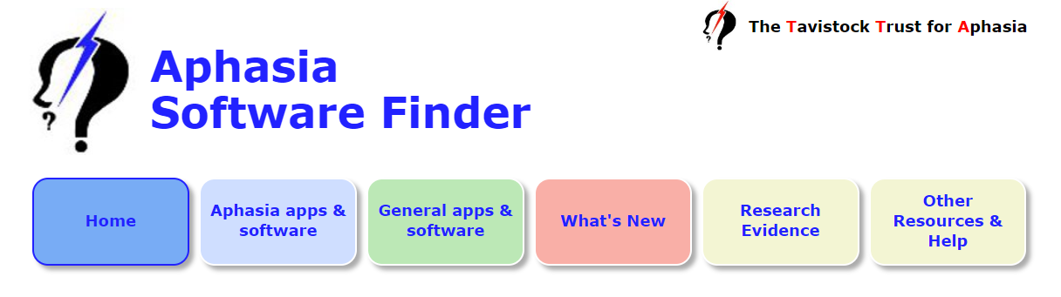

<https://www.asha.org/public/speech/disorders/Aphasia/>

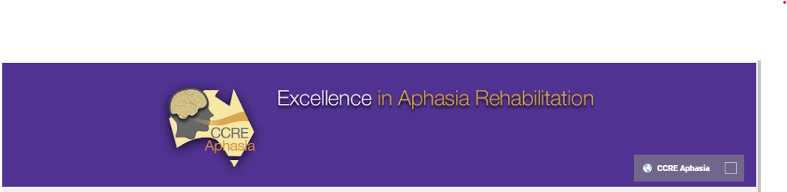

<https://www.youtube.com/user/aphasiachannel>

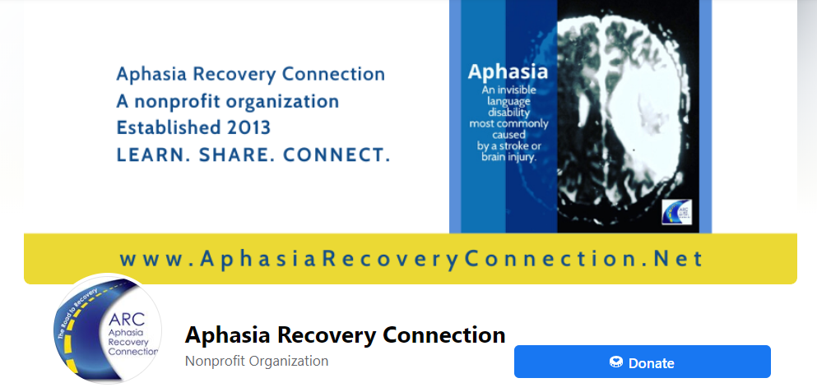

<https://www.facebook.com/aphasiaARC>

[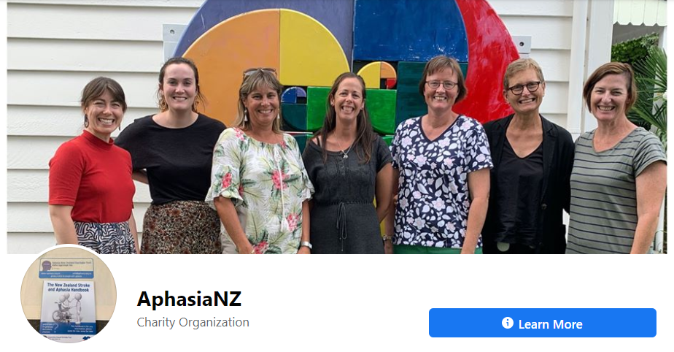](https://www.facebook.com/aphasiaARC)

<https://www.facebook.com/AphasiaNZ>