Car price prediction based on structured scraped data

Nikola Jovišić
Faculty of Technical Sciences
University of Novi Sad
Trg Dositeja Obradovića 6
21000 Novi Sad
nikolajovisic4@gmail.com
Miloš Živić
Faculty of Technical Sciences
University of Novi Sad
Trg Dositeja Obradovića 6
21000 Novi Sad
miloszivic99@gmail.com

Abstract—This scientific paper presents a novel approach to automatizing car pricing based on large datasets of previous car estimations. Due to a lack of structured and wrangled datasets concerning the market in Serbia, the datasets are constructed through web scraping, specifically from polovniautomobili.com. The structured data columns contain attributes such as manufacturer, model, production date, mileage, type of fuel, engine power, registration date, and additional equipment. The dataset also contains images and textual description in free form. The goal is to predict a price based on that to help both buyer and seller to make sure that the deal is fair. Techniques that were tried are MLP neural networks, SVMs, xgboost etc, as well as some MCA dimensionality reduction. Both classification on bucketized price values and regression has been tried out.
Keywords—cars; prices; regression; classification

Introduction

Economy crisis which implied a lack of materials, European ecology laws forbidding diesel vehicles, rise of electric car technology and therefore dismissal of fossil fuel engine research all had a major impact on availability, demand and, of course, price of new, as well as used, vehicles. This phenomenon gave quite a strong motivation to automatize pricing of cars based on large datasets of previous estimations made by other sellers.
To solve this problem, due to a lack of structured and wrangled datasets concerning market in Serbia, datasets which are used are constructed through web scraping, specifically from polovniautomobili.com. For every car advertisement attributes scraped are:
- structured data
- textual description
- images.
Structured data columns concerning manufacturer, model, production date, mileage, type of fuel, engine power, registration date, additional equipment etc. are expected to be the variables contributing the most to a useful car price estimating model. The images and free textual form are not the best source of information that and has been proven in [6] by trying to extract the data from them in this very dataset, so this paper is only focused on the structured data part.
The subject of price prediction is widely defined so it means both regression and classification approaches. Although directly applying regression is probably what first comes to mind when price prediction is considered, classification into buckets of cheap-mid-expensive is something worth considering, and that is what [1] is trying to exploit. Further applying different regression models to different buckets is also something promising.

Data preparation

Expected outputs of the model – prices – were, fortunately, provided through scraping, so no labeling labor had to be carried out. As normalization of outputs is not recommended, it has not been applied, but as this is the price which is being talked about, another type of transformation is recommended, and that is logarithm. Prices tend to follow logarithmic trends, so it makes sense to apply logarithm to labels, and construct the model to transform it back using exponential function for inference and evaluation.
For the inputs it is a bit more complicated. The structure of an ad on polovniautomobili.rs is very rich in the number of attributes, so some decisions had to be made on which to keep, which to drop, which to reduce in dimensionality etc.
A table of data has been formed in a way that first general and additional information, as they are referenced in the data, has been concatenated. The information about additional equipment, as well as safety equipment has been compressed just to one number which is an indicator of how many of those are actually present in the car, but not the details about individual ones.
All the new cars were eliminated from the dataset because they were a very small part of it and arguably needed a completely different model for predicting price because different attributes are expected to contribute to the price of a new and a used car. A lot of the other attributes (of which some could not contribute at all and some maybe could in theory, but in practice would only unnecessarily make the model more complex) like does it has a floating flywheel, is it in the ownership int the papers of the person selling the car on the ad, is it available for buying on a loan, is it an interest-free loan, is the wheel on the left or the right side etc. were also dropped.
The year of production and of registration has been transformed into a number of years passed from the production and the registration till the date of scraping, number of doors turned into an enumerable for 3 or 5 doors, mileage parsed into a number in kilometers, power of the engine used only in one unit (horsepower), emission type of engine ordinally encoded etc.
A more challenging part of preparing the data is to encode manufacturers and models. As there are not that many of them, one-hot encoding both of these columns is certainly one option. On the other hand, for example a combination of a Mercedes and a Focus (Ford model) is something that will never happen, but model will be ‘trained and able to predict’ a price of something like that. Definitely, the vector space representing manufacturer and model made by concatenating one-hot encodings of each of them is unnecessarily large-dimensional.
Another approach would be to reduce this space to a
number of columns = number of manufacturers + number of models of a manufacturer with the largest number of different models.
That way one-hot encoding of manufacturers would be kept, but space for models would be drastically reduced because a column dedicated to model would now have multiple semantics - a column could, for example, represent C class (Mercedes), Focus (Ford), 500L (Fiat) etc. It would not, however, ever represent both B class (Mercedes) and C class (Mercedes) as those are from the same manufacturer. This approach reduces dimensionality by a lot, but it has its downsides. One of them is certainly that there is some non-linear dependencies model has to learn. It has to learn to treat certain attribute representing model completely differently when different manufacturer is considered.
The approach that has been used here is some kind of a compromise between fully widening vector space and embedding as much as can be embedded. The MCA [7] algorithm has been used for reducing dimensionality. Namely, first thing that has been done is that both manufacturer and model columns have been encoded in one-hot manner. Then, instead of keeping it that way, training data encoded like that has been passed to a MCA algorithm. Initially, PCA offered itself as a commonly used option for dimensionality reduction, but because this is categorical data, MCA is used because it is basically a PCA for categorical data. When applied, MCA, similarly to PCA, creates new columns in such a way that last columns are unnecessary because they are constant in all rows. This implies that algorithm finds dependencies between manufacturers and models that were described. When the rank of that new matrix is computed the number of actually independent columns in the new space is acquired and the number of unneeded columns can be computed as
number of unneeded columns = number of columns – rank
and that number of columns can be cut off. What is interesting is what actually that rank and the answer is not as in previously described approach, that is
rank ≠ number of manufacturers + number of models of a manufacturer with the largest number of different models.
but rather a simpler
rank = number of all models.
This happens because when only linear dependencies are caught the model can get rid of model encodings, but it has to have a separate column for every model. That is, not matrix can be constructed to multiply initial one-hot concatenated matrix to a representation from the second approach.
The MCA encoding was kept and experiments with it have even been extended to other categorical attributes in the dataset to even discover some hidden dependencies between attributes.
All columns were normalized using min-max scaling because when histograms of individual columns were displayed it was obvious that more or less data was distributed uniformly and it is suggested to use min-max scaling on uniformly distributed data, rather than standard; while standard scaling is suggested on normally distributed data.
MCA, scalers and other parts of the preprocessing pipeline are serialized to later be used on new data.

Model architecture

For the specific problem of classifying cars into price buckets or conducting regression no pretrained models were found to be available. Therefore, custom models trained from scratch were to be used.
Because the problem (is from a structural point of view) actually very simple, all inputs were transformed into numbers, that is – floating point numbers, no images or data of recurrent nature were to be used; a multi-layer perceptron neural network was chosen as a neural network model. Specifically, architecture chosen after some manual tuning is:

- Linear layer (inputs x 500)
- ReLU activation
- Linear layer (500 x 300)
- ReLU activation
- Linear layer (300 x 15)
- ReLU activation
- Linear layer (15 x 1)
- Sigmoid activation.

Number of inputs is a parameter that changed through different phases of experimenting, as different attributes were chosen and different encodings were used and it was adapted accordingly. In general, it was at the order of magnitude of about 3-5*10².
Number of outputs is 1 because this network was used as a regression model and the one and only output was price (as described in chapter 2, with applied logarithm).
This complexity of architecture seemed to have caught all the important functional dependencies, but not to be too complex to overfit the data or take long to train.
For the price prediction, xgboost was also used, parametrized as maximum depth to 6, eta to 0.2, objective to regression square error.
SVM for regression (SVR) was used parameterized as C=50.0, degree=10.
For the experiments with preliminary classification (classification to buckets), as described in [1] random forest algorithm was tried out.
The idea behind this preliminary classification is to:

- divide into categories for the user
- divide into categories for the model.

That is, classification in the categories itself could be considered the model output, as it can be useful. But for the second point, it is very reasonable to consider different models for different price ranges because cheap and expensive cars are very different in what they have to offer in terms of attributes and therefor attributes affect the price very differently. So, as experimented with in [1], maybe simpler models were more effective on cheap and expensive cars and more complex models on mid-range, or maybe quite the opposite.
So, a random forest classifier with a number of estimators set at 10 and criterion set to ‘entropy’ was used for classifying in 3 different classes. By displaying the histogram of prices interestingly, 3 approximate distributions seemed to be existent and were separable in:

- 0-10.000 EUR – cheap
- 10.000-20.000 EUR – mid-range
- 20.000-55.000 EUR – expensive.

Any car that would be priced above 55.000 EUR would not be considered by the model, and therefore this model is not recommended to be used in cases where user would expect car to be priced in that range.

Training

Training has been conducted on local CPU. Models are not very complex so this is not a problem – training took reasonable time.
Dataset of 5506 car ads has been split into 0.7-0.2-0.1 for training-validation-testing. Batch size used was 30, as suggested in literature. Loss function used was cross entropy loss for multi-class classification task and a MSE loss for regression. For the optimizer ADAM was used because it is considered to be one of the best, especially when it comes to fast converging. Evaluating model on validation set during the training gave insight on an optimal number of epochs, early stopping guidance, saving the best model state dictionary (alongside the mentioned preprocessing pipeline, this is the only model state that has to be serialized in order to be used for inference) etc.

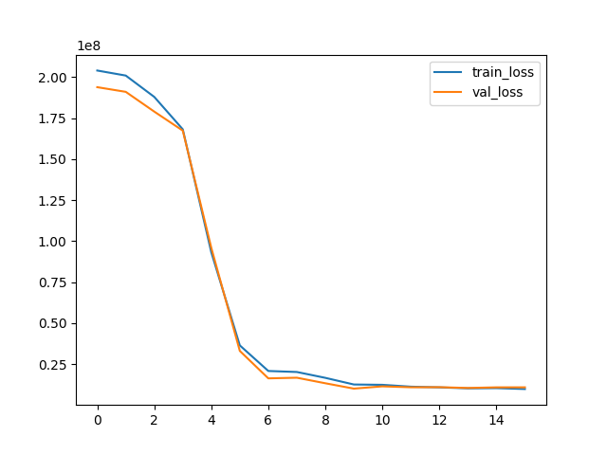
Figure 1 Train and validation loss trough training

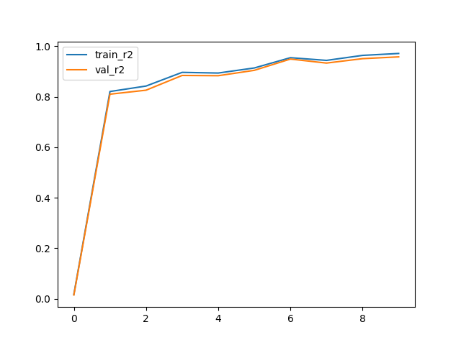
Figure 2 Train and validation R2 score trough training

Results

Sources

[1] Gegic, E., Isakovic, B., Keco, D., Masetic, Z., & Kevric, J. (2019). Car price prediction using machine learning techniques. TEM Journal, 8(1), 113-118. ISSN: 2217-8309. https://doi.org/10.18421/TEM81-16
[2] Venkatasubbu, P., & Ganesh, M. (2019). Used cars price prediction using supervised learning techniques. International Journal of Engineering and Advanced Technology, 9(1S3), xxx-xxx. ISSN: 2249-8958
[3] Monburinon, N., Rungpheung, S., Chertchom, P., Buya, S., Kaewkiriya, T., & Boonpou, P. (2018). Prediction of Prices for Used Car by Using Regression Models. In Proceedings of the 2018 5th International Conference on Business and Industrial Research (ICBIR). Bangkok, Thailand.
[4] Gajera, P., Gondaliya, A., & Kavathiya, J. (2021). Old car price prediction with machine learning. International Research Journal of Modernization in Engineering Technology and Science, 03(03), 284.
[5] Abdi, H., Valentin D., Multiple Correspondence Analysis, Neil Salkind (Ed.) (2007). Encyclopedia of Measurement and Statistics
[6] Živić M., Jovišić N., Car price prediction based on images and textual data (2023) (unpublished)
[7]https://en.wikipedia.org/wiki/Multiple_correspondence_analysis

