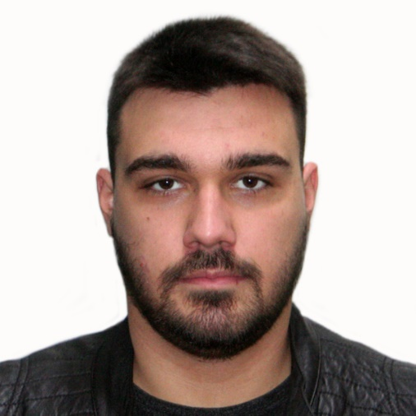 NIKOLA MILJKOVIĆ

Software Engineer

* **EDUCATION**

**Faculty of Technical Sciences | University of Novi Sad**

Bachelor of Engineering – BE

Applied Computer Software Engineering

*October 2017 – May 2023*

Master of Engineering – MEng,

Applied Computer Software Engineering

*October 2023 - Present*

* **PROFESSIONAL EXPERIENCE**

**Continental Automotive | System Test Engineer**

*October 2021 – Present*

*Novi Sad, Serbia*

*Responsible for designing and automating System level tests in order to ensure that the software delivered by the development team meet all specific customer requirements*

**DEVPRO Solutions | .NET/Web Software Engineer**

*September 2020 - October 2020*

*Belgrade, Serbia*

*Student Internship, integration testing of the application and identifying, troubleshooting, and solving application code-related issues*

* **PORTFOLIO PROJECTS**
* WPF application for status monitoring
* Guessing game of two components server and an indefinite number of players using C/C++
* Web Application using ASP.NET MVC
* Web Application using Flask in python 3 with database
* Space invaders game using Python PyQT5
* Create DST Tool application for reading diagnostics files, compare and generate requirements in excel using PyQT5
* Create panel in Vector CANoe for calculate CRC and Clock and export results using CAPL Code
* **LICENSES & CERTIFICATIONS**

Certified Tester Foundation Level (CTFL) ISTQB® - International Software Testing Qualifications Board

# SKILLS

C/C++, Angular, MVC, SQL, Django,

PyQt5, Flask, WPF, JavaScript, Microsoft

Azure, ASP.NET, Networking (UDP/TCP),

SCADA (Modbus protocol), Big Data,

Machine learning, UML, Jira, Git, Docker,

Embedded Software, Requirements

analysis, Soldering, Agile, V-Model, Test

Automation, Electrical measurements,

Microcontrollers (Arduino), PyTest, SWATT,

Selenium, Jenkins, Robot Framework,

MATLAB, VHDL, Issue analysis,

Validation, ASPICE, UDS protocol,

PowerBi, TAF, VDM, AUTOSAR, CAN/LIN

bus, Vector CANoe, CAPL Code, CANoe

DiVa, CANdelaStudio, IBM Rhapsody, IBM

DOORS, DOORS DXL

# LANGUAGES

English – Professional Working Proficiency

German – Elementary Proficiency

Serbian – Native or Bilingual Proficiency

* **CONTACT & INFO**

 29.05.1998

 [sdnikola72@gmail.com](mailto:sdnikola72@gmail.com)

** +**381 649747 247

 Novi Sad, Serbia

 [linkedin.com/in/nikola-miljković-9361481a5](https://www.linkedin.com/in/nikola-miljkovi%C4%87-9361481a5/)

<https://github.com/nikolaaa98>

