1. Write a shell script to get the current date, time, username and current working directory

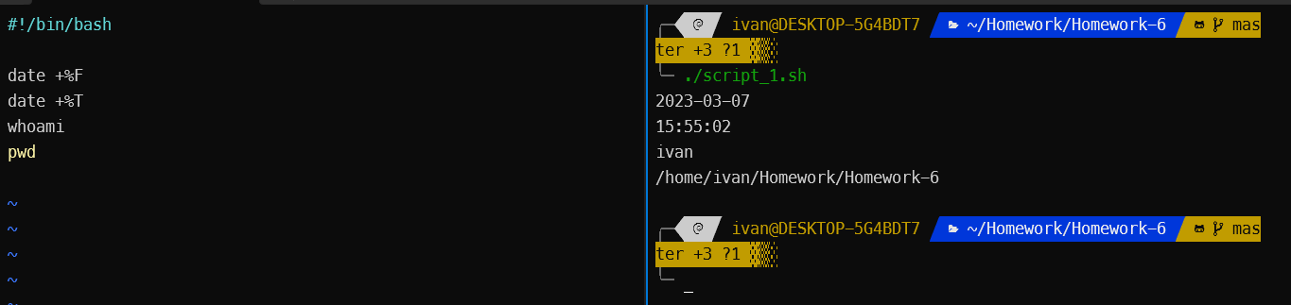

2. Write a shell script that prints “I love learning about DevOps” on the screen. Message should be a variable.

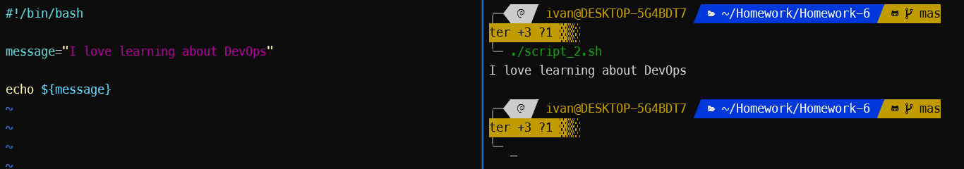

3. Write a shell script that displays “plan code build test release deploy” on the screen with each appearing on a separate line.

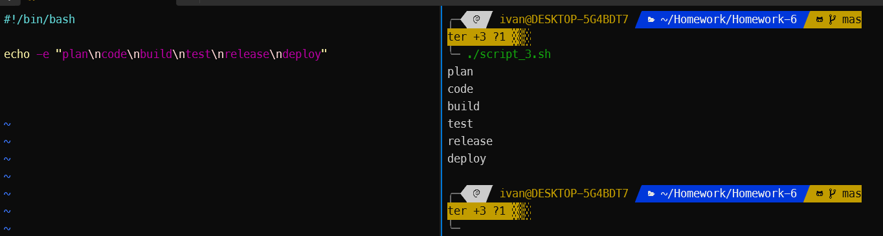

4. Write a shell script that prompts the user for a name of a file or directory and reports if it is a regular file, a directory, or another type of file. Also perform a ls command against the file or directory with the long listing option.

