Deep Learning Autoencoders for Building Principal Component Portfolios

Nikolay Nikolaev
https://nikolaevny.github.io/

Portfolio arbitrage is a practical economic task that searches for profitable investment allocations
in a selected universe of stocks. The dynamics of multiple financial price series from
a portfolio of stocks may be considered to be driven by a number of common economic factors
as well as idiosyncratic terms [1]. This idea stimulates the research into machine learning
methods which investigate hidden factor models of cross-covariances between asset prices.
Two popular methods for finding latent factors are the Principal Component Analysis
(PCA) [2] and the Autoencoders (AE) [3],[4]. They help to discover combinations of stocks
(market factor) that explain most of the variance in the selection (systematic risk). Having
such factors facilitate the creation of market neutral portfolios by treating the remaining
idiosyncratic risk as a mean-reverting (Ornstein-Uhlenbeck) spread process [5]. The spread
can be modeled by a differential equation to generate trading signals when the spread is
away from the equilibrium level (historical mean).

Although there are various algorithms for principal transformations of stock returns into
uncorrelated factors, there are two desired characteristics that most of them fail to deliver:
1) the algorithms should be robust, that is capable of reliable processing of noisy, corrupted
by outliers data; and 2) the algorithms have to identify smooth mappings, that is models that
produce smooth functions leading to fewer whipsaws (since they hinder the generation of
profitable trading signals). Both these characteristics can be obtained by training of the
underlying latent factor model using Bayesian techniques [6] because: 1) they can handle
the output noise through a a suitably chosen ((heavy-tailed Student-t) probability distribution
so as to overcome the effects from the outliers; and 2) they can handle separately the
uncertainty of the weight parameters by imposing on them a corresponding distribution
that impacts the smoothness of the model.

The standard PCA procedure [2] computes statistically optimal factors, but can not directly
achieve these two features. The alternative probabilistic PPCA [6] provides means for
probabilistic treatment for principal component extraction, however it still manipulates
large matrices offline which renders it numerically unstable and inaccurate. There are
robust RPCA [7] versions that attempt only to trim outliers but they are inefficient on data
coming from heavy-tail distributions. There are also incremental (online) IPCA algorithms [8]
for online processing of the latent model, but they perform greedy search which leads to
suboptimal results. Overall, the the traditional PCA has several limitations: 1) it may fail
to compress enough information into a few principal components because it may not be
able to capture enough variance (this may happen if the provided series are not sufficiently
interrelated); 2) the procedure is sensitive to noise and outliers as outliers cause large
deviations in the principal components and lower the accuracy of the results (this may
happen as the procedure extracts factors from normal variations while financial price series
are typically non-Gaussian).

A contemporary approach to stable principal component analysis provide the Autoencoder (AE)
networks [3],[4],[9]. The Autoencoders are deep learning machines that extract latent factors
and approximate the given input without explicit calculation of the covariance matrix. The
training of an AE finds weights that specify the directions in the data with maximal variances,
seeking minimal square error between the original inputs and the transformed representation.
A two-layer autoencoder network with linear activations is equivalent to the PCA model in
the sense that the AE weight matrix projects the data in the same principle subspace spanned
by the PCA loading vectors. Although the weights correspond to the factor loadings, as they
are also used to create the principal components, they are not identical to the loadings. The
Autoencoders are especially convenient for online learning and large scale problems as they
can be trained iteratively using modern stochastic gradient descent techniques [3].

Our research develops efficient portfolio trading tools using Autoencoder networks that
discover principal components via Bayesian treatment of the model. Following Variational
Bayesian inference [6] we obtain analytical formulae for all model parameters (including
the noise variance and the individual regularizers for each weight). The AE performs weighted
encoding of the inputs into a lower dimensional space, and next weighted decoding of the
compressed copy back to an approximate version in the original space (using a non-Gaussian
reconstruction error model). The inferred weights, corresponding to the eigenvectors of the
covariance matrix, are taken to calculate the allocations for the stocks in the eigenportfolio.
More precisely, we construct an eigenportfolio as a linear combination of all stocks which
are allocated contributions according to their corresponding coefficients in the first principal
component (that is, the combination explains the maximal variance in the data). Trading
positions are opened/closed when the z-score statistic of the residual spread exceeds the
predefined limits of theoretical mean-reverting behaviour.

An implementation of the deep learning Autoencoder was applied to build and trade
a portfolio of stocks from the technology sector. Daily closing prices of 11 co-integrated
stocks (with tickers: GOOGL,AAPL,MSFT,MU,INTC,CSCO,BIDU,ADBE,TXN,AVGO,QCOM)
were downloaded from internet (1/1/2010 - 30/12/2018). Our trading robot was made to
buy (sell) shares of GOOGL and sell (buy) shares of the stocks from the synthetic portfolio
allocated according to their regression coefficients. Empirical tests were conducted using
rolling data windows from the past six months for spread computation and model calibration.
The results from the back-testing experiments show that the AE-based strategy rapidly
identifies trading opportunities and achieves systematically good profits with minimal risk.
The econometric performance evaluated over the out-of-sample (unseen) future 2230 days
was as follows: Success rate 74.93%, Cumulative return [PnL] 1015.62%, Annualized
Mean Return 124.38%, Annualized StDeviation 71.05%, Annualized Sharpe Ratio 1.71,
and Maximum Drawdown 0.1966. The constructed eigenportfolio out-performed the
Gaussian model, and also a benchmark Dynamic Factor Model [1],[10] for portofios.
The plot in the figure below shows the first two principal components of the covariance
matrix and the dispersion-location ellipsoid [11] of all stocks at the end of the trading period.
This plot demonstrates visually that the AE method really learns ortogonal weight vectors,
in other words the obtained factors are uncorrelated and each of them provides unique
information. It should be noted that these two components captured respectively 65.36%,
and 10.17% of the variance in the data.

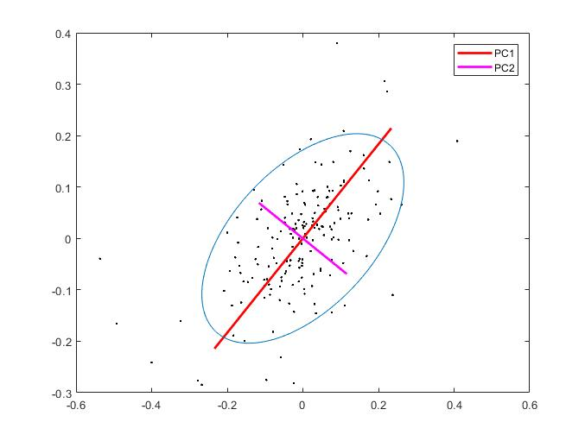
References:

[1] Pitt,M.K. and Shephard,N. (1999). Time-Varying Covariances, In: J.M.Bernardo, et al.,
Bayesian Statistics 6, Oxford University Press, pp.547-570.

[2] Jolliffe,I.T. and Cadima,J. (2016). Principal Component Analysis: A Review and Recent
Developments, Philosophical Transactions. Series A, Mathematical, Physical, and Engineering
Sciences, vol. 374, N:2065.

[3] Goodfellow,I., Bengio,Y. and Courville,A. (2016). Deep Learning, MIT Press, Cambridge, MA.

[4] Heaton,J.B., Polson,N.G. and Witte,J.H. (2016). Deep Learning for Finance: Deep Portfolios,
Applied Stochastic Models in Business and Industry, vol.33, N:1, pp.3-12.

[5] Avellaneda,M. and Lee,J-H. (2010). Statistical Arbitrage in the US Equities Market,
Quantitative Finance, vol.10, N:7, pp.761-782.

[6] Bishop,C. (2006). Pattern Recognition and Machine Learning, Springer-Verlag, New York.

[7] Hallin,M., Paindaveine,D. and Verdebout,T. (2014). Efficient R-estimation of Principal
and Common Principal Components, J. American Statistical Association, vol.109, pp.1071–1083.

[8] Cardot,H. and Degras,D. (2018). Online Principal Component Analysis in High Dimension:
Which Algorithm to Choose?, International Statistical Review, vol.86, N:1, pp.29-50.

[9] Hinton,G.E. and Salakhutdinov,R.R. (2006). Reducing the Dimensionality of Data with
Neural Networks, Science, vol.313, N:5786, pp.504-507.

[10] Nikolaev,N. and Smirnov,E. (2012). Analytical Factor Stochastic Volatility Modeling for
Portfolio Allocation, In: R.Yager and R.Golan (Eds.) Proc. IEEE Conf. Computational
Intelligence for Financial Engineering and Economics (CIFEr-2012), New York, pp.78-85.

[11] Meucci,A. (2005). "Risk and Asset Allocation", Springer-Verlag, Berlin.

