Self-Tuning Local Learning Machines for
Prediction of Stock Market Returns

Nikolay Nikolaev
https://nikolaevny.github.io/
Current advances in machine learning provide various sophisticated models for predicting financial time series. The proper use of such models for analysing real-world data requires good understanding of their theoretical underpinnings. When reporting unsuccessful results, however, many researchers erroneously tend to blame the poor results on the insufficient generalization potential of the considered models. Our studies found that one common problem in handling financial time series is the incorrect selection of the machine learning strategy: global vs. local learning.
The selection of a proper learning strategy is extremely important for the success of the time series modelling technology. Processing directly price series (after detrending) requires global methods of high dimensionality because such series typically feature long distance autocorrelations. For example, one can develop deep-memory models using internal or external memory. Processing returns on prices requires local models of low dimensionality as return series typically show low autocorrelations. The nearest neighbour approach to local learning is especially appropriate for describing stock return movements because it is less affected by the changing autocorrelations in price series depending on the volatility.
The local learning machines (LLMs) based on the nearest neighbours approach [1],[2] are very suitable tools for modeling time series of returns on prices. LLM often outperform global models, and are found significantly better than random walk models on such financial tasks such as: stock market prediction [3],[4],[5],[6] macroeconomic forecasting [7], commodity markets [8], exchange rate prediction [9], [10], interest rates calibration [11], etc.. The nearest neighbours procedure searches over the past time series for finding behaviour patterns (represented by lagged vectors of a chosen embedding dimension) having similar shape to the recent reference vector (these are the values immediately preceding the last in the series). The assumption is that the evolution of nearest segments can be exploited to make reasonable forecasts.
Most practical applications simply implement the standard nearest neighbour regression framework [1],[2] without improvements. It includes two steps: 1) neighbour selection, and 2) forecast generation. The selection usually considers the traditional Euclidean and Mahalanobis distances for measuring the closeness between the neighbours and the reference vector directly. The forecast generation is made using one of the three methods [12]: 1) local linear approximation (LLA) [1]; 2) linear interpolation method (LIM) [13], and 3) local hyperplane approximation (LHA) [14]. The first two methods LLA and LIM involve least-squares fitting which when applied to financial time series leads to suboptimal results (phase delayed predictions) because the lagged input patterns from time series are not exactly independent. The third LHA method extrapolates the future points in proportion to the discrepancy between the neighbours and the reference vector, but it is equivalent to the LLA and the LIM. A significant amount of research uses weighted ensemble averaging for prediction, but it is inferior to the above three methods.
When comparing two segments from a financial time series one can not expect precise shape matching between, rather we should be interested in finding nearly close patterns after performing invariant transformations on them. The key idea is to design a self-tuning mechanism that adapts the patterns for achieving accurate and robust nearest neighbour learning. That is why, we apply a linear transformation to make the similarity less sensitive to the magnitude and phase of the serial data. Note that the typical distance measures only estimate spatial correlations but not temporal dependencies.
Our research invented a Self-tuning Local Learning Machine (SLLM) that performs nearest neighbour regression especially for predicting financial time series. It performs self-adaptive translations of the neighbouring vectors during both phases selection and forecasting. The SLLM is original and involves two elaborated phases:
- Invariant neighbour selection- it takes a predefined number of nearest patterns using an invariant distance metric to determine the proximity after linear transformations of the vectors, the metric accounts for the changes in the magnitude and period for accurate estimation of the nearness. The chosen close neighbours are taken to generate a forecast with a corresponding weighting, calculated with a suitable weighting function (this function is positive, monotonically decreasing and smooth with respect to the distance);
- Local movement extrapolation- the prediction is made by averaging over the future series movements after the neighbours. The predicted next series values accommodate effects from the adjusted shapes formed by the changes in the series amplitude and trend. This is a kind of iterative extrapolation, rather than forecasting with coefficients obtained by fitting.
Implementations of SLLM prototypes are available in Matlab and C/C++ (versions in Java and Python are coming soon). Our expertise is in using the SLLM models to design daily trading algorithms (for stock market indices and prices) with various technical indicators.
The figure below illustrates the accurate forecasting without phase delay achieved by the SLLM tool on a particular series of returns from the DJI stock market index (closing prices). Training was carried out using 1000 index values from 4 recent years ending on 5 January 2018. The econometric performance estimated with one-step ahead predictions of the last 800 days (the plot shows the predictions from 20 July 2015 to 10 November 2015) using a simple dual moving average crossover trading strategy (buy when the predicted price is higher than MA(5) and sell when the predicted prices goes below MA(5)) is as follows: Hits 76.72 %, Number of Trades 221, Profitable trades 161, Success rate 72.83, Mean return (per trade) 24.35, StDeviation (per trade) 81.65, Sharpe ratio 4.27, and Maximum drawdown 0.28. The real total profit was 2.37 times the buy and hold profit. The high directional accuracy means that even higher profits can be obtained with more sophisticated trading strategies.
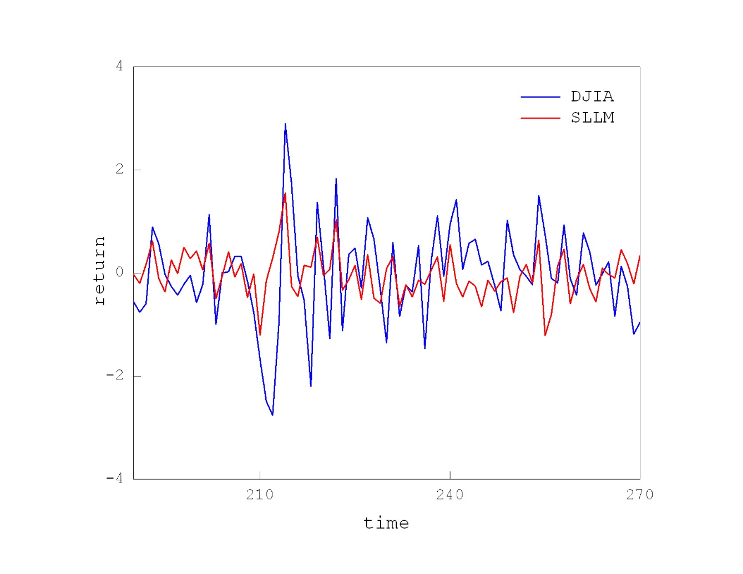
References:
[1] Doyne Farmer,J. and Sidorowich,J.J. (1987). Predicting chaotic time series, Phys. Rev. Letters, vol.59, pp.845-848.
[2] Casdagli, M. (1989). Nonlinear prediction of chaotic time series. Physica D, vol. 35, pp.335–356.
[3] Teixeira,L.A. and De Oliveira,A.L.I. (2010). A method for automatic stock trading combining technical analysis and nearest neighbor classification, Expert systems with applications, vol.37, no.10, pp.6885–6890.
[4] Huck,N. and Guegan,D. (2005). On the use of nearest neighbors in finance. Revue de Finance, vol.26, pp.67-86.
[5] Shi,Y., Gorban,A.N. and Yang,T.Y. (2014). Is it possible to predict long-term success with k-nn? A Case study of four market indices (FTSE100, DAX, HANGSENG, NASDAQ), Journal of Physics: Conference Series, vol. 490, no.1.
[6] Zhang,N., Lin,A. and Shang,P. (2017). Multidimensional k-nearest neighbor model based on EEMD
for financial time series forecasting, Physica A, vol.477, pp.161–173.
[7] Guerrón-Quintana, P. and Molin,Z. (2017). Macroeconomic Forecasting in Times of Crises. FEDS Working Paper No. 2017-018.
[8] Agnon,Y., Golan,A. and Shearer,M. (1999), Nonparametric, Nonlinear, short-term forecasting: theory and evidence for nonlinearities in the commodity markets, Economics Letters, vol.65, pp.293-299.
[9] Gencay,R. (1998). The predictability of security returns with simple technical trading rules, Journal of Empirical Finance, vol.5, N:4, pp.347-359.
[10] Fernández-Rodríguez,F., Sosvilla-Rivero,S. and Andrada-Félix,J. (2004). Nearest-Neighbour Predictions in Foreign Exchange Markets. In: Chen SH., Wang P.P. (eds) Computational Intelligence in Economics and Finance. Advanced Information Processing. Springer, Berlin.
[11] Barkoulas,J. Baum,C.F. and Chakraborty,A. (2003). Nearest-Neighbor Forecasts of U.S. Interest Rates. Int. Journal of Banking and Finance, pp.119-135.
[12] Liu,Z., Ren,X. and Zhu,Z. (1997). Equivalence between different local prediction methods of chaotic time series, Physics Letters A 227, pp.37-40.
[13] Linsay (1991). An efficient method of forecasting chaotic time series using linear regression, Physics Letters A, vol. 153, pp.353-356.
[14] Navone,H.D. and Ceccatto,H.A. (1995). Forecasting chaos from small data sets: a comparison of different nonlinear algorithms, Journal of Physics A: Mathematical and General, vol.28, N:12, pp.3381-3388.

