Universal Cointegration for Pairs Trading via Machine Learning

Nikolay Nikolaev
https://nikolaevny.github.io/

Pairs trading [1], [2], [3] exploits arbitrage opportunities arising when the prices of two stocks
with common trends diverge temporarily from their average relation. Statistical evidence for stable
long-term common movements in price series can be obtained with the cointegration measure [4].
Two series of stock prices are cointegrated in their linear combination produces a stationary residual difference series (also called spread). The important property of of a stationary spread series is that
it oscillates in time around its mean. The presense of cointegration facilitates the implementation of
mean-reverting trading strategies [5]. Such a trading strategy captures the divergence of the spread
from the historical average and generates a corresponding decision: buy the under-valued stock,
and sell the over-valued stock.

One popular method for detecting cointegration is the Granger causality test [6]. It builds
autoregressive models to represent the temporal relationships between the series and selects lagged
input variables for them. When the considered series are causally connected, the information from
one of the series helps to improve the forecasting of the other. The success of the regression is judged using statistical measurements for stationarity in the residuals. A weakness of the Granger method
is that it critically relies on the use of linear regression models. The problem is that their parameters
are estimated by least squares fitting, which suffers from numerical instability and entails overfitting
of the data. Moreover, the linear regression models are used as global approximators that are
unreliable for describing financial time series (it is commonly assumed that prices and returns have properties of Brownian motion [7]). All these disadvantages affect unfavourably the profitability
when taken for pairs trading.

The modern approach is to search for universal cointegration [8] using machine learning techniques.
The universal cointegration analysis identifies stationary long-term relationships without restricting
the integration order to one, without limiting the model coupling to be linear, and without requiring
independence of the variables within the model. This analysis uses the method of Convergent Cross
Mapping (CCM) [9] which assumes that a pair of series feature the same dynamics, and makes
predictions as cross-combinations from past temporal segments (known as neighbors). The CCM uses
the non-parametric k-Nearest Neighbor (kNN) algorithm to look for positive correlation. The accuracy
of the results depend on the tuning of the kNN algorithm, in the sense of tuning the embedding
dimension and the search depth. It should be noted that the kNN handles implicitly the noise in the
data, avoids overfitting, and achieves reliability in the machine learning for pairs trading [10].

Our research developed a pairs trading tool based on universal cointegration implemented following
the CCM method. The CCM learns to reproduce the causal dynamics of pairs from time series by
constructing a function that takes close mutual neighbors as arguments. We designed a specialized
kNN algorithm for local learning from coupled financial time series. This kNN algorithm has two
original and distinguishing aspects: 1) invariant neighbour selection- it calculates similarity after
making adjustments to the amplitudes and periods of the candidate temporal patterns; and 2) mutual centroid prediction- it computes future values by combining data from coupled neighbors and
weighting the succeeding points after the precedents. This is a self-adaptive, noise-tolerant learning mechanism whose output is tested to determine whether universal cointegration between the series
exists. The extend of comovement is evaluated with the Pearson correlation coefficient.
Experimental investigations with recent prices of two benchmark stocks [5] for pairs trading
demonstrated that the novel tool has potential to generate excess returns. Daily closing prices of
the Coca-Cola Company (KO) and PepsiCo Inc. (PEP) from the period 2/1/2013 to 28/9/2021
were downloaded from the Internet. We computed residual spreads from their combination and
treated them as stochastic Ornstein–Uhlenbeck (OU) processes [2] in order to describe properly
their mean-reverting behaviour. The trading rule for exploiting the relative movements of these
processes was made with fixed levels for opening/closing positions, without using stop-loss
conditions, and without using prespecified time limits for holding the opened positions. The
spreads were smoothed in advance with hyperparameters optimized with training data from
the initial period 2/1/2013 to 23/9/2016.

Backtesting was carried out by walking forward over the data from the recent five years
(from 26/9/2016 to 28/9/2021). We used a rolling window of 30 days for machine learning of
three kinds of models incorporated in the pairs trading tool: 1) an AR(1) model calibrated by
a simple linear estimation algorithm; 2) a Granger regression (GR) model with automatic order
selection and ordinary least squares fitting; and 3) a kNN local model with nonparametric learning
within the CCM methodology. Before running these training algorithms the model order was
determined using the Bayesian Information Criterion (BIC). The economic performance was
evaluated with several measures of the accumulated wealth as well as with several risk measures.
The results (calculated over the entire time interval) given in the table below indicate that the
novel pairs trading tool using the CCM/kNN local model outperforms on daily trading the other
versions, using respectively GR and AR models, as it achieves higher profits with lower risk.

---------------------------------------------------------------------
Performance Statistics CCM/kNN GR AR
---------------------------------------------------------------------
Number of Trades 34 34 36
Profitable trades 26 19 24
Success rate 75.78% 66.81% 64.67%
Cumulative Return [PnL] 338.22% 269.74% 185.91%
Annualized Mean Return 71.74% 57.11% 38.36%
Annualized StDeviation 48.15% 47.35% 35.58%
Annualized Sharpe Ratio 1.48 1.26 1.12
Maximum Drawdown 0.0807 0.1077 0.2463
---------------------------------------------------------------------

The following plots illustrate the given price series (top panel), the computed spread with
with the buy/sell threshold lines (middle panel), and the evolution of the profits achieved
with the implemented three models (bottom panel).

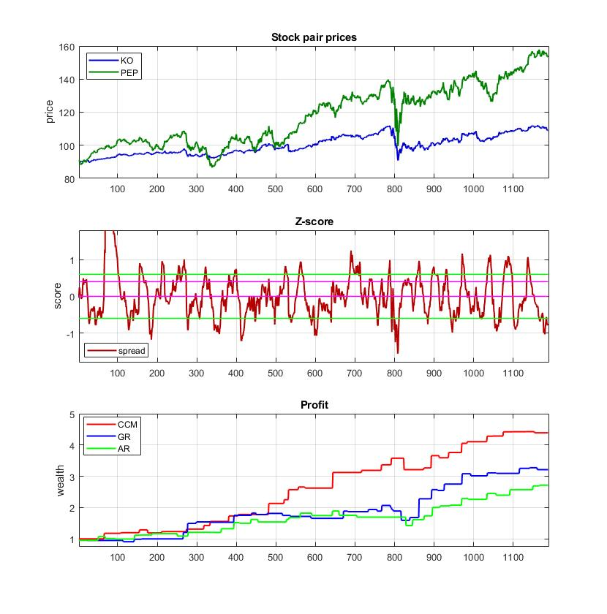
References:

[1] Vidyamurthy,G. (2004). Pairs Trading: Quantitative Methods and Analysis. John Wiley and Sons, Hoboken, NJ.

[2] Elliott,R.J., Van Der Hoek,J. and Malcolm,W. P. (2005). Pairs Trading, Quantitative Finance, vol.5, N:3, pp.271-276.

[3] Krauss,C. (2016). Statistical Arbitrage Pairs Trading Strategies: Review and Outlook, Journal of Economic Surveys,
vol.31, N:2, pp.513-545.

[4] Engle, R. F. and C. W. J. Granger (1987), Co-integration and Error Correction: Representation, Estimation and Testing,
Econometrica, 55, 251–276.

[5] Chan,E. (2008). Quantitative Trading: How to Build Your Own Algorithmic Trading Business, John Wiley and Sons.

[6] Granger,C.W.J. (1969). Investigating Causal Relations by Econometric Models and Cross-spectral Methods,
Econometrica, vol.37, N:3, pp.424–438.

[7] Hull,J. (2018). Options, Futures and Other Derivatives, 9th edition, Pearson Education, Harlow, England.

[8] Tu,C.,Fan,Y. and Fan,J. (2019). Universal Cointegration and Its Applications, iScience, vol.19, pp.986-995.
Available at SSRN: https://www.sciencedirect.com/science/article/pii/S2589004219303268.

[9] Sugihara,G. et al. (2012). Detecting Causality in Complex Ecosystems, Science, vol.338, N:6106, pp.496–500.

[10] Stavroglou,S.K., Pantelous,A.A., Stanley,H. and Zuev,K.M. (2019). Hidden Interactions in Financial Markets,
Proc. of the National Academy of Sciences of the United States of America, vol.116, N:22, pp.10646-10651.
Available at: https://www.pnas.org/content/116/22/10646.

