Finding Structure in the Co-movement of Stock Prices via Adaptive Metric Unsupervised Learning

Nikolay Nikolaev
https://nikolaevny.github.io/

Building portfolios involves stock selection by searching for relationships in the
stock prices movements. Having determined the connections between the stocks one can
partition them into clusters and apply modern techniques for making portfolios. For example,
there could be made a mean-reverting eigenportfolio with the stocks from each cluster.
The assumption is that stocks in different groups feature distinctive behaviour and can be
treated separately. Clustering of stocks is currently an active research area [1],[2],[3],[4].
A clustering algorithm places time series into groups of similar elements with respect to
a chosen distance measure. The group centers (centroids) are continuously updated to
minimize the distance-based objective function so as to optimize the allocations. When
handling time series of prices or returns the proximity measure should take into account
also for the temporal variability in the sequentially arriving data.

Popular unsupervised machine learning algorithms for clustering are the K-means algorithm [5]
and the Self-Organizing Map (SOM) networks [6]. The SOM network dedicates a separate
neuron to represent each cluster, and trains the neuron weights by modulated matching
of the inputs with a neighborhood function. It is a self-organizing network because the
neurons are allowed to compete for attracting the given input, and then the best-matching
neuron is pulled to this input. The SOM algorithm features several advantages over the
K-means, namely: 1) it defines a nonlinear mapping from the input space to the space
of clusters; 2) it allows assignment of an input to several groups (soft clustering);
3) it carries out more robust learning as it is less sensitive to noise; and 4) it keeps
the neurons topologically structured, while the K-means moves freely the inputs without
keeping relationships between them. The SOM is a kind of neural network mechanism that
inherently establishes the connections between the clusters, which provides valuable
information for analyzing the dependency structure of the data. Suitable for temporal
data processing are the Temporal Kohonen Map (TKM) [7] and the Recurrent
Self-Organizing Map (RSOM) [7].

The K-means algorithm and the SOM neural networks are typically applied to time series
using the squared Euclidean or the Pearson correlation distance measures [8]. The
research in econophysics recommends the correlation metric [9] for relating stocks
as it connects them in properly defined ultrametric spaces. It should be noted, however,
that later research [10] shows that the normalized Euclidean distance is actually
equivalent to the Pearson correlation metric. A common problem in both of them is that
they are not flexible enough to compare fairly the shapes of time series [8]. More
precisely, these measures are sensitive to distortions in the time dimension. A measure
that accounts for elastic time shifting is the Dynamic Time Warping (DTW) [11], but it
does not produce correct results with noisy data, and it is slow to compute. Moreover,
it is not straightforward to incorporate the DTW measure in clustering algorithms that
rely on averaging. Comparing time series requires a distance measure that is invariant
to scaling, and translation (phase shifts) so as to facilitate the discovery of meaningful
similarity. The distance is invariant when even if the patterns seem scaled
on the Y-axis or shifted on the X-axis it still captures similarity in shapes.

Our research developed an innovative SOM network tool for clustering using a flexible
transformation-based shape measure, which is especially appropriate for finding temporal
patterns in real-world financial time series. This metric adapts the pattern from the chosen pair for comparison by linear transformation, which helps to update more precisely the cluster centroids.
Stable performance is achieved using an incremental gradient descent training of the
centroids. The architecture of the the self-organizing network is considered a two-dimensional
rectangular lattice. The center weights are initialized with a random number generator.

The SOM tool was applied to extract the connections between all companies from the
S&P500 stock market index. Daily closing prices of all stocks were downloaded from
the Internet (1/1/2014-30/12/2018), and were converted to log-returns. The SOM network
was implemented as a rectangular structure with 3x3 neurons (the number of clusters was
pre-determined using ellipsoid clustering). The stock return series and the final learned
centoids were treated using Principal Component Analysis to
reduce their dimensionality. The figure below shows a scatterplot of the projections
of stock returns onto the subspace spanned by the first 2 eigenvalues. Over the cluster
assignment of all stocks (given with red circles), we plot the neighbourhood relations
between the clusters with green lines. The mesh illustrates that the cluster centoids are
topologically ordered. This arrangement provides hints for portfolio selection because
each cluster is representative for a market segment. Overall, such clustering helps us
to analyse the factors that influence the joint evolution of multiple stock price/return
series. One is inclined to build a portfolio by picking stocks from the neighborhood
of a particular centroid. If the objective is diversification and risk reduction there
could be considered stocks from distant peripheral clusters on the grid [12].

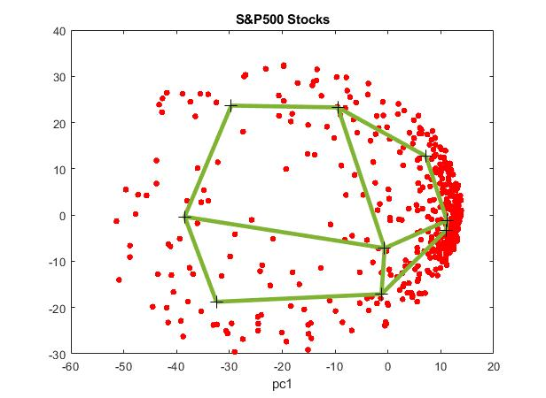
References:
[1] Ross,G.J. (2014). Dynamic Multifactor Clustering of Financial Networks,
Physical Review E, vol.89, N:2.

[2] Leon,D., Aragon,A., Sandoval,J., Hernandez,G., Arevalo,A. and Nino,J. (2017).
Clustering Algorithms for Risk-Adjusted Portfolio Construction, Procedia
Computer Science, vol.108, N:2017, pp.1334-1343.

[3] Nagy,L. and & Ormos,M. (2018). Friendship of Stock Market Indices:
A Cluster-Based Investigation of Stock Markets, J. Risk and Financial
Management, vol.11, N:4, pp.1-16.

[4] Huber,C. (2019). Machine Learning for Hedge Fund Selection,
Wilmott Magazine, Wiley, vol.2019, N:100, pp.74-81.

[5] Bishop,C. (2006). Pattern Recognition and Machine Learning, Springer.

[6] Deboeck,G.J. and Kohonen,T. (Eds.) (2010). Visual Explorations in Finance
with Self-Organizing Maps, Springer, London.

[7] Varsta,M., Heikkonen,J., Lampinen,J. and Millan,J.Del R.(2001). Temporal
Kohonen Map and the Recurrent Self-Organizing Map: Analytical and
Experimental Comparison, Neural Processing Letters, vol. 13, pp.237-251.

[8] Xu,R. and Wunsch,D. (2005). Survey of Clustering Algorithms, IEEE Trans.
on Neural Networks, vol.16, N:3, pp.645-678.

[9] Mantegna,R.N. and Stanley,H.E. (2000). An Introduction to Econophysics:
Correlations and Complexity in Finance, Cambridge University Press, UK.

[10] Berthold,M.R. and Hoppner,F. (2016). On Clustering Time Series Using
Euclidean Distance and Pearson Correlation, Technical Report, University
of Konstanz. https://arxiv.org/abs/1601.02213

[11] Wang,X., Mueen,A., Ding,H., Trajcevski,G., Scheuermann,P. and Keogh,E. (2012).
Experimental Comparison of Representation Methods and Distance Measures for
Time Series Data, Data Mining and Knowledge Discovery, vol.26, N:2, pp.275–309.

[12] Pozzi,F., Di Matteo,T. and Aste,T. (2013). Spread of Risk Across Financial
Markets: Better to Invest in the Peripheries", Scientific Reports,
vol.3(1665), pp.1-7.

