Regime-based Machine Learning of Green Stock Portfolios

Nikolay Nikolaev
https://nikolaevny.github.io/

There is widely accepted empirical evidence in finance that the patterns in the markets change
over time, and the assumprion is that prices are not generated by a single economic regime. The
prevailing opinion is that the stock markets evolve through bullish and bearish periods. This suggests
that portfolio managers should vary the invested asset proportions with the shifts in market behaviour.
The econometric research already designed regime-switching (RS) models [1], [2] that account for
assumed changes in the economic variables. These are sophisticated models which identify abrupt
structural alterations in the dynamics of asset prices. There have been reported various applications
of these RS models to portfolio construction tasks [3],[4],[5], [6], [7]. The key idea is to achieve
optimal asset allocations via extraction of regimes in the market fluctuations.

A switching model includes a number of submodels (one for each regime) with different parameters
which describe structural changes in the data. Each submodel represents a (time-dependent) density
function, and their combination yields a density model that approximates well non-Gaussian series
(like series of returns on prices). The shifts between the submodels are controlled by a discrete state
variable that follows a Markov process (the state depends only on the most recent previous state).
Such Markov regime-switching models capture well some statistical moment characteristics of the
real markets. The design difficulty is how to determine the regime-dependent components,
that is to decompose the market dynamics so that it reflects the state of the economy.

Our research developed a computational tool for building portfolios under regime-switching. The
rationale is that the exploitation of market regimes helps us to find more accurate model parameters.
We assume that the returns of a market tracking portfolio follow a two-regime-switching model
(alternate between bull and bear periods). The overall regime-based model reproduces realistically
the occasional breaks in the mean, and allows us to create really good portfolios. A distinguishing
feature of our tool is that we have implemented a Markov Regime-Switching (MRS) model.
Its regimes are separated by distinct means and volatilities, while the lagged input coefficients are
common for both submodels. The switching parameters are calibrated with the Hamilton’s filter [1],
and the Kim’s smoother [2]. The two sets of asset betas are estimated using a Bayesian machine
learning technique [8] and next processed in a dynamic mean-variance setting. At each moment
in time the portfolio weights are calculated dependent on the particular regime, that is the
portfolio is conditioned on the regimes.

This novel tool was designed for building green stock portfolios. Currently there is a growing demand
for responsible investment in green energy firms that produce energy using renewable sources. Our
hypothesis is that prices of renewable stock companies depend not only on economic, but also on environmental conditions, hence the impact of these conditions on the periodic behaviour of green
stock prices could be more pronounced. Therefore, switching portfolios of green stocks may may be
expected to achieve higher profits. We conducted experiments to study the effects of regime-switching
on asset allocation using data of 13 renewable companies, namely: AY, BLDP, GPRE, ENPH, FSLR,
NEE, NEP, OPTT, ORA, REGI, SEDG, SPWR and TSLA. The daily closing prices of these companies
from 3/1/2020 to 26/9/2020 were downloaded from the Internet. There were implemented for comparison
a classical Mean-Variance Portfolio (MVP) [9], and an Equally Weighted Portfolio (EWP) [10]. The
EWP is a naïve diversification strategy that is known to exhibit consistently good performance. Empirical analysis was carried out with several standard measures which are given in the table below. The results
in this table demonstrate that the MSARP portfolio clearly outperforms the other portfolio strategies,
as it delivers higher risk-adjusted profits with much higher Sharpe ratio.

----------------------------------------------------------------------
Green Portfolio EWP MVP MSARP
----------------------------------------------------------------------
Performance Statistics:
Cumulative returns [PnL] 103.81% 112.03% 154.22%
Compounded returns 1.28% 1.75% 1.84%
Mean return 19.74% 25.69% 27.06%
StDeviation 24.98% 25.82% 26.87%
Skewness -1.02% -0.84% -0.55%
Kurtosis 9.27% 9.01% 8.64%
Sharpe ratio 0.91% 1.03% 1.08%
Risk Characteristics:
Sortino ratio 3.46% 4.59% 4.4.67%
Value-at-Risk (CFVar) 7.90%(5.32%) 10.33%(5.48%) 10.04%(5.47%)
Expected Shortfall 4.15% 5.69% 5.46%
Maximum Drawdown 13.77% 14.45% 14.81%
----------------------------------------------------------------------

The evolution of the accumulated profits from the considered portfolio strategies are illustrated
in the plot below, along with the shifts in the regimes. The regimes (bull with grey color, and
bear with white color) are identified using the returns from the market tracking portfolio
given with blue color in the bottom plot.
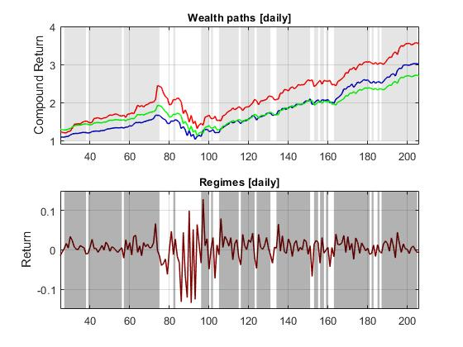

The results from this preliminary study indicate that our novel model compare favourably to
the popular MVP and EWP strategies on building portfolios from green stocks. In this sense, the
MSARP tool can be useful for taking profitable investment decisions under regime-switching.

References:

[1] Hamilton,J.D. (1994). Time Series Analysis, Princeton University Press, NJ.

[2] Kim,C.J. and Nelson,C.R. (1999). State-space Models with Regime Switching, The MITPress, Cambridge, MA.

[3] Ang,A. and Bekaert,G. (2004). How Regimes Affect Asset Allocation, Financial Analysts Journal, vol.60, N:2, pp.86-99.

[4] Guidolin,M. and Timmermann,A. (2007). Asset Allocation under multivariate Regime Switching,
Journal of Economic Dynamics and Control, vol.31, N:11, pp.3503-3544.

[5] Jiang,P., Liu,O. and Tse,Y. (2015). International Asset Allocation with Regime Switching: Evidence from the ETFs,
Asia-Pacific Journal of Financial Studies, vol.44, N:5, pp.661-687.

[6] Nystrup,P., Hansen,B.W., Madsen H., and Lindstrom,E. (2015). Regime-based versus Static Asset Allocation:
Letting the Data Speak, The Journal of Portfolio Management, vol.42, N:1, pp.103–109.

[7] Costa,G. and Kwon,R. (2018). Risk Parity Portfolio Optimization under a Markov Regime-Switching Framework,
Quantitative Finance, vol.19, N:2, pp.1-19.

[ 8] Barber,D. (2012). Bayesian Reasoning and Machine Learning, Cambridge University Press, UK.

[ 9] Markowitz,H.M. (1959). Portfolio Selection, Wiley, New York.

[ 10] DeMiguel,V.,Garlappi,L. and Uppal,R. (2009). Optimal Versus Naive Diversification: How Inefficient is
the 1/N Portfolio Strategy? Review of Financial Studies, vol.22, N:5, pp.1915-1953.

