Online Portfolio Trading by Dynamic Reinforcement Learning

Nikolay Nikolaev
https://nikolaevny.github.io/

The computerized trading systems become increasingly popular due to the electronic nature of the transactions executed on most of the stock markets. There are various computational algorithms for
financial investing currently running on the electronic trading exchanges. Among these, increasingly
popular become the machine learning algorithms for building portfolios of assets [1],[2],[3],[4]. These
learning machines offer potential for finding optimal allocations and suggests efficient rebalancing
which helps to maximize profits while minimizing the risk. They carry out not simply statistical analysis
of financial data, but also identify temporal dependencies that are useful for describing the evolution
of sequentially arriving asset prices. Having such capacity is useful when conducting search for
profitable allocations in a selected universe of stocks.

There are two main approaches to computing trading signals for investment decision making:
1) indirect approach that involves fitting time series (of returns on prices), and uses the predictions to
generate buy/sell signals; and 2) direct approach that involves optimizing directly some financial criteria
(like the Sharpe ratio) and uses the results to generate trading signals. Although the indirect approach
is very popular in computational finance, its main idea to approximate and forecast financial series
can not realized accurately, as it is well known that prices and returns are unpredictable. The idea of
direct methods to produce trading signals without time series fitting is theoretically and practically
more reliable. Moreover, the direct solutions match the goal of investors to maximize returns
without regard to any price approximation error.

The objective of online portfolio selection [1] (called also short-time portfolio optimization [3]) is
to increase gradually the cumulative wealth by maximizing gain increments at each time step,
instead of batch (offline) maximization of the overall return with some quadratic objective function
(which is numerically difficult and problematic). Recent research investigates various algorithms
for online learning of portfolio allocations (weights), like: OLMAR [1], [5], SSPO [3], TCO [6], etc..
These algorithms are computationally fast and can achieve good results, because they react fast to
changes in the market, but this flexibility makes them unstable. One reason for their instability is that
they perform weights updating which reflects the movements of the series and, therefore, are behind
the real evolution of data. The better alternative to capture the movement with perespective is by
exploiting the hidden dynamics of the series. This can be achieved using dynamic models that
represent time dependencies (they describe accurately data whose characteristics change
over time), such as NARMA recurrent neural networks [7].

A portfolio machine for direct maximization of the Sharpe ratio based on recurrent networks has
already been proposed using principles from reinforcement learning [8]. The network training procedure
optimizes iteratively an economic performance criterion by passing the output positions again to the
model as delayed feedbacks on its action. These action feedbacks serve as rewards that reinforce the
parameter updating so as to increase the model utility (risk-adjusted growth) with respect to the Sharpe measure. Thus, the algorithm continuously maximises the performance using the feedback action signals without forecasting returns and without handling noisy covariance matrices. The performance function accounts also for transaction costs, and depends on the trading history. The impact of the historical data
requires to use proper temporal training.

Our research developed a Reinforcement Learning machine for Online Portfolio trading (RLOP) using
a recurrent neural network. The network model takes as inputs series of returns from the assets in the
portfolio, and outputs allocations for each asset (the current version generates long only trading sugnals).
The recurrent network is suitable for representing financial time series as it is especially designed to learn from sequential data via an internal memory. The memory maintains short-term temporal information
which influences subsequent outputs. This network is a dynamic model that we treat with a proper dynamic
training algorithm, the so called BackPropagation Through time (BPTT) [9]. A distinguishing feature of
our machine is that we implement the BPTT with a modern stochastic gradient descent technique [10] for computing the temporal derivatives (it helps to obtain unbiased parameter estimates). This technique is further elaborated using momentum and adaptive learning rate for switching between passive and
aggressive updating depending on the recent profitability.

We conducted experiments to study the usefulness of our tool RLOP and to relate it to representative
state-of-the-art online portfolio selection algorithms: the SSPO [3], the OLMAR[5] and the TCO[6].
Stock prices from four major indices were downloaded from the Internet as follows:
SP500 (2/1/2019-30/12/2019, 485 stocks), DJIA30 (2/1/2017-30/12/2017, 30 stocks),
FTSE100 (2/1/2017-30/12/2017, 100 stocks), and NYSE/Nasdaq (2/1/2015-30/12/2015, 484 stocks)
(stocks whose data were incomplete were discarded). Using an unsupervised learning procedure we
selected 10 stocks from each data set for building the portfolios. Transaction costs (0.25%) were
incorporated according to the proportional commission model [1]. Specific for RLOP is that it uses
historic prices from the last month to train the model. The SSPO provides an original formulation with proven convergence (the function to be optimized has a unique minimum), which is processed with an iterative algorithm derived following the alternating direction method of multipliers. The TOC and
OLMAR exploit the mean-reversion concept using an incremental algorithm which updates the
allocations so that the wealth is transferred from stocks that have increased in value toward stocks
that have decreased in value (with the expectation that this will change).

The usefulness of the examined algorithms was evaluated with two statistics (as in similar research [5],[6]): the Annualized Percentage Yield (APY) as a measure of the accumulated wealth, and the annualized
Sharpe Ratio (SR) as a measure of the risk-adjusted returns. The results given in the table below include
the APY and the corresponding SR in parentheses.

-----------------------------------------------------------------------------------
SP500 DJIA30 FTSE100 NYSE
-----------------------------------------------------------------------------------

OLMAR 0.3289 0.2265 0.1624 0.1465
(1.8783) (2.1648) (1.2495) (0.6231)

TCO 0.4231 0.2149 0.2235 0.2914
(2.0126) (2.1450) (1.3682) (0.8353)

SSPO 0.4075 0.1637 0.1076 0.1295
(1.9372) (1.9536) (0.9281) (0.6018)

RLOP 0.4875 0.1807 0.1344 0.1569
(2.1942) (2.0326) (0.9327) (0.6477)
----------------------------------------------------------------------------------

The results in this table demonstrate that: 1) the RLOP algorithm outperforms the previous strategies
only on the SP500 dataset (as it achieves best APY and best SR), so it can not be expected to be
better than the previous alternatives in all markets, and 2) the previous mean-reversion algorithms can
really be profitable across different markets, although they can be unstable in some environments. We
are inclined to think that it is very difficult to capture the dynamics of financial time series in functional
form even with powerful recurrent neural network models used within the framework of reinforcement learning. The following figure illustrates the instantaneous Sharpe ratio (blue curve) that is optimized
directly during trading, and the continuously accumulated Sharpe ratio of the whole portfolio (red curve)
obtained during simulations using the SP500 series.

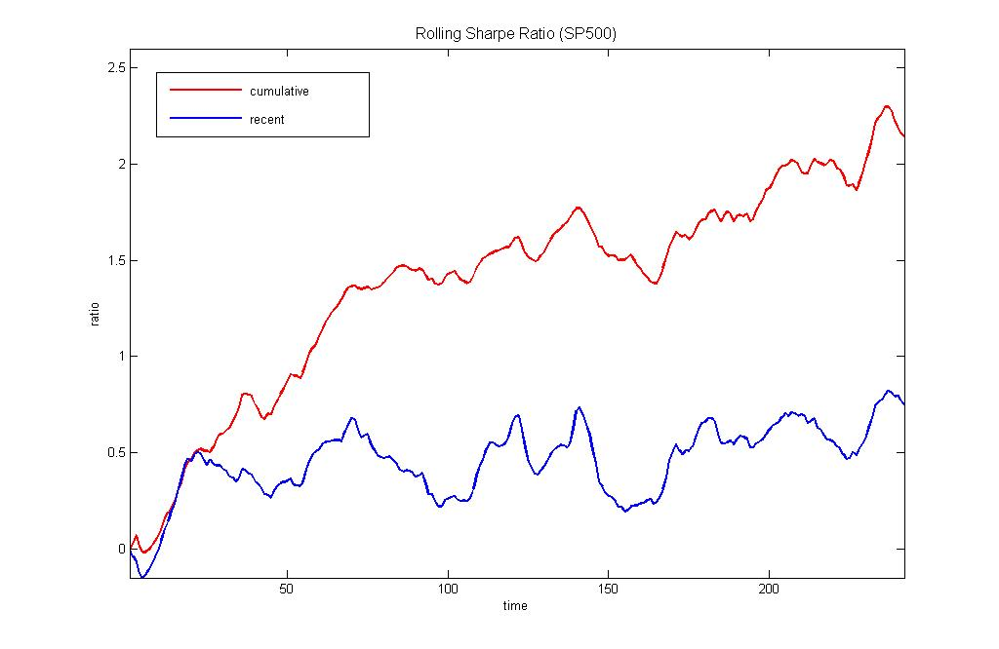
References:

[1] Li,B. and Hoi,S.C.H (2015). Online Portfolio Selection: Principles and Algorithms,
CRC Press, Taylor and Francis Group, Boca Raton, FL.

[2] Almahdi,S. and Yang,S.Y. (2017). An Adaptive Portfolio Trading System: A Risk-return
Portfolio Optimization using Recurrent Reinforcement Learning with Expected Maximum Drawdown,
Expert Systems with Applications, vol.87, N:30, pp.267-279.

[3] Lai,Z-R., Yang,P-Y., Fang,L. and Wu,X. (2018). Short-term Sparse Portfolio Optimization
Based on Alternating Direction Method of Multipliers, J. Machine Learning Research, vol.19, N:63, pp.1-28.

[4] Ha,Y. and Zhang,H. (2020). Algorithmic Trading for Online Portfolio Selection under Limited
Market Liquidity, European Journal of Operational Research (Available at SSRN:
http://dx.doi.org/10.2139/ssrn.3188878 ).

[5] Li,B., Zhao,P., Hoi, S.C.H., Sahoo,D. and Liu,Z-Y. (2015). Moving Average Reversion Strategy
for On-line Portfolio Selection, Artificial Intelligence, vol.222, pp.104-133.

[6] Li,B., Wang,J., Huang,D. and Hoi,S.C.H. (2018). Transaction Cost Optimization for Online Portfolio
Selection, Quantitative Finance, vol.18, N:8, pp.1411-1424.

[7] Connor,J.T.,Martin,R.D. and Atlas,L.E. (1994). Recurrent Neural Networks and Robust Time Series
Prediction, IEEE Trans. on Neural Networks, vol.5, N:2,pp.240-254.

[8] Moody,J., Wu,L., Liao,Y. and Saffell,M. (1998). Performance Functions and Reinforcement
Learning for Trading Systems and Portfolios, Journal of Forecasting, vol.17, N:5-6, pp.441-470.

[9] Werbos, P. J. (1990). Backpropagation Through Time: What It Does and How to Do It,
Proceedings of the IEEE, vol.78, N:10, pp.1550–1560.

[10] Goodfellow,I., Bengio,Y. and Courville,A. (2016). Deep Learning, The MIT Press, Cambridge, MA.

