Bayesian Machine Learning for Robust On-line Portfolio Selection

Nikolay Nikolaev
https://nikolaevny.github.io/

The predominant amount of trades on the biggest stock markets in the world today are done
automatically. Electronic trading is conducted using various kinds of algorithms, like for example portfolio robo-advisors. Such on-line portfolio selection algorithms [1],[2],[3],[4],[5],[6]
calculate asset allocations sequentially with the arrival of stock price data. At every time instant
when stock prices arrive the allocations are re-estimated to take into account the new information
from the market. The objective of on-line portfolio investing is continuous increase of the cumulative
wealth by maximizing the incremental gains. The allocations (weights) indicate the portions of
wealth to be transferred between the assets. The activity of buying and selling corresponding
fractions of assets is called rebalancing. Since on-line portfolio selection is fast and assumes
regular rebalancing, it is convenient for active and high-frequency trading.

The three main kinds of on-line portfolio selection strategies are: trend-following [1], [2], pattern matching [3], and trend-reversal [4]. The Universal Portfolio (UP) [1] is an early trend-following algorithm that runs several trading experts to generate capital allocation proposals, and makes the investment decision as a mixture with boosting the contributions from the successful ones. The
leaders are stimulated in order to achieve overall wealth growth close to this of the best predictor in hindsight. More sophisticated versions aim at systematic rebalancing using second-order properties
of the regret function measuring the mistakes [2]. The trend-following strategies have been popular
as they have established asymptotic optimality, but they are computationally slow. The pattern
matching strategies select segments from each stock price relative series with similar pattern to the
one leading to the current moment, and optimize the asset weights with respect to these nearest
segments [3]. Although the pattern matching strategies typically feature optimal growth rate, they
are also computationally inefficient. Currently most popular seem the trend-reversal strategies based
on the sound mean-reversion principle [6]. When building portfolios these strategies transfer capital
from stocks that have moved up (increased in price) recently to stocks that have moved down (since
they are expected to increase in price next) [7],[8].

The reversal to the mean is a very useful concept in sequential portfolio construction, but it
is not sufficient for making successful trading algorithms. It is also important to emphasise that
the stock price series are always noisy, and have to be handled carefully when looking for optimal
allocations. The real-world prices are used for computing portfolio weights with formulae including
estimates of the mean portfolio returns, which are actually unknown [9]. The accurate estimation of
mean portfolio returns requires cleaning of the stock prices (which is a well known problem in
computational finance [10]). This can be done by maximum likelihood estimation of the sample
mean (for example, using the method of moments) using the historical price data. We recommend
reliable treatment of historical price series using probabilistic inference [10].

Our research developed a robust on-line portfolio construction tool using Bayesian machine
learning. We apply variational Bayesian inference [11] to derive a learning algorithm for robust
regression, which is especially suitable for processing financial time series typically contaminated
by large amounts of noise (the robust data manipulation is necessary to prevent overfitting the noise
and to achieve good predictability). The original feature of our tool is a Bayesian learning algorithm
for calibrating heavy-tailed models of returns on prices (based on an approximation of the Student-t density by an infinite mixture of Gaussians). After pre-processing the price series with this algorithm, sequential estimation of the weights is accomplished with stochastic gradient descent search for
solving the portfolio optimization problem. The optimization problem involves minimizing the
deviation from the previous weights, and the distance from the mean reversion threshold. The
motivation is to keep the portfolio close to the previous one, and to rebalance it when the return
increases above the threshold. The threshold parameter is estimated at every time step using a
discrete version of the Ornstein–Uhlenbeck stochastic differential equation (which provides
a description of mean-reverting processes).

Experimental Portfolio Analysis. Representative state-of-the-art strategies from each kind were taken
and compared with our novel tool on several online portfolio trading tasks. The following strategies were tested: ONS [2], BNN [3], ANTICOR [4], OLMAR [7], and our Bayesian Robust Online Portfolio Selection (BROPS). The ONS [2] algorithm uses the Newton method for minimizing the regret function and rebalances the portfolio at every time step (it passively transfers the wealth). The BNN [3] uses
a log-optimal utility function which is applied to historical price relative segments preselected with
a nonparametric nearest neighbour technique. The ANTICOR [4] is a strategy that implements aggressively the reversal to the mean philosophy taking into account the cross-correlations between
the stock prices in the portfolio (suggesting to buy less correlated assets with inferior performance).
OLMAR is a contemporary aggressive strategy that processes the current portfolio vector with
predictions of the mean returns. All the strategies were applied using the recommended parameters from the respective papers [7],[8].

The efficacy of these strategies was examined on several real-world data sets downloaded from the Internet : NYSE/Nasdaq (28/2/2012-19/2/2016, 484 stocks), DJIA30 (2/1/2014-29/12/2017, 30 stocks),
SP500 (1/7/2013-30/6/2017, 485 stocks), FTSE100 (23/2/2015-15/2/2018, 100 stocks), and Euro STOXX50 (2/10/2009-1/11/2013, 50 stocks). We selected 20 stocks from each data set when building
the portfolios in order to produce comparable results. Daily trading simulations were conducted starting with initial wealth one (we hold positions in every stock for a day and adjust the positions after that).
The usefulness of the examined strategies was evaluated with two statistics (as in similar research [7],[8]): the Annualized Percentage Yield (APY) as a measure of the accumulated wealth, and the annualized Sharpe Ratio (SR) as a measure of the risk-adjusted returns. The results given in the table below (every entry includes the APY and the corresponding SR in parentheses) demonstrate that: 1) the strategies that exploit the mean-reversion property perform better than the other strategies on sequential portfolio trading; and 2) our novel BROPS consistently outperforms the previous strategies on all studied
markets, as it achieves best APY and best SR.

------------------------------------------------------------------------------------------------------------------
Strategy NYSE DJIA30 SP500 FTSE100 EuroSTOXX50
------------------------------------------------------------------------------------------------------------------
ONS 0.1615 0.0812 0.2569 0.0727 0.1095
(0.4499) (0.3152) (1.4761) (0.1568) (0.3824)

BNN 0.1094 0.1283 0.1254 0.0852 0.0843
(0.4526) (0.8170) (1.0136) (0.1945) (0.2541)

ANTICOR 0.0925 0.2349 0.2839 0.2350 0.1037
(0.4147) (1.3358) (1.1275) (0.9752) (0.3219)

OLMAR 0.1237 0.2468 0.3882 0.2628 0.1142
(0.5381) (1.3216) (1.6414) (0.9863) (0.3435)

BROPS 0.1865 0.2891 0.4255 0.2879 0.1388
(0.6273) (1.6880) (1.7882) (1.1244) (0.5652)
-----------------------------------------------------------------------------------------------------------------

Overall, the improved results from the experimental studies indicate that our BROPS strategy
has potential to generate high profits with low risk. The main reason for the reliability of the novel strategy is its resilience to outliers in the data and shocks in the market, that is why it tracks more plausibly the evolution of the prices. The figure below offers a bar plot of the daily returns from
the two best strategies: BROPS (red boxes), and OLMAR (blue boxes).
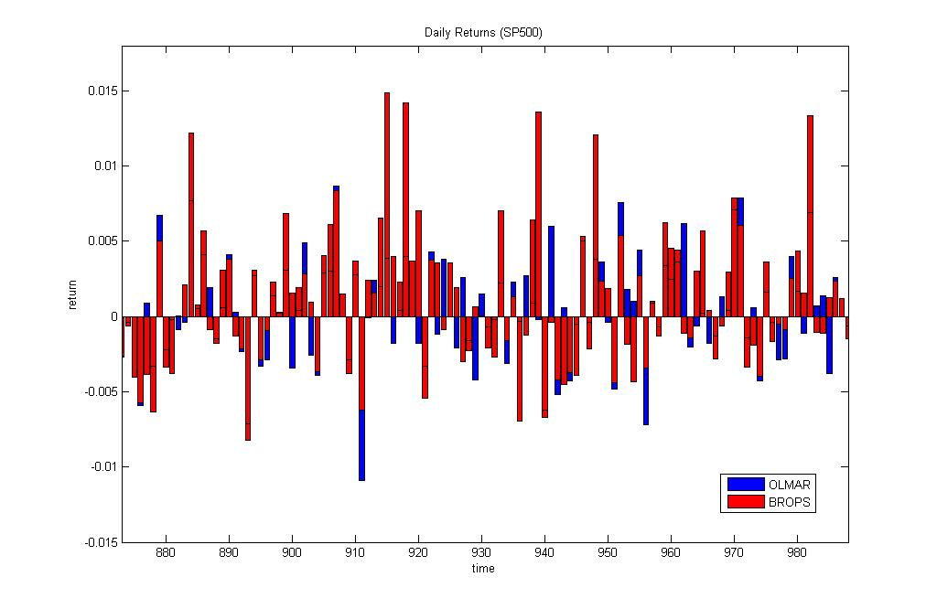
References:
[1] Cover,T.M. (1991). Universal Portfolios, Mathematical Finance, vol.1, N:1, pp.1–29.

[2] Agarwal,A., Hazan,E., Kale,S. and Schapire,R.E. (2006). Algorithms for Portfolio Management
based on the Newton Method, in Proc. 23rd Int. Conf. on Machine Learning, Pittsburgh, PA, pp. 9–16.

[3] Györfi,L., Udina,F. and Walk,H. (2008). Nonparametric Nearest Neighbor based Empirical
Portfolio Selection Strategies, Statistics and Risk Modeling, vol.26, N:2, pp.145–157.

[4] Borodin,A., El-Yaniv,R. and Gogan,V. (2004). Can We Learn to Beat the Best Stock, Journal
of Artificial Intelligence Research, vol. 21, N:1, pp.579–594.

[5] Tsagaris,T., Jasra,A. and Adams,N. (2012). Robust and Adaptive Algorithms for Online

Portfolio Selection, Quantitative Finance, vol.12, N:11, pp.1651-1662.

[6] Li,B. and Hoi,S.C.H. (2014). Online Portfolio Selection: A Survey, ACM Computing Surveys,
vol.46, N:3, pp.1-33.

[7] Li,B., Zhao,P., Hoi, S.C.H., Sahoo,D. and Liu,Z-Y. (2015). Moving Average Reversion Strategy
for On-line Portfolio Selection, Artificial Intelligence, vol.222, pp.104-133.

[8] Huang,D., Zhou,J., Li,B., Hoi,S.C.H. and Zhou,S. (2016). Robust Median Reversion Strategy for Online
Portfolio Selection, IEEE Trans. on Knowledge and Data Engineering, vol.28, N:9, pp.2480-2493.

[9] Lai,T.L., Xing,H. and Chen,Z. (2011). Mean-Variance Portfolio Optimization when Means and Covariances
are Unknown, The Annals of Applied Statistics, vol.5, N:2A, pp.798–823.

[10] Bishop,C.M. (2006). Pattern Recognition and Machine Learning, Springer-Verlag, New York.

[11] Tipping,M.E. and Lawrence,N.D. (2005). Variational Inference for Student-t Models: Robust Bayesian
Interpolation and Generalised Component Analysis. NeuroComputing, vol.69, N:1, pp.123–141.

