Generative Adversarial Networks for Machine Learning of Constrained Portfolios

Nikolay Nikolaev
https://nikolaevny.github.io/

The mean-variance portfolio (MVP) theory [1] is a fundamental framework for rational investment
management. It provides formulations for building profitable portfolios with reduced risk, which are
extended by adding various constraints (like budgeting, no-shorting, leveraging, etc.) to ensure their
practical usefulness. The constrained formulations often lead however to non-convex optimization
problems that are difficult to solve even by the well known Quadratic Programming (QP) approach.
These difficulties stimulate the research into alternative modern approaches, such as the Alternating Direction Method of Multipliers (ADMM) [2],[3] and the Successive Convex Oprimization (SCO) [4].
The ADMM is suitable for arbitrary large constrained optimization tasks as it splits them into subtasks
that are tackled separately. The SCO deals with a given non-convex function by approximating it
with another tractable convex function at each iterative step. The advantage of these algorithms is
that they are computationally more efficient than the popular QP.

Our research developed a machine learning tool for constraint portfolio optimization using
a Generative Adversarial Network (GAN) [5]. The GAN is a composite model of a generator network
and a discriminator network that play adversarial game in which each tries to influence the other,
while being controlled by different parameters. The generator learns to produce samples from the
distribution of the data. The discriminator evaluates the feasibility of the drawn samples and decides
whether they are realistic or fake. We designed the generator using a Deep Neural Network (DNN) [6]
for representing synthetic distributions of portfolio weights (stock allocations), aiming at recovery of
good allocations (without forecasting returns on prices as in some previous works [7]). A uniform
random prior is passed as input, propagated forward through the network, and the network output
returns a weights vector sample. The discriminator applies analytical formulae [8] to compute
optimal weights which suggest a reference mean-variance portfolio for comparisons.

The GAN operates according to the function matching principle using portfolio utility maximizing
functions for each network associated with their performance. The common objective is closeness
between the utilities obtained with sampled weights (by the generator network) and the utilities
obtained with optimal weights (by the discriminator network). Currently the common objective
incorporates budgeting and positivity constraints in addition to desired target returns, but it can
accommodate any other constraints (like the tracking error suggested in relevant research [9]). The
common objective is taken for stochastic gradient descent training of the composite model. The
DNN is a three-layer architecture of rectified and sigmoidal activations that has trainable parameters
on every connection. The discriminator has only one parameter that measures the degree of similarity between the reference portfolio and the proposed sampled portfolio [10]. During the optimization
process the discrepancy between the assumed optimal weights and the sampled weights decreases,
and the generator converges to a better estimator of the weights distribution leading to portfolios
with improved performance. The advantage of this approach is that it has capacity to learn fast
the weights distribution in nonparametric fashion.

Experimental studies were conducted to examine the suitability of the proposed GANP tool for
building constrained mean-variance portfolios. Daily closing prices of all stocks from the S&P500
index were downloaded from the Internet (1/4/2019-11/12/2020). We selected 10 stocks with uncorrelated
price movements, and next transformed their prices into daily returns. After closing of each trading
day optimal mean-variance portfolio weights were compute recursively using returns from the
previous one month, and synthetic portfolio weights were sampled after retraining the GAN model.
The trading was initiated starting with 10000 pounds, and the full portfolio value was reinvested when rebalancing. The performance and risk statistics of the obtained synthesized portfolios (GANP) are
compared with these from the convential approach (MVP).
---------------------------------------------------------
Portfolio MVP GANP
---------------------------------------------------------
Performance Statistics:
Cumulative returns [PnL] 43.81% 72.43%
Compounded returns 0.44% 0.65%
Mean return 9.03% 13.03%
StDeviation 15.77% 19.48%
Skewness -0.88% -0.89%
Kurtosis 9.59% 9.54%
Sharpe ratio 0.57% 0.64%
Risk Characteristics:
Sortino ratio 2.51% 3.27%
Value-at-Risk (CFVar) 4.66%(3.91%) 5.79%(4.03%)
Expected Shortfall 2.95% 3.52%
Maximum Drawdown 12.92% 13.61%
---------------------------------------------------------
Overall these results demonstrate that constrained portfolios whose weights have been
sampled by GAN can really outperform conventional mean-variance portfolios. As an
explanation of the learning potential of GAN the plot below illustrates that the two-dimensional
projection of the synthesized weight density (produced after dimensionality reduction of the
sampled weights at the end of a particular trading day) is very close indeed to the density of
recursively computed optimal weights.
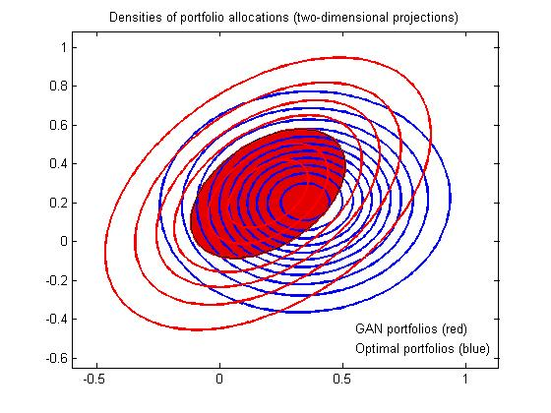

References:

[1] Markowitz,H.M. and Todd,G.P. (2000). Mean-Variance Analysis in Portfolio Choice and Capital Markets.
Wiley, New York.

[2] Lai,Z-R., Yang,P-Y., Fang,L. and Wu,X. (2018). Short-term Sparse Portfolio Optimization Based on Alternating
Direction Method of Multipliers, Journal of Machine Learning Research, vol.19, pp.1-28..

[3] Richard,J-C. and Roncalli (2019). Constrained Risk Budgeting Portfolios: Theory, Algorithms, Applications and
Puzzles, Available at SSRN: https://ssrn.com/abstract=3331184

[4] Feng,Y. and Palomar,D. (2015). SCRIP: Successive Convex Optimization Methods for Risk Parity Portfolio
Design, IEEE Trans. on Signal Processing, vol.63, N:19, pp.5285-5300.

[5] Goodfellow,I. at al. (2014). Generative Adversarial Networks, In: Proc. Int. Conf. on Neural Information
Processing Systems (NIPS 2014), pp. 2672–2680, Available at: https://arxiv.org/abs/1406.2661

[6] Schmidhuber, J. (2015). Deep Learning in Neural Networks: An Overview, Neural Networks, vol.61, pp.85–117.

[7] Mariani,G. et. al. (2019). PAGAN: Portfolio Analysis with Generative Adversarial Networks,
Available at: https://arxiv.org/abs/1909.10578

[8] Irlicht,L. (2014). Fast Recursive Portfolio Optimization, Algorithmic Finance, vol.3, N:3-4, pp.173-188.

[9] Pun,C.S., Wang,L. and Wong,H.Y. (2020). Financial Thought Experiment: A GAN-based Approach to
Vast Robust Portfolio Selection, In Proc. 29th Int. Joint Conf. on Artificial Intelligence (IJCAI '20),
Available at SSRN: https://ssrn.com/abstract=3613739

[10] Kim,Y., Kang,D., Jeon,M. and Lee,C. (2019). A GAN-MP Hybrid Heuristic Method for Non-convex
Portfolio Optimization Problem, The Engineering Economist, vol.64, N:3, pp.196-226.

