Building Smart Beta Portfolios with Large-Scale Machine Learning

Nikolay Nikolaev

Smart Beta portfolios [1],[2],[3] offer the investor possibility to choose exposures (betas) to specific
factors that are assumed to be driving the market evolution. This is a strategy that seeks smart asset allocations using risk control schemes, rather than using traditional capitalization weighting. The aim
is to outperform the market with balanced risk reduction via increased diversification (using measures
that depend on correlations and volatilities, but do not depend directly on expected returns). The greater diversification brings reduced volatility and enhanced performance compared to other strategies like
simple index tracking [4]. The Smart Beta is usually implemented with less frequent rebalancing and
is often classified as passive investment.

Recent research actively investigates risk-based approaches to building Smart Beta portfolios, like
the Most Diversified Portfolio (MDP) [5], and the Risk Parity Portfolio (RPP) [6]. Both approaches
provide formulae (volatility diversification objective functions) that help to distribute the risk
proportionally among the assets (without using directly returns). When looking for smart allocations
the diversifying functions are optimized simultaneously with minimization of the market tracking error
(taking into account weight constraints). Fast contemporary algorithms for such problems are the Cyclical Coordinate Descent (CCD) [7], and the Alternating Direction Method of Multipliers (ADMM) [8]. Their
advantage over standard Quadratic Programming (QP) optimizers is that they are numerically efficient.
The CCD algorithm is mainly convenient for strictly convex and differentiable functions, while the
ADMM can be applied with various composite objective functions without imposing such restrictions
on them [9],[10]. Moreover, the ADMM is a kind of machine learning algorithm which is more suitable
for large tasks as it splits them into subtasks that are better tackled separately.

Our research developed a tool for computing low volatility Smart Beta portfolios using large-scale
machine learning. The distinguishing contributions of our machine learning framework are: 1) a novel ADMM algorithm for constrained identification of Most Diversified Portfolios (MDP); 2) stochastic
gradient descent training algorithms with analytical derivatives for quadratic optimization and tracking
error minimization; and 3) an algorithm for predictive estimation of covariance matrices according to
the method of moments. The tool is elaborated to learn allocations for long-only positions with desired
target returns (tuned with appropriately chosen risk-aversion parameter). If necessary the sparsity can
also be tuned dynamically with an available cardinality parameter.

Practical Portfolio Formation. Experimental investigations were conducted to examine the performance
of the proposed ADMM-based tool for creating Smart Beta portfolios. Daily closing prices of all stocks
from the S&P500 index were downloaded from the Internet (1/7/2013-30/6/2017). Initially 25 stocks
were taken with high exposure to momentum and volume factors (selection phase), and next their
portfolio weights were recomputed rolling forward with a moving window of 5 working days (weighting phase). At the close of the last trading day of each week the portfolio weights were recomputed using the
data from the previous 6 months. The trading was initiated starting with 1000000 pounds, and the full portfolio value was reinvested when rebalancing every week. The collected numerical evidence show
that the proposed Smart Beta MDP tool found a portfolio with superior out-of-sample performance
compared to the standard Markowitz MVP portfolio in terms of statistical characteristics and
econometric performance (the results annualized over 176 weeks are given in the table below).

---------------------------------------------------------
Portfolio MVP Smart-Beta MDP
---------------------------------------------------------
Performance Statistics:
Cumulative returns [PnL] 48.37% 56.83%
Compounded returns 0.44% 0.51%
Mean return 11.71% 12.53%
StDeviation 10.92% 9.11%
Skewness -1.97% -1.62%
Kurtosis 20.27% 19.59%
Sharpe ratio 0.98% 1.39%
Risk Characteristics:
Sortino ratio 3.95% 4.78%
Value-at-Risk (CFVar) 2.68% 1.94%
Expected Shortfall 5.94% 7.44%
Maximum Drawdown 11.42% 8.71%
---------------------------------------------------------

These results demonstrate that the Smart Beta portfolio achieved higher risk-adjusted returns with
much improved Sharpe ratio, as well as higher annualized returns. Note that these profits were obtained
with lower Value-at-Risk and drawdown. The return profiles of the computed portfolios, the diversity
ratio and the drawdowns are illustrated in the figure below. Overall, these successful experiments suggest
that our novel machine learning tool could be useful for practical portfolio management.
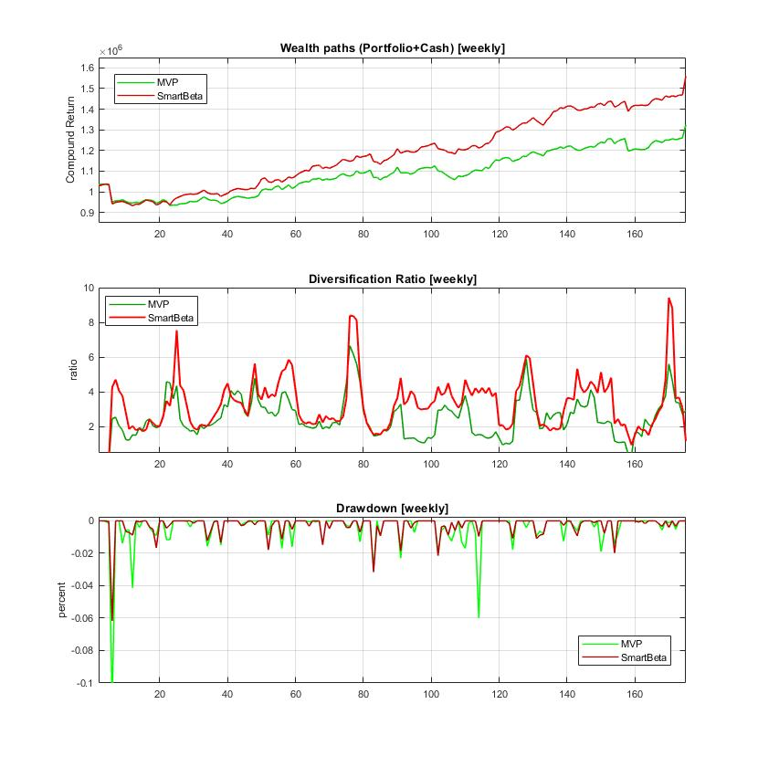

References:

[1] Amenc,N., Goltz,F. and Lodh,A. (2012). Choose Your Betas: Benchmarking Alternative Equity Index Strategies,
The Journal of Portfolio Management, vol.39, N:1, pp.88-111.

[2] Richard,J-C. and Roncalli,T. (2015). Smart Beta: Managing Diversification of Minimum Variance Portfolios,
Chapter 2, In: Jurczenko,E. (Ed.), Risk-based and Factor Investing, ISTE Press, Elsevier, UK, pp.31-63.

[3] Cazalet Z., Grison P. and Roncalli T. (2014), The Smart Beta Indexing Puzzle, Journal of Index Investing, vol.5, N:1, pp.97-119.

[4] Benidis,K., Feng,Y. and Palomar,D.P. (2018). Sparse Portfolios for High-Dimensional Financial Index Tracking,
IEEE Trans. on Signal Processing, vol.66, N:1, pp.155-170.

[5] Choueifaty,Y. and Coignard,Y. (2008). Toward Maximum Diversification, Journal of Portfolio Management,
vol. 34, N:4, pp.40–51.

[6] Qian,E.E. (2016). Risk Parity Fundamentals, CRC Press, Boca Raton, FL.

[7] Griveau-Billion,T., Richard,J-C. and Roncalli,T. (2013). A Fast Algorithm for Computing High-Dimensional Risk
Parity Portfolios, Available at SSRN: https://ssrn.com/abstract=2325255

[8] Boyd,S., Parikh,N., Chu,E., Peleato,B. and Eckstein,J. (2011). Distributed Optimization and Statistical Learning via the
Alternating Direction Method of Multipliers, Foundations and Trends in Machine Learning, vol.3, N:1, pp.1–122.

[9] Zhao,Z. and Palomar,D.P. (2019). Large-Scale Regularized Portfolio Selection via Convex Optimization,
In: Proc. of the 7th IEEE Global Conference on Signal and Information Processing, Ottawa, ON, Canada.

[10] Kremer,P.J., Lee,S., Bogdan,M. and Paterlini,S. (2020). Sparse Portfolio Selection via the Sorted l1-Norm,
Journal of Banking and Finance, vol.110.

