Efficient Direct Reinforcement Learning of Low-risk Portfolios

Nikolay Nikolaev
https://nikolaevny.github.io/

Reinforcement Learning (RL) shows encouraging results for computing automated investment strategies
[1],[2],[3],[4],[5],[6],[7],[8]. The RL paradigm offers procedures that easily accomodate risk-adjusted performance functions and facilitate portfolio optimization without forecasting models. The RL algorithms continuosly maximize the objective function by taking actions without explicitly provided targets, that is using only inputs and feedbacks on their performance. This algorithmic capacity to take behavioural decisions makes them especially convenient for the design of reliable portfolio trading systems.

The two main RL methods currently studied as alternatives for financial portfolio construction
and trading are [1],[4]: 1) value-based (Q-learning), and 2) policy-based (Direct Reinforcement) learning. Recent research in Q-learning uses deep neural networks for finding portfolio allocations [2],[3],[5], like
the Deep Q-network algorithms [2], and the Deep Reinforcement learning algorithms [3],[5]. These algorithms try to estimate state-action value functions and derive implicitly the investment policy (strategy). The Q-learning method has, however, several technological limitations: 1) it manipulates state-action functions that are discountinuous, hence even a small change in the function value may lead to very different unfavourable policy; and 2) it is affected by the curse of dimensionality and the search dimensions rapidly increase as the model is expanded (hence it may require training of very large deep neural networks). The theoretical and empirical studies recommend the Direct Reinforcement (DR) learning as a potentially better mechanism for finding profitable portfolios [6],[7],[8]. The DR represents directly the policy and conducts policy search by updating it using instantaneous measures of performance (like the Sharpe ratio to balance the accumulated profit with the acceptable risk).

A Recurrent neural network for maximization of the Sharpe ratio following direct Reinforcement
Learning (RRL) principles has been already designed [6]. The RRL optimizes an economic performance
criterion by passing the output positions again to the model as delayed feedbacks on its action, and
these actions then reinforce the parameter updating to improve the risk-adjusted growth. Although
the RRL machine is theoretically appealing (as it is a proper dynamical system), it has serious drawbacks
that may entail poor results in practice. Recurrent neural networks are notoriously difficult to train [9]
due to the vanishing/exploding gradients problem and the difficulty to identify the initial weights
(the pre-training should accumulate sufficiently accurate initial weights). Moreover, the convergence
of the training procedure depends strongly on the initialization of the recurrent connections as well as
on the initial weights. One solution to all these issues is to consider feedforward neural networks (where connections between the neurons do not form directed cycles) for reinforcement learning.

Our research developed a Connectionist Reinforcement Learning machine for efficient computation
of Online Portfolios (CRLOP). This is a multi-output feedforward neural network where each network output generates allocation for a particular asset in the portfolio and the inputs pass lagged returns from
the corresponding asset prices. The network is trained with an original hybrid risk-return optimization
function, which includes the Sharpe ratio and an additional term that accounts for the risk asymmetrically
(this term discounts the effects from the loosing trades). This is necessary to overcome
the equal treatment of high profits and heavy losses in the symmetric standard deviation formula. During training the network adapts the weights to achieve higher portfolio profits with low-risk by sensing the returns and using them to reinforce its performance without fitting the data, this uses the goodness of the recent updating action on the current state of the algorithm. The allocations are obtained incrementally in forward manner by passing the data through the network and modifying the weights (with immediate rewards from the previous results) using a modern stochastic training technique. The network operation yields directly a risk-averse investment strategy as a sequence of allocations and rebalancing decisions.
The novel tool CRLOP was applied to the task of online portfolio selection and compared with
several representative state-of-the-art algorithms: the OLMAR[10], the SSPO [11], and the Recurrent Reinforcement Learning (RRLOP) [6] which we implemented with a multi-output network.
Stock prices from four major indices were downloaded from the Internet as follows:
SP500 (2/1/2019-30/12/2019, 485 stocks), DJIA30 (2/1/2017-30/12/2017, 30 stocks),
FTSE100 (2/1/2017-30/12/2017, 100 stocks), and NYSE/Nasdaq (2/1/2015-30/12/2015, 484 stocks)
(stocks whose data were incomplete were discarded). Ten stocks from each data set were picked in
advance using an unsupervised learning procedure. Transaction costs (0.25%) were used according to
the proportional commission model [10]. Specific for CRLOP and RRLOP is that they use historic
prices from the last three months to train the networks. The SSPO uses an iterative algorithm derived
according the alternating direction method of multipliers. The OLMAR exploits the mean-reversion
concept using an incremental algorithm which updates the allocations so that the wealth is transferred
from stocks that have increased in value toward stocks that have decreased in value.

The usefulness of the studied algorithms was evaluated with two statistics (as in similar research [10]):
the Annualized Percentage Yield (APY) as a measure of the accumulated wealth, and the annualized
Sharpe Ratio (SR) as a measure of the risk-adjusted returns. The results from the simulated online trading
given in the table below show the APY and the corresponding SR in parentheses.

-----------------------------------------------------------------------------------
SP500 DJIA30 FTSE100 NYSE
-----------------------------------------------------------------------------------

OLMAR 0.3289 0.2265 0.1624 0.1465
(1.8783) (2.1648) (1.2495) (0.6231)

SSPO 0.4075 0.1637 0.1076 0.1295
(1.9372) (1.9536) (0.9281) (0.6018)

RRLOP 0.4923 0.1896 0.1448 0.1583
(2.2015) (2.0417) (0.9454) (0.6496)

CRLOP 0. 5216 0.2392 0.1571 0.1722
(2.5478) (2.4319) (1.0168) (0.7541)
----------------------------------------------------------------------------------

The results in this table demonstrate that the proposed Connectionist Reinforcement Learning machine
is able to outperform reliably the above competing algorithms on daily trading. The following plots
illustrate that the CRLOP improves upon the previous recurrent version RRLOP, more precisely it
generates higher cumulative wealth (top panel), attains higher Sharpe ratio (middle panel), and
achieves profits with consistently lower drawdown (bottom panel).

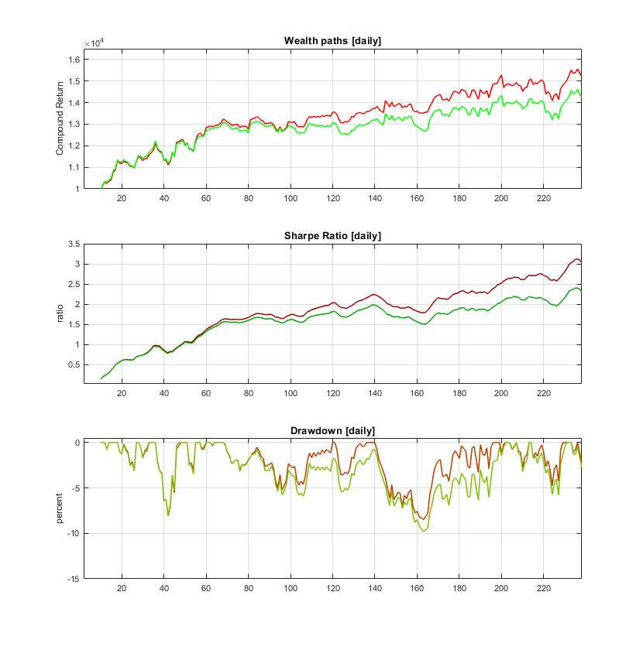
References:

[1] Dixon,M., Halperin,Igor and Bilokon,P. (2020). Applications of Reinforcement Learning,
Chapter 10, In: Machine Learning in Finance. From Theory to Practice, Springer, pp.347-418.

[2] Mosavi,A., Ghamisi,P., Faghan,Y. and Duan,P. (2020). Comprehensive Review of Deep Reinforcement
Learning Methods and Applications in Economics, Available at: https://arxiv.org/abs/2004.01509.

[3] Zhang,Z., Zohren,S. and Roberts,S. (2018). Deep Reinforcement Learning for Trading,
Available at: https://arxiv.org/abs/1911.10107.

[4] Fischer,T.G. (2018). Reinforcement Learning in Financial Markets- A Survey,
FAU Discussion Papers in Economics 12/2018, Friedrich-Alexander University
Erlangen-Nuremberg, Available at: https://www.econstor.eu/handle/10419/183139.

[5] Jiang,Z., Xu,D. and Liang,J. (2017). A Deep Reinforcement Learning Framework for the
Financial Portfolio Management Problem, Available at: https://arxiv.org/abs/1706.10059.

[6] Moody,J. and Saffell,M. (2001). Learning to Trade via Direct Reinforcement,
IEEE Trans. on Neural Networks, vol.12, N:4, pp.875-89.

[7] Deng,Y., Bao,F., Kong,Y., Ren,Z. and Dai,Q. (2017). Deep Direct Reinforcement Learning for
Financial Signal Representation and Trading, IEEE Trans. on Neural Networks and Learning
Systems, vol.28, N:3, pp.653-664..

[8] Casqueiro,P.X. and Rodrigues,A.J. (2006). Neuro-dynamic Trading Methods,
European Journal of Operational Research, vol.175, N:3, pp.1400–1412.

[9] Pascanu,R., Mikolov,T. and Bengio,Y. (2013). On the Difficulty of Training Recurrent Neural Networks
In: Proc. 30th Int. Conf. on Machine Learning (ICML'13), vol.3, pp.1310-1318.

[10] Li,B., Zhao,P., Hoi, S.C.H., Sahoo,D. and Liu,Z-Y. (2015). Moving Average Reversion Strategy
for On-line Portfolio Selection, Artificial Intelligence, vol.222, pp.104-133.

[11] Lai,Z-R., Yang,P-Y., Fang,L. and Wu,X. (2018). Short-term Sparse Portfolio Optimization
Based on Alternating Direction Method of Multipliers, J. Machine Learning Research, vol.19, N:63, pp.1-28.

