Efficient Computation of Sparse Risk-based Portfolios using Machine Learning

Nikolay Nikolaev
https://nikolaevny.github.io/

The risk-based approaches to portfolio construction [1],[2],[3],[4],[5] are modern alternatives to the Markowitz approach to asset management (active investment). These approaches seek portfolio allocations
that diversify the risk, rather than capital allocations. The rationale is that a proper diversification can
enhance the profits as it can be more resistant to market fluctuations. This is achieved by balancing the
exposure to higher-risk assets with lower-risk assets, so that less volatile assets receive increased weights.
Such portfolios are computed with optimization routines using risk diversification measures. These
measures are defined by functions that depend on the asset volatilities, and the total portfolio volatility
(the volatility is considered estimate of risk), but do not depend directly on the returns of the individual
assets (assumptions about expected returns do not determine the allocations).

Popular risk adjusting approaches are the Most Diversified Portfolio (MDP) [6], and the Equal Risk Contribution (ERC) [7] portfolio. Common in both MDP and ERC is that they aim at diversification
by decomposing the total risk into risk contributions from the particular assets with imposed certain constraints (the individual risks are given by the investor as risk budgets). The MDP tries to maximize
the ratio between the weighted average volatility of the assets and the total portfolio volatility. Thus,
it implicitly stimulates selection of less correlated assets (because when the assets are less correlated
the weighted average volatility is larger than the overall portfolio volatility), and this indicates
opportunities for diversification. The ERC strategy looks for equal risk exposure between all assets
of the investment universe so that each asset contributes equally to the total risk (this model is known
as risk parity). More precisely, the ERC objective is minimization of the squared differences between
the risk contributions from all pairs of assets in the portfolio.

The formulation of such risk-based portfolios requires solving numerically difficult optimization tasks.
These complex constraint optimization tasks are typically addressed using nonlinear programming algorithms, like SQP and IPM [8]. Although such quadratic programming algorithms are easily accessible,
they have several drawbacks: 1) their convergence on real-world financial data is problematic; 2) they
are sensitive to the initialiazation of the parameters, and 3) they are often intractable (i.e., they may
not even work) when applied to large number of assets. Current research investigates machine learning algorithms [4] for stable optimization with tuneable global convergence on high-dimensional data,
such as the coordinate descent [9], and the projected gradient descent [10].

Our research developed an efficient (reliable and fast) tool for finding sparse risk-based portfolios using
a machine learning algorithm. This is a universal tool which simultaneously perfroms portfolio selection
and diversification while searching for asset allocations. Its distinguishing feature is a projection algorithm
that jointly selects and estimates constrained weights efficiently with explicit update equations (without
running procedures for quadratic programming). The learning algorithm minimizes iteratively the objective
function in one direction at each time step (like the cyclical coordinate descent algorithm [9]), and
also accomodates cardinality constraints to obtain sparse results. Technically speaking, the algorithm minimizes successively quadratic loss functions by computing Euclidean projections in a greedy manner.
It is different from the primal projected gradient search algorithm [10] which does not facilitate sparsity.
That is why, the tool is especially suitable for solving high-dimensional risk-based portfolios with
capital constraints.
Portfolio Backtesting. Experiments were conducted using data from the EURO STOXX 50 Index
that captures the performance of largest companies in the eurozone. Daily closing values from all 50
stocks (from 04/10/2009 to 31/10/2013) were downloaded from Internet. Long-only portfolios were
computed using a rolling window of 5 working days and rebalancing at the close of the last trading
day of each week (the results were annualized over 212 weeks). The trading was initiated starting with 1000000 pounds, and the full portfolio value was reinvested when rebalancing. We implemented for comparison several approaches: the classical mean-variance portfolio MVP, the MDP portfolio [6], and
the ERC portfolio [7]. Each of their objective functions were embedded for sparsification within the novel greedy projected gradient descent algorithm to find out how they affect the portfolio performance. In order
to make fair comparisons each approach was applied with the same cardinality, that is each portfolio was constrained to have 5 assets (selected out of the originally given 50) and repartitioned correspondingly.

Empirical Analysis. The analysis involved estimation of several standard measures which are given
in the table below. The results in this table demonstrate the MDP portfolio leads to highest returns.
The MDP style delivered more consistent risk-adjusted profits (with much higher Sharpe ratio) than the
other strategies on these data, and both risk budgeting strategies MDP and ERC clearly outperformed
the classical MVP portfolio. This behavior was achieved not only by stimulating diversification among
the assets but it is due to the enforced selection of promising assets at the end of each week. The evolution
of the accumulated profits and the diversification ratios from the studied portfolio strategies are
illustrated in the plot below.

----------------------------------------------------------------------
Sparse Portfolio MVP ERC MDP
----------------------------------------------------------------------
Performance Statistics:
Cumulative returns [PnL] 75.12% 125.74% 169.52%
Compounded returns 0.75% 1.25% 1.69%
Mean return 15.24% 22.42% 27.18%
StDeviation 16.80% 21.43% 22.91%
Skewness -0.42% 0.07% 0.07%
Kurtosis 4.62% 5.69% 5.26%
Sharpe ratio 0.91% 1.05% 1.18%
Risk Characteristics:
Sortino ratio 5.37% 6.23% 7.19%
Value-at-Risk (CFVar) 8.98%(3.73%) 10.70%(4.25%) 11.38%(4.52%)
Expected Shortfall 5.89% 6.75% 7.70%
Maximum Drawdown 9.83 %11.19% 11.71%
----------------------------------------------------------------------

Overall, the proposed tool is numerically reliable and suitable for composing portfolios with active
management. It can automatically identify small number of diverse assets with low covariance (that is
why, it attains highly profitable performance). If such concentrated portfolios are not preferable, the
investor may tune the cardinality (or simply set it equal to the number of assets) and command
different desired levels of diversification.
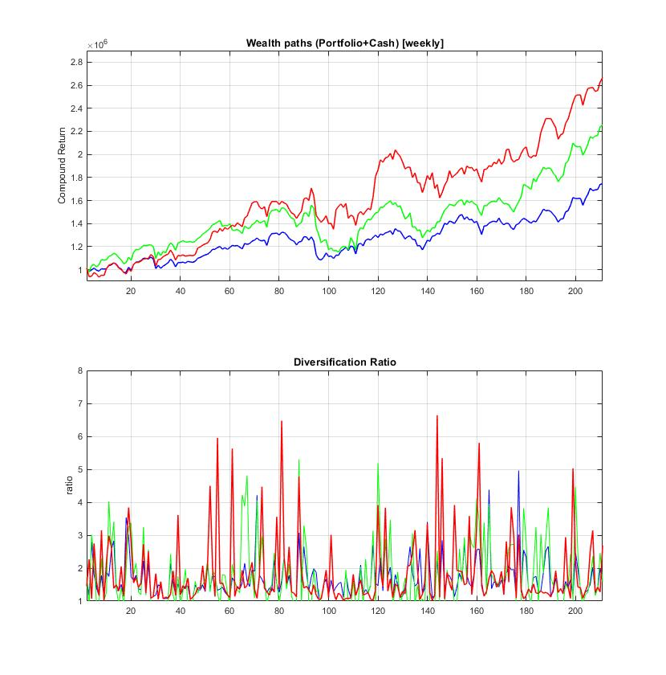
References:

[1] Lee,W. (2011). “Risk Based Asset Allocation: A New Answer to an Old Questions?
Journal of Portfolio Management, vol.37, N:4, pp.11–28.

[2] Leote de Carvalho,R., Lu,X. and Moulin,P. (2012). Demystifying Equity Risk Based Strategies: A Simple
Alpha plus Beta Description, Journal of Portfolio Management, vol. 38, N:3, pp.56-70.

[3] Roncalli,T. (2014). "Introduction to Risk Parity and Budgeting", Chapman and Hall/CRC Press, Boca Raton, FL.

[4] Richard,J-C. and Roncalli (2019). Constrained Risk Budgeting Portfolios: Theory, Algorithms, Applications and
Puzzles, , Available at SSRN: https://ssrn.com/abstract=3331184

[5] Ardia,D., Boudt,K. and Nguyen,G. (2018). Beyond Risk-based Portfolios: Balancing Performance and Risk
Contributions in Asset Allocation, Quantitative Finance, vol.18, N:8, pp.1249-1259.

[6] Choueifaty,Y. and Coignard,Y. (2008). Toward Maximum Diversification, Journal of Portfolio Management,
vol. 34, N:4, pp.40–51.

[7] Maillard,S., Roncalli,T. and Teiletche,J. (2010). The Properties of Equally Weighted Risk Contribution
Portfolios, Journal of Portfolio Management, vol.36, N:4, pp.60–70.

[8] Mausser,H. and Romanko,O. (2014). Computing Equal Risk Contribution Portfolios, IBM Journal of Research
and Development, vol.58, N:4, pp.5:1-5:12.

[9] Griveau-Billion, T., Richard, J-C., and Roncalli, T. (2013), A Fast Algorithm for Computing High-dimensional
Risk Parity Portfolios, Available at SSRN: https://ssrn.com/abstract=2325255

[10] Feng,Y. and Palomar,D. (2015). SCRIP: Successive Convex Optimization Methods for Risk Parity Portfolio
Design, IEEE Trans. on Signal Processing, vol.63, N:19, pp.5285-5300.

