Nonparametric Machine Learning for Algorithmic Cryptocurrency Trading

Nikolay Nikolaev
https://nikolaevny.github.io/

The cryptocurrencies are attractive for algorithmic trading because of their high volatility on the
stock markets. The volatility can be exploited by converting a sequence of crypto prices into
an oscillating series and simulating mean-reversion trading: buy when the series moves higher
than the equilibrium level, and sell when it reverses back. A trading algorithm takes such decisions
after estimating the price movement direction through historical or predictive time series analysis.
Trading is more profitable when the algorithm can look into the future evolution of prices. The
problem is that it is extremely difficult and practically impossible to predict accurately the
stochastic behaviour of prices/returns (they are assuned to follow a standard Brownian motion),
so the task is to produce useful forecasts for their immediate trajectory. This can be accomplished
with a proper description of their dynamics, and a corresponding learning mechanism. One such mathematical framework is provided by the nonparametric machine learning [1].

The nonparametric machine learning offers methods that forecast time series directly without
searching for explicit models. Some popular nonparametric methods are: density estimation [2],
and nearest neighbors [3],[4]. They carry out memory-based (local) learning by calculating distances
from provided training data patterns, and next extrapolation with a suitable technique like probabilistic
averaging. Both methods are local as they use information from the samples in the neighborhood
of the query vector to make predictions. The density estimation method typically uses a fixed
neighborhood window, while the nearest neighbor method uses a flexible neighborhood (the
window is adjusted to balance the bias variance tradeoff). These methods capture the dynamics
of the data by time-delay embedding, but do not build a model, and do not require fitting of data
(that is, they are robust to structural uncertainty).

Our research developed a Self-adaptive Local Learning Machine (SLLM) for nonparametric
prediction of financial series of returns on prices. The SLLM implements the nearest neighbor
method with two distinguishing features: 1) it performs neighbours selection using an adaptive
distance metric [5] which evaluates closeness after linear transformation of the data patterns,
that is the machine looks for similar shapes in the movement of returns by sliding the query
across the historical returns while stretching, shrinking and amplifying the patterns; and 2) it
performs distance-based extrapolation [6] through local averaging proportional to the degree
of similarity with the query vector, thus the forecast reflects the essential characteristics of the
data trajectory. The optimal number of nearest neighbours is determined by cross-validation [7].

The SLLM is elaborated to generate forecasts of returns for algorithmic cryptocurrency trading. The
return forecasts are converted to prices, and next taken to compute the residuals between the
forecasted prices and the mean price from the most recent past. The key idea is to predict eventual
opportunities arising when prices deviate significantly from their fair value, and trade with the
expectation that they will revert back. Assuming that the residual series represents a mean-reverting Ornstein-Uhlenbeck process [8], we calibrate its parameters (mean and variance) online and use
them to build trading signals. A long trade is initiated when the variance-normalized residuals
(score) exceeds the market threshold. Respectively, a short trading signal is sent when the
score goes below the equilibrium threshold. The continuous re-calibration of the spread mean
and variance parameters helps to respond quickly to the changing market conditions. Overall,
this is a market neutral strategy whose returns are uncorrelated with the market returns.

Empirical studies were conducted to examine the efficacy of the SLLM machine for
practical intraday Bitcoin trading. Historical intraday BTC/USD exchange rates were downloaded
from the Internet, more precisely we considered data sampled every 5 minutes from 12:00 on
2019-11-22 to 12:00 on 2019-12-09. At every discrete time step data from the past 3 hours
were used for machine learning with embedding dimension 30 minutes in the nearest neighbour
technology. The performance of the SLLM tool was evaluated with several measures of the
accumulated wealth (success rate, mean return, standard deviation of returns, and real total
profit [PnL]), as well as with two risk measures (the annualized Sharpe ratio and maximum
drawdown). The predictive potential of the SLLM was measured as the number of correctly
predicted directional price changes (Hits). The results (calculated over the entire time interval
including) given in the table below indicate that the elaborated local learning machine
demonstrates stable economic performance.

---------------------------------------
Performance Statistics SLLM
---------------------------------------
Number of Trades 253
Profitable trades 146
Success rate 57.71%
Mean return 0.96%
StDeviation 10.20%
Sharpe ratio 1.36
Maximum Drawdown 23.82%
Real total profit [PnL] 1781.50
Buy and Hold profit [PnL] 534.00
Hits 65.29
---------------------------------------

The figure below shows that the SLLM algorithm following a mean-reversion trading strategy
successfully exploits the market inefficiencies and achieves gradually increasing profits (red curve),
which are much higher than the eventual profits that could have been accumulated using
the buy and hold strategy (blue curve).
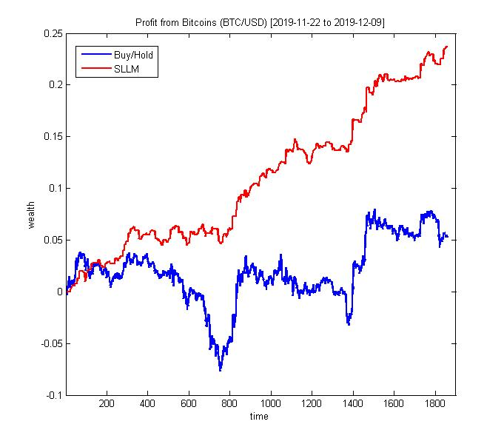
References:

[1] Hastie,T., Tibshirani,R. and Friendman,J. (2009). The Elements of Statistical Learning:
Data Mining,Inference and Prediction, Springer, 2nd Ed., New York.

[2] Härdle,W., Lütkepohl,H., and Chen,R. (1997) . A Review of Nonparametric Time Series Analysis,
Int. Statistical Review, vol.65, N:1, pp.49-72.

[3] Fernández-Rodríguez,F., Sosvilla-Rivero,S. and Andrada-Félix,J. (1999). Exchange-rate Forecasts
with Simultaneous Nearest-neighbour Methods, Int. Journal of Forecasting, vol.15, pp.383-392.

[4] Martínez,F., Frías, M.P., Pérez,M.D. and Rivera,A.J. (2019). A Methodology for Applying k-Nearest
Neighbor to Time Series Forecasting, Artificial Intelligence Review, vol.52, N:3, pp.2019-2037.

[5] Kulesh,M., Holschneider,M. and Kurennaya,K. (2008). Adaptive Metrics in the Nearest Neighbours
Method, Physica D, vol.237, N:5, pp.283–291.

[6] Guerron-Quintana,P. and Zhong,M. (2017). Macroeconomic Forecasting in Times of Crises,
Finance and Economics Discussion Series 2017-018, Board of Governors of the Federal
Reserve System (U.S.). Available at SSRN: https://ssrn.com/abstract=2842489

[7] Sorjamaa,A., Reyhani,N. and Lendasse,A. (2005). Input and Structure Selection for k-NN Approximator,
In: Proc.IWANN 2005 Comp. Intelligence and Bioinspired Systems, Springer, LNCS-3512, pp.985-992.

[8] Avellaneda,M. and Lee,J.-H. (2010). Statistical Arbitrage in the US Equities Market,
Quantitative Finance, vol.10, N:7, pp.761-782.

