Machine Learning with Dynamic Time Patterns for Algorithmic Trading

Nikolay Nikolaev
https://nikolaevny.github.io/
The algorithmic trading frameworks typically include estimation of financial time series models
often performed through machine learning techniques. The proper machine learning from time series
requires dynamic models and corresponding dynamic training algorithms (both the model and the
training algorithm should depend explicitly on time parameters). Handling financial series of
prices/returns is a very difficult task, however, because they are randon fluctuations which are
commonly assumed to follow standard Brownian motion. That is why, the popular global function
models even if they are dynamic can not capture global mappings in such series and can not forecast
well. Applied to financial time series of prices/returns the global function models simply produce
outputs with time delay (phase lagging) that are useless for algorithmic trading. When addressing
such tasks one should rather look for solutions with alternative local models, which build the
forecast by exploiting the continuations (succeeding points) of similar historical patterns to the
current query pattern. The rationale is that the local dynamics from similar past sections may
have a tendency to repeat itself.

Successful local machine learning from financial time series of retuns on prices can be achieved
using the k-Nearest Neighbors (kNN) algorithm [1],[2]. The kNN provides a technique for
computing the probability density function of the data using only selected close patterns (neighbors)
to the query. Query is a segment of points preceding and including the last point in the series. This
is a nonparametric technique which evaluates a local density model directly with the neighbours
guided by a suitable distance metric (without fitting a global parameterized equation to all data).
The learning procedure searches for patterns in the given time series, assuming that the data
evolution repeats its movements in sections without considerable changes. The prediction is
obtained via weighted averaging of the data following the nearest neighbors, that is by averaging
their retrospective forecasts. Applied to time series of prices/returns the kNN identifies similar
local behaviour in their evolution. Having such information about the trajectory of the price
evolution helps to generate plausible predictions without time delay.

The accuracy of kNN depends on the distance metric. In context of time series analysis this is
an algorithm that matches the fluctuations in the query with histories from the past (it should
account for deviations from the mean as well as the overall level). There are various sophisticated
similarity measures for time series, such as: Adaptive Shape Distance (ASD) [3], Complexity
Invariance Distance (CID) [4], Dynamic Time Warping (DTW) [5], etc.. Among these, the
DTW stabilizes the kNN performance as it compares more reliably temporal patterns by warping
the data along the time axis. The DTW searches for alignment of the query and the reference
pattern to make them resemble to each other. This is a procedure that expands and compresses
the patterns in time using dynamic programming. Such elastic handling of data evolving through
time helps to capture flexibly the motion in time series data [6].

Our research developed a nearest neighbour based machine learning tool (kNN-DTW) for nonparametric forecasting of time series using dynamic time patterns. The tool has two distinguishing features:
1) it implements an original statistical DTW for robust matching of temporal patterns, which uses standardization of the distance norm by the volatility of the series (this prevents the comparisons
from distortions by abnormal noise, and helps to obtain results with close volatility to the current
situation); and 2) it implements individual weighting of the neighbors, so that each neighbor is treated differently. The weights scale the contribution of each neighbor according to its closeness to the query,
and the weights decay with increasing the distance. These features together make the kNN-DTW tool
more noise tolerant, and more accurate on predicting real-world financial time series.

Since the kNN technology is especially popular for algorithmic trading in the foreign exchange
markets [7],[8],[9],[10] we conducted experiments using intraday USD/GBP rates. Data sampled
every 5 minutes from 9:00 on 1-march-2021 to 17:00 on 31-march-2021 were downloaded from
the Internet. Three versions of the nearest neighbors algorithm were made using the cited above
distances: kNN-DTW, kNN-ASD and kNN-CID. The learning algorithm was applied to rolling
windows of 120 past series points using embedding dimension 15. The economic performance was
evaluated with two measures of the accumulated wealth (Success rate, and Real total profit [PnL]),
as well as with two risk measures (Sharpe Ratio and Maximum Drawdown). The ability of the
algorithms to forecast the sign of future returns was evaluated with the percentage of correctly
predicted directional changes (Hits). The accuracy of the resilts was estimated with the formula
for normalized mean average error (NMAE). The results (calculated over the entire time interval)
given in the table below indicate that the novel kNN-DTW machine outperforms the other nearest
neighbour based algorithms, using respectively ASD and CID distance measures, as it achieves
higher profits with lower risk.

---------------------------------------------------------------------
Performance Statistics kNN-Euclid kNN-DTW kNN-ASD kNN-CID
---------------------------------------------------------------------
Number of Trades 894 894 894 894
Profitable trades 551 554 549 540
Success rate 61.34% 62.05% 60.42% 59.42%
Sharpe Ratio 0.76 0.81 0.61 0.53
Maximum Drawdown 1.21% 1.13% 1.47% 1.33%
Real total profit [PnL] 7.80% 8.44% 6.13% 5.74%
Buy and Hold profit [PnL] -0.85% -0.89% -0.89% -0.89%
HITS 71.75 73.56 70.22 70.54
NMAE 0.8779 0.8602 0.9151 0.9267
---------------------------------------------------------------------

The cumulative profits illustrated in the right plot below (bold red curve) support empirically the
belief that the kNN-DTW performance is fairly stable even when external transient noise disturbs
the market dynamics. The plot on the left shows that the forecasted returns (red curve)
approximate adequately the given returns (green curve) without time delay.

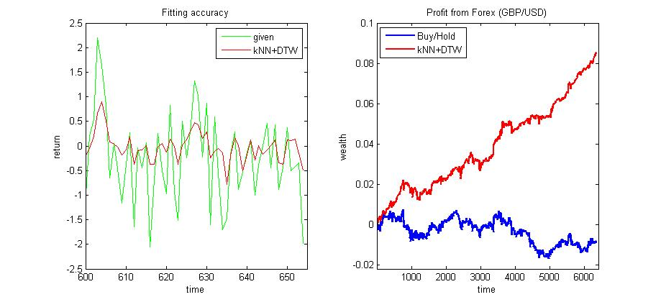
References:

[1] Farmer,J.D. and Sidorowich,J.J. (1987). Predicting Chaotic Time Series,
Physical Review Letters, vol.59, N:8, pp.845-848..

[2] Sauer, T. (1994). Time Series Prediction by using Delay Coordinate Embedding. In: Weigend,A.S. and
Gershenfeld,N.A. (Eds.), Time Series Prediction:Forecasting the Future and Understanding the Past.
Addison Wesley, UK, pp.175-193.

[3] Kulesh,M., Holschneider,M. and Kurennaya,K. (2008). Adaptive Metrics in the Nearest Neighbours
Method, Physica D, vol.237, N:5, pp.283–291.

[4] Batista,G.E., Keogh,E.J. and Tataw,O.M. (2014). CID: an Efficient Complexity-Invariant Distance for
Time Series, Data Mining and Knowledge Discovery, vol.28, N:3, pp.634–669.

[5] Berndt,D.J. and Clifford,J. (1994). Using Dynamic Time Warping to Find Patterns in Time Series,
In: AAAIWS'94: Proc. 3rd Int. Conf. on Knowledge Discovery and Data Mining (KDD Workshop),
vol.10, N:16, pp.359-370.

[6] Nakagawa,K., Imamura,M. and Yoshida,K. (2017). Stock Price Prediction with Fluctuation Patterns
using Indexing Dynamic Time Warping and k-Nearest Neighbors, In: JSAI-isAI 2017: New Frontiers
in Artificial Intelligence, LNCS 10838, Springer, pp.97-111.

[7] Guegan,D. and Mercier,L. (2005). Prediction in Chaotic Time series: Methods and Comparisons with
an Application to Financial Intra-day Data, The European Journal of Finance, vol.11, N:2, pp.137-150.

[8] Álvarez-Díaz,M. (2008). Exchange Rates Forecasting: Local or Global Methods?
Applied Economics, vol.40, N:15, pp.1969-1984.

[9] Tang,L., Pan,H. and Yao,Y. (2018). K-Nearest Neighbor Regression with Principal Component Analysis
for Financial Time Series Prediction, In: ICCAI 2018: Proc. Int. Conf. on Computing and Artificial Intelligence,
ACM Digital Library, pp.127–131.

[10] Umemoto,H., Toyota,T. and Ohara,K. (2018). k-NN Based Forecast of Short-Term Foreign Exchange Rates,
In: PKAW 2018: Knowledge Management and Acquisition for Intelligent Systems, LNCS 11016,
Springer, pp.139-153.

