Robust Portfolio Optimization via Connectionist Machine Learning

Nikolay Nikolaev
https://nikolaevny.github.io/

The Mean-Variance Portfolio (MVP) of Markowitz [1] is a popular model for investment
diversification and management that helps to achieve maximized profits with reduced
risk. It involves search for the amount of money to invest in each asset given the sample
covariance matrix of asset returns, which is a constrained quadratic programming (QP)
problem typically addressed using standard optimization routines [2]. The QP in context
of large scale financial applications is a difficult problem because the sample covariance
matrix of stock returns is very noisy and this misleads the optimization procedures. The
practical complication is that standard optimizers tend to overfit the noise while searching
for solutions, and this leads to suboptimal results. One strategy for dealing with the noise
is through statistical cleaning of the covariance matrix in advance [3].

An alternative strategy for building improved portfolios is to use connectionist learning
machines [4],[5] in optimization tools. The connectionist machines carry out robust training
of the model by flexible balancing the overfitting with the generalization performance. This
flexibility is an advantage over other contemporary search algorithms for such optimization
tasks, like evolutionary algorithms and swarm intelligence [6],[7]. Popular connectionist
approaches to the QP problem are the Hopfield neural networks (HNN) [5],[8] and the
Multilayer Perceptrons (MLP) [9].

The behaviour of the Hopfield networks is described by an energy function that corresponds
to the objective function of the optimization task [8]. The HNN features asympthotic
stability as the training equation guarantees that the error will settle at a stable lowest
energy state that represents the solution. However, since the model is nonlinear the error
landscape has multiple equilibrium states, and the error evolution can settle at different local
minima because of unsuitable initialization or appearance of mutually competing
attractors [9]. Such frustrations mean that the network can fail to find acceptable solutions.

The Multilayer Perceptron networks have been considered for nonlinear programming [10]
since they have abilities to handle uncertain and unprecise data, and they show reliable
performance on noisy practical data [11]. This version of the classical MLP network is
elaborated to minimize an error function that mimics the objective function of the
constrained quadratic programming problem. The network is calibrated using the error
backpropagation learning algorithm, but it has a slow convergence rate because of
reliance directly on gradient descent search. Moreover, the MLP network depends
critically on the initial conditions and this is a notoriously difficult issue.

Our research developed a QP optimizer with an embedded Multilayer Perceptron that
elaborates on the good features of both: optimizers with stable convergence and neural
networks with robust calibration. We implemented an original Connectionist Optimization
Machine (COM) suitable for finding portfolio allocations. Its distinctive features are:
1) it conducts second-order search using the analytical derivatives of the neural network
model,which leads to improved accuracy compared to the use of numerical derivatives
(computed by differencing), and 2) it performs input denoising simultaneously with the
learning of the model parameters, that is it removes the noise from the sample covariance
matrix during calibration. It should be noted that adopting the framework of classical QP
optimizers enables easy accommodation of various constraints in the training procedures.

Mean-Variance Portfolio Analysis. We conducted experiments in portfolio estimation
using 20 stocks from the technology sector (with tickers: GOOGL,AAPL,MSFT,MU,
INTC, CSCO, IDU,ADBE,TXN,AVGO,QCOM,AMT,HPQ,IBM,ORCL,NTAP,GLW,
AMAT,AMZN,LOGI). Daily closing prices of these stocks were downloaded from
internet (1/6/2015 - 1/6/2017). The portfolio weights (indicating the allocations) were
computed with an implementation of the proposed COM optimizer based on
a primal-dual interior-point method for solving quadratic programming problems.

The figure below shows the characteristics of the obtained portfolios using COM
in the standard deviation-mean space, known also as the risk-return space. One can
see the mean-variance efficient frontier curve (shown in red) and 1000 randomly
sampled portfolios (shown with red dots below the curve) computed starting from
random allocations (using the rand() function in Matlab). The efficient frontier shows
graphically the computed portfolios with the novel COM optimizer which can maximize
the returns for the assumed risk. The investor can use such plots in order to select
combinations of assets that can offer optimal returns with lower risk (they are on
the efficient frontier curve). The portfolio with minimum standard deviation among
these on the efficient frontier is the minimum variance frontier portfolio.

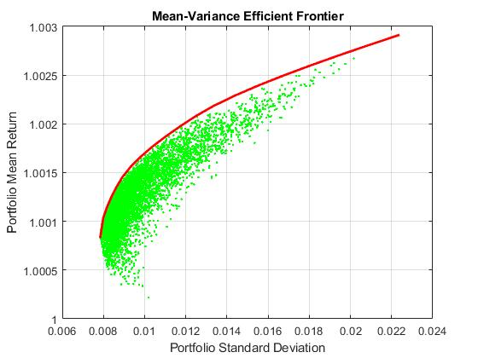
References:
[1] Markowitz,H.M. and Todd,G.P. (2000). Mean-Variance Analysis in Portfolio Choice and Capital Markets.
Wiley, New York.

[2] Best,M.J. (2010). Portfolio Optimization. Chapman&Hall/CRC Finance, Boca Raton, FL.

[3] Bun,J.U., Bouchaud,J-P. and Potters,M. (2017). Cleaning Large Correlation Matrices: Tools from
Random Matrix Theory, Physics Reports, vol.666, pp.1-109.

[4] Shadbolt,J. and Taylor,J.G. (Eds.) (2002). Neural Networks and the Financial Markets:Predicting,
Combining and Portfolio Optimisation, Springer-Verlag, London.

[5] Fernandez,A. and Gomez,S. (2007). Portfolio Selection using Neural Networks,
Computers and Operations Research, vol.34, N:4, pp.1177-1191.

[6] Anagnostopoulos,K. and Mamanis,G. (2009). Multiobjective Evolutionary Algorithms for Complex
Portfolio Optimization Problems, Computational Management Science, vol.8, N:3, pp.259-279.

[7] Zhu,H., Wang,Y., Wang,K. and Chen,Y. (2011). Particle Swarm Optimization (PSO)
for the Constrained Portfolio Optimization Problem, Expert Systems and Applications,
vol.38, N:8, pp.10161–10169.

[8] Tagliarini,G.A., Christ,J.F. and and Page,E.W. (1991). Optimization using Neural Networks,
IEEE Trans. on Computers, vol.40, N:12, pp.1347–1358.

[9] Molter,C., Salihoglu,U. and Bersini,H. (2005). Learning Cycles Brings Chaos in Hopfield Networks,
In: Proc. 2005 IEEE Int. Joint Conference on Neural Networks, IJCNN '2005, pp.770-775.

[10] Reifman.J. and Feldman,E.E. (2002). Multilayer Perceptron for Nonlinear Programming,
Computers and Operations Research, vol.29, N:9, pp.1237-1250.

[11] Nikolaev,N. and Iba,H. (2006). Adaptive Learning of Polynomial Networks: Genetic
Programming, Backpropagation and Bayesian Methods, Springer, New York.

