Support Vector Machine Learning of Sparse Portfolios

Nikolay Nikolaev
https://nikolaevny.github.io/

The portfolio construction task involves finding an optimal subset of assets for investment and
estimating their allocations. An efficient method for solving both tasks simultaneously is to use
high-dimensional regression models (where asset prices/returns are used as regressors and allocations
as weights) with cardinality constraints [1]. This is a numerically difficult problem because learning
high-dimensional models from noisy, real-world financial data leads to weights that are not very
precise. Overcoming such computational difficulties is important for the practical applicability
of such models. The common strategy to mitigate these difficulties is to develop stable procedures that
seek sparse models by shrinking the weights using regularization techniques [1],[2],[3].

The main approaches to stable learning of sparse regression models for portfolios are: 1) Bayesian
Shrinkage [4]; 2) l1-norm penalization [5], and 3) e-insensitive loss [6]. The common effect from
all these approaches is that they avoid large variations in the results and attain better generalization (predictability). The Bayesian shrinkage imposes different probabilistic assumptions on each weight
(via regularization hyperparameters) and can be quite accurate. Although the hyperparameters are
obtained with analytical formulae, they also depend on specific assumptions that are very difficult
to determine in practice. The l1-norm (norm-one) penalization is easier to implement, but it is
unable to promote enough sparsity when building long-only portfolios. More flexible for
finding parsimonious models is the approach using e-insensitive loss because it is noise
tolerant when handling imprecise (and corrupted) practical data.

The algorithmic framework using e-insensitive loss is called epsilon Support Vector Regression
(e-SVR) machine [7]. The insensitive loss function helps to achieve robust model calibration because
it allows error deviations within a certain predefined interval, and penalizes deviations outside of
this e-tube (errors smaller than e are ignored). The magnitude of the sensitivity hyperparameter
controls the degree of overfitting through its impact on the fitting error. The e-SVR minimizes the
structural risk (which is a kind of generalization error consisting of fitting error plus regularization)
and, that is why, it learns parsimonious models. In this sense, it yields better generalizing models
than the other penalized regression algorithms Bayesian Ridge Regression (BRR)[8] and LASSO [9]
which use the typical square loss training error.

Our research implemented a reformulated e-SVR machine for efficient and robust learning of
portfolios (including the number of assets/cardinality and the weights/allocations). This reformulation
enables fast and reliable convergence to unique globally minimal solutions (without using slow
optimization procedures). The plausible values of the hyperparameters that govern the model
complexity are found with a cross-validation technique using the available historical data. Actually
there are two hyperparameters: the first determines the size of the sensitivity, and the second
determines its influence on the magnitude of the fitting error.

The possibility to build portfolios with sparse regression algorithms was investigated using the
benchmark Fama-French FF48 dataset [10] (in order to be comparable to previous research).
This set includes 48 time series (returns on securities) collected during 30 years (1976-2006). Starting
from year 1981 (that is, data from the last 5 years were used for training), the data were rolled by
a month ahead. At the end of each month we run each algorithm to compute the allocations (with
which the portfolio returns were obtained at the next time step) and then we selected a sparse portfolio. Sparsity here means that the portfolio contains only a small number of active (long-only)
positions. Such experiments were conducted with cardinality from 10 to 25 securities, in order to
analyse the potential of each algorithm to operate with different levels of sparseness. The estimated
annual mean returns, risks (standard deviations of the returns), and Sharpe ratios are given in the table
below. The results in this table indicate that the e-SVR outperforms although slightly the other
sparse regression algorithms, as it finds portfolios that demonstrate higher returns with less variance.
Moreover, the e-SVR finds portfolios that achieve consistently higher Sharpe ratios the other
competing machine learning algorithms.

-------------------------------------------------------------------------------------------
10 15 20 25 Portfolio Cardinality
-------------------------------------------------------------------------------------------
BRR 0.1589 0.1546 0.1505 0.1492 Returns (mean)
0.1564 0.1563 0.1587 0.1559 Risk (stdev)
0.9983 1.0002 0.9588 0.9641 Sharpe (ratio)

LASSO 0.1482 0.1543 0.1455 0.1492 Returns (mean)
0.1677 0.1537 0.1571 0.1583 Risk (stdev)
0.8836 1.0035 0.9264 0.9437 Sharpe (ratio)

e-SVR 0.1645 0.1618 0.1556 0.1560 Returns (mean)
0.1542 0.1521 0.1484 0.1511 Risk (stdev)
1.0643 1.0586 1.0402 1.0134 Sharpe (ratio)
-------------------------------------------------------------------------------------------

The preliminary results show that the e-SVR machine can be a feasible tool for asset selection
and allocation estimation, as it is capable of finding sparse and profitable portfolios. The figure
below illustrates the effect from the hyperparameters on the cardinality of the portfolios
obtained over the FF48 data.
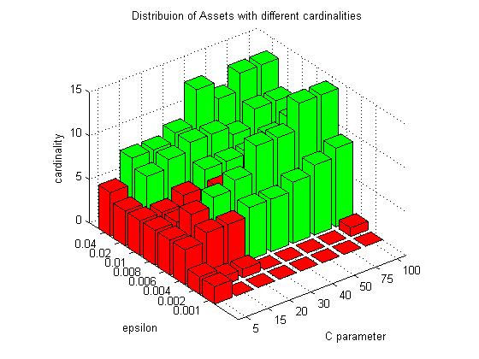
References:

[1] Brodie,J., Daubechies, I., De Mol,C., Giannone, D. and Loris, I. (2009). Sparse and Stable
Markowitz portfolios. PNAS Proc.of the National Academy of Sciences of the USA,
vol.106, N:30, pp.12267–12272.

[2] Quispe,L.P.Y. (2014). Constrained Shrinkage Estimation for Portfolio Robust Prediction,
American Journal of Economics, vol.4, vol.2A, pp.27-41.

[3] Fastrich,B., Paterlini,S. and Winker,P. (2015). Constructing Optimal Sparse Portfolios using
Regularization Methods, Computational Management Science, vol.12, N:3, pp.417–434.

[4] Frey,C. and Pohlmeier,W. (2016). Bayesian Shrinkage of Portfolio Weights,
Available at SSRN: https://ssrn.com/abstract=2730475.

[5] Kremer,P.J., Lee,S., Bogdan,M. and Paterlini,S. (2020). Sparse Portfolio Selection via the
Sorted l1-Norm, Journal of Banking and Finance, vol. 110 (C).

[6] Rossbach,P. and Karlow,D. (2019). Structural Minimization of Tracking Error,
Quantitative Finance, vol. 19, N:3, pp.357-366.

[7] Vapnik,V. (2000). The Nature of Statistical Learning Theory, (2nd ed.), Springer-Verlag, New York.

[8] Bishop,C. (2006). Pattern Recognition and Machine Learning, Springer, New York.

[9] Hastie,T., Tibshirani,R. and Wainwright,M. (2015). Statistical Learning with Sparsity: The Lasso
and Generalizations, Chapman & Hall/CRC Press, Boca Raton, FL.

[10] Fama/French Data Library: Research Portfolios- FF48 data set (2020).
(http://mba.tuck.dartmouth.edu/pages/faculty/ken.french/data_library.html)

