Machine Learning of Heavy-Tailed Dynamic Spread Models for Statistical Arbitrage

Nikolay Nikolaev
https://nikolaevny.github.io/

Statistical arbitrage (statarb) is a trading strategy that analyzes the dynamics of mispricing
in combinations of assets with the aim to exploit deviations from equilibrium levels in the
markets [1],[2], and generate buy/sell trading signals (so as to make profits before participants
eliminate the arbitrage opportunities). The statarb technology identifies systematic market-
dependent components from a slected set of assets, and computes the residual price difference
(spread) from the remaining stocks in the portfolio. The spread is actually the unexplained
information by the systematic components, that is the idiosyncratic residual (a separate model
is calibrated for the spread of each particular stock). One popular idea is that the spread
evolution follows a stochastic mean-reverting process [2],[4],[8],[9],[10],[11]. The mean
reverting behaviour suggests that price divergencies will return back to their average, and
this helps to take short/long positions as well as to build automated trading systems.

The machine learning task in context of the statarb framework involves formulation of
dynamic models for the spread and derivation of robust estimation algorithms (candidate
assets are selected through search for cointegrating relationships with mean-reversion
property). Dynamic models are necessary to account explicitly for the time dependencies
in the spread series, because prices arrive sequentially in time (and their distribution is
time-varying). Robust estimation algorithms are necessary as price returns often feature
heavy-tailed characteristics [5], and standard Gaussian treatment cannot handle them
plausibly. When spreads are obtained from price returns, they are expected to have similar
statistical characteristics. They should be handled properly in order to achieve stable
learning of the parameters, otherwise simply training with the Gaussian assumption
leads to innacurate results. This reasoning motivates the increasing recent research
interest into mixture spread models to explain non-Gaussian data.

Mixture models are popular in economics as they accurately capture data coming from
time-varying non-normal distributions, and this helps to accommodatewell aberrant
changes in time series arising from occasional events. A mixture model is a composition
of submodels (each contributing a specific distribution with different specifications)
which provide capacity to describe flexibly distributions of various shapes and stylized
characteristics. Such combinations applied to spreads include: threshold autoregressive
(TAR) models [6], logistic mixture autoregressive (LMAR) models [7], autoregressive
hidden Markov models (AR-HMM) [8],[9], and regime-switching models (RSM)
[5],[10],[11],[12]. A common feature in them is the maintenance of different means
(representing trends) and variances (representing uncertainties).

The TAR models infer the mixture data distribution using threshold variables for level
segmentation. The LMAR models are more general and less sensitive to outliers as they
use logistic functions to calculate the mixing proportions depending on the past history.
Improved temporal convolution is alternatively achieved using unobserved (latent)
state variables to guide the selection of the particular mixing component. Assuming
that these latent variables are related through a Markov chain (the state change in the
chain depends only on the most recent state carrying all information from the past),
there have been devised two different kinds: AR-HMM and RSM models.
The AR-HMM are implemented wtih constant transition probabilities to control regime
changes, while RSM are implemented with dynamic transition probabilities. The RSMs
are more sophisticated tools because their time-varying transitions imply that the model
structure also changes dynamically.

The discrete Markov regime-switching models are found suitable for learning
mean-reverting spreads [5],[8],[9],[10],[11],[12] as they describe complex patterns
(having non-Gaussian characteristics), like heterogeneity, multimodality, skewness and
kurtosis. Viewed theoretically, the switching models emit mixtures that help us to
describe more adequately (without being disturbed by outliers) time series with peaked
and heavy-tail distributions. The evolution of the spread shifts between high and low
mean regimes, and it can stay there for prolonged periods of time. While using
regime-switching spread models is theoretically appealing, they often cannot achieve
satisfactory fitting accuracy on practical financial data because of the unobserved
nature of the hidden regimes (which are technically very difficult to infer). Rather
such models can be useful for detecting turning points between persistent (not sudden)
changes in time series [13]. The switching models are usually outperformed even
by ordinary time-varying parameter models obtained by rolling regression.

Our research develops machine learning tools for statistical arbitrage with continuous
mixture models. These are continuous mixture models for mean-reverting spreads based
on a discrete version of the Ornstein–Uhlenbeck stochastic differential equation. They
are calibrated online with computationally efficient mixture filters to obtain plausible
parameter estimates on the typically non-Gaussian financial data. Our tools have two
distinctive advantages: 1) the filters are applied to heavy-tailed models elaborated with
dynamic scale-mixtures of normal and gamma densities (that actually approximate
Student-t distributions), and 2) they perform robust sequential Bayesian estimation of
the parameters. Overall, these are learning machines that carry out predictive adaptation
of the models to the changes in the markets via forecasting of their time-varying
parameters. The filtering algorithms adjust dynamically the hedge ratios between the
assets with the arrival of data over time, and this helps to achieve better exploitation
of arising arbitrage opportunities.

Current experiments show that our tools have potential to generate excess returns when
applied to a pairs trading task [3] (the spread is computed from two stocks only, whose
price movements are cointegrated): betting on the prices of Coca-Cola ('KO') and
Pepsi ('PEP') during the recent period between 1 january 2010 and 30 december 2018.
The model parameters were taken to calculate the normalized spread (z-score) and
trading positions were opened/closed when the z-score exceeds the predefined limits of
the mean-reverting behaviour. We used a trailing period of 30-day data window, and
performed signal computations on closing prices from the last trading day. The
econometric performance estimated with one-step ahead predictions of the last 2150
days was as follows: Success rate 72.02%, Cumulative return [PnL] 275.28%,
Annualized Mean return 32.06%, Annualized StDeviation 18.48%, Annualized Sharpe
ratio 1.37, and Maximum Drawdown 0.0386. The real total profit was 1.68 times the
Gaussian model profit, and 2.54 times the buy and hold profit. The plots in the figure
below illustrate the spread with the buy/sell threshold lines (in the middle pannel), the
profit from our robust heavy-tail (non-Gaussian) model with the red curve, the profit
from a linear Gaussian model with the light green curve, and the profit achieved
using the buy-and-hold strategy with the black curve (in the bottom pannel).
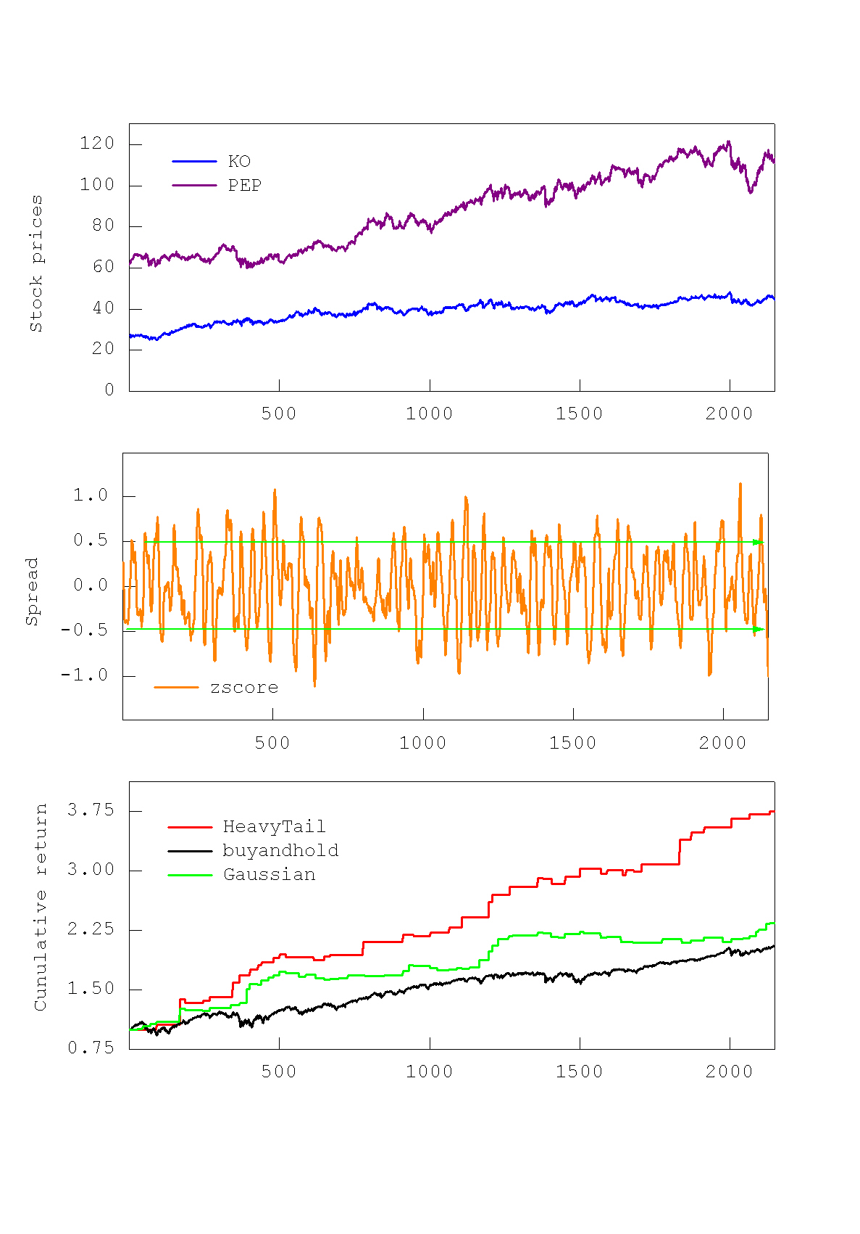
References:
[1] Burgess,A.N. (1999). A Computational Methodology For Modelling The Dynamics Of Statistical Arbitrage, PhD Dissertation,
London Business School, University of London, UK.
[2] Avellaneda,M. and Lee,J-H. (2010). Statistical Arbitrage in the US Equities Market, Quantitative Finance, vol.10, N:7, pp.761-782.
[3] Vidyamurthy,G. (2004). Pairs Trading: Quantitative Methods and Analysis, John Wiley and Sons, Hoboken, NJ.
[4] Elliott,RJ. and Bradrania,R. (2018). Estimating a regime switching pairs trading model, Quantitative Finance, vol.18, N:5, pp.877–883.
[5] Bauwens,L., Hafner,C.M. and Laurent,S. (Eds.) (2012). Handbook of Volatility Models and Their Applications, Wiley Handbooks
in Financial Engineering and Econometrics, John Wiley and Sons, Hoboken, NJ.
[6] Chen,C.W.S., Chen,M. and Chen,S-Y. (2014). Pairs Trading via Three-Regime Threshold Autoregressive GARCH Models, In:
V.N.Huynh et al. (Eds.), Modeling Dependence in Econometrics. Advances in Intelligent Systems and Computing, vol.251.
Springer, pp.127-140.
[7] Cheng,X., Yu,P.L.H. and Li,W.K. (2011). Basket trading under co-integration with the logistic mixture autoregressive model,
Quantitative Finance, vol.11, N:9, pp.1407-1419.
[8] Sipos,I. and Levendovszky,J. (2015). Optimizing Sparse Mean Reverting Portfolios with AR-HMMs in the Presence of Secondary
Effects, Periodica Polytechnica Electrical Engineering and Computer Science, vol.59, N:1, pp.1-8.

[9] Tenyakov,A. and Mamon,R. (2017). A computing platform for pairs-trading online implementation via a blended Kalman-HMM
filtering approach, Journal of Big Data, vol.4, N:1, pp.4-46.
[10] Bock,M. and Mestel,R. (2009). A Regime-Switching Relative Value Arbitrage Rule, Operations Research Proceedings 2008,
B.Fleischmann et al. (Eds.), Springer-Verlag, Berlin, pp.9-14.
[11] Yang,J-W., Tsai,S-Y., Shyu,S-D. and Chang,C-C. (2016). Pairs trading: The performance of a stochastic spread model with regime
switching-evidence from the S&P 500, Int. Review of Economics and Finance, Elsevier, vol.43(C), pp.139-150.
[12] Bai,Y. and Wu,L. (2018). Analytic value function for optimal regime-switching pairs trading rules, Quantitative Finance,
vol.18, N:4, pp.637-654.
[13] Fornaciari,M. and Grillenzoni,C. (2017). Evaluation of on-line trading systems: Markov-switching vs time-varying
parameter models, Decision Support Systems, vol.93, pp.51–61.

