Algorithmic Cryptocurrency Trading with Sharpe-optimal Deep Learning

Nikolay Nikolaev
https://nikolaevny.github.io/

Algorithmic trading [1] uses computer programs to analyze market data and generate trading
signals with suitable models. Particularly appropriate for such tasks are the neural networks due
to their ability to learn flexible nonlinear models with good predictive capacity. The problem is
how exactly to train these networks on financial price data so as to produce useful trading decisions,
because prices are very difficult (practically impossible) to forecast. Since prices are considered
to follow Geometric Brownian Motion, it can not be expected the neural network learning machinery
will induce sufficient predictive potential simply by fitting the data with error-minimization
procedures. Better results can be obtained by training the neural network parameters on price
returns using directly a financial objective instead of a fitting criterion [2]. Thus, the model can
be adapted just to capture the directional fluctuations in the given series which are sufficient for
sending trading signals. The financial objective to achieve high profits with low risk can be
specified with different formulae, like the Sharpe ratio [3] for example.

Two proper approaches to modeling changes in time series of relative price returns are the
Sharpe-optimal Connectionist Learning (SCL) [4],[5] and the Recurrent Reinforcement
Learning [6],[7]. Both these approaches use neural networks, which weight parameters are
trained to optimize their performance measured by a chosen economic criterion such a
risk-adjusted profit. The SCL employs a feedforward network and updates its weight
parameters to maximize the Sharpe ratio over all available data in offline manner. The RRL
uses a recurrent network and carries out weight updating in online manner with rewards for
achieved profitability (received through feedback information from previous actions). Although
this mechanism reinforces the model utility, it may not help to reach good results because it
uses recurrent neural networks that are notoriously difficult to train, since: 1) their convergence
is problematic as they suffer from the vanishing gradients problem; and 2) they are highly
sensitive to the initialization of the weights and the internal memory.

Our research developed a Sharpe-optimal Deep Learning (SDL) machine suitable for
high-frequency algorithmic trading. A feedforward deep neural network [8] is elaborated to
predict the position size (which serve as a corresponding buy/sell trading signal) given a time
series of relative price returns. The deep neural network brings increased flexibility for enhanced
nonlinear modeling through a tuneable multilayer structure, including rectified units (leading
to sparsity) and sigmoidal units (providing nonlinearity). The network model is trained with
a risk-adjusting backpropagation algorithm that implements gradient ascent in the performance
space. The performance is measured with a modified Sharpe ratio that discounts effects
from the loosing trades. This helps to overcome equal treatment of high profits with heavy
loses in the alternative standard deviation formula. During training the neural network
continuously improves its skills to take useful trading decsisions (without external supervised help).

Empirical studies were conducted to examine the efficacy of the developed machine for
practical intraday Bitcoin trading. Since Bitcoin prices are considered to evolve independently
from the major stock market indices, we are inclined to think that there could be more probable
to seek patterns in their directional movement using Sharpe-optimal Deep Learning. Historical
intraday BTC/USD exchange rates were downloaded from the Internet, more precisely we took
data sampled every 5 minutes from 6:00 on 2019-12-05 to 6:00 on 2019-12-09. At every
discrete time step data from the past 24 hours were used for neural network training with
embedding dimension 30 minutes. The performance of the SDL was compared with this
of the RRL using several measures of the accumulated wealth (success rate, mean return,
standard deviation of returns, and real total profit [PnL]), as well as with two risk measures
(the annualized Sharpe ratio and maximum drawdown). The results, calculated over the entire
time interval, given in the table below indicate that the novel SDL is successful in simulated
trading.

---------------------------------------------------
Performance Statistics RRL SDL
---------------------------------------------------
Number of Trades 64 78
Profitable trades 39 52
Success rate 61.94% 67.65%
Mean return 0.45% 0.49%
StDeviation 6.12% 5.43%
Sharpe ratio 1.16 1.38
Maximum Drawdown 13.79% 12.24%
Real total profit [PnL] 362.00 411.00
Buy and Hold profit [PnL] 148.00 148.00
---------------------------------------------------

The figure below demonstrates that the SDL machine is able to generate trading
decisions leading to gradually increasing profits (red curve), which grow much more reliably
than the profits from the RRL machine (light purple curve), and both are higher than the
eventual profits from the buy and hold strategy (dark green curve).

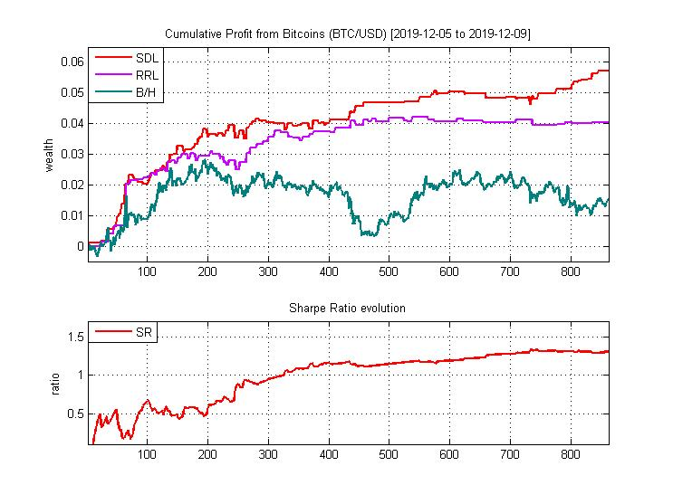

References:

[1] Chan,E. (2013). Algorithmic Trading: Winning Strategies and Their Rationale, Wiley, NJ.

[2] Bengio,Y. (1997). Using a Financial Training Criterion Rather than a Prediction Criterion,
Int. Journal of Neural Systems, vol.8, N:4, pp.433-443.

[3] Sharpe,W.,F. (1994). The Sharpe Ratio, The Journal of Portfolio Management, vol.21, N:1, pp.49–58.

[4] Choey,M. and Weigend,A.S. (1997). Nonlinear Trading Models Through Sharpe Ratio Maximization,
Int. Journal of Neural Systems, vol.8, N:4, pp.417-431.

[5] Gao,X. and Chan,L. (2000). An Algorithm for Trading and Portfolio Management Using Q-learning
and Sharpe Ratio Maximization, In: Proc. Int. Conf. Neural Inf. Processing ICONIP-2000, pp.832-837.

[6] Moody,J. and Saffell,M. (2001). Learning to Trade via Direct Reinforcement,
IEEE Trans. on Neural Networks, vol.12, N:4, pp.875-89.

[7] Koker,T.E. and Koutmos,D. (2020). Cryptocurrency Trading Using Machine Learning,
Journal of Risk and Financial Management, MDPI, vol.13, N:8, pp.1-7.
Available at: https ://www.mdpi.com/1911-8074/13/8/178.

[8] Goodfellow,I., Bengio,Y. and Courville,A. (2016). Deep Learning, The MIT Press, Cambridge, MA.

