Deep-Memory Networks vs. Deep Learning Networks
for Stock Market Prediction

Nikolay Nikolaev
https://nikolaevny.github.io/
Deep Learning Networks (DLN) [1,2,3] are popular tools for machine learning. The power of DLNs is in their ability to discover complex functions of real-world noisy data by composing hierarchically simple representations, technically speaking they learn to generalize well by extracting features. The good results of DLN on data mining tasks motivated recently researchers to seek improved results in financial forecasting as well [4,5,6,7,8]. The problem is that the application of DLN to stock market modelling is not straightforward, and their suitability for such tasks has not been yet fully investigated.
Some popular deep networks already applied to time series processing tasks include: Deep Belief Networks (DBN) using stacked Restricted Boltzmann Machines (RBM) [9], Autoencoders (AE) [10] and Convolutional Neural Networks (CNN) [11]. These networks achieve better forecasting performance using sophisticated pre-training algorithms as well as supervised training algorithms. The DBNs use energy-based RBM modules for initialization. A more stable approach to pre-training offer the AE modules which try to reconstruct the given inputs with a compression layer calibrated in unsupervised manner. The CNN networks avoid overfitting by dimensionality reduction with sparse convolutional layers of locally connected neurons with shared weights, followed by a pooling layer and dense sigmoidal layers.
A common problem of the above DLN machines is that they realize actually static mappings and are unable to capture time relationships in the data. In order to pass previous information a model should have some memory. The simplest memory is tap delay line from lagged observations. Although when deep networks are taken to fit time series they are typically equipped with such delay mechanisms, their training does not handle directly the time dimension of the data, rather time-delay deep networks are still trained with static learning algorithms which leads to suboptimal results.
Effective deep learning architectures for time series regression are the Recurrent Neural Networks (RNN) [12] and the Long-Short Term Memory (LSTM) [13] networks. They are designed to learn long-term dependencies via memory feedbacks and gates for behavioural control. These networks are trained with dynamic derivatives that account explicitly for the time relationships in the data. It has been found however that they often struggle to learn well patterns if not cautiously initialized. Another problem is that the size of the network architecture and the temporal memory are selected with computationally expensive model selection criteria.
Our research invented a novel tool Deep-Memory Neural Networks (DMNN) for machine learning from financial time series and stock market forecasting. The idea of DMNN is to achieve good extrapolation potential by learning signal characteristics from time series, rather than by extracting features as the other deep networks.
The rationale for making deep memory networks for stock market prediction is that financial time series often feature slowly decaying autocorrelations [14] and this requires long-memory embeddings. Long range dependence properties have been found in various financial series, like stock prices, stock market indices, exchange rates, etc. The long-term memory concept has already been studied for building volatility models where improved results have been reported, but little research has been done on using this concept for making price models. According to the cybernetic analysis of financial data [15] model memory depth is proportional to the tradable cycle. It is found by extracting the cyclic component from the given series and next measuring the dominant cycle period.
The DMNN model takes lagged input vectors of predetermined depth, and is treated as a dynamical system using sequential Bayesian estimation to accommodate properly the temporal dimension. Thus, during training the DMNN becomes fitted to its full potential of being a dynamic machine that learns time-dependent functions, and this is its essential advantage over the other DLNs which are typically trained as static functions. There are implemented various filters that make the DMNN behave like nonlinear autoregressive models with time-varying parameters.
The DMNN training procedure is original and involves two special algorithmic technologies:
- Initialization with Gaussian processes- overall the model is considered as a stochastic process description whose weights are estimated with an information-theoretic method. This method helps us to avoid overfitting the data while estimating the assumed Gaussian process in supervised manner (so that it becomes close and adequate to the training data);
- Dynamic weight training and data cleaning- the learning algorithm performs simultaneous weights updating and noise cleaning. A double filter is elaborated to adapt the neural network weights to cleaned input data which facilitates generation of more accurate predictions on sequentially arriving data like financial price series.
The figure below illustrates the unique forecasting potential of the DMNN tool. It shows the prediction of a recent DJI stock market index series (daily closing values). The training was performed using 1259 values. The long-term (multi-step ahead) predictions of the future 100 values begin from 15 February 2016 (the starting point in the plot is 1281).
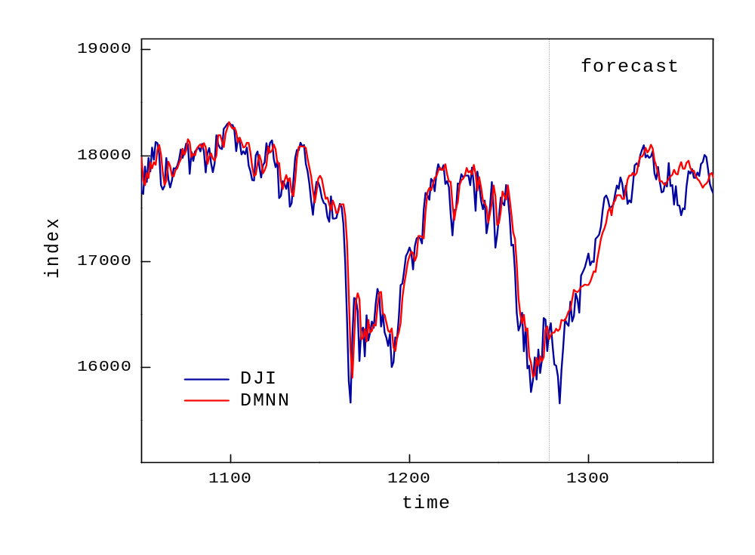

References:
[1] LeCun,Y., Bengio,Y. and Hinton,G.E.(2015). "Deep Learning", Nature, vol.521, pp.436-444.

[2] Schmidhuber,J. (2015). "Deep Learning in Neural Networks: An Overview", Neural Networks, vol.61, pp.85-117.

[3] Goodfellow,I., Bengio,Y. and Courville,A. (2016). "Deep Learning", MIT Press.
www.deeplearningbook.org

[4] Hrasko,R., Pacheco,A.G.C. and Krohling,R.A. (2015). "Time Series Prediction Using Restricted Boltzmann Machines and Backpropagation", Procedia Computer Science, vol.55, pp.990-999.

[5] Chen,K., Zhou,Y. and Dai,F. (1015). "A LSTM-based method for stock returns prediction: A case study of China stock market", In: Proc. 2015 IEEE Int. Conf. on Big Data, IEEE Press.

[6] Heaton,J.B., Polson,N.G., and Witte,J.H. (2017). “Deep learning for finance: deep portfolios”, Applied Stochastic Models in Business and Industry, vol.33, pp.3-12.

[7] Chong,E., Han,C. and Parka,F.C. (2017). "Deep learning networks for stock market analysis and prediction: Methodology, data representations, and case studies", Expert Systems with Applications, vol.83, pp.187-205.

[8] Chen,J-F., Chen,W-L., Huang,C-P., Huang,S-H. and Chen,A-P. (2017). "Financial Time-Series Data Analysis Using Deep Convolutional Neural Networks", In: Proc. 2016 7th Int. Conf. on Cloud Computing and Big Data (CCBD), IEEE Press.

[9] Hinton,G.E., Osindero,S. and Teh,Y-W. (2006). "A fast learning algorithm for deep belief nets", Neural Computation, vol.18, pp.1527-1554.

[10] Bengio,J., Lamblin,P., Popovici,D. and Larochelle,H. (2007). "Greedy layer-wise training of deep networks", In: NIPS'06 Proc. of the 19th Int. Conf. on Neural Inf. Proc. Systems, pp.153-160.

[11] Krizhevsky,A., Sutskever,I. and Hinton,G.E. (2012). "ImageNet classification with deep convolutional neural networks ", In: NIPS'12 Proc. of the 25th Int. Conf. on Neural Inf. Proc. Systems, pp.1097-1105.

[12] Werbos, P.J.(1990). "Backpropagation through time: what it does and how to do it", Proc. of the IEEE 78(10), pp.1550-1560.

[13] Hochreiter,S. and J. Schmidhuber,J. (1997). “Long short term memory”, Neural Computation, vol.9, pp.1735-1780.

[14] Teyssière,G. and Kirman, Alan P. (Eds.) (2007). "Long Memory in Economics"
Springer-Verlag, Berlin.

[15] Ehlers,J.F. (2004). "Cybernetic Analysis for Stocks and Futures",
John Wiley & Sons, Hoboken, NJ.

