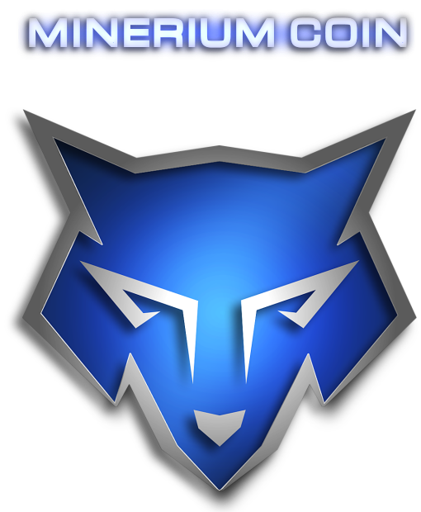

**Minerium's mission:**

Minerium Coin's goal is to be implemented for real-life use.   
Minerium is not just a coin, it is a cryptocurrency.

First, we are aiming to increase its value, then to get a stable price, which will happen at the end of the block rewards process in 2 years.   
A minimal value of 1000 Satoshis (0.00001000 BTC) is the ideal and what we will achieve.   
  
This is why we are first focusing on an investment platform which will allow you to use Minerium to buy online.   
A partnership with Amazon, Newegg and Netflix, for example.

We realized that many projects have a too long mining process lasting over several years which give fewer chances to the new miners to make profits.   
  
The new SuperDay function is the best remedy for this situation, giving a chance to everyone during the mining process.   
See the [chart](https://mineriumcoin.com/block_rewards.png) for more details about this specifically.

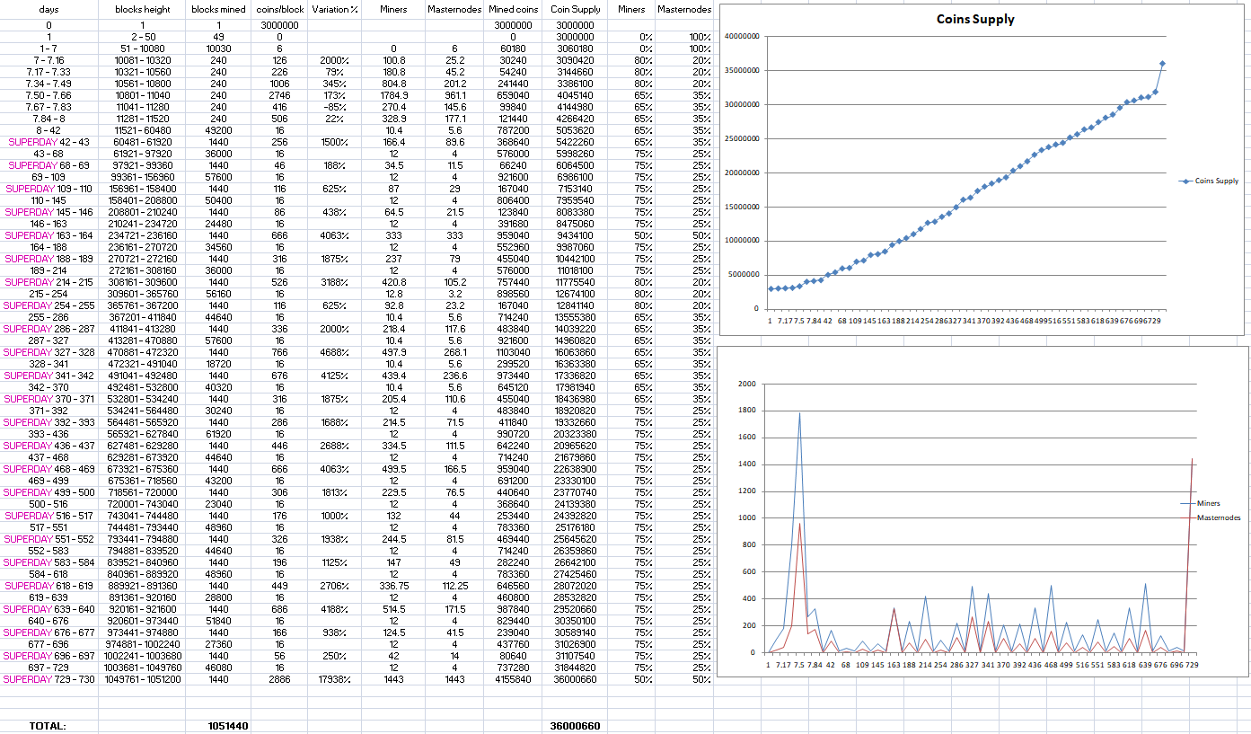

**Minerium over the years:**

The reward's period lasts 730 days (2 years). After this, the miners will be compensated by the rewards of the transactions fees.

Compared to Bitcoin, Minerium has the capacity to adjust its difficulty much faster at every 3 blocks.   
Its ratio "max PoW/difficulty" is set up to never go very high on the mining difficulty, to avoid the blockchain being stuck and struggling for hours or days.   
This will allow a very fluid circulation of the blocks on the network and make a real-life use of Minerium.

For example, anyone can easily help the blockchain with a single CPU, or a cellphone and be rewarded with the mining fees.   
This would be a great income as the coin's value at this time will make it be worth for the very low ratio electricity/mining cost.

The remaining coins that will not be bought during the Presale period (which ends on the 1st of May) will be burnt by being thrown into a river.

Everything will be recorded in an uncut video. Its private key will be unknown to everyone, even the team.   
The public wallet address will be available to anyone (by block explorer or the cli-command in the wallet) and you will have access to it at any time to verify that no coins will ever be spent.

The goal is to have fewer coins in circulation. This will increase its value, giving less control to one person or a group in the market.

Minerium is a cryptocurrency that has to be used and developed by and for the people.

Minerium Coin's Team



**WHYMINERIUM**?:• ASICS friendly• 51% attacks resistant• Adopts Segwit transations• Based peer-to-peer cryptocurrency that is forked from Syscoin and Martkist coin• Uses the POW (Proof of Work) combined with the Masternodes for more security and passive profits -Avoiding frozen blockchain - Blocks are fluid• Adopts the technique of PrivateSend which allows anonymous transactions -It mixes all the transactions into multiple parts, everything inside one single transaction.SPECIFICATIONS:• Name: Minerium• Algorithm: Sha256• Block: 1 minute• Difficulty: 3 blocks• Ticker: MINR• Block size: 6mb• P2P Port: 6116• RPC Port: 6117• Prune height: 1,000,000• Max supply: 36,000,660 coins• Masternodes: 15,000 coins• POW Confirmations: 36• Instant send Confirmations: 6• Masternode Confirmations: 13• Premined: 3 million (8.33%) - for presale - first 200 masternodes - Tip bots & giveaway to community - bounties• : Gains will be used for paying servers such as explorers, nodes & website, the developers, future development for real use of the cryptocurrency in real life - new exchanges - aiming Binance (see Roadmap)

LINKS:• Website: https://mineriumcoin.com• Twitter: https://twitter.com/mineriumcoin• Discord: https://discord.gg/yPfMCwH• Telegram: https://t.me/MineriumCoinOfficial

