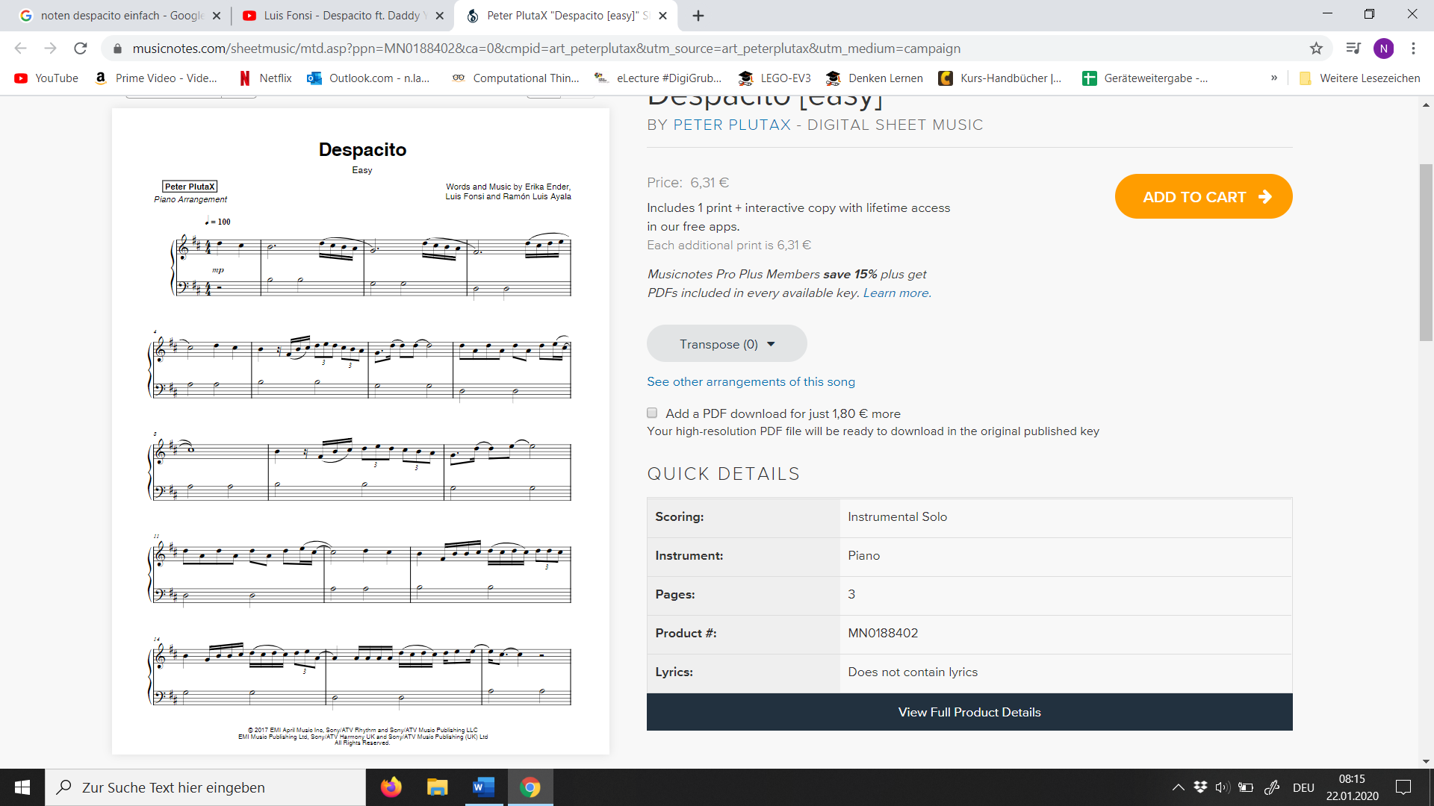
H G H H C# D c# D C#DE A A A A A A D C# D C# DE E E C# C#
D A D A D A D E C# C# D C# H F#H H C#D C#D C# D D C#
C# H F# H C# D E D C#H A G D D E E
C# D C H F# H C D E D C H A G D D D D D A D A D A D E C#
D C H D C H A G D C H A G D C D E

