MarketSafe Sprint Schedule & Gantt Chart
Comprehensive sprint plan derived from provided Sprint 1-6 breakdown, consolidated into a single project schedule and visualized in a Gantt chart.

Sprint Overview
Sprint | Objective | Schedule | Primary Focus
Sprint 1 | Design and Develop the Account Creation of MarketSafe | June 1, 2025 – June 28, 2025 | Login/sign-up UX, multi-factor authentication, and user onboarding data capture
Sprint 2 | Integrate 3D Facial Authentication | June 29, 2025 – July 26, 2025 | Research, registration flow, and biometric review
Sprint 3 | Design and Develop the Admin Module of MarketSafe | July 27, 2025 – August 23, 2025 | Admin dashboard UX and database-backed moderation tools
Sprint 4 | Design and Develop the Account Creation of MarketSafe (User App Expansion) | August 24, 2025 – September 21, 2025 | Home, notification, and profile experiences
Sprint 5 | Design and Develop Marketplace Collaboration Features | September 21, 2025 – October 18, 2025 | In-app messaging and item listing workflows
Sprint 6 | Test and Debug | October 19, 2025 – November 5, 2025 | Unit, integration, security testing, and stabilization

Gantt Chart (Sprints 1-6)
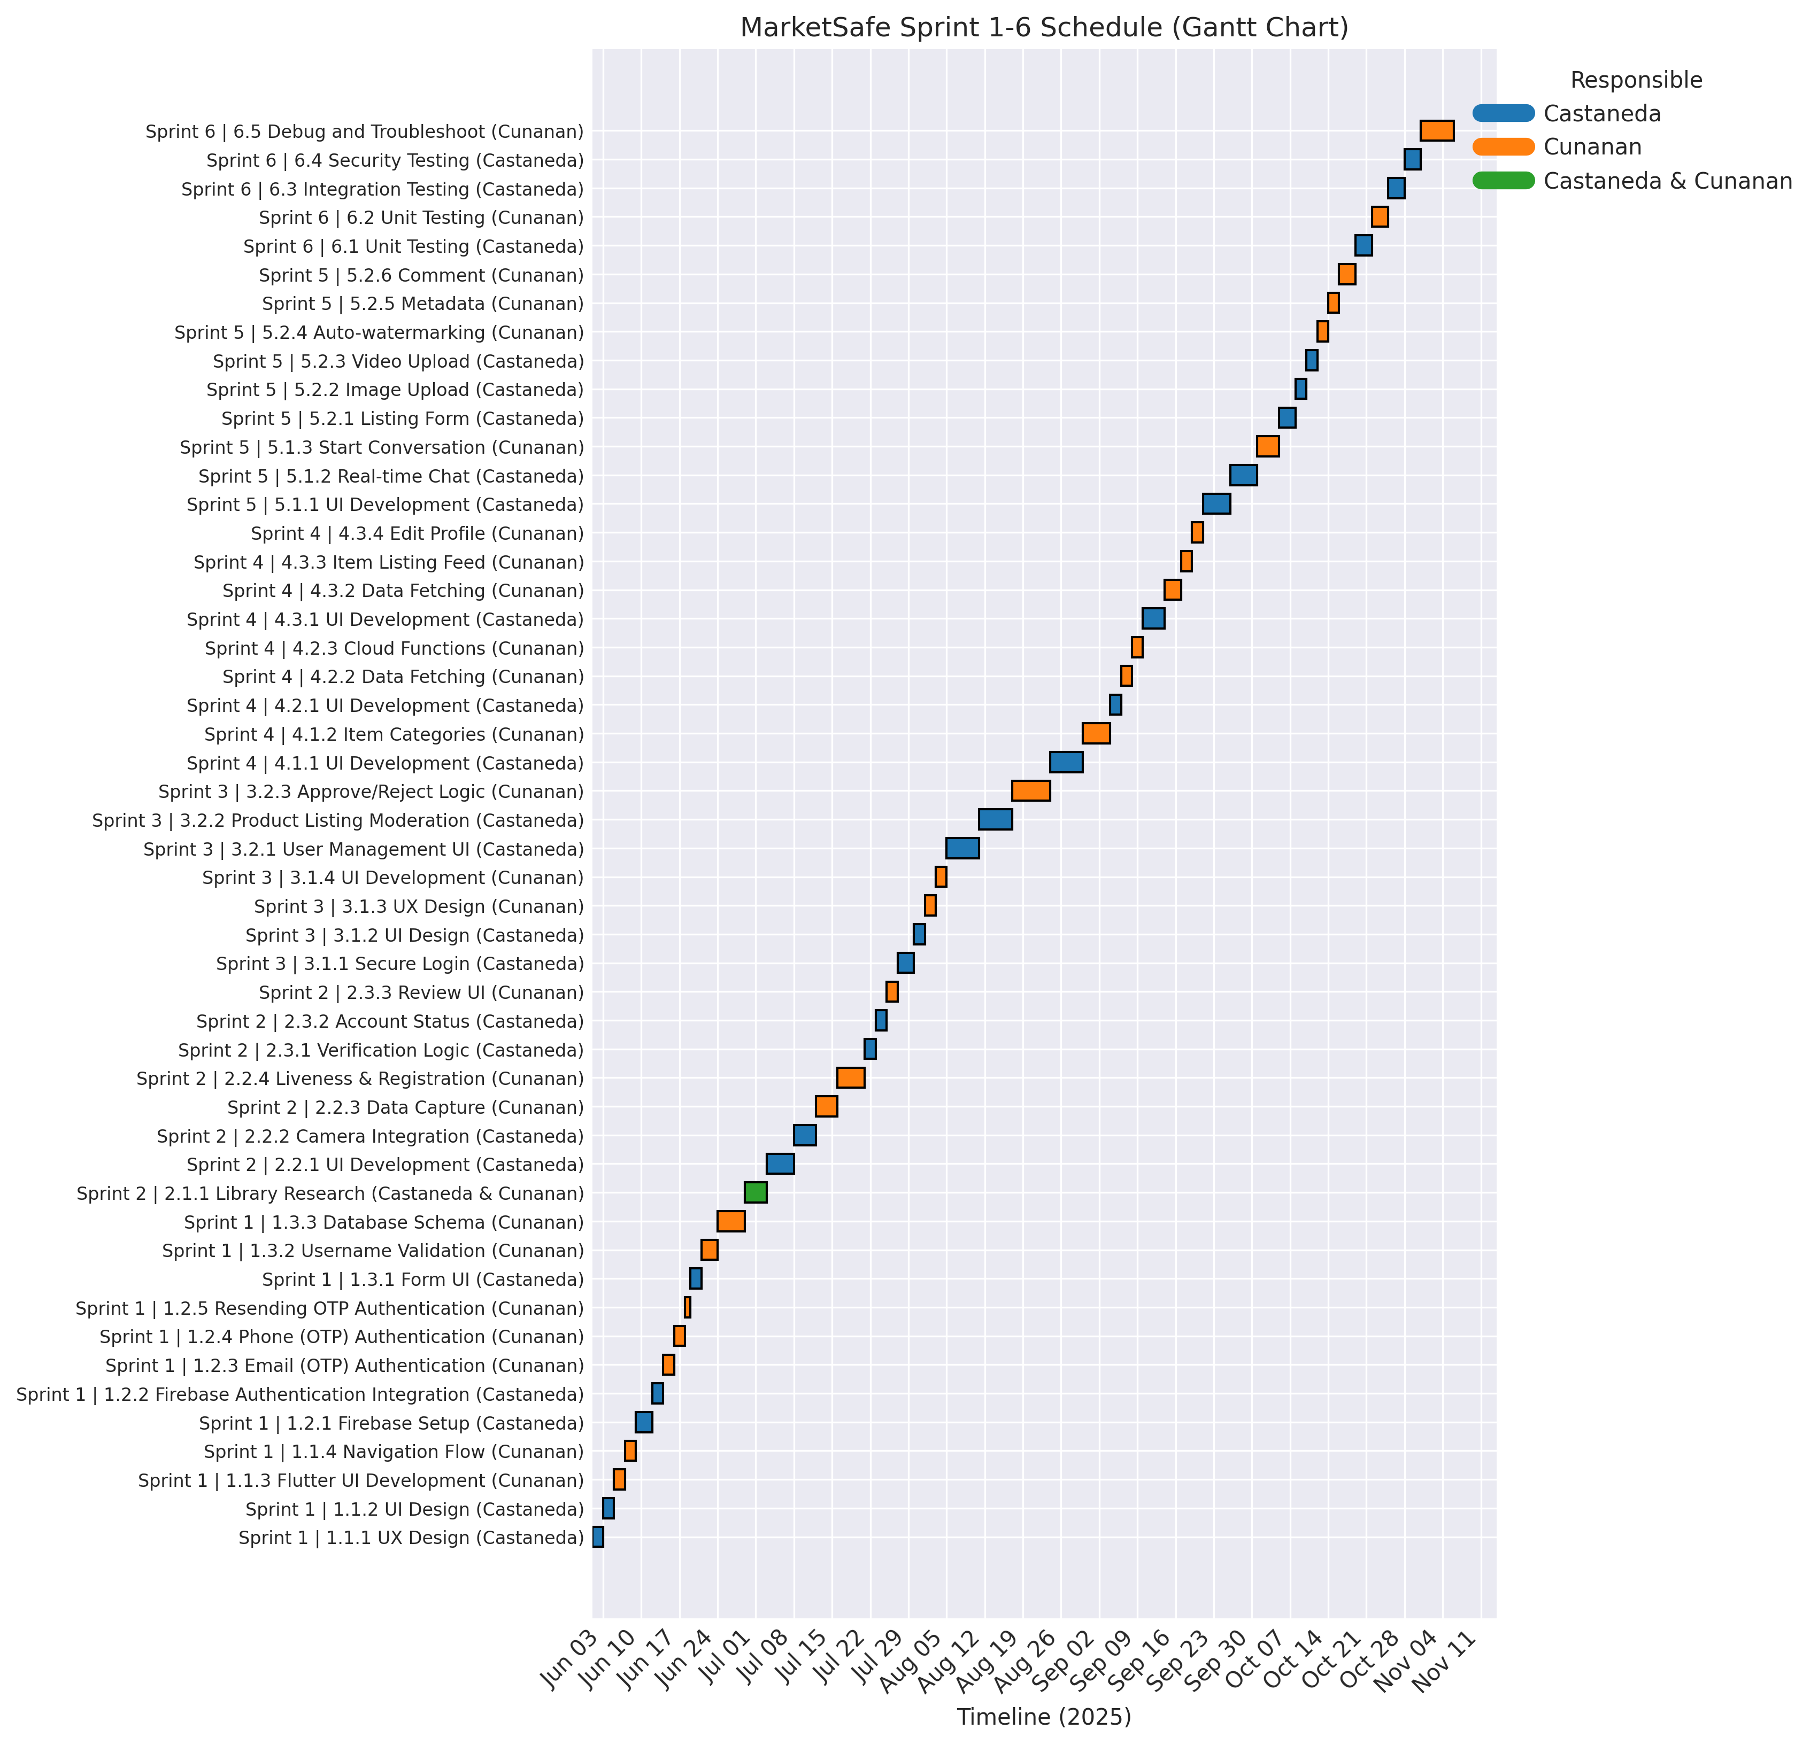
Figure: Visual schedule aligning all sprint deliverables and responsible owners across the June–November 2025 release window.

Detailed Task Schedule

Sprint 1 – Design and Develop the Account Creation of MarketSafe
Task | Owner | Start | End | Duration (days)
1.1.1 UX Design | Castaneda | Jun 01, 2025 | Jun 02, 2025 | 2
1.1.2 UI Design | Castaneda | Jun 03, 2025 | Jun 04, 2025 | 2
1.1.3 Flutter UI Development | Cunanan | Jun 05, 2025 | Jun 06, 2025 | 2
1.1.4 Navigation Flow | Cunanan | Jun 07, 2025 | Jun 08, 2025 | 2
1.2.1 Firebase Setup | Castaneda | Jun 09, 2025 | Jun 11, 2025 | 3
1.2.2 Firebase Authentication Integration | Castaneda | Jun 12, 2025 | Jun 13, 2025 | 2
1.2.3 Email (OTP) Authentication | Cunanan | Jun 14, 2025 | Jun 15, 2025 | 2
1.2.4 Phone (OTP) Authentication | Cunanan | Jun 16, 2025 | Jun 17, 2025 | 2
1.2.5 Resending OTP Authentication | Cunanan | Jun 18, 2025 | Jun 18, 2025 | 1
1.3.1 Form UI | Castaneda | Jun 19, 2025 | Jun 20, 2025 | 2
1.3.2 Username Validation | Cunanan | Jun 21, 2025 | Jun 23, 2025 | 3
1.3.3 Database Schema | Cunanan | Jun 24, 2025 | Jun 28, 2025 | 5

Sprint 2 – Integrate 3D Facial Authentication
Task | Owner | Start | End | Duration (days)
2.1.1 Library Research | Castaneda & Cunanan | Jun 29, 2025 | Jul 02, 2025 | 4
2.2.1 UI Development | Castaneda | Jul 03, 2025 | Jul 07, 2025 | 5
2.2.2 Camera Integration | Castaneda | Jul 08, 2025 | Jul 11, 2025 | 4
2.2.3 Data Capture | Cunanan | Jul 12, 2025 | Jul 15, 2025 | 4
2.2.4 Liveness & Registration | Cunanan | Jul 16, 2025 | Jul 20, 2025 | 5
2.3.1 Verification Logic | Castaneda | Jul 21, 2025 | Jul 22, 2025 | 2
2.3.2 Account Status | Castaneda | Jul 23, 2025 | Jul 24, 2025 | 2
2.3.3 Review UI | Cunanan | Jul 25, 2025 | Jul 26, 2025 | 2

Sprint 3 – Design and Develop the Admin Module of MarketSafe
Task | Owner | Start | End | Duration (days)
3.1.1 Secure Login | Castaneda | Jul 27, 2025 | Jul 29, 2025 | 3
3.1.2 UI Design | Castaneda | Jul 30, 2025 | Jul 31, 2025 | 2
3.1.3 UX Design | Cunanan | Aug 01, 2025 | Aug 02, 2025 | 2
3.1.4 UI Development | Cunanan | Aug 03, 2025 | Aug 04, 2025 | 2
3.2.1 User Management UI | Castaneda | Aug 05, 2025 | Aug 10, 2025 | 6
3.2.2 Product Listing Moderation | Castaneda | Aug 11, 2025 | Aug 16, 2025 | 6
3.2.3 Approve/Reject Logic | Cunanan | Aug 17, 2025 | Aug 23, 2025 | 7

Sprint 4 – Design and Develop the Account Creation of MarketSafe (User App Expansion)
Task | Owner | Start | End | Duration (days)
4.1.1 UI Development | Castaneda | Aug 24, 2025 | Aug 29, 2025 | 6
4.1.2 Item Categories | Cunanan | Aug 30, 2025 | Sep 03, 2025 | 5
4.2.1 UI Development | Castaneda | Sep 04, 2025 | Sep 05, 2025 | 2
4.2.2 Data Fetching | Cunanan | Sep 06, 2025 | Sep 07, 2025 | 2
4.2.3 Cloud Functions | Cunanan | Sep 08, 2025 | Sep 09, 2025 | 2
4.3.1 UI Development | Castaneda | Sep 10, 2025 | Sep 13, 2025 | 4
4.3.2 Data Fetching | Cunanan | Sep 14, 2025 | Sep 16, 2025 | 3
4.3.3 Item Listing Feed | Cunanan | Sep 17, 2025 | Sep 18, 2025 | 2
4.3.4 Edit Profile | Cunanan | Sep 19, 2025 | Sep 20, 2025 | 2

Sprint 5 – Design and Develop Marketplace Collaboration Features
Task | Owner | Start | End | Duration (days)
5.1.1 UI Development | Castaneda | Sep 21, 2025 | Sep 25, 2025 | 5
5.1.2 Real-time Chat | Castaneda | Sep 26, 2025 | Sep 30, 2025 | 5
5.1.3 Start Conversation | Cunanan | Oct 01, 2025 | Oct 04, 2025 | 4
5.2.1 Listing Form | Castaneda | Oct 05, 2025 | Oct 07, 2025 | 3
5.2.2 Image Upload | Castaneda | Oct 08, 2025 | Oct 09, 2025 | 2
5.2.3 Video Upload | Castaneda | Oct 10, 2025 | Oct 11, 2025 | 2
5.2.4 Auto-watermarking | Cunanan | Oct 12, 2025 | Oct 13, 2025 | 2
5.2.5 Metadata | Cunanan | Oct 14, 2025 | Oct 15, 2025 | 2
5.2.6 Comment | Cunanan | Oct 16, 2025 | Oct 18, 2025 | 3

Sprint 6 – Test and Debug
Task | Owner | Start | End | Duration (days)
6.1 Unit Testing | Castaneda | Oct 19, 2025 | Oct 21, 2025 | 3
6.2 Unit Testing | Cunanan | Oct 22, 2025 | Oct 24, 2025 | 3
6.3 Integration Testing | Castaneda | Oct 25, 2025 | Oct 27, 2025 | 3
6.4 Security Testing | Castaneda | Oct 28, 2025 | Oct 30, 2025 | 3
6.5 Debug and Troubleshoot | Cunanan | Oct 31, 2025 | Nov 05, 2025 | 6

Prepared automatically from Sprint 1-6 requirements. Dates are inclusive, showing continuous coverage without gaps between phases.

