PROGRAM OUTPUT
GEOGRAPHICAL INTERPOLATION OF USERS DEVICES GIVEN AN UNCERTAINTY

index
Point
hash_id
nearest_coord
new_distance
new_point
timestamp
uncertainty

245
POINT (14.6085908322872 59.12388880343857)
9.0
POINT (14.6085908322872 59.12388880343857)
3.1269626693514514
POINT (59.12391687380919 14.6085908322872)
1610725030.0
3.1269626693514514

246
POINT (14.6085572780476 59.12386995101352)
9.0
POINT (14.6085572780476 59.12386995101352)
2.1859144650366846
POINT (59.12388957370683 14.6085572780476)
1610725031.0
2.1859144650366846
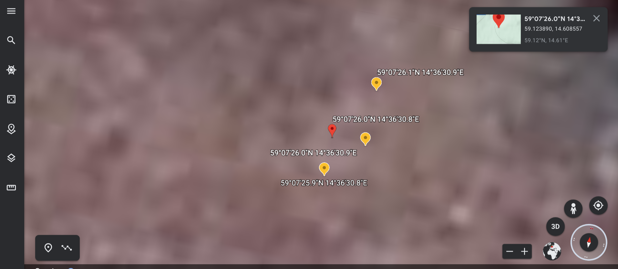
The new interpolated coordinates from their previous coordinates using the uncertainty in meters. We project them on a map and obserse if they have logical distance. Actually their new coordinates are valid. The right yellow area has the points around 3 meters aways from each other, the left yellow area has the points with around 2 meters away .The above output of the program is valid.

