VALIDATION OF VALIDITY FOR THE NEW
INTERPOLATED COORDINATES
WHICH CREATED CONSIDERING THE UNCERTAINTY.

index (row index)
Point (initial cooridnates)
hash_id (user)
nearest_coord (from the polygon area)
new_distance (result of uncertaianty + distance from the closed coordinate)
new_point (after interpolation)
timestamp (epoch time)
uncertainty (meters)

2 points for user 9.0

245
POINT (14.6085908322872 59.12388880343857)
9.0
POINT (14.6085908322872 59.12388880343857)
3.1269626693514514
POINT (59.12391687380919 14.6085908322872)
1610725030.0
3.1269626693514514

246
POINT (14.6085572780476 59.12386995101352)
9.0
POINT (14.6085572780476 59.12386995101352)
2.1859144650366846
POINT (59.12388957370683 14.6085572780476)
1610725031.0
2.1859144650366846

The new interpolated coordinates from their previous coordinates using the uncertainty in meters.

-- We project them on a map and obserse if they have logical distance.

-- Their new coordinates are valid in terms of logical measurements.
bothpoint are in a parallel line.

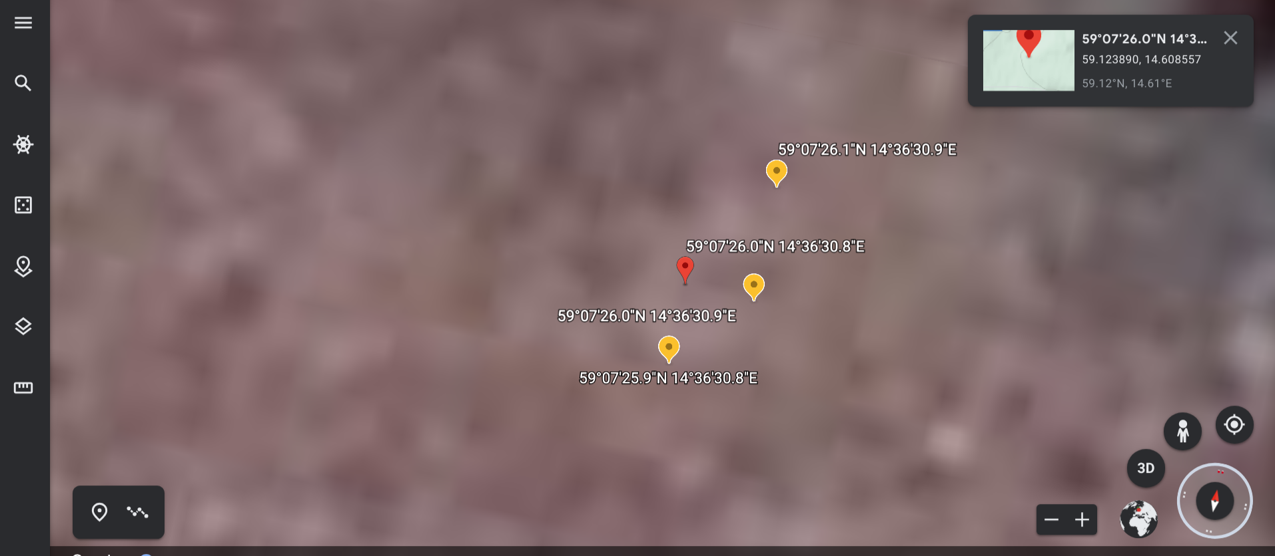
The right yellow area has the points around 3 meters aways from each other,
the left yellow area has the points with around 2 meters away .

