**Lab: While Loop**

Problems for exercise and homework for the "**Programming Basics**" course [@ SoftUni Global](https://softuni.org).

**Submit** your solutions in the **SoftUni Judge** system a: <https://judge.softuni.org/Contests/Compete/Index/3455>

## Read Text

Write a program that reads text from the console (string) and prints it until it receives the "**Stop**" command.

### **Sample Input and Output**

|  |  |  |  |  |
| --- | --- | --- | --- | --- |
| **Input** | **Output** |  | **Input** | **Output** |
| Peter  SoftUni  Washington  Bulgaria  SomeText  Stop  AfterStop  Europe  HelloWorld | Peter  SoftUni  Washington  Bulgaria  SomeText |  | Washington  Berlin  Moscow Athens  Madrid  London  Paris  Stop  AfterStop | Washington  Berlin  Moscow Athens  Madrid  London  Paris |

### Hints and Guidelines

1. Initialize an **input** variable that will hold the word:



1. In a **while loop**, until you enter a "**Stop**" command, read a new word and print it to the console:

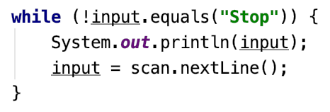

### Testing in the Judge System

Test the solution to this problem here: <https://judge.softuni.org/Contests/Compete/Index/3455#0>

## Password

Write a program that reads a **username** and **password**. Then type the password again and check if it is correct

* If the password is **invalid**: the user must type **again** his password.
* If the password is **correct**: print **"Welcome {username}!"**.

### Sample Input and Output

|  |  |  |  |  |
| --- | --- | --- | --- | --- |
| **Input** | **Output** |  | **Input** | **Output** |
| Peter  1234  pass  1324  1234 | Welcome Peter! | William  secret  secret | Welcome William! |

### Hints and Guidelines

1. Initialize **username** and **password** variables that will contain the values:

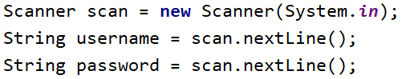

1. Initialize an **input** variable that will hold the repeated login password:



1. In the **while loop**, until you enter a valid password, read it again:

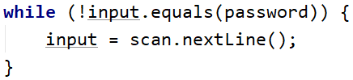

When a valid password is entered, print a **successful login message**:

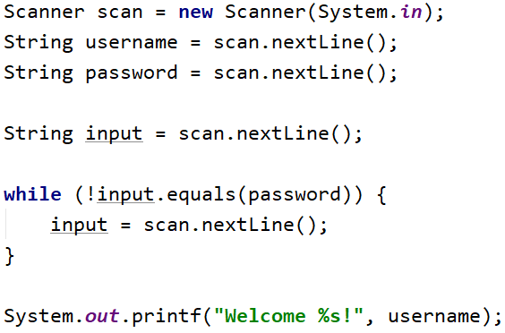

### Testing in the Judge System

Test the solution to this problem here: <https://judge.softuni.org/Contests/Compete/Index/3455#1>

## Sum Numbers

Write a program that reads an integer from the console and integers on each line until their sum is greater than or equal to the original number. At the end of the reading, print the **sum of the entered numbers**.

### **Sample Input and Output**

|  |  |  |  |
| --- | --- | --- | --- |
| **Input** | **Output** | **Input** | **Output** |
| 100  10  20  30  40 | 100 | 20  1  2  3  4  5  6 | 21 |

### Hints and Guidelines

1. Initialize variable **n** - the number originally read from the console.



1. Initialize the variable **sum** in which we will add the read numbers:



In a **while loop**, until the value of the originally read number is reached, read a new number and add it to the sum::

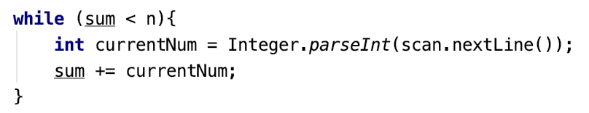

1. Print the **sum of the numbers** when it becomes **equal to or greater than** the number originally entered:

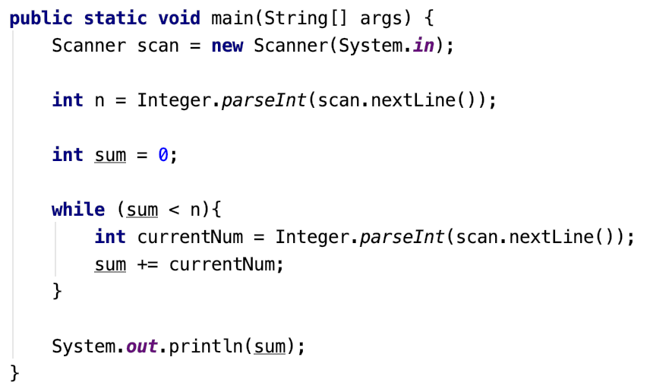

### Testing in the Judge System

Test the solution to this problem here: <https://judge.softuni.org/Contests/Compete/Index/3455#2>

## Sequence 2k+1

Write a program that reads the number **n** entered by the user and prints **all the numbers** **≤ n from the sequence: 1, 3, 7, 15, 3…** Each next number is calculated by **multiplying** the **previous one** by **2** and **adding** **1**.

### Sample Input and Output

|  |  |  |  |  |  |  |  |  |  |  |
| --- | --- | --- | --- | --- | --- | --- | --- | --- | --- | --- |
| **Input** | **Output** |  | **Input** | **Output** |  | **Input** | **Output** |  | **Input** | **Output** |
| 3 | 1  3 | 8 | 1  3  7 | 17 | 1  3  7  15 | 31 | 1  3  7  15  31 |

### Hints and Guidelines

1. Read **n** - an integer that represents the end of the series

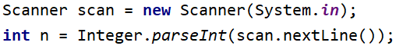

1. 2. In a **while loop** until **n** is reached, calculate a new number from the sequence and print it:

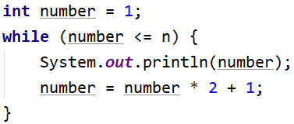

### Testing in the Judge System

Test the solution to this problem here: <https://judge.softuni.org/Contests/Compete/Index/3455#3>

## Account Balance

Write a program that calculates **how much money** is in the account after you make a **certain number of deposits**. On each line you will receive the amount you need to deposit in the account until you receive the command "**NoMoreMoney**". For each amount received, the console must display "**Increase:** " + the amount and **add it to the account**. If you get a number less than 0, "**Invalid operation!**" must be displayed on the console and the program must end. When the program ends, "**Total:** " must be printed + the total amount in the account **formatted to the second decimal place**.

### Sample Input and Output

|  |  |  |  |  |
| --- | --- | --- | --- | --- |
| **Input** | **Output** |  | **Input** | **Output** |
| 5.51  69.42  100  NoMoreMoney | Increase: 5.51  Increase: 69.42  Increase: 100.00  Total: 174.93 | 120  45.55  -150 | Increase: 120.00  Increase: 45.55  Invalid operation!  Total: 165.55 |

### Testing in the Judge System

Test the solution to this problem here: <https://judge.softuni.org/Contests/Compete/Index/3455#4>

## Max Number

Write a program that, before receiving the "**Stop**" command, reads **integers** entered by the user and **finds the largest** of them. Enter one number per line.

### Sample Input and Output

|  |  |  |  |  |  |  |  |  |  |  |  |  |  |
| --- | --- | --- | --- | --- | --- | --- | --- | --- | --- | --- | --- | --- | --- |
| **Input** | **Output** |  | **Input** | **Output** |  | **Input** | **Output** |  | **Input** | **Output** |  | **Input** | **Output** |
| 100  99  80  70  Stop | 100 | -10  20  -30  Stop | 20 | 45  -20  7  99  Stop | 99 | 999  Stop | 999 | -1  -2  Stop | -1 |

### Testing in the Judge System

Test the solution to this problem here: <https://judge.softuni.org/Contests/Compete/Index/3455#5>

## Min Number

Write a program that, before receiving the "**Stop**" command, reads **integers** entered by the user and finds **the smallest** one of them. Enter one number per line.

### Sample Input and Output

|  |  |  |  |  |  |  |  |  |  |  |  |  |  |
| --- | --- | --- | --- | --- | --- | --- | --- | --- | --- | --- | --- | --- | --- |
| **Input** | **Output** |  | **Input** | **Output** |  | **Input** | **Output** |  | **Input** | **Output** |  | **Input** | **Output** |
| 100  99  80  70  Stop | 70 | -10  20  -30  Stop | -30 | 45  -20  7  99  Stop | -20 | 999  Stop | 999 | -1  -2  Stop | -2 |

### Testing in the Judge System

Test the solution to this problem here: <https://judge.softuni.org/Contests/Compete/Index/3455#6>

## Graduation

Write a program that calculates a student's **average grade** throughout his or her **12 years of study**. On the first line you will receive the student's name, and on each line their **annual grades** (12 grades in total). The student goes to the next grade if their annual grade is **greater than or equal to 4.00**. If the student has failed more than once, they is expelled, and the program ends by **printing the student's name** and in which **class he needs to repeat**.

Upon successful completion of 12th grade to print:

"{**name of student**} graduated. Average grade: {**average grade through the years**}"

**In case the student is expelled from school, print:**

"{**name of student**} has been excluded at {g**rade he was expelled at**} grade"

**The value must be formatted to the second decimal place.**

### Sample Input and Output

|  |  |  |  |  |
| --- | --- | --- | --- | --- |
| **Input** | **Output** |  | **Input** | **Output** |
| John  5  5.5  6  5.43  5.5  6  5.55  5  6  6  5.43  5 | John graduated. Average grade: 5.53 | Sophie  5  6  5  6  5  6  6  2  3 | Sophie has been excluded at 8 grade |

### Testing in the Judge System

Test the solution to this problem here: <https://judge.softuni.org/Contests/Compete/Index/3455#7>