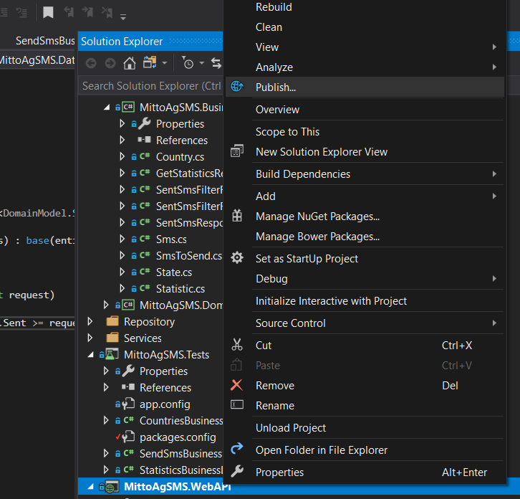

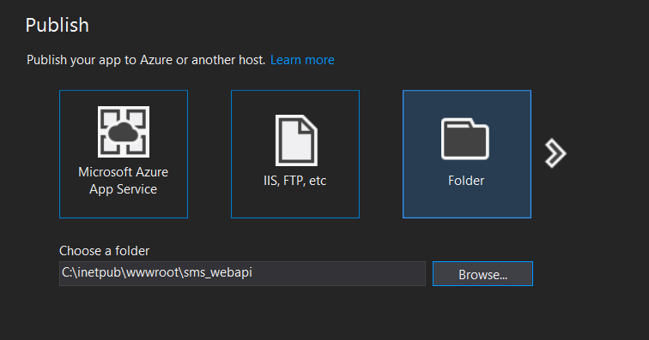

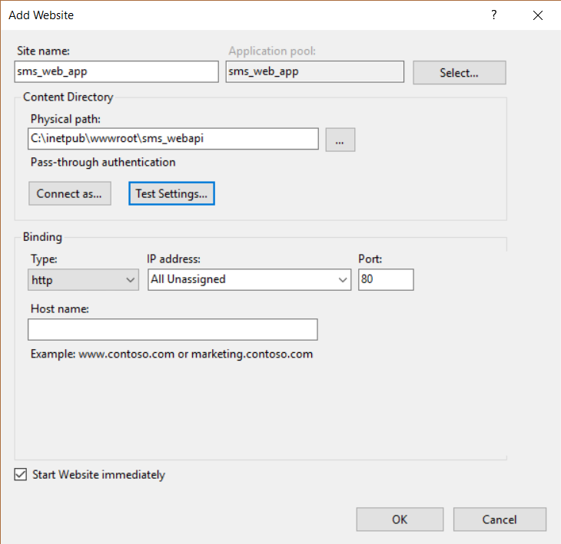

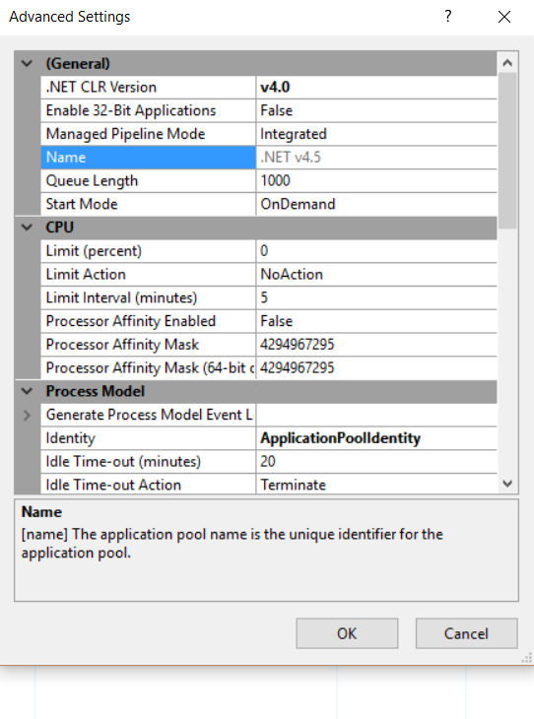

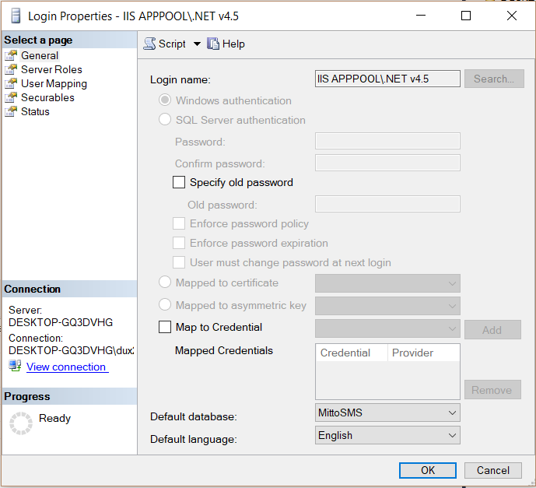

### Accessing Database under IIS APPPOOL\\ASP.NET v4.0

As we are using ASP.NET v4.0 App Pool make sure **IIS APPPOOL\\ASP.NET v4.0** is added to your Database Server -> Security -> Logins.

If it's not there go ahead and add new login with name **IIS APPPOOL\\ASP.NET v4.0** or else it will throw run time error exception **Login failed for user 'IIS APPPOOL\\ASP.NET v4.0'**