Windows 2.0 installation
and setup
  - VisionEval Workbench for Windows 11 x64
Install Workbench, choose a workspace, connect the native R and VisionEval runtime, and install the packages used in the Windows tutorials. Existing compatible installations can be reused after verification.

Before you begin
Use Windows 11 x64 and an internet connection for the initial downloads. The Workbench installer installs the desktop application; R and VisionEval are configured separately. Windows runs one model job at a time.

Watch alongside this guide
Installing Workbench and Runtime on Windows
Installing Asset Packages and Building Region Assets on Windows
Windows resources and downloads
Installation and upgrade quick start
Full Windows User Guide
The installation video starts with no R or earlier VE_Runtime. Page 2 explains the choices when you already have R or VisionEval. Workspace selection is on page 3, runtime verification on page 4, and asset installation on pages 5 and 6.

Install Workbench and choose your runtime approach
1. Download the Windows x64 setup executable for Workbench 2.0.0. Run the installer, then launch VisionEval Workbench from the Start menu.
Download the Windows Workbench installer
2. If you have an older Workbench workspace, open that workspace to retain its projects, installed assets, and results. Make a complete backup before upgrading. The application and workspace are separate.

If R is already installed
The managed installer reuses a compatible R 4.5.x installation when available. If no compatible R is found, it installs R 4.5.3 for the current user. An older R installation does not need to be uninstalled just to install Workbench.

If VisionEval is already installed
Let Workbench detect the existing VE_RUNTIME, VE_HOME, and Rscript.exe, or select those paths yourself. A compatible, verified VE-40-RC7 installation can be reused. An older runtime that has not passed verification is not ready to run in Workbench 2.0.

Preserve an older setup
Choose new, separate folders for both the RC7 working folder (VE_RUNTIME) and its package library (VE_HOME) when keeping an older VisionEval setup. Installing RC7 into the older package-library folder can replace its contents. VE_RUNTIME and VE_HOME must never be the same folder or be nested inside each other.
A separate managed setup is a straightforward option if you want to keep the old installation intact. Check the selected folders before starting installation; removing the previous runtime is optional, not a prerequisite.

Choose your workspace
3. On first launch, accept the suggested File Explorer-visible workspace or use Change location to choose an empty folder with room for assets and results. Keep it separate from VE_RUNTIME and VE_HOME. A connected external SSD is supported.
4. If you already have a workspace, select Open existing workspace and choose its root folder. Do not choose only its Projects or Results subfolder. Workbench retains the existing work instead of creating a replacement workspace.
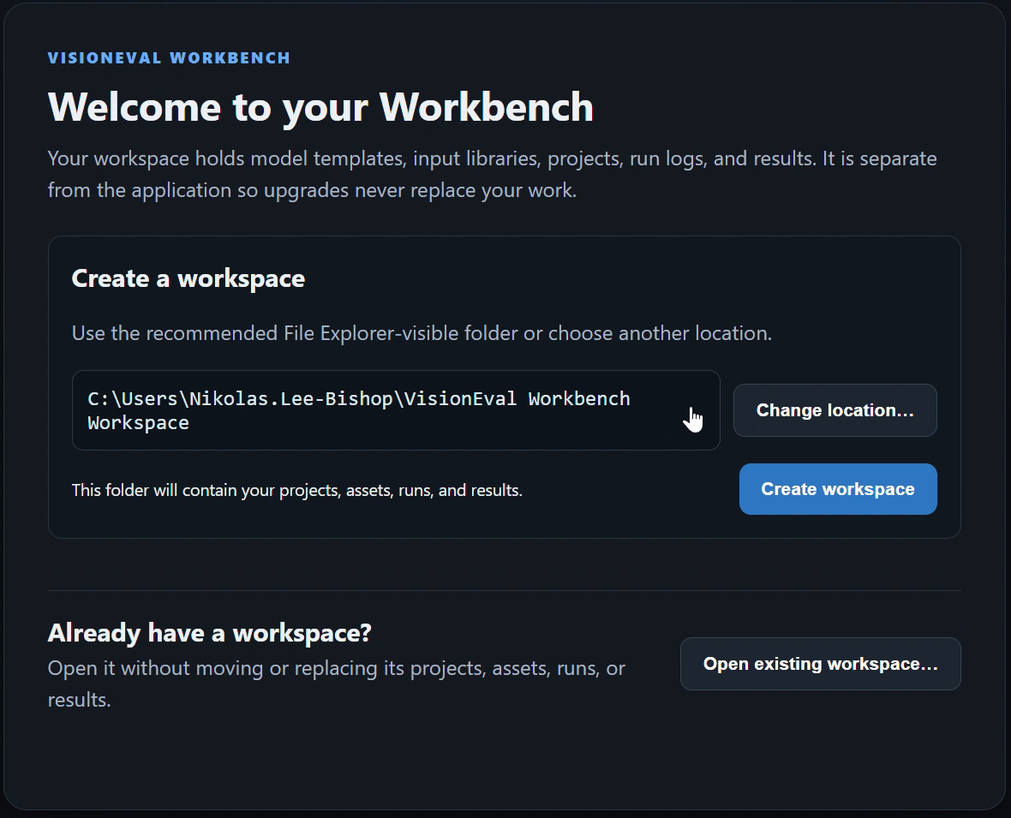
Figure 1. The Windows first-launch screen offers a new workspace or an existing workspace.
After opening Workbench, use the gear button or Ctrl+, and select Workspace. Check Current workspace before installing packages or creating a project. Open another workspace selects an existing location; Move workspace relocates the current one. See the Workspaces and resources guide for backups and SSD moves.

Install and verify the native runtime
5. If no usable runtime is found, choose Install R 4.5.3 + VisionEval RC7 in first-launch setup, or open Settings → Runtime. The managed installation is for the current user and does not require administrator privileges.
6. For an existing setup, choose its VE_RUNTIME working folder and review the independently selected VE_HOME and Rscript.exe paths. Use detection again or the advanced overrides when a path is incorrect. Select Verify runtime after any change.
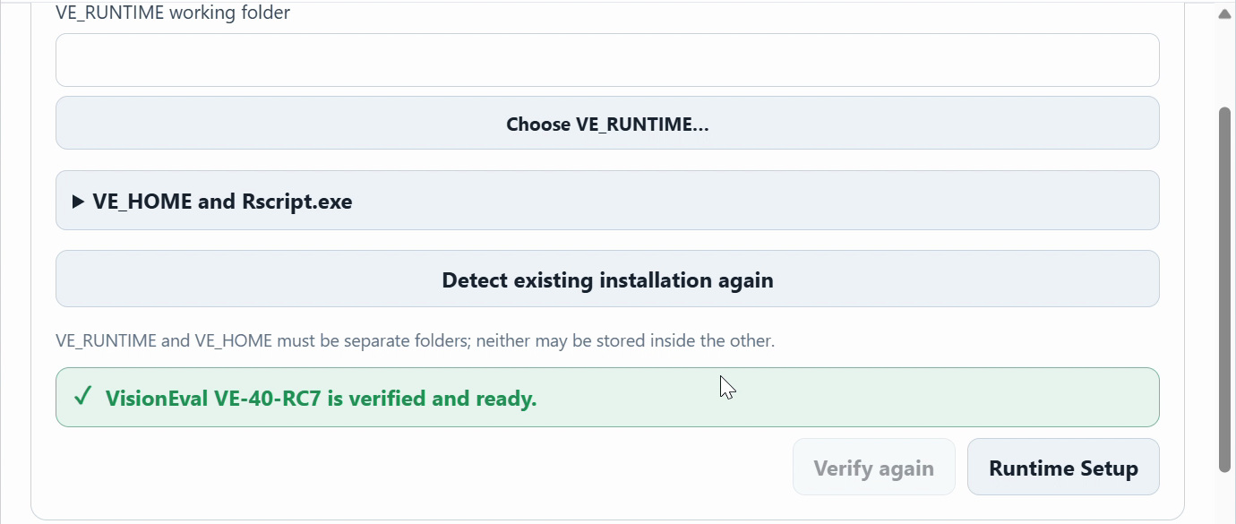
Figure 2. First-launch setup reports that VisionEval VE-40-RC7 is verified and ready.

Default managed folders
The working folder is normally %LOCALAPPDATA%\VisionEval\VE_Runtime. The package library is normally %USERPROFILE%\VE_Home. R 4.5.3, when needed, is installed under the current user’s local application directory. These runtime folders are separate from the workspace.
7. Confirm the green verified and ready message and Native VisionEval ready in the application header. Verification checks the actual R installation, required packages and modules, and RC7 commit provenance. A package version of 4.0.0 alone does not establish RC7 compatibility.
Skip for Now lets you finish workspace setup, but Run stays unavailable until a runtime passes verification. If installation or verification fails, correct the reported path or use the Runtime repair controls, then verify again. Finish setup after the connection is ready.

Install the PlanRVA package
8. Download planrva-2.0.zip. Open Settings → Assets, choose Install package, and select the ZIP or its extracted package folder.
Download PlanRVA 2.0
9. Review the package name and the Package checked and ready to install status. Choose Install Package only after those checks pass.
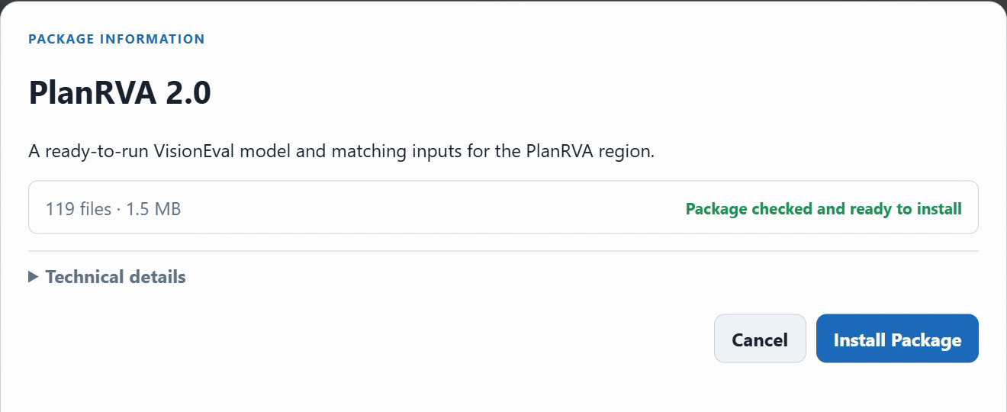
Figure 3. The Windows package preview identifies PlanRVA 2.0 and validates it before installation.
10. Confirm that PlanRVA appears among the installed assets. Choose it as the model-package default if needed, then save Settings. Open Explore to review the installed input explanations and Create → Setup to choose the model package.
PlanRVA supplies the model template and matching inputs used in the project and Hypercube examples. Its project selector shows 51 CSVs in the recording. Workbench copies installed assets into the selected workspace and leaves the downloaded archive intact. Existing projects stay pinned to their recorded assets when defaults change.

Add Virginia regional data
11. To build other supported Virginia MPO regions, also download virginia-mpo-regions-2.0.zip and install it through Settings → Assets.
Download Virginia MPO Regional Data 2.0
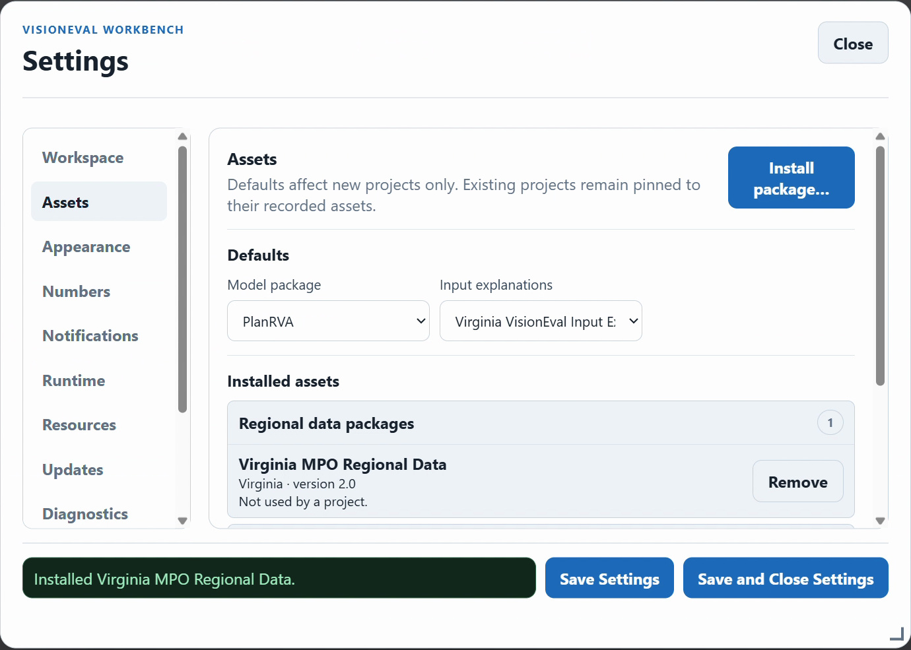
Figure 4. The Virginia MPO Regional Data package appears in the Windows installed-assets list.
12. Open Create → Develop, select Virginia MPO Regional Data, choose the paired Virginia InputLibrary and the desired MPO, then preview the region before building its assets. The Windows video uses Charlottesville-Albemarle.

You are ready for the walkthroughs
Check the current workspace, the native-runtime ready indicator, and the installed package names. Use PlanRVA for the population and employment scenario example and the fuel-cost and fuel-tax Hypercube. The Project and scenario guide also explains the separate regional-build workflow. The Virginia package provides supported MPO builds; it does not enable a statewide Virginia model run.

