VisionEval Workbench Installation and Setup

for Windows
Link to VE Workbench: https://github.com/nikolasleeb/VisionEval-Workbench/releases

  - Install VisionEval Workbench
- Click on “VisionEval Workbench 1.0.0” under Releases
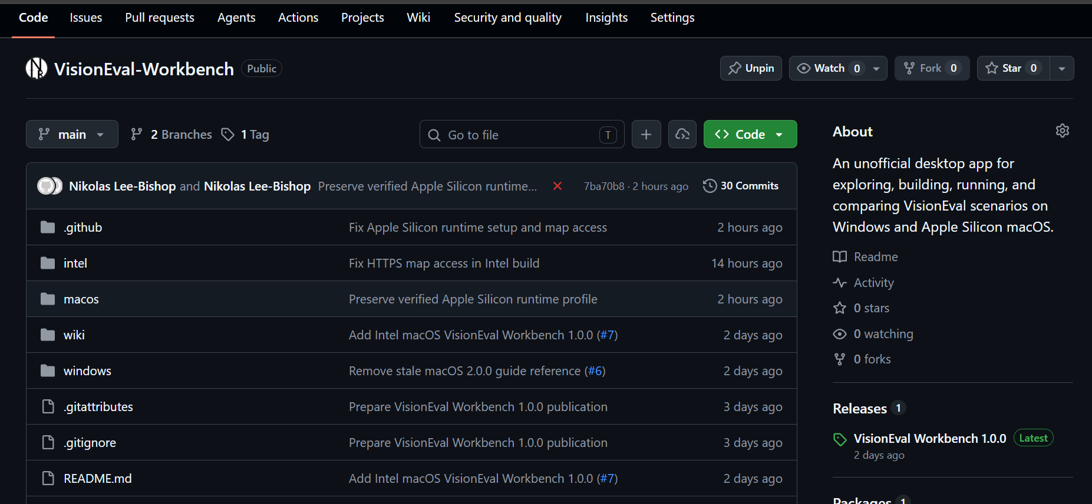
- Scroll down to Assets and click on “VisionEval-Workbench-v1.0.0-windows-x64-setup.exe”
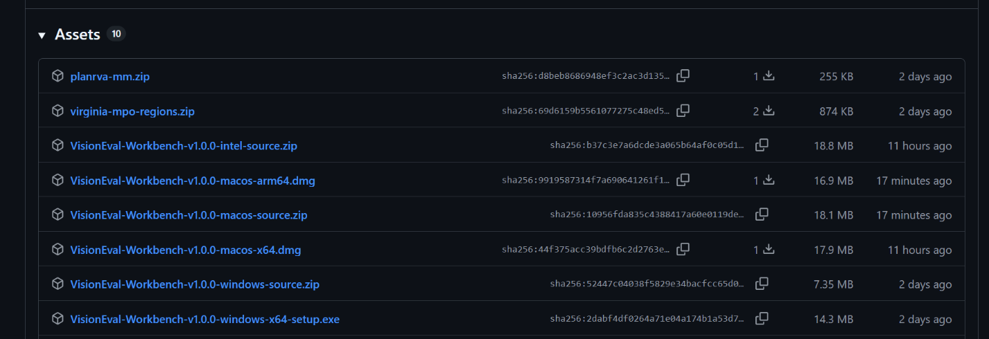

- Allow it to download and then go to Downloads and click on it. The following warning window will appear, click “more info” and then “run anyway”
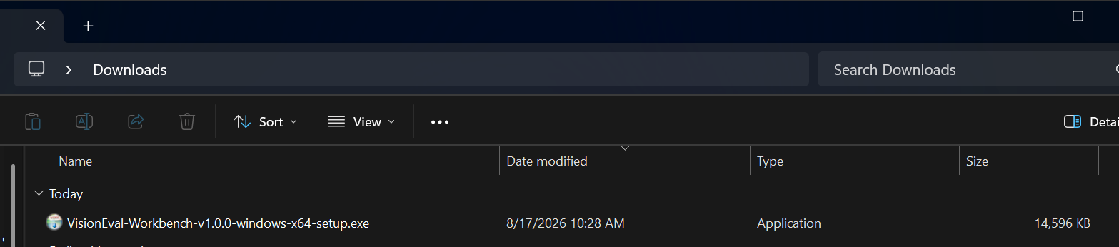
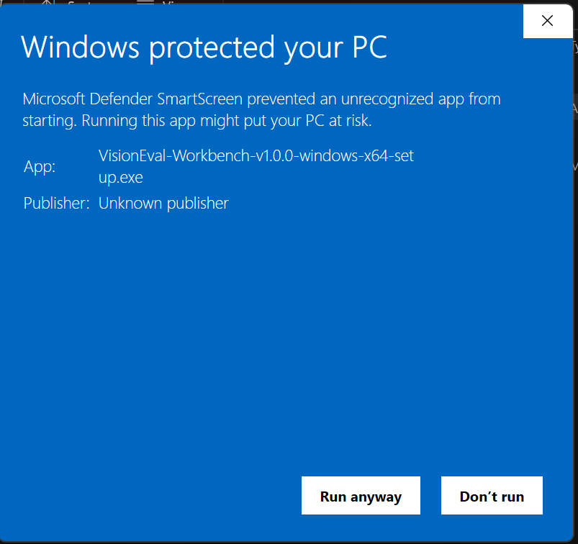

- Now the VisionEval Installer window will open, on the first window hit “next”
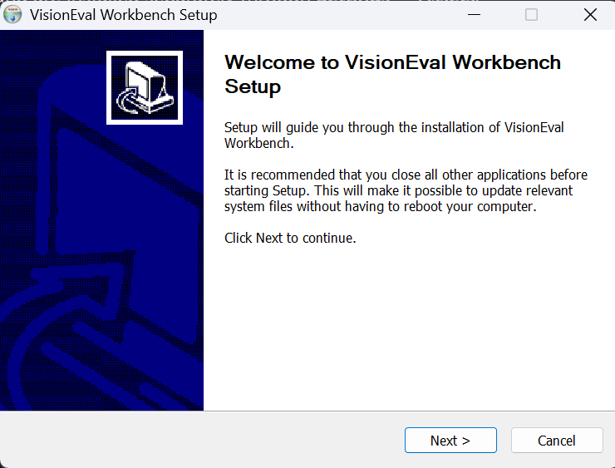
Then the next screen will ask where you want to store the app data. I recommend the user folder or somewhere where it won’t get deleted
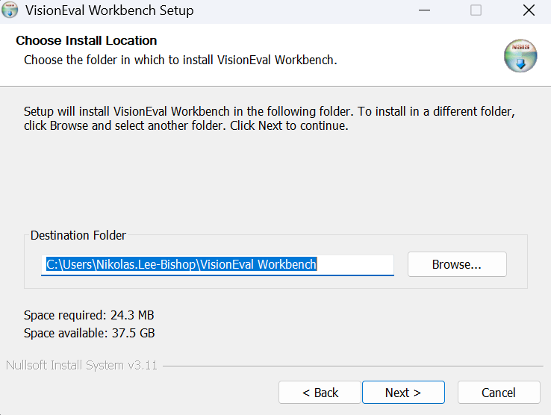

Then it will ask you if you want an icon on your desktop and if you want the app to start once it’s finished installing.
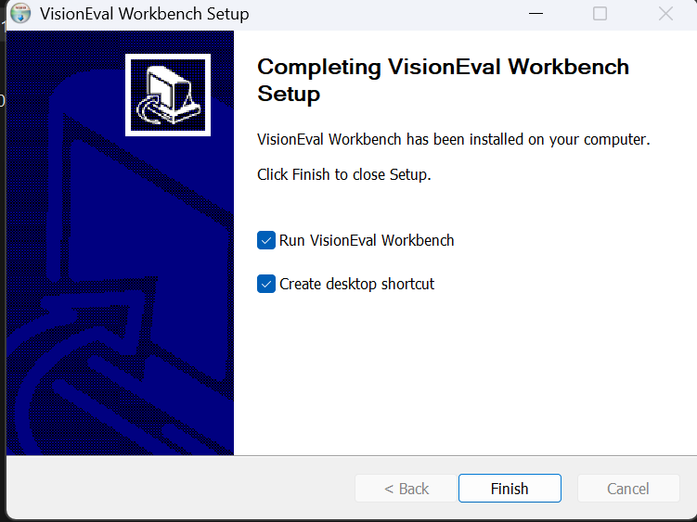

- If you checked “Run VisionEval Workbench”, then it should open automatically and look like this:
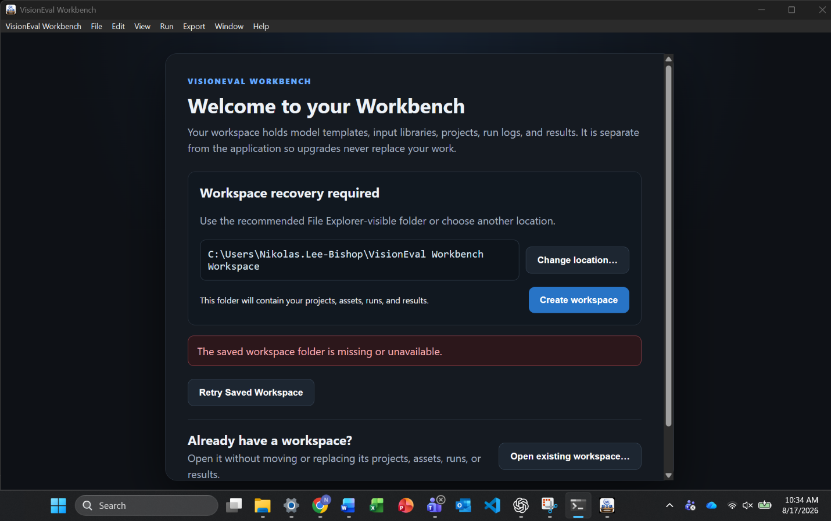

- Select either “Change Location” or “Create Workspace”. This is where your input files/output files, etc. will live.
Change location will open the file explorer to choose another space to put the folder

- After it creates the workspace folder, the next step is to connect to the runtime for VisionEval

For this step you will want to find where you put VE_Runtime or what you named it.

For example, my runtime is just named VE. VE_Runtime is where the inputs are modified and open a .bat to start the R program. For some users it may auto-suggest where your runtime is located. If you are having problems, you can use the advanced overrides.
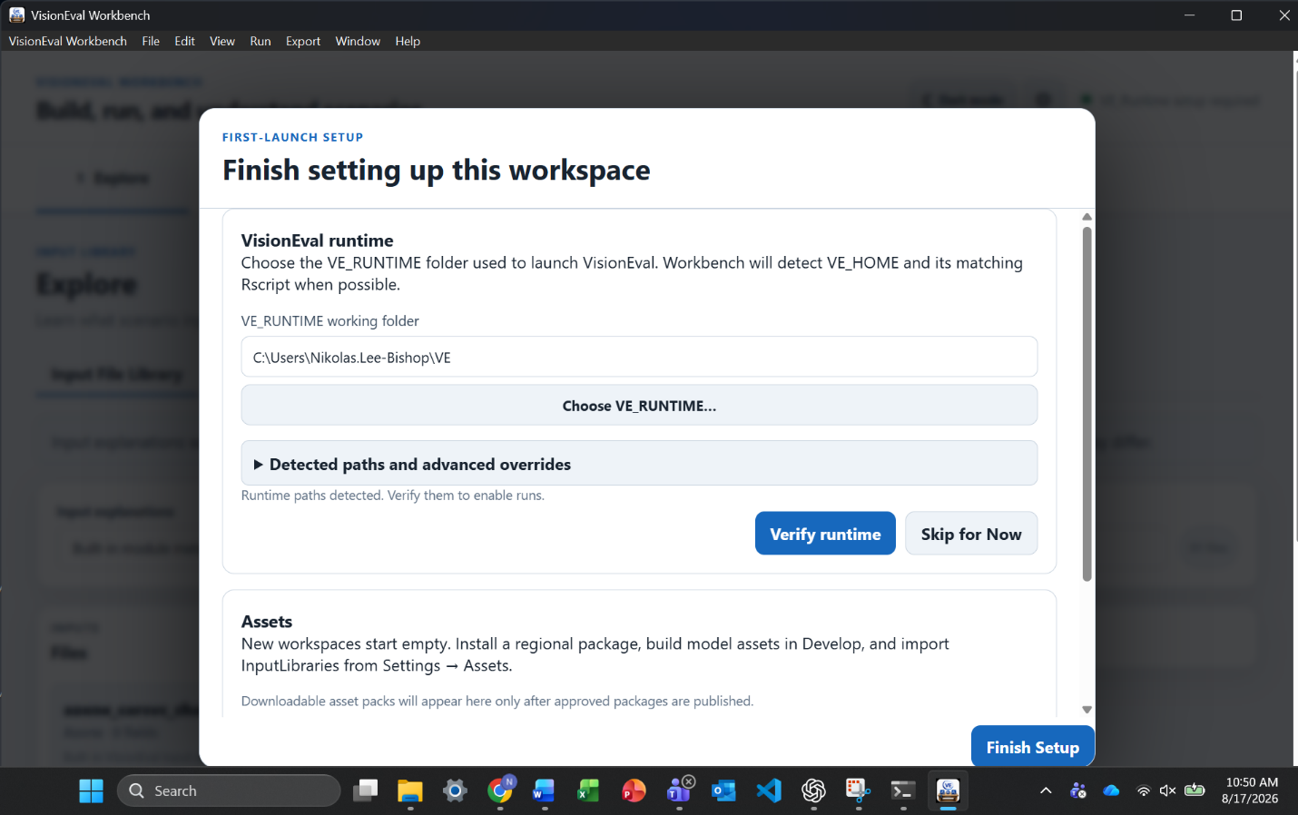

- After you hit “Verify runtime” it will show that’s it verifying your runtime is built correctly. You will see the following message when it has verified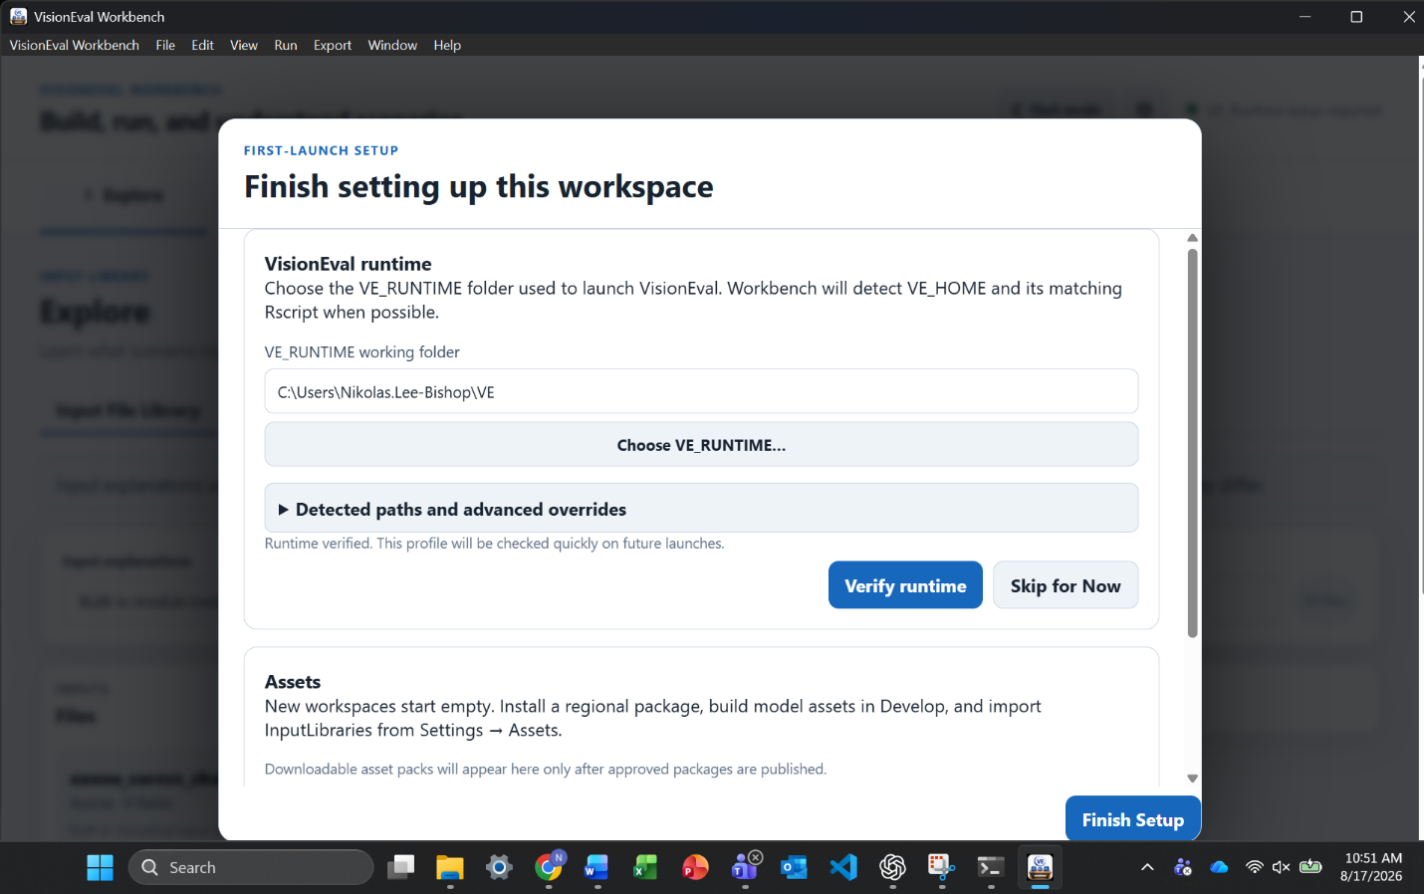
The next step once VisionEval Workbench is installed and connected to the runtime, is to import a package

  - Installing a Package into VisionEval Workbench
- The next step is to install a package with data and inputs.
On the GitHub, in releases, there should be 2 packages:
planrva-mm.zip
virginia-mpo-regions.zip
You can download them by clicking on them
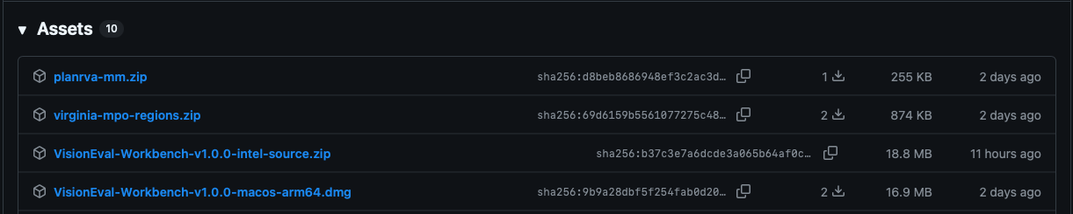

- Open the settings for the workbench, this can be done by either clicking visioneval workbench and then clicking settings or clicking the gear button in the top right
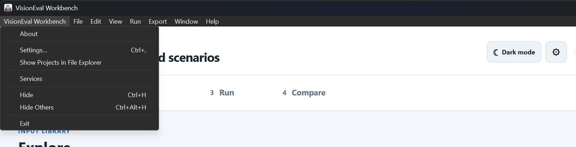

- Once in Settings, choose Assets, and then click “Choose ZIP”
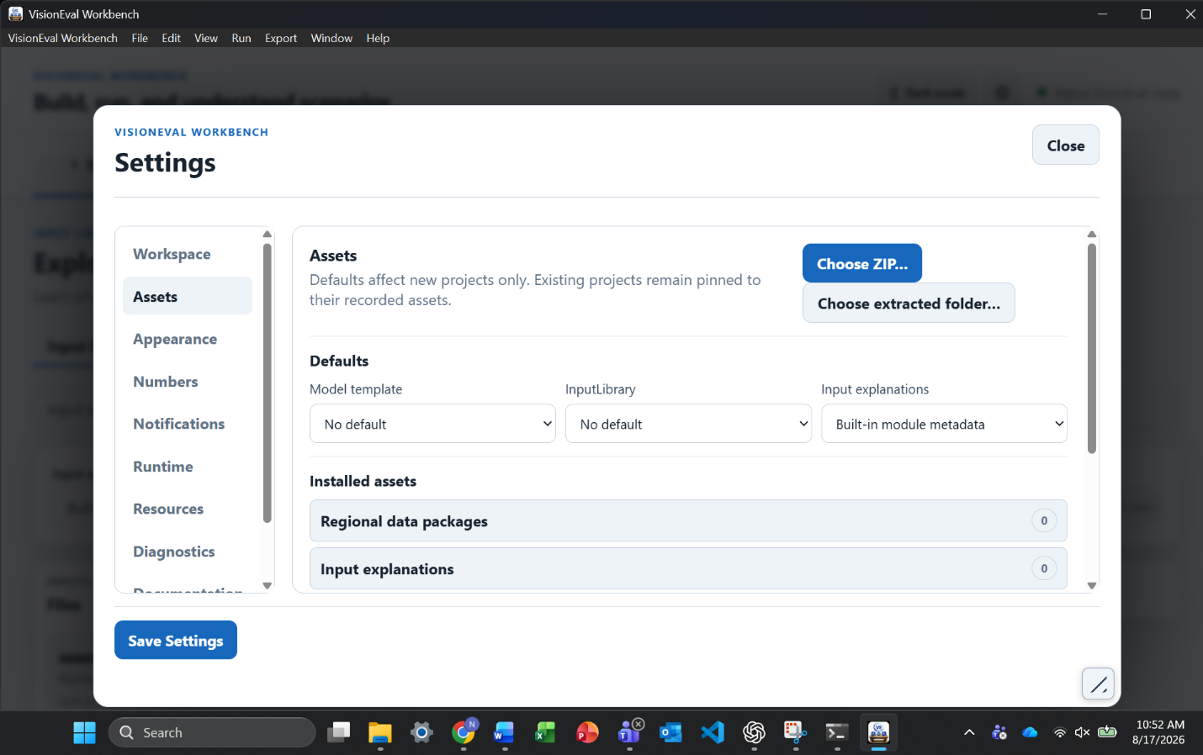

- Then the file explorer will open, and you should see the folder(s) for the package(s) in Downloads. Click whichever one you want to install and hit “open”
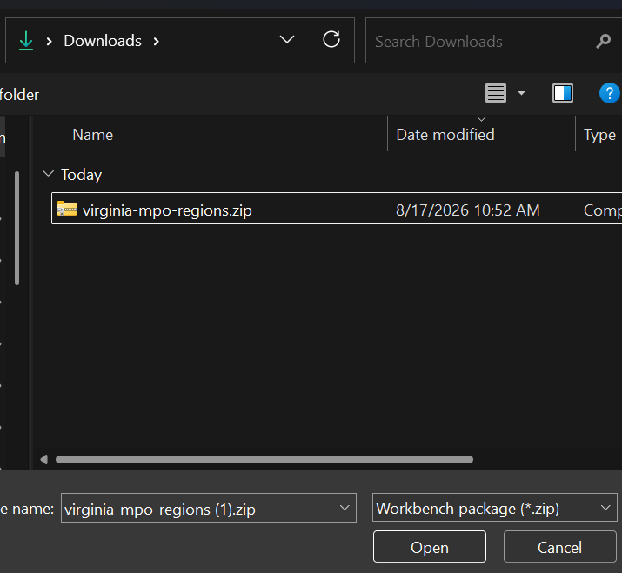
- You should see the package show up as an Installed asset. If so, then hit “Save changes” and close the settings window. 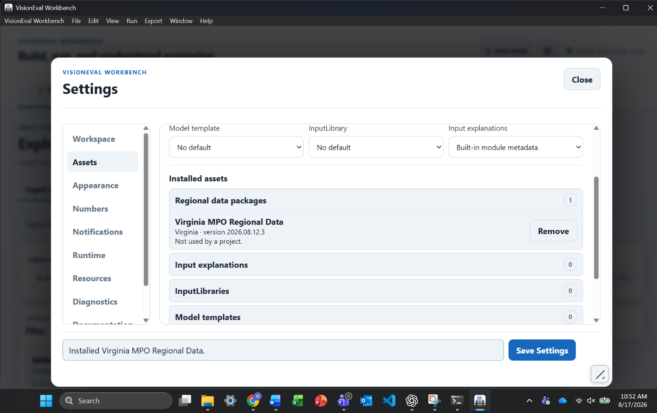
- Congrats, you have installed all the necessary parts to begin using VisionEval Workbench!

Next step: Scenario walkthrough
Continue with the VisionEval Workbench scenario exercise: View PDF | Download editable Word file | Tutorials and Walkthroughs Wiki

