VisionEval Workbench Installation and Setup

for Apple Silicon Mac
Link to VE Workbench: https://github.com/nikolasleeb/VisionEval-Workbench/releases

  - Mac Docker Installation Steps:
- Go to: https://www.docker.com/products/docker-desktop/
- click “Download Docker Desktop”
  - choose download for mac
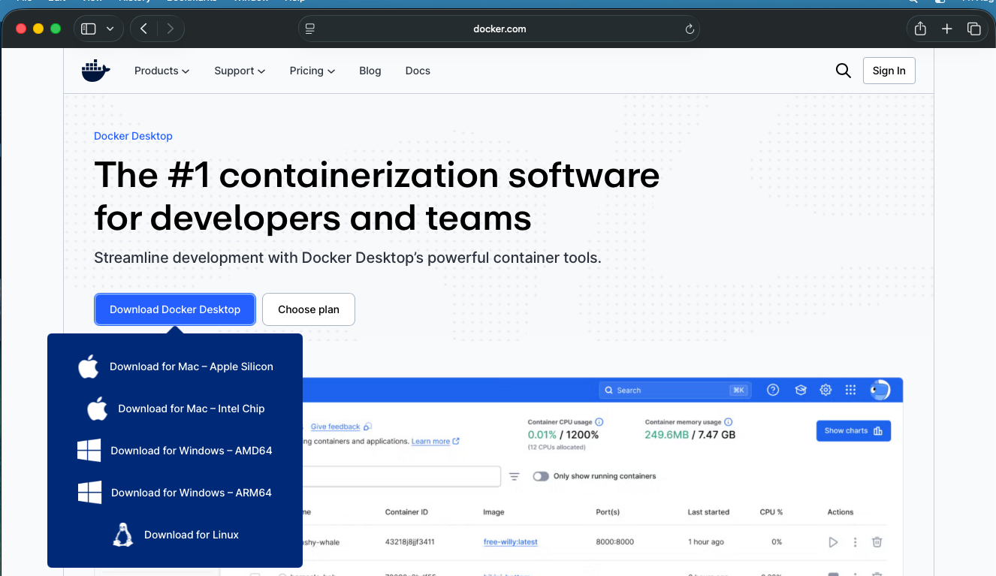
- click on Docker.dmg in your Downloads folder and follow the instructions
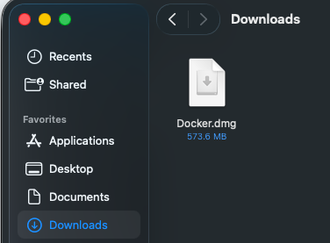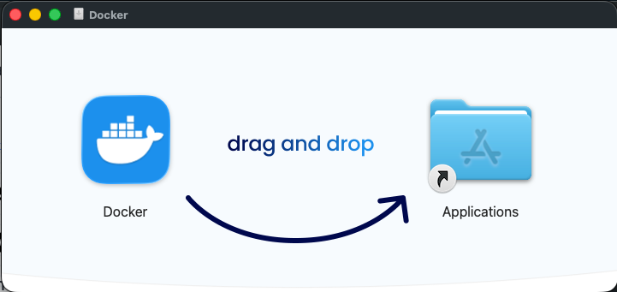

- go to Applications and open Docker
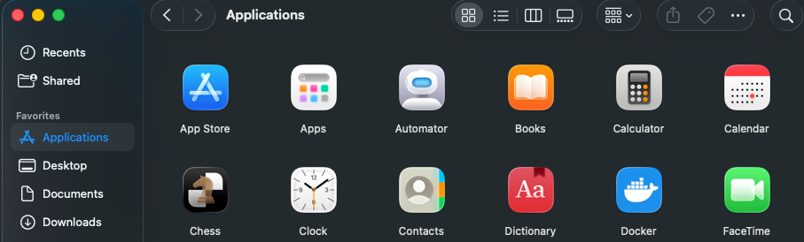
- Hit “Open” when prompted if you’re sure that you want to open it
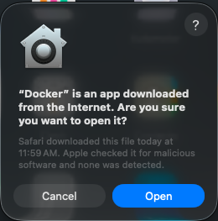
- The next step is to move to install the VisionEval Workbench on the following page

  - Install VisionEval Workbench
- Click on “VisionEval Workbench 1.0.0” under Releases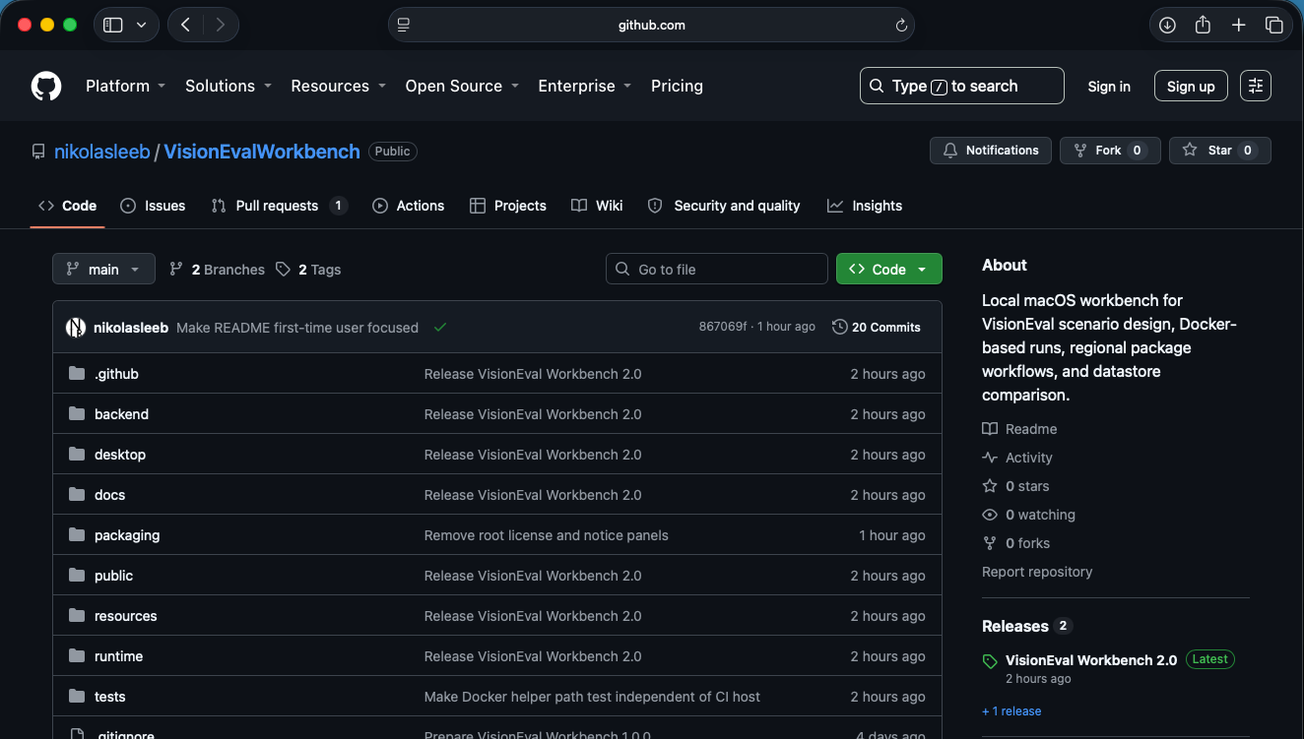

- Scroll down to Assets and click on “VisionEval-Workbench-v1.0.0-mac-arm64.dmg”
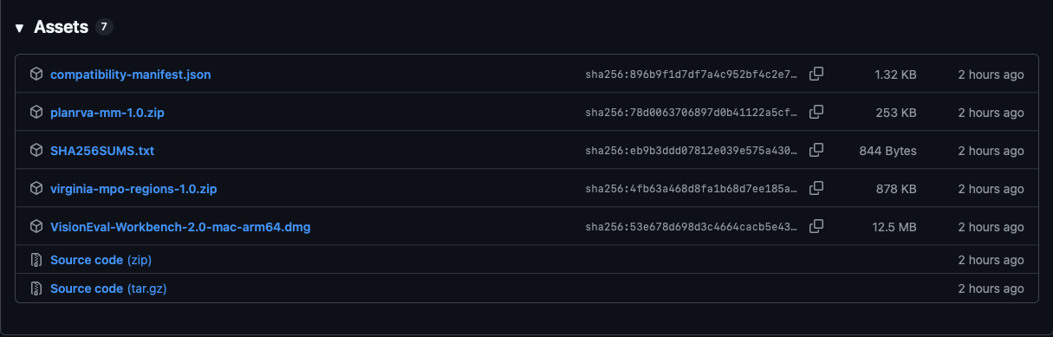

- Allow it to download and then go to Downloads and click on it. Drag it to Applications
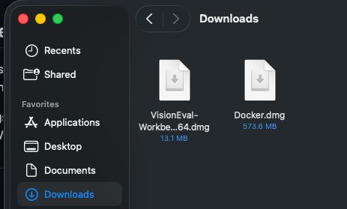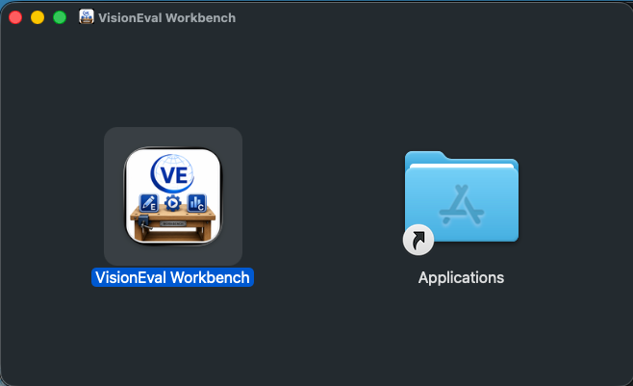

- Go to Applications and click on “VisionEval Workbench”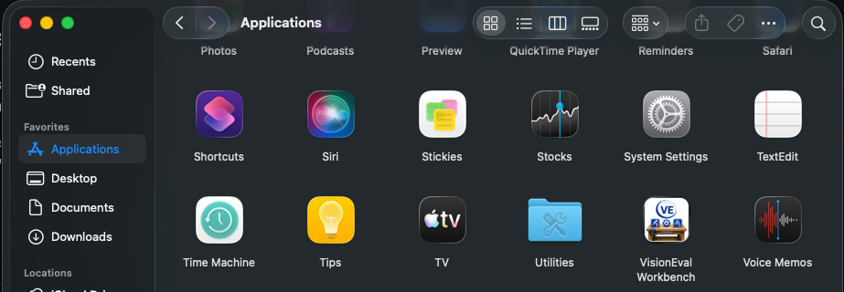

- When the following pop-up occurs, hit “Cancel”
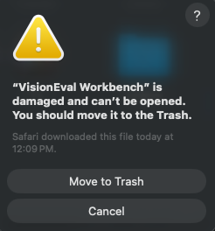

- Go to Applications and open the Terminal. Copy & paste in the following:
xattr -dr com.apple.quarantine "/Applications/VisionEval Workbench.app"
open "/Applications/VisionEval Workbench.app"
Then hit “ENTER” on the keyboard
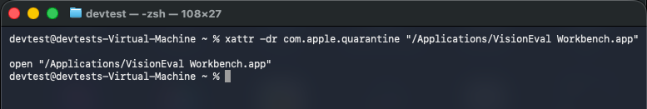

- VisionEval Workbench should open automatically and look like this:
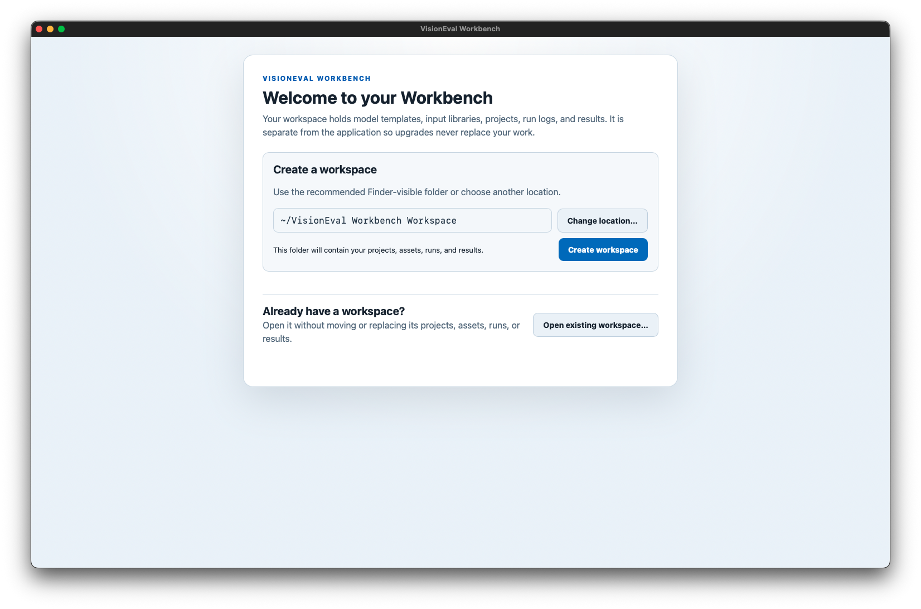

- Select either “Change Location” or “Create Workspace”
Change location will open the finder to choose another space to put the folder

- The following screen will occur, if you have successfully installed Docker, then hit “Install Runtime”
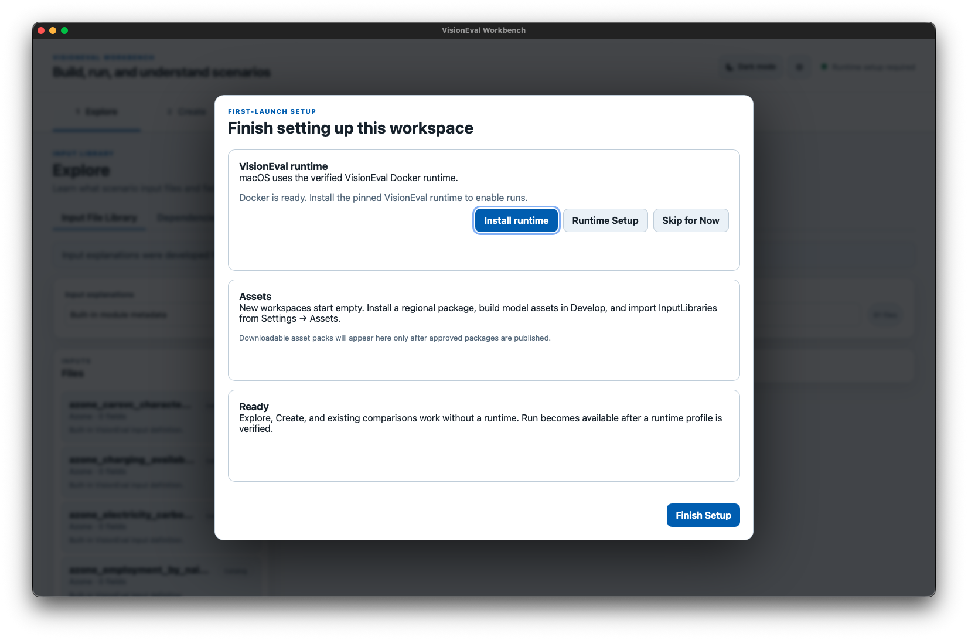

- The following pop-up will occur. Hit “Allow”. This is going to the GitHub page and collecting the VisionEval Docker Image and Installing it to Docker so that VisionEval will run models.
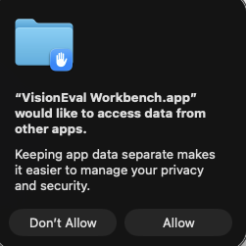

- It usually takes a couple minutes to install. If the VisionEval runtime box looks like this then it is working:
If it takes more than 10 - 15 minutes, there might be a problem
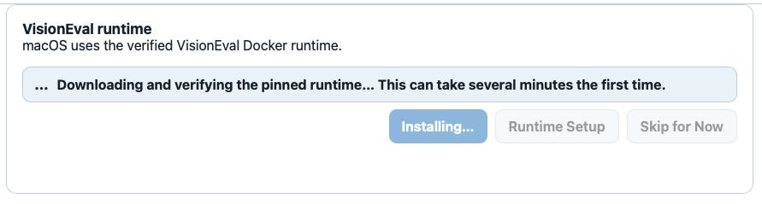

- If your computer has notifications enabled you’ll get the following notification when it’s finished
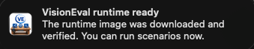

Otherwise, the VisionEval runtime box will look like this when finished installing:
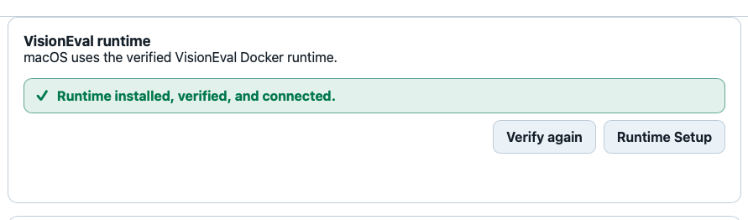

If it looks like this, then hit “Finish Setup” in the bottom right of the window and you’ll be taken to the main application

  - Installing a Package into VisionEval Workbench
- The next step is to install a package with data and inputs.
On the GitHub, in releases, there should be 2 packages:
planrva-mm.zip
virginia-mpo-regions.zip
You can download them by clicking on them
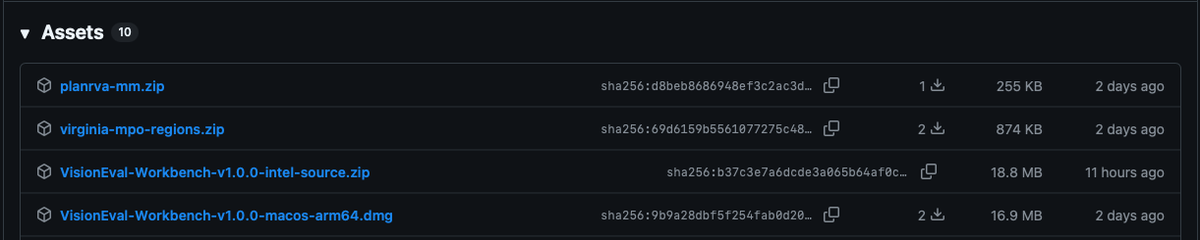

- Open the settings for the workbench, this can be done by either clicking visioneval workbench and then clicking settings or clicking the gear button in the top right
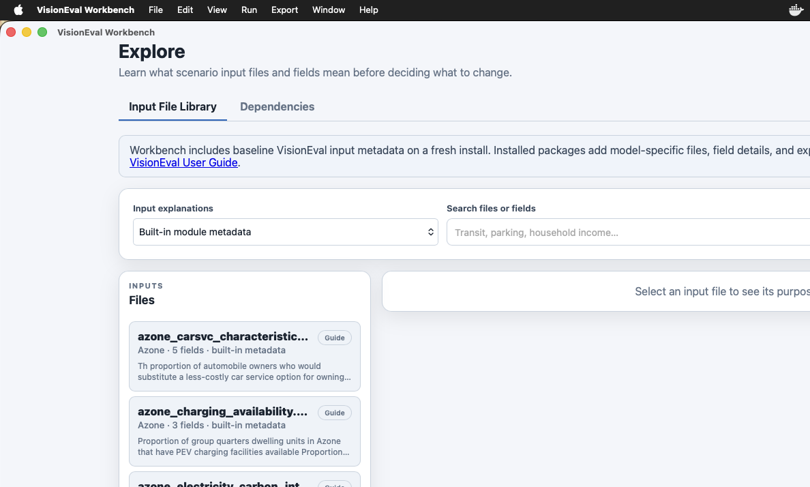
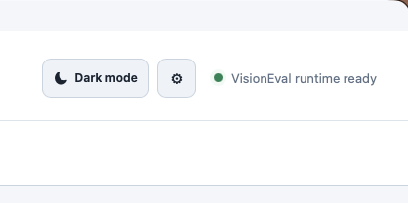

- Once in Settings, choose Assets, and then click “Install package”
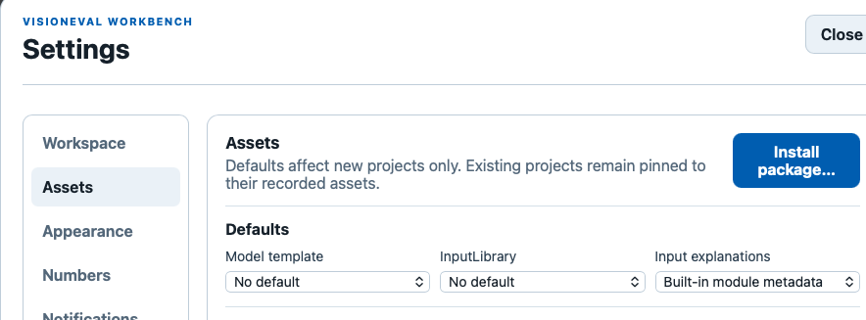
- A window will open and then click “Choose extracted folder”
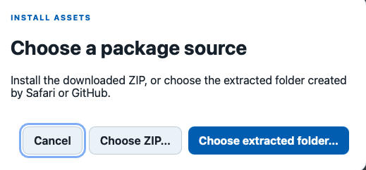
- Then the finder window will open, and you should see the folder(s) for the package(s) in Downloads. Click whichever one you want to install and hit “Open”

If you don’t see the package try “Choose ZIP”

- You should see the package show up as an Installed asset. If so, then hit “Save changes” and close the settings window. 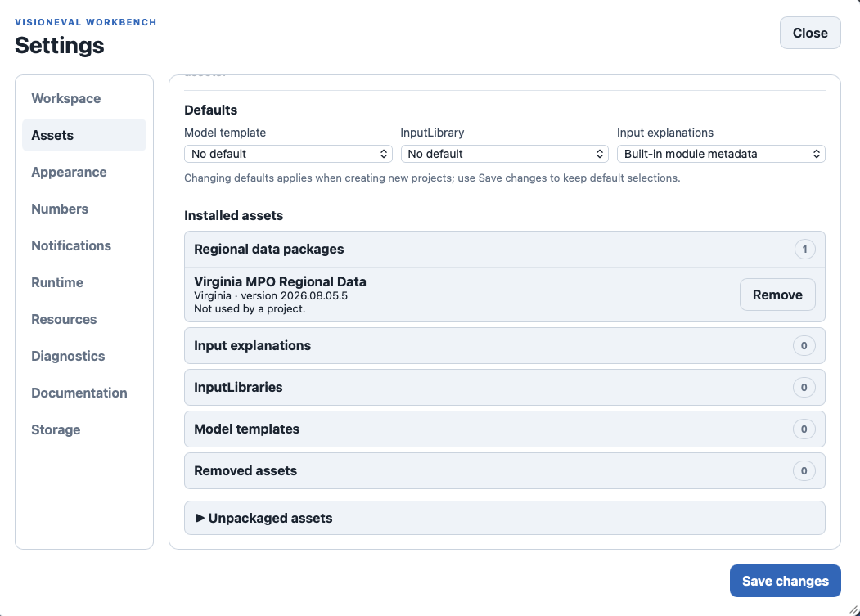
- Congrats, you have installed all the necessary parts to begin using VisionEval Workbench!

Next step: Scenario walkthrough
Continue with the VisionEval Workbench scenario exercise: View PDF | Download editable Word file | Tutorials and Walkthroughs Wiki

