VisionEval Workbench Installation and Setup

for Intel Mac (x64)
Link to VE Workbench: https://github.com/nikolasleeb/VisionEval-Workbench/releases

  - Mac Docker Installation Steps:
- Go to: https://desktop.docker.com/mac/main/amd64/207573/Docker.dmg
this will download a usable version of Docker for Intel Macs running MacOS 13**

- click on Docker.dmg in your Downloads folder and follow the instructions
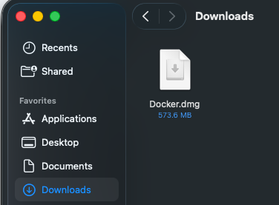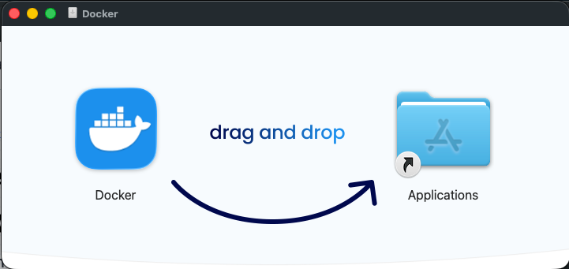

- go to Applications and open Docker
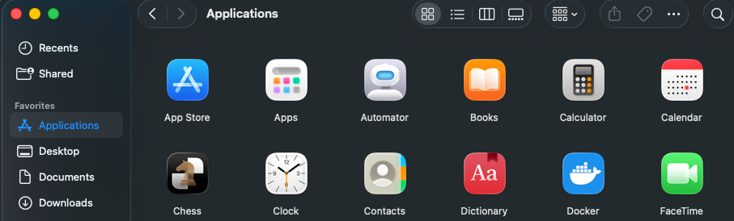

** If you are running MacOS 14 then try going to this link and downloading the latest Intel Mac Version. On my Intel Mac, the latest version would not work which is why the other link has been provided for a previous version of Docker that did work.

- Hit “Open” when prompted if you’re sure that you want to open it
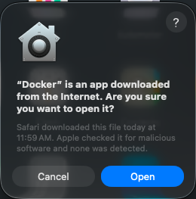

- The next step is to move to install the VisionEval Workbench on the following page

  - Install VisionEval Workbench
- Click on “VisionEval Workbench 1.0.0” under Releases
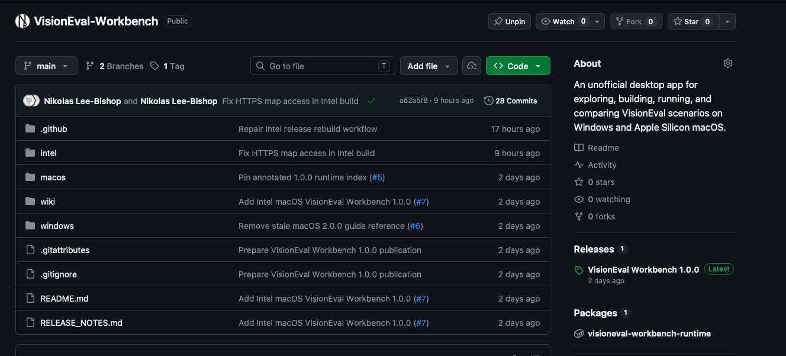

- Scroll down to Assets and click on “VisionEval-Workbench-v1.0.0-macos-x64.dmg”
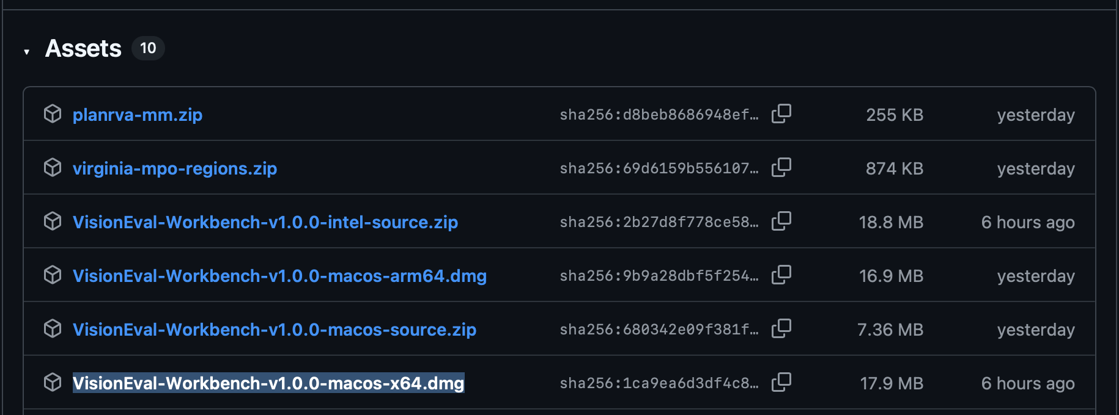

- Allow it to download and then go to Downloads in Finder and click on it. Drag it to Applications
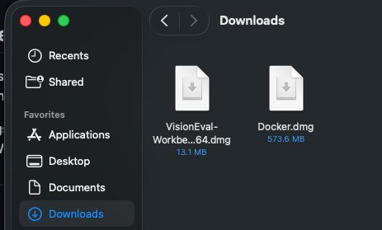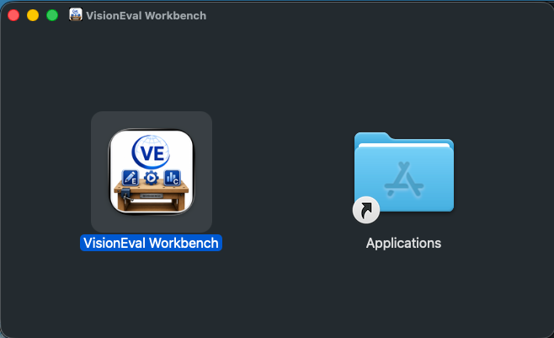

- Go to Applications and click on “VisionEval Workbench”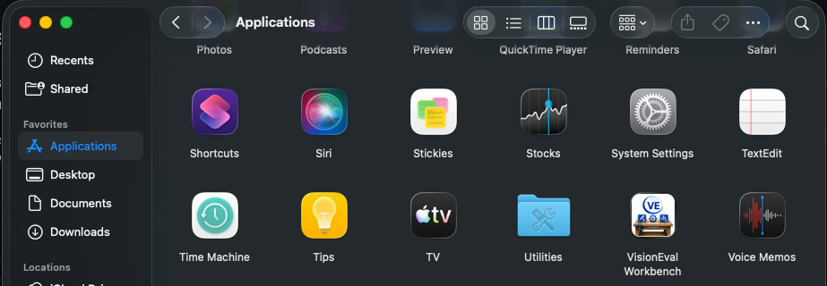

- When the following pop-up occurs, hit “Cancel”
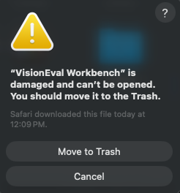

- Go to Applications and open the Terminal. Copy & paste in the following:
xattr -dr com.apple.quarantine "/Applications/VisionEval Workbench.app"
open "/Applications/VisionEval Workbench.app"
Then hit “ENTER” on the keyboard
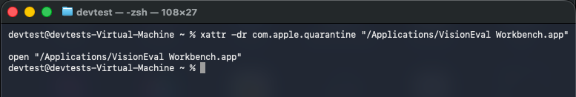

- VisionEval Workbench should open automatically and look like this:
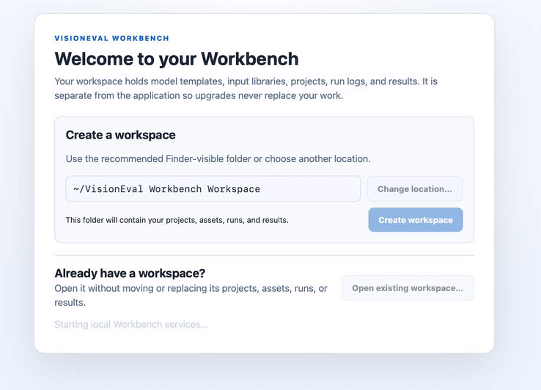

- Select either “Change Location” or “Create Workspace”
Change location will open the finder to choose another space to put the folder

- The following screen will occur, if you have successfully installed Docker, then hit “Install Runtime”
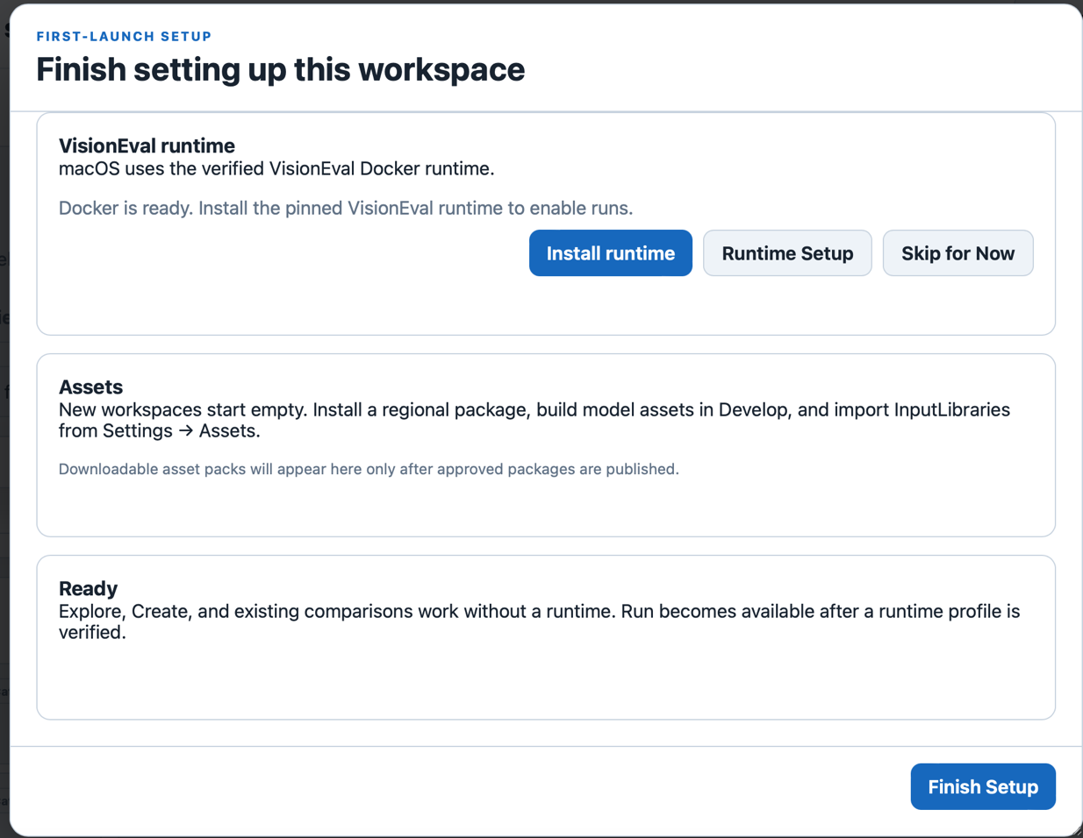

- The following pop-up might occur. Hit “Allow”. This is going to the GitHub page and collecting the VisionEval Docker Image and Installing it to Docker so that VisionEval will run models.
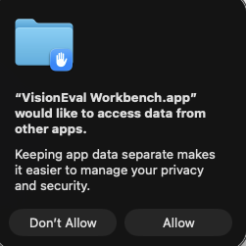

- It usually takes a couple minutes to install. If the VisionEval runtime box looks like this then it is working:
If it takes more than 10 - 15 minutes, there might be a problem
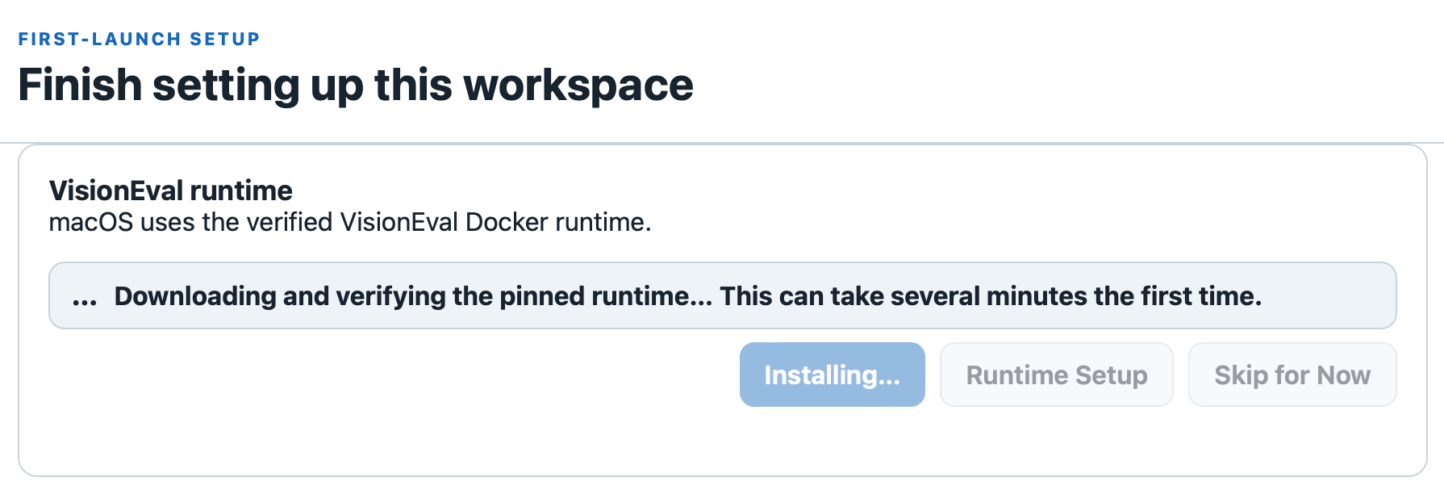

- If your computer has notifications enabled you’ll get the following notification when it’s finished


Otherwise, the VisionEval runtime box will look like this when finished installing:
If it looks like this, then hit “Finish Setup” in the bottom right of the window and you’ll be taken to the main application
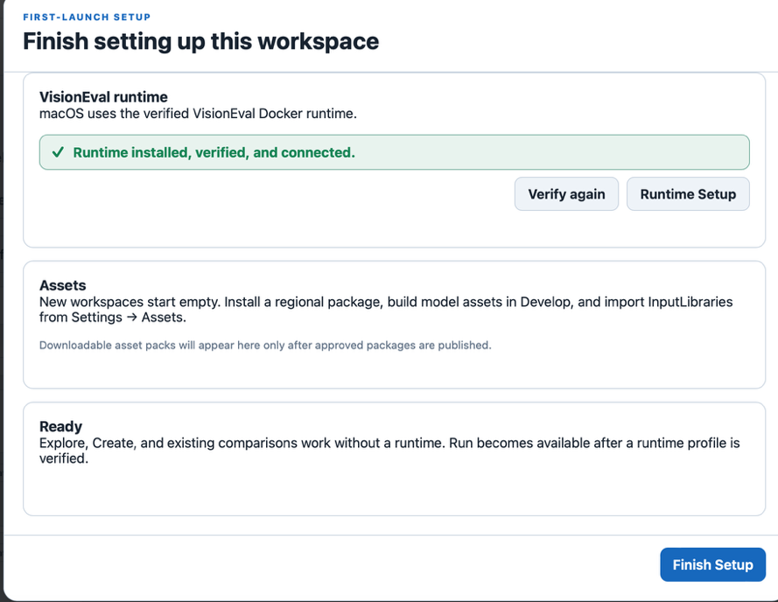
  - Installing a Package into VisionEval Workbench
- The next step is to install a package with data and inputs.
On the GitHub, in releases, there should be 2 packages:
planrva-mm.zip
virginia-mpo-regions.zip
You can download them by clicking on them
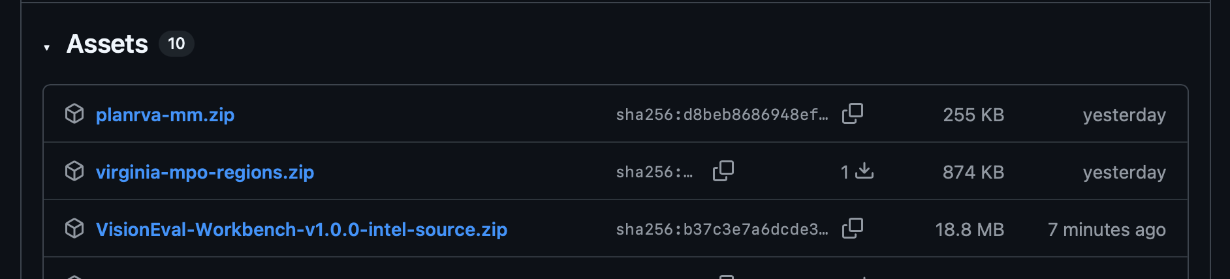

- To install a package in the workbench, go to “Create > Develop”. Hit “Install regional package”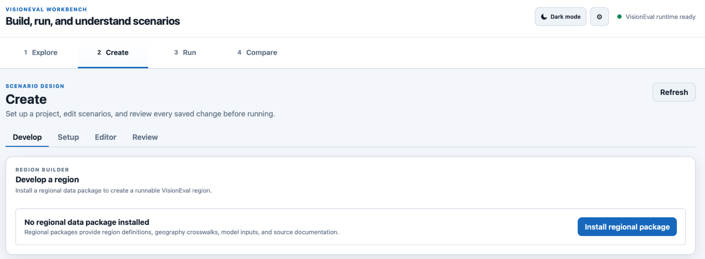

- Next Hit “Choose extracted folder”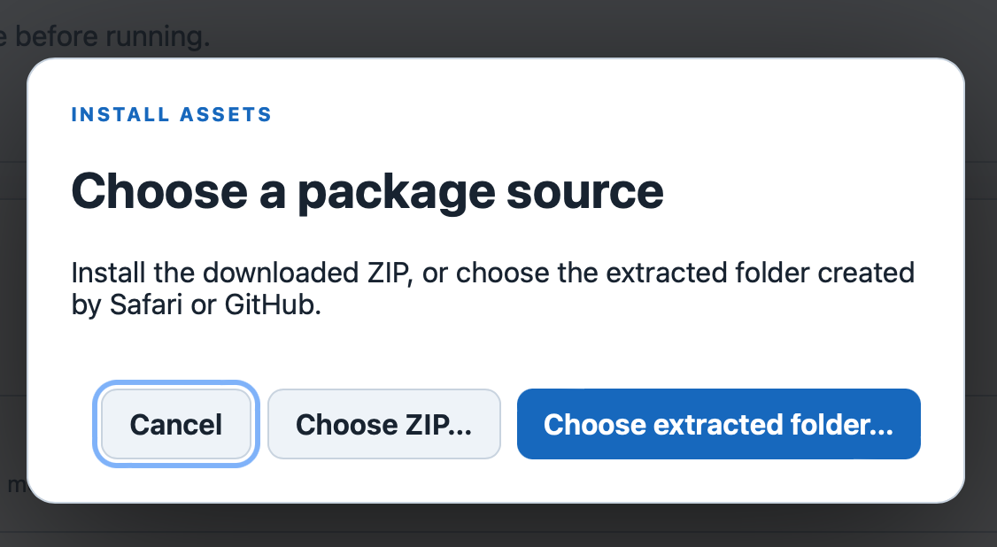

- Then select the package and hit “Open”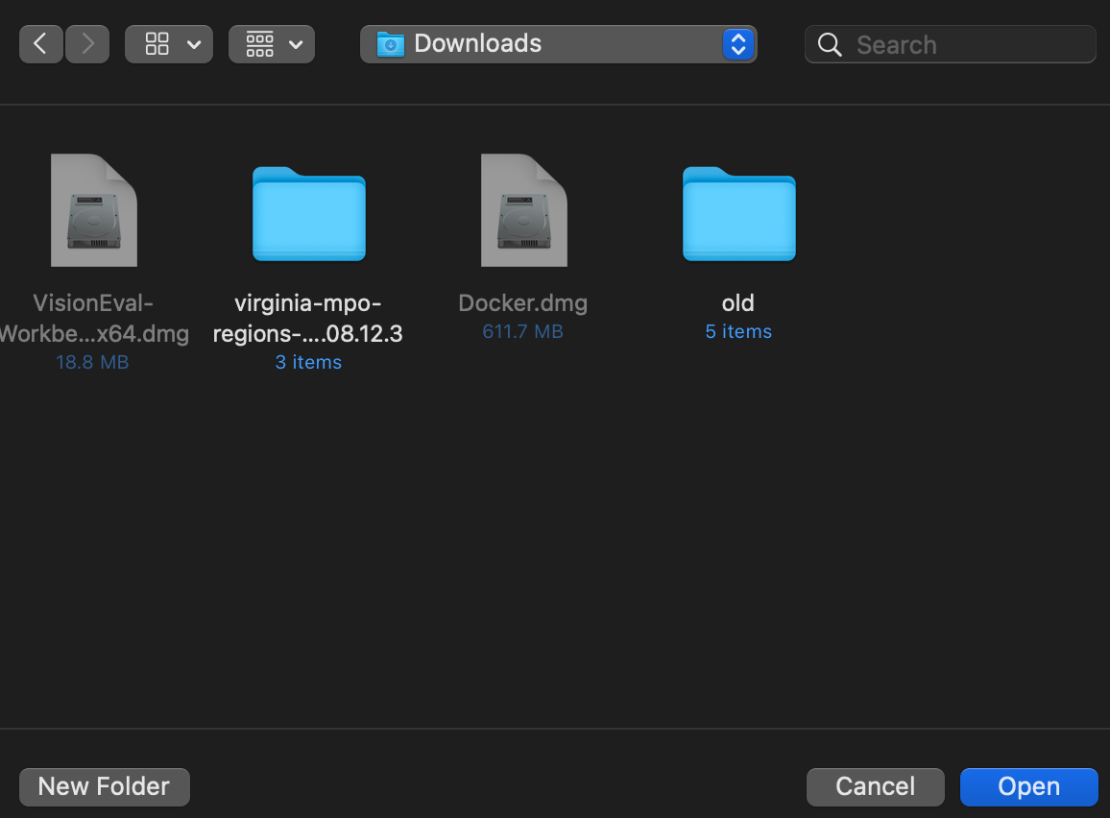
- Congrats, you have installed all the necessary parts to begin using VisionEval Workbench!

Next step: Scenario walkthrough
Continue with the VisionEval Workbench scenario exercise: View PDF | Download editable Word file | Tutorials and Walkthroughs Wiki

