Mac 2.0 installation
and setup
  - VisionEval Workbench for Apple Silicon macOS
Install the desktop application, connect its Docker runtime, and add the packages used in the Mac walkthroughs. At the end, Workbench should show a ready runtime and the installed PlanRVA model and inputs.

Before you begin
Use an Apple Silicon Mac and an internet connection for the initial downloads. This guide is not for Intel Macs or Windows. Allow disk space for Docker, the runtime image, packages, and model results; run results can be much larger than the application installer.

Watch alongside this guide
Mac videos on the Workbench website
Docker installation video
Workbench and runtime installation video
Asset package installation video
Follow the sections in order: Docker, Workbench, workspace, runtime, PlanRVA, and Virginia regional data. If you already have a working Docker installation, keep it and continue with Workbench.

Install Docker and Workbench
1. Download Docker Desktop for Mac with Apple silicon from Docker’s official website. Check the current macOS requirements and your organization’s Docker Desktop licensing requirements there.
Docker Desktop Mac installation instructions
2. Open the Docker disk image, drag Docker to Applications, and open Docker from Applications. Complete its setup and wait until the Docker engine is running. You do not need to create model containers yourself.
3. Download VisionEval-Workbench-v2.0.0-macos-arm64.dmg from the public Workbench release. This is the Apple Silicon installer, not a source-code ZIP or a runtime metadata file.
Download Workbench 2.0 for Apple Silicon
4. Open the Workbench disk image and drag VisionEval Workbench to Applications. Open the copy in Applications. For an update, quit Workbench before replacing the application; your workspace is separate from the app.
The public Mac installer is Developer ID signed and notarized. This guide does not ask you to remove quarantine attributes or disable macOS security settings. If macOS rejects a download, stop and check that you used the official Apple Silicon release.

Keep application and workspace separate
Applications contains the software. Your workspace contains projects, installed assets, model runs, and results. Replacing the application does not mean replacing or deleting the workspace.

Choose your workspace
5. On first launch, use the workspace setup offered by Workbench. Choose a location with sufficient space for your model results. Most people need only one workspace.
6. Open Settings and select Workspace. Check the Current workspace path before installing packages or creating projects. The screenshot uses a separate documentation workspace so the examples do not change existing work.
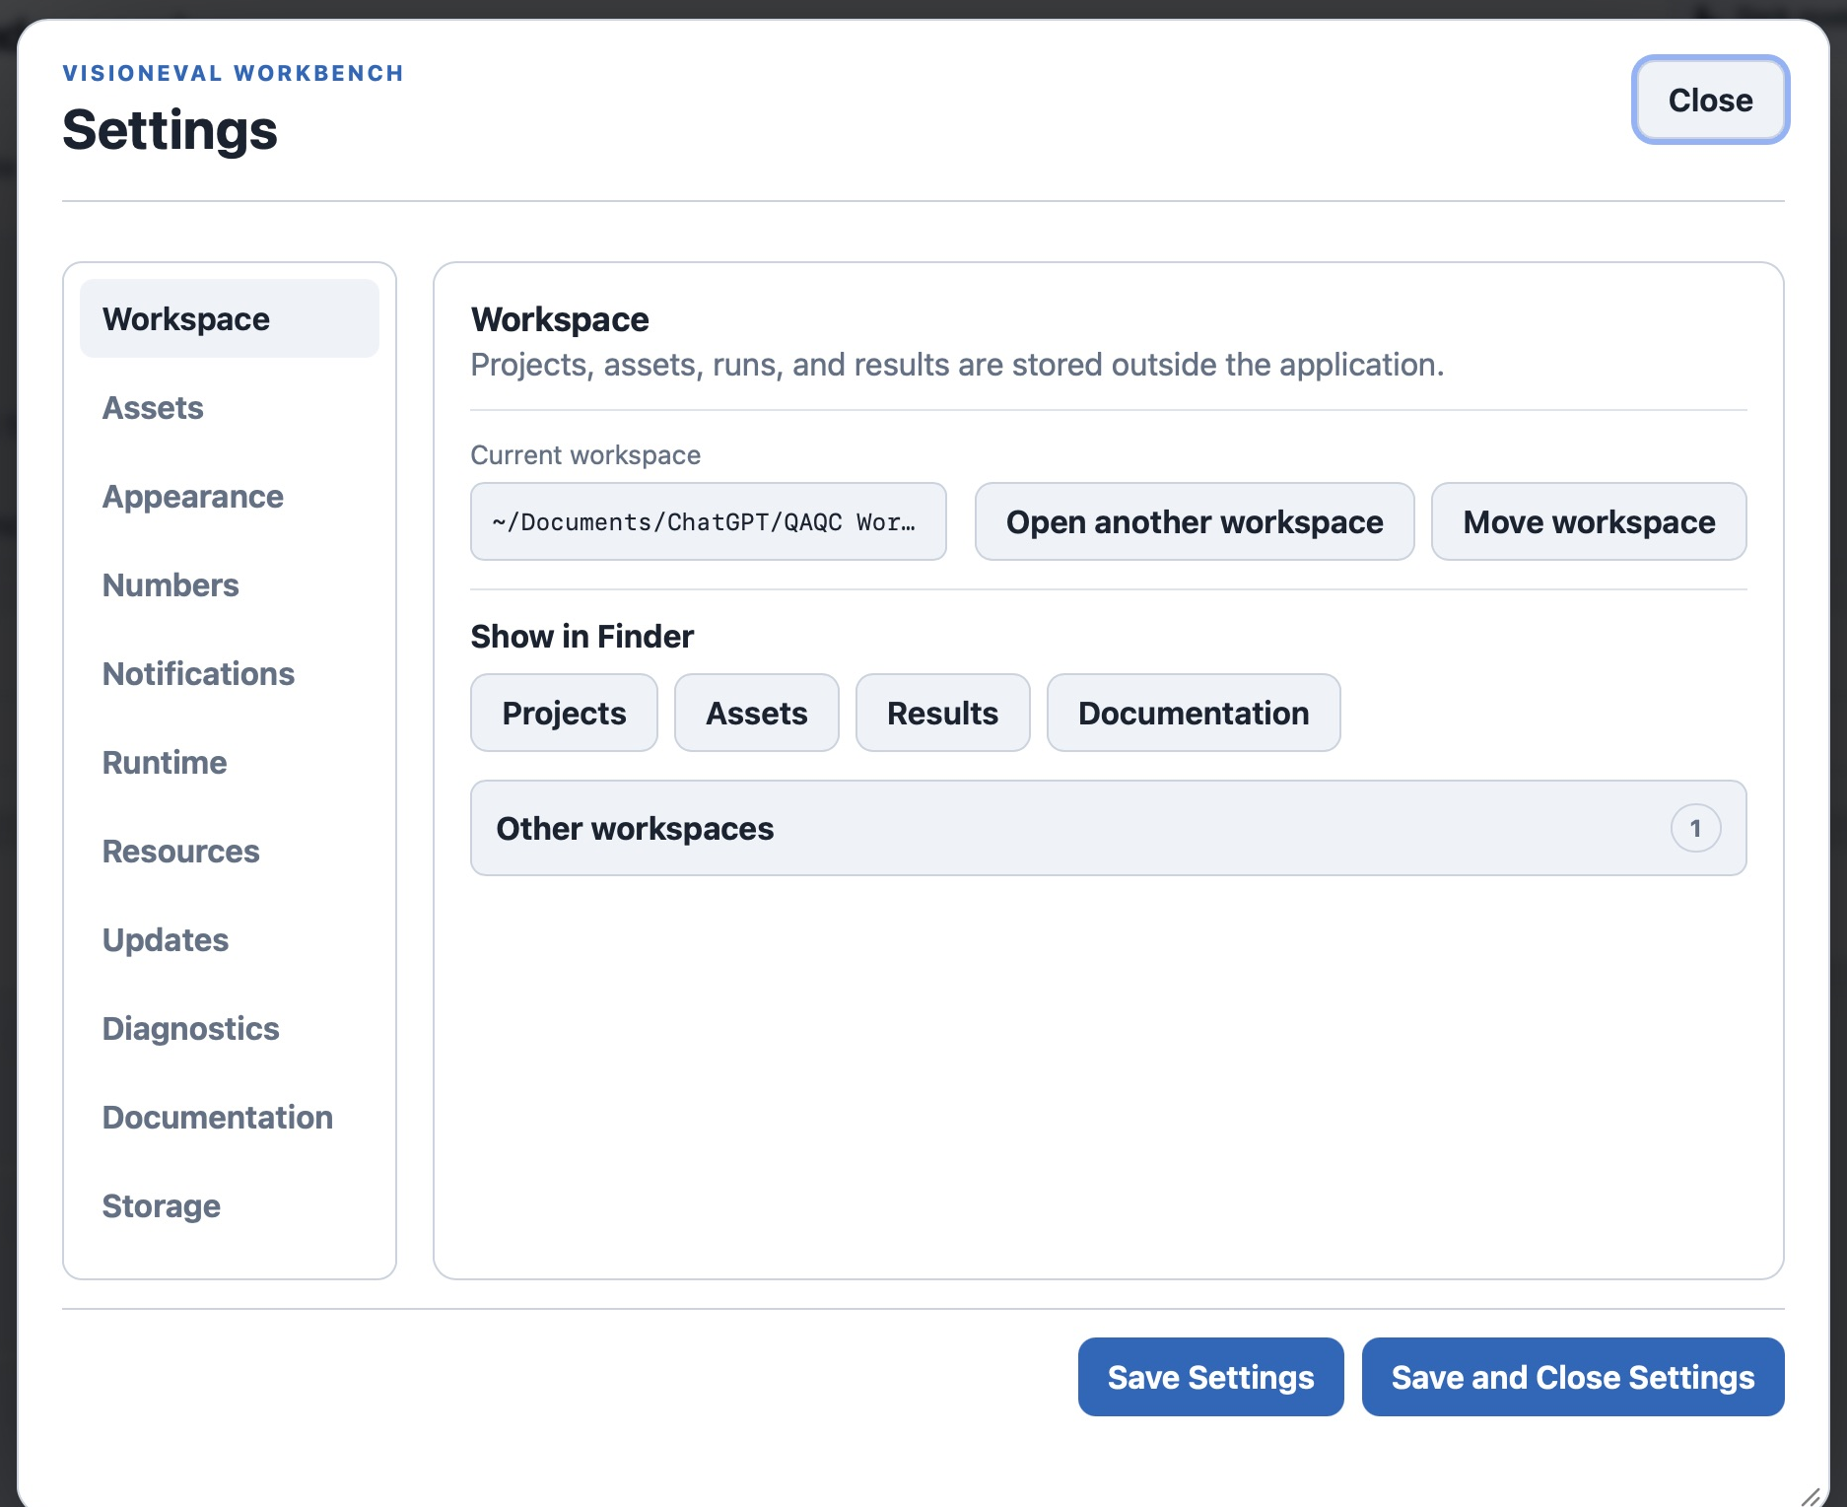
Figure 1. Workspace settings show where Workbench stores your work.
Open another workspace selects an existing workspace or lets you work in another location. Move workspace relocates the current workspace. Moving to an SSD is covered separately in Workspaces and resources; do not move a workspace while model runs are active.

Install and verify the runtime
7. Keep Docker Desktop running. In Settings, select Runtime. If no runtime is configured, use Install runtime and follow the confirmation shown by Workbench. Leave the app open while the runtime downloads and verifies.
8. Wait for the Runtime status to become Ready. The Mac edition uses the Docker adapter and the arm64 architecture. The verified VisionEval release in this example is VE-40-RC7.
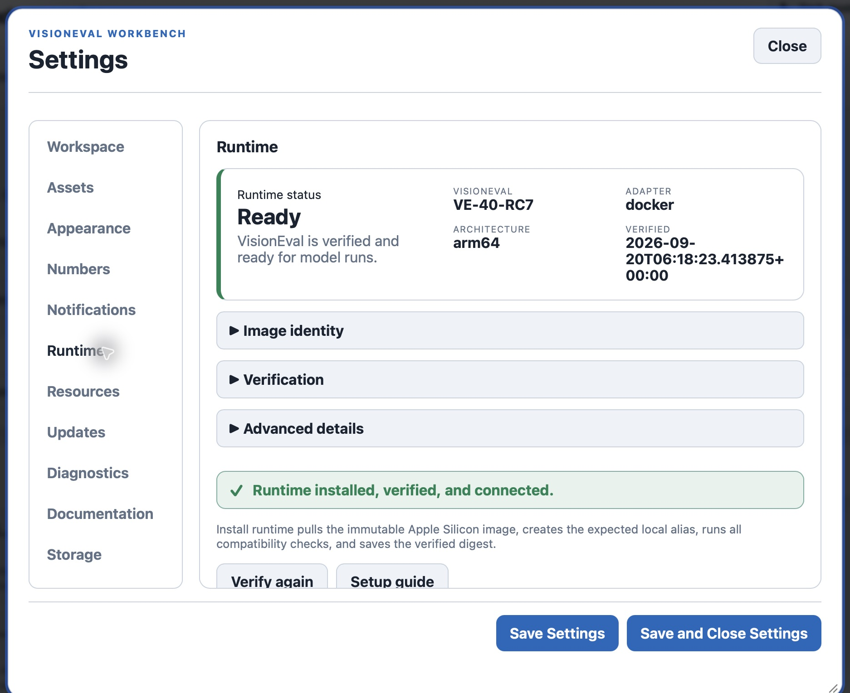
Figure 2. A ready Mac runtime is installed, verified, and connected.
9. If the runtime needs attention, first check that Docker Desktop is running, then use Verify again. Runtime status is the readiness check; an update advisory is not a substitute for successful verification.

Install the PlanRVA package
10. Download planrva-2.0.zip from the Workbench 2.0 release. Keep it as a ZIP for the simplest installation. If your browser has already expanded it, Workbench also accepts the extracted package folder.
Download the PlanRVA package
11. In Settings → Assets, choose Install package and select the downloaded ZIP. Workbench validates the package and opens its preview. Read the package name and intended use before confirming.
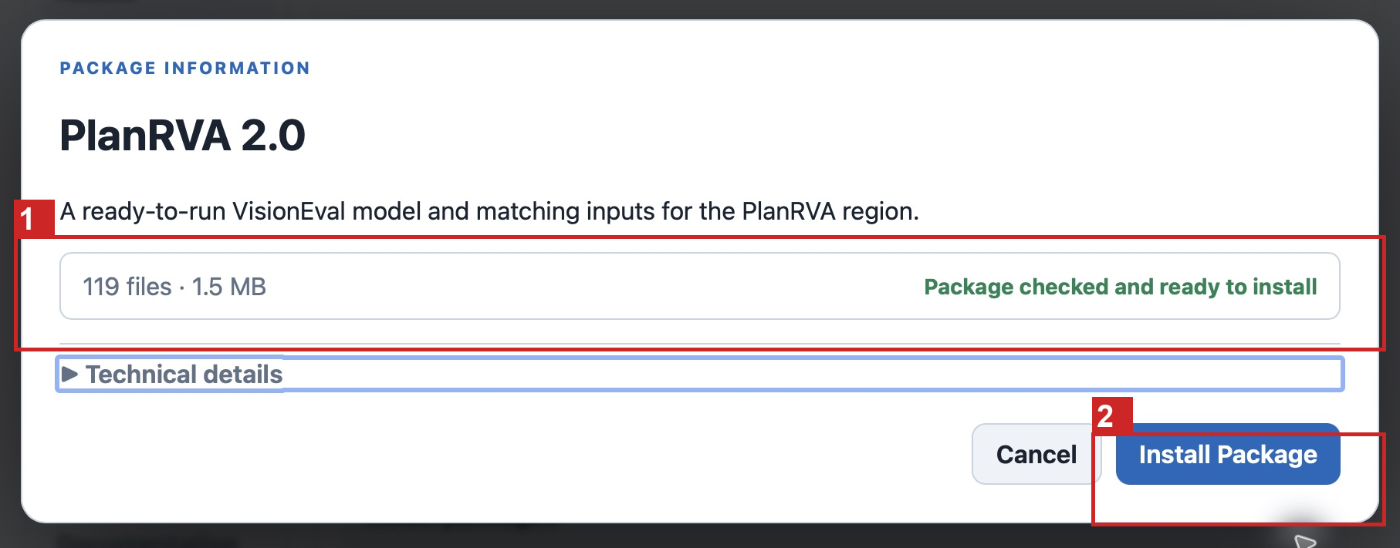
Figure 3. The PlanRVA package preview is ready for installation.
1 Check the package is ready. 2 Confirm with Install Package.
12. Click Install Package. After the preview closes, wait for the success message and check the installed assets. PlanRVA supplies both a Model package and its paired Input Library; it is not only a set of explanations.
The tested package contains 51 input CSV files. Package totals in the preview also include manifests, model files, and documentation, so the preview file count is not the same as the input-file count.

Add Virginia regional data
13. If you want to develop another Virginia MPO or a custom region, download virginia-mpo-regions-2.0.zip and install it through the same Assets workflow. It is optional for the ready-to-run PlanRVA example.
Download Virginia MPO regional data
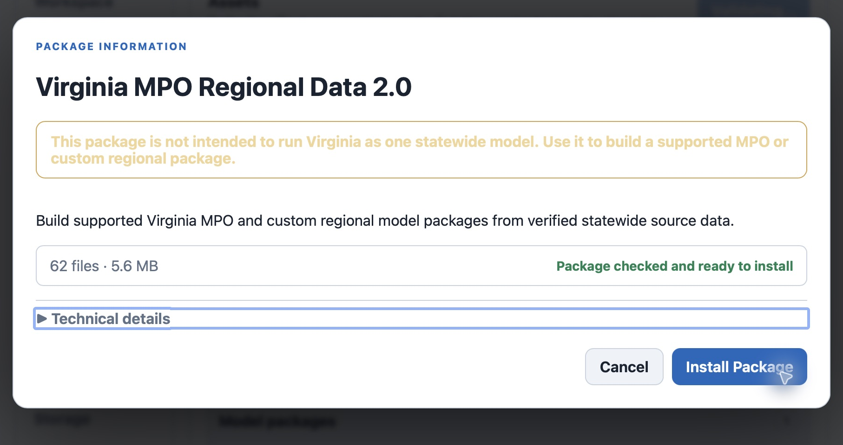
Figure 4. Virginia regional data are source data for Region Builder, not a statewide model to run.
14. Confirm the installation and check Regional data packages and Input explanations in Assets. In Create → Develop, choose the Virginia develop source and its matching statewide input data when building a region. Do not substitute PlanRVA’s regional Input Library for statewide Virginia coverage.

You are ready for the walkthrough
Check three things before continuing: the workspace path is correct, Runtime says Ready, and PlanRVA is installed with its model and Input Library. Use the Project and scenario walkthrough next; Hypercube is a separate workflow with its own guide.

