Mac 2.0 project and
scenario walkthrough
  - PlanRVA fuel cost and tax example
Create a PlanRVA project, preserve its baseline, change fuel cost and fuel tax, run both versions, and compare the completed results. This follows the first scenario in the Mac video, with current Version 2 controls and fresh screenshots.

Before you begin
Install PlanRVA with its paired Input Library. Keep Docker Desktop running and check that Settings → Runtime says Ready. Use a separate workspace if you want to practice without changing existing projects.
Project and scenario video
All Mac videos

The example you will create
Project: PR Fuel Tax and Cost. Scenario: 10% Both Everywhere. Increase FuelCost.2024 and FuelTax.2024 by 10 percent for target year 2045 across all matching PlanRVA rows. Compare the result with the untouched baseline.

Create the project
1. Open Create → Setup. Enter PR Fuel Tax and Cost, select PlanRVA as the model package, and use its paired Input Library. Create the project with a fresh baseline.
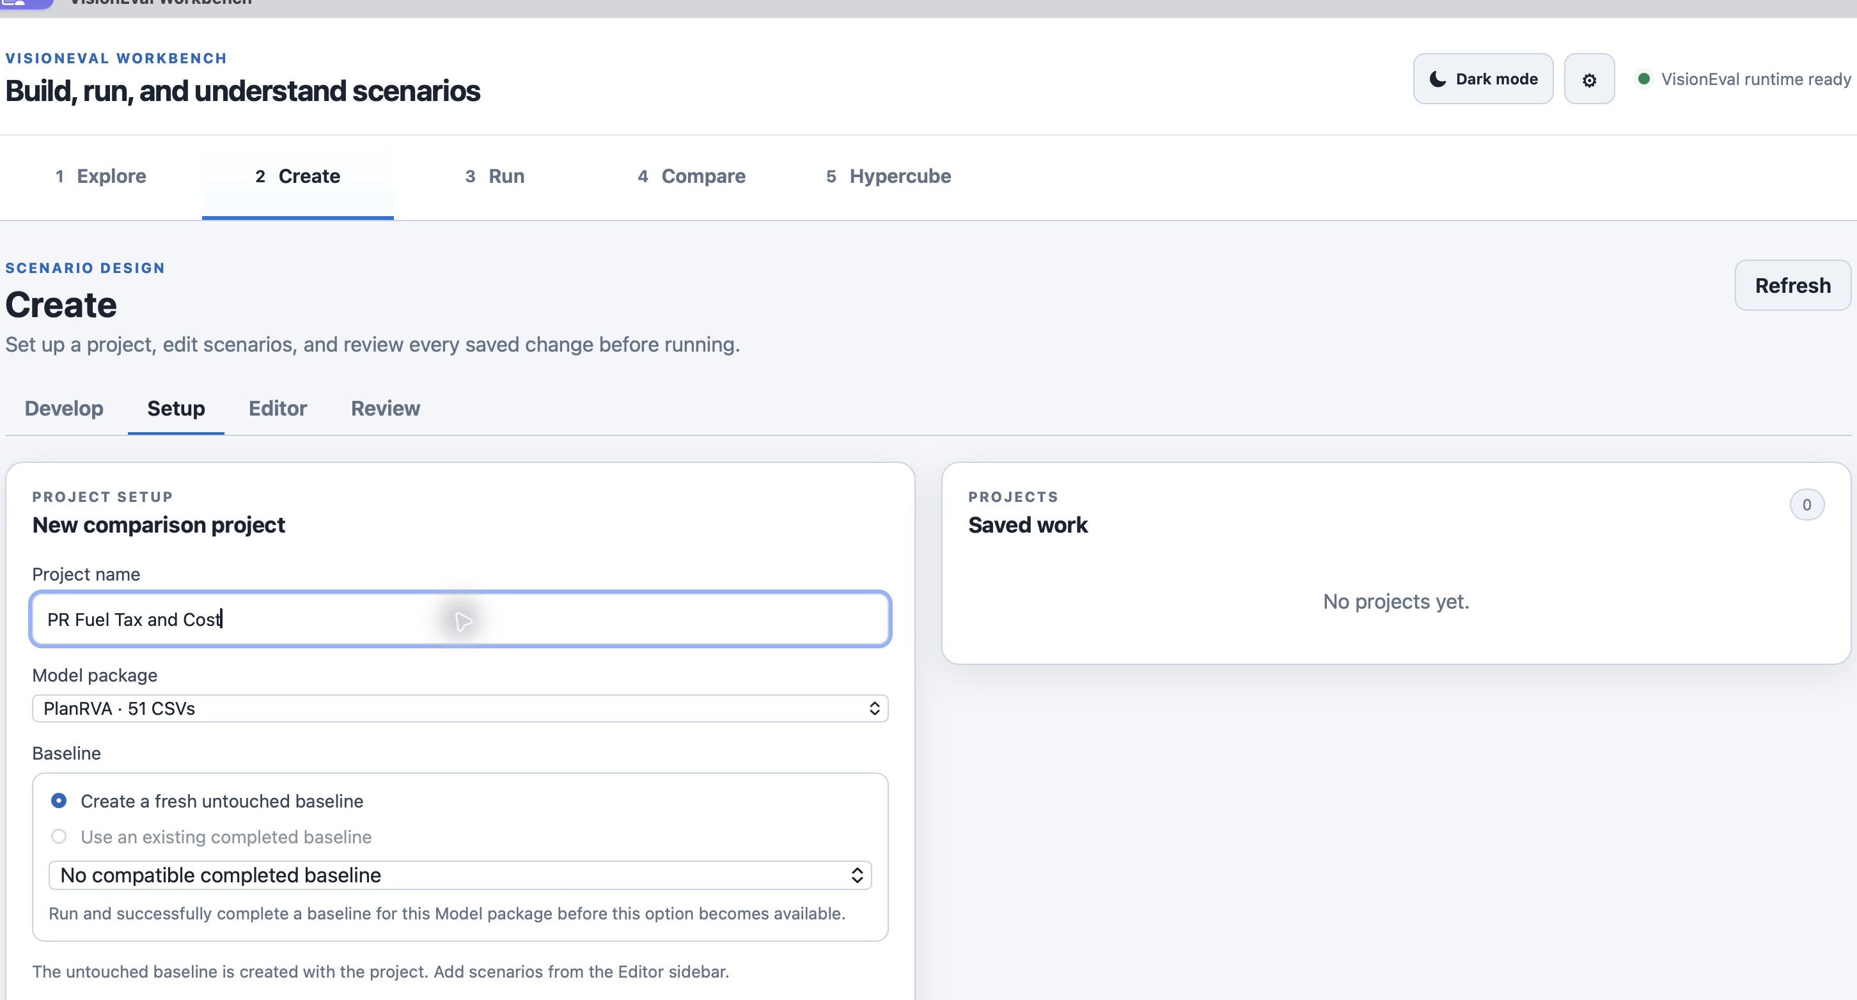
Figure 1. Create a project from the PlanRVA model and its matching inputs.
2. Create a scenario named 10% Both Everywhere. The baseline is your reference; make edits in the scenario, not in the installed source package.
The video also demonstrates additional scenarios. Begin with this one complete comparison before adding them. Scenario names describe your intention; Review confirms what was actually saved.

Choose how to edit the scenario
There are two ways to start an edit in the scenario sidebar. Both save changes in the scenario, leaving the installed model package unchanged.
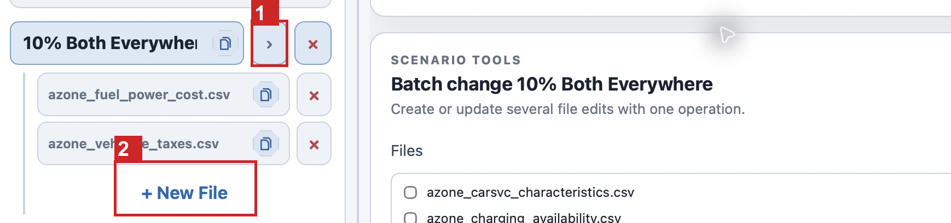
Figure 2. Use the scenario arrow for Batch Change or New File for a single-file edit.
1 Scenario arrow opens Batch Change. 2 New File opens the single-file editor.
Use Batch Change when several files need the same operation, value, year, and location scope. For this example, fuel cost and fuel tax both increase by 10 percent everywhere, so one batch keeps their settings consistent.
Use + New File when you want to work on one input file, inspect its rows, edit individual cells, or apply a file-specific operation. This is useful when fuel cost changes everywhere but fuel tax changes only in Richmond, or when different files need different percentages. Calculated operations use Apply and Save Change; direct cell edits require Save Direct Edits.

Change fuel cost and fuel tax
3. Open Batch Change in the scenario editor. Add azone_fuel_power_cost.csv with FuelCost.2024 and azone_veh_use_taxes.csv with FuelTax.2024.
4. For both files, choose Increase by %, enter 10, set the shared target year to 2045, and select all matching rows. Apply the change from the untouched baseline rather than compounding an earlier scenario edit.
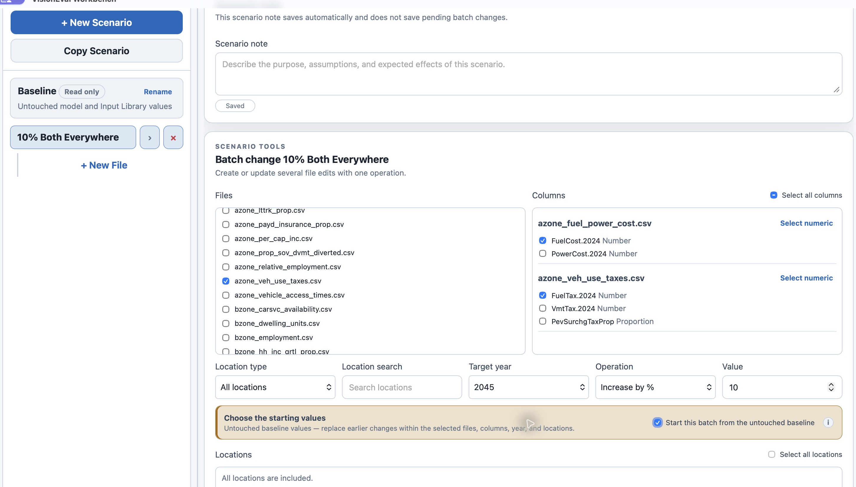
Figure 3. Batch Change applies the same percentage operation to the two selected inputs.
The target year selects dated input rows. It does not change the model’s configured years or rename the input column. Save the batch after checking every selected file and field.

Review the saved changes
5. Open Create → Review and select the scenario. Check the files, scope, and before and after values before submitting a run.
Start with the scenario summary. It describes the saved operation and scope, such as Increased 10% across 2 files · all locations, and counts the saved files, changed rows, and changed cells. Use it to check that the saved changes match your intention, then expand the scenario and file details to inspect before and after values. The summary describes saved input changes, not predicted model results or unsaved editor changes.
Expand Automatic summary inside the scenario to read the generated description of its saved changes. Read it alongside your scenario note: the note explains your intention, while the automatic summary helps check what was actually saved.
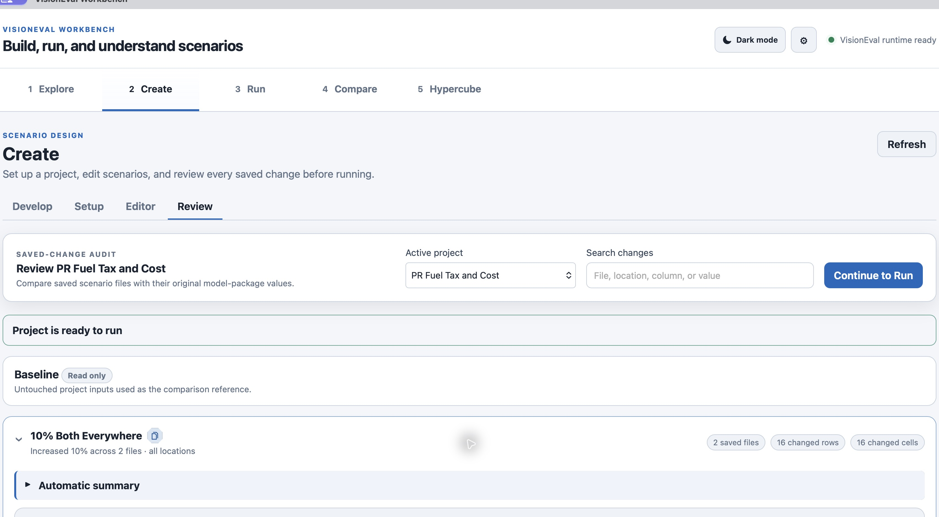
Figure 4. Review confirms the saved input changes before a model run.
In this example the saved batch changed two files and 16 values. Review reported two files, 16 rows, and 16 changed cells. If your counts differ, check the package, target year, scope, and earlier edits before continuing.
For the video’s Richmond-only tax example, select the intended Richmond locality for that tax edit. For 25% Both Everywhere, start from the untouched baseline and apply 25 percent; do not add 25 percent to an already increased value.

Run the baseline and scenario
6. Open Run and select the baseline and 10% Both Everywhere. Choose queued execution for one run at a time, or a small parallel batch that fits Docker’s shared memory pool.
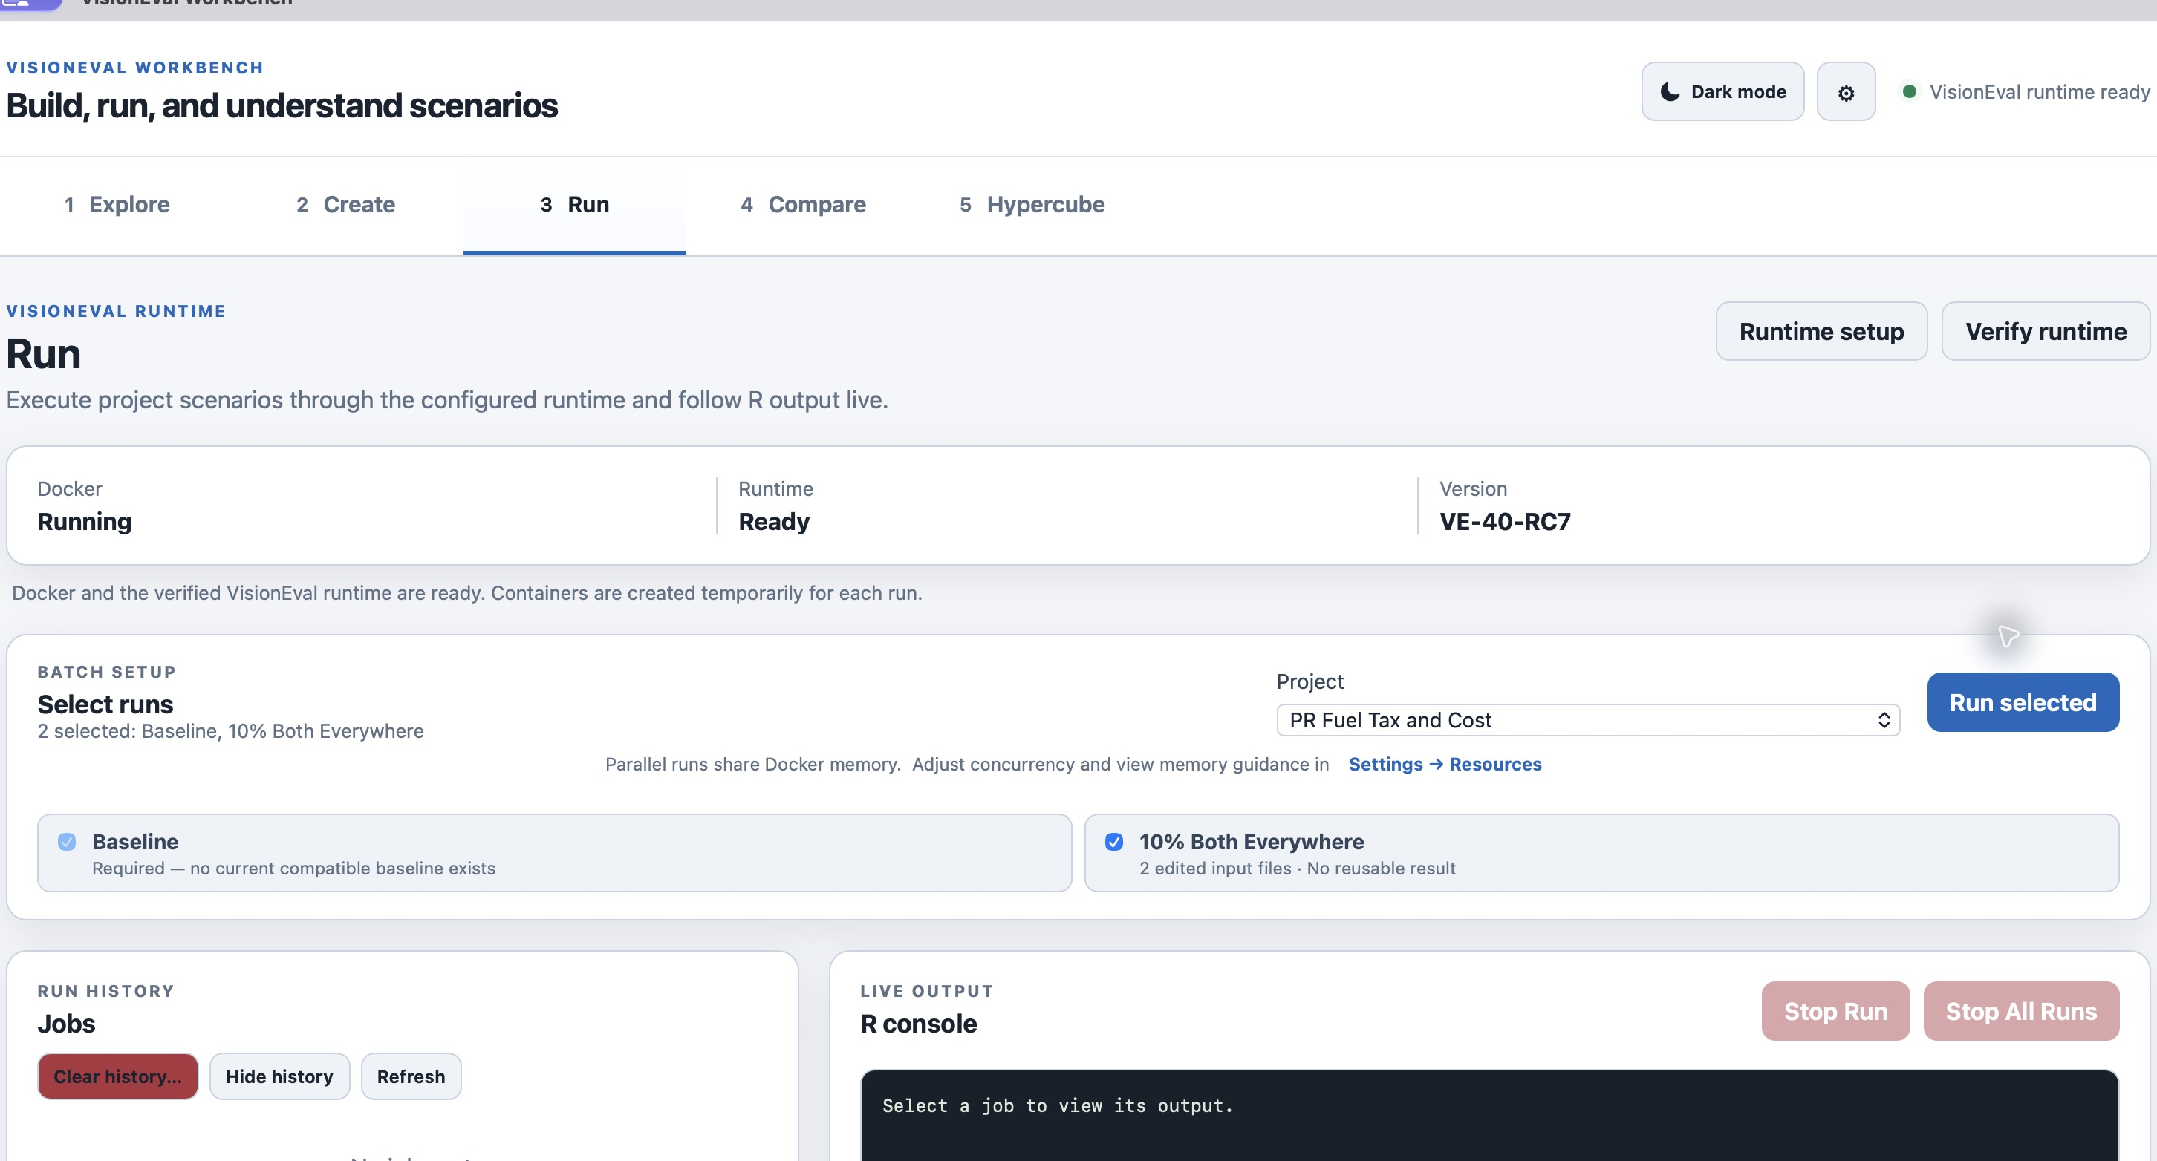
Figure 5. Select both the reference baseline and the scenario for execution.
7. Start the selected runs and leave Workbench and Docker open. Wait for successful completion, not just a running container or a progress percentage. If a run fails, read its job log before retrying.
The documentation test completed both runs successfully. Runtime and duration vary by computer. See Workspaces and resources before increasing concurrency.

Find changes across the completed results
8. Open Compare. Select PR Fuel Tax and Cost — Baseline as the reference and PR Fuel Tax and Cost — 10% Both Everywhere as the comparison. Select year 2045, keep All locations, and choose Find All Changes before focusing on one variable.
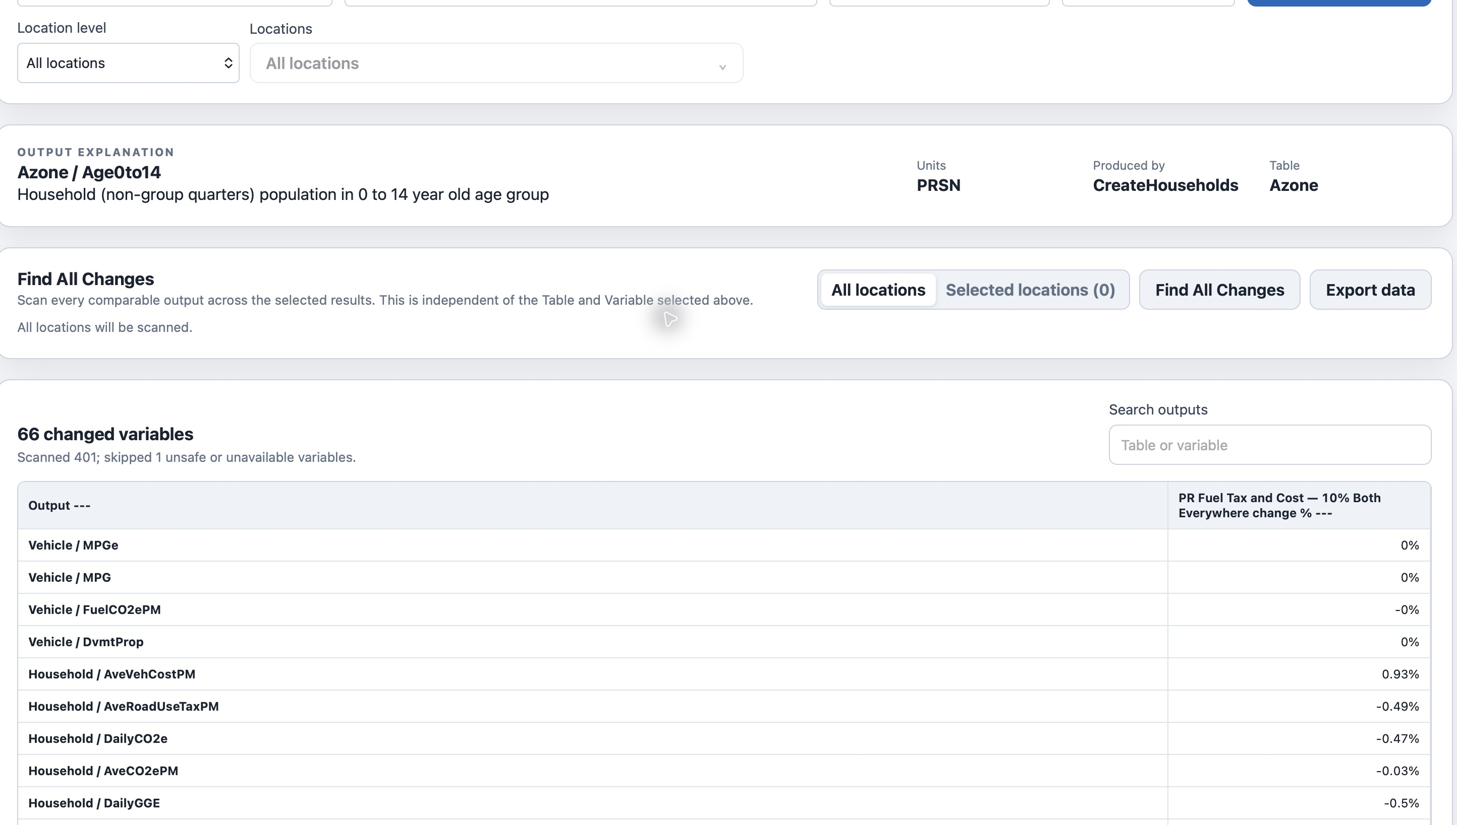
Figure 6. Find All Changes scans comparable outputs before you choose a variable to explore.
Wait for the scan to finish, then review the changed outputs. The scan is independent of the Table and Variable chosen in the single-variable controls. Use its results to identify which outputs changed, rather than assuming that only the variable you expected was affected. Check units, coverage, and any warnings before interpreting a difference.

Explore one changed variable
After reviewing Find All Changes, use the single-variable explorer to investigate an output in more detail. For this example, select Household and AveVehCostPM with year 2045, then choose Update Comparison. Keep the same reference and comparison results.
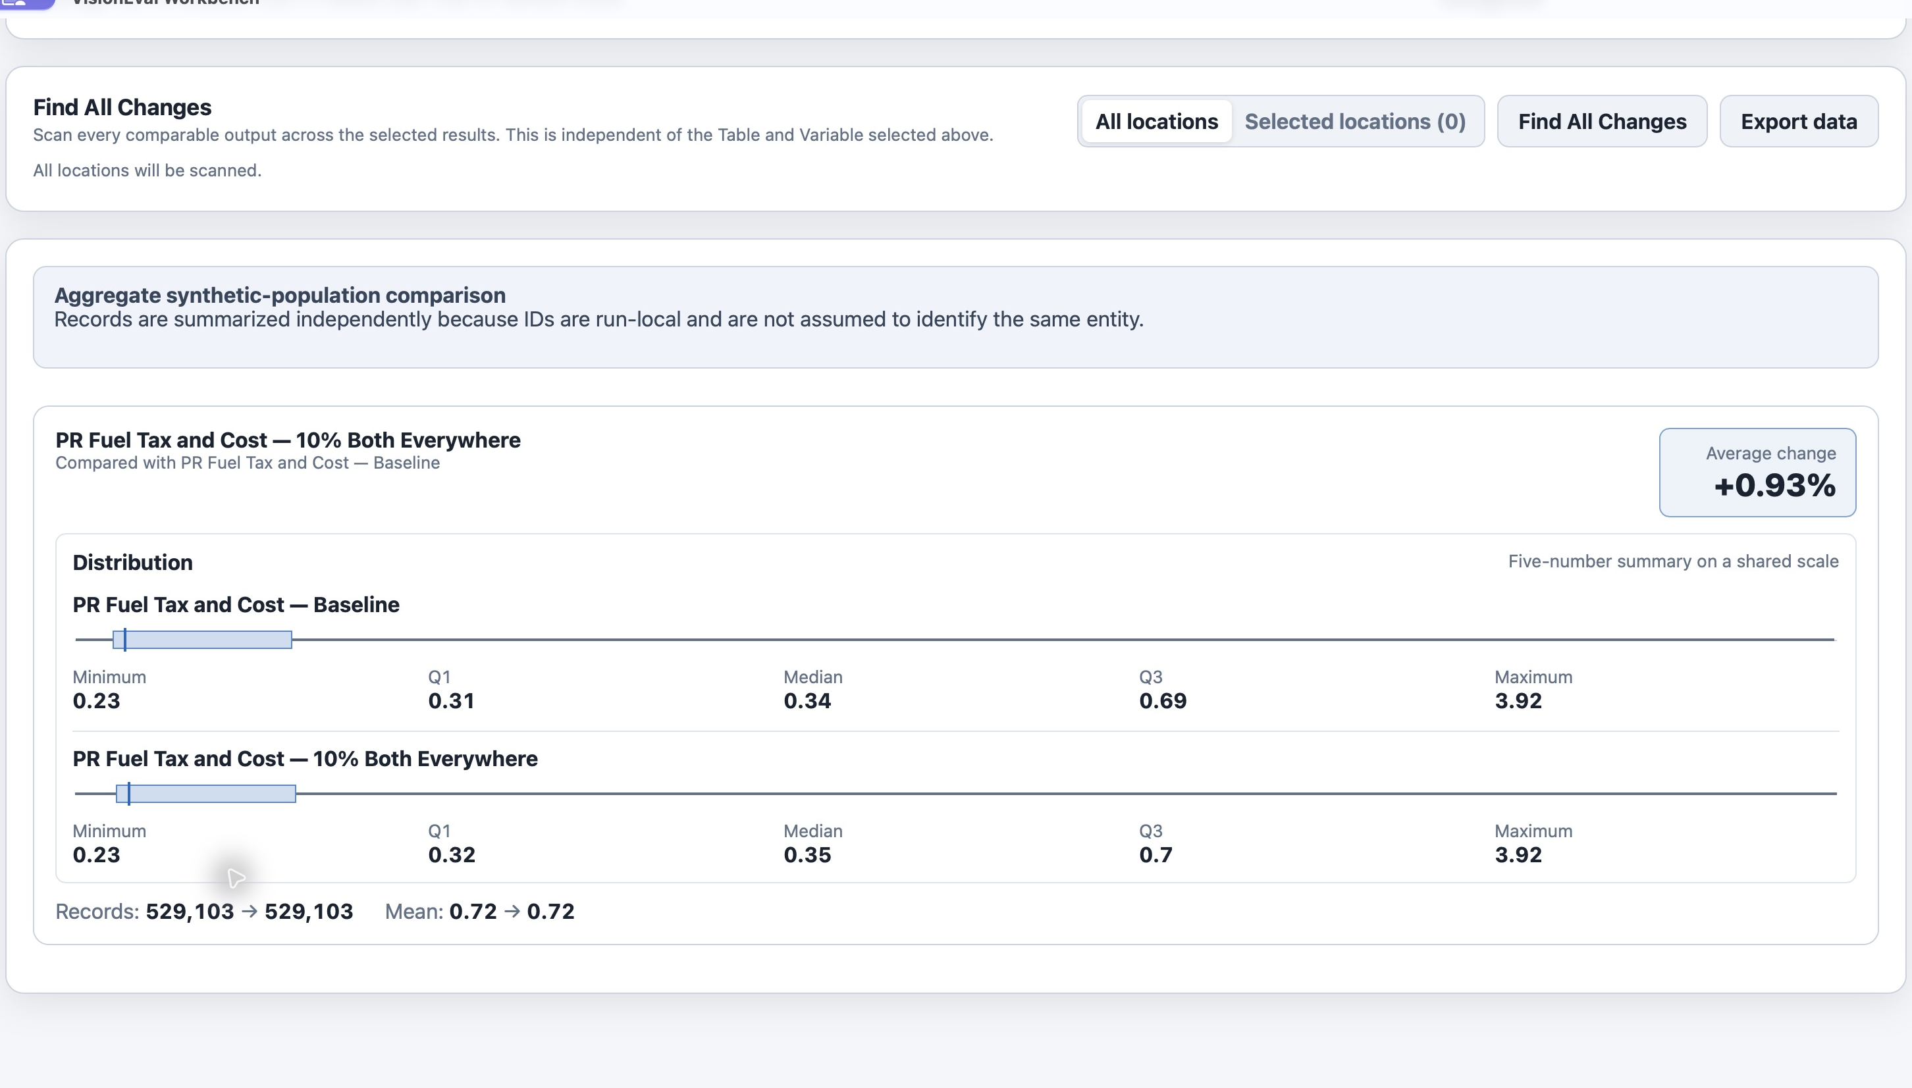
Figure 7. The single-variable comparison shows the selected output in detail.
The example’s average change is about +0.93 percent. This is an observed result for this package and run, not a promised result for another model. Household outputs are compared as aggregate distributions; do not assume household IDs identify the same household across independently generated runs.
Check the output variable and units before interpreting a change. A positive value means an increase relative to the reference, not automatically an improvement. Percent change requires a meaningful nonzero reference.

Map and export the comparison
9. Open Map Visualization. Keep the same reference, comparison, year, table, and variable. Choose County/locality, Mean, then Generate Map. Select Change % for this example.
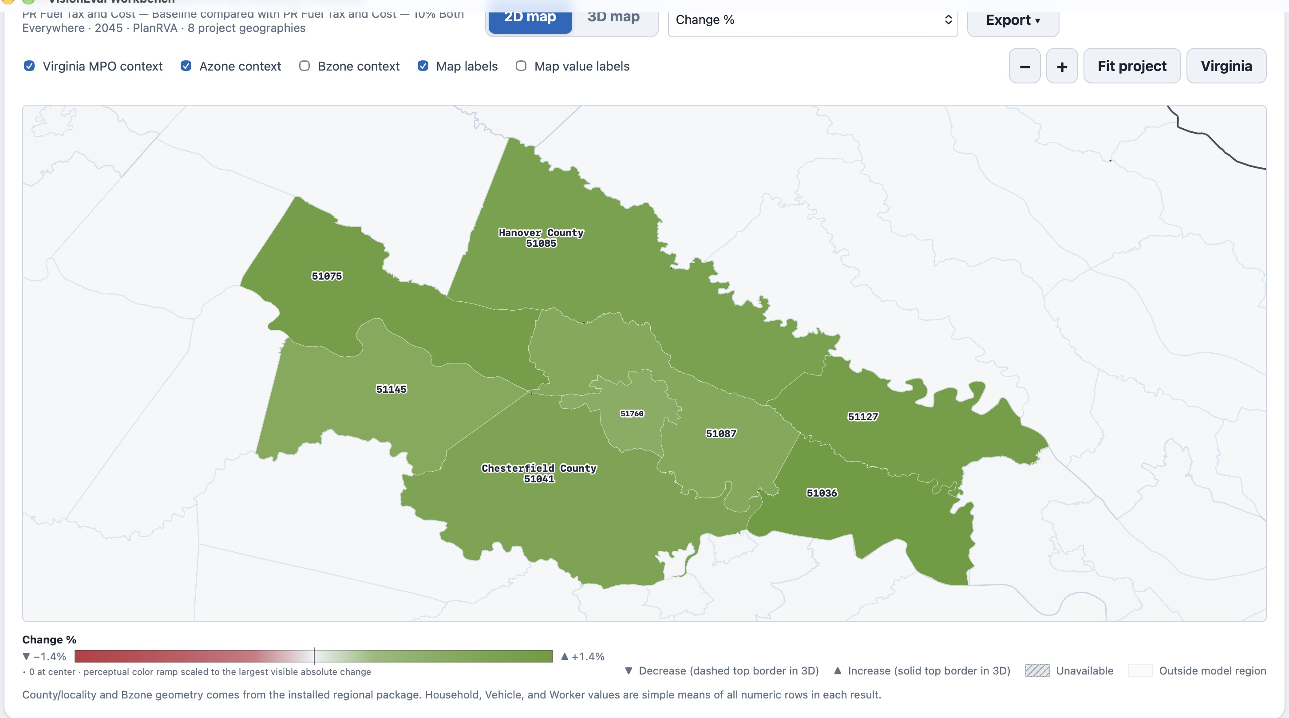
Figure 8. County and locality means show the selected change across the PlanRVA model region.
10. Check the map legend and geography before exporting. Context boundaries are reference layers, not additional modelled data. Use Export for the displayed map and include the reference, scenario, year, variable, and calculation in its caption.
Use the Percent-Change Chart for a broader output comparison. Tables, charts, and maps answer different questions; review the numeric comparison before drawing conclusions from color alone. Hypercube experiments use a separate project and walkthrough.

Develop another Virginia region
11. Install the Virginia MPO Regional Data package, then open Create → Develop. Choose Virginia MPO Regional Data as the Develop source and Virginia InputLibrary (49 files) as the input data source. Choose Official MPO and Charlottesville-Albemarle Metropolitan Planning Organization.
12. Choose Preview region. Check the included Bzones, localities, and boundary-overlap explanation before building. View map can help review the selected boundary.
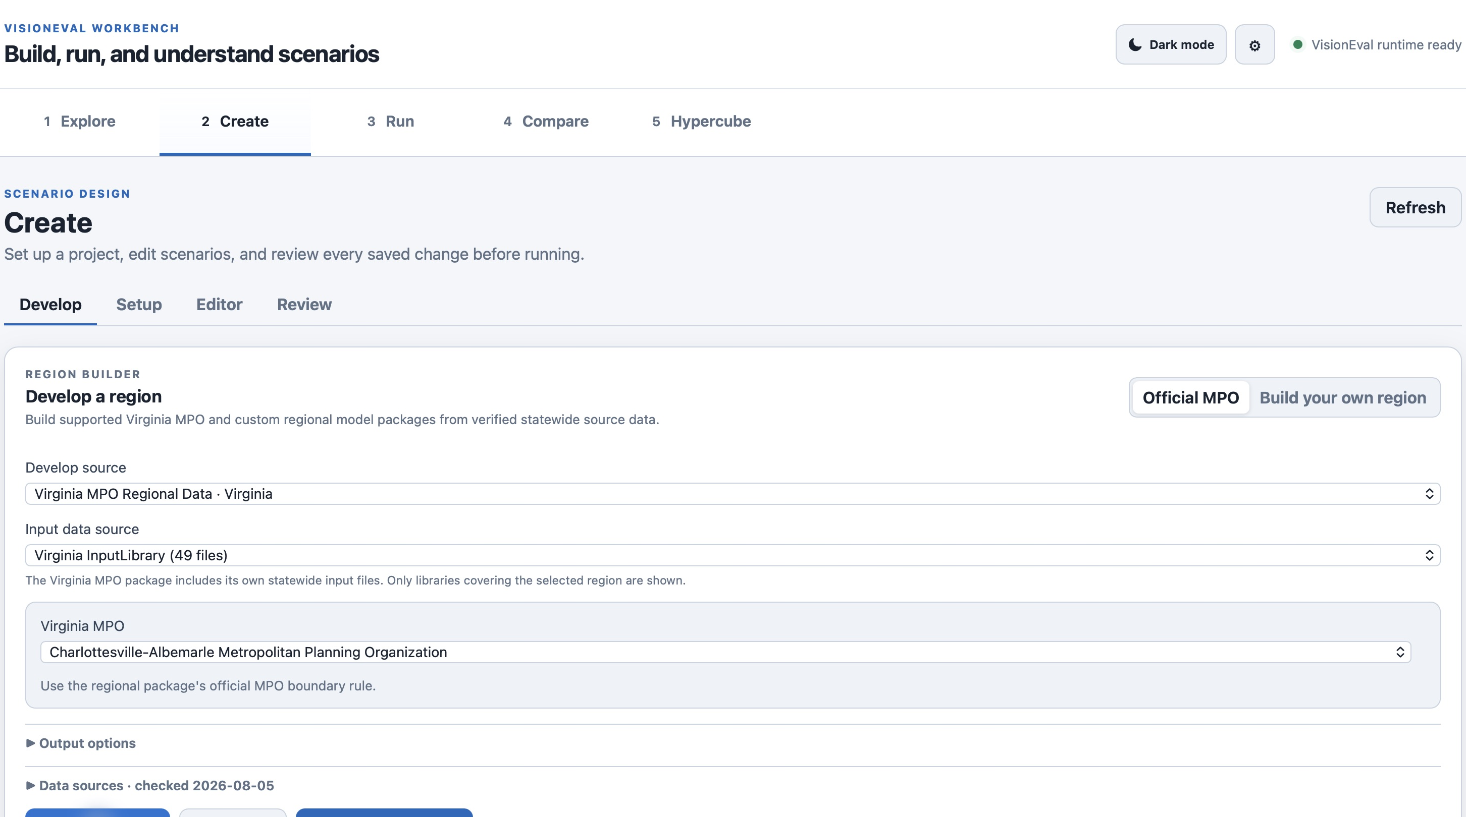
Figure 9. The statewide Virginia inputs cover the selected Charlottesville–Albemarle region.
This example includes 110 Bzones and two localities: Albemarle County and Charlottesville City. Six boundary-crossing Bzones are included under the installed package’s boundary rule. Azone and Marea values remain whole-locality values; selecting Bzones does not make those values proportional to the selected area.
PlanRVA inputs cover the PlanRVA model region, not every Virginia MPO. Use the statewide Virginia InputLibrary for other regions. The regional package includes those input files even though they are not listed as a separate installed Input Library in Settings → Assets.

Build and use the regional assets
13. When the preview says Ready to build, choose Build region assets. Workbench creates a filtered Input Library and runnable model package, then selects the built region in Create → Setup.
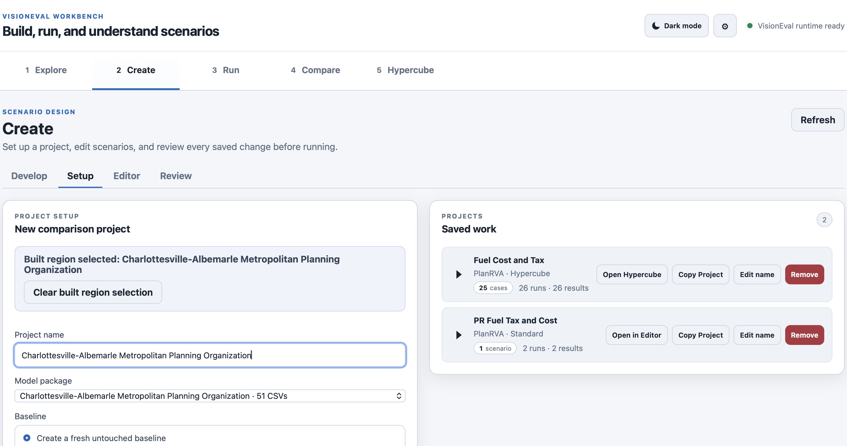
Figure 10. The built regional model is selected for a new comparison project.
14. Give the new project a meaningful name and create it with a fresh untouched baseline. Continue with scenario editing, Review, Run, and Compare as in the PlanRVA example; choose inputs appropriate to this regional model.
For Build your own region, use Edit geography to choose the intended Azones and Bzones, then preview again. If required input rows are missing, correct the source or selection before building. Do not substitute another region’s inputs to bypass a coverage error.

