Mac 2.0 workspaces
and resources
  - Parallel runs and external drive workspaces
Use Docker resources deliberately and keep your workspace intact when changing its location. This guide explains the difference between opening an existing workspace and moving your current workspace to a new folder.

Docker resources and parallel runs video
Move a workspace to an SSD video

Application and workspace
The application in Applications is the software. Your workspace holds projects, packages, runs, and results. Updating the app does not relocate your workspace. Check the current path in Settings → Workspace whenever you are unsure which copy is open.

Set resources for model runs
1. Open Settings → Resources. Check Docker’s shared memory pool and Workbench’s concurrency setting before starting a large batch.
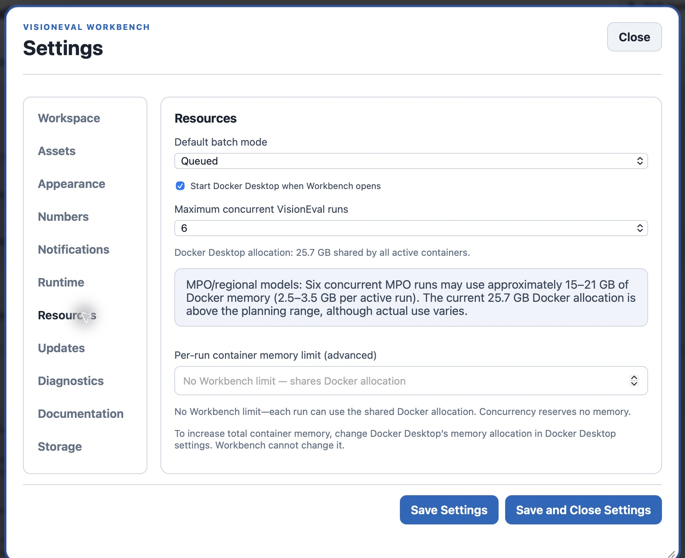
Figure 1. Concurrency controls simultaneous jobs but does not reserve Docker memory.
2. Begin with one or two regional runs. Current regional guidance is approximately 2.5–3.5 GB per active run, with actual use varying by model stage and inputs. Leave headroom for Docker and other work.
3. Increase the shared memory allocation in Docker Desktop settings if needed. Automatic memory mode adds no Workbench per-run cap. An advanced per-run limit is a ceiling, not a reservation, and can terminate a run that reaches it.
More concurrency is not always faster. Every active container shares Docker’s allocation. The video’s settings and timing are examples for that computer, not a recommended maximum for every Mac.

Check and back up the workspace
4. Open Settings → Workspace and read Current workspace. Use the Projects, Assets, Results, and Documentation buttons to reveal those categories in Finder.
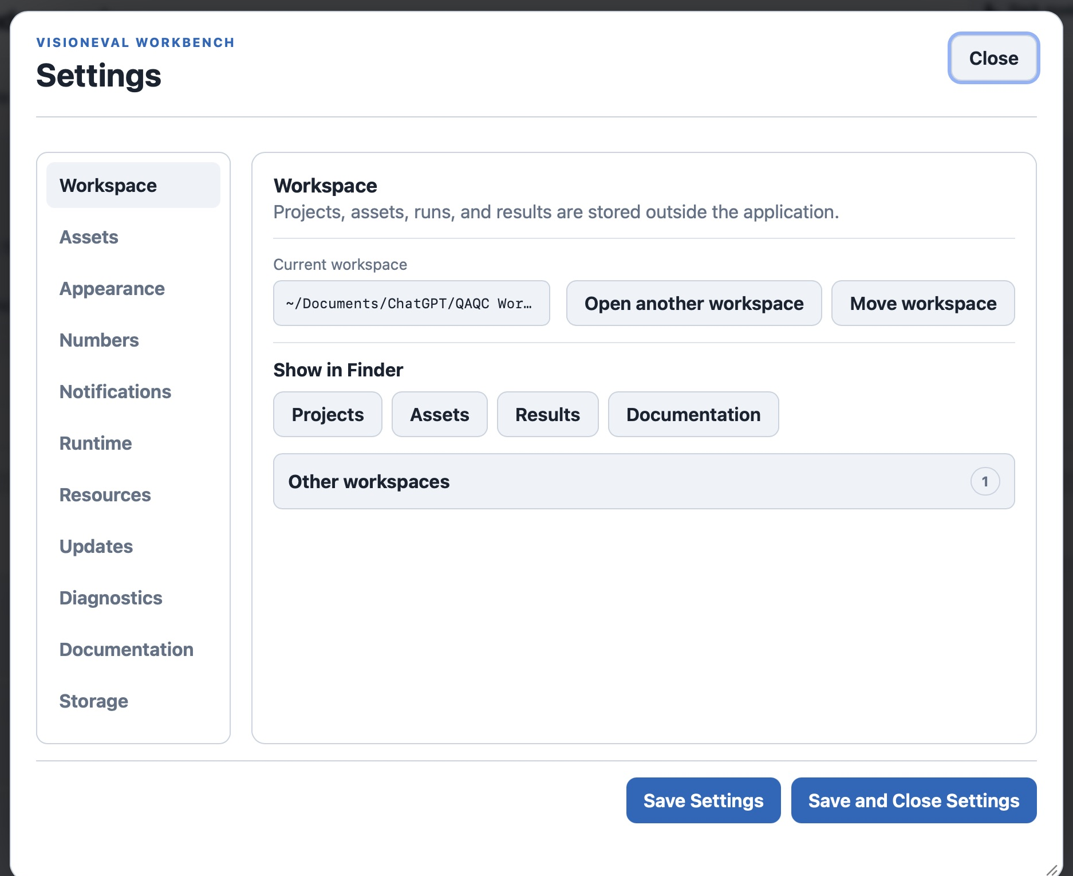
Figure 2. Check the workspace path before opening or moving another copy.
5. For a complete backup, copy the entire workspace root after jobs and file saves finish. Include the hidden .workbench folder, which contains essential managed state. Copying only Projects does not preserve all results and installed assets.
Most users need one workspace. Separate workspaces are useful for testing or unrelated organizations. Forget removes a recent-workspace shortcut, not its files. Use Workbench’s managed removal controls for projects and assets.

Open an existing SSD workspace
6. Connect the SSD. Finish or cancel every active and waiting job before switching workspaces. Choose Open another workspace and select the complete workspace root, not Projects, Results, or the drive root.
7. Confirm Current workspace now shows the intended SSD folder. Check the expected projects and installed assets. Open an existing workspace when its complete files are already there; do not use Move workspace to overwrite another copy.

Choose the right action
Open another workspace selects a complete workspace that already exists. Move workspace copies and verifies your current workspace into a new empty destination, then switches to that location. A folder containing partial files from a failed move is not automatically a usable workspace.
Keep the drive attached while using its workspace. Quit Workbench before ejecting that drive through Finder, and wait for file copies and saves to finish before unplugging it.

Move the current workspace
8. Back up important work, then finish or cancel active and waiting jobs. Connect the SSD and create a new empty folder with a clear name. Choose that folder, not your home folder or the entire SSD.
9. Choose Move workspace and select the empty destination. Keep Workbench open and the drive connected while copying and verification finish. Do not force quit simply because a large copy takes time.
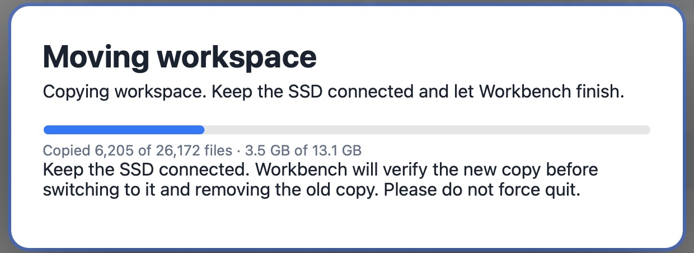
Figure 3. The move shows copying progress before verifying the new files.
Copying and verification are separate stages, so the progress bar may restart when verification begins. During verification the original workspace is still active. Wait until the progress dialog closes and Current workspace shows the destination.

Reopen and check the moved workspace
10. After successful verification, check the new Current workspace path, projects, assets, and results. Quit and reopen Workbench with the drive attached, then confirm the same workspace opens.
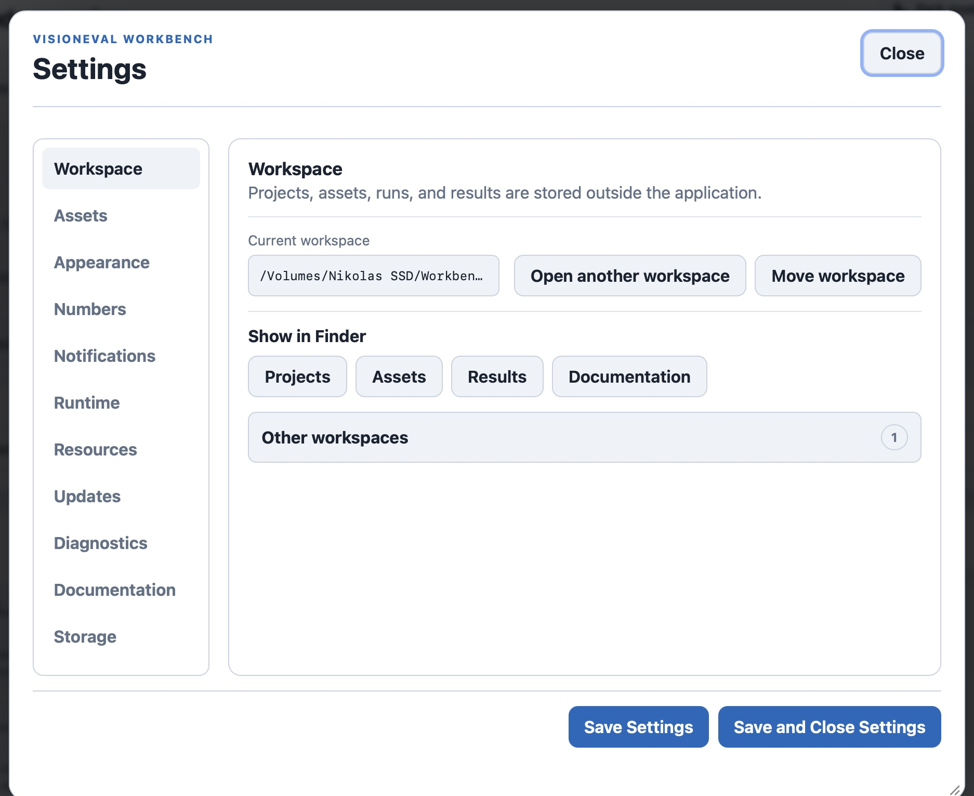
Figure 4. After restarting, Current workspace still points to the SSD folder.
Open Create → Setup and check your project list, Settings → Assets for installed packages, and Compare or Hypercube → Analyze for a completed result. Reopening should not require reinstalling packages or rerunning completed cases. To return to another existing workspace, choose Open another workspace and select its root folder; switching does not copy or remove either workspace.
Move workspace removes the old workspace copy after the new copy has been verified and its location saved. Keep a separate backup if you want to retain a copy at the previous location. If cleanup cannot finish, original files may remain; that is not a second active workspace.

If the move fails
Workbench saves the new path only after verification. If verification fails, keep the original and the destination copy until they have been checked. Files visible on the SSD do not prove that the move succeeded. Use a new empty destination for a retry rather than overwriting a nonempty folder.
Do not manually delete a workspace merely to clear an error. If startup fails or the expected projects are missing, stop and preserve both copies. Report the displayed error and the exact source and destination folders.

