Windows 2.0 Hypercube
walkthrough
  - Fuel cost and tax response matrix
Create a two-axis fuel-cost and fuel-tax experiment, generate nine cases, run them through the native Windows queue, and inspect the completed response matrix. Learn the difference between exporting an analysis and exporting a case package.

Before you begin
Use a verified native runtime, the PlanRVA model package, and a workspace with enough space for the completed Datastores. Windows runs one model job at a time. Start with a small matrix, especially on a computer with less than 16 GB of RAM.

Watch alongside this guide
Hypercube Walkthrough on Windows
Windows resources and companion guides
Download PlanRVA 2.0
Full Windows User Guide

The final recorded experiment
Project Fuel Cost & Tax uses FuelCost.2024 and FuelTax.2024 with percentage increases of 0, 25, and 50 on each axis, target year 2045, and all matching rows. The final matrix is 3 × 3 = 9 cases. Earlier, larger previews in the recording are exploratory and are not the generated definition used here.

Create a Hypercube project
1. Open 5 Hypercube → Build or press Ctrl+5. Create a Hypercube project named Fuel Cost & Tax and choose the intended PlanRVA model package and matching inputs.
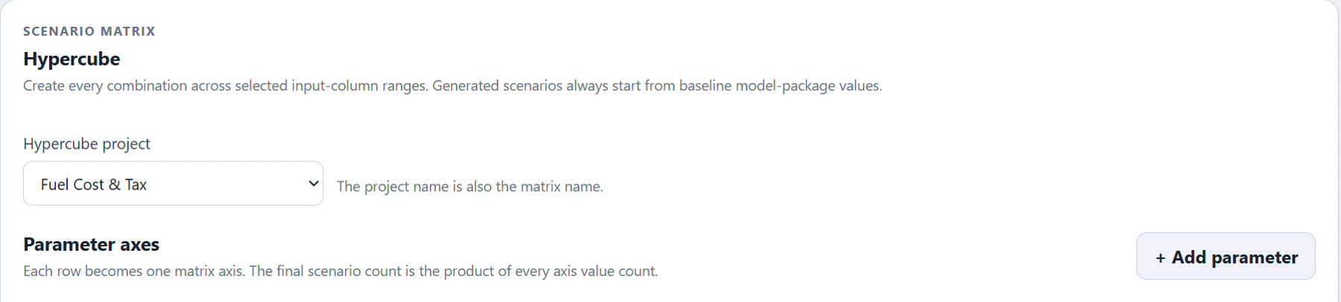
Figure 1. Select the created Fuel Cost & Tax project before defining the parameter axes.
2. Confirm the package before defining axes, and check the generated package provenance again in Review. Hypercube projects belong in 5 Hypercube, while ordinary scenario projects are created in 2 Create → Setup.
The project name is also the matrix name. Build changes save the draft automatically; saving a draft does not create cases. Wait for Saved, and resolve Not saved — Retry before previewing or generating the experiment.

Define the two parameter axes
3. For the first axis choose azone_fuel_power_cost.csv, column FuelCost.2024, and Increase by %. For the second choose azone_veh_use_taxes.csv, column FuelTax.2024, with the same operation.
4. Set Start 0, End 50, and Interval 25 for both axes. This produces the values 0, 25, and 50. Set the shared target year to 2045 and geography to All matching rows.
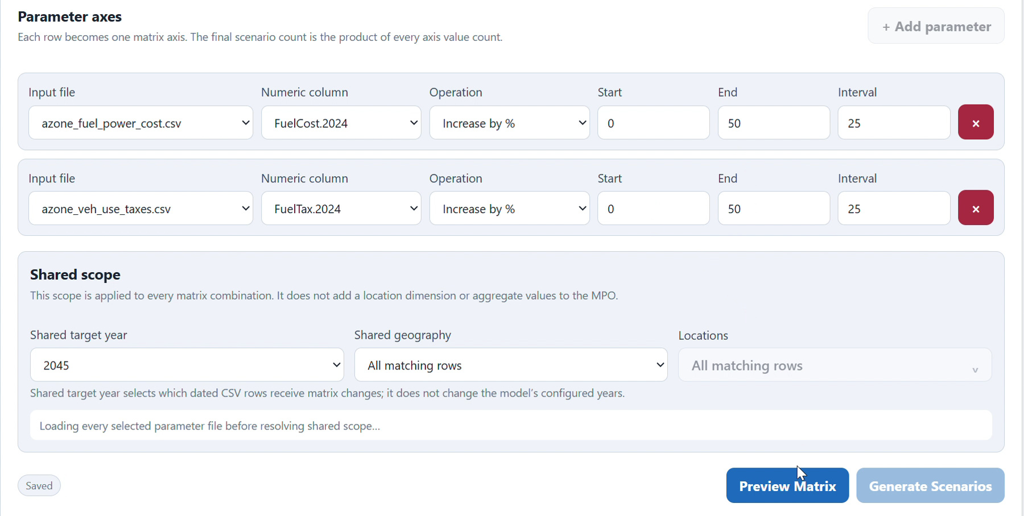
Figure 2. The final Windows axis definition uses 0 to 50 at intervals of 25 for both parameters.
The shared year selects dated input rows; it does not change the model’s configured simulation years. All matching rows applies each combination to every compatible selected row without adding another geography dimension. If you choose a specific geography, select at least one location.
Windows 2.0 permits up to two axes, at most 20 generated values per axis, and at most 400 cases in a new or replacement definition. An interval must be at least 2. The nine-case example stays well within those limits.

Preview the matrix before generating
5. Choose Preview Matrix after the definition is saved. Check every generated value, the shared scope, and the exact case count. For this example, two axes with three values each should produce 9 scenarios.
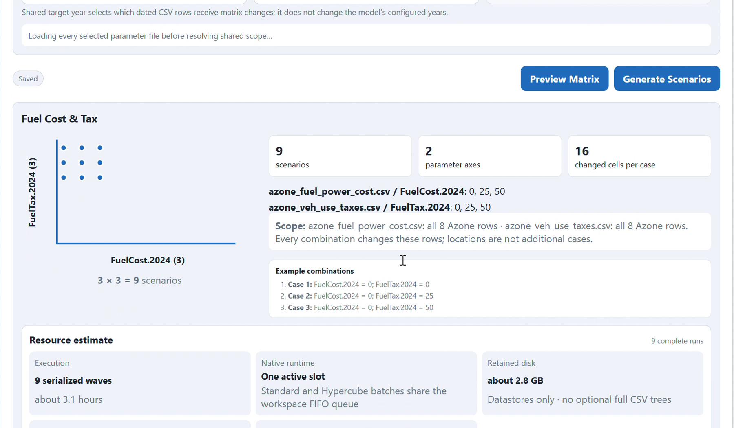
Figure 3. Preview resolves the saved axis values into the final nine-case matrix.
6. Review detected RAM, free workspace space, the serialized execution estimate, and retained storage when available. Reduce the matrix if the experiment is too large for the time or storage available.
Windows executes one case at a time. Runtime and disk estimates depend on comparable runs on this computer and are provisional. Less than 16 GB of RAM prompts small-matrix guidance and closing other memory-intensive applications; RAM alone is not a technical block.
Preview does not create scenarios. Changing the saved draft requires a new preview so you can check the latest definition before generation.

Generate scenarios and review provenance
7. Choose Generate Scenarios only when the preview is correct. Open Review and confirm both axes, the generated values, case count, year, geography, and model provenance.
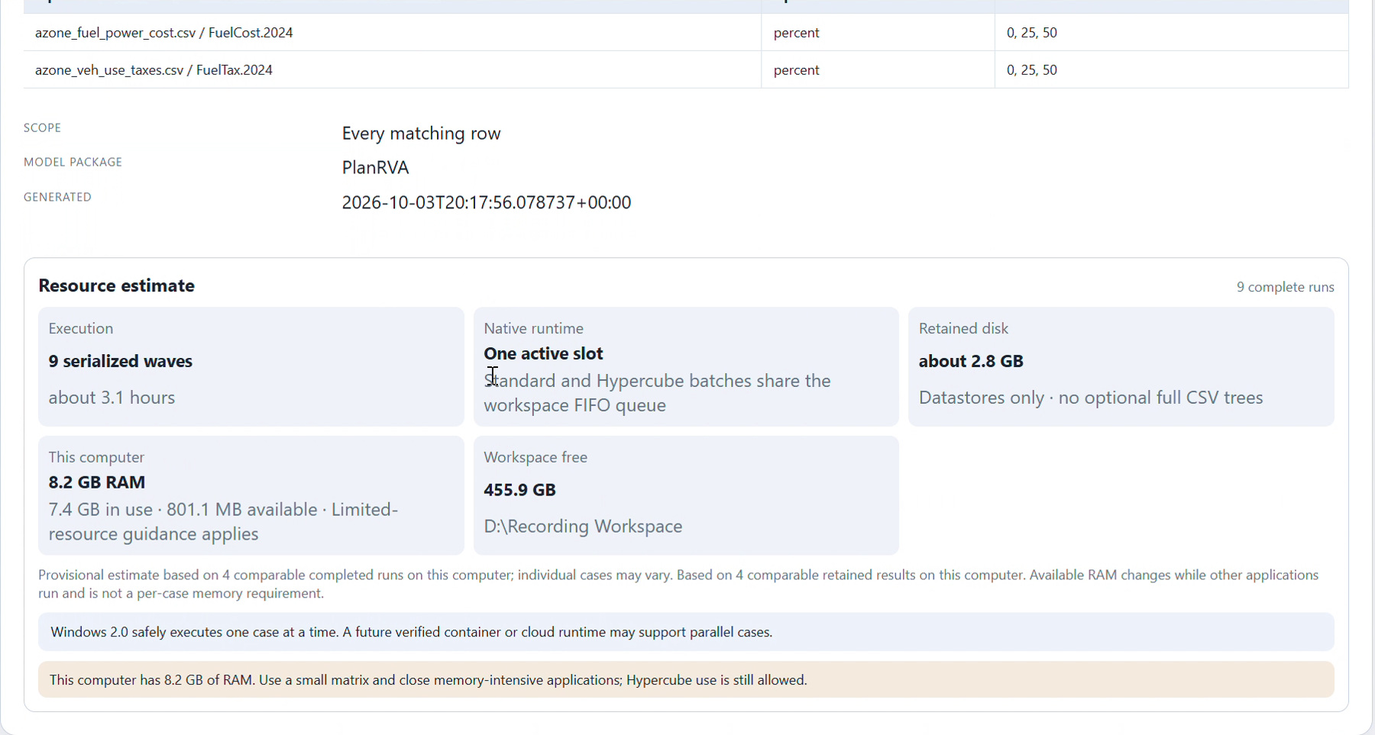
Figure 4. Review confirms PlanRVA provenance and shows Windows’ single active native slot.
8. Verify PlanRVA in the generated definition, 2045, all matching rows, and the nine fuel-cost/tax combinations. The resource card describes this computer’s estimate rather than a universal run duration.
A generated definition can be replaced only before any case is submitted and before the project has results. After that point, create another Hypercube project for a changed experiment. Individual generated cases cannot be deleted without invalidating the matrix.
Keep the common baseline unchanged. A 0% / 0% case is still a generated case in the matrix; it does not remove the project’s common baseline.

Run the matrix through the native queue
9. Open Hypercube → Run, choose the project, and select Run Missing. Workbench queues only a missing baseline and missing cases. A fresh nine-case project can therefore require ten jobs including the baseline.
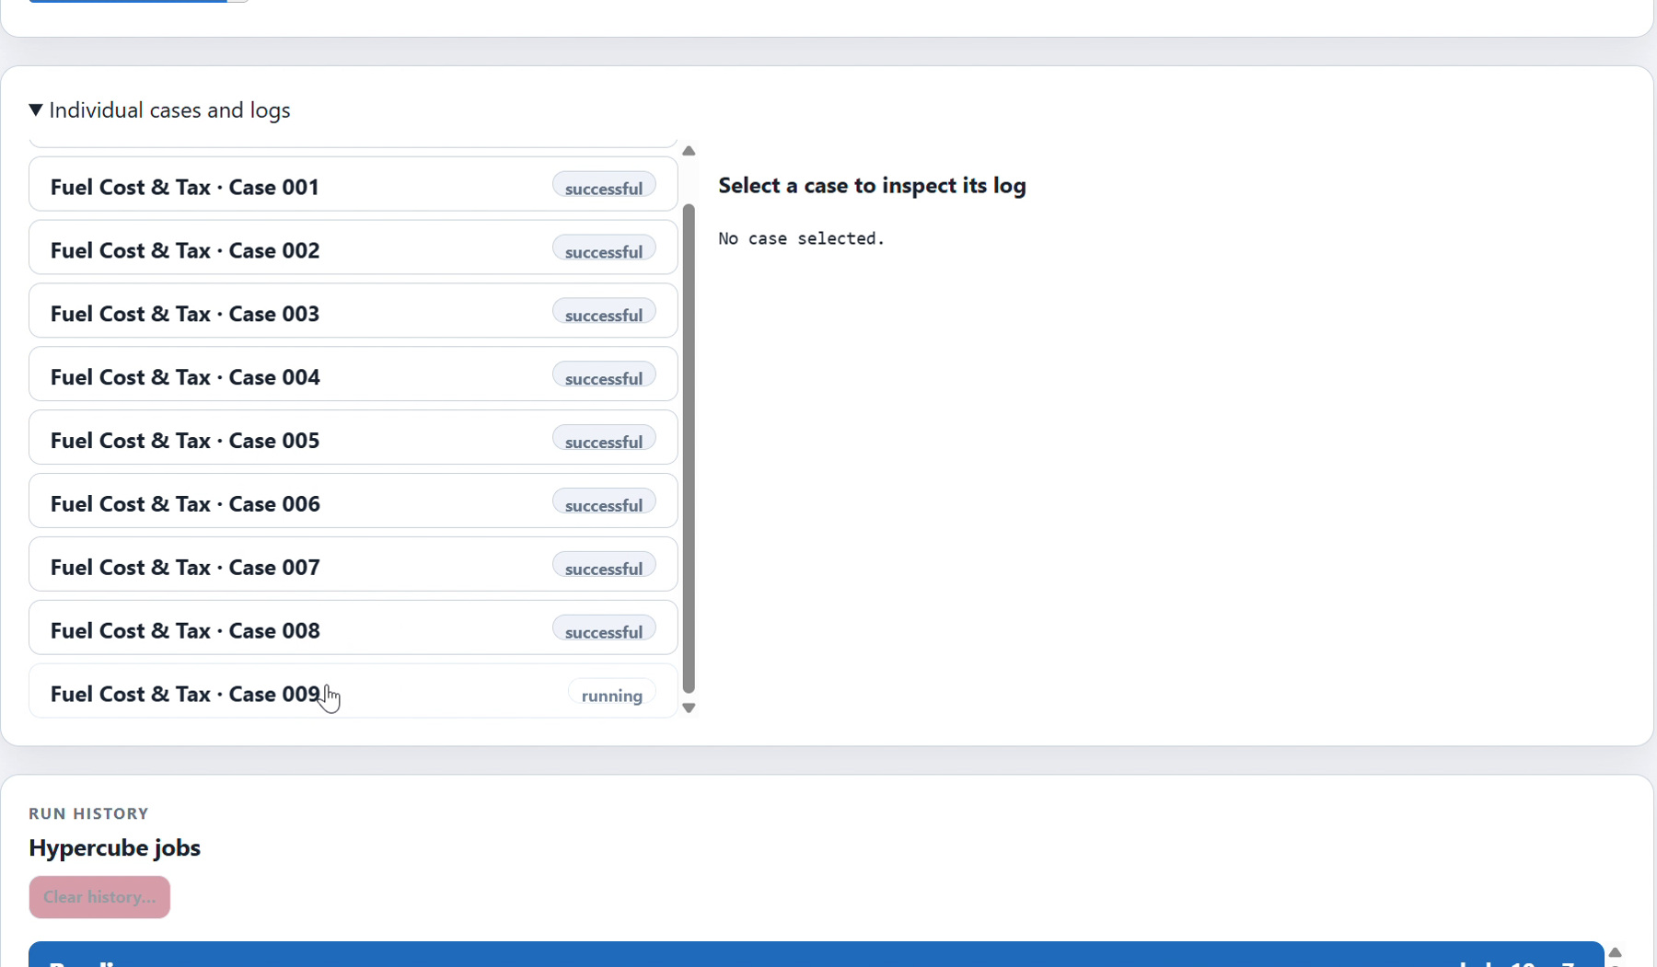
Figure 5. The Windows Run view tracks individual cases as the native batch progresses.
10. Follow the batch totals, the active case, waiting jobs, and logs. Standard projects and Hypercubes share the native queue, with one active model job. Keep Workbench and the workspace drive available until the work finishes.
Use Retry Failed for failed work. Stop This Hypercube removes its waiting jobs and stops its owned active R process tree. Successful cases are not routinely rerun. Completed results retain authoritative Datastores and skip optional persistent full CSV export trees.
Run time varies; neither the video’s elapsed time nor its resource estimate is a promise for another computer. Analyze verified completed cases, and check baseline availability before interpreting changes.

Find changes across outputs first
11. Open Analyze. Set the Find All Changes year to 2045 and choose its aggregation deliberately; the Windows recording uses Median. Start the scan to discover sensitive outputs across completed cases.
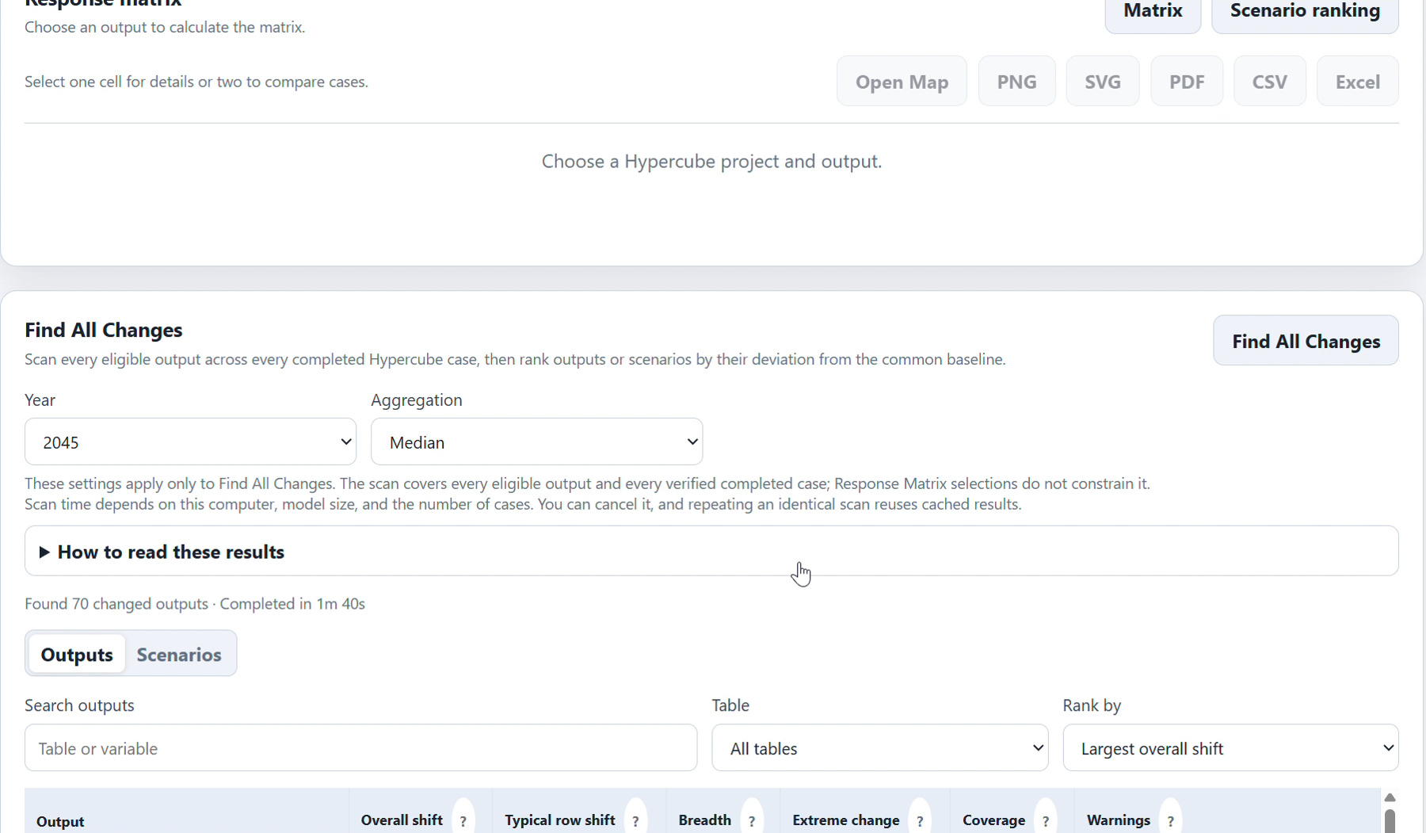
Figure 6. Hypercube Find All Changes reports output sensitivity across the completed experiment.
12. Search and rank the output list, or use the Scenarios view to compare cases across eligible outputs. Select an output to inspect its scenario-ranking details without another scan.
Find All Changes has its own Year and Aggregation controls, independent of the single-output response matrix. Sum measures totals, Mean the arithmetic average, and Median the middle row or location. Rankings measure sensitivity, not desirability.
A large or uncached scan can take time. Watch the progress and cancel if needed. Safe fingerprinted summaries can be reused; household, vehicle, and worker rows use aggregate distributions where IDs cannot be safely matched across runs.

Explore the response matrix
13. In Output and calculation, select 2045, Household, AveVehCostPM, Percent change from baseline, and a deliberate aggregation. The recorded Windows control selection is Median. Choose All locations, X axis FuelCost.2024, and Y axis FuelTax.2024, then Update Analysis.
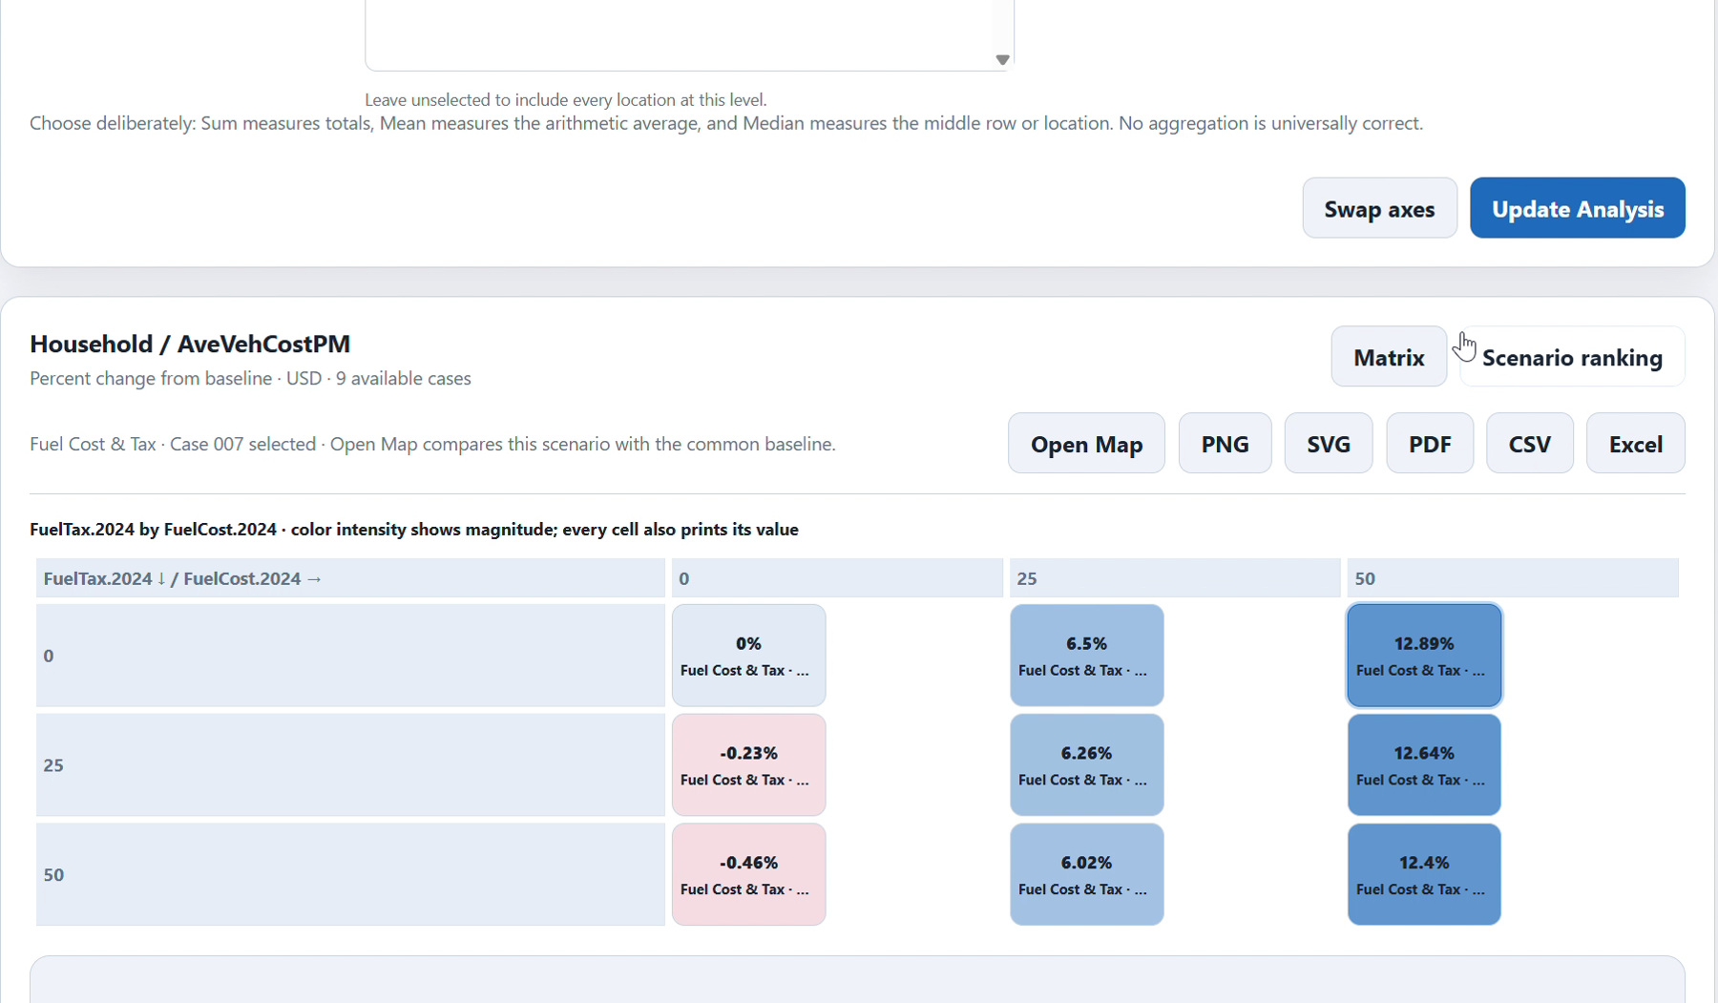
Figure 7. The response matrix contains one cell for each of the nine generated combinations.
14. Select one cell for details or two cells for an in-place difference. Check the displayed case, values, metric, and units. A positive percentage describes an increase in the selected output; it does not establish that the policy is better.
Scenario ranking offers a sortable alternative to the matrix. Zero-reference percentage changes are unavailable rather than infinite. Changing aggregation changes the question being answered, so use the same calculation when comparing figures.
Select a case before using Open Map. The map is a geographic drilldown of the selected case and output, rather than a new model run.

Inspect a case on the map
15. Select a matrix cell and choose Open Map. Confirm the case and common baseline, output table and variable, year, geography, aggregation, and metric in the map controls before generating the view.
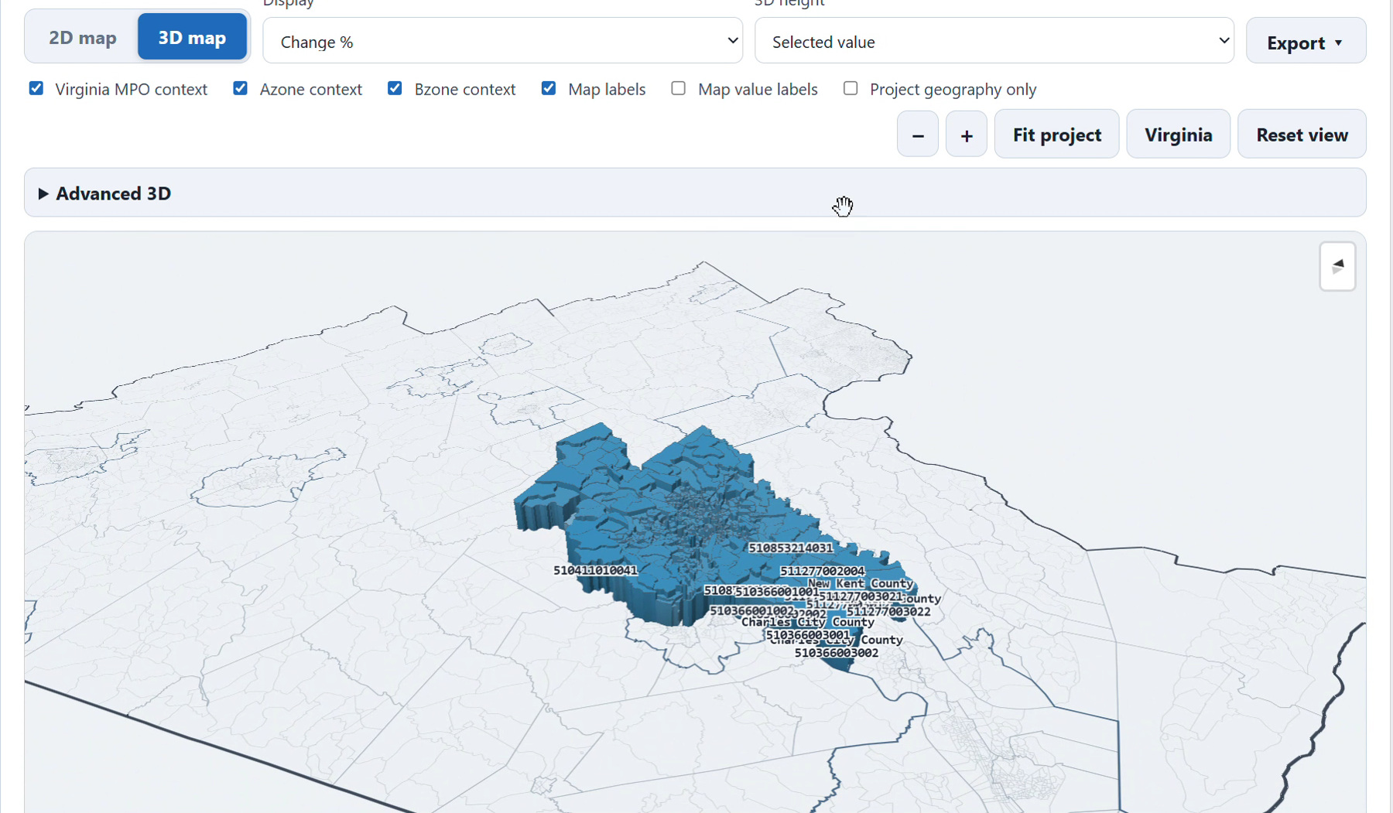
Figure 8. The selected Hypercube case can be inspected over the model package’s geography.
16. Inspect the legend and zones, then export the displayed analysis as PNG, SVG, PDF, CSV, or Excel where offered. Check the exported title, case labels, year, units, aggregation, and scope.
Spatial results depend on the package’s geometry and the output’s location information. If a view initially shows a different default variable, reselect the intended output. Keep the map’s geographic averaging distinct from the matrix’s selected aggregation.
Analysis exports contain the displayed figure or data. They do not contain the complete resolved inputs and generated model-output tree. Use the separate Export workflow on the next page when sharing a reproducible case package.

Export analysis or a case package
17. For a response matrix or ranking, choose its PNG, SVG, PDF, CSV, or Excel export. Review the generated file and retain its calculation settings with the result.
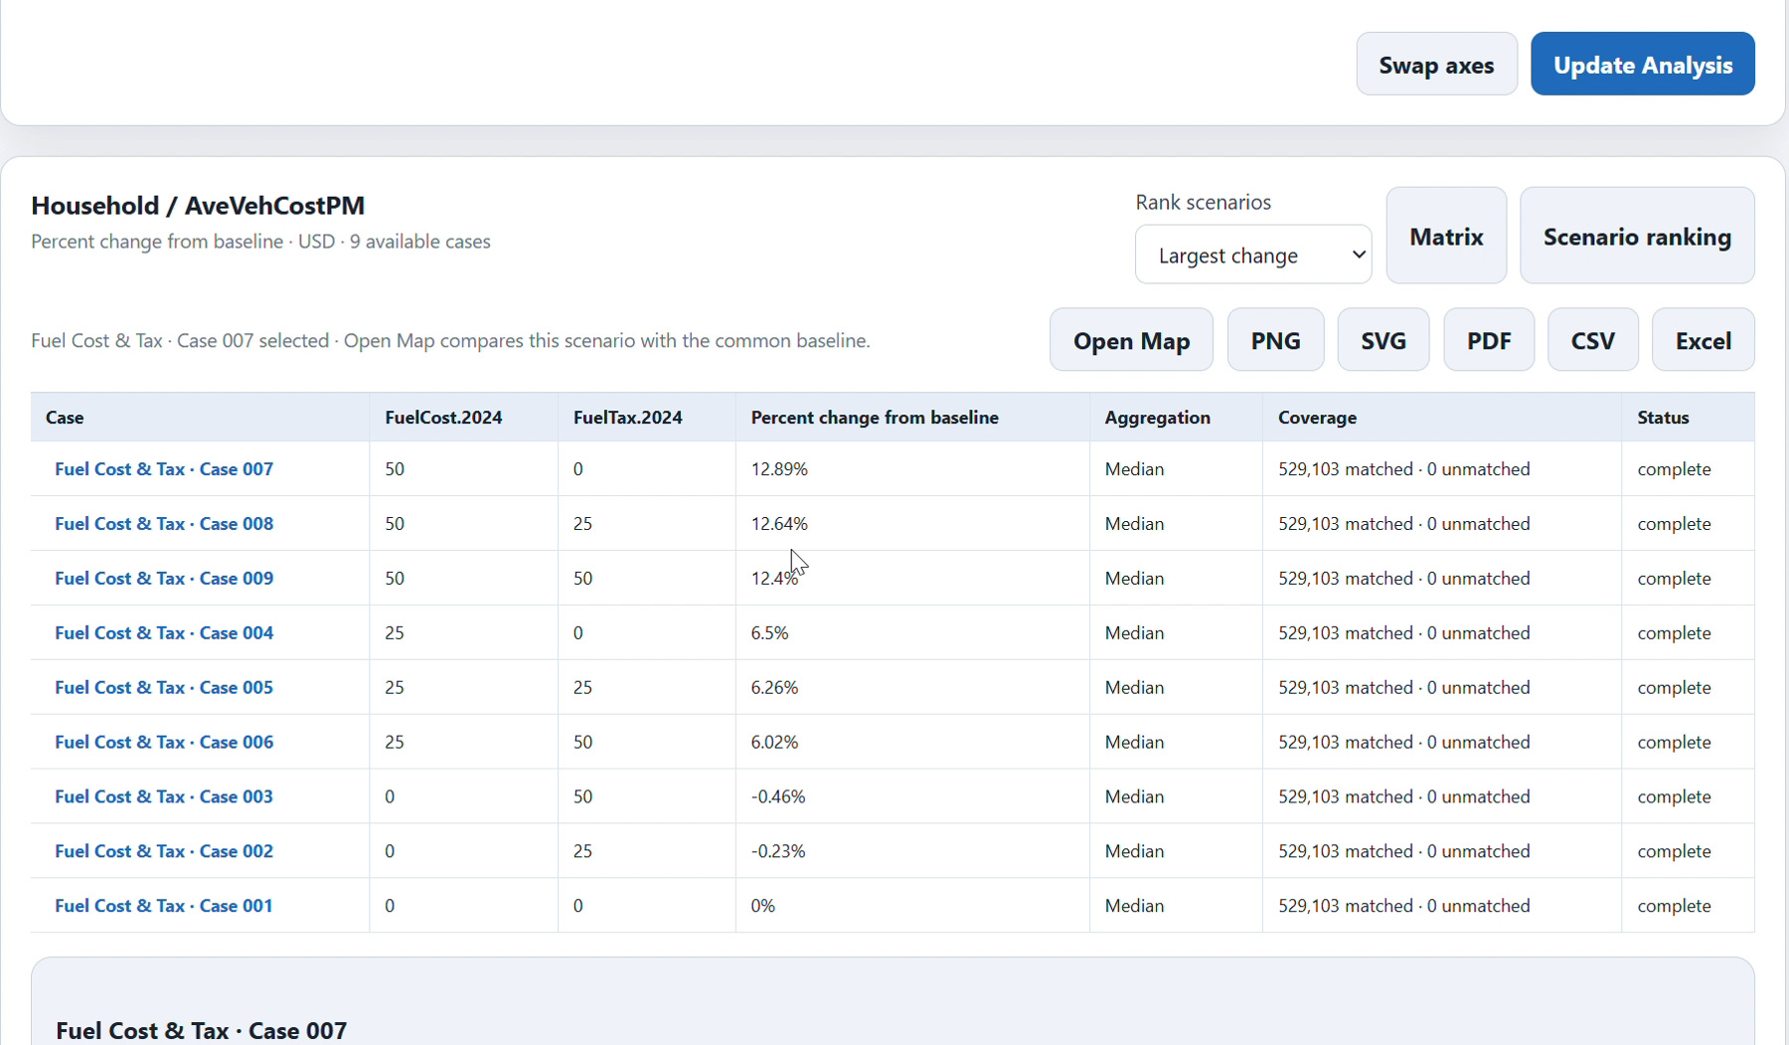
Figure 9. Scenario ranking provides analysis export controls; a case ZIP uses the separate Export workflow.
18. For a complete case package, open 5 Hypercube → Export. Choose the common baseline or up to three verified completed cases per batch. Workbench queues each item separately and opens one Windows save dialog for each ZIP.
19. Wait through preparation, temporary CSV generation, compression, and saving. Choose an export destination you can find in File Explorer. Check each ZIP’s manifest and included input/output files before sharing it.
A case ZIP contains the complete resolved input CSV set, generated output CSVs, and a manifest with project, case, axes, runtime, and fingerprints. It does not include the Datastore. Temporary generated CSVs are cleaned up after completion or cancellation. Keep a complete workspace backup separately if you need the authoritative results and internal state.

