Windows 2.0 project and
scenario walkthrough
  - Create scenarios and compare completed results
Build a Standard project, preserve its baseline, edit and review saved scenarios, queue native model runs, and compare the results. The Windows example changes population, dwellings, and employment; the final pages show regional asset building.

Before you begin
Complete Installation and setup first. Confirm that the native runtime is verified, PlanRVA is installed, and your workspace has space for the resulting Datastores. Install Virginia MPO Regional Data only when following the regional-build pages.

Watch alongside this guide
Project and Scenario Workflow Walkthrough on Windows
Installing Asset Packages and Building Region Assets on Windows
Windows resources and companion guides
Download PlanRVA 2.0
Full Windows User Guide

The example you will create
The recording uses PopHHEmp Scenario, PlanRVA, and target year 2045. It names the scenarios 10% Above Baseline Every, 25% Above Baseline Every, and Suburbanization 25%. Scenario names describe intent; Review establishes what was actually saved. Pages 2–9 cover the project workflow; pages 10–11 cover Charlottesville-Albemarle region assets.

Create the project
1. Open 2 Create → Setup. Name the project PopHHEmp Scenario, choose PlanRVA, and select Create a fresh untouched baseline. Choose Create project.
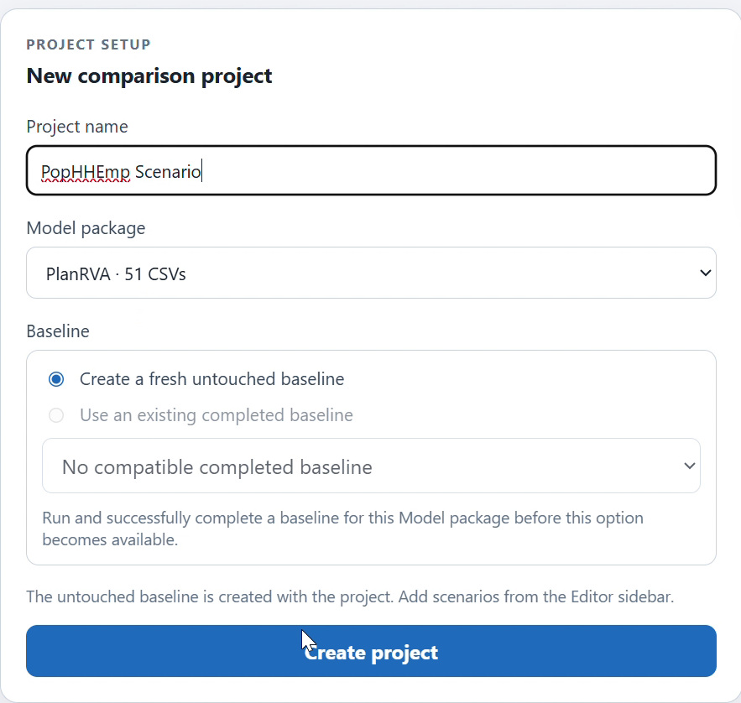
Figure 1. Standard project setup uses PlanRVA and preserves a fresh untouched baseline.
2. Open Editor for the new project. The baseline is read-only. Add editable scenarios with New Scenario; changes belong to the selected scenario and do not alter the installed InputLibrary or baseline.
An existing completed baseline can be reused only when Workbench offers a verified compatible result for the same model package and InputLibrary. The regional assets built on pages 10–11 are a separate model choice. Do not silently substitute them for PlanRVA when following this example.

Choose how to edit a scenario
3. Select New Scenario and name it 10% Above Baseline Every. Use Batch Change for the same operation across several files, or New File to edit one CSV. Confirm the active project and scenario before changing values.
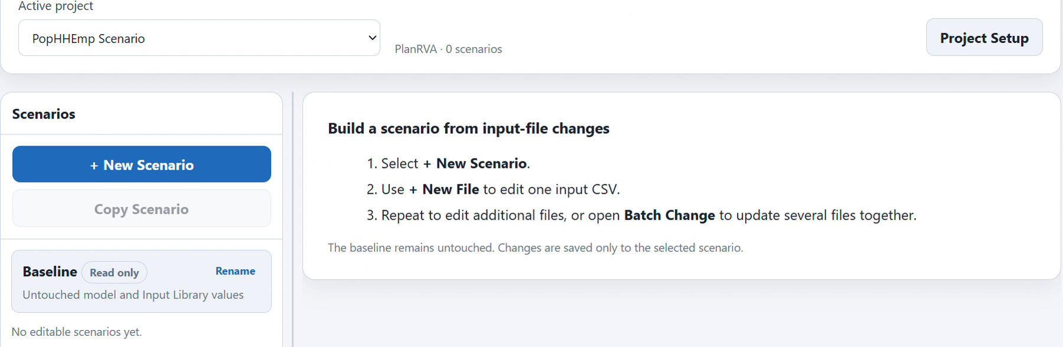
Figure 2. The Windows Editor keeps the baseline read-only and offers scenario and file creation.
4. For the batch example, select azone_gq_pop_by_age.csv, azone_hh_pop_by_age.csv, bzone_dwelling_units.csv, and bzone_employment.csv. Select their relevant numeric count columns, not Year, location IDs, or unrelated proportions.

Saving has different meanings
Apply and Save Batch Changes persists a batch immediately. In single-file mode, Apply and Save Change saves a calculated operation; manual table edits need Save Direct Edits or Ctrl+S. Notes save separately. Clear selections clears controls and does not remove saved changes.
Use the file explanations in Explore to understand fields before selecting them. Population age groups, dwelling-unit counts, and employment counts are different inputs even when they share the same percentage operation.

Apply percentage changes deliberately
5. For the 10% scenario, choose All locations, target year 2045, Increase by %, and value 10. Check all four file and field selections, then choose Apply and Save Batch Changes.
6. To create the 25% variant, create a fresh scenario or copy the first scenario and rename it 25% Above Baseline Every. Set the value to 25. When copying earlier changes, turn on Start this batch from the untouched baseline to make the selected cells 25% above baseline.
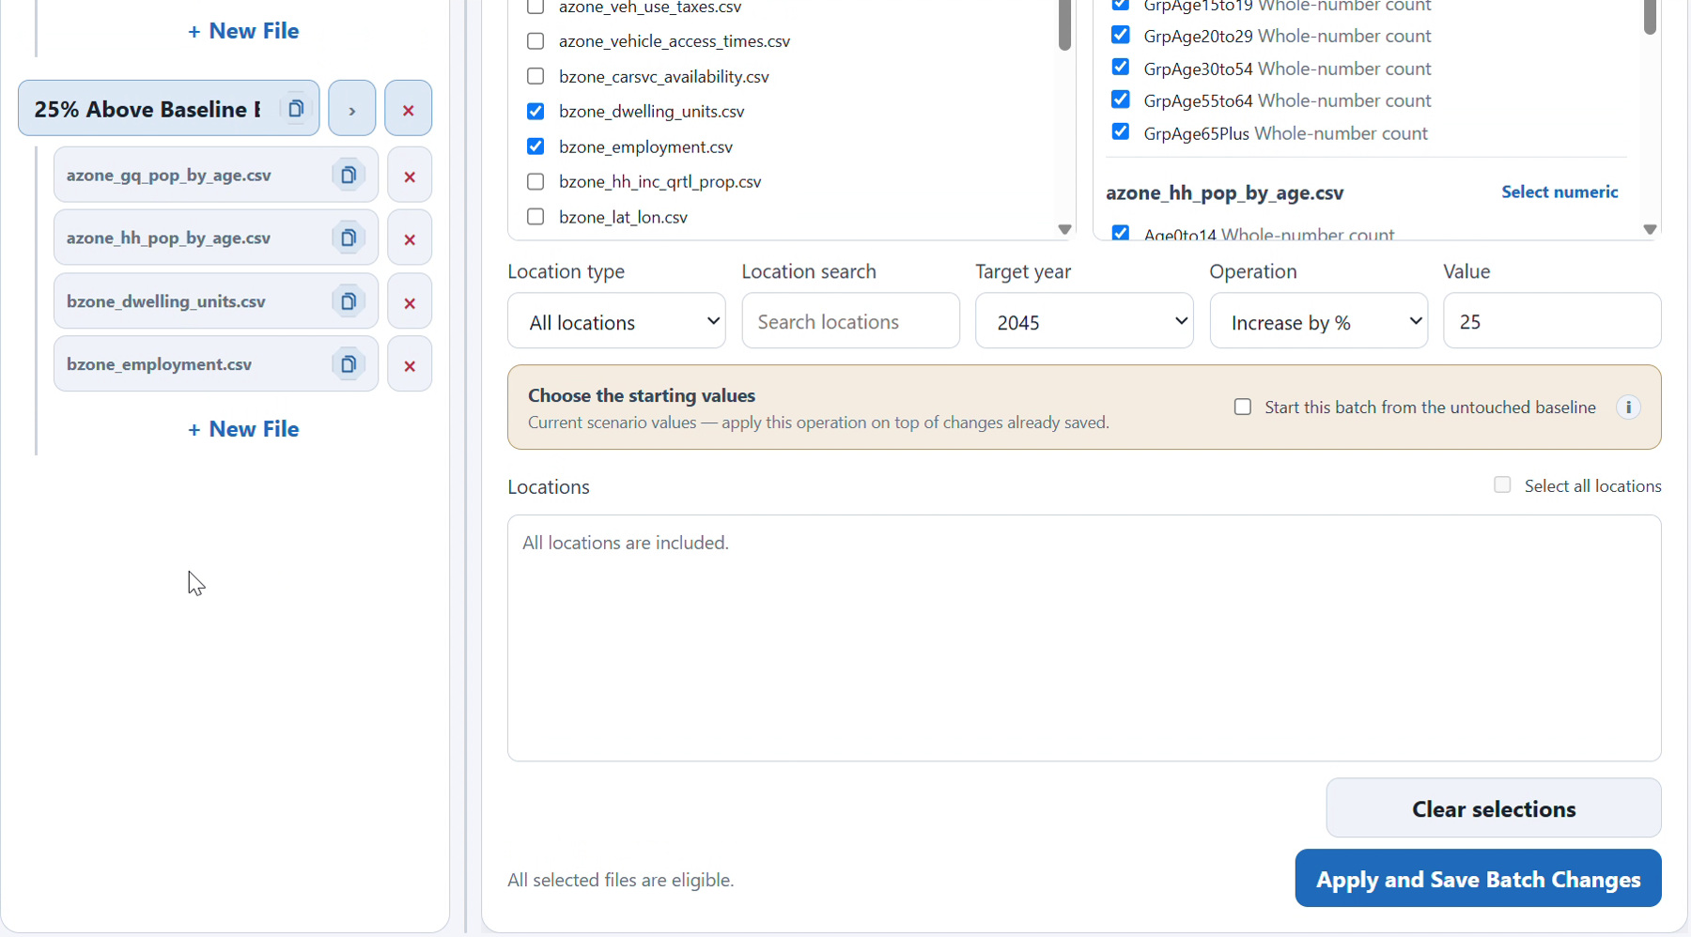
Figure 3. Batch controls include the starting-value choice; this recorded frame still has that option unchecked.
With the starting-value option off, the operation compounds on saved scenario values. A further 25% increase after 10% produces 1.10 × 1.25 = 1.375, or 37.5% above the original, before count rounding. The recording’s scenario name is not a substitute for checking that option and the saved before/after values.
7. For the Suburbanization 25% example, use County scope for the intended batch and select the desired counties. The recording leaves Richmond City unchecked in its county selection. Scope can differ between saved files; confirm it in Review. A County selection requires at least one county.

Review the saved changes
8. Open Create → Review and confirm the active project. Expand each scenario and its saved files. Check years, locations, changed fields, notes, and the before/after values against the intended experiment.
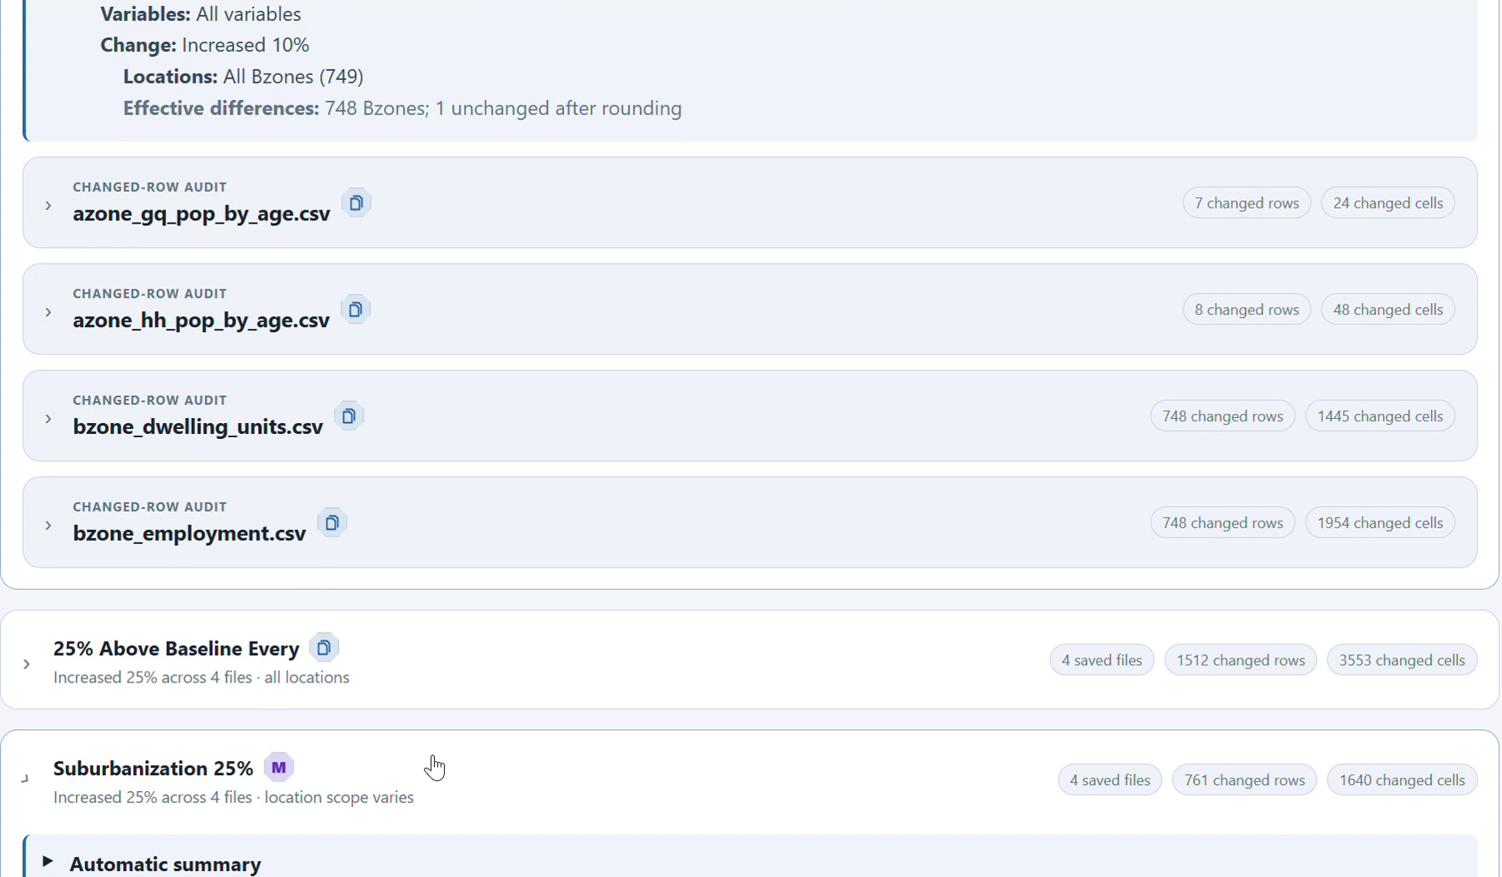
Figure 4. Review presents the saved population and employment scenarios and their change summaries.
9. Expand the Automatic summary and Changed-row audit when you need the complete saved-change explanation. Check the 10% and 25% variants against untouched values and review the county scope separately for each Suburbanization file.
Count fields can be rounded to whole numbers, so some selected cells may remain unchanged. Changed-row and cell totals depend on the selected fields, scope, source package, and earlier operations. Resolve validation warnings before continuing.
Continue to Run opens Run with the reviewed work selected; it does not start VisionEval. If the saved changes are wrong, return to Editor, correct them, and review again.

Queue the baseline and scenarios
10. Open 3 Run. Confirm Native VisionEval ready, the project, the untouched baseline, and the three scenarios you intend to run. Start the selected jobs only after Review is acceptable.
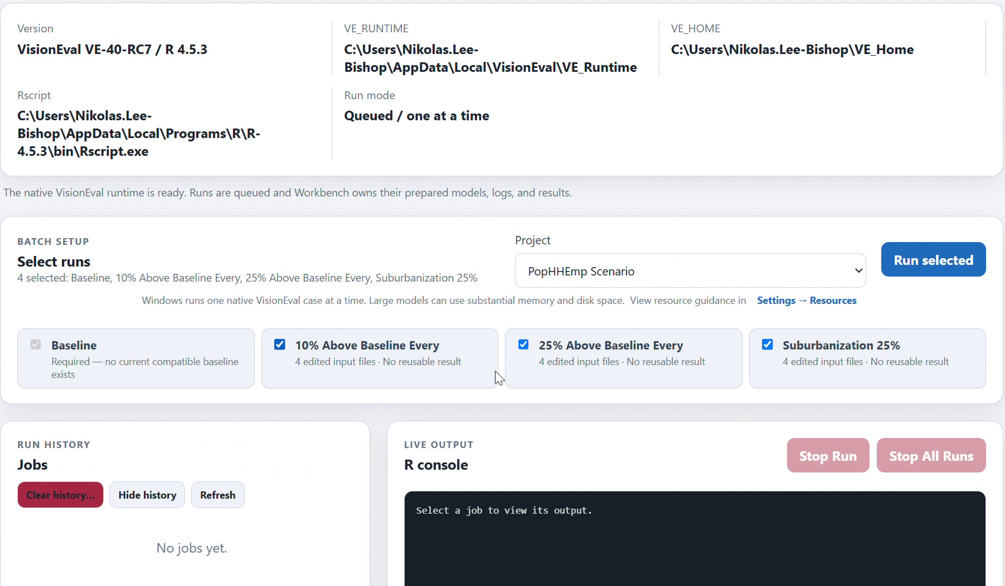
Figure 5. The Windows Run view selects the baseline and scenarios for the native queue.
11. Allow the queue to finish. Windows executes one model job at a time; other selected jobs wait. Read the active job’s live R output and status. A result becomes available only after its expected Datastore is verified and registered.
Elapsed time depends on the model, scenario, computer, and available memory. The recording includes long runs; it is not a timing guarantee. If a job fails, inspect its log or Settings → Diagnostics, correct the cause, and retry the affected work. Do not move the workspace while jobs are queued or active.

Find changes across completed results
12. Open 4 Compare → Compare. Choose the completed baseline as the reference and the completed scenario results as comparisons. Set a common year, 2045 in this example.
13. Choose Find All Changes to scan comparable outputs across the selected results. Use All locations for an overall scan, or deliberately choose its independent location filter.
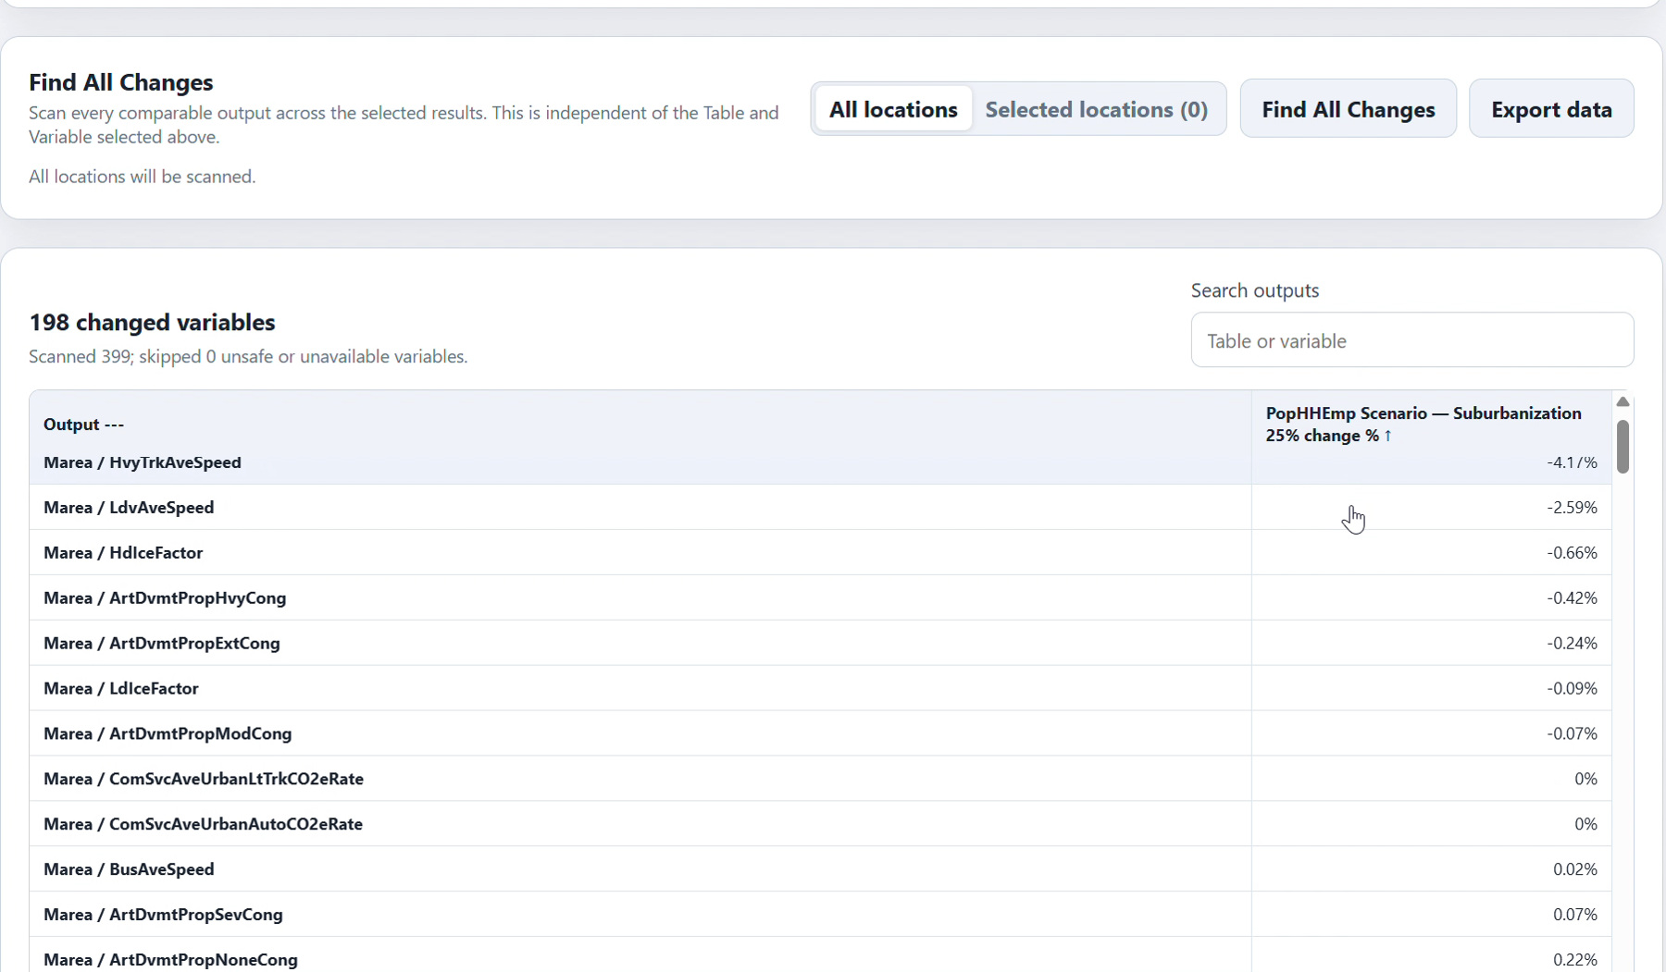
Figure 6. Find All Changes lists observed output differences across the selected Windows results.
The discovery scan is independent of the detailed Table and Variable controls. A cold scan may take time; repeated compatible requests can use the disposable comparison cache. A skipped variable has a reason and does not invalidate all other outputs.
Use the results to identify outputs worth inspecting. For numeric outputs, this Compare scan reports summed-value percentage changes relative to the reference. A positive change is an increase in the measured output, not automatically a better policy outcome.

Inspect one changed variable
14. Choose a table and variable for the detailed comparison. The recording inspects Household → BikePMT, year 2045. Check the reference, comparison, geography filter, statistics, and distribution before interpreting a change.
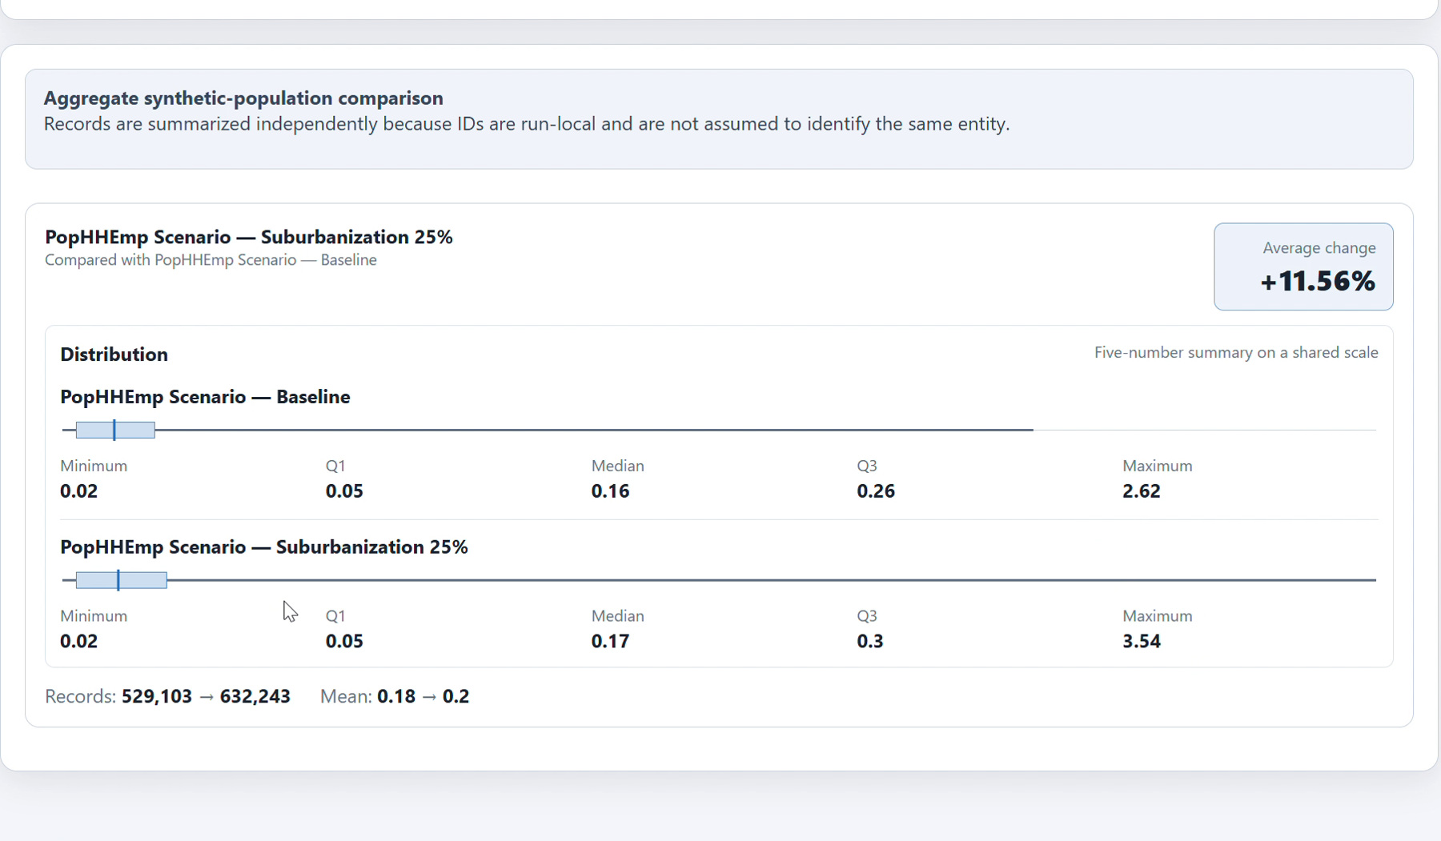
Figure 7. The detailed Household BikePMT view compares distributions of the completed results.
15. Use sorting, changed-row filters, and paging where appropriate. Read the variable explanation and units. Household, Vehicle, and Worker identifiers are local to each run, so aggregate distributions are used where individual matching would be unsafe.
Changing population can also change the number of synthetic records. Distinguish a summed total from a mean, a distribution shift, and the number of records. The guide’s screenshots illustrate one completed experiment; your numerical results can differ.
For reusable data, choose Export data. Current View exports all matching rows for the active variable and scope, rather than only the visible page. Full Variable Data exports the complete selected outputs in original order and ignores active location filters.

Map and export the comparison
16. Open Map Visualization and confirm its own reference and comparison selectors. In the recorded example, choose Household → BikePMT, year 2045, and a supported locality or Bzone geography. Check aggregation and the displayed metric before generating the map.
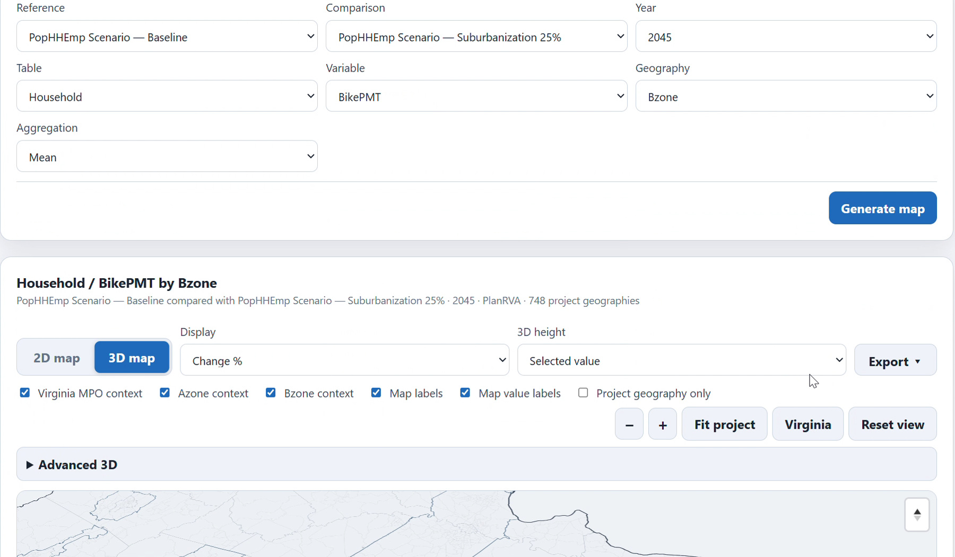
Figure 8. The Windows map compares the chosen scenario and baseline over the package’s geography.
17. Inspect zones and the legend, then export the current view as PDF, PNG, or SVG, or export the scoped data as CSV or Excel. Visual exports preserve the viewport; data exports preserve the current geographic scope.
18. Use Percent-Change Chart for several numeric outputs with a common year. Its result pair and location filter are independent of Compare and Map. Choose Generate chart, review the labels, then export the displayed analysis.
Change metrics are centered on zero. A nonzero comparison with a zero reference has no defined percentage. Excel exports include provenance and typed values. Save exports outside internal workspace folders and retain the baseline and scenario labels with shared figures.

Develop a Virginia MPO region
19. Install Virginia MPO Regional Data 2.0 through Settings → Assets. Open Create → Develop, select the regional package and its paired Virginia InputLibrary, and choose Charlottesville-Albemarle Metropolitan Planning Organization.
Download Virginia MPO Regional Data 2.0
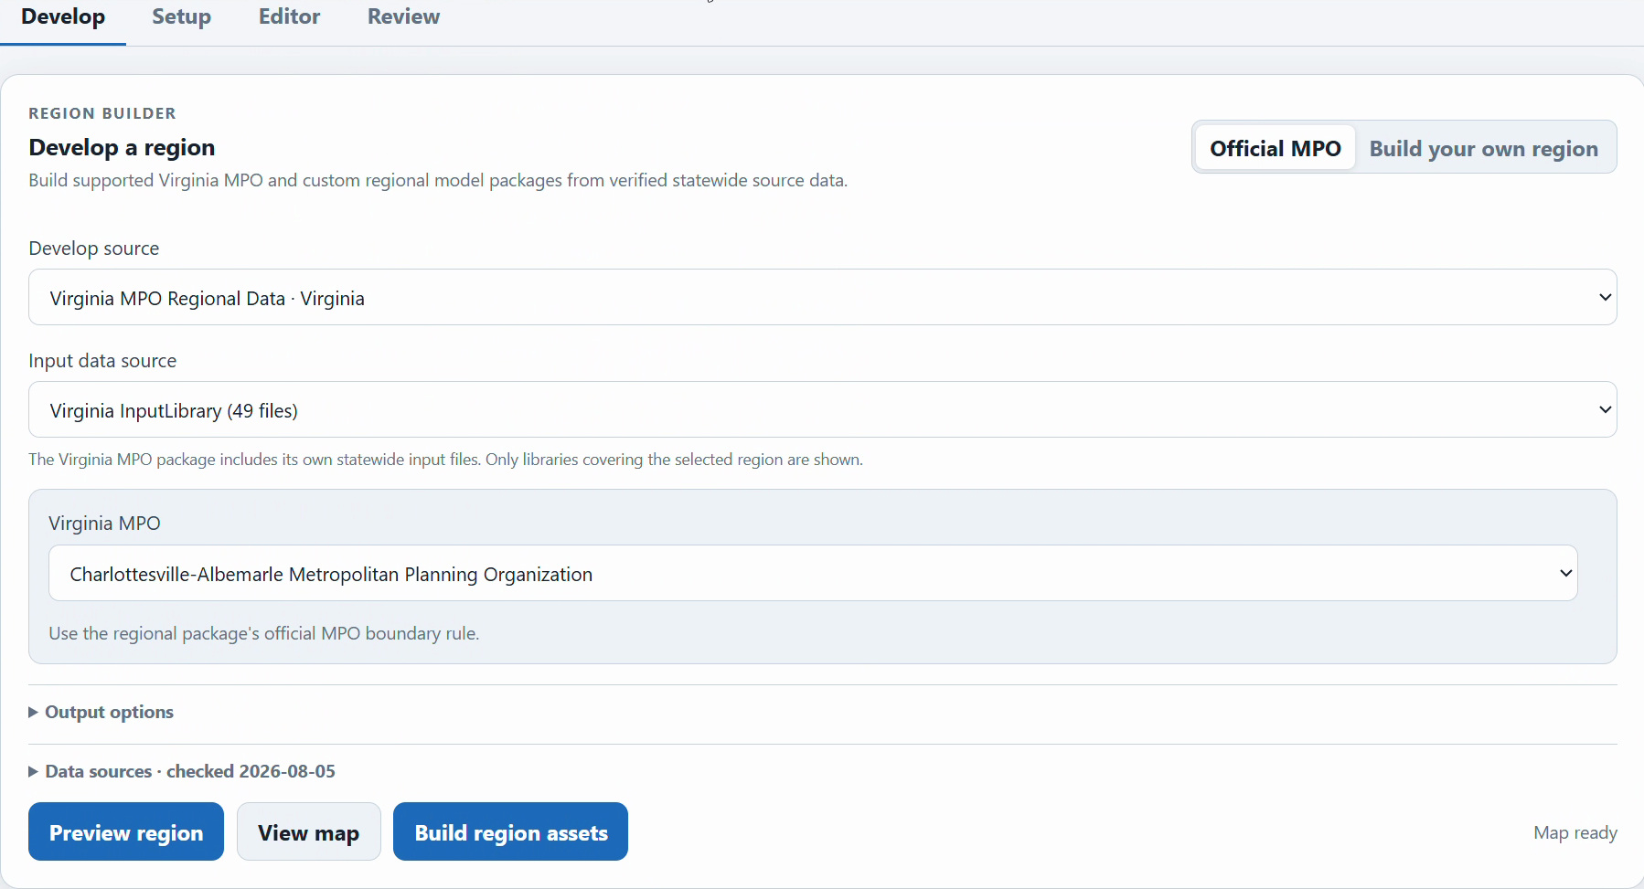
Figure 9. Region Builder selects the Virginia package, its InputLibrary, and Charlottesville-Albemarle.
20. Review Data sources, package notes, and output options. Choose Preview region and inspect included localities, Bzones, boundary cases, and warnings. Use View map for spatial context when geometry is ready.
PlanRVA alone supports subregions inside its own model coverage. The separate Virginia package supplies the other supported MPO choices. The map downloads official geometry on first use and caches it; preview and build use the packaged crosswalk and can work offline.

Build and use the regional assets
21. Review the preview. The recorded Charlottesville-Albemarle selection includes 110 Bzones, 2 Azones/localities, and 6 boundary overlaps, with Albemarle County and Charlottesville City. Check your installed package’s preview rather than assuming those counts for other regions.
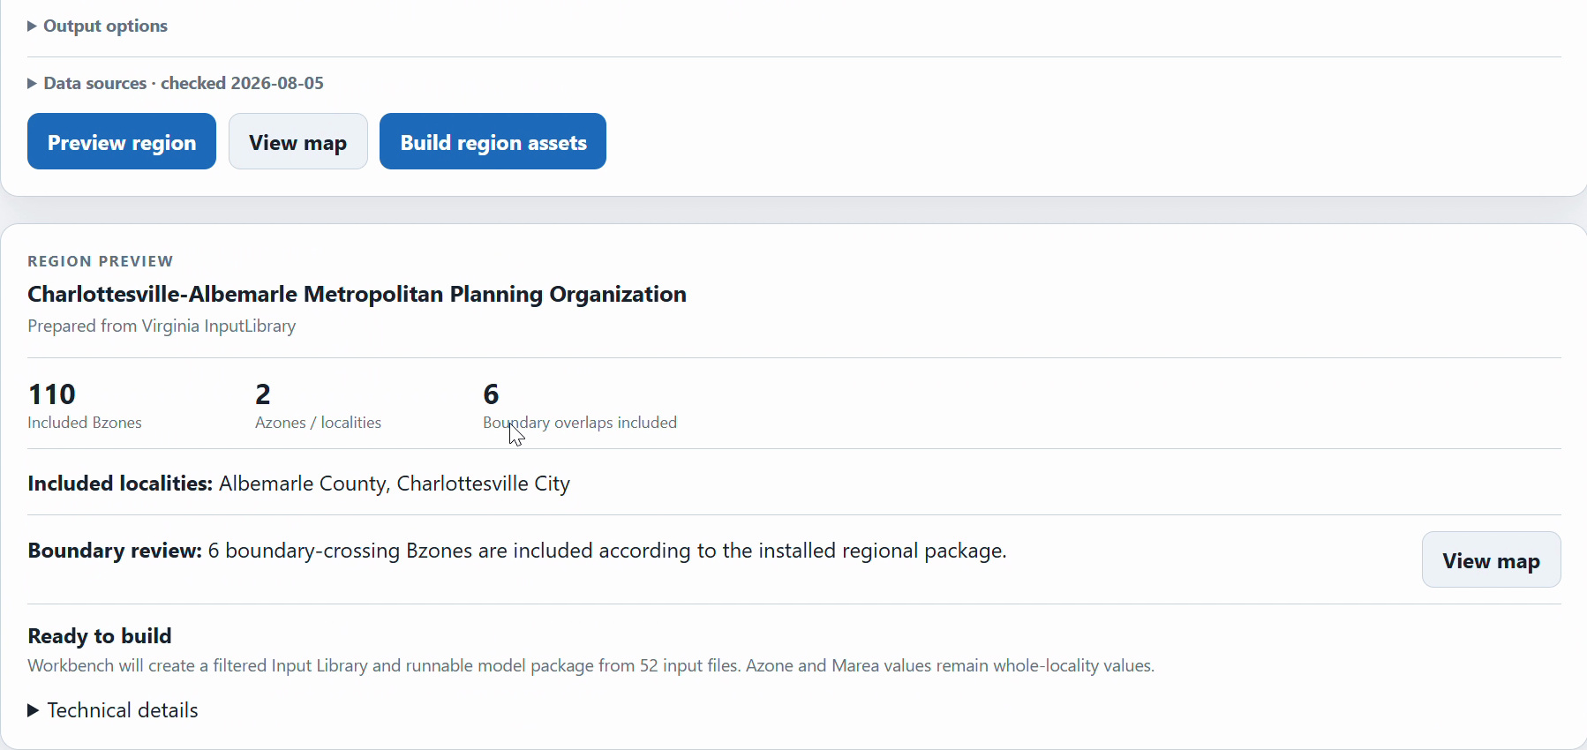
Figure 10. The regional preview exposes included localities and boundary overlaps before building.
22. If acceptable, choose Build region assets. Workbench creates a filtered InputLibrary and a matched runnable model template. Continue to Setup and create a project from the generated assets; confirm the paired template selected by Workbench.
The generated region uses complete Bzones rather than clipping each Bzone to the MPO polygon. Azone and Marea values remain whole-locality inputs; non-spatial files and compatibility defaults require review before policy use. Boundary overlaps and generated assumptions are recorded in the manifest.
Keep this regional project separate from the PlanRVA population and employment example. Preserve the regional baseline, review scenario edits, and run a small initial job before committing to a larger experiment. Workbench 2.0 supports packaged MPO execution, not one statewide Virginia run.

