Windows 2.0 workspaces
and resources
  - Native runs backups and external SSD workspaces
Understand where Windows Workbench stores your work, check resource guidance, back up the complete workspace, and safely open or move an existing workspace to an SSD.

Before you begin
Know which workspace is active and finish or stop queued model jobs before moving it. Keep a complete backup on a separate storage device. Connect an external SSD before opening a workspace stored there.

Application and workspace
The desktop application, workspace, and native R/VisionEval runtime are separate. The workspace holds Projects, Assets, Results, Documentation, and internal .workbench state. Copying only the installer, Projects, or Results is not a complete backup.

Companion resources
Windows tutorials and downloads
Installing Workbench and Runtime on Windows
Hypercube Walkthrough on Windows
Download the Windows Workbench installer
Full Windows User Guide
The illustrations for the SSD move come from the Windows workspace recording. Resource guidance is on page 2, backups on page 3, opening an existing SSD workspace on page 4, moving on page 5, and checking the move on page 6.

Check resources before model runs
1. Open Settings with the gear button or Ctrl+, and select Resources. Review detected memory and capacity on the drive holding your active workspace. Use Storage for the breakdown of results, assets, prepared models, projects, and caches.
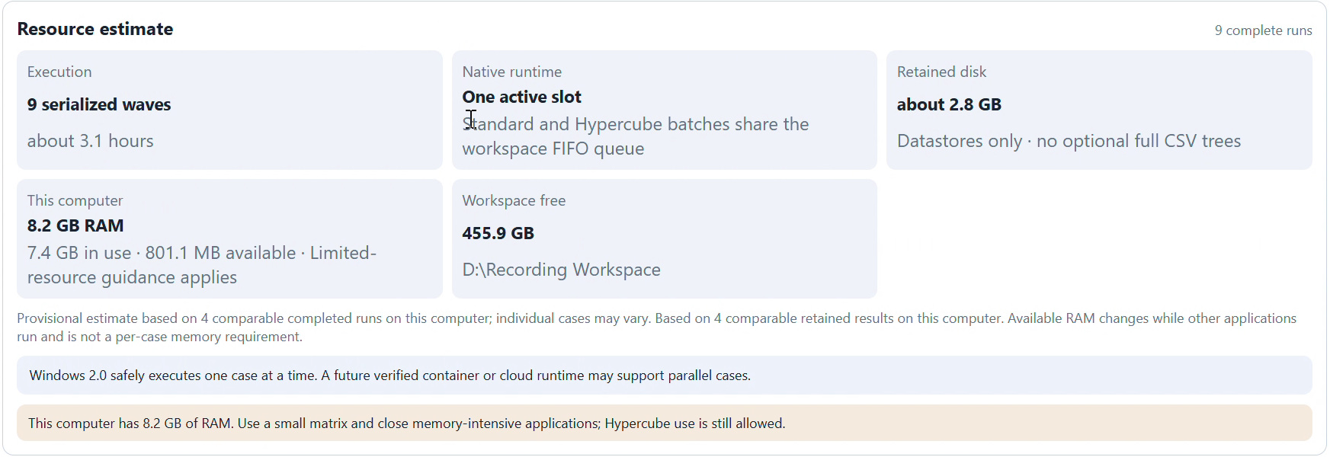
Figure 1. Windows’ Hypercube resource estimate shows a single native slot and workspace-drive capacity.
2. Plan for one VisionEval job at a time. Adding more queued cases increases total work; it does not enable simultaneous Windows model runs. Native Windows execution uses the verified R installation rather than Docker Desktop.
3. Keep Hypercubes small on a computer with limited RAM and close other memory-intensive applications. Less than 16 GB is guidance, not a block. Check both free disk space and the estimated retained results before starting a large experiment.
The screenshot’s elapsed-time and disk estimates belong to that experiment on that computer. Available memory changes as other applications run. Keep enough space for result Datastores and temporary exports; an external SSD can help when internal space is limited.

Check and back up the workspace
4. Open Settings → Workspace and inspect Current workspace. Use the Projects, Assets, Results, and Documentation folder buttons to locate those folders in Windows File Explorer. Confirm their common parent workspace folder.
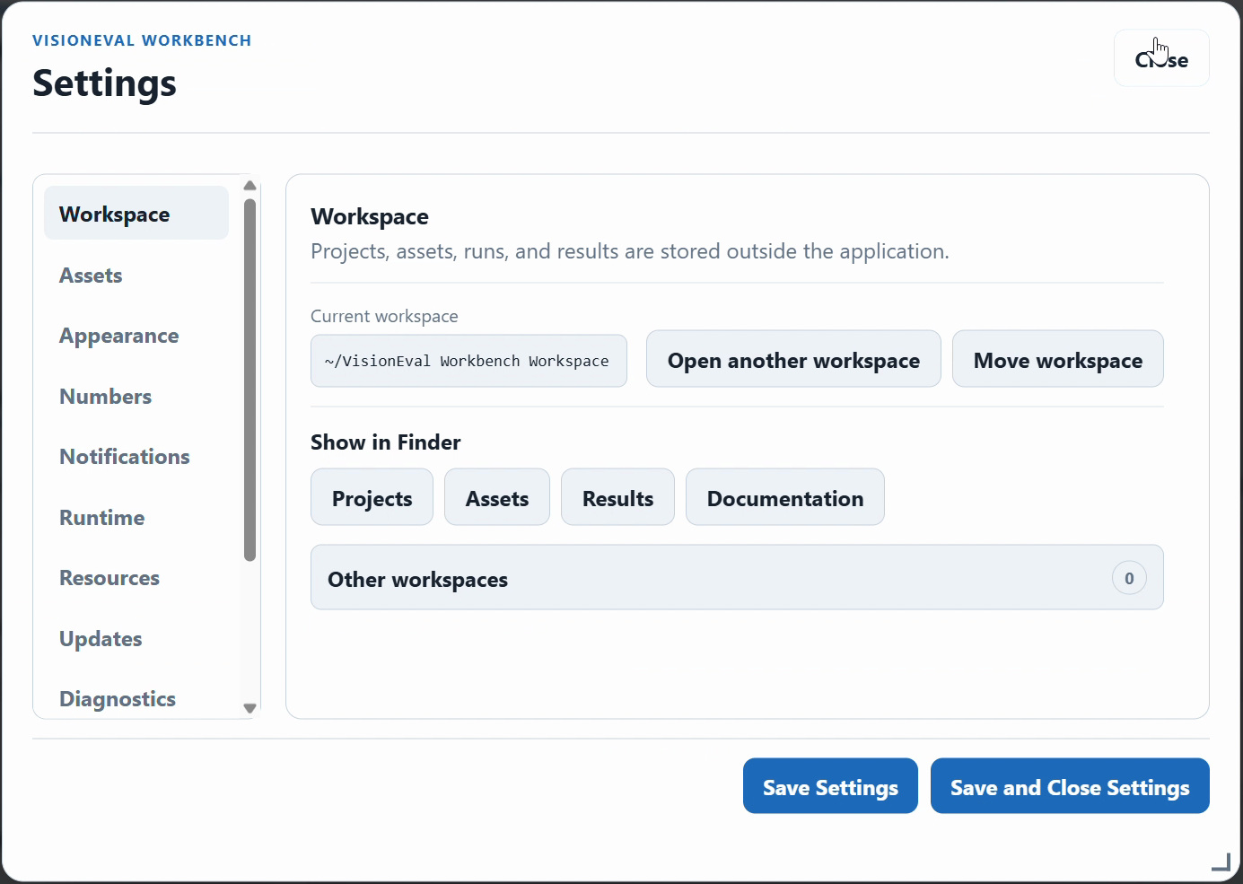
Figure 2. Workspace settings provide the active-workspace location and folder shortcuts.
5. Finish or stop active and waiting jobs, close Workbench, and copy the complete workspace root to a separate backup destination. Include Projects, Assets, Results, Documentation, and the hidden .workbench folder.
6. In File Explorer, show hidden items if needed and verify that the copy includes the internal folder as well as your projects and results. Keep the original until the backup is checked.
Back up separately any R or VisionEval folders kept outside the workspace if you need to preserve that exact runtime installation. Settings → Diagnostics exports logs and runtime/profile information for troubleshooting; a diagnostics ZIP is not a full workspace backup. Personal documentation in Documentation/User Notes is part of the workspace.

Open an existing SSD workspace
7. Connect the SSD and check that Windows File Explorer can read it. If it already holds a complete workspace, choose Settings → Workspace → Open another workspace and select the workspace root on that drive.
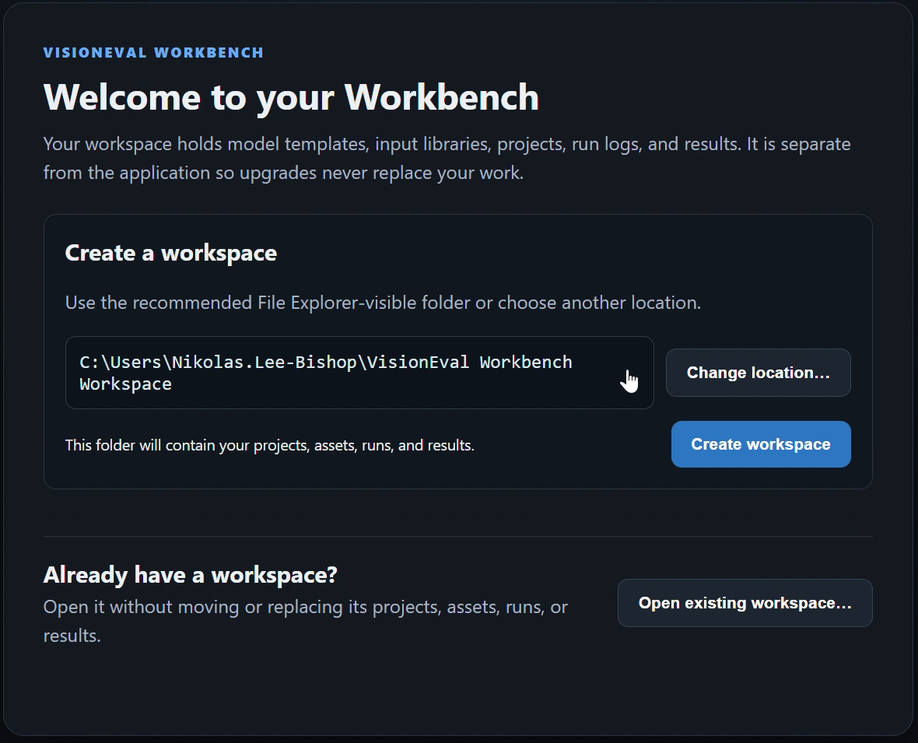
Figure 3. First launch also offers Open existing workspace when you already have a complete workspace.

Choose the right action
Open another workspace changes the active workspace to an existing folder; it does not copy or move the old one. Move workspace relocates the current workspace through a verified copy. To create a new workspace, choose a new empty location through the workspace setup flow.
8. Check the active path, installed packages, projects, and completed results after opening. Verify the native runtime separately if its paths have changed. A workspace on an SSD does not automatically move R, VE_RUNTIME, or VE_HOME.
Drive letters can change when external drives are reconnected. If a saved workspace is unavailable, connect the drive and select the correct existing root. Do not create a fresh empty workspace over the missing location or assume an empty view means the original work has disappeared.

Move the current workspace to an SSD
9. Back up the full workspace first. Finish or stop model jobs, connect the SSD, check free space, and choose a destination folder that does not already contain another workspace.
10. Open Settings → Workspace → Move workspace. Choose the destination in the Windows folder dialog and let Workbench copy and verify the complete workspace. Keep the drive connected and do not force quit.
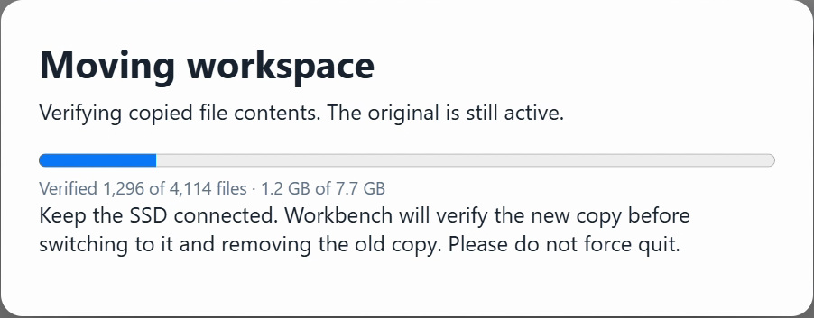
Figure 4. During verification, the recorded move reports that the original workspace is still active.
Workbench verifies copied file contents before switching to the new copy and removing the old copy as part of the move. The progress text identifies copying and verification separately. The recording’s file count and size are specific to that workspace.
11. Wait until the move finishes and Workbench returns to its normal view. Do not disconnect the SSD while copying, verifying, cleaning up, or using that workspace. Check the completed move as described on the next page.

Reopen and check the moved workspace
12. After the move, return to Settings → Workspace and verify the current root and folder locations in File Explorer. Confirm that Projects, Assets, Results, and Documentation are on the intended drive.
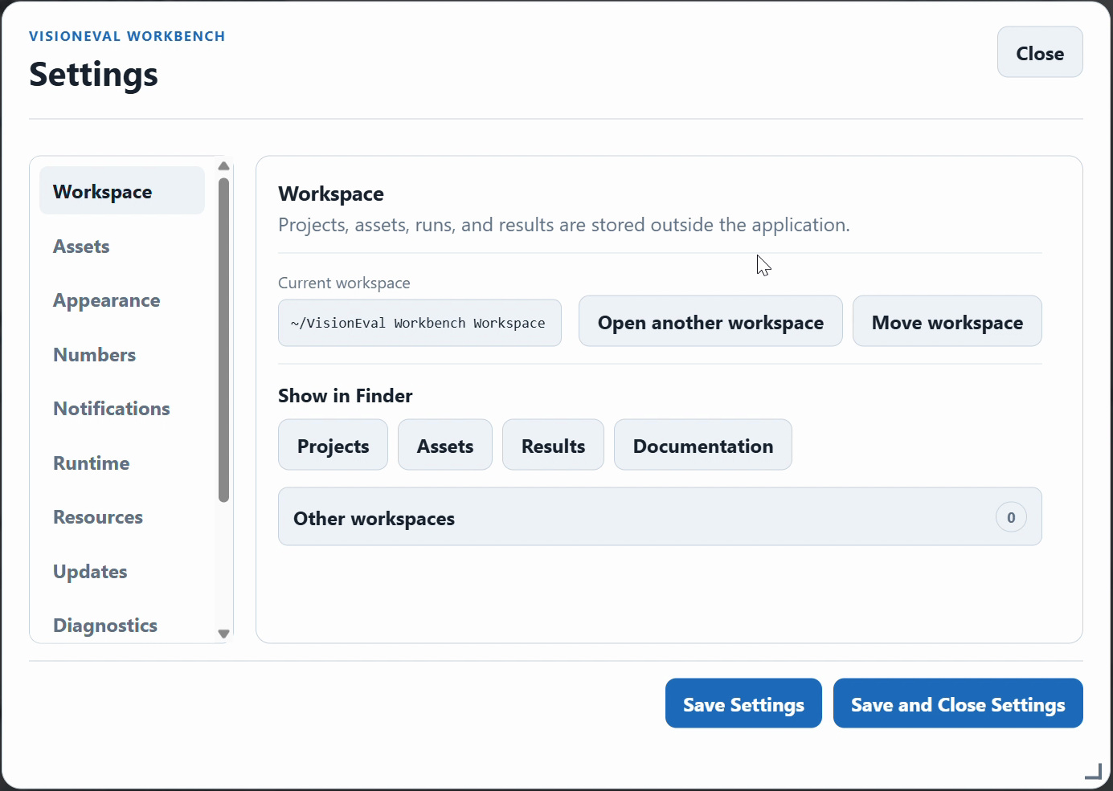
Figure 5. The recording returns to Workspace settings after the move; confirm the actual folder locations.
13. Close and reopen Workbench with the SSD connected. Confirm that the expected projects, installed assets, completed results, and personal notes are still available. Open a completed result and inspect a familiar comparison or map.
14. Check Native VisionEval ready. If R, VE_RUNTIME, or VE_HOME also moved, select their changed paths in Settings → Runtime and verify again. Keep the checked backup independently of the active SSD.

If a check fails
Keep the original or backup intact and reconnect the drive. Use Open another workspace to select the verified complete root, then inspect Settings → Diagnostics if the workspace cannot open. Do not delete the only complete copy, manually merge internal state, or repeat a move into an uncertain destination.
When you finish using the external workspace, close Workbench before safely ejecting the drive through Windows. A disconnected SSD makes that workspace unavailable until it is reconnected.

