Q1: Sensing: Circuit to Sense Rigid Side Walls

Equipment:
normal open push buttons, resistors, diodes
Assumption:
V_{CC} is lower than the breakdown voltage of the diode so that diode can stand the voltage.

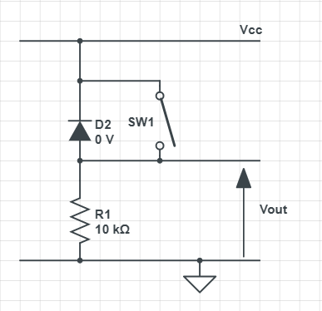
Figure 1: Circuit diagram for push button
As shown below in the circuit diagram of the sensor mounted either on the left or the right of the robot. One 1N4001 diode is connected in series of a 10kΩ resistor. The diode is connected backwards so that it is always reverse-biased. One normal open push button is connected in parallel with the diode. The output terminals are connected in parallel with the resistor, meaning its voltage is just the same as that of the resistor. Since the robot need to sense on both sides, two such circuits are needed in practice.

The reason for choosing a resistor with such a large resistance is to reduce the current flow through the circuit and thus the energy dissipation. Similarly, the reason for the usage of diodes is also due to their large resistance. The push button is here as a pressure sensor—it keeps open unless the robot touches the wall. V_{CC} is set to 3.3 V so that the output voltage is around 3.3 V when the push button is pressed. We need such a voltage since Arduino reads a voltage higher than 3V as HIGH and lower as LOW.

Noting that a reverse biased diode has extremely high resistance and thus only a low voltage is across the resistor when the push button is not pressed. Besides, the diode is short-circuited by the push button when the button is pressed and so that the output voltage level (i.e., the voltage across the resistor) is high.

To control the robot with the sensing circuit, we need to connect it to one pin in Arduino and set its pin mode to input. Whenever Arduino detects a HIGH on that pin, it means the robot collides with the wall and needs to change its direction of motion.

In our case, we choose to use pin 3 and pin 4 for the two input pins respectively.

Question 2: Sensing – Circuit to sense front unstable walls

The task at hand is to create a proximity sensor using an IR LED and a photodiode. We design a circuit and ensure the photodiode is reverse-biased with a constant voltage and producing a readable voltage.

The first problem was initially thought to have a solution of a voltage buffer, but it was later discussed that simply controlling the voltage received by the photodiode via a voltage divider would be sufficient, as the varying current wouldn’t affect the voltage received by the photodiode. As for ensuring a readable voltage is produced, a common emitter amplifier was proposed as the current produced by the photodiode would be on a minuscule scale, causing measurement difficulties.

The voltage would be linearly related to the current through the relation of
$V_{out}=I_{C}R$
Where $I_{C}$ is found through the relation with the bias current, $I_{B}$:
$I_{C}=βI_{B}$
Hence, as the current provided by the photodiode increases, the base-collector voltage varies and as a result, the collector current increases, alongside the collector voltage, allowing measurements to be taken by the Arduino. $V_{out}$ would be read by an analogue read pin on the Arduino, whilst the 9V battery is chosen to be the power source to prevent strain on the 5V source from the Arduino itself, allowing freedom of power, including the fact that the 9V cell will be more than sufficient to provide enough power.

In terms of biasing our actual circuit, the majority of this depends on the specifications of the components themselves, which are:
- Photodiode
- Resistors
- NPN BJT (Do note that a PNP BJT could also be used but preferred to use NPN due to faster mobility of electrons)
- 9V cell
- IR LED

We can, however, bias some parts with estimates regarding the BJT and photodiode behaviour. We can assume that 2V, according to the graph found below, is a viable voltage for the photodiode to operate in reverse bias. With this, we have formed a potential divider as seen in Figure 3, controlling the 2V input. The resistor values have been chosen to be reasonably large as base currents are commonly on the scale of a few $μA$ and the ratio $R2/(R1+R2)$ must be 2/9. Hence the resistors of $700kΩ$ and $200kΩ$ are used, also chosen since the base current should ideally only depending on the photodiode current produced.

The emitter and collector resistors will behave on the behaviour of the photodiode, but we can estimate rough values by assuming the current through the diode is on the scale of micro-amps, such as 1-10*10⁻⁶A, which is 10 times less than the current flowing through the potentiometer calculated through $R_{1}+R_{2}=\frac{9V}{I}$. Though it would increase depending on the behaviour of the diode, we can choose an emitter resistor within the scale of 102-103, as the emitter current, roughly equivalent to the collector current, would be equivalent to $βI_{B}=200*10^{-6}=2mA$, giving a resistance of (2-0.7)/(0.002)= 650Ω, though doesn’t account for the voltage drop across the photodiode, hence may be lower. A 2kΩ resistor can be used at the collector to control the voltage at the output such that it drops 4V at the chosen current values. This will be refined once the specifications of the actual photodiode are received, after which accurate biasing can occur.
The accompanying section with the IR LED will be simply connected in series with a resistor based on its specification, on the same plane as the photodiode for the IR rays to ‘bounce’ off a wall in front and be detected by the photodiode.

The output would be read by the Arduino through the analogue pin and
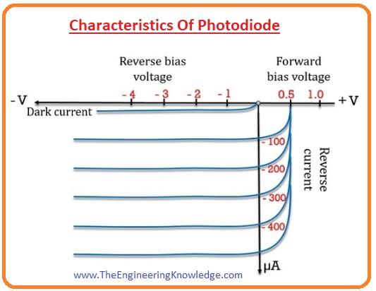
Figure 2:Graph showing the behaviour of a generic photodiode https://www.theengineeringknowledge.com/wp-content/uploads/2020/02/Characteristics-Of-Photodiode.jpg
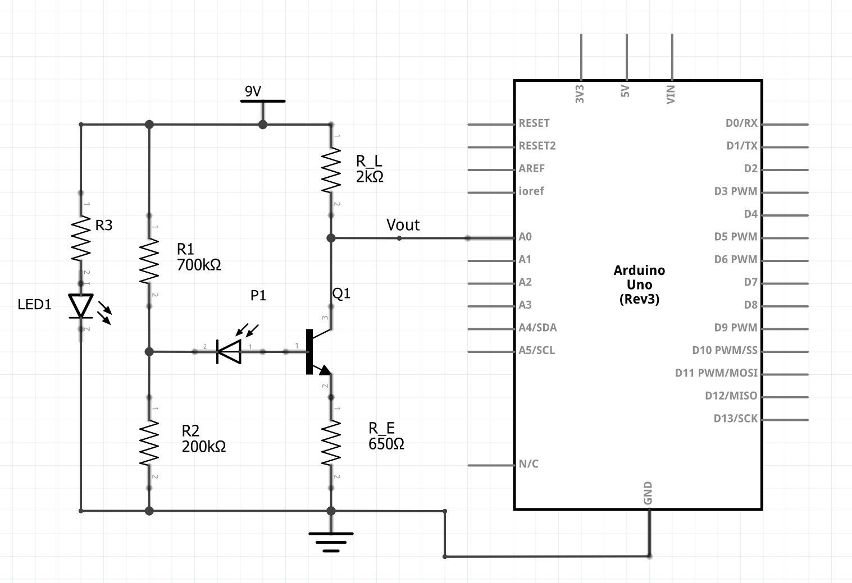
Figure 3: Circuit diagram of the sensor system
Question 3: Actuation – Motor Driver Circuits (Forward)

1, The maximum current required by the motor is 0.12A.
2, The Arduino operates at 5V and can supply a maximum of 0.04A from a digital output pin.
3, The state of the BJT is at saturation when operating.
4, The motor operates at 9V

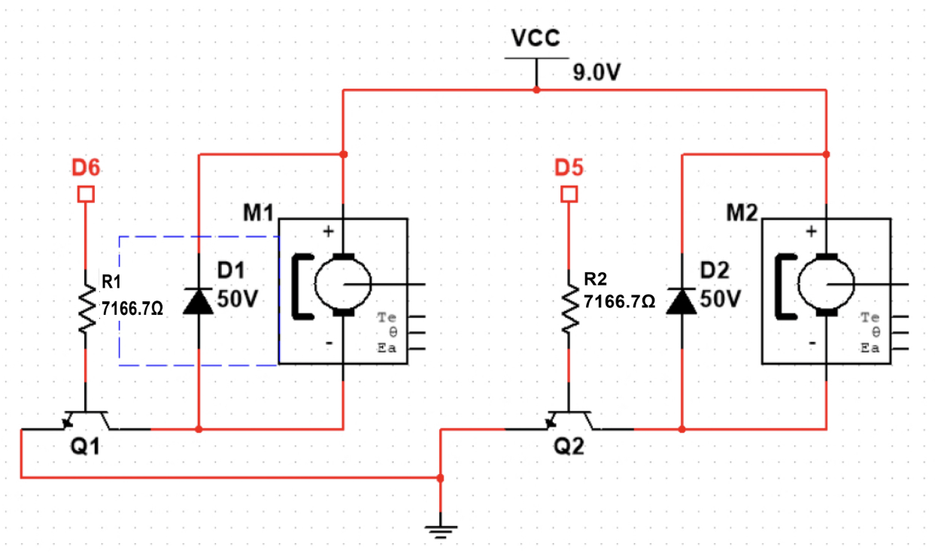
The circuit contains an NPN BJT, a resistor and a diode. The emitter of the BJT should be connected to the ground—both the Arduino and the power supply. The motor’s positive terminal should be connected to the 9V VCC, which is provided by the battery, a diode is connected across the motor, which is used for protection against back EMF generated by the motor. and the negative terminal is connected to the collector of the BJT. The base is connected to the output pin of Arduino. The emitter is connected to the ground. The circuit diagram is shown below. Two identical circuits should be built to control two motors.
Figure 4:circuit diagram for motor diver
To limit the current flowing into the base of the transistor, a resistor should be connected to decrease the current. Connect one leg of the base resistor to the digital output pin. Connect the other leg to the base of the transistor. The value of the resistance is calculated and shown below.
$I_{B}=\frac{I_{C}}{β}=\frac{0.12}{200}0.6mA$
$R=\frac{(V-V_{be})}{I_{B}}=\frac{(5-0.7)}{0.6{×10}^{-3}}=7166.67 ohm$
The diode acts as a protection mechanism against counter-electromotive force when the motor is turned off. It provides a safe path for circulating currents and protects the transistor and other components. In normal operation, when the motor is on, the diode is in reverse bias and does not affect the operation of the circuit.

In this setup, the transistor is driven into saturation region by current flowing through the base resistor when the Arduino's output pin is high. As a result, the motor can be turned on by current flowing from the positive side of the power supply through the transistor's collector-emitter junction and into the motor. The motor is turned off when the digital output pin is low because the transistor is in the cut-off region and there is no current flowing through it.

Question 4: Actuation – Motor driver circuits (Left and Right)

The motors in the front of the robot and the back of the robot are utilized to allow the robot to move left or right. This means that the motors must be able to rotate in both directions. To do so we will need:
- 2 DC motors
- 8 BJT NPN Transistors
- 8 IN4001 Diodes
- 10 Resistors
- 9V Battery
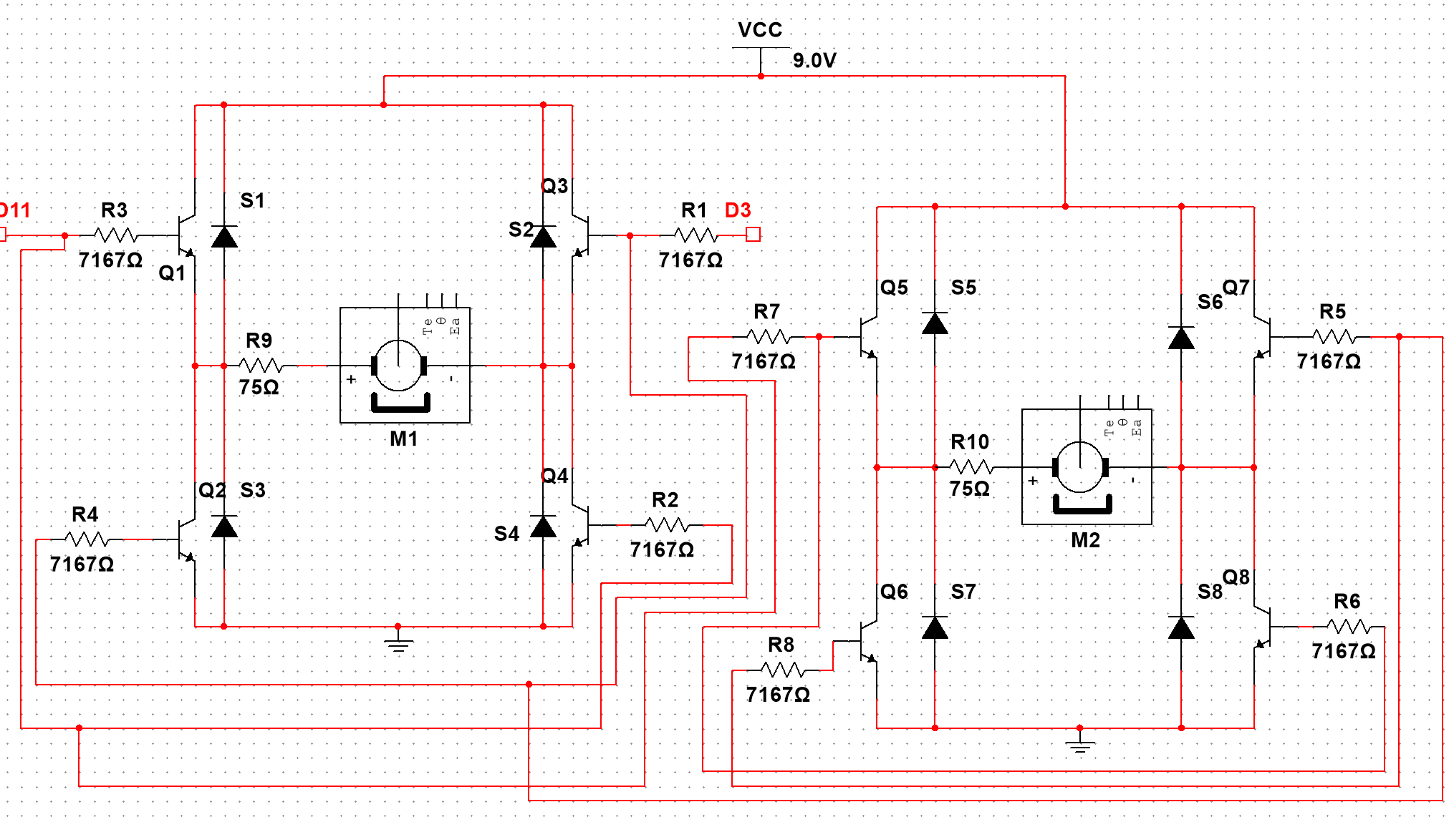
Figure SEQ Figure \* ARABIC 5: Circuit Diagram for both left and right wheel motors
This is an H-bridge bidirectional dc motor control. Each motor contains 4 BJT transistors with certain combinations that allow the current to flow to the motor in such a way that it rotates in two different directions. To rotate the motor in one direction one of the Arduino pins is set to HIGH, with a voltage of 3.3 V and the other to LOW, 0 V. For example, setting pin D11 to HIGH and D3 to LOW, current flows to the base of transistors Q1 and Q4 thus allowing current to flow from Vcc, through transistor Q1, through motor M1 and through to transistor Q4. Additionally, the motor on the back of the robot will have transistors Q5 and Q8 turned on and Q7 and Q6 turned off, thus causing this motor to rotate in the same direction allowing the robot to move left or right. Doing the opposite and setting D3 HIGH instead causes the current to flow in the opposite direction relative to the motor thus causing it to rotate in the other direction and move the robot in the other direction.
The NPN BJT transistors were selected to act as a switch and amplify the current from the Arduino through the base terminal.

NPN BJTs were chosen instead of PNP because of the faster transitions of electrons, thus making this type of BJT more suitable for quick switching between the turning ON and OFF the motors. When the base current is zero, the transistor acts as an open switch to allow the other transistors to act as closed switches when their base currents exceed the base current threshold. They act as amplifiers since the current flowing through it from collector to emitter is proportional to the base current and much greater than it, so a small base current can allow a large current to flow through the motor.

When the current flow through the motor suddenly changes (due to turning it off or on) there is an induced EMF produced in the conducting coil which rotates in the motor. This opposes the supply voltage thus a voltage spike is sent in the opposite direction. This may damage the Arduino and the transistors thus connecting a diode parallel to the motor blocks this voltage spike. The motor is obviously utilized to allow the robot to be mobile. Lastly, the resistors are there to limit the base current to a certain range and the current flowing through the motor, to stop the motors from rotating at high speeds to allow the sensors enough time to function and send corresponding commands to the actuators. The DC motor needs approximately 0.12A to run, therefore, we will require a 75 Ω resistor in series with the motor. Additionally, the base resistance should equal:
$I_{B}=\frac{I_{C}}{β}=\frac{0.12}{200}0.6mA$
$R=\frac{(V-V_{be})}{I_{B}}=\frac{(5-0.7)}{0.6{×10}^{-3}}=7166.67 ohm$$≃7167 Ω$.

Question 5

void setup() {
PBL = Pushbutton Left-hand side of robot
PBR = Pushbutton Right-hand side of robot
PVF = Photovoltage Front of robot
M1 = Left motor
M2 = Right motor
M3 = Front motor
M4 = Back motor
// Voltage across the photodiode which suggests the motor is close to the wall
Below threshold of photovoltage = Vmin

int i = 1;
}

void loop() {

While (i != 0) {
//There is a wall only in front of the robot
While (PBL and PBR are OFF && PVF < Vmin) {
M3 and M4 are turned on to move left && M1 and M2 are turned off};
//There is a wall in front of the robot and on its right, thus it must move left
While((PBR is ON && PVF < Vmin && PBL OFF) {
M3 and M4 are turned on to move the robot to the left && M1 and M2 are turned off}
//There is a wall in front of the robot and on its left, thus it must move to the right
While (PBL is ON && PVF < Vmin && PBR OFF) {
M3 and M4 are turned on to move the robot to the right && M1 and M2 are turned off}
//There is no wall in front of the robot, thus it must move forwards
While (PVF < Vmin) {
M1 and M2 are turned on && M3 and M4 are turned off;
//When Count == 7 the robot has passed 7 front walls, therefore, it has successfully exited the maze
Count = Count + 1;
If (count == 7) {
exit(0);}
}
}
}

Question 6: West Open Pit Mine of Fushun in Liaoning, China

Introduction (Nikolaos Mitsokapas)
The West Open Pit Mine of Fushun is one of the largest mines in Asia, located in the west of Fushun City, Liaoning province. It had been mined for 118 years from 1901 and shut down in 2019. The mine is 6.6 km long and 2.2 km wide, with a mining depth of 218 m and a total area of 13.2 km². It fuelled China's heavy industries with an annual production of 4,500,000 tons of coal and 12,000,000 tons of oil shale[1].

History (Daniel Li)
Mining started in 1901. At first, the Japanese were trying to rent it in 1903 and then, in 1931, after Japan invaded North-East China, they control the mine and forcibly occupied it. According to an exhibit at the Fushun Coal Mine Museum, Japan mined over 223 million tons of here and nearly 300,000 Chinese miners sacrificed under their control [2]. However, after 30 years of development under Japanese control, Fushun became a prospering country.
In 1949, the People’s Republic of China had established. The China Communist Party highly focused on the mine and kept developing it. The mine got bigger and bigger.
After decades of mining, it caused frequent mudslides and ground sinking, making the mine in danger. The local government realized the problem finally in the late 1980s and felt it was time for a change. They try to refill some parts of the mine. In 2019, the mine shut down after serving the nation for over a century. Its big impact on the process of China's industrialization is undeniable. But it was time for it to retire before it got into a more dangerous situation and damage the local environment.

Current State (Zhiyang Gao)
After the shutdown of the mine, it became a tourist site. There is a museum about the mine. The museum shows people its history and publicizes mineral knowledge and the future of environmental protection. It attracted many people to travel here, which promote the development of tourist. At the same time, the local government planned to build an ecological management area base on the mine. The area has reached 1.4 million square meters. One-fifth of the process had been finished up to 2022 and still need to spend 5 to 10 more years to finish the rest. After it builds up, it will become an eco-friendly site in northeast China[3]. After the mine witnessed how the coal industry in north-east China developed and declined, it finally retired and still benefits the city.

Product and resources from the mine (Jaiveer Safri)
Fushun is known as “the capital of coal”. Fushun West Open Pit Mine is rich in coal and oil shale. But it has other metal resources like iron, copper, magnesium, and gold. The main company of mining coal and oil shale is called Fushun Mining Group. It has very developed mining technology. The company has coalbed methane resources of around 8.9 m3. Also, it owns geological and exploitable reserves of high-grade oil shale about 3 billion tons and 920 million tons respectively. It can produce about 6 million tons of coal per year, their main products are blending coking coal and steam coal[4].

Impact on Society (Kunchen Lyu)
The mine plays a significant role in the local economy. The presence of extensive coal reserves in the Fushun region has been instrumental in fuelling the city's industrial development because Fushun's coal mines have supported the growth of power generation plants, and other heavy industries in the area.
Also, mining is essential to improve the local employment rate, as it can provide more job opportunities to local residents, including both direct employment in mining operations and indirect employment in supporting industries such as equipment manufacturing, transportation, and services. Fushun has 2.14 million inhabitants, including 1.34 million in the urban area. It is now part of the Shenyang-Fushun built-up area. The large population also enables the demand for a workforce in the Magnificent West Pit.
However, the Magnificent West Pit caused significant environmental problems. Hundreds of years of mining did cause massive natural disasters locally over the past century. Spatial-temporal appeared in the western part of the southern slope in 1927, most frequently occurring from 1970 to 2000. Nevertheless, the frequency of landslide disasters decreased and was mostly distributed from May to September after 2000 due to compensation efforts (etc., inside backfill). These disasters also destroyed several buildings every year, causing massive economic losses[5].
Therefore, the government of Fushun has created a group called the Magnificent West Pit Comprehensive Treatment and Integrated Utilisation and Urban Transformation Green Development Promotion Group specifically to manage the mine's environment. This group has also released an action plan for treatment and development that considers both the recovery of the economy and the welfare of the populace. These initiatives will represent a breakthrough in the thorough treatment of the surrounding area and ecological restoration.

Conclusion(Nikolaos Mitsokapas)
West Open Pit of Fushun is a very important and potential mine, it gained a lot of focus from the country and local government. It had a great influence on the process of the development of heavy industry and mineral industry. Even though it had retired, it is still making contributions to the local environment, agriculture, tourist industry, and economy. It brings people other thoughts about how to deal with the pit after mining and the sustainability of development.

Reference
[1] “Mining operations at Fushun West open cast mine”, Whitworth, K, 1979-10-01
[2]“Coal, Which Built a Chinese City, Now Threatens to Bury It” https://www.nytimes.com/2015/10/07/world/asia/china-coal-mines-fushun.html
[3] “Fushun transforms century-old coal mine into tourist site”
https://news.cgtn.com/news/2020-07-13/Fushun-transforms-century-old-coal-mine-into-tourist-site-S5NhJE70o8/index.html
[4]“Mill story Fushun Mining Group, Hupo Paper PM1, China”
https://tissuestory.com/TS%20PDFs/ANDRITZ_MillStory_Fushun.pdf
[5] Peng, J., Li, S., Xiaoji, H., & Ji, G. (2022). Spatial-temporal distribution characteristics and influencing factors of geological disasters in the open-pit mining area of western Fushun, Liaoning Province. The Chinese Journal of Geological Hazard and Control, 68–76.

