***Sport Disciplines Conduct, Rules and Regulations***

**AUBG Olympics**

The Skills Challenge

**a. Elements of the skills challenge:**

**i. Suicides:** the participant runs back and forth in an area designated by two straight lines that are 10 meters apart. There is going to be a small hurdle half the distance to present a bigger challenge for the participants. The contestant will start from one line, jump over the hurdle, touch the other line with his/her hand and run back. This will count as one “suicide”. The participants will have to do THREE of them to be able to continue to the next challenge.

• ***Penalty:*** each missed suicide is charged with 10 seconds time penalty.

**ii. Cone drill:** the contestant will have to put his/her hand on a cone and make five full circles (CLOCKWISE) around the cone without lifting his/her hands. Keeping the coordination is vital for successfully completing the other exercises.

• ***Penalty:*** each missed circle will be charged with 2 seconds time penalty.

**iii. Accuracy test:** the contestant will have three attempts to throw a football (American Football) in a net that is going to be 15 meters away from them. Failure to accomplish the task in three attempts will result in penalty.

• ***Penalty:*** if all three attempts are unsuccessful the penalty will be 3 seconds.

**iv. Bridge over the River:** the participant will have to walk to the next obstacle in a very straight line in order not to fall in the “river”.

• ***Penalty:*** failure to do so will result in a 2 second penalty.

**v. Snakes on the trail:** the contestant will have to pass under 2 hurdles by crawling on the ground.

• ***Penalty:*** taking down a hurdle will result in a penalty of 3 seconds

**vi. Tire challenge:** the contestant will have to pass through eight tires while stepping into them. The tires will be arranged in a chess pattern. Failure to step in a tire will result in a time penalty.

• ***Penalty:*** each missed tire will be charged with 2 seconds time penalty.

**vii. Push-ups:** the male contestant will have to make ten push-ups in the designated area. The female contestants on the other hand will have to make

10 abs (abdominal presses) in the designated area

• ***Penalty:*** each missed push-up will be charged with 2 seconds time penalty.

**b. Scoring and referees:**

i. The person who finishes the route for the least time will be the winner.

Results will be compared after the penalties have been added to the score of the participant.

ii. There are going to be two referees that are going to supervise the event and watch for any penalties.

iii. Referees’ decisions are final.

**c. Map:** for map of the rout please check *Exhibit 1* on the following page:

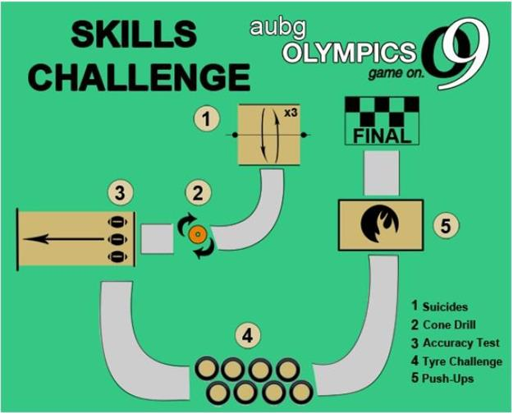*Exhibit 1: Map of Skills Challenge route*