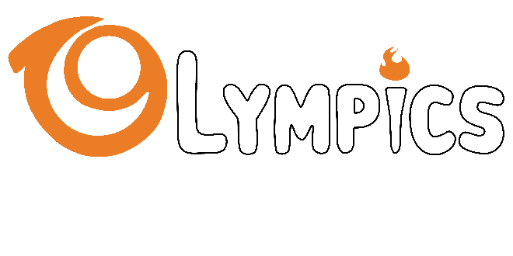

***Sport Disciplines Conduct, Rules and Regulations***

**AUBG Olympics**

The 3-Point Shootout Competition

1. The competitors will shoot 2 balls from each of the five different positions on the 3-point line on the basketball field.
2. There will be no time limit.
3. The 3 competitors who have scored the most will advance to the final.
4. In case a tie in for the first three positions, all the competitors with equal score will advance to the final.

The AUBG Olympics Sport Rules and Regulations