# GrimEntertainment – Game advertising website

1. If user is not logged in you will see nothing but a page like this one – welcoming page with register/login buttons 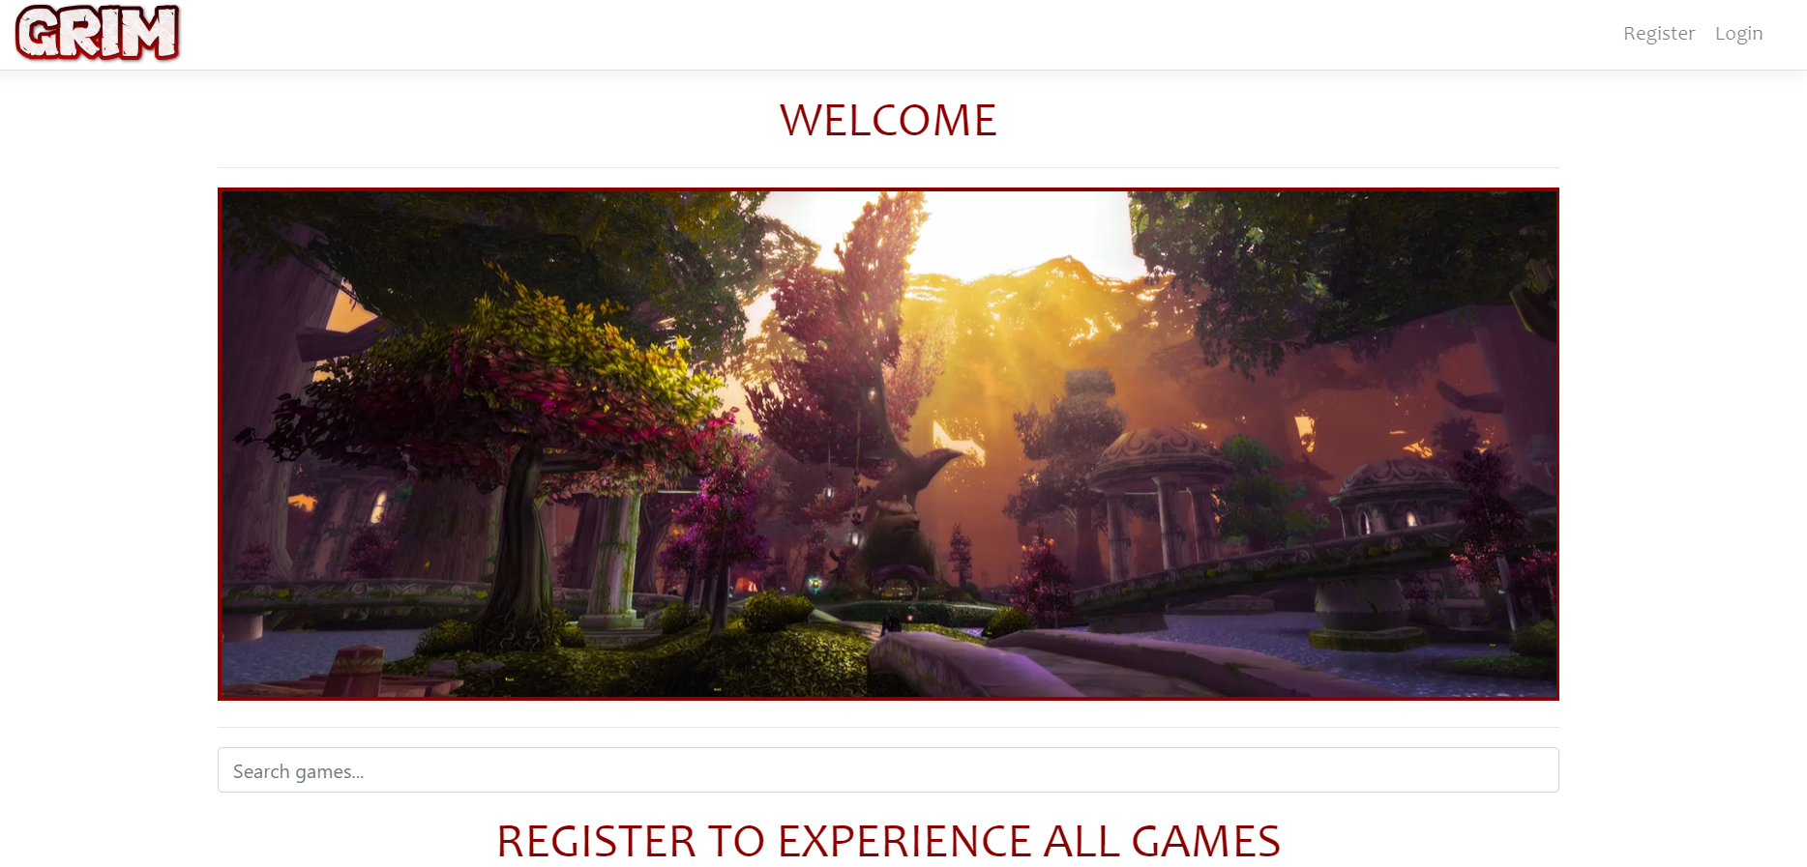
2. Register page looks like this. Also if you submit invalid data an error will occur!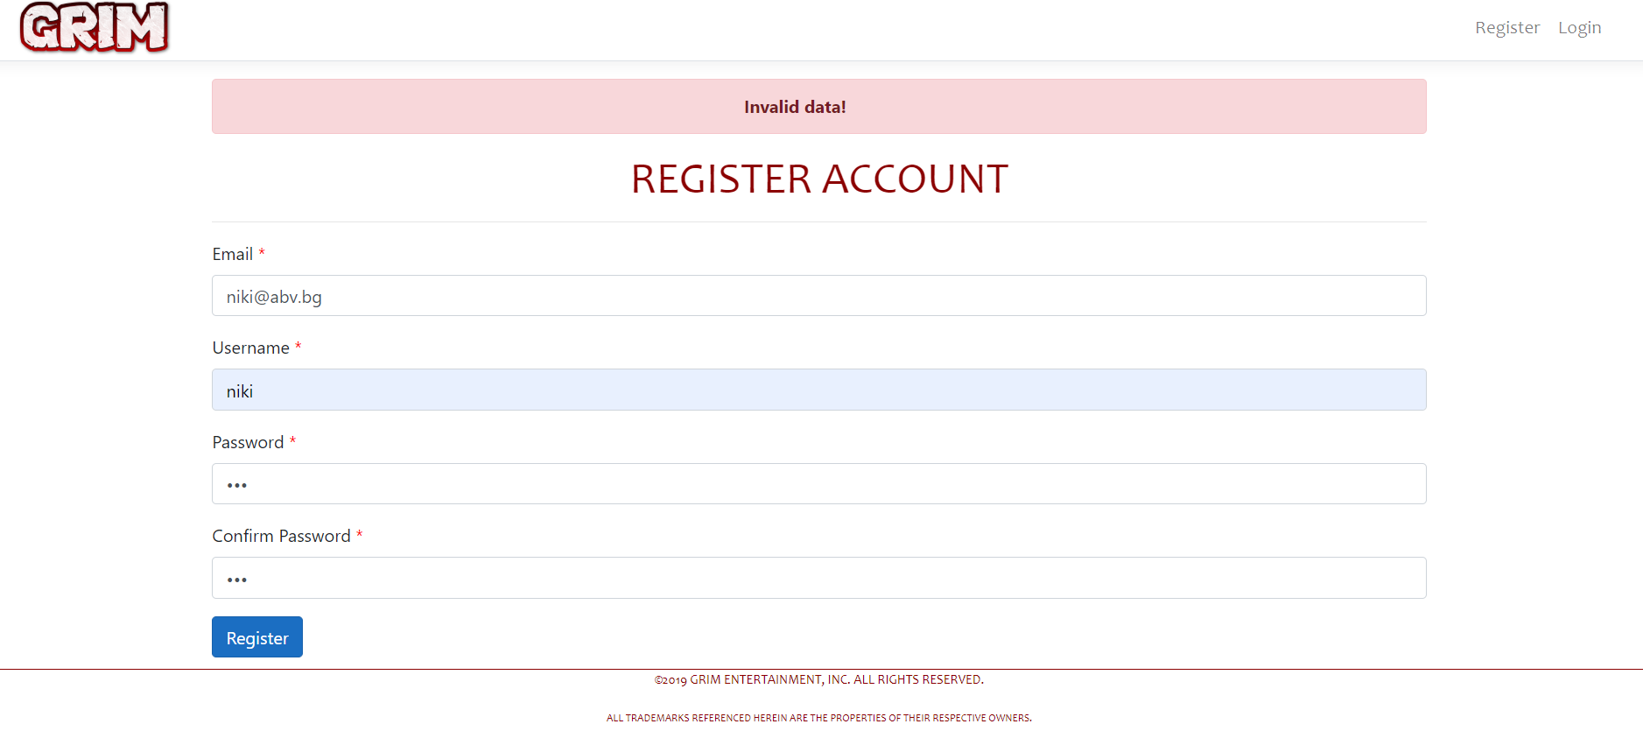
3. After successful register you will be redirected to login page. Again if you submit incorrect data an error will occur!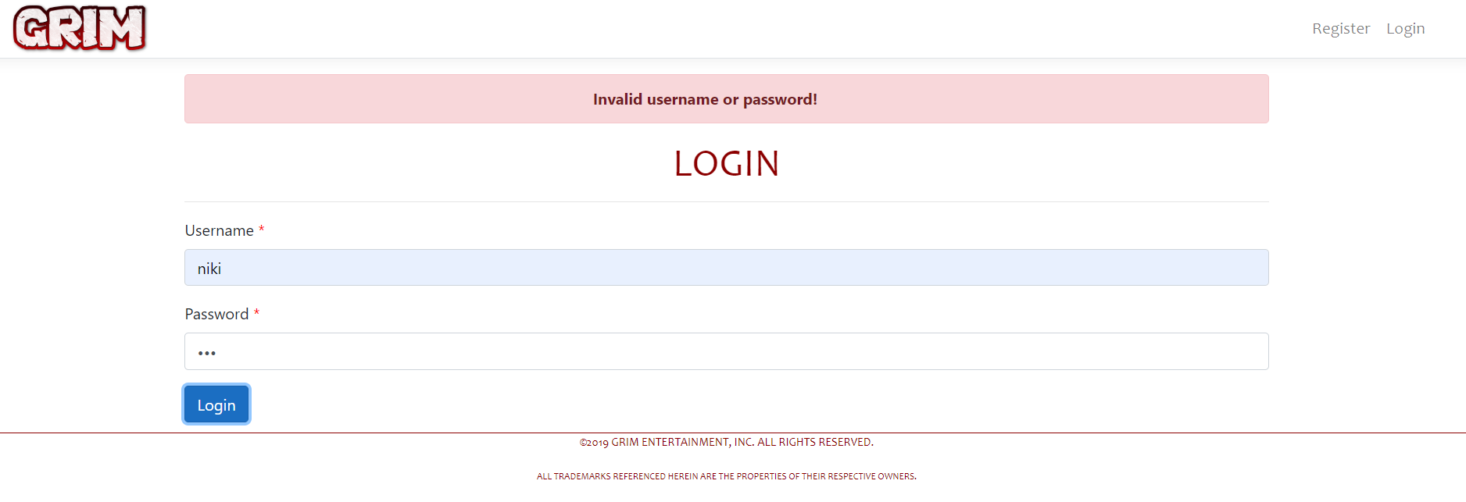
4. After successful login you will be able to see all published games, check your account information, publish a game and logout. 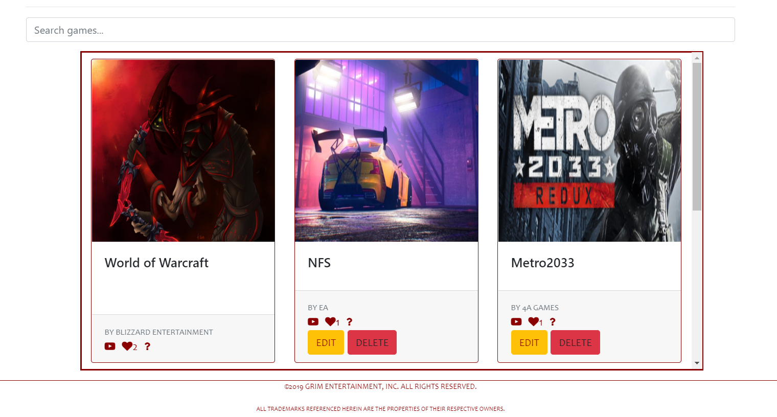
5. If some of the games are linked to your profile (you are the publisher) you will have full control over them (Edit or Delete). Also as logged user you can "like" a game, check out the video trailer, search a game or get some more information about the game after clicking the question mark.
6. Edit game page looks like this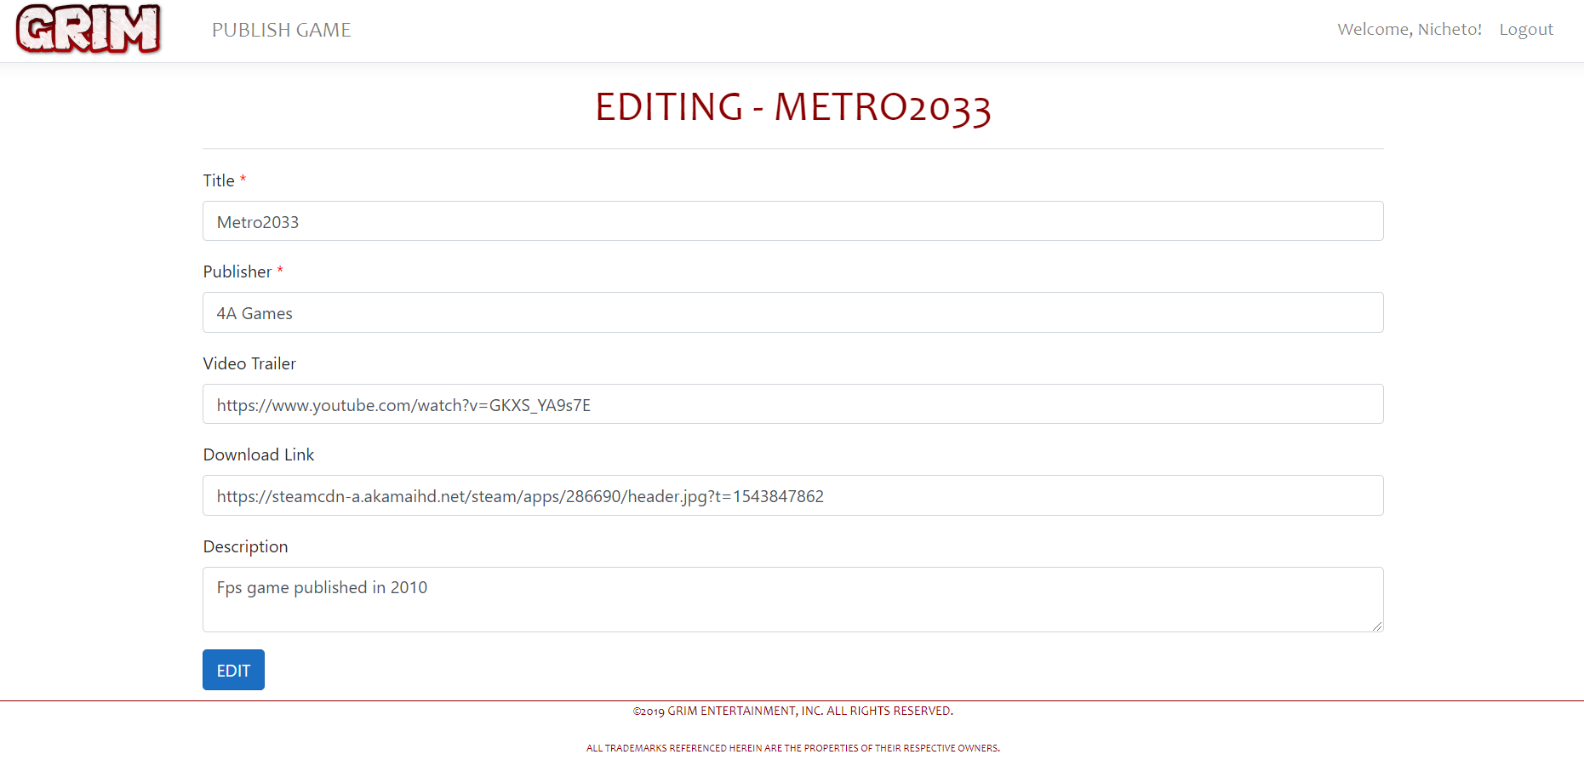
7. Publish game page. If you again try to submit incorrect data, for example recurring title, an error will occur! 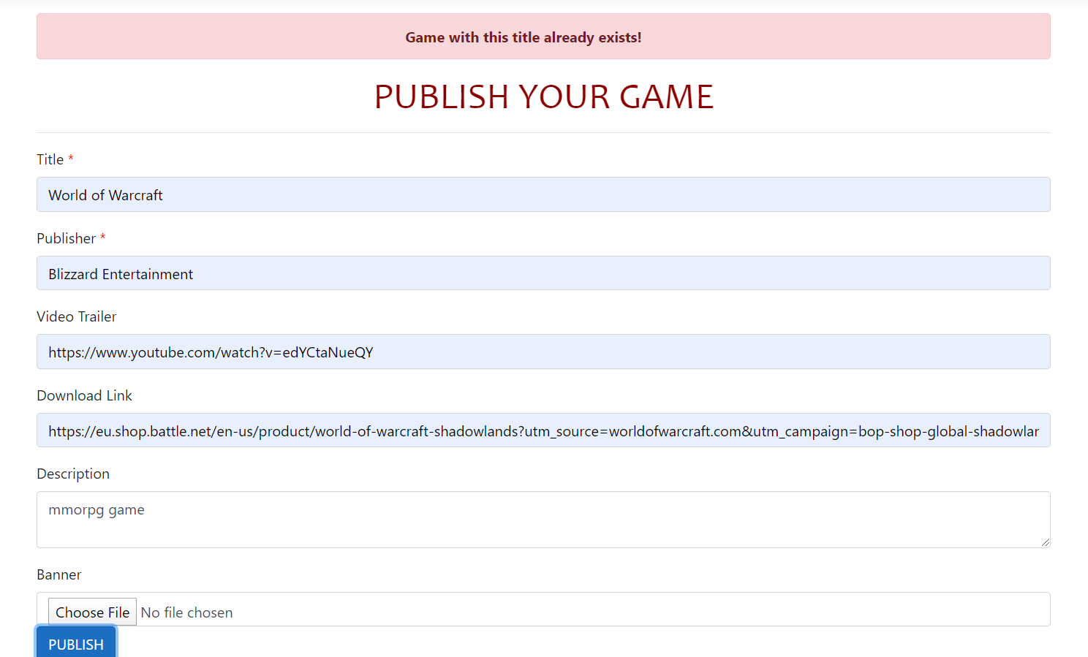
8. After successfully publishing the game it will appear on home page where everyone can see it.

THE AUTHENTICATION IS PROVIDED BY JWT TOKENS

THE BACK-END IS POWERED BY ASP.NET CORE WEB API AND IIS EXPRESS SERVER

©2019 GRIM ENTERTAINMENT. All trademarks referenced herein are the properties of their respective owners.