

|  |
| --- |
| Prototype1 |
| 18/08/18 16:44 |
| **Author:** Nikolay Cardenas  **File name:** Prototype1.vp  **Version** 1.0 |

|  |
| --- |
| Site Map |
|  |

01. Site Map / Prototype1 

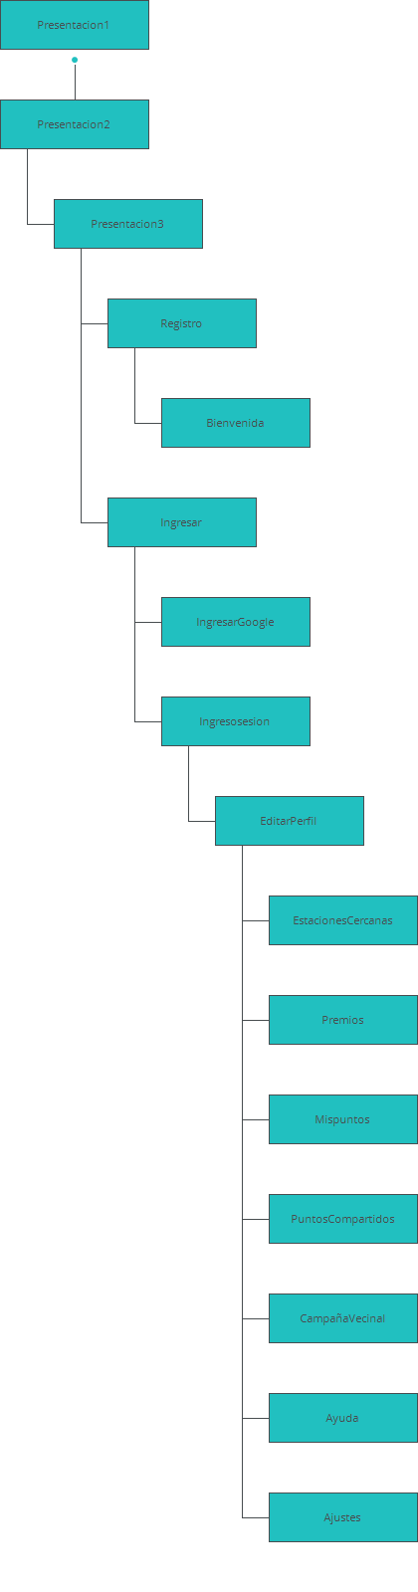

|  |
| --- |
| Screens |
|  |

02. Screens / Prototype1 

|  |  |  |  |
| --- | --- | --- | --- |
|  |  |  |  |

|  |  |
| --- | --- |
|  |  |

Slide de publicidad.

Ingresar

|  |  |  |  |  |  |  |  |  |  |
| --- | --- | --- | --- | --- | --- | --- | --- | --- | --- |
|  | Interactions   |  |  | | --- | --- | | 1 | **on Click:** goes to 'Registro' 🡪 | | 2 | **on Click:** goes to 'IngresarGoogle' 🡪 goes to 'Registro' 🡪 | | 3 | **on Click:** goes to 'Ingresosesion' 🡪 | | 4 | **on Click:** goes to 'Ingresosesion' 🡪 | |

02. Screens / Prototype1 

IngresarGoogle

|  |  |
| --- | --- |
|  | Interactions  **5 on Click:** goes to 'Ingresar' 🡪 |

|  |  |
| --- | --- |
|  |  |

|  |  |
| --- | --- |
|  | Ingreso sesion  Interactions  6  **on Click:** goes to 'Ingresar' 🡪  7  **on Click:** goes to 'EditarPerfil' 🡪  8  **on Click:** goes to 'Registro' 🡪 |

|  |  |
| --- | --- |
|  | Registro  Interactions  9  **on Click:** goes to 'Ingresar' 🡪 goes to 'Bienvenida' with effect: |

|  |  |  |  |  |  |  |  |  |  |  |  |  |  |  |  |  |  |
| --- | --- | --- | --- | --- | --- | --- | --- | --- | --- | --- | --- | --- | --- | --- | --- | --- | --- |
|  | Tus Indicadores  Interactions   |  |  | | --- | --- | | 31 | **on Click:** goes to 'EstacionesCercanas' 🡪 | | 32 | **on Click:** goes to 'Premios' 🡪 | | 33 | **on Click:** goes to 'Mispuntos' 🡪 | | 34 | **on Click:** goes to 'PuntosCompartidos' 🡪 | | 35 | **on Click:** goes to 'CampañaVecinal' 🡪 | | 36 | **on Click:** goes to 'Ayuda' 🡪 | | 37 | **on Click:** goes to 'Ayuda' with effect: slide left 🡪 | | 38 | **on Click:** goes to 'Ajustes' 🡪 | |

|  |  |
| --- | --- |
|  | Tus Indicadores |

|  |  |
| --- | --- |
|  | Mis puntos  Interactions  **on Click:** goes to 'EditarPerfil' 🡪  **on Click:** goes to 'EditarPerfil' 🡪  **on Click:** goes to 'EditarPerfil' 🡪 |

|  |  |
| --- | --- |
|  | Puntos compartidos  Interactions  **on Click:** goes to 'EditarPerfil' 🡪  **on Click:** goes to 'EditarPerfil' 🡪  **on Click:** goes to 'EditarPerfil' 🡪 |

|  |  |
| --- | --- |
|  | Premios  Interactions  **on Click:** goes to 'EditarPerfil' 🡪  **on Click:** goes to 'EditarPerfil' 🡪  **on Click:** goes to 'EditarPerfil' 🡪 |

|  |  |
| --- | --- |
|  | Puntos Ecologicos Cercanos  Interactions  **on Click:** goes to 'EditarPerfil' 🡪  **on Click:** goes to 'EditarPerfil' 🡪  **on Click:** goes to 'EditarPerfil' 🡪 |

|  |  |
| --- | --- |
|  | Campaña  Interactions  **on Click:** goes to 'EditarPerfil' 🡪  **on Click:** goes to 'EditarPerfil' 🡪  **on Click:** goes to 'EditarPerfil' 🡪 |

|  |  |
| --- | --- |
|  | Interactions  **on Click:** goes to 'EditarPerfil' 🡪  **on Click:** goes to 'EditarPerfil' 🡪  **on Click:** goes to 'EditarPerfil' 🡪 |

|  |  |
| --- | --- |
|  | Ajustes  Interactions |

|  |  |
| --- | --- |
|  | Ayuda Interactions  **on Click:** goes to 'EditarPerfil' 🡪  **on Click:** goes to 'EditarPerfil' 🡪  **on Click:** goes to 'EditarPerfil' 🡪 |

